NCSX Engineering Design Document

Design Description
Diagnostic Systems (WBS 3)

NCSX PDR

October 7-9, 2003

Lead Author: David Johnson

Table of Contents
1 Design Requirements and Constraints 1
2 Design Description and Performance 6
3 Design Basis 10
4 Design Implementation 10
5 Reliability, Maintainability, and Safety 10
6 Cost, Schedule, and Risk Management 11

Table of Figures
Figure 1 Vacuum vessel segment showing flared midplane ports 2
Figure 2 Viewing concept for Thomson scattering 7
Figure 3 Viewing concept for MSE/CHERS 8
Figure 4 Sightlines of 20-channel soft x-ray array 9
Figure 5 Sightlines of multi-channel FIR interferometer/polarimeter 9

Tables
Table 1 Research phases, essential measurements, and diagnostics requirements 2
Table 2 Preliminary measurement requirements 5
Table 3 Work Breakdown Structure (Level 2) for Diagnostics (WBS 3) 11
Table 4 Diagnostic Systems (WBS 3) cost summary by expense class (WBS Level 3) Error! Bookmark not defined.
Table 5 Diagnostic Systems (WBS 3) cost summary by year of expenditure (WBS Level 2) Error! Bookmark not defined.

Design Requirements and Constraints
The diagnostic systems provide the detailed measurements of the plasma parameters that are critical to the research goals of NCSX. For example, the spatial profiles of electron temperature and density are fundamental inputs needed for nearly all of the envisioned research topics. These systems typically include state-of-the-art instrumentation detecting light or particles from the plasma or plasma facing components, and the supporting interface hardware that provides the required views. The requirements for measurements are derived from the NCSX research program. Table 1 lists, for the various research phases of the program, the required plasma measurements that need to be added as the program advances in maturity. Also listed are the proposed diagnostic techniques added at each phase to make these measurements.
The diagnostics that are part of the NCSX Project are those needed to verify that the core device has met its engineering goals. These are the diagnostic systems listed in Phases 1 and 2 – the Initial Operation Phase and the Initial Field Mapping Phase. However, it is important to consider the full complement of diagnostics needed for the research mission, in order to insure that the diagnostic implementation is consistent with the design of the core machine in the context of various technical constraints. Most of the conceptual design effort in the diagnostic area has addressed this important issue.
The most serious of the technical constraints are spatial constraints. Inside the vessel, for example, there is a gap with a minimum distance of 5 cm between the first wall of the PFCs and the inner vessel wall. Magnetic sensors and leads must fit in this gap along with the PFCs and associated supporting and heating hardware. Compact soft x-ray arrays for tomography must also be located in this gap. There are also various geometrical constraints between diagnostic sightlines, the vacuum vessel, and the PFCs. Another important spatial constraint, which affects the device as well as the diagnostic designs, is the requirement for manned, in-vessel access for installation and maintenance activities. These constraints appear workable in the current design.
Outside the vessel there are also spatial constraints affecting diagnostics. The gap between the outer vessel wall and the modular coils is very tight in some areas, and magnetic sensors may be needed in these areas. Space on the platform and on the floor of the NCSX cell will be needed for a large number of diagnostic equipment racks and other diagnostic components. At this point in the design, it appears that these constraints can also be satisfied.
The most serious spatial constraints occur at the vacuum boundary. Diagnostic port extensions need to be positioned between modular coils and associated support structures at locations where they will not interfere with the TF coils or TF supports as they extend out through the cryostat. In the design of the core machine, diagnostic access was given a high priority, and there are several examples of how this consideration affected the design direction. The 18 TF coil design, which places the TF coils over the average toroidal position of the modular coils, resulted in better diagnostic access, relative to previous TF configurations. The six large midplane ports on either side of the beam ports have been flared toroidally, permitting large aperture, wide-angle views of the plasma at this location. These flared ports are shown in Figure 1, and later examples show how these flared ports provide flexible viewing for several NCSX diagnostics.
Viewing concepts for several diagnostics have been completed, and some will be described below. These studies provide confidence that diagnostic access through the vacuum vessel is adequate for the measurements listed in Table 1. More detailed definition of the interface between the diagnostic port extensions and the PFCs, and of the interface between the port extensions and the cryostat are needed during the detailed design phase.
A port labeling logic has been adopted which takes advantage of stellarator symmetry to provide valuable geometrical information in the label while also permitting unique locations. These labels were used in the definition of the port map, which defines the allocation of ports among the various diagnostic systems.
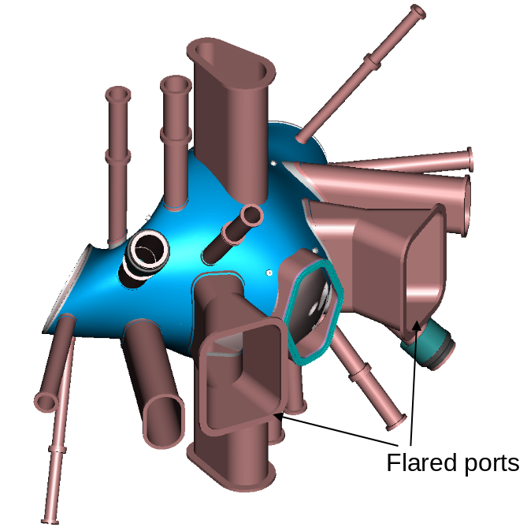
Figure 1 Vacuum vessel segment showing flared midplane ports

Table 1 Research phases, essential measurements, and diagnostics requirements
Research program phase/Measurement | Diagnostic technique
1. Initial Operation (0.5 T, room temperature)
I_{p} | Rowgowski coil
Wide-angle image of plasma/wall | Visible camera (1)
2. Initial Field Line Mapping (no plasma)
Vacuum flux surfaces | E-beam, fluorescent probe & CCD camera
3. 1.5 MW Initial Experiments (1.5 MW NBI, 1.2 T, cryogenics, minimal PFCs)
Boundary position and shape | Saddle loops, flux loops, B probes, 3-D EFIT
Total stored energy | Diamagnetic loop
Wide-angle image of plasma/wall | Visible cameras with filters (2)
Core T_{e} | Basic Thomson scattering or filtered SXR diodes,  & x-ray crystal spectrometer
n_{e} profile | FIR interferometer/polarimeter
Core T_{i} | X-ray crystal spectrometer
Total P_{rad} | Wide angle bolometer
Low m,n MHD modes (<100 kHz) | Compact soft x-ray arrays (8 20-channel arrays)
Magnetic axis position | Compact soft x-ray arrays & 3-D EFIT
Impurity identification | Visible spectrometer
VB, H_{α} & carbon line emission | Visible filterscopes
PFC temperature | Compact IR camera
4. 3 MW Heating (3 MW NBI, full PFCs, 350 C bake)
T_{e} profile | Full Thomson scattering system
T_{i}, v_{θ} profiles | DNB & CHERS
Rotational transform profile | DNB & MSE, FIR inter./polar., 3-D EFIT
Higher m,n MHD modes | Additional soft x-ray arrays (8 20-channel arrays)
High-frequency MHD (<5 MHz) | High-frequency Mirnov coils
Flux surface topology | Tangential SXR camera
Impurity concentrations | Absolute VUV spectroscopy
Z_{eff} profile | Thomson scattering detector system
P_{rad} profile | Core bolometer array
Fast ion loss | Fast ion loss probe, IR camera
Ion energy distribution | Neutral particle analyzer
Neutron flux | Epithermal neutron detector
SOL n_{e} and T_{e} | Movable Langmuir probe
Edge neutral pressure | Fast pressure gauges
5. Confinement & β push (3 MW NBI & 6 MW NBI or RF, 2 T, divertor)
Core n_{e} fluctuations | Fluctuation diagnostic (HIBP and/or BES)
Core helium density profile | DNB & He CHERS
Divertor P_{rad} profile | Divertor bolometer arrays
Divertor plate temperature | Fast IR camera & thermocouples
Target T_{e} & n_{e} | Plate-mounted Langmuir probes
Divertor recycling | Divertor filtered 1-D CCD camera
Divertor Impurity concentrations & flows | Divertor VUV spectroscopy
6. Long pulse (Existing heating & 3 MW long pulse NBI or RF)
Divertor T_{e} & n_{e} profiles | Divertor Thomson scattering

In addition to the tight space constraints between diagnostics and other machine components, there are other technical constraints that are challenging. Many of the diagnostic systems will need re-entrant front-end components located near the plasma. These components may be subjected to large thermal excursions during bakeout or cryostat cool down. It is likely, in some cases, that diagnostic component cooling/heating will be needed. The lengths of the re-entrant front end may be considerable, and difficulties maintaining precise alignment will grow with increasing length. The magnetic field strength at the re-entrant front end could be large, since this location will be adjacent to modular coils. Thus, the design of the diagnostic front-end needs to be sensitive to eddy current forces.
A typical diagnostic system consists of several component parts. There is the front-end collection system, which may be a magnetic sensor, a particle collector, or a lens system collecting light from the plasma. This collector must be supported on a mount, which may need to accommodate adjustable alignment of the system. There is typically a relay system of fiber optic or copper cables that carry the signals from the collectors to the signal conditioning components, which are generally located in equipment racks near the machine, to avoid the noise and expense introduced by long relay cables. In the case of systems utilizing components sensitive to x-rays, gammas or neutrons, the signals may need to be optically relayed to areas just outside the cell shield wall.
Space needs to be reserved around the core machine for these racks. Ultimately, approximately 50 equipment racks will be needed. The high-bay area currently planned for NCSX has adequate space for such racks, provided supporting subsystems that can be conveniently positioned further from the machine are so located. Currently, there are five rooms on the west side, adjacent to the outside of the radiation shield, reserved for diagnostic systems that are sensitive to radiation.
WBS 3 is responsible for the basic diagnostic system components. These include sensors, collection systems and associated support structures, sensor cables, and signal conditioning hardware and racks. There are several critical areas of diagnostic support that are the responsibility of other WBS elements. These tasks have been planned and budgeted in the WBS elements listed below, including both project and upgrade components:
- Port extensions and their interface with the vacuum vessel and cryostat - WBS 1
- Interface between port extensions and PFCs - WBS 1
- Junction boxes near the machine where sensor cables join field cables - WBS 4
- Field cables which join sensor cables to racks, and associated cable trays - WBS 4
- AC power to racks, rack grounding and isolation - WBS 4
- Modular data acquisition and control system, including timing and triggering, standard digitizers, control modules, and associated crates and computers, with software (nonstandard digitizers covered in WBS 3) - WBS 5
- Platform around machine - WBS 73
- Remote control of view port shutters for between shot GDC - WBS 231
Each diagnostic system must be designed to satisfy specific measurement requirements. These requirements can be described in terms of the range of the plasma parameter being measured, the desired accuracy, and the spatial and temporal resolution required to permit the experimental investigation of the various research topics. Table 2 is a preliminary listing of such requirements. At this point, these requirements should be viewed as design goals for the diagnostics, and the values listed may evolve as more consideration is given in matching the measurement needs to the experimental program. Quantitative confirmation that these goals can be met in the case of a specific diagnostic will be part of the preliminary design for that diagnostic system.
Table 2 Preliminary measurement requirements
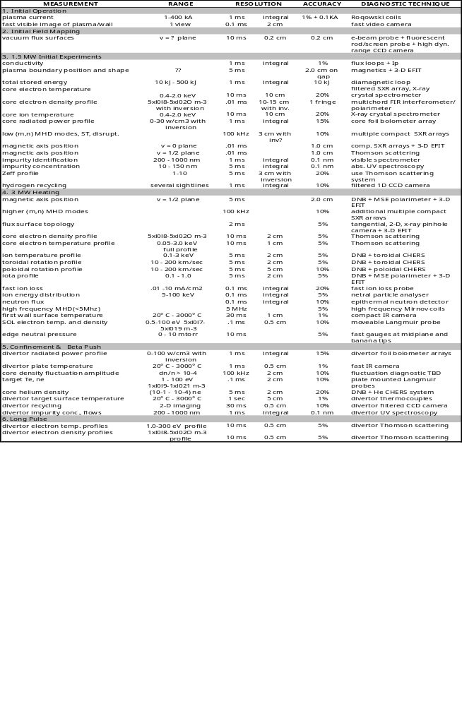

Design Description and Performance
This section contains more details on the design elements for the diagnostics for Phases 1 and 2, which are funded as part of the NCSX MIE Project. A similar short description will be given for certain critical diagnostics in Phases 3 and 4 that will be funded under the NCSX Program.
Diagnostic Integration - As the design of the core machine continues, it is important to continue the integration of diagnostics into the device with higher levels of definition. For example, developing sightline concepts for the full array of planned diagnostics may point to the need for slight modifications in the diagnostic port extensions. Another example is the further definition of space needs for in-vessel sensors, and the integration of these sensors into the PFCs and associated support structures. The allocation of port space between diagnostics and other auxiliary systems is another important part of this integration effort.
Magnetics - The magnetic sensors include diamagnetic loops, flux loops, saddle loops, Rogowski coils and B-coils that will provide signals to measure the magnetic flux change in the many geometries necessary to determine the magnetic field geometry using an equilibrium reconstruction code. Because of the strong shaping in NCSX plasmas, such a magnetic reconstruction can provide important information on profiles of plasma pressure and toroidal current.
A typical magnetic diagnostic channel consists of a high temperature sensor coil mounted between the carbon first wall and the vacuum vessel with high temperature leads to a vacuum electrical feedthrough. The signal is transmitted via field cables a junction box and then to an integrator, and finally to a digitizer to provide flux versus time. Many of the signals will also be inputs to the plasma control computer, which will use them to control the coil currents, which determine the plasma size and shape as well as the toroidal plasma current.
There is little experience with feedback control of the evolution of a 3-D stellarator plasma. A numerical study is underway to ascertain the optimum number, type, and placement of the sensors needed for equilibrium reconstruction and control. This study is scheduled to be completed during FY04. The computational tools development needed to perform this analysis will be funded by the NCSX program, collaborating with other stellarator groups and building on existing tools. Rough estimates indicate that several hundred sensors of several different types may ultimately be required.
Many of these sensors are located exterior to the vacuum vessel and become trapped once the core machine is assembled. Therefore, we have budgeted these sensors within the construction project, even though they would not be used until the third phase (1.5 MW Initial Experiments). Included are 200 saddle loops consisting of 4-sided trapezoidal loops of mineral insulated (MI) cable clamped to the outer surface of the vessel, under the vessel heating/cooling tubes. The number is a guess, anticipating the outcome of the numerical study. Other external sensors included in this category are loops of MI cable co-wound with each modular coil, and with each of the TF, PF, OH and trim coils, plus 2 external rogowski coils and 2 diamagnetic loops. The construction project includes termination of all of these sensors in boxes outside the cryostat, but field cabling, integrators and digitizers are included for only ~10 of these sensors.
Fast Visible Camera – A fast visible camera will be used initially to view the plasma through a window in a tangential neutral beam port. In this temporary configuration, the camera will be supported on a mount attached directly to the vacuum window with no shutter. The camera will be moderately fast with a full frame rate of at least 1 kHz to permit viewing of the startup evolution. A PC with frame grabber will be used to control the camera, and to capture and store the data.
Field Mapping - The field mapping hardware consists of a probe drive with an electron gun at its tip, which can be accurately positioned along a line through the nominal cross-section. The axis of the gun also needs to be adjustable for alignment with the local field. During field mapping the electron beam from the gun will intercept a phosphor, coated on a fine mesh or a moveable probe. Strike points will be compared to expectations of a code, which will compute the beam trajectory for given coil currents. Magnetic island structures will be investigated at reference vacuum configurations. In later phases, the influence of trim coil currents will be assessed.
The following short concept descriptions are for diagnostic systems that are not part of the NCSX project, however, they are included because access compatibility issues will likely influence the design of the core device, particularly the details of the port extensions.
Thomson Scattering - Because of the moderate density and relatively low magnetic field on NCSX, it will not be possible to use conventional ECE techniques for measuring T_{e}(R,t). Thus Thomson scattering will be a key diagnostic, providing both T_{e}(R,t) and n_{e}(R,t). The current concept for this diagnostic uses a Nd:YAG laser system with a laser repetition rate of 100 Hz (possibly using 2-50 Hz lasers). Twenty filter polychromators will be used with 4 spectral channels each. Light from 3 positions in the plasma will be relayed via 3 different fiber optic bundle lengths to each polychromator. Fast transient recorders (4x20 = 80 channels at 1 Gs/s) will resolve the three time-multiplexed signals from the APD detectors. In this way a 60 point spatial profile will be recorded for each laser pulse, with a spatial resolution of ~ 1 cm. In the current concept, the laser is fired vertically in the v=0 symmetry plane shown in the midplane cutout view depicted in Figure 2.

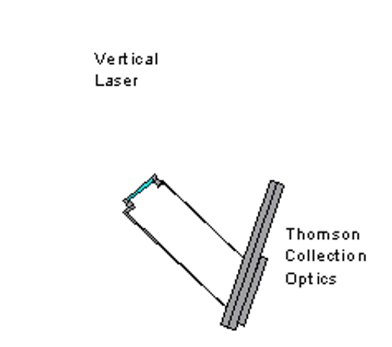
Figure 2 Viewing concept for Thomson scattering

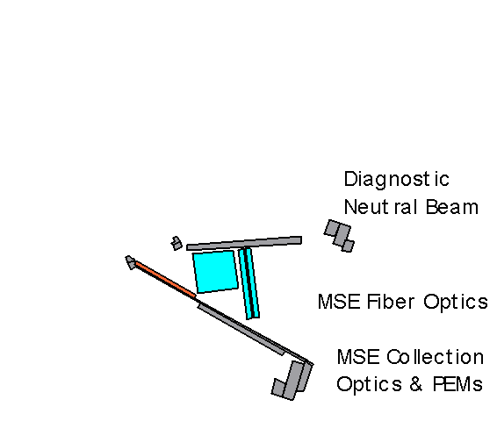
Figure 3 Viewing concept for MSE/CHERS

Active Spectroscopy - The NCSX heating beams inject nearly parallel to flux surfaces. Because of the large beam cross-section, this means that viewing the intersection of the beam with the core plasma region from any position results in sightlines that cross many flux surfaces, and hence poor spatial resolution. In principal, information from many views from different angles could be inverted to regain localization, this would be very difficult in the 3-D geometry of NCSX.
A diagnostic neutral beam (DNB) with a compact cross-section, injected as shown in Figure 3, could be used for profile measurements of T_{I} and v_{φ} with a CHERS system viewing carbon charge exchange emission and an iota with a MSE polarimeter system viewing D_{α} emission. The expected radial resolution varies from ~1 cm at the outer plasma edge to ~2 cm at the inner edge, sufficient to provide detailed radial profiles. Ideally such a beam would have an energy of 50 keV/amu, a neutral current > 50 mA/cm², a diameter of < 6 cm, and a pulse length of ~ 500 msec.
Compact Soft X-Ray Arrays - X-ray tomography using a large number of sightlines in multiple fan arrays is a powerful technique for investigating MHD mode structure, and thereby the topology of equilibrium flux surfaces. Such arrays have been used on both tokamaks and stellarators, typically with extensive coverage in one or two poloidal cross-sections. In order to achieve such coverage on NCSX, it will be necessary to install compact arrays inside the vacuum vessel, between the first wall and the vacuum vessel. The initial installation will have 160 channels (8 arrays of 20 channels each) with an additional 160 channels to be added later. Spatial resolution in the plasma core of ~2 cm can be obtained with nearly complete plasma coverage with 160 channels if the arrays are located near the oblate plasma cross section. Figure 4 shows the sightlines from one 20-channel SXR array with ~2 cm resolution in the oblate cross section; the other arrays would be spaced roughly equally around this poloidal cross section.

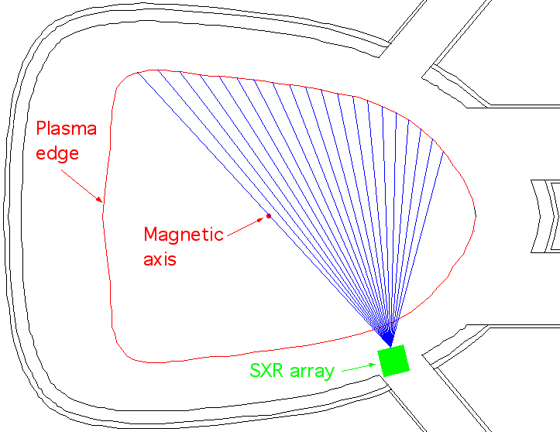
Figure 4 Sightlines of 20-channel soft x-ray array

It appears that the required the radial space is available inside the vessel in the vicinity of the oblate cross section. The available space is affected by the design of the welded vacuum vessel joints at the oblate cross sections.
Multi-channel FIR Interferometer/Polarimeter Figure 4 shows the candidate geometry for the FIR interferometer/polarimeter used to measure j(R), n_{e}(R), and B_{p}(R) fluctuations. This configuration makes use of the radially elongated top and bottom ports at the v=0 symmetry plane. This system would use a vertical sheet FIR laser beam similar to systems used on TEXT and MST, to achieve 1.0 - 1.5 cm radial channel spacing with 20 - 30 channels..
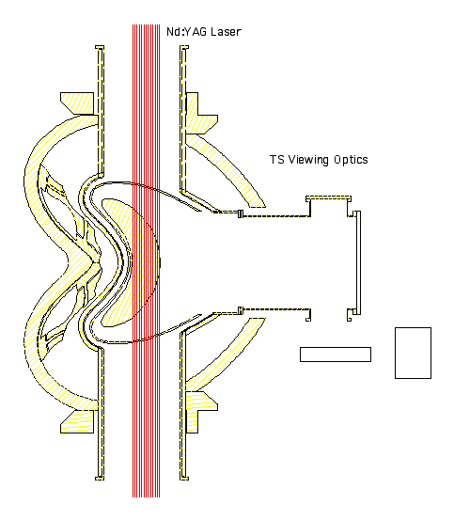
Figure 5 Sightlines of multi-channel FIR interferometer/polarimeter

Design Basis
There are two distinct components of the diagnostics design. The first is the diagnostic implementation plan. The basis for this plan is past experience on similar scale devices such as NSTX. It was assumed that the range of research topics and the pace of the research will be similar to that on NSTX, and that, compared to that machine, a similar number of diagnostics of similar complexity will be needed for NCSX.
The second design component is the collection of concepts for specific diagnostics. For some diagnostics in the Project, like visible cameras and 1 mm interferometer, the concepts are straightforward extensions of past experience on machines like NSTX. However, in other cases, such as magnetics and field mapping, the NCSX requirements dictate development of new tools or new techniques.
In the case of magnetics, we assume that the sensor types are similar to those currently in use on other fusion devices. However, selection of the optimum sensor types and optimum locations will be done using numerical optimization techniques. Space constraints, temperature constraints, vacuum material constraints and signal processing needs for the magnetic diagnostics should not, however, be strongly affected by this optimization.
The field mapping effort is also in need of further definition of design requirements, before engineering concepts have a firm basis. More work is needed to model the vacuum configurations to be probed, the necessity of probing more than one toroidal position in the field period, the necessity of probing evolving vacuum configurations, and the necessity of diagnosing configurations with cryogens in the coils. At this stage, we assume that a spatial resolution requirement of a few mm over the full cross-section at one toroidal position, with a time resolution of tens of seconds. This represents a capability comparable to that of previous systems. We also assume that a vacuum vent will be needed to deploy this diagnostic.

Design Implementation
Implementation of the designs for diagnostics is a straightforward extension of capability at PPPL and in the broader US fusion community. As is the case on NSTX, participation by the broader community in diagnosing this device is an essential part of the NCSX program. The organizational structure and funding process for these diagnostic collaborations is not yet defined.
The diagnostic plan assumes that new diagnostic components will be procured or fabricated. Plasma diagnostic instrumentation benefits greatly from rapidly evolving sensor and data acquisition technologies. Diagnostic designs should seek to take advantage of the progress toward more sensitive, compact measurement devices.
In most cases, diagnostic system components will be assembled and tested on a laboratory bench prior to assembly on NCSX. For example, a magnetic pickup coil will be wound, have leads attached, be vacuum prepped, and be tested in the lab, before delivery for field installation. Optical systems will also be pre-assembled and characterized prior to installation on the machine. Once installed, diagnostic components typically will have more tests done. For magnetics, this might include resistance and polarity tests. For optical diagnostics, this would include alignments and calibrations, as well as shutter tests. Alignments will likely involve the use of a measurement arm or laser ranger, to locate sightlines relative to machine benchmarks. Manned entry into the vessel will be necessary for a variety of diagnostic installation and maintenance tasks.

Reliability, Maintainability, and Safety
The requirements for diagnostic reliability and redundancy vary according to the impact of failure. For example, an in-vessel sensor or a shutter needs to be more reliable than a component external to the cryostat, since repair of in-vessel components would involve venting the vessel, or worse, manned entry. Ex-cryostat repairs could be accomplished when the Test Cell is next available for entry. Access for ex-vessel repairs for magnetic sensors located between the vessel and the modular coils will be very difficult once the machine is assembled, and therefore high reliability and redundancy will be designed into these components.
The three most common hazards faced in installing and operating diagnostic systems are fall hazards, high voltage hazards, and laser eye hazards. Diagnostic designs will include engineered safeguards to minimize these and other hazards. Personal protective gear and special training will be required of personnel facing certain hazards.

Cost, Schedule, and Risk Management
Error: Reference source not found is a summary of estimated costs (by expense class) for Diagnostic Systems (WBS 3) in the NCSX MIE Project. The total cost is estimated to be $1504K in year of expenditure dollars with an overall contingency of 30%.
The cost for Magnetic Diagnostics (WBS 31) is $452K. Cost drivers for the magnetics task include the:
- Large number of ex-vessel sensors in complicated 3D geometries (~ 250),
- Need to design mounts for many unique geometries with differing spatial constraints,
- Careful documentation of sensor location and wiring, and
- Fabrication of large number termination boxes.
Existing designs for sensors in machines like NSTX can likely be modified, assuming space constraints do not become more severe. There is some possibility that some sensor development may be needed. The results of the planned optimization of sensor number, type, and location are not in hand. Largely for the latter reason, a sizable contingency is justified for this activity.
The cost of Edge and Divertor Diagnostics (WBS 36) is $97K. This cost element includes a fast visible camera. The visible camera job covers the work needed to procure and mount a fast CCD cameras with magnetic shielding, and control electronics and PCs. Contingency is justified because this is a top-down estimate.
The cost of Electron Beam (EB) Mapping Diagnostics (WBS 38) is $283K. The planned implementation is similar to previous designs. Design requirements are not fully defined, and it is assumed that Research Preparation will fund studies to define relevant scenarios and tighten spatial and temporal resolution requirements.
The cost of Diagnostics Integration (WBS 39) is $672K. This cost is a top-down estimate based on experience at PPPL with diagnostics for similar scale devices in the tokamak and ST configuration. The main responsibility is to interact with machine designers to facilitate diagnostic access adequate to carry out the research mission of NCSX, which includes a full diagnostic set, such as that listed in Table 1. The contingency is based on the fact that we have little direct experience with stellarators, with cryostat interfacing, or with highly re-entrant assemblies. Also we expect that the preliminary measurement requirements listed in Table 2 will evolve during the machine design.
Table 3 Work Breakdown Structure (Level 2) for Diagnostics (WBS 3)
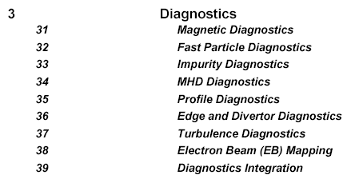

The schedule for implementing the Diagnostic Systems (WBS 3) may be seen in the project Master Schedule, provided as part of the Preliminary Design Report. Title II for diagnostic systems will generally be completed in FY06. Fabrication, installation, and testing will occur in parallel with machine assembly during the nine months preceding first plasma in mid-FY07.
Most of the diagnostics are not part of the MIE Project and will be installed after first plasma in time for when they are needed in the experimental program. The strategy for scheduling diagnostic implementation begins with basic monitoring of global quantities and impurities and core measurements of T_{i} and T_{e} during the 1.5 MW Phase. In the 3 MW Heating Phase, more detailed profile information for T_{e}, T_{i}, v_{φ}, and iota will become available. Diagnostics for measuring MHD activity, fast ion behavior, and edge and divertor characteristics will see a steady improvement in capability. Core turbulence measurements become available toward the end of the proposed plan.
Diagnostic Systems are composed of many individual diagnostics. Technical, cost, and schedule risks are minimized by:
- Providing a large number of ports with areas and view angles appropriate for measurement requirements,
- Locating diagnostics where they can be readily accessed,
- Providing high reliability and redundant measurements for diagnostics that cannot be readily accessed,
- Providing diagnostics integration concurrently with the design of the stellarator core (in some cases, long before the preliminary design of the individual diagnostic needs to be initiated),
- Applying diagnostic designs already proven on other machines,
- Drawing on the capabilities of the whole US fusion community instead of just PPPL/ORNL,
- Staging the diagnostics implementation to benefit from rapidly evolving sensor and data acquisition technologies, and
- Assembling and testing diagnostic components prior to installation on NCSX.

