CONFIGURATION FLEXIBILITY AND ROBUSTNESS

Neil Pomphrey for the NCSX team

NCSX Conceptual Design Review
May 21-23, 2002

Princeton Plasma Physics Laboratory

OUTLINE

To achieve the science goals of the NCSX mission, the coils must be capable of supporting a wide range of variations in plasma configuration about the reference baseline equilibrium.

- Numerical experiments demonstrate the flexibility of NCSX coils to support such configuration variations, and demonstrate the robustness of performance of NCSX plasmas for substantial variations about reference design values of plasma current, beta, and profile shape.

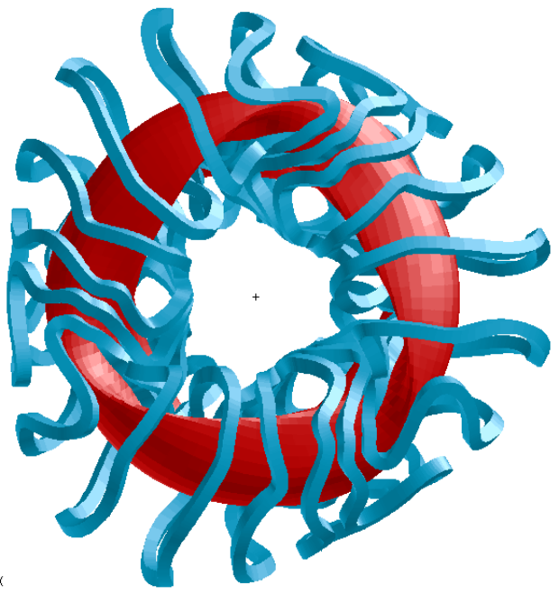
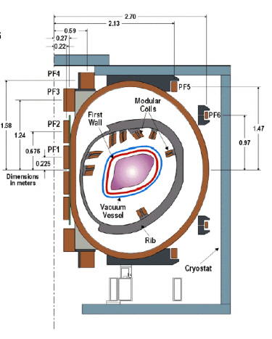
NCSX COILS FOR FLEXIBILITY ANALYSIS
2
1
2’
3’
3
1’

“M45” and “M45h”

- 18 modular coil currents in 3 independent groups (M1 - 3)
- 6 axisymmetric poloidal field coils (4 circuits PF3 – 6 provide shaping fields)
- 18 auxiliary TF coils (1 circuit) providing 1/R field ± 0.5 T
- Coil current limits provided by the engineers – to be satisfied in flexibility runs

PLASMA PERFORMANCE AS β AND I_{p} ARE VARIED
(B_{T} = 1.7 T)

- Using reference bootstrap-consistent profiles of p(s) and J.B(s) coil currents were varied to produce stable configurations over a wide range of I_{p} and β, spanning I_{p} ∈ [0, 174 kA], β ∈ [0, 4%]. The calculated varation in QA-ness measure ε_{h} is less than a factor of 2 compared with the reference S3 value 0.45%.

- For these un-optimized profiles, stable configurations were also found at I_{p} = 174 kA, β = 5.0% and I_{p} = 174 kA, β = 6.0%.

- Configurations with low β−limits (e.g., β ~ 1%) are easily dialled by an appropriate choice of coil currents.
COIL CURRENTS FOR I_{p} – β SCAN

Coil Currents for reference S3 configuration ( = 4.2%):
M 1  [kA-turns] | M 2  [kA-turns] | M 3  [kA-turns] | TF  [kA-turns] | PF3  [kA-turns] | PF4  [kA-turns] | PF5  [kA-turns] | PF6  [kA-turns]
694.2 | 654.6 | 551.1 | 27.8 | 1524.2 | 1180.0 | 95.2 | -2.3

Coil current variation over entire I_{p} - β scan: Each column shows max +/- variation
ΔI_{M1}  [kA-turns] | ΔI_{M2}  [kA-turns] | ΔI_{M3}  [kA-turns] | ΔI_{TF}  [kA-turns] | ΔI_{PF3}  [kA-turns] | ΔI_{PF4}  [kA-turns] | ΔI_{PF5}  [kA-turns] | ΔI_{PF6}  [kA-turns]
+52. | +41. | +46. | +31. | +0. | +0. | +78. | +28.
-38. | -12. | -27. | -46. | -1691. | -1627. | -222. | -36.

- Modular coil currents vary < ±10% over the I_{p} - β plane,
B_{T}^{Aux} varies < ±0.10 T, PF currents vary ~ 100% but within allowables.

PLASMA PERFORMANCE AS PROFILES ARE VARIED

Question:
- What happens to plasma performance (β-limits, QA measure ε_{h}) when plasma profiles are varied about reference forms at fixed I_{p}, B_{T}?
- Is the reference configuration sitting atop a pinhead optimum so that as the profiles are varied the performance drops precipitously?

Answer:
- NO! – We find configurations with a wide range of current and pressure profiles which have β-limits in excess of 3.0% and which have good QA.

CURRENT PROFILE VARIATION IN CORE AND EDGE

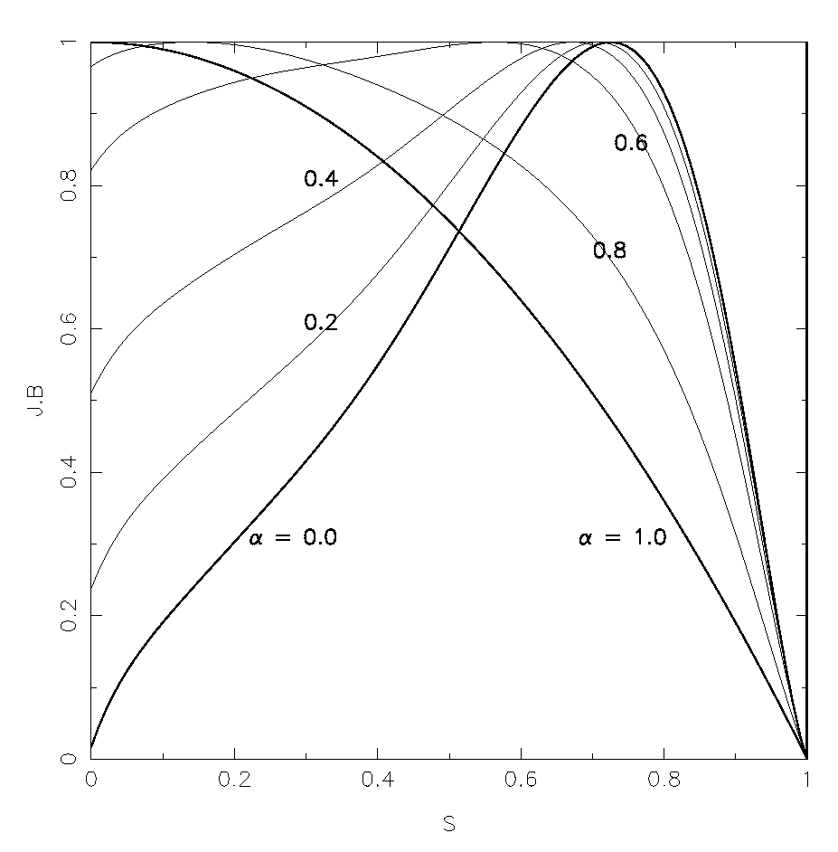
- Using the reference p(s), and I_{p} = -174 kA, B_{T} = 1.7T, for what range of J.B profiles can we find stable configurations with β 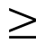 3.0%?

- Profiles with 0 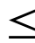 α 0.5 are stable at β = 3.0%. Stable configs have ε_{h}0.5% at s=0.5

- Finite edge current density appears to be stabilizing*. Using the profile shown (J.B^{edge}/J.B^{max} = 0.5) a stable configuration using S3 coil currents was found at β = 5%!

0.5

J.B

α=0.0 (reference)
α=1.0

*M.I. Mikhailov, V.D. Shafranov
“Stable Current Profile in a Stellarator with Shear”
Nucl. Fusion 30, 413-421 (1990)

- H-mode profiles may be beneficial to NCSX stability (contrast with tokamaks).

COIL CURRENTS FOR CURRENT PROFILE SCAN
Each column shows max +/- variation relative to current required to support α = 0.0 state
ΔI_{M1}  [kA-turns] | ΔI_{M2}  [kA-turns] | ΔI_{M3}  [kA-turns] | ΔI_{TF}  [kA-turns] | ΔI_{PF3}  [kA-turns] | ΔI_{PF4}  [kA-turns] | ΔI_{PF5}  [kA-turns] | ΔI_{PF6}  [kA-turns]
+26. | +5. | +3. | +4. | +0. | +0. | +8. | +1.
-4. | -4. | -1. | -1. | -8. | -168. | -0. | -0.
- coil current changes are small --> small change in plasma shape
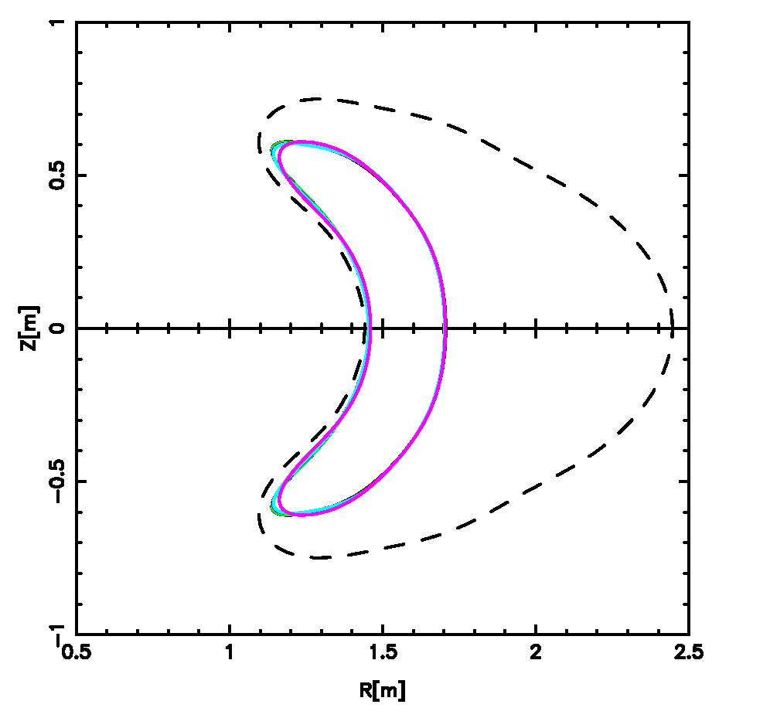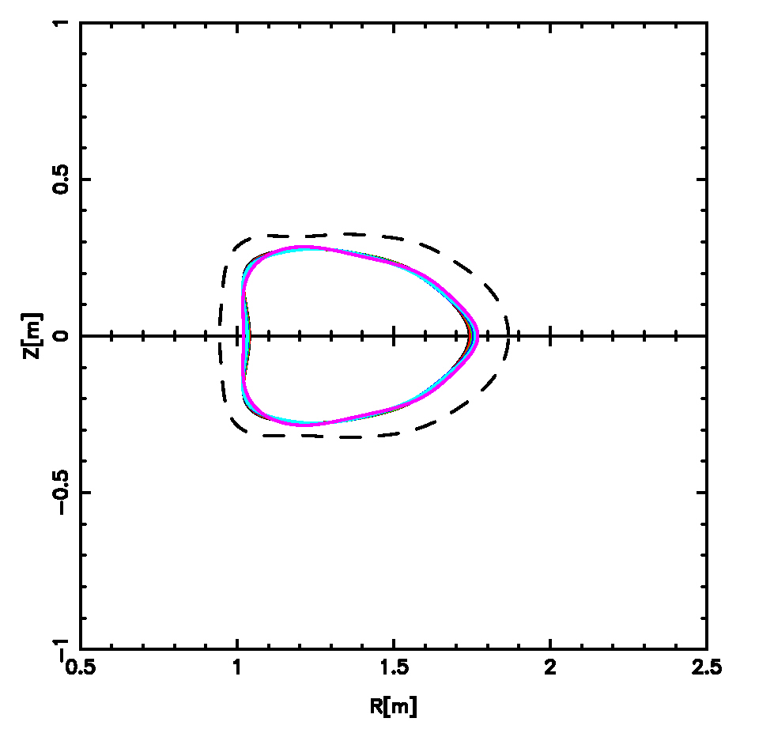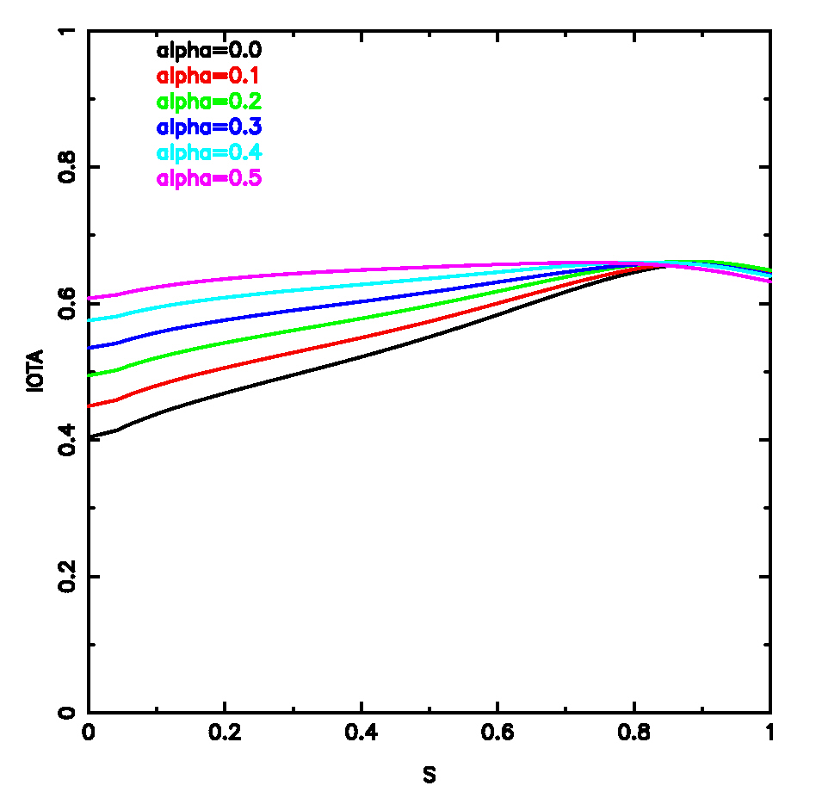
V= 0.0
V= 0.5
Loss of stability possibly due to loss of shear.
First Wall
PRESSURE PROFILE VARIATION
(β = 3.0%)
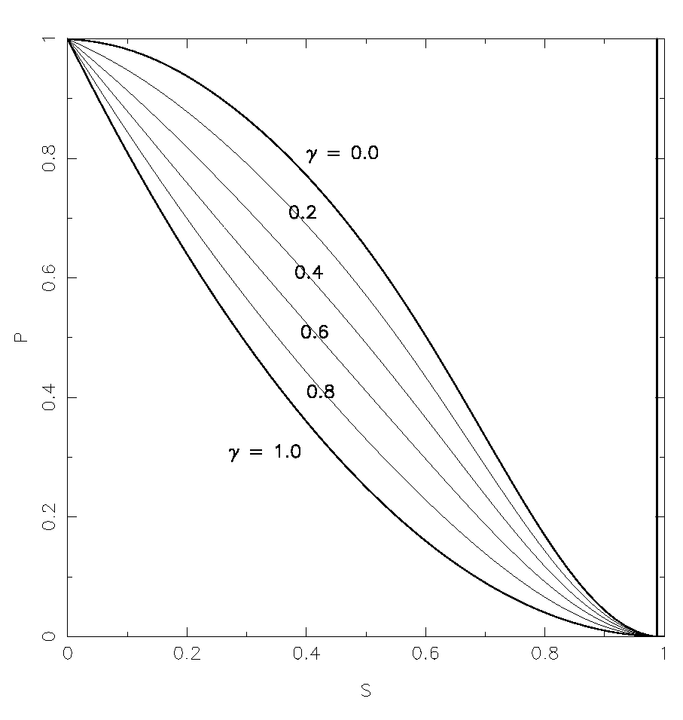

P

S

Test profile with pedestal
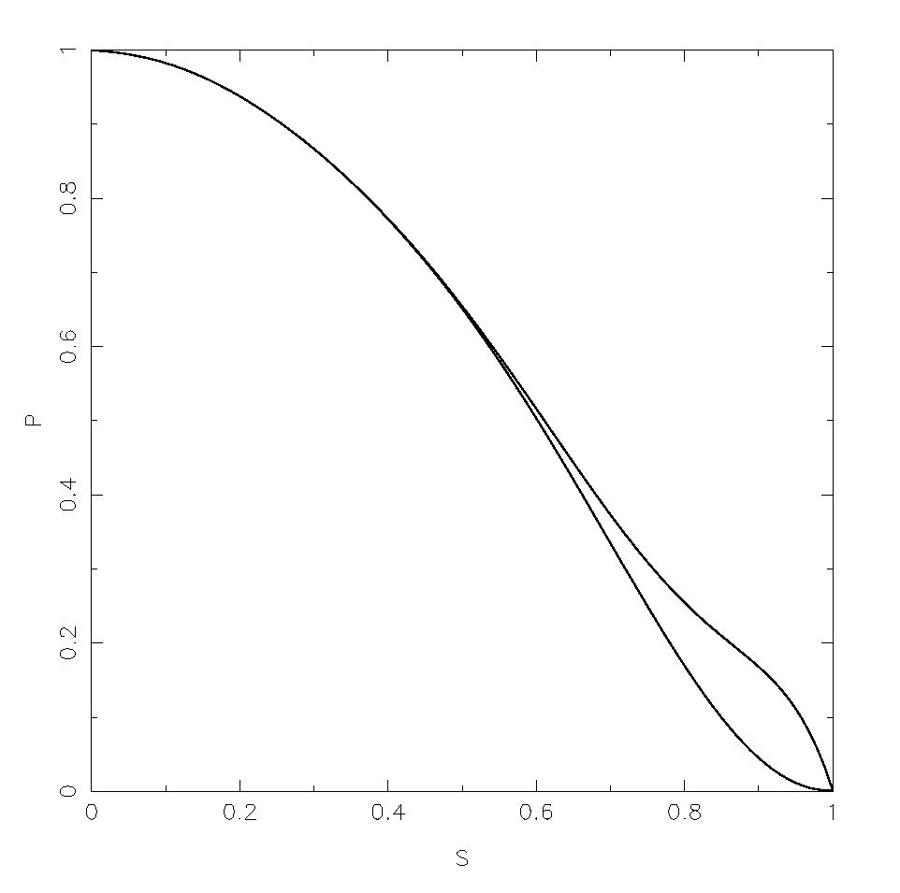

P

S

Ref

- Stable configurations at β = 3.0% found for 0 ≤ γ ≤ 0.8 i.e., includes peaked profiles (γ = 1.0 was stable at β = 2.5%).

- Pressure profile with finite edge gradient shown above was stable at β = 4.0% for I_{p} = 174 kA, B_{T} = 1.7 T.

FLEXIBILITY TO VARY QA-NESS
(configs here have I_{p} = -87.5 kA, β = 2.0%)
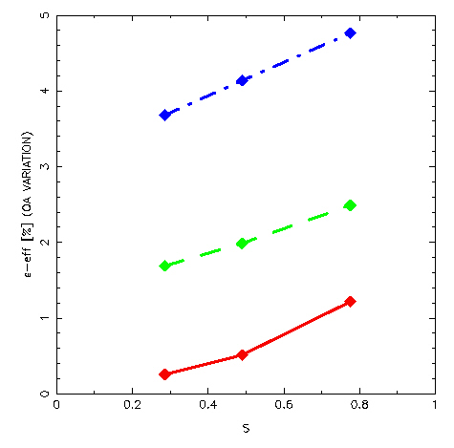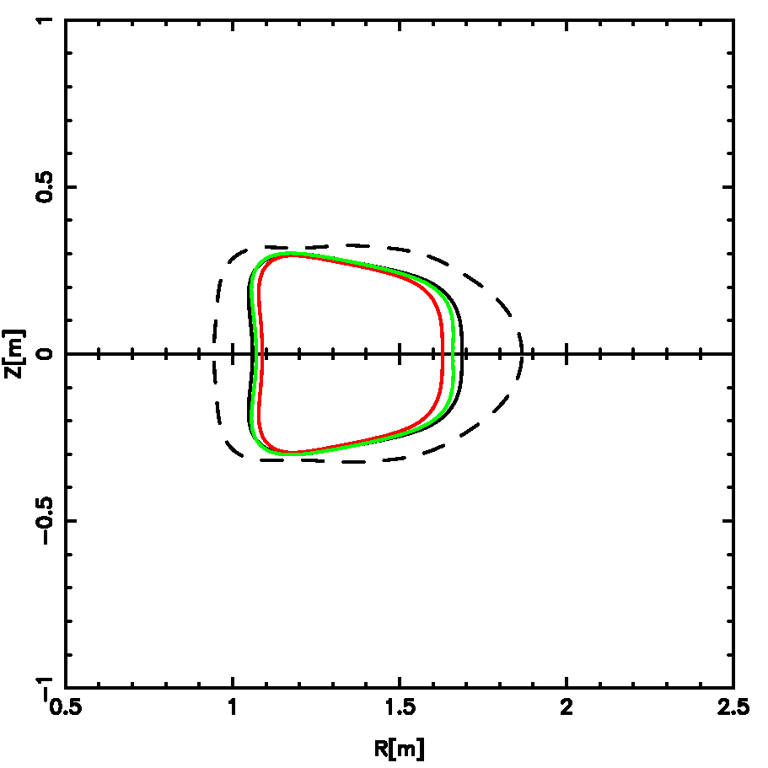
ε_{eff} [%] (QA variation)
ΔI_{M1}  [kA-turns] | ΔI_{M2}  [kA-turns] | ΔI_{M3}  [kA-turns] | ΔI_{TF}  [kA-turns] | ΔI_{PF3}  [kA-turns] | ΔI_{PF4}  [kA-turns] | ΔI_{PF5}  [kA-turns] | ΔI_{PF6}  [kA-turns]
-111. | -38. | +145. | +0. | +0. | -7. | -2. | +0.
V=0.5
s
ε_{eff} optimized
Difference in coil currents between the high and low ε_{eff} configs shown above

FLEXIBILITY TO CONTROL EXTERNAL TRANSFORM
- variation at constant shear (I_{p} = 174 kA, B_{T} = 1.7 T)

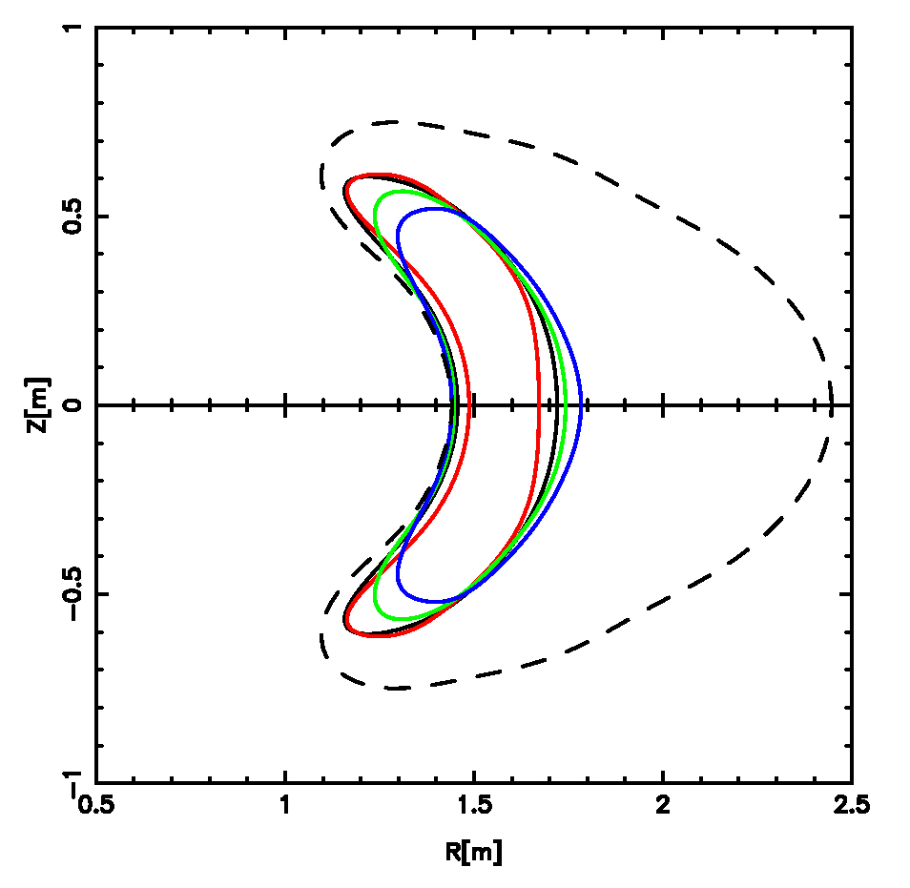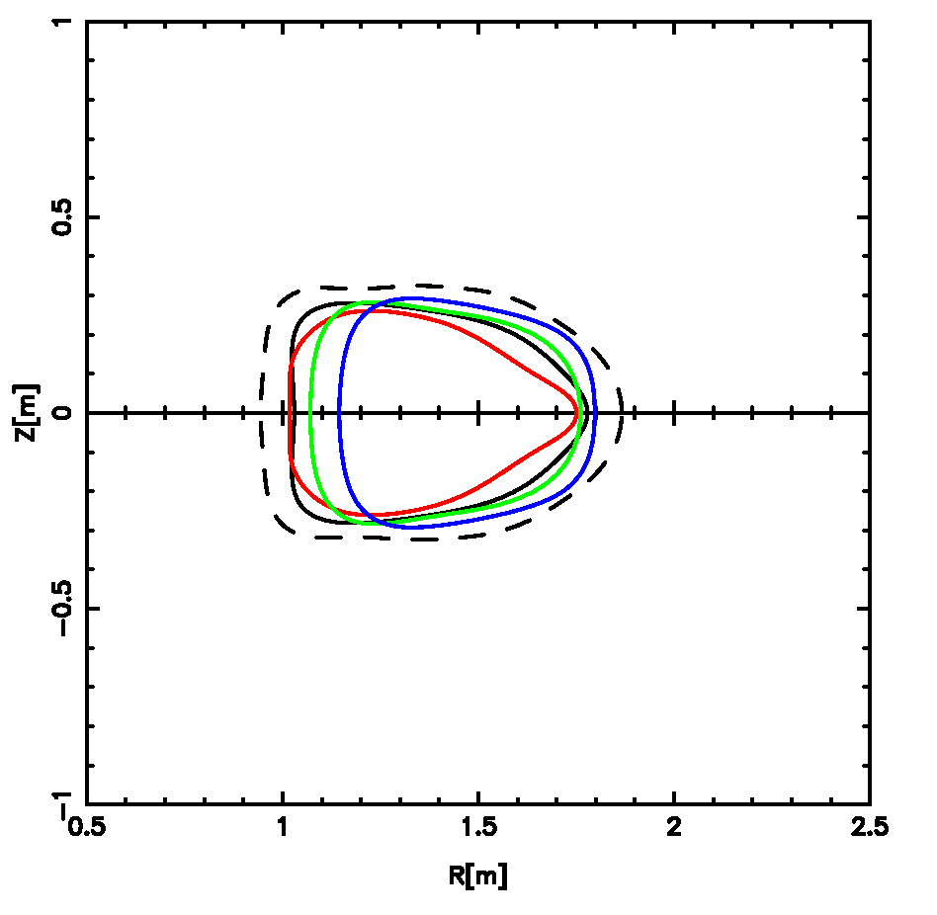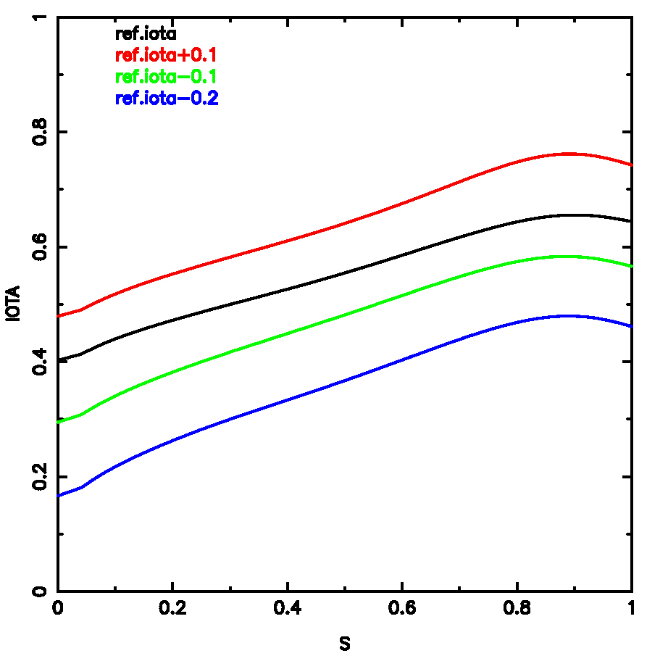
V=0.5
V=0.0
baseline S3

Substantial changes Δι(s) ∈ [-0.2, +0.1] relative to the baseline S3 state are possible
Δι(s) | ε_{eff}(s=0.5) | ΔI_{M1}  [kA-turns] | ΔI_{M2}  [kA-turns] | ΔI_{M3}  [kA-turns] | ΔI_{TF}  [kA-turns] | ΔI_{PF3}  [kA-turns] | ΔI_{PF4}  [kA-turns] | ΔI_{PF5}  [kA-turns] | ΔI_{PF6}  [kA-turns]
+0.1 | 0.5% | +65. | +60. | +75. | -67. | 0. | -1021. | +113. | +1.
-0.1 | 0.7% | -78. | -61. | -66. | +73. | 0. | -393. | -33. | +0.
-0.2  NOTE SUBSTANTIAL CHANGES IN MAGNETIC AXIS: R_{mag}[m] = 1.447 + 0.119 cos v, Z_{mag} [m] = -0.065 sin v  R_{mag}[m] = 1.566 + 0.053 cos v, Z_{mag} [m] = -0.014 sin v | 1.6% | -181. | -157. | -161. | +167. | -1684. | -947. | -40. | +7.
FLEXIBILITY TO CONTROL EXTERNAL TRANSFORM
(b) variation at constant ι(0) – changing the shear
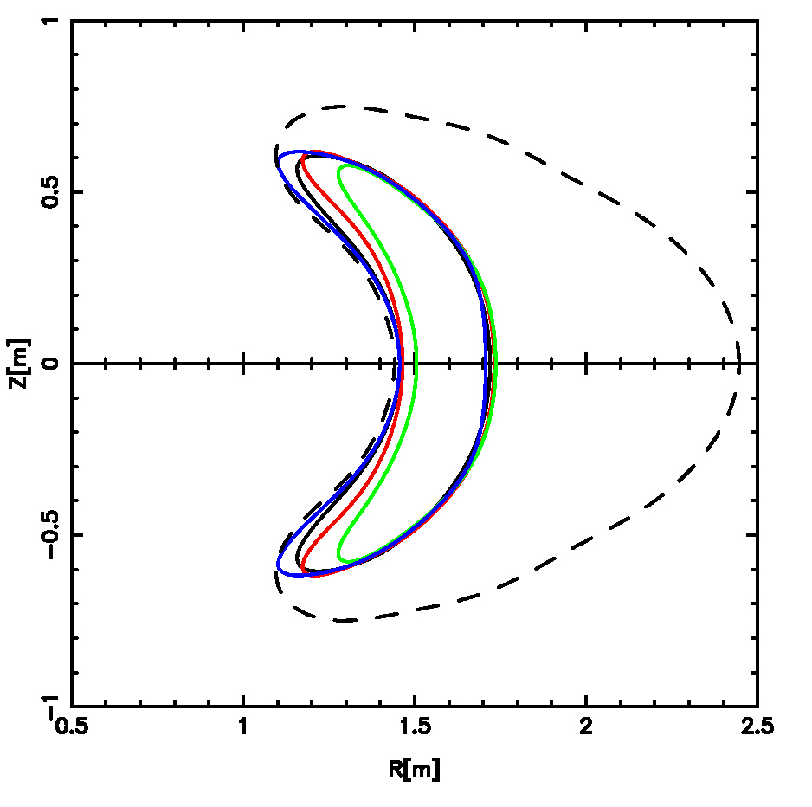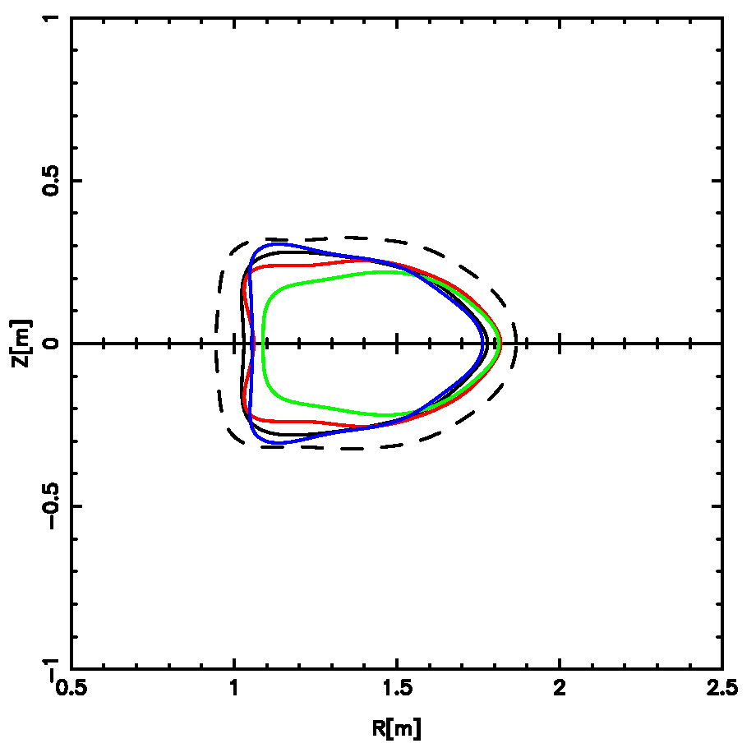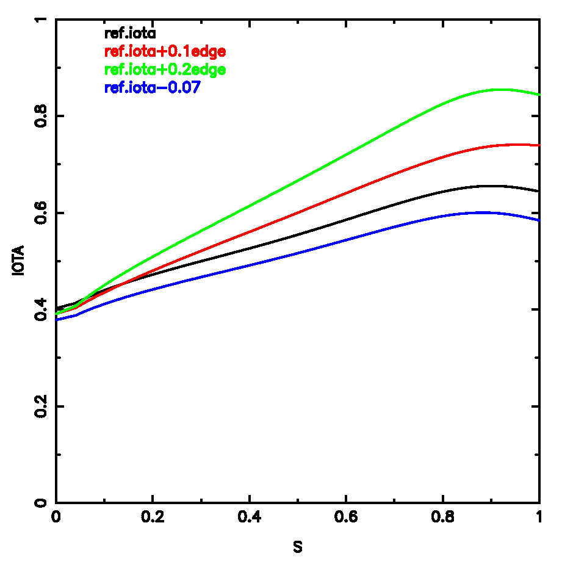
V=0.0
V=0.5
baseline S3

Range of shear accommodated by the coils is ∫ = (ι_{max} – ι₀)/s_{max} = 0.23 → 0.53
Δι(1) | ΔI_{M1}  [kA-turns] | ΔI_{M2}  [kA-turns] | ΔI_{M3}  [kA-turns] | ΔI_{TF}  [kA-turns] | ΔI_{PF3}  [kA-turns] | ΔI_{PF4}  [kA-turns] | ΔI_{PF5}  [kA-turns] | ΔI_{PF6}  [kA-turns]
-0.07 | -218. | +309. | -139. | +15. | 0. | -1161. | +68. | +0.
+0.1 | +40. | +20. | -13. | -19. | 0. | -617. | -35. | +0.
+0.2 | +64. | +1. | +17. | -29. | 0. | -1219. | -94. | -2.

SUMMARY

- The performance (β-limits QA-ness measure ε_{eff}) of NCSX plasmas produced by the M45 coils is robust w.r.t. substantial variations of I_{p} and profile shapes about reference design values.

- The NCSX coil system has considerable flexibility to support the wide range of experiments required by the NCSX mission.

SUPPLEMENT

I_{p} - β SCAN RESULTS (B_{T} = 1.7 T)

- For a 5x5 matrix of equally spaced I_{p} , β values spanning I_{p} ∈ [0, 174 kA], β ∈ [0, 4%], vary coil currents to seek stable configurations with optimized ε_{h}.
β[%]

 | 0.0 | 1.0 | 2.0 | 3.0 | 4.0
0. | ε_{h} = 0.82%  S1 | ε_{h} = 0.89% | ε_{h} = 0.79% | X | X
-44.  Ip[kA] | ε_{h} = 0.77% | ε_{h} = 0.68% | ε_{h} = 0.67% | ε_{h} = 0.61% | ε_{h} = 0.72%
-87.5 | ε_{h} = 0.71% | ε_{h} = 0.65% | ε_{h} = 0.51% | ε_{h} = 0.72% | ε_{h} = 0.60%
-131. | ε_{h} = 0.52% | ε_{h} = 0.46% | ε_{h} = 0.42% | ε_{h} = 0.41% | ε_{h} = 0.45%
-174. | ε_{h} = 0.37% | ε_{h} = 0.39% | ε_{h} = 0.36% | ε_{h} = 0.40% | ε_{h} = 0.45%  S3
- ε_{h} < 1% at s = 0.5 over the matrix (i.e., QA is good)
- Each configuration shown is marginally stable at the given I_{p} , β
=>configs with low β-limits are easily dialled

Stable configs were also found at
Ip= -174 kA, β=5.0% Ip= -174 kA, β=6.0%

REFERENCE PROFILES OF PRESSURE AND CURRENT
(USED IN I_{p} - β SCAN)

S
S
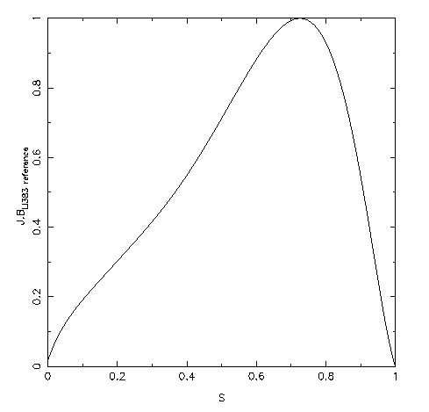
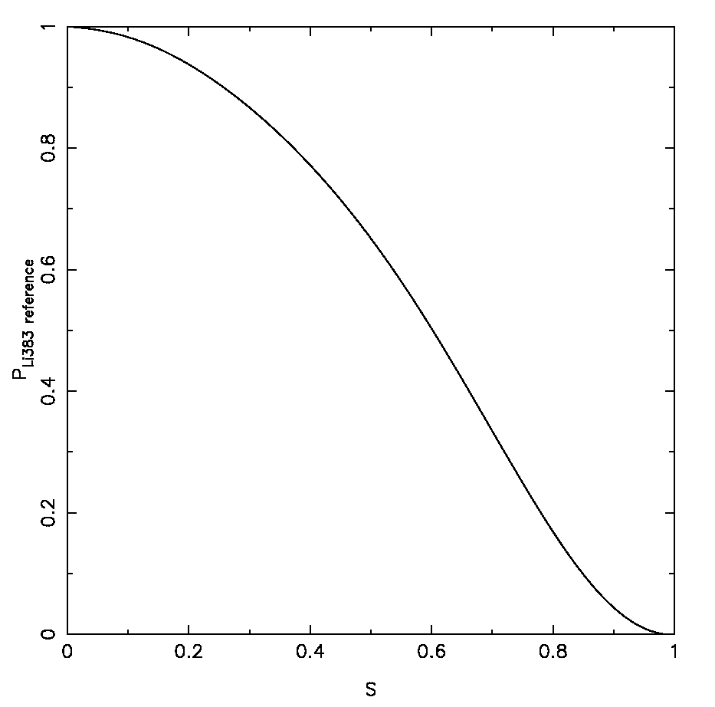
Pressure (reference)
J.B (reference)

PLASMA SHAPES AND ι(S) PROFILES FOR I_{p}-β SCAN
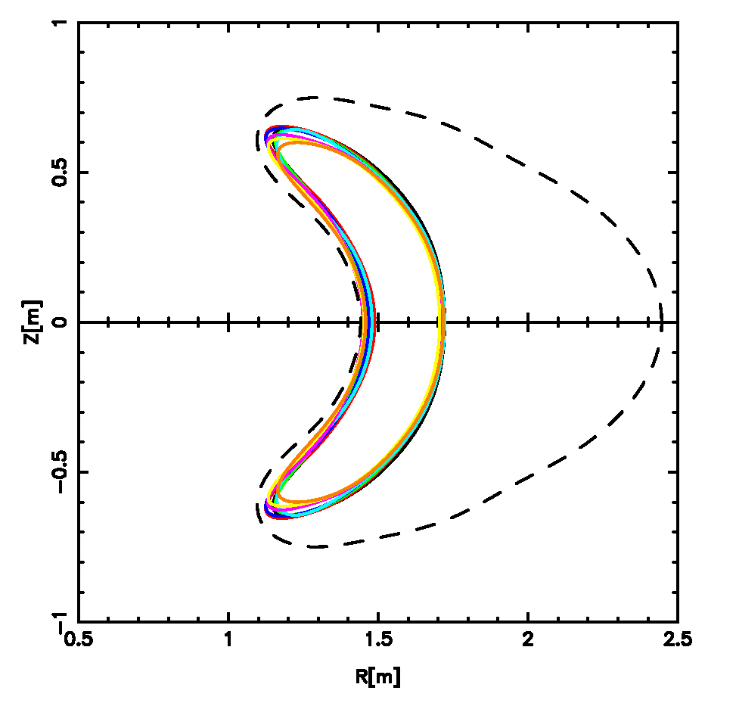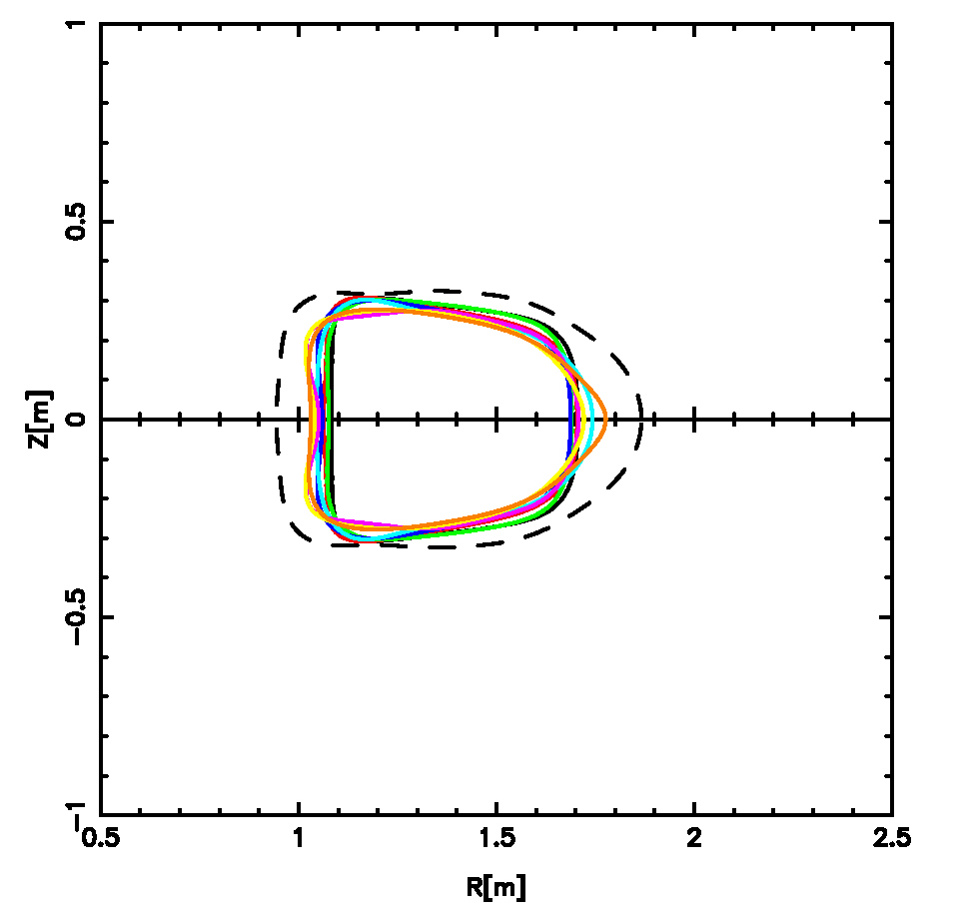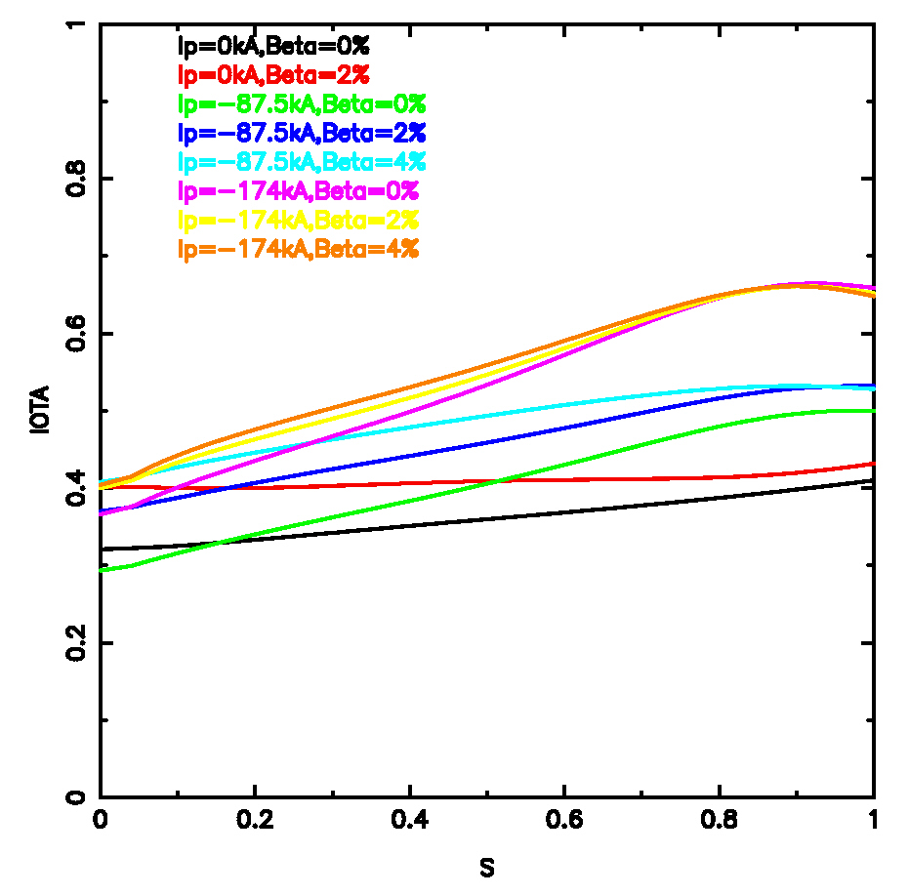

- Note wide range of iota profiles (shear and edge iota values) for which stable plasmas are found.
ROBUSTNESS OF EQUILIBRIA
- Begin with reference S3 equilibrium, supported by coil currents {I_{j}}
- Individually perturb each coil current, I_{j} → I_{j} + ΔI_{j}, where ΔI_{j} = 0.05x I_{j}^{max}
- Calculate new free-boundary equilibrium, compare the new shape with the old reference, and monitor the changes in physics parameters
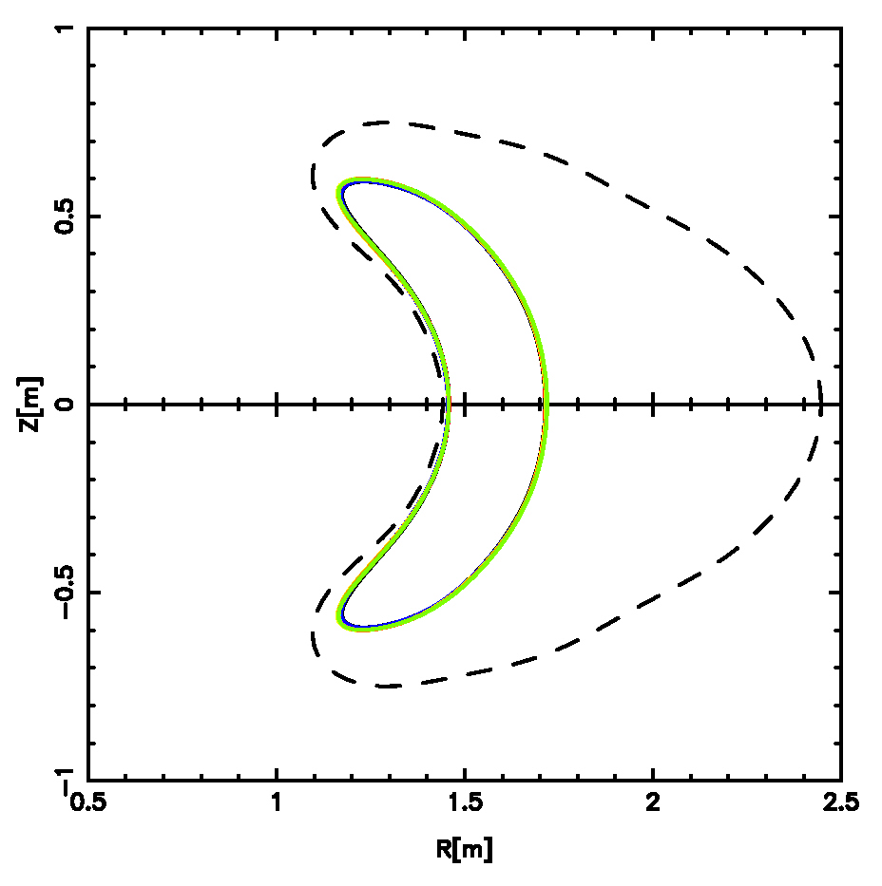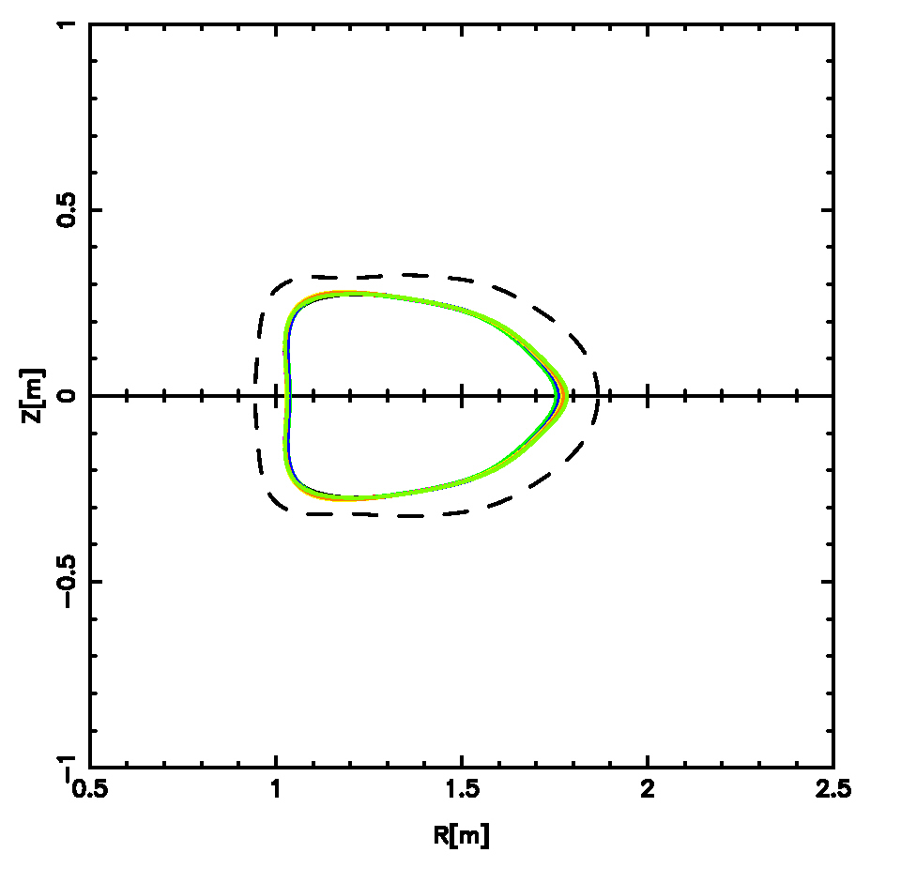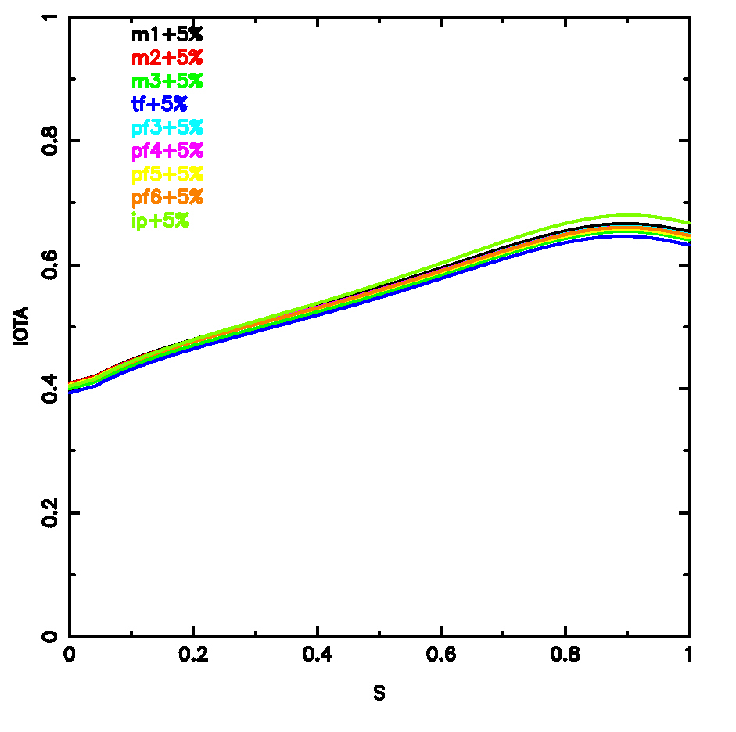
PFC boundary
V=0.0
V=0.5
Shape and physics properties (stability and QA) are well-preserved ⇒ equilibrium is robust.

EQUILIBRIUM CHANGE AFTER I_{p} + β QUENCH
- Black: reference S3 equilibrium (I_{p} = -174. kA, β = 4.2%)
- Red: I_{p} = 0. kA, β = 0.% (post-quench) using S3 coil currents
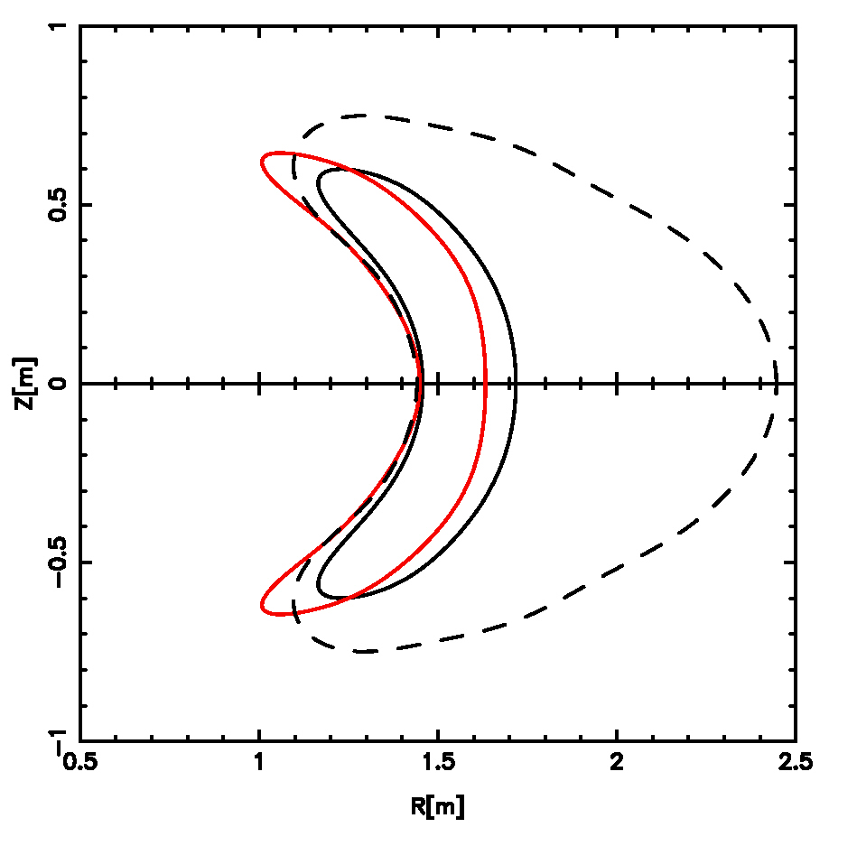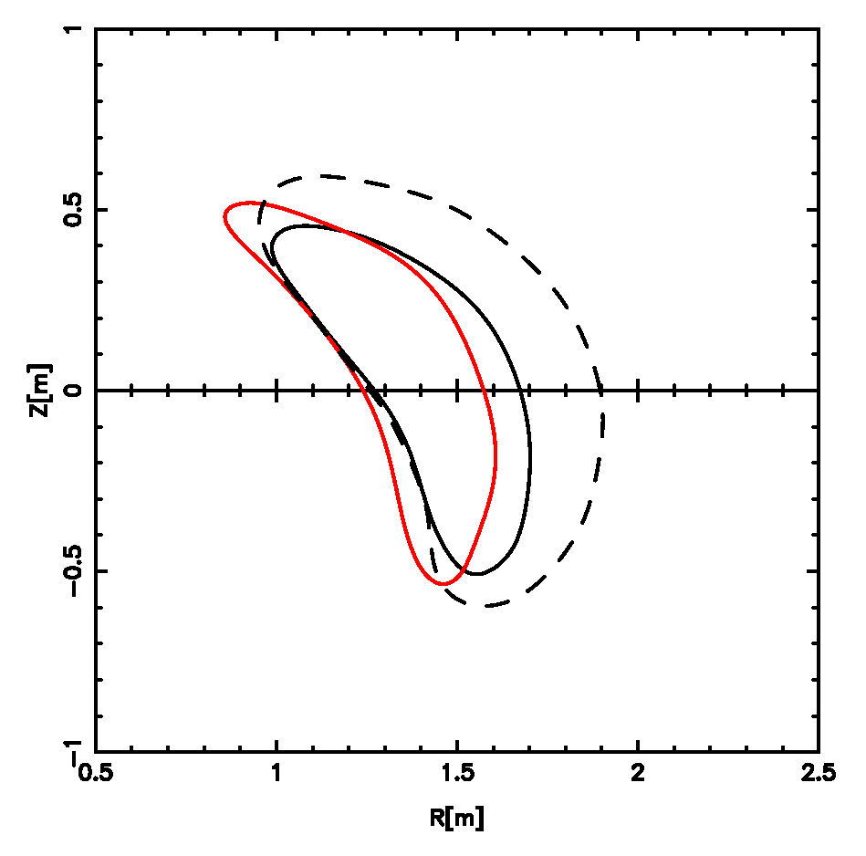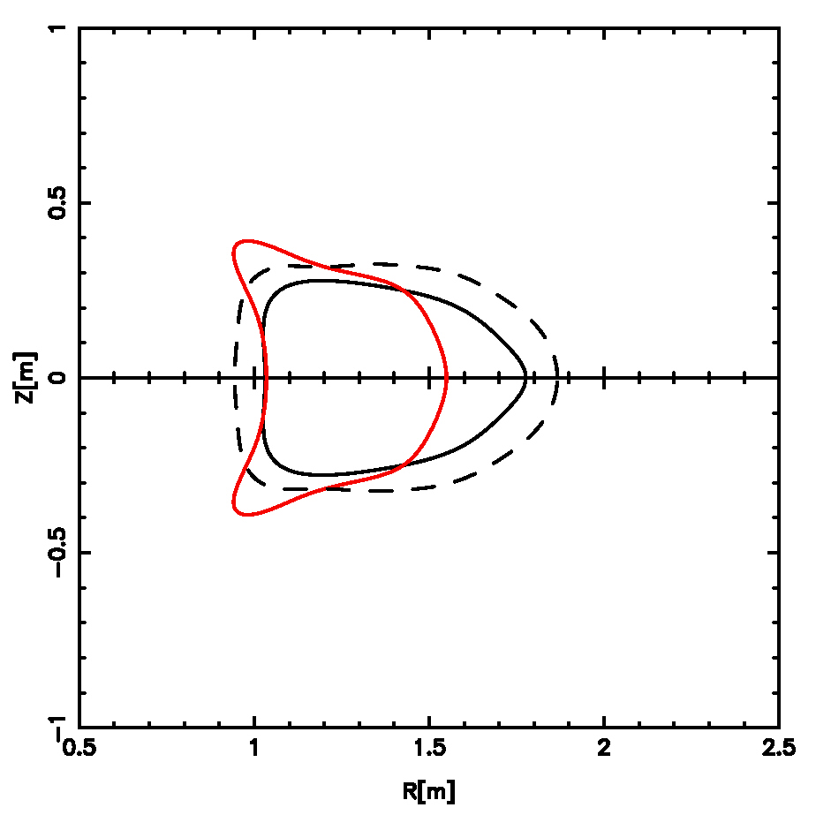
V=0.0
V=0.25
V=0.5
- <R> = - 0.10m as result of quench (no limiter assumed for calculation)
- Dramatically smaller displacement than for a tokamak!
PLASMA OFFSET 2cm FROM FIRST WALL
(shown in black, compared with reference s3 plasma)
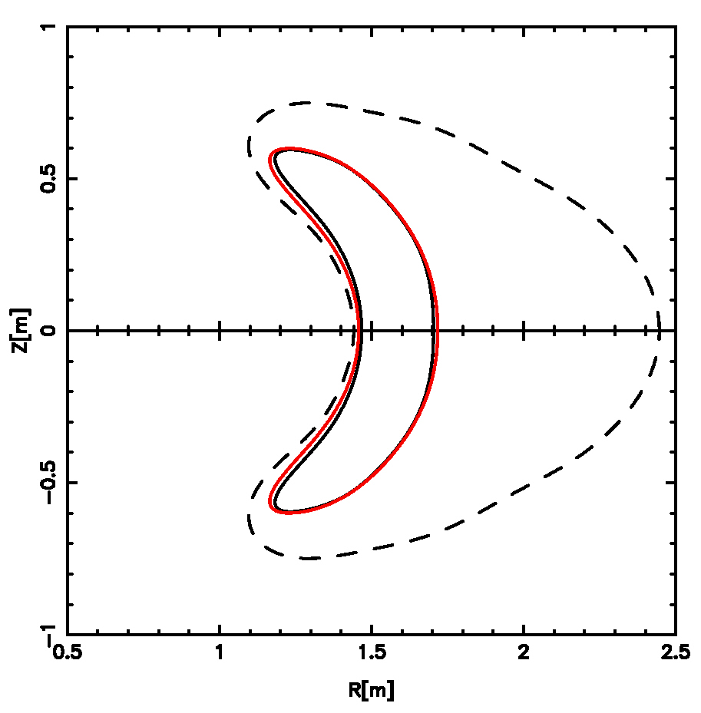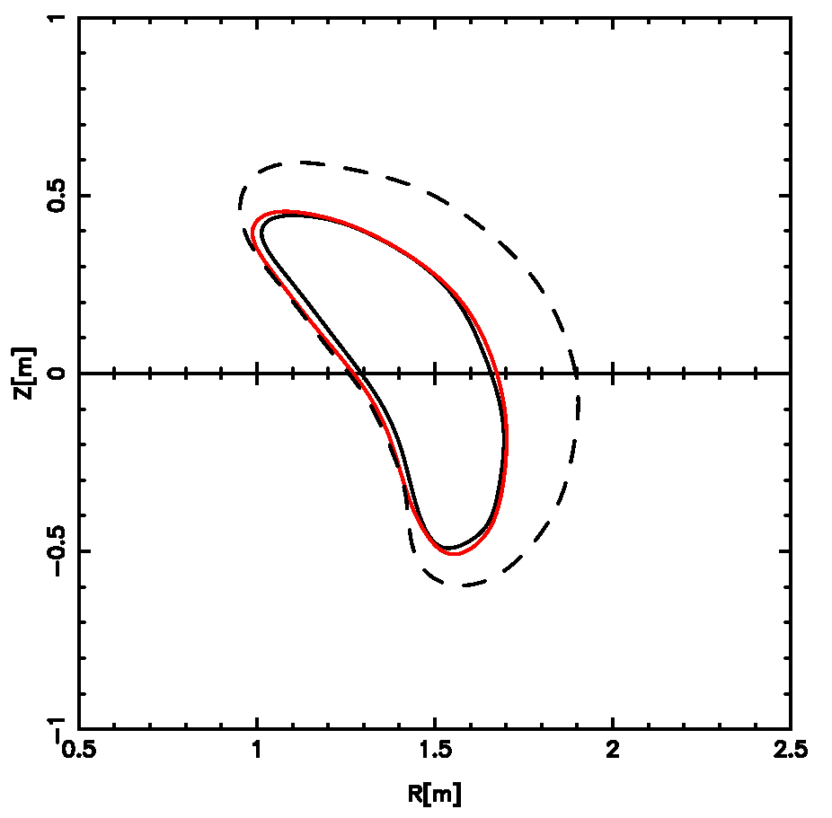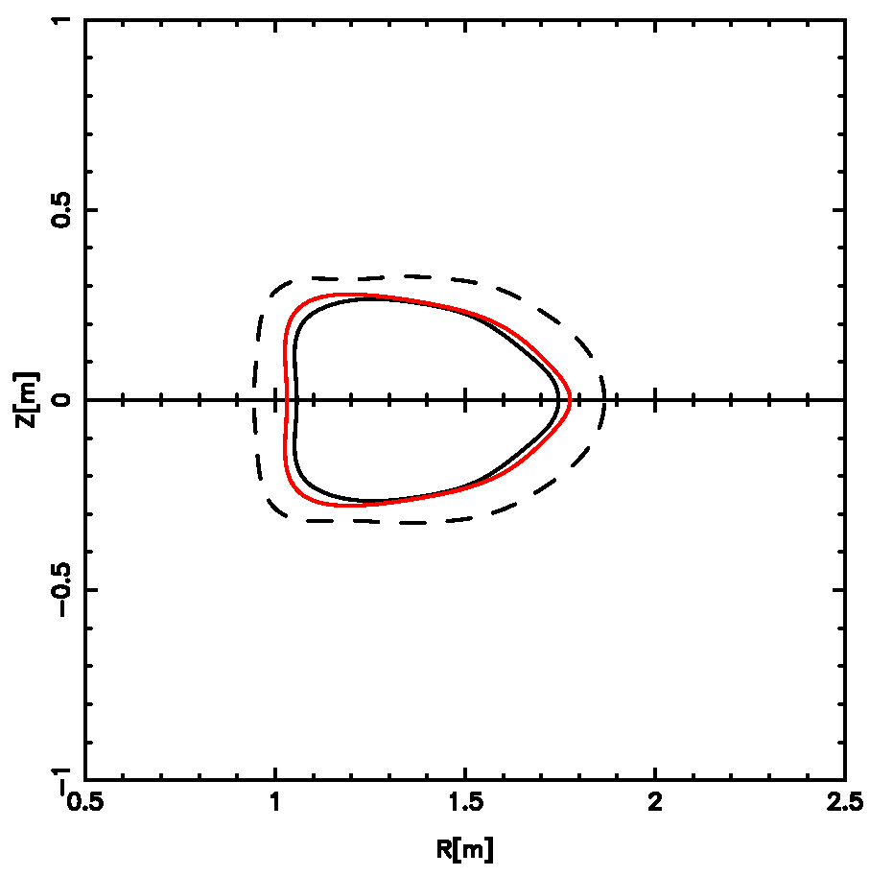
V=0.0
V=0.25
V=0.5
 | M 1  [kA-turns] | M 2  [kA-turns] | M 3  [kA-turns] | TF  [kA-turns] | PF3  [kA-turns] | PF4  [kA-turns] | PF5  [kA-turns] | PF6  [kA-turns]
Ref S3 | 694.2 | 654.6 | 551.1 | 27.8 | 1524.2 | 1180.0 | 95.2 | -2.3
2cm offset | 745. | 726. | 608. | 18. | 136. | 616. | 130. | 7.

A = 4.4 → 4.6, Vol = 2.90 → 2.63 m³, ε_{eff}(s=0.5) = 0.45 → 0.41%
FLEXIBILITY TO EXPLORE STABILITY BOUNDARIES AND 3D SHAPE STABILIZATION

- Each stable free-boundary configuration in the I_{p} - β scan lies at a point of marginal stability w.r.t. kink and ballooning modes for the given profiles.

- To illustrate the type of experiment that can be run on NCSX aimed at understanding the physics that determines stability boundaries, consider two free-boundary configurations from the I_{p} - β scan:
C1
C3

I_{p} = -44 kA, β = 1.0% and I_{p} = -44 kA, β = 3.0%

EXAMPLE OF 3D SHAPE STABILIZATION

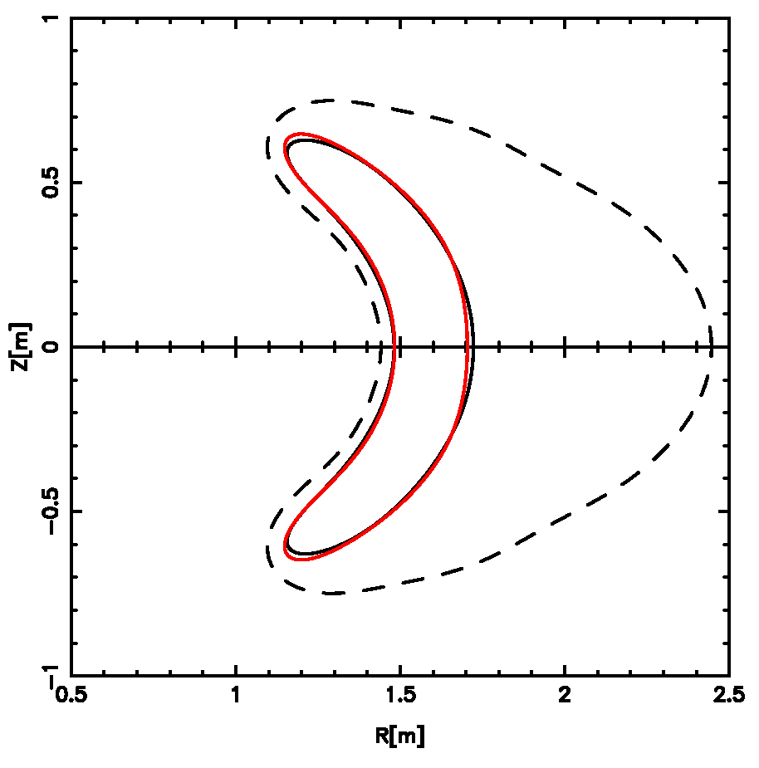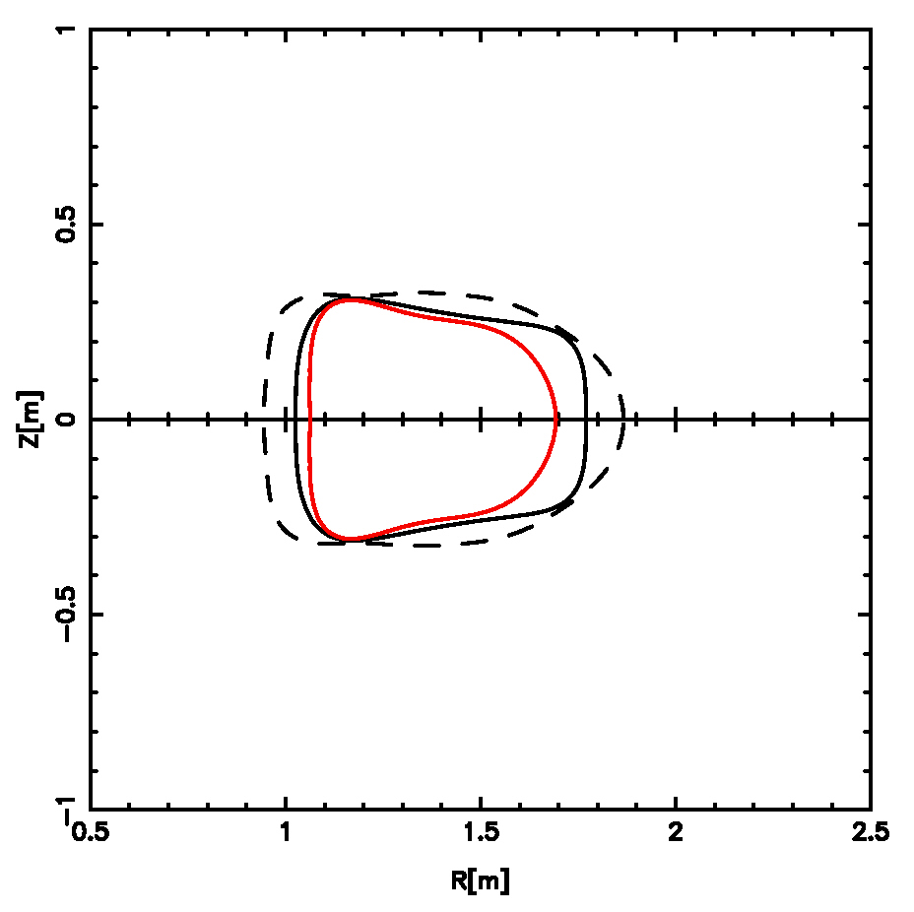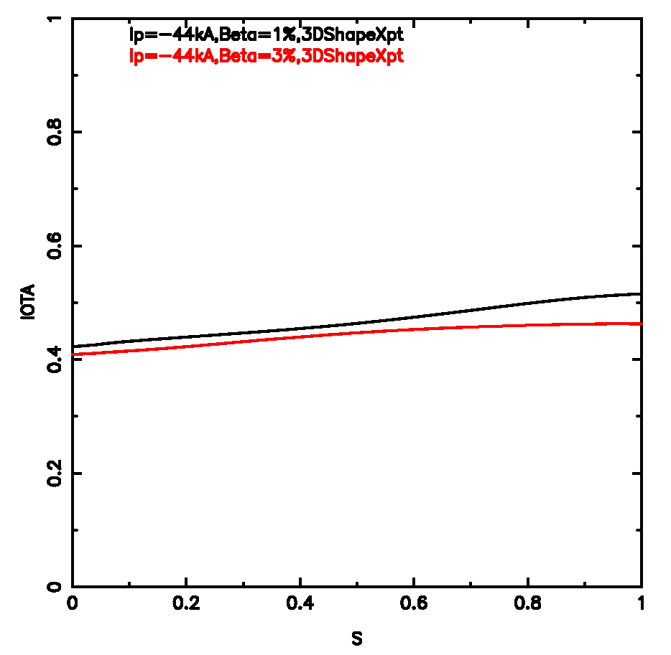

C1
C3
ι_{edge} = 1/2

- β_{lim} = 1.0% for C1 (black)
- β_{lim} = 3.0% for C3 (red)

Difference in β-limits is due to change in shape.
ι–CONTROL CAN REMOVE AMBIGUITY OF ι_{edge}=0.5 ROLE

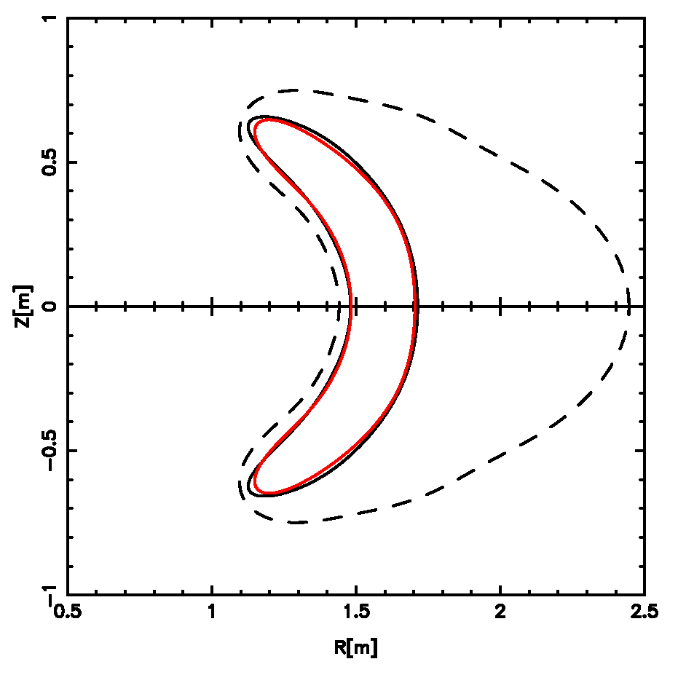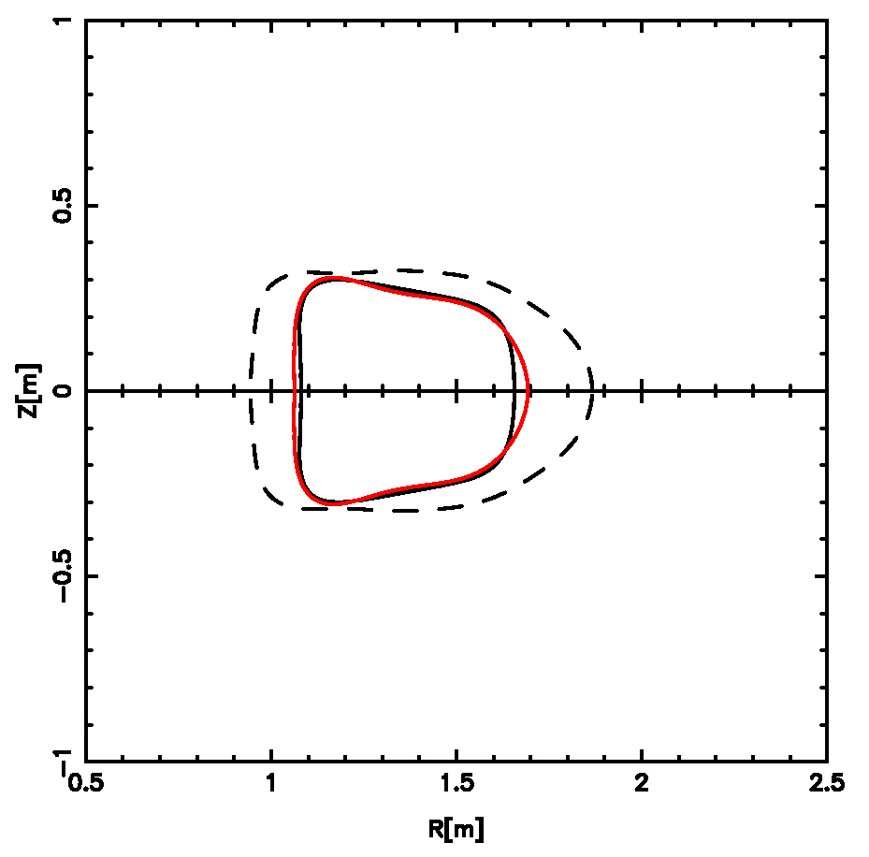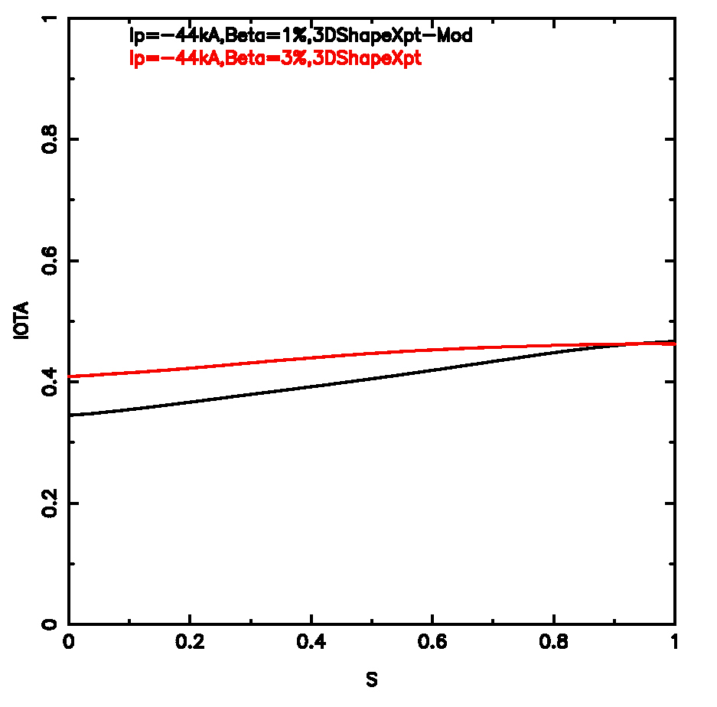

ι_{edge} = 1/2
C1-mod
C3

- Impose ι-control on C1 to produce new configuration, C1-mod, whose β-limit is still 1.0%, but which has the same ι_{edge} as the β_{lim} = 3.0% configuration.
(note: the config with the lower β-limit actually has the highest shear!)

COIL CURRENTS FOR 3D SHAPE STABILIZATION

 | M 1  [kA-turns] | M 2  [kA-turns] | M 3  [kA-turns] | TF  [kA-turns] | PF3  [kA-turns] | PF4  [kA-turns] | PF5  [kA-turns] | PF6  [kA-turns]
C1  I_{p}: -44.0 kA  β: 1.0%  ι(0): 0.42  ι(1): 0.52 | 827.1 | 776.8 | 380.0 | -0.4 | -1.4 | +7.5 | -0.0 | +0.0
C3  I_{p}: -44.0 kA  β: 3.0%  ι(0): 0.41  ι(1): 0.46 | 733.6 | 700.4 | 593.7 | -13.0 | -166.7 | +134.7 | +80.2 | +0.4
C1-mOD  I_{p}: -44.0 kA  β: 1.0%  ι(0): 0.35  ι(1): 0.47 | 659.9 | 670.0 | 655.7 | -0.7 | -1.4 | +5.8 | -0.1 | +0.0

PIES RUNS IN FLEXIBILITY SPACE

From current profile scan (α = 0.4):
I_{p} = -174 kA, B_{T} = 1.7 T, β = 3.0%
From pressure profile scan (γ = 0.4):
I_{p} = -121 kA*, B_{T} = 1.7 T, β = 3.0%

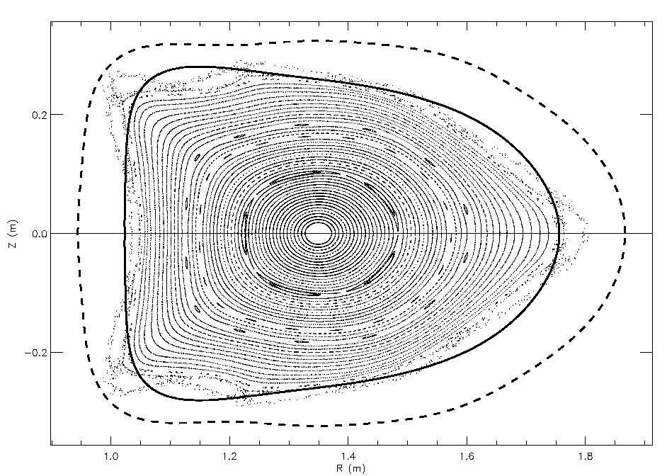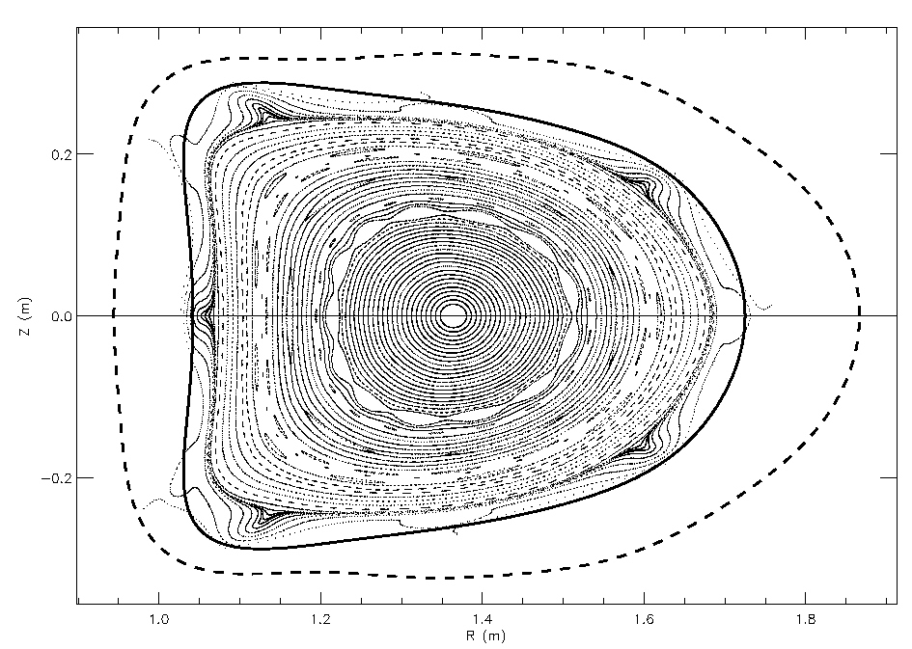
First Wall
Vmec starter boundary
* ι(1) = 0.58

