

GSI V-STARS Target Acceptance Test Document
22 October 2004

1. V-STARS Target Acceptance Test Descriptions 2
2. Test Fixture Description 2
3. Fixture Calibration Description 4
4. Target Certification Description 6

1. V-STARS Target Acceptance Test Descriptions
Periodically all targets should be tested to detect targets with flaws that are not readily perceptible during visual inspection. This testing helps identify targets with “dead spots” or other flaws which will negatively impact on the performance of the system.

GSI has developed an inexpensive, quick, easy and accurate testing procedure for checking tooling targets. The procedure measures a small, calibrated aluminum test fixture containing numerous standard bushings. Each test fixture is precisely calibrated using a set of calibrated targets and GSI’s V-STARS system. By periodically measuring tooling targets, the user can ensure the high accuracy inherent in the V-STARS system is maintained.

2. Test Fixture Description
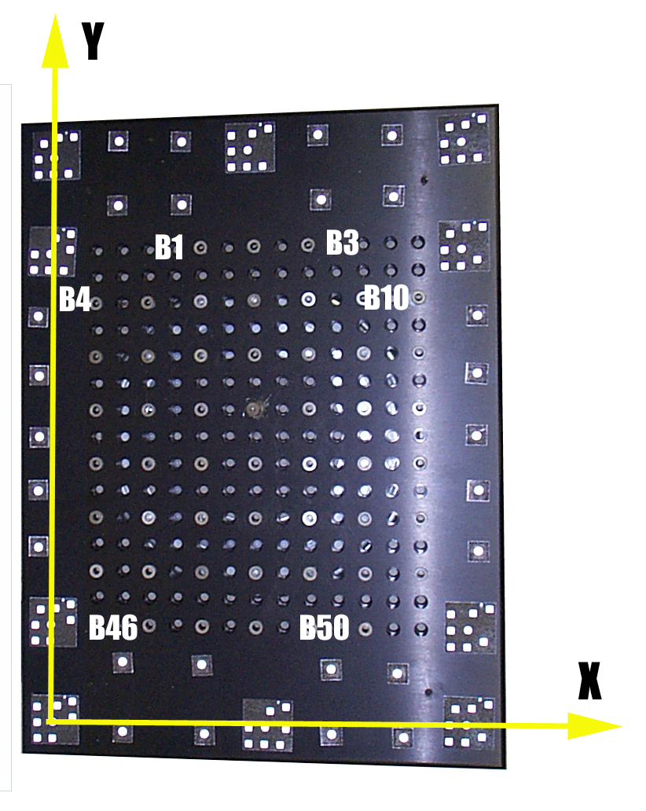
The target test fixture consists of a targeted, rigid, aluminum plate ½” thick that is nominally 18” wide by 24” long. A picture of the plate is shown on the right. The plate has several coded targets affixed to its periphery, as well as several individual stick-on targets. There are 195 holes drilled in the test fixture in a regular 13 by 15 grid spaced at 1” intervals. Normally, 50 of the holes have standard ¼” diameter bushings installed. The remaining holes can be used to add bushing targets for other diameter shank targets if desired. The plate coordinate system is defined so the origin is at the coded target in the bottom left corner when the plate is viewed as shown below. The X axis goes through the coded target in the bottom right corner, and the X-Y plane is defined by these two coded targets, and the coded target in the upper left corner. The bushings are labeled B1 through B50 as shown on the right. B1 is the upper left bushing, and B50 is the bottom right bushing.
Y
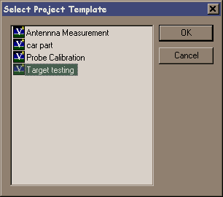
The holes on this plate are calibrated and these values are issued with the plate. These coordinates form the basis of all future target comparisons. To further simplify the process the plate benchmark values are set up in a template project. This relieves the user of the burden of setting up the project each time testing is done.

B1
B50
B4
B46

3. Fixture Calibration Description
The Target Test Fixture (TTF) is calibrated using the V-STARS system and a set of previously calibrated flat (0 degree) tooling targets. The previously calibrated targets are installed in the 50 bushings. Also, a minimum of two NIST calibrated Invar scale bars are rigidly attached to the plate to provide scale. An AutoBar must also be placed on the plate (at least for the first measurement) since this is an initial measurement. The plate is calibrated by taking a series of measurements consisting of the following sequence.

- Take all pictures at a distance of about 1.5 meters from the center of the plate so that the camera axis makes about a 45 degree angle with the plate. This puts the lens of the camera about one meter (40”) out from the center of the plate, and one meter (40”) above the plate. Camera placement is not critical. Aim the camera so it is roughly centered on the format; aiming is also not critical. The plate has a rotating base so generally a tripod is used to place the camera at the proper height above and distance from the plate, and the plate is then rotated to the desired positions.
- Set the strobe exposure so the targets are well exposed but none of the targets are saturated (pixel values of 255). Normally this is a power setting of 0 on the strobe. This makes the measurement more sensitive to voids or “dead areas” in a target.
- For each measurement, take a set of 16 pictures. This consists of 8 positions spaced approximately every 45 degrees around the plate with two pictures taken at each position. Take one of the two pictures at each position with the camera in the normal viewing position, and the other with the camera rolled approximately 90 degrees to the first. The relative direction of the roll (clockwise or counterclockwise) does not matter. Nor does the order of the rolls. Take the pictures and roll the camera in whatever manner is most convenient. See the diagram below.

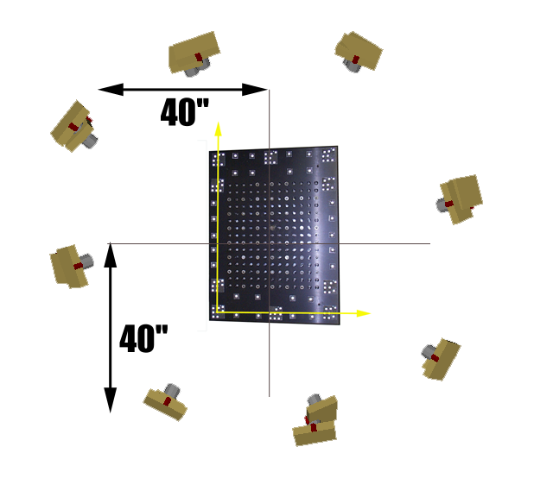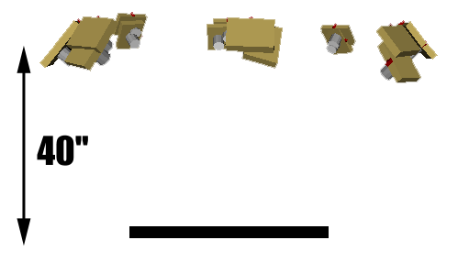
Top View Side View

- Rotate each target approximately 180 degrees in the bushing and repeat Step 3) above.
- Measure the 32 pictures and then process them as two separate 16 picture bundle adjustments with the scale values applied. The scale values for each bundle must agree to an RMS value of 0.001” or better, or else the measurements must be re-done. Before re-doing the measurement, check the scale values and check the assembly of the scale bars and the quality of the scale targets.
- Axis align the two measurements as shown earlier so that the coded target in the bottom left corner is the origin. The X axis goes through the coded target in the bottom right corner, and the X-Y plane goes through these two points and the coded target in the top, left corner.
- Use a Standard transformation to best-fit transform the two measurements to each other using only the targets on the plate (no bushing targets). The targets on the plate must agree to an RMS value of better than 0.0005” or better or else the measurement must be re-done. No bushing target should disagree in any coordinate by more than 0.002” or the measurement should be re-done with a new target placed in the rejected bushing(s).
- Use a Direct transformation to average the two transformed measurements to get the final calibrated values.

NOTE: To make steps 7 and 8 easier we recommend you do them in the following way:
For step 7 do the following.
- Name the Bundle using the first 16 pictures: BUNDLE – FIRST 16.3D (case does not matter)
- Name the Bundle using the second 16 pictures: BUNDLE – SECOND 16.3D
- Run WINTRANS and select the Standard Transformation Tab
- Make BUNDLE – FIRST 16 the Primary file.
- Make BUNDLE – SECOND 16 the Secondary file.
- Call the Transformed file FIRST 16 VS SECOND 16.3D (case does not matter)
- Set the cutoff to 25 microns (0.001”)
- Unclick the Hold Scale check box.
- Press the Start button to start the transformation.
- The number of points in each file and the number of matched points should be 36 (10 coded targets plus 26 individual surface targets) plus the number of targets installed in bushings.
- The number of accepted points should be 36 (no rejects).

For Step 8 do the following
- Run WINTRANS (if it is not already running). Select the Direct transformation tab.
- Make BUNDLE – FIRST 16 the Primary file.
- Make FIRST 16 VS SECOND 16 the Secondary file.
- Make TARGET CAL PLATE SN### the Average file where ### is the serial # of the plate.
- Save the Averaged file on a floppy disk or CD/DVD and attach it to the cal plate.
- Save the project (with or without pictures depending on your preference) for further reference.

NOTE: If the calibrated targets are suspect or unavailable, repeat steps 3-8 several times while relocating the targets in a different bushing each time. Then average all measurements, and remove any outliers from the calculation. Use the average of these values to get the final calibrated values.

4. Target Certification Description
The targets are certified using the V-STARS system and a calibrated plate. The certification procedure is very similar to the calibration procedure described in Section 3. However, no AutoBar or scale bars need to be used since the plate has calibrated values for the coded targets and individual targets on the plate. The procedure below can be used for all types of tooling targets (0 degree, 45 degree, 90 degree, spherical). Install the targets in the bushings (all bushings do not have to have targets, and all the targets do not have to be the same type), and follow the procedure below:

- Take all pictures at a distance of about 1.5 meters from the center of the plate so that the camera axis makes a 45 degree angle with the plate. This puts the lens of the camera about one meter (40”) out from the center of the plate, and one meter (40”) above the plate. Camera placement is not critical. Aim the camera so it is roughly centered on the format; aiming is also not critical. The plate has a rotating base so generally a tripod is used to place the camera at the proper height above and distance from the plate, and the plate is then rotated to the desired positions.
- Set the strobe exposure so the targets are well exposed but none of the targets are saturated (pixel values of 255). This makes the measurement more sensitive to voids or “dead areas” in a target.
- For the measurement, take a set of 16 pictures. This consists of 8 positions spaced approximately every 45 degrees around the plate with two pictures taken at each position. Take one of the two pictures at each position with the camera in the normal viewing position, and the other with the camera rolled approximately 90 degrees to the first. The relative direction of the roll (clockwise or counterclockwise) does not matter. Nor does the order of the rolls. Take the pictures and roll the camera in whatever manner is most convenient. See the diagram in Section 3.
- Measure the pictures and then process them. Use the calibration file provided with the plate as the drive file. The calibrated values were placed in the design area of the file. This simplifies the following steps.
- Use a Standard transformation to best-fit transform the measured results to the calibrated values. The sigmas for the points are set so that only the targets on the plate are used for the transformation. No bushing targets are used for the transformation. The RMS of the transformation should be less than 0.0005” or the measurement should be re-done.
- The differences after transformation should be 25 microns (0.001”) or less for each bushing coordinate. Reject any target with any coordinate difference larger than 25 microns (0.001”). Check rejected targets to make sure they are fully inserted in the bushing (especially if the Z coordinate is unacceptable). You can clean any rejected targets using the procedures described in Section ??. Re-inserted and/or cleaned targets should be re-tested. Rejected targets should be marked and set aside for refurbishment.

NOTE: The calibration file is named TARGET CAL PLATE - SN###.3D where ### is the serial number of the plate.

