ORNL-NCSX Project Memorandum

To: David Williamson, B. Nelson, K. Freudenberg (ORNL)
From: Leonard Myatt (Myatt Consulting, Inc.)
Date: 23 July 2007
Subject: Bolt Loading at the Modular Coil Flange Connections and Their Qualification
Distribution: by Williamson

1.0 Executive Summary

A structural analysis of the NCSX Modular Coil (MC) assembly is presented. The analysis focuses on the coil-to-coil bolted connections (so-called A-A, A-B, B-C & C-C) in an effort to determine the acceptability of these mechanical joints. The analysis is based on an evolutional global ANSYS model of the A-B-C half-field period, and detailed models of the so-called Type-1 (through-hole) & Type-2 (tapped-hole) bolted joints used to secure these flanged connections. All models are provided by ORNL. An effective stiffness of each bolted joint type is determined and incorporated into the global model with equivalent beam elements. Various levels of friction are analyzed and the resulting bolt shear force and interface slip distributions are presented. The detailed models are also used to determine the stress range in the bolts from EM load cycles. A design-basis fatigue curve for the bolts is presented and used along with detailed model stresses to produce a bolt life (N) as a function of shear load (F) map for each joint configuration.

The analysis shows that a friction coefficient of 0.4 is sufficient to nearly provide a no-slip joint with a preload value of ~72 kip (kilo-pounds). The vast majority of the flange interfaces remain "stuck" while subjected to what is thought to be the most demanding EM loading. In most cases, the bolt shear loads are held below 3 kip. However, one of the B-C inboard bolts is exposed to a 9 kip load range. The bolt life map indicates that in order to survive the estimated 100000 EM load cycles, this highly-loaded Type 2 bolted connection should employ a SS bushing, which could carry a 10 kip shear load. Upgrading the Type 2 joint to a Type 2a by counter-boring the adjacent flange and extending the metallic sleeve into the counter-bore increases the shear capacity of the joint to 13 kip. The N v. F curves for each of (5) joint types provides a quick and simple means for evaluating other global coil support configurations which produce different bolt shear loads.

Changes from July 23, 2007 memo release:

A slight change to the Type 1 & 2 bolted joint design (shim clearance hole) has lead to a re-analysis of these two joints. The analysis presents a revised design-basis fatigue curve showing allowable bolt shear load as a function of worst-case EM load cycles. Curves for each joint type indicate that the Type 1 joint shear loads should not exceed ~15 kip, while the Type 2 joint shear loads should not exceed ~9 kip for a 100000 cycle design life.

2.0 Analysis Methodology

A CAD model of the MC half-field period assembly (plus a second A-coil) is shown in Fig. 2.0-1 and provides an overview of the modeling scope. This incarnation of the model may not represent the latest configuration because of recent changes to the number and location of the inboard bolts.

The non-linear (frictional) analysis of this structure is based on the half-field period model shown in Fig. 2.0-2. Structural continuity between adjacent coils is handled two different ways to accommodate the computational limitations of this large problem:

- At one particular interface, pipe elements with appropriate section properties are used to represent the characteristics of a bolted interface (see Attachment Section 4.1). Contact elements at this interface are allowed sliding contact (no separation).
- The other bolted interfaces are modeled with "Bonded Contact."

This un-bonded, sliding-only contact surface modeling approach seems to be the only way to get the analysis to complete in a reasonable amount of time (of order 12 hours). When the more general contact behavior is implemented (stick-slip, open-closed), the model takes four days to reach 4% of the EM load case. The simplified approach is decent, with frictional shear only developing when a positive normal pressure occurs. So, shear loads in the bolts are reasonably accurate. However, since this approach simulates a "hooked" interface, it does not accurately represent the change in axial load on the bolts.

Simulating the 12-coil MC system with a half-field period (3-coil) model requires the application of displacement U(R,θ,Z) constraint equations (CE) to the cut boundaries (θ=0º & 60º). Nodes on these symmetry planes are rotated into a cylindrical coordinate system. Fig. 2.0-4 shows a graphical representation of this boundary condition which illustrates the following general rule. The vertical lines represent the link between the +Z nodes and -Z nodes.

UR(R,θ,Z) = +UR(R,θ,-Z)
Uθ(R,θ,Z) = -Uθ(R,θ,-Z)
UZ(R,θ,Z) = -UZ(R,θ,-Z)

The electromagnetic loading (EM) is limited to one particular time-point (t=0.0s) within one particular current scenario (2T High-β). It is commonly thought that this represents the worst load case. However, there has been no attempt to verify this position. The nodal force files for each coil are provided by ORNL. Fig. 2.0-5 shows a plot of the coils and nodal force vectors (for visualization purposes).

Special Considerations

The purpose of this effort (beside the independent check of PPPL and ORNL analyses) is to upgrade the global model to simulate the more realistic flange-to-flange connectivity. Previous modeling approaches assume bonded contact at flange connections which maintains a linear structure. Here, equivalent-property bolts and sliding contact are introduced at each flange interface (one at a time); A-A, A-B, B-C & C-C. This results in a non-linear analysis and adds substantial complexity to an already large model. Sliding, frictionless contact is the simplest embodiment of this upgrade. However, it ignores the most significant mechanical component to the bolted connection: joint shear capacity form friction. Adding friction to the simulation adds another complication which is not only non-linear, but path-dependent. Loads must be applied gradually to allow the model to initiate slippage when the shear load exceeds the frictional capacity of the interface. Embedded in the contact model are "normal" and "transverse" stiffness values. ANSYS determines "appropriate" values of each. Of course, these default values handle a wide range of modeling scenarios, but not necessarily all situations.

Following the presentation of numerous global model results which showed high shear loads in some of the bolts, a detailed review of the contact element characteristics uncovered a defect in the model. The default contact element shear stiffness (~0.17E11 N/m³) was found to be too soft, and flange faces slipped when they should have been stuck. Over-riding the default shear stiffness value with incremental increases produced lower bolt shear loads and longer computer run-times for the representative A-A interface. This characteristic is shown in Fig. 2.0-6. A shear stiffness of 5E11 N/m³ seems to provide a reasonable compromise in accuracy and run-time. All analyses presented here use this value which is ~30x larger than the default stiffness.

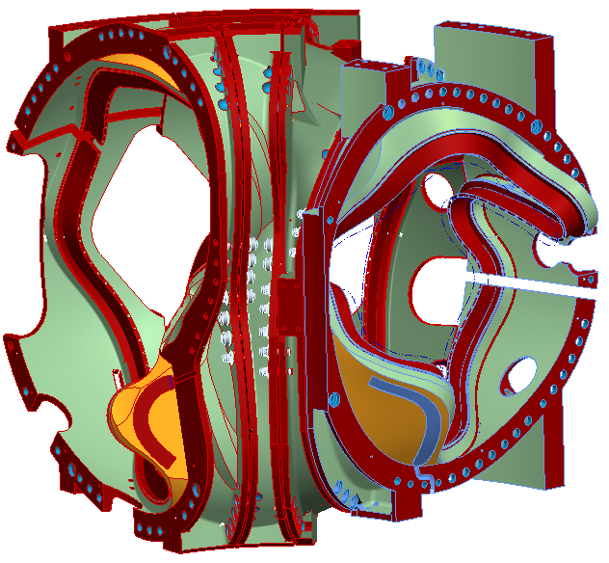
Fig. 2.0-1 A-A-B-C Coil CAD Model (courtesy PPPL)

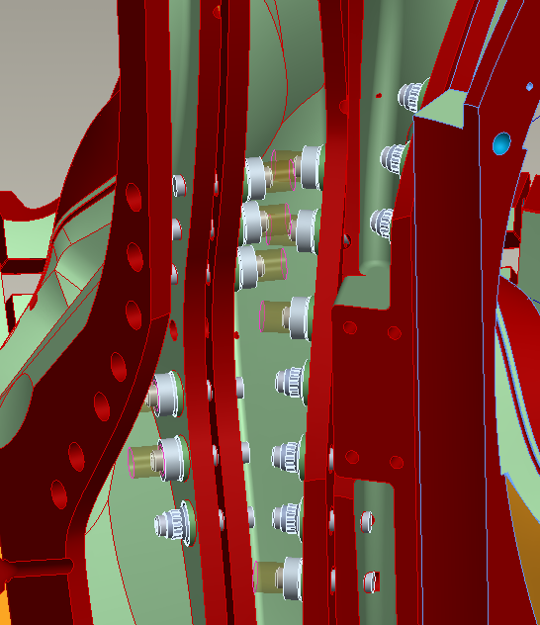
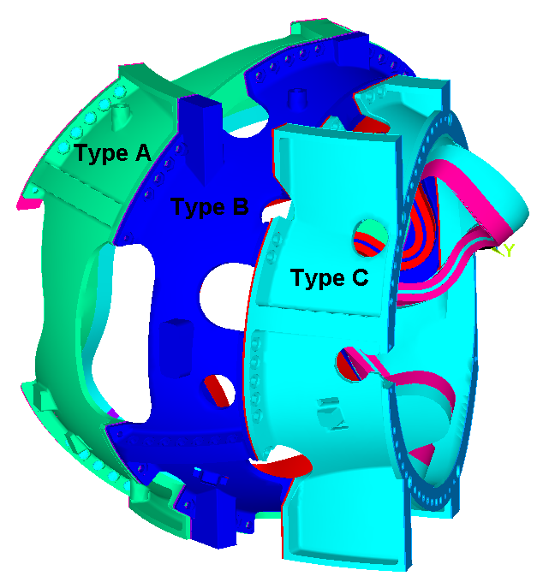
Fig. 2.0-2 Half-Field Period Global ANSYS Model (courtesy K. Freudenberg, ORNL)

Model Boundaries in a cylindrical coordinate system are at:
θ=0º (mid-thickness A-A shim)
θ=60º (mid-thickness C-C shim)
Fig. 2.0-3 Pipe Elements with Appropriate Section Properties Used to Simulated Bolted Connection
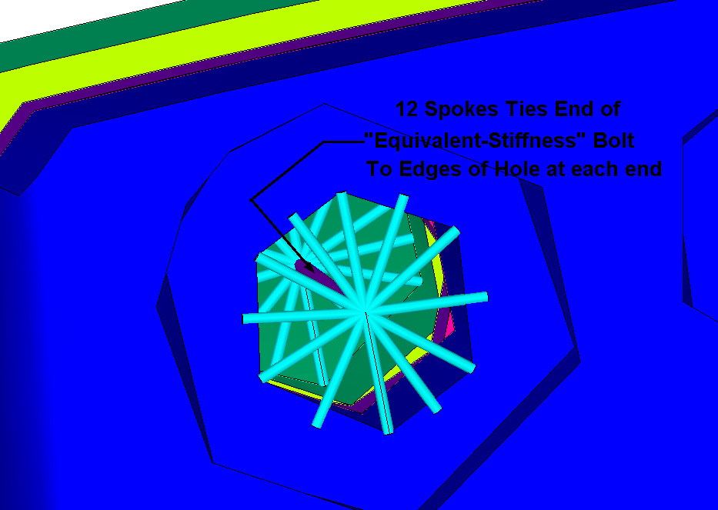
Equivalent Pipe Elements Tie A-B Flanges (diameters scaled for visualization purposes)
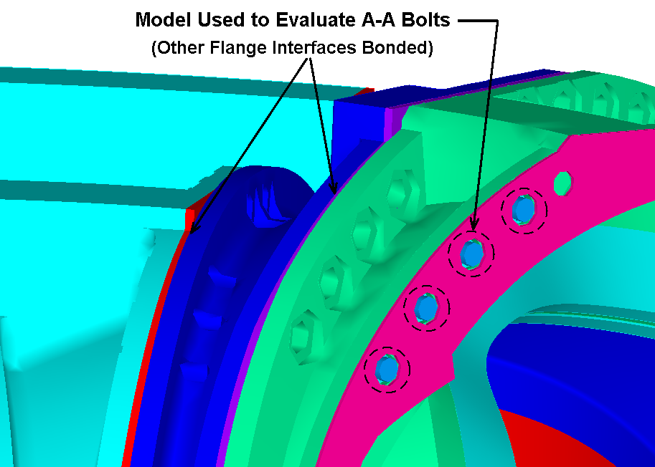
Pipe Elements Go to mid-Thickness of A-A Shim
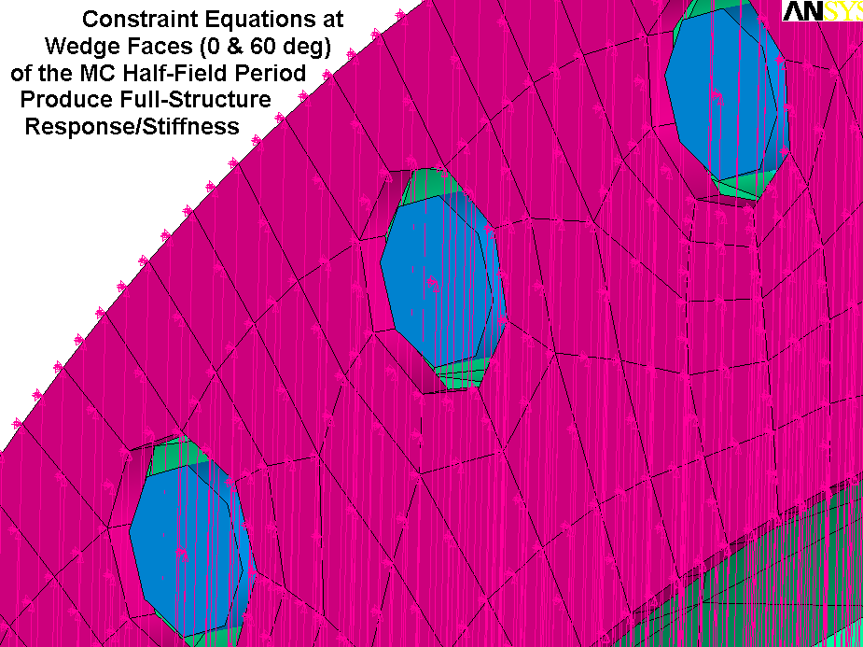
Fig. 2.0-4 Constraint Equation Symbols at A-A Shim Mid-Thickness

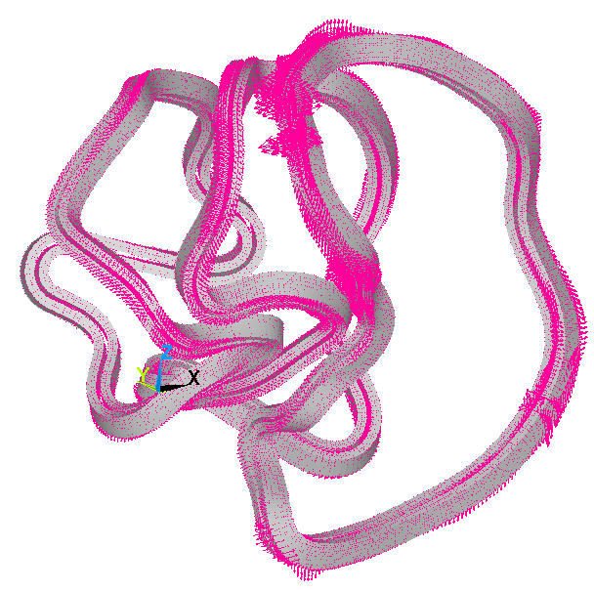
Fig. 2.0-5 Nodal Forces (t=0.0s of 2T, High-β)

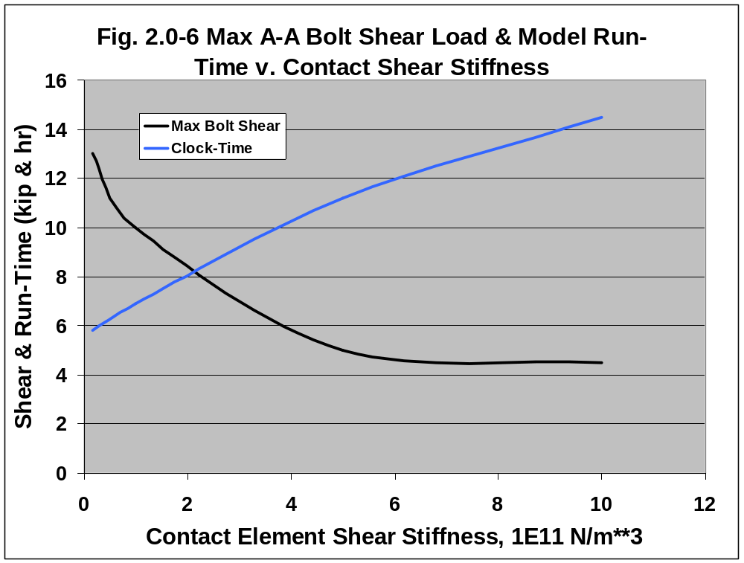
3.0 Results

3.1 Bonded Interfaces

The analysis begins with a simulation assuming all coil-to-coil flange interfaces are bonded. This provides an estimate of the shear loads which must be carried by friction and bolts, with particular attention given to the inboard leg region. A postprocessing macro is developed to integrate the two in-plane shear components over small regions and turn them into shear stress as a function of poloidal angle shown in Figs. 3.1-1 through 3.1-4. The plots show the magnitude of the shear stress at each interface. Interfaces A-A, A-B & C-C must transmit a peak shear stress of ~10 MPa, while B-C has a peak of ~18 MPa. Of course, the shear areas differ substantially, so the magnitude of the shear forces is different for each interface.

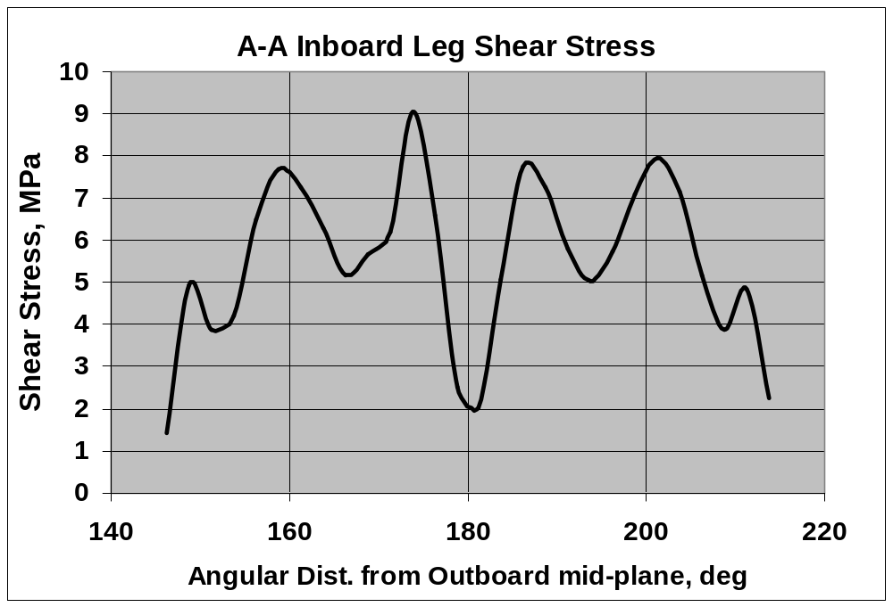
Fig. 3.1-1 Subdivision of A-A Inboard Leg and Integrated Shear Stresses
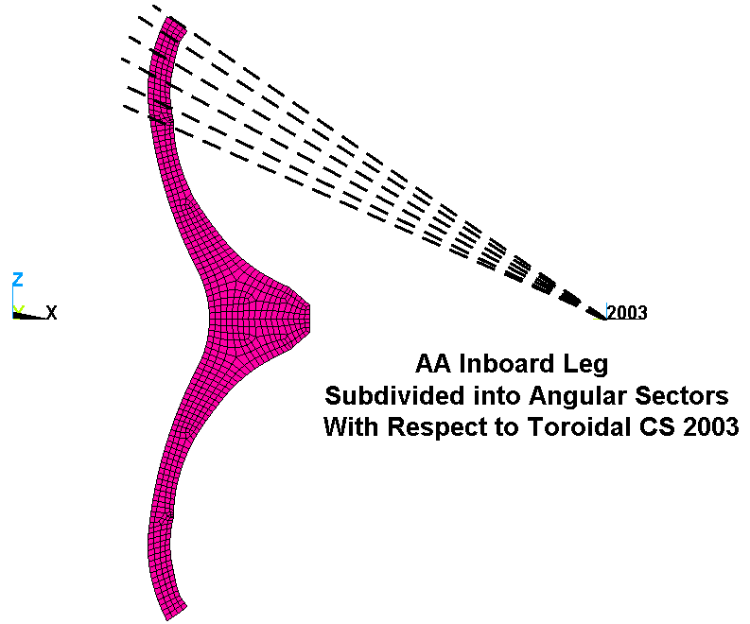
Fig. 3.1-2 Subdivision of A-B Inboard Leg (Similar to A-A) and Integrated Shear Stresses
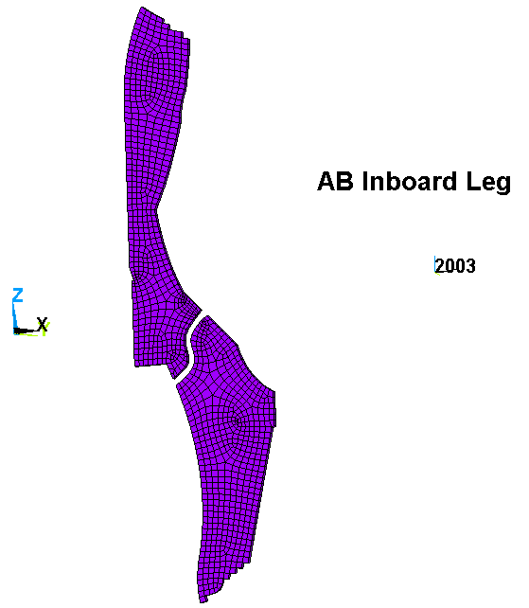
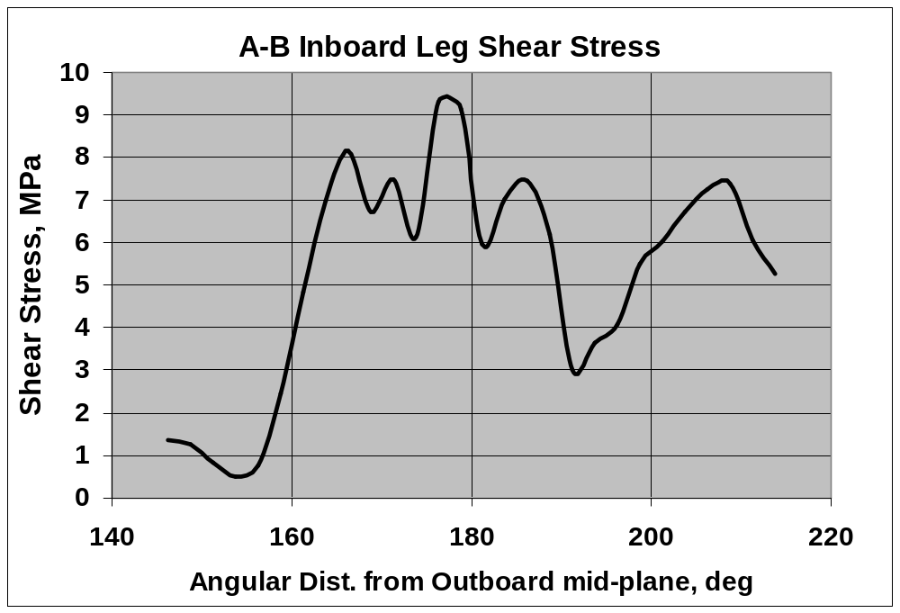
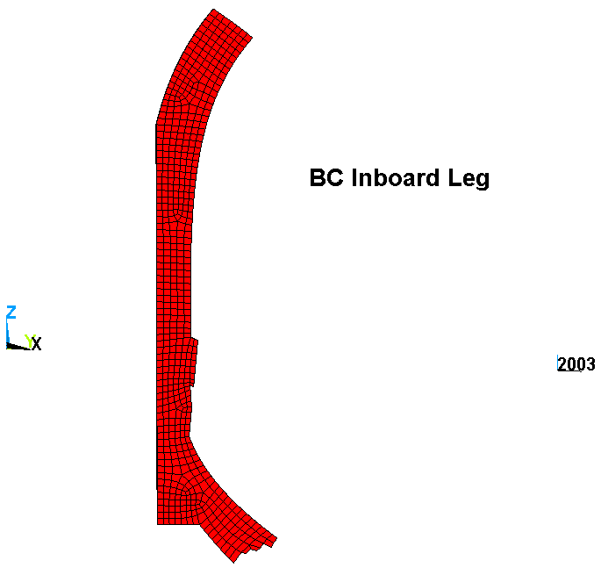
Fig. 3.1-3 Subdivision of B-C Inboard Leg (Similar to A-A) and Integrated Shear Stresses
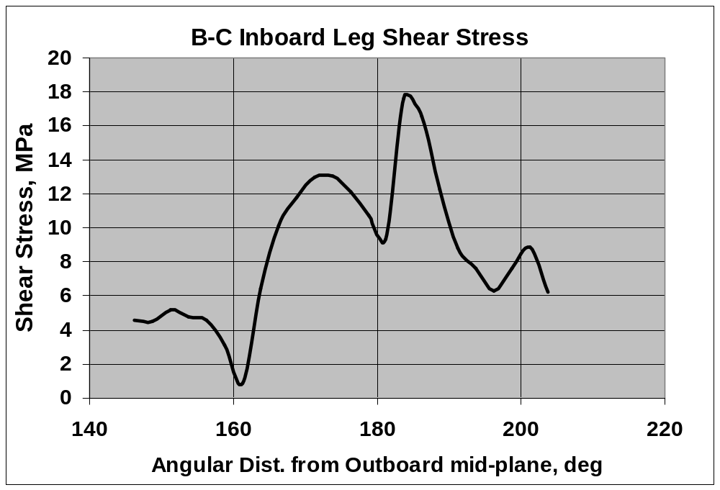

Fig. 3.1-4 Subdivision of C-C Inboard Leg (Similar to A-A) and Integrated Shear Stresses
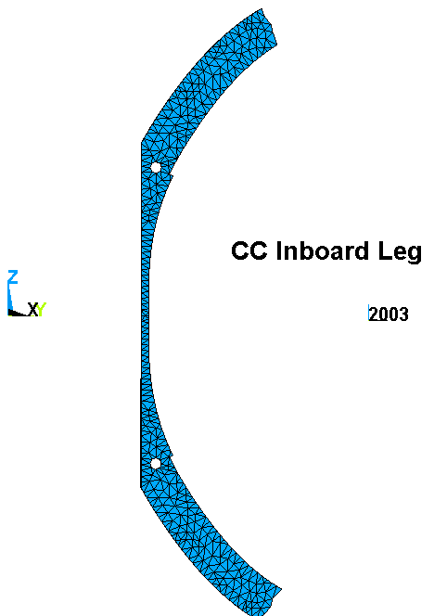
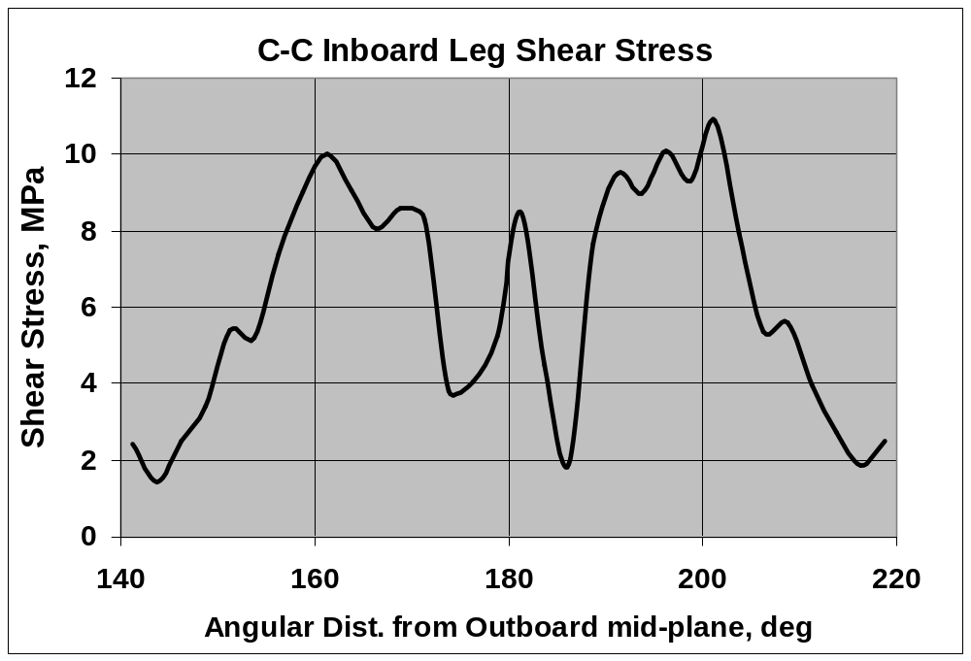
3.2 Bolted Interfaces with Friction

Various analyses have indicated the need to improve structural continuity in the inboard leg region of the MC system. Designers have responded by modifications which include the addition of inboard leg bolts at A-A, A-B & B-C. The global model is exercised in an effort to quantify the shear load on the bolts.

Fig. 3.2-1 shows a bar chart of the tensile preload and transverse shear load form the EM load application in each of the 26 A-A bolts, and a model plot showing the bolt numbering system (courtesy K. Freudenberg). The bolts are preloaded to roughly 75 kip (kilo-pounds), and the flange and shim surfaces have a finish which produces a design-basis friction coefficient of 0.4. Bolt numbers 21 & 26 carry the largest shear force at ~3 kip, while all others carry <2 kip.

Fig. 3.2-2 shows a contour plot of the A-A interface slippage and bolt shear load vectors as a result of the EM load application. The blue regions of the contour plot are limited to the areas where bolts pull the flanges together and indicate little or no slippage. In the region between bolts (1 & 26 and 20 & 21) the relative motion is non-zero, but still quite small with a maximum value of 0.12 mm (<0.005"). The vector plot highlights the bolt shear magnitude and direction not carried by friction.

A similar series of plots is included for the other flanged interfaces: A-B (Figs. 3.2-3 & -4), B-C (Figs. 3.2-5 & -6), and C-C (Figs. 3.2-7 & -8). Table 3.2-1 lists the salient numerical values. The plots show that most of the bolt shear loads are quite small (<3 kip). The exception is bolt #30 on the B-C interface, which carries 9 kip from the EM load cycle. This interface also slips by ~0.4 mm as a result of the unbolted inboard leg. C-C has long regions without bolts, but the structure does not exhibit such large slippage (<0.2 mm).

The most critical result is the 9 kip shear load on B-C bolt #30.

Table 3.2-1 Summary of MC Flange Interface Loads (75 kip Preload, μ=0.4)
Flange Set | Max Bolt Shear, kip | Max Slippage, mm
A-A | 3 | 0.12
A-B | 3 | 0.27
B-C | 9 | 0.40
C-C | 3 | 0.17
Fig. 3.2-1 A-A Bolt Preload & EM-Driven Shear Load (top) & Bolt Numbering (bottom)
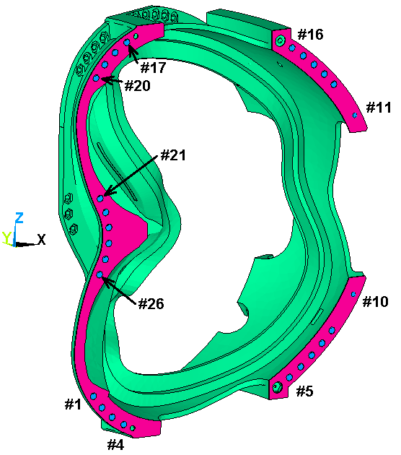
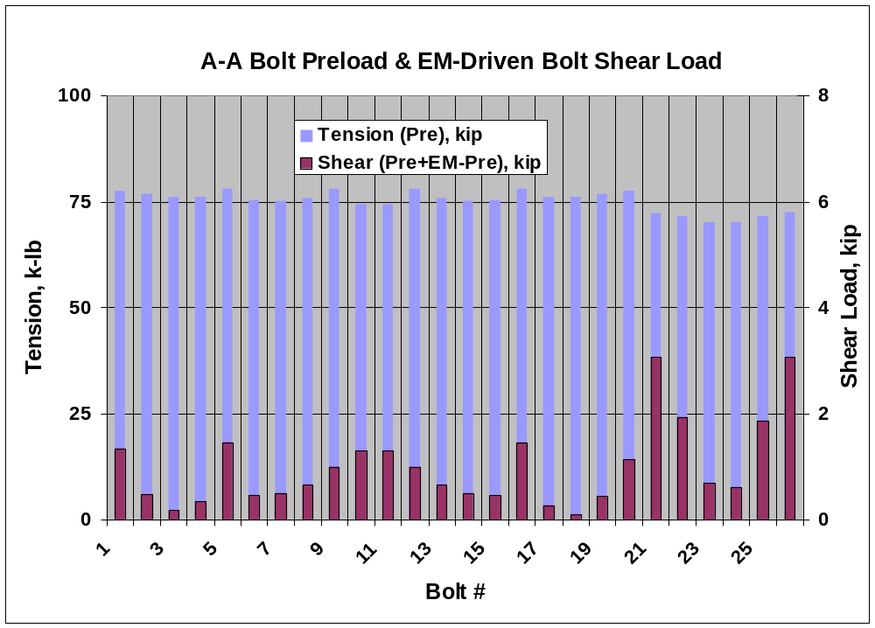
Fig. 3.2-2 A-A Slip [m] & Bolt Shear Loads [kip] from EM Load Application
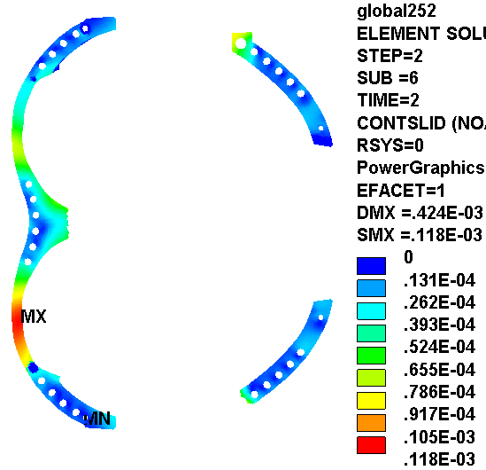

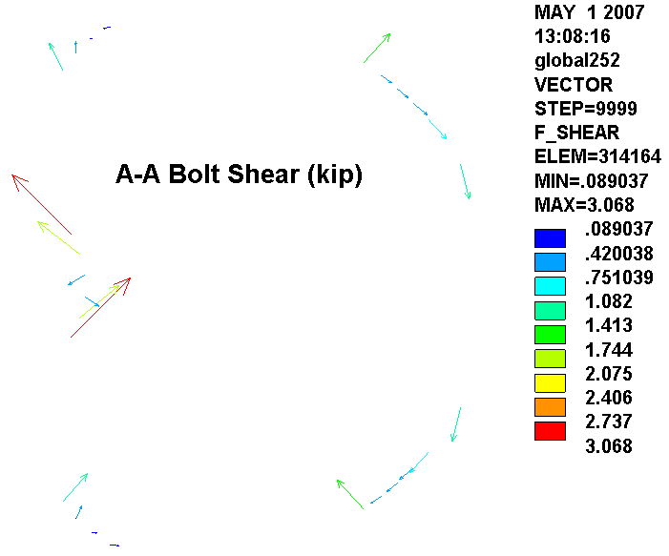
Fig. 3.2-3 A-B Bolt Preload & EM-Driven Shear Load (top) & Bolt Numbering (bottom)
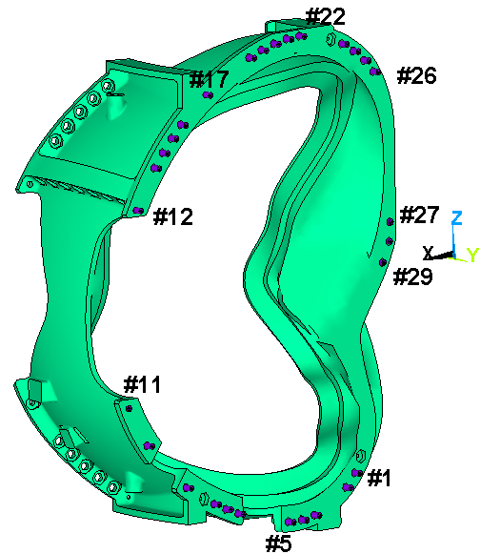
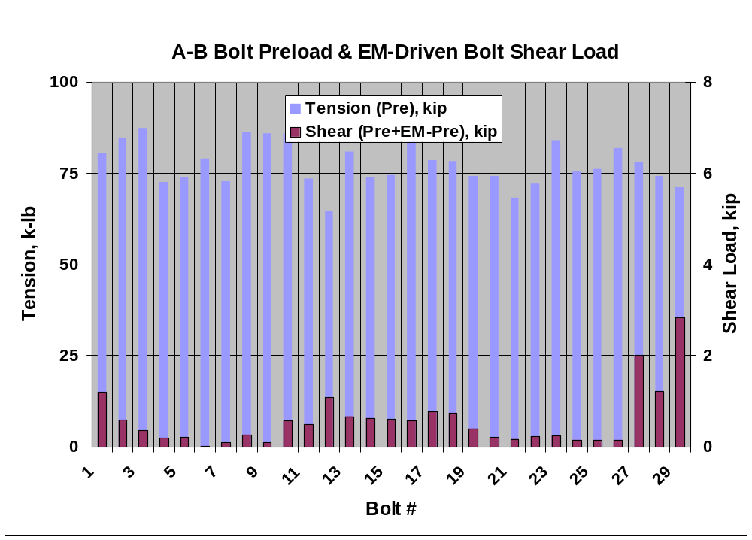

Fig. 3.2-4 A-B Slip [m] & Bolt Shear Loads [kip] from EM Load Application
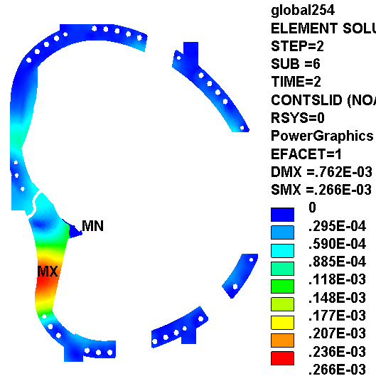

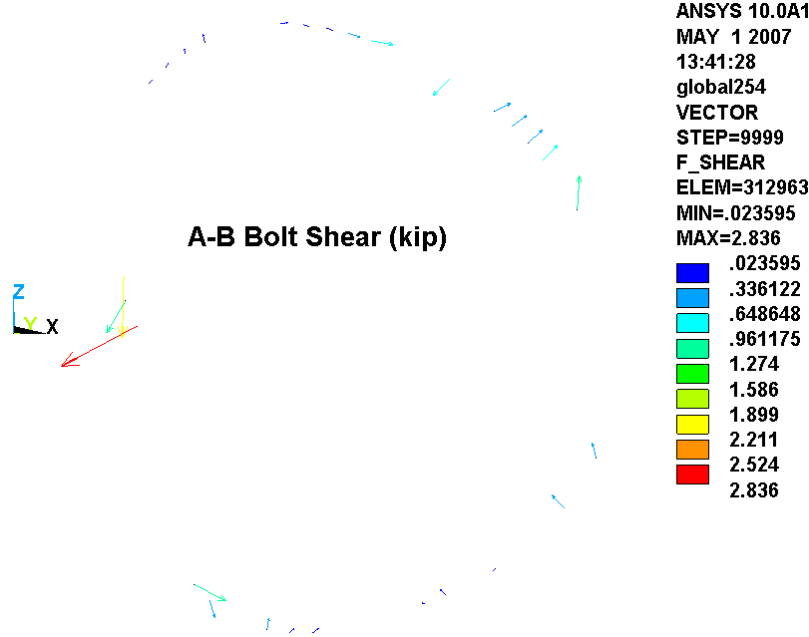
Fig. 3.2-5 B-C Bolt Preload & EM-Driven Shear Load (top) & Bolt Numbering (bottom)
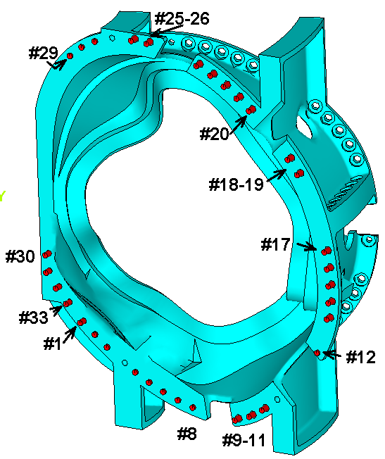
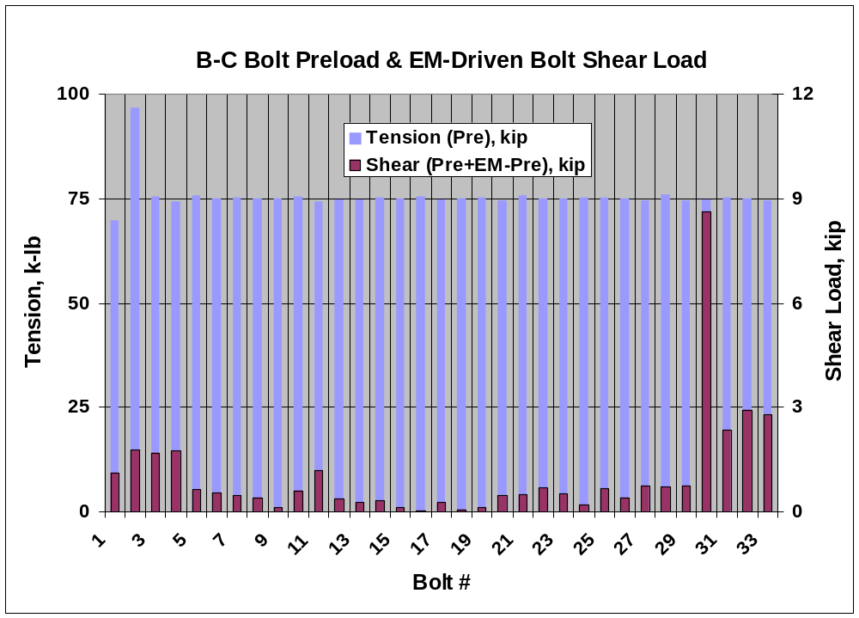
Fig. 3.2-6 B-C Slip [m] & Bolt Shear Loads [kip] from EM Load Application
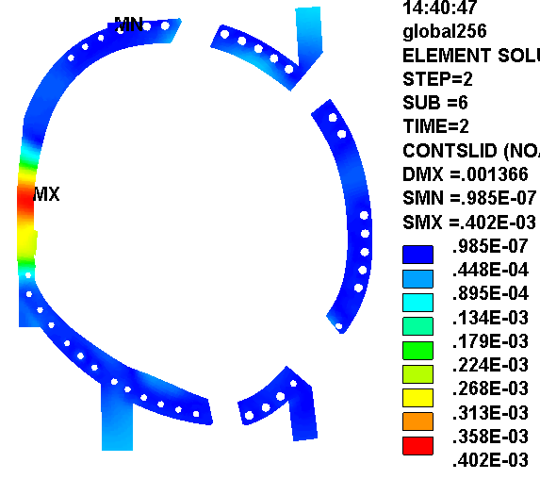
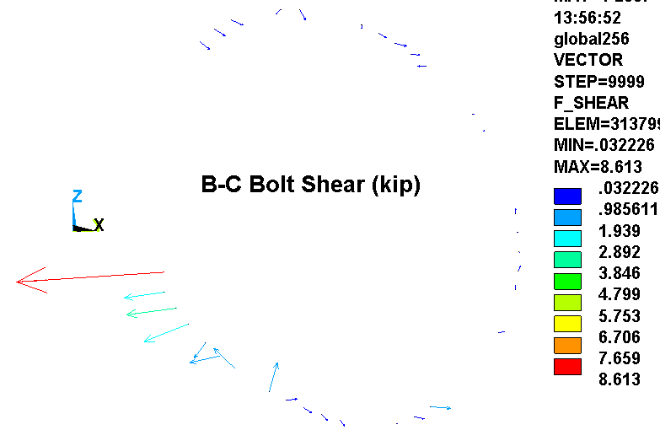
Fig. 3.2-7 C-C Bolt Preload & EM-Driven Shear Load (top) & Bolt Numbering (bottom)
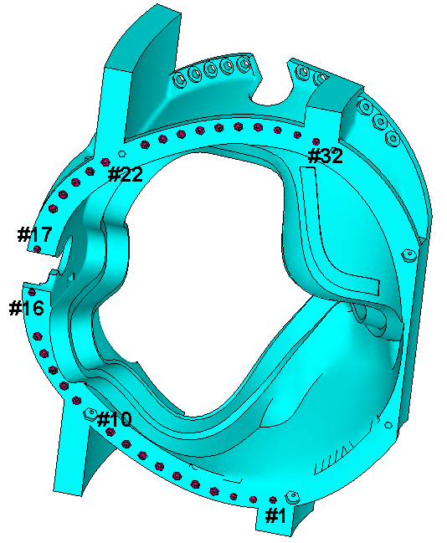
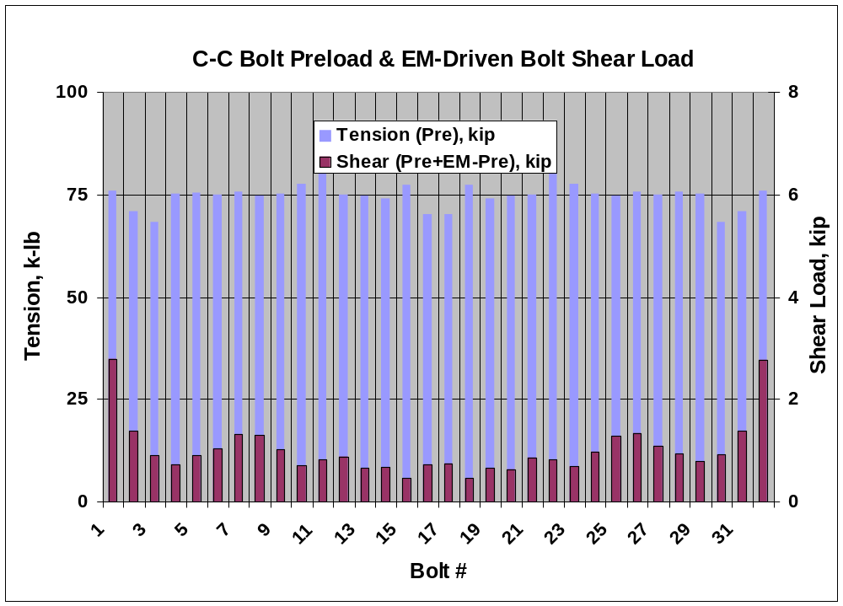
Fig. 3.2-8 C-C Slip [m] & Bolt Shear Loads [kip] from EM Load Application
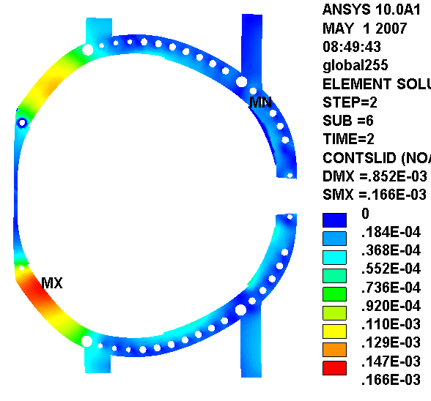
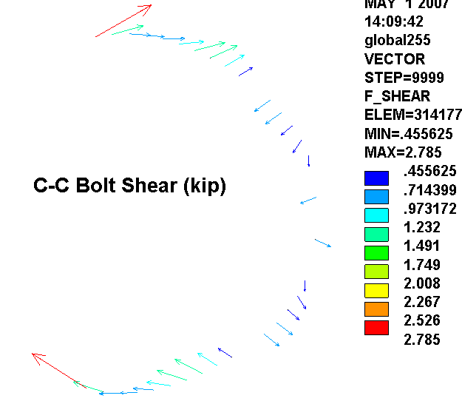
4.0 Attachments

4.1 Stiffness, Stress and Equivalent Models, Type-1 & Type-2 Bolted Joints (circa Nov 2006)

Design sketches of the Type-1 and Type-2 bolted connections are shown in Fig. 4.1-1. Detailed models are developed and used to determine their effective stiffness and local stresses from a unit shear load as shown in Figs. 4.1-2 and 4.1-3. When a unit load of 25 kip is applied to each joint type flange, bolt stresses develop as shown in Fig. 4.1-4. These results assume that Stycast fills a 30 mil annular gap around G11 collars. Recent design modifications eliminate the Stycast and change the collar material to SS. No revision to the detailed model has been made to evaluate this design change.

Notice that a 25 kip shear load produces bolt stresses of 107 ksi & 124 ksi in the Type-1 & Type-2 bolted joints, respectively. With an expected shear load of 13 kip, the bolt stresses will be 56 ksi and 64 ksi, excluding stress concentrations at the thread. Stresses of this order will require a fatigue evaluation for this high-cycle application.

Figs. 4.1-5 & 4.1-6 show equivalent joint modeling for inclusion in the global model. Notice that if the bolts are subjected to transverse slip, then the equivalent stiffness is like a 2.75" to 2.9" diameter rod in bending. If the joints are locked by friction, then the joint stiffness is determined by the actual bolt diameter (e.g., 1.375").
Fig. 4.1-1 Type-1 (through) & Type-2 Bolted (tapped) Joints (images Courtesy D. Williamson)
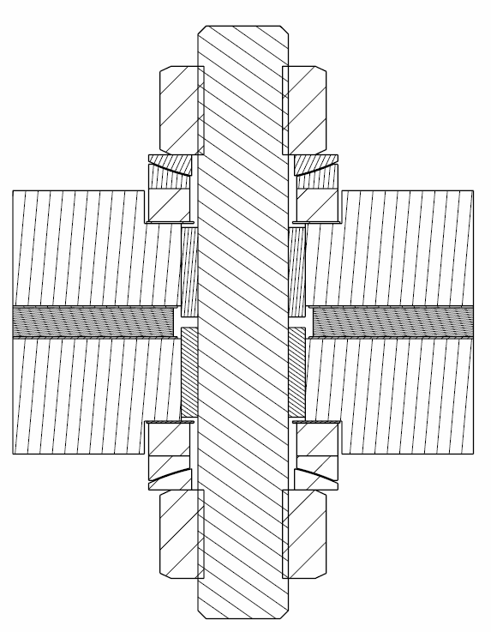
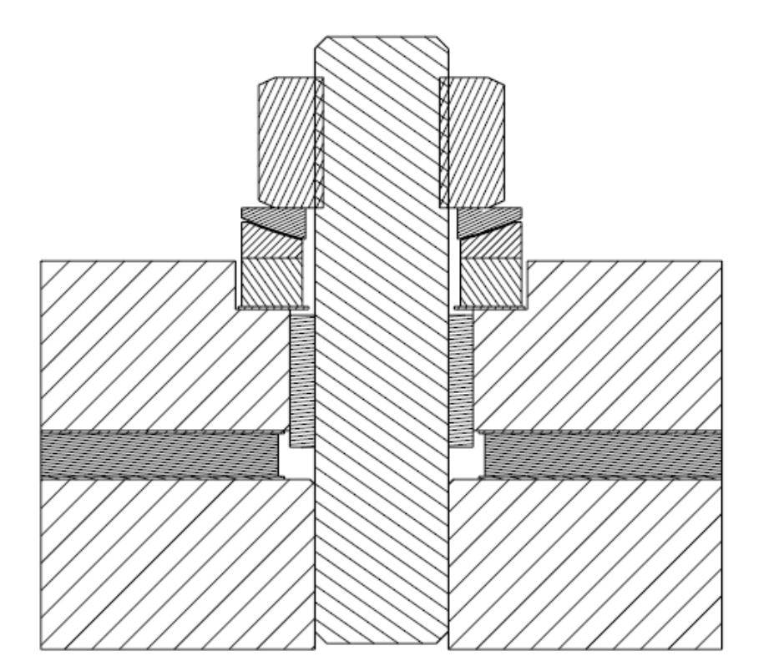

Fig. 4.1-2 Type-1 Stiffness Calculation
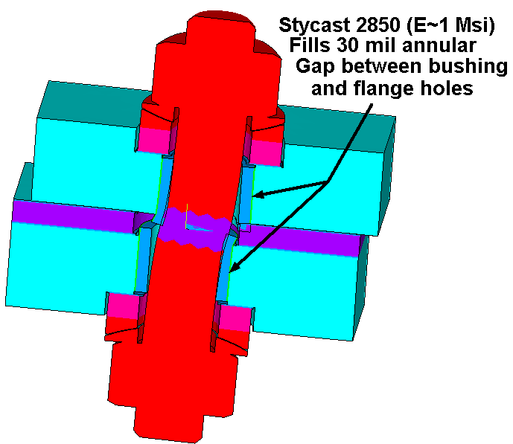

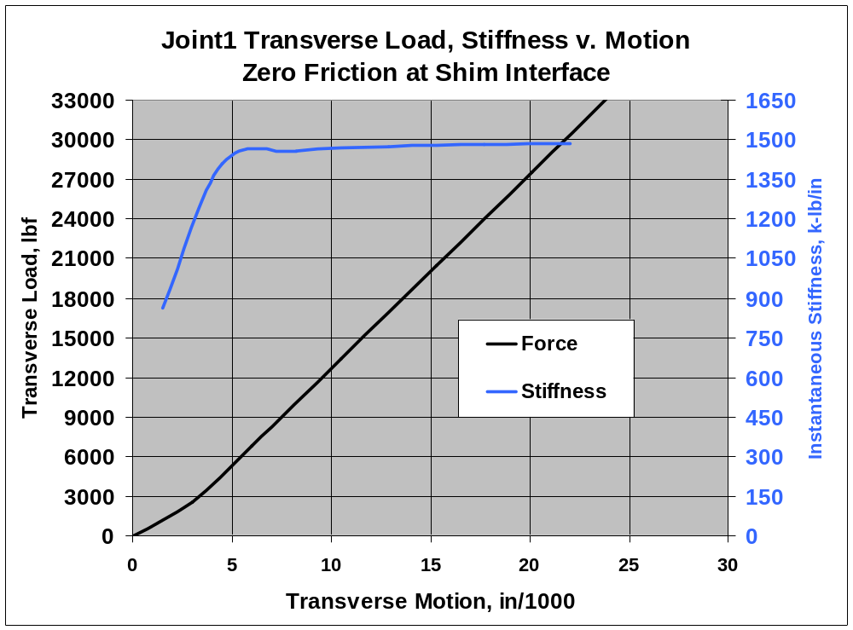
Fig. 4.1-3 Type-2 Stiffness Calculation
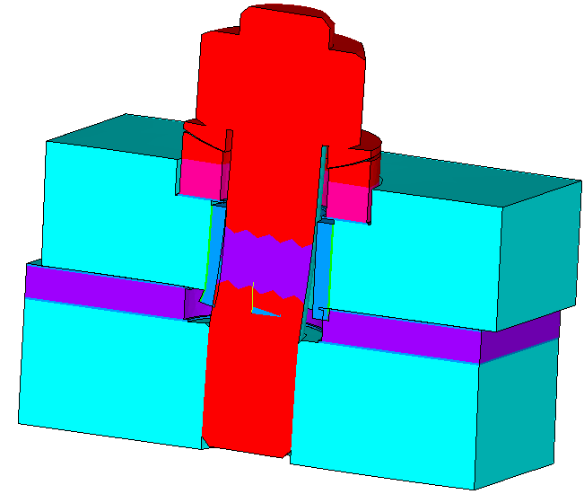
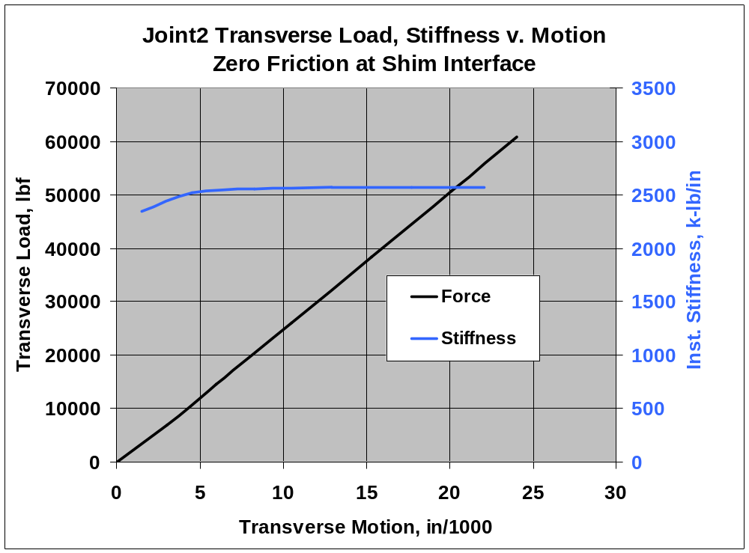
Fig. 4.1-4 Fastener Stress from 25 kip shear load
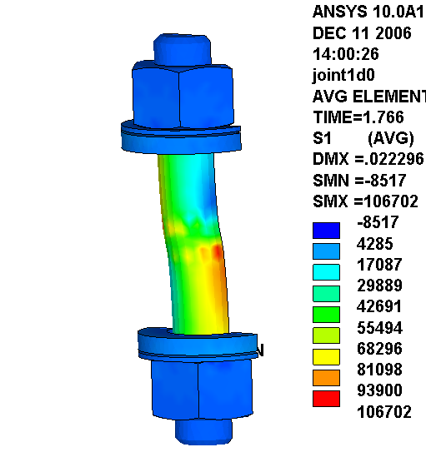
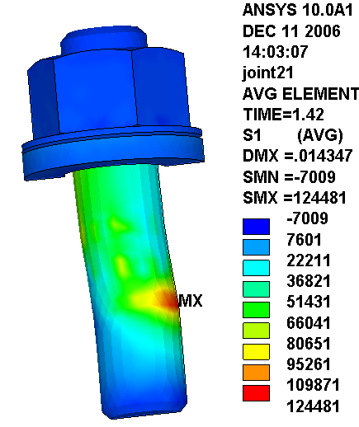
Fig. 4.1-5 Equivalent Type-1 Bolted Connection (2.9" dia. bolt in bending)

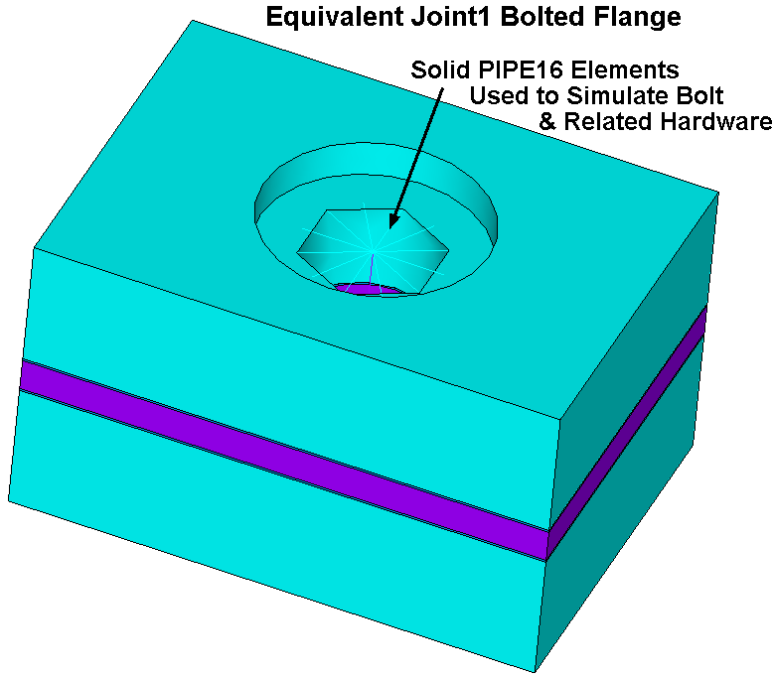
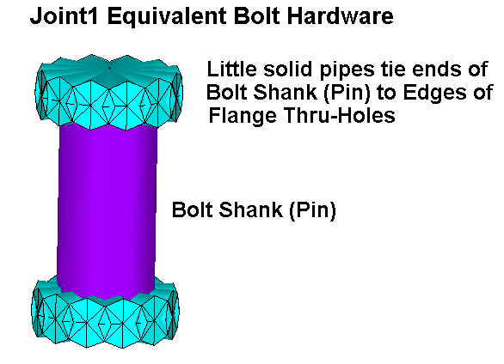
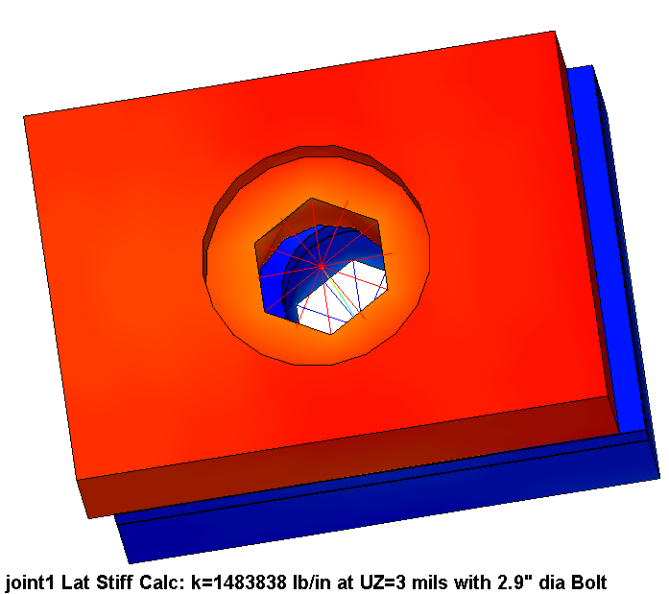
Fig. 4.1-6 Equivalent Type-3 Bolted Connection (2.75" dia. bolt in bending)
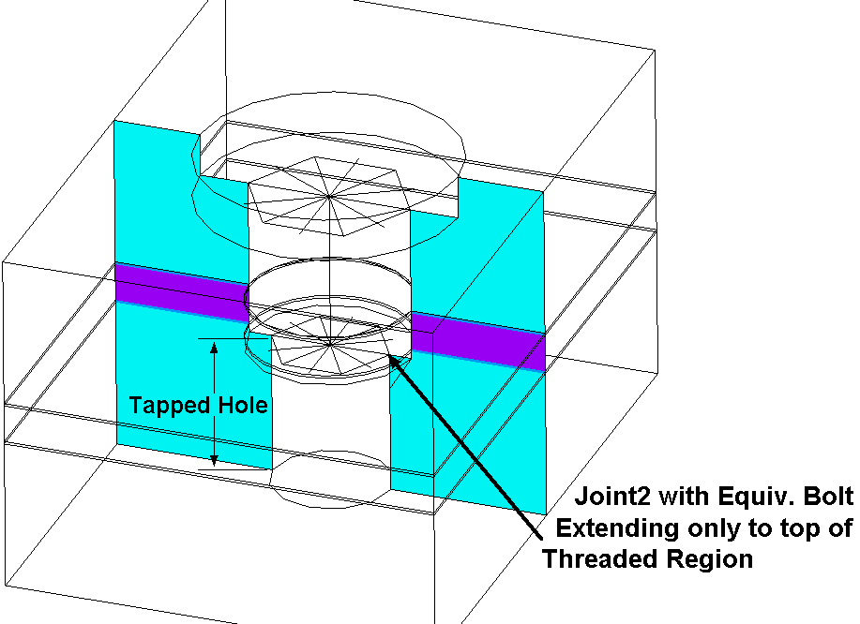

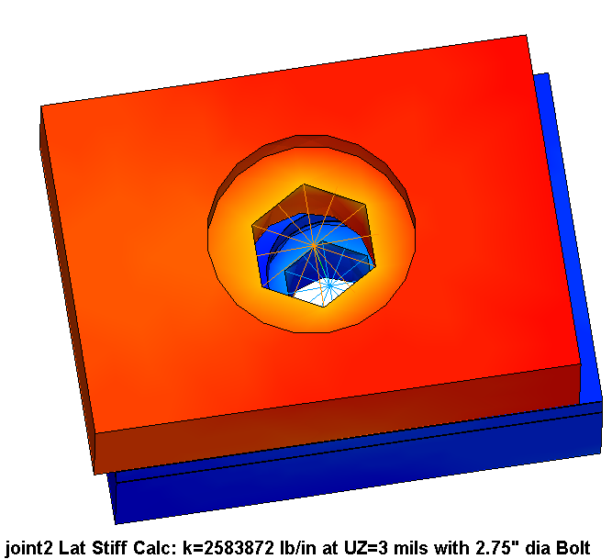
4.2 Stresses in the Revised Type-1 & Type-2 Bolted Joints (circa May 2007)

Slight modifications to the reference Type 1 & Type 2 bolted joints (shown in Fig. 4.2-1) have lead to a re-analysis of these mechanical fasteners. In this section, solid models from ORNL are cut in half (for computational efficiency), contact elements are added, material properties, boundary conditions and loads are applied and stresses are reported for a 20 kip unit shear load. Details are discussed below.

ANSYS models of the Type 1 & Type 2 joints are developed from ORNL SAT files (courtesy K. Freudenberg). Half-symmetry model plots are shown in Figs. 4.2-2 through 4.2-4, and correspond to the Type 1 (through-bolt), Type 2 (tapped hole), and Type 2a (extended steel bushing, tapped hole). Standard contact elements are judiciously placed between the shims and flanges, and between the bolt shank and the bushings & shim hole. All other interfaces should never slide or break contact, and so "gluing" these volumes before meshing improves the computational efficiency of the model without detracting from its accuracy. Two different bushing materials are considered; G-11CR and SS.

The joints are preloaded by imposing an elevated reference temperature on the slice of bolt shank material shown as blue in the model plots. This typically requires one solution cycle since calculating the reference temperature required to produce the desired 72 kip (48.5 ksi) preload would be difficult to estimate for this geometry.

After establishing the proper preload, the joints are loaded by applying a shear load of 10 kip to the half-model, which is equivalent to 20 kip per joint. Friction is neglected since the intent of the analysis is to determine stresses produced by the shear load appearing on the bolts, as determined by the global model results of section 3.2. Therefore, the two load cases per analysis are executed:

- Load Step 1 (time=1.0): Bolt Preload ~72 kip, 0.0 kip Shear Load
- Load Step 2 (time=2.0): Bolt Preload plus 20 kip Shear Load

While the static tensile stress in the bolt is important, the cyclic EM loading is likely to be the more critical design factor. When evaluating the effects of changes in a stress-state, the stress range is the salient parameter. Load Step 1 results are subtracted from Load Step 2 results to produce a stress range. This operation subtracts-out the preload stress which does not change during the shear load application cycle.

Fig. 4.2-5 shows plot of the 1st principal stress range in the Type-1 bolt as a result of this load step subtraction operation. These contour plots also show the "Stress Linearization Path." This "Path" is placed at a critical location within the bolt shank, where large bending stresses coincide with the geometric stress concentration of the threads. You will notice that the path does not occur at the location of the maximum stress in the model. By studying Fig. 4.2-1 we see the extent of the threads, where these local tensile stresses will be amplified by the thread stress concentration factor. Model stresses are higher at other locations within the shank, but there are no threads at those locations to intensify the stress.

Similar 1st principal stress plots are shown in Figs. 4.2-6 for the Type-2 (G-11 & Metallic bushings) and Fig. 4.2-7 for the Type-2a (extended metallic bushing) configurations. Notice that the Path occurs right at the maximum stress location for these Type-2 and Type 2a joints, since it happens to coincide with bolt thread.

The following (5) plots show the axial stress profile as a function of distance along the path for each configuration. The plots reveal some noteworthy results:

- The stress profile indicates a predominantly Bending component (no surprise)
- The MEM+BEND stress and TOTAL stress are essentially the same for the Type-1 joint
- There is a significant PEAK stress component {TOTAL-(MEM+BEND)}in the Type-2 & 2a joints based on the bolt-hole geometric discontinuity.

Since the model does not explicitly include the bolt threads, their influence has to be added by amplifying the local MEM+BEND stress. This is perfectly consistent with the ASME Code approach and the textbook definition of a Stress Intensification Factor (SIF). Incidentally, the SIF of these bolt threads will be a function of the thread form. Rolled threads have a lower SIF than cut threads. However, in the absence of a precise value, the ASME Code recommends a bolt thread SIF (k_{thread}) of 4.0 as shown in Fig. 4.2-13.

Below each stress profile or "section" plot is a listing of the categorized stresses for each stress component. We need to amplify a particular stress component by the thread SIF. Amplifying SY is a logical choice since the thread concentration is normal to this stress component. However, amplifying S1 (max tensile stress) is also appropriate and conservative, if not essentially the same as SY. In addition, it would be difficult to ignore the Peak stress component that the model is able to capture, which also contributes to the total stress at this max stress location. Therefore, the total stress range which is used to evaluate the fatigue life of the bolts is defined as follows:

∆S_{tot} = (k_{thread})(∆S1) + PEAK

Table 4.2-1 lists the numerical values of this operation and the Total Intensified Stress Range. Keep in mind that these values are based on a 20 kip unit shear load.

Table 4.2-1 Joint Fastener Fatigue Evaluation, 20 kip Shear Load Range
Joint Type | Type 1 |  | Type 2 |  | Type 2a
Bushing Material | G-11CR | SS | G-11CR | SS | SS
Un-Intensified Stress Range per 20 kip Shear Load (∆S1), ksi | 30.4 | 17.9 | 50.4 | 42.9 | 35.4
Thread Stress Intensification Factor | 4 | 4 | 4 | 4 | 4
Peak Stress Range per 20 kip Shear Load, ksi | 0.3 | 0.0 | 47.4 | 41.5 | 26.3
Total Intensified Stress Range per 20 kip Shear Load, ksi | 122 | 72 | 249 | 213 | 168

Now, these stresses must be compared to a design-basis fatigue curve of the bolt material at the 77K operating temperature. Fig. 4.2-14 shows fatigue data for our A286 bolt material at RT, 77K and 4K (Reference: N. Suzuki, "Low-Cycle Fatigue Characteristics of Precipitation-Hardened Superalloys at Cryogenic Temperatures," Journal of Testing and Evaluation, JTEVA, Vol. 28, No. 4, July 2000. pp. 257-266.). The 77K curve is digitized in an Excel spreadsheet, and curve-fit to AN^{B}. The coefficient A is divided by 2 to make a design-basis fatigue curve. The equation is then used to estimate the number of cycles to failure as a function of the bolt shear load for each of the (5) configurations listed in Table 4.2-1. Results are plotted and shown in Fig. 4.2-15.

Clearly, Type 1 joints can support higher cyclic shear loads than Type 2 joints. Using SS bushings instead of G-11CR bushings improves the fatigue life of both Type 1 & Type 2 joint designs. In addition, modifying the Type 2 design by extending the bushing into a counter-bore in the adjacent flange face increases the shear capacity over the reference Type 2 design. The plot shows that only the Type 2 joint with a G-11 bushing does not provide sufficient fatigue strength to survive the estimated 9 kip load range for 100,000 EM cycles. The plot can also be used to evaluate the acceptability of any design for any number of cycles.
Fig. 4.2-1 May 2007 Joint Designs, Type 1 (top) & Type 2 (bottom), courtesy D. Williamson
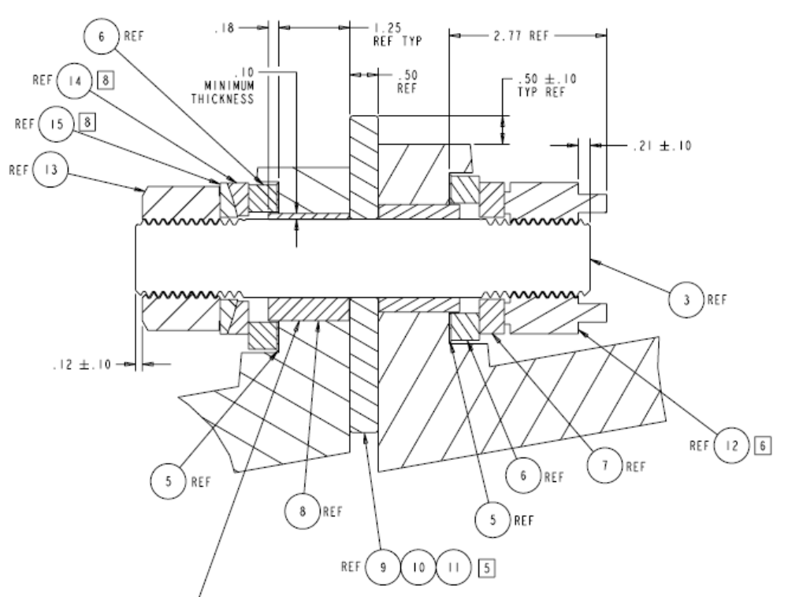
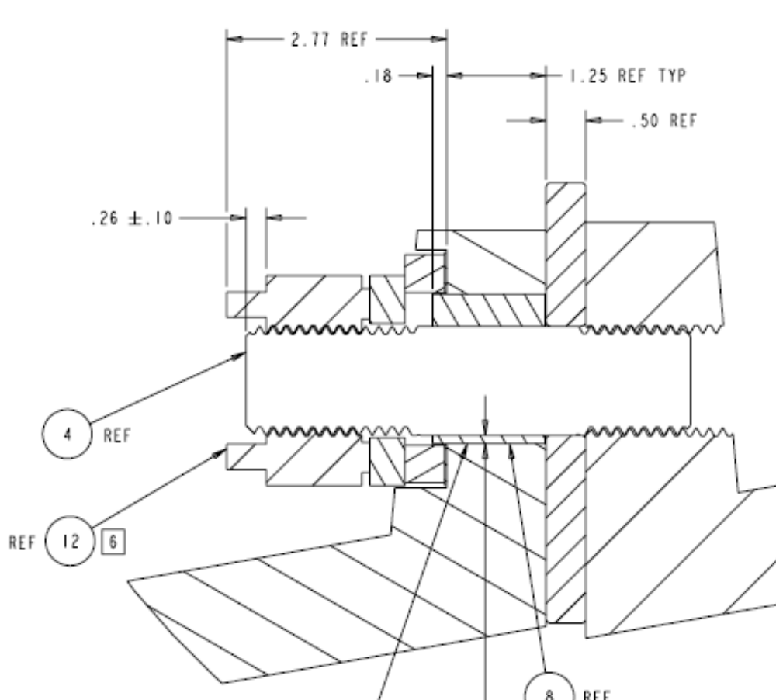
Fig. 4.2-2 ANSYS Model, Type 1 Bolted Connection
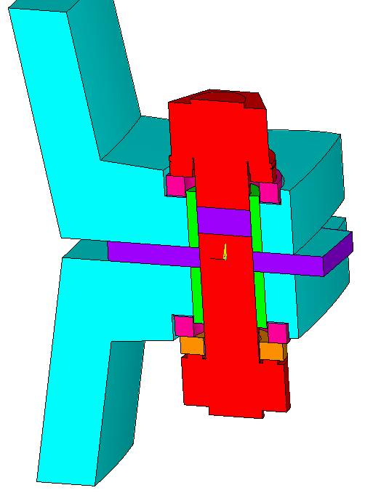

Fig. 4.2-3 ANSYS Model, Type 2 Bolted Connection
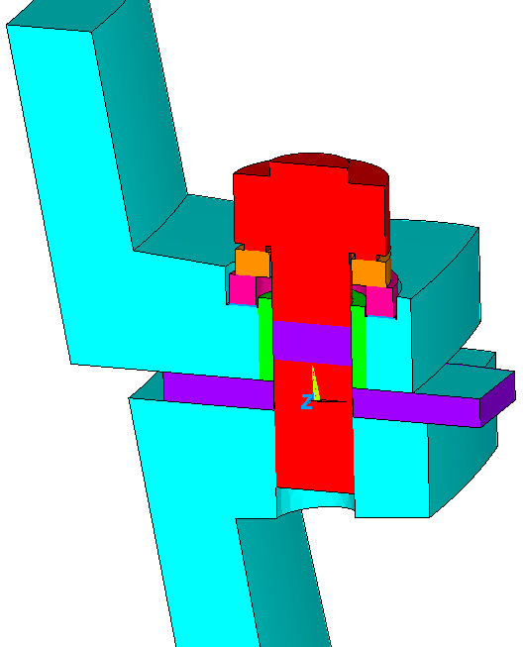
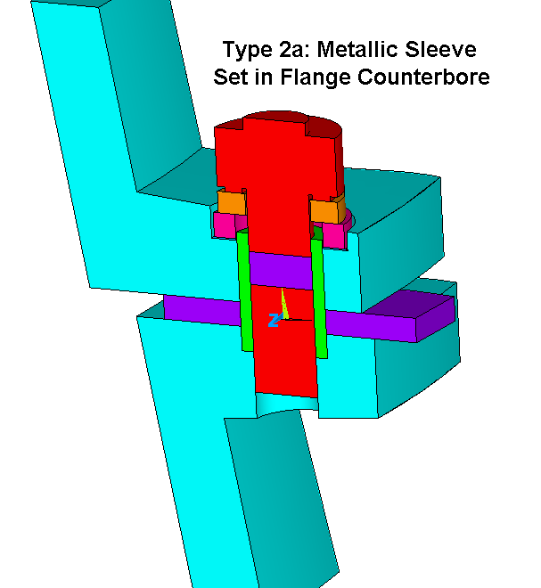
Fig. 4.2-4 ANSYS Model, Type 2a Bolted Connection, Extended Metallic Bushing

Note: There are no contact elements between the bolt shank and bushing ID for this Type 2a configuration. The intention of this bolting structure is to isolate the bolt from stresses due to shear and local contact. In this case, the metallic bushing is designed to carry the shear load.
Fig. 4.2-5 1st Principal Stress Range in Type 1 Bolt from 20 kip Shear Load
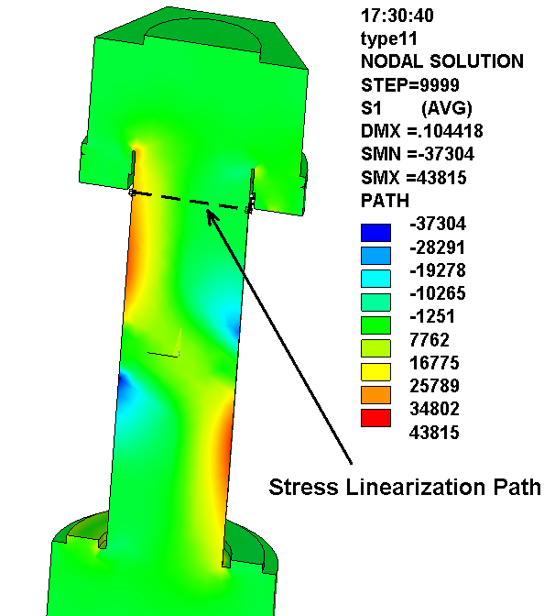
G-11 Bushing (top), Metallic Bushing (bottom)
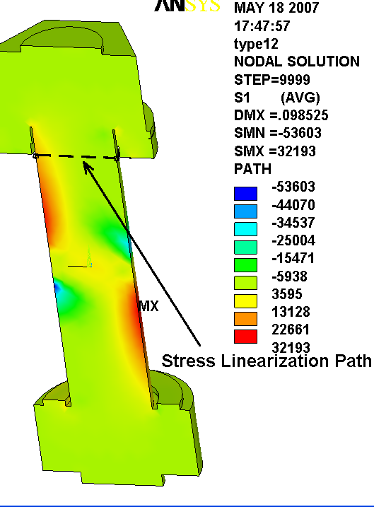
Fig. 4.2-6 1st Principal Stress Range in Type 2 Bolt from 20 kip Shear Load
G-11 Bushing (top), Metallic Bushing (bottom)
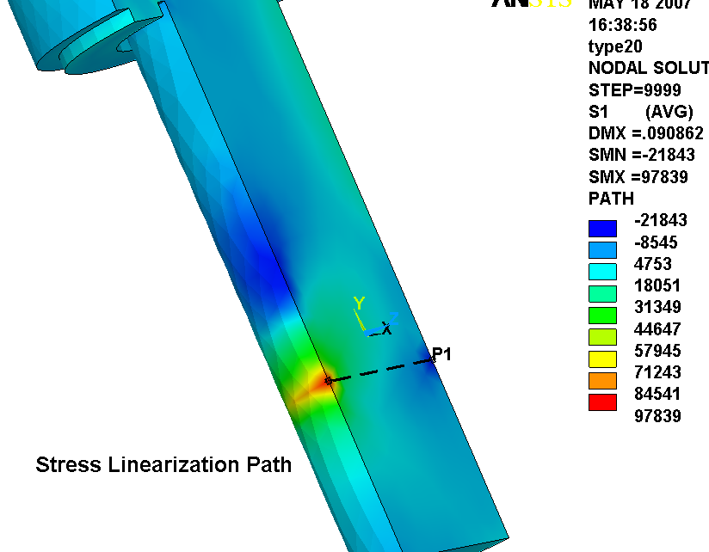
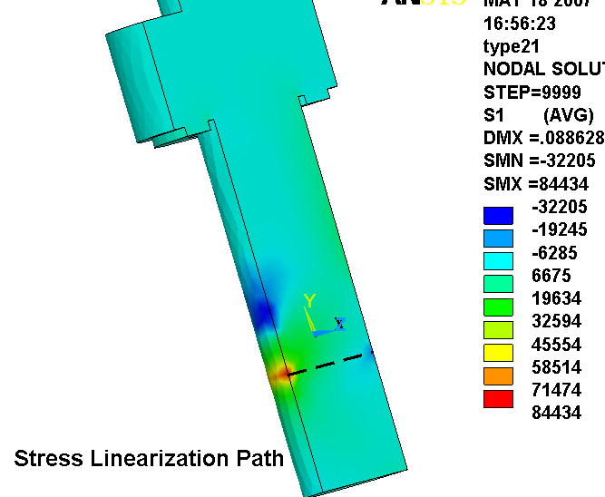
Fig. 4.2-7 1st Principal Stress Range in Type 2a Bolt from 20 kip Shear Load
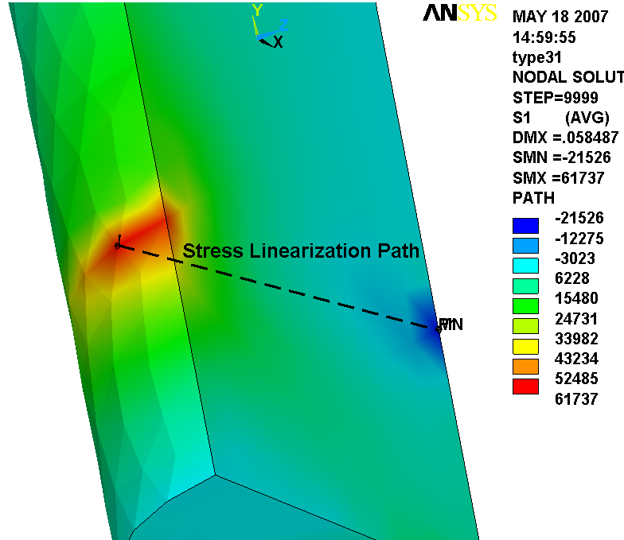
Extended Metallic Bushing

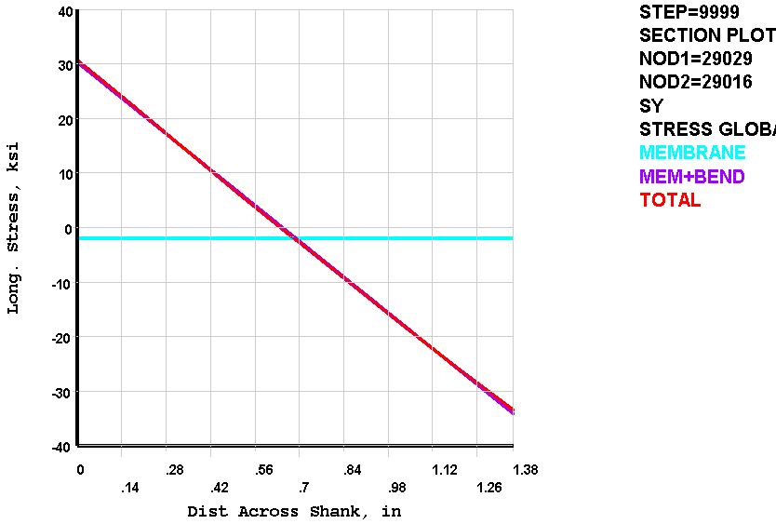
Fig. 4.2-8 Type 1 Section Stress Profile, G-11 Bushing

** MEMBRANE PLUS BENDING ** I=INSIDE C=CENTER O=OUTSIDE
SX SY SZ SXY SYZ SXZ
I 1.573 0.3030E+05 721.7 -1654. 9.750 -0.1127
C -11.86 -1914. -63.53 -1473. 2.267 -1.354
O -25.28 -0.3413E+05 -848.7 -1293. -5.217 -2.596
S1 S2 S3 SINT SEQV
I 0.3039E+05 721.7 -88.40 0.3048E+05 0.3008E+05
C 790.4 -63.53 -2717. 3507. 3168.
O 23.64 -848.7 -0.3418E+05 0.3420E+05 0.3378E+05

** TOTAL ** I=INSIDE C=CENTER O=OUTSIDE
SX SY SZ SXY SYZ SXZ
I -27.02 0.3069E+05 466.5 -10.28 -1.327 11.06
C -43.60 -2182. -104.6 -2464. -2.889 9.850
O 22.69 -0.3347E+05 -452.3 -13.39 8.259 13.59
S1 S2 S3 SINT SEQV TEMP
I 0.3069E+05 466.7 -27.27 0.3072E+05 0.3047E+05 0.000
C 1573. -104.7 -3799. 5372. 4760.
O 23.08 -452.7 -0.3347E+05 0.3350E+05 0.3326E+05 0.000

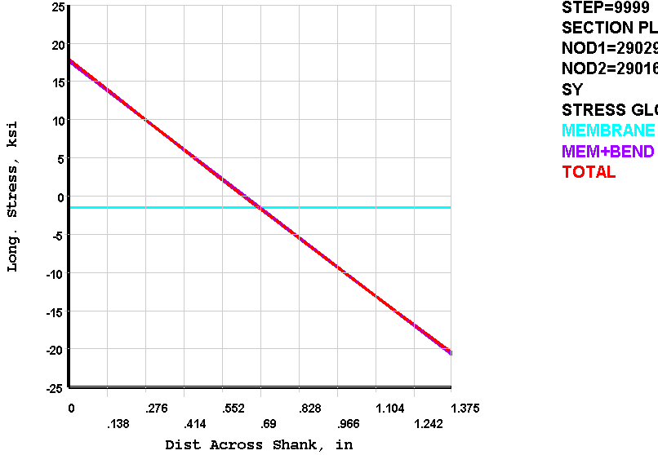
Fig. 4.2-9 Type 1 Section Stress Profile, Metallic Bushing

** MEMBRANE PLUS BENDING ** I=INSIDE C=CENTER O=OUTSIDE
SX SY SZ SXY SYZ SXZ
I 28.58 0.1767E+05 343.8 -1781. 8.942 0.6724
C 26.95 -1501. -84.05 -1653. 2.717 -1.073
O 25.33 -0.2067E+05 -511.9 -1524. -3.508 -2.818
S1 S2 S3 SINT SEQV
I 0.1785E+05 343.8 -149.4 0.1800E+05 0.1776E+05
C 1084. -84.06 -2558. 3641. 3220.
O 137.0 -511.9 -0.2078E+05 0.2092E+05 0.2060E+05

** TOTAL ** I=INSIDE C=CENTER O=OUTSIDE
SX SY SZ SXY SYZ SXZ
I -13.44 0.1792E+05 235.3 4.414 -0.8974 6.801
C 45.76 -1649. -115.4 -2615. -1.723 6.860
O 12.15 -0.2042E+05 -298.2 -9.731 3.657 6.875
S1 S2 S3 SINT SEQV TEMP
I 0.1792E+05 235.4 -13.63 0.1793E+05 0.1781E+05 0.000
C 1947. -115.4 -3550. 5498. 4810.
O 12.31 -298.4 -0.2042E+05 0.2043E+05 0.2028E+05 0.000

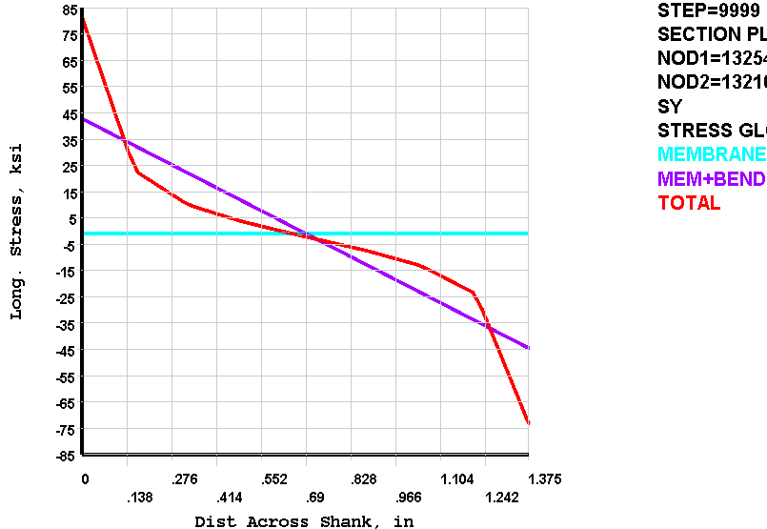
Fig. 4.2-10 Type 2 Section Stress Profile, G-11 Bushing

** MEMBRANE PLUS BENDING ** I=INSIDE C=CENTER O=OUTSIDE
SX SY SZ SXY SYZ SXZ
I 0.2945E+05 0.4281E+05 0.1865E+05 0.1259E+05 -395.8 -43.14
C 2610. -848.9 489.6 0.1099E+05 -9.107 -86.52
O -0.2423E+05 -0.4450E+05 -0.1767E+05 9386. 377.6 -129.9
S1 S2 S3 SINT SEQV
I 0.5038E+05 0.2189E+05 0.1863E+05 0.3175E+05 0.3025E+05
C 0.1200E+05 489.4 -0.1024E+05 0.2224E+05 0.1927E+05
O -0.1766E+05 -0.2055E+05 -0.4819E+05 0.3053E+05 0.2919E+05

** TOTAL ** I=INSIDE C=CENTER O=OUTSIDE
SX SY SZ SXY SYZ SXZ
I 0.4460E+05 0.8141E+05 0.3299E+05 0.2953E+05 -1163. -1249.
C 1394. -2113. 42.81 8763. -13.10 40.58
O -0.3290E+05 -0.7316E+05 -0.2834E+05 0.2367E+05 1042. -1418.
S1 S2 S3 SINT SEQV TEMP
I 0.9784E+05 0.3301E+05 0.2815E+05 0.6969E+05 0.6739E+05 0.000
C 8578. 42.89 -9297. 0.1787E+05 0.1548E+05
O -0.2184E+05 -0.2840E+05 -0.8414E+05 0.6230E+05 0.5929E+05 0.000

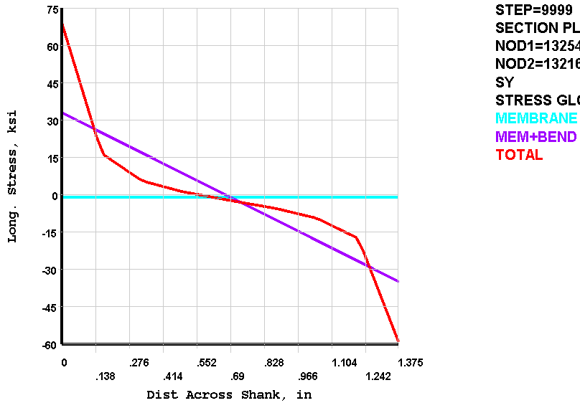
Fig. 4.2-11 Type 2 Section Stress Profile, Metallic Bushing

** MEMBRANE PLUS BENDING ** I=INSIDE C=CENTER O=OUTSIDE
SX SY SZ SXY SYZ SXZ
I 0.2632E+05 0.3294E+05 0.1584E+05 0.1286E+05 -337.0 -32.61
C 2301. -923.6 655.2 0.1107E+05 -10.89 -68.57
O -0.2171E+05 -0.3478E+05 -0.1453E+05 9285. 315.3 -104.5
S1 S2 S3 SINT SEQV
I 0.4291E+05 0.1640E+05 0.1578E+05 0.2713E+05 0.2683E+05
C 0.1188E+05 655.0 -0.1050E+05 0.2238E+05 0.1938E+05
O -0.1452E+05 -0.1690E+05 -0.3961E+05 0.2509E+05 0.2399E+05

** TOTAL ** I=INSIDE C=CENTER O=OUTSIDE
SX SY SZ SXY SYZ SXZ
I 0.4016E+05 0.6896E+05 0.2870E+05 0.2613E+05 -992.3 -1087.
C 690.7 -2303. 219.3 9920. -16.71 38.51
O -0.2834E+05 -0.5885E+05 -0.2332E+05 0.1995E+05 882.0 -1187.
S1 S2 S3 SINT SEQV TEMP
I 0.8443E+05 0.2871E+05 0.2468E+05 0.5976E+05 0.5785E+05 0.000
C 9226. 219.4 -0.1084E+05 0.2006E+05 0.1741E+05
O -0.1839E+05 -0.2338E+05 -0.6874E+05 0.5036E+05 0.4806E+05 0.000

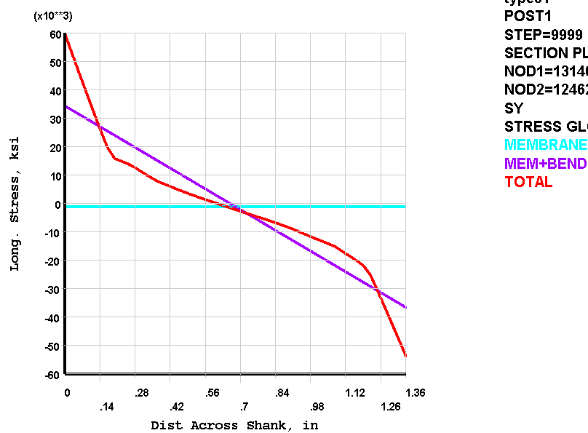
Fig. 4.2-12 Type 2a Section Stress Profile, Metallic Bushing

** MEMBRANE PLUS BENDING ** I=INSIDE C=CENTER O=OUTSIDE
SX SY SZ SXY SYZ SXZ
I 0.2494E+05 0.3430E+05 0.1689E+05 3258. 799.6 1310.
C 4517. -1151. 1488. 1346. 187.1 613.0
O -0.1590E+05 -0.3660E+05 -0.1392E+05 -566.5 -425.4 -83.92
S1 S2 S3 SINT SEQV
I 0.3539E+05 0.2405E+05 0.1668E+05 0.1871E+05 0.1633E+05
C 4938. 1370. -1455. 6394. 5550.
O -0.1391E+05 -0.1589E+05 -0.3662E+05 0.2272E+05 0.2179E+05

** TOTAL ** I=INSIDE C=CENTER O=OUTSIDE
SX SY SZ SXY SYZ SXZ
I 0.3710E+05 0.5968E+05 0.2774E+05 6984. 1081. 1822.
C 3307. -2161. 879.0 -183.4 66.68 506.1
O -0.2153E+05 -0.5378E+05 -0.2247E+05 437.9 -78.75 -46.18
S1 S2 S3 SINT SEQV TEMP
I 0.6174E+05 0.3539E+05 0.2740E+05 0.3434E+05 0.3112E+05 0.000
C 3413. 781.2 -2170. 5583. 4838.
O -0.2153E+05 -0.2248E+05 -0.5378E+05 0.3226E+05 0.3179E+05 0.000
Fig. 4.2-13 ASME Code Base Thread Stress Intensification Factor (NB-3232.3 (c))
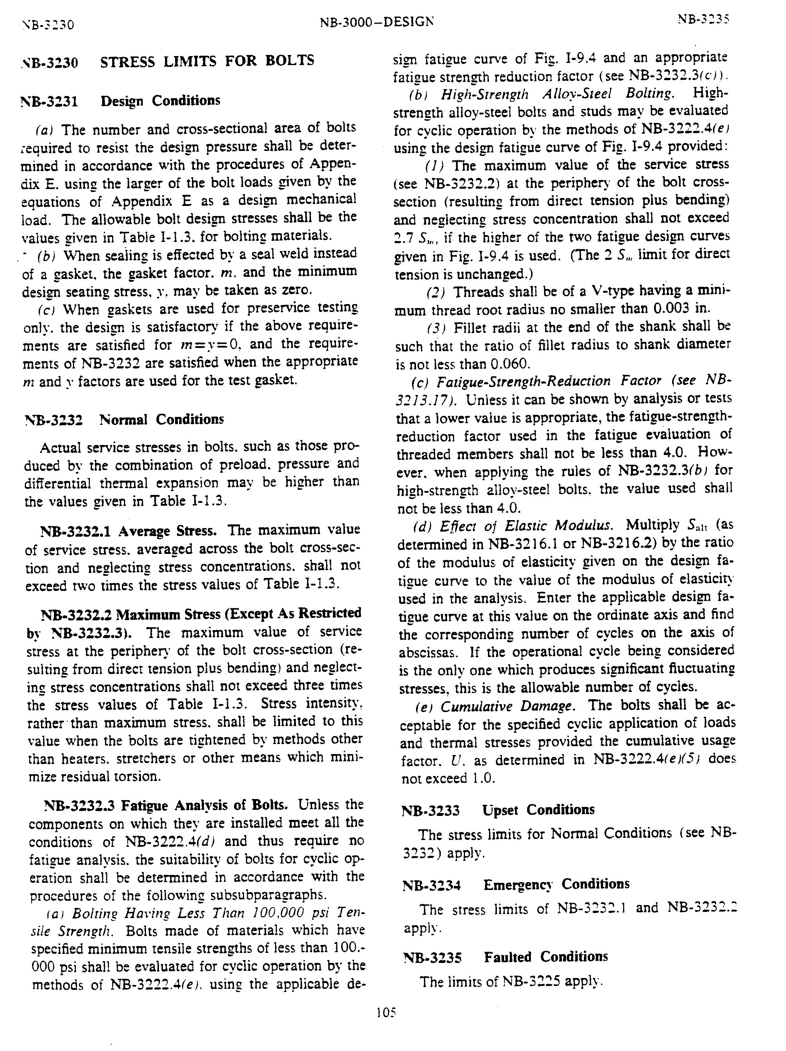
Fig. 4.2-14 Fatigue Data for A286 (N. Suzuki) & Proposed NCSX Design-Basis Fatigue Curve
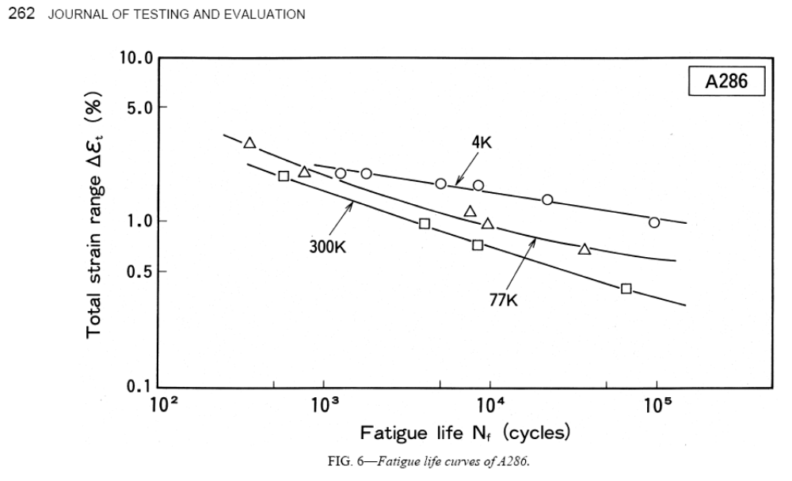
Notes:
1. Suzuki reports an elastic modulus of 223 GPa for A286 at 77K.
2. Total Stress Range = Elastic Modulus x Total Strain Range
3. NCSX Structural Design Criteria requires reducing test data by a factor of 2 to obtain a design-basis fatigue curve.
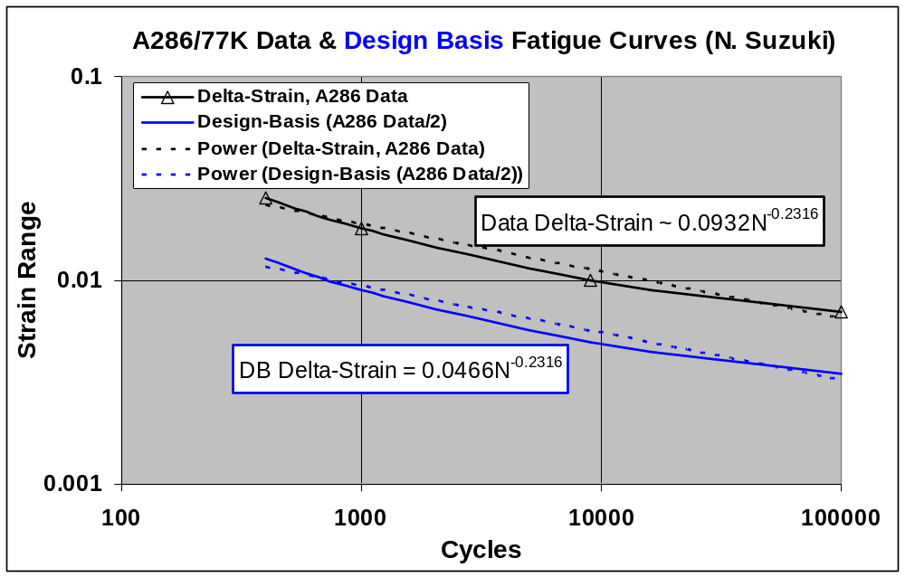

Fig. 4.2-15 Allowable Number of Shear Load Cycles (N) v. Bolt Shear Load
for each of the (5) Bolted Joint Configurations
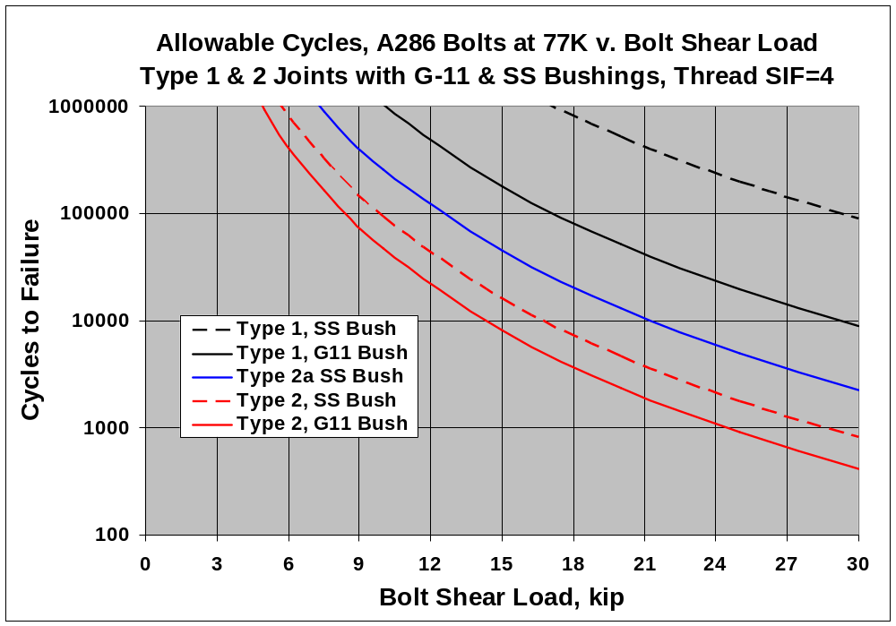
Assumptions:
1. Stresses scale with applied bolt shear load.
2. Stress Intensification Factor of 4.0 applicable to bolt threads.
3. Cycles to Failure obtained from Design-Basis fatigue curve-fit and FE model stresses.

4.3 Stresses in the Revised Type-1 & Type-2 Bolted Joints (circa July 2007)

The recent release of the final reference Type 1 & Type 2 bolted joint design details (UT-Battelle ORNL drawing SE 140-190 Rev 2, parts shown in Fig. 4.3-1) indicates one minor which necessitates a re-analysis of these mechanical fasteners. The shims have a clearance hole of 1.5" diameter. (They used to be a tight-fit to the bolt). The analysis methodology follows the approach presented in section 4.2. Even the models are carried over from the section 4.2 analyses, with this simple shim hole change (see Figs. 4.3-2 & 4.3-3).

Fig. 4.3-4 shows a stress contour plot of the Type 1 bolt subjected to a 20 kip shear load. The contours correspond to the stress range (Load Step 2 minus Load Step 1) and therefore reflect the stress range from the shear load only. Paths P1 and P2 define the sections through the highest thread stress (2" from the ends of the bolt). Although the plot shows the 1st principal stress, we must be mindful of the 3rd principal stress which would be "tensile" if the shear load sign was applied as a negative value.

Table 4.3-1 lists the section stress range from this 20 kip shear load across the P2 and P3 bolt sections. Recall from section 4.2 that the Total bolt stress range is defined by the following equation with an adjustment proposed here to include ∆S3 also:

∆S_{tot} = (k_{thread})(∆S1) + PEAK or (k_{thread})(∆S3) + PEAK

Similar results are shown in Fig. 4.3-5 and Table 4.3-2 for the Type 2 joint with the following exception. There is only one critical bolt section which occurs at the surface of the tapped hole.

Table 4.3-3 lists the numerical values associated with this equation and the Total Intensified Stress Range. Keep in mind that these values are based on a 20 kip unit shear load and can come from ∆S1 or ∆S3.

Table 4.3-3 Total Intensified Joint Fastener Stress from 20 kip Shear Load Range
Joint Type | Type 1 | Type 2
Un-Intensified Stress Range, ksi | -35.4 | -50.5
Thread Stress Intensification Factor | 4 | 4
Peak Stress Range, ksi | -1.1 | -40.0
Total Intensified Stress Range, ksi | 143 | 242

These revised total intensified stress values are used in a spread sheet along with A286 fatigue data to create the design-basis shear load fatigue curve shown in Fig. 4.3-6. Focusing on the project's 100000 cycle design life, we see that the Type 1 joint shear loads should not exceed ~15 kip, while the Type 2 joint shear loads should not exceed ~9 kip. While the clearance hole in the shim has almost no impact on the Type 2 joint, it results in a slight reduction in the shear capacity of the type 1 joint.
Fig. 4.3-1 July 2007 Joint Designs, Type 1 (top) & Type 2 (bottom), courtesy D. Williamson
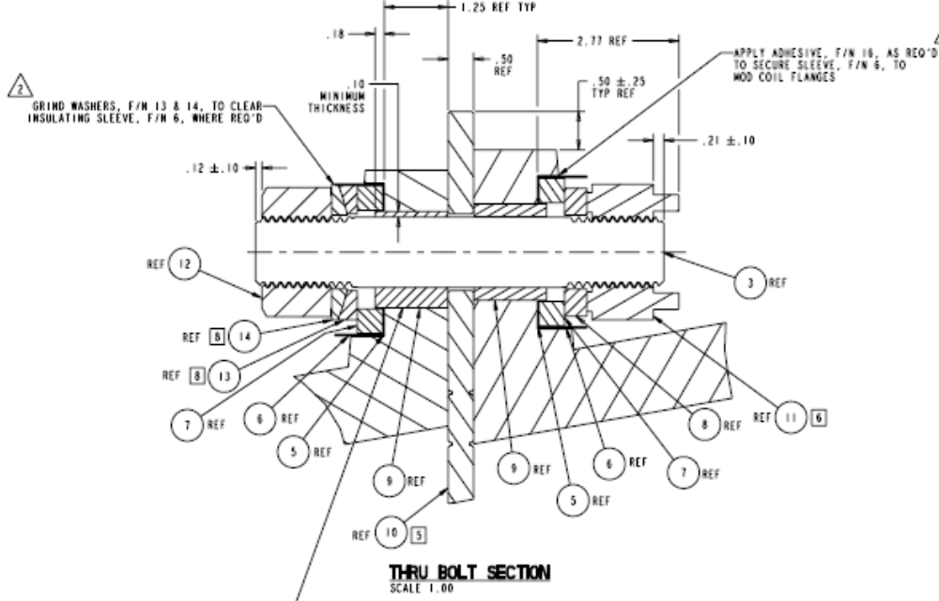
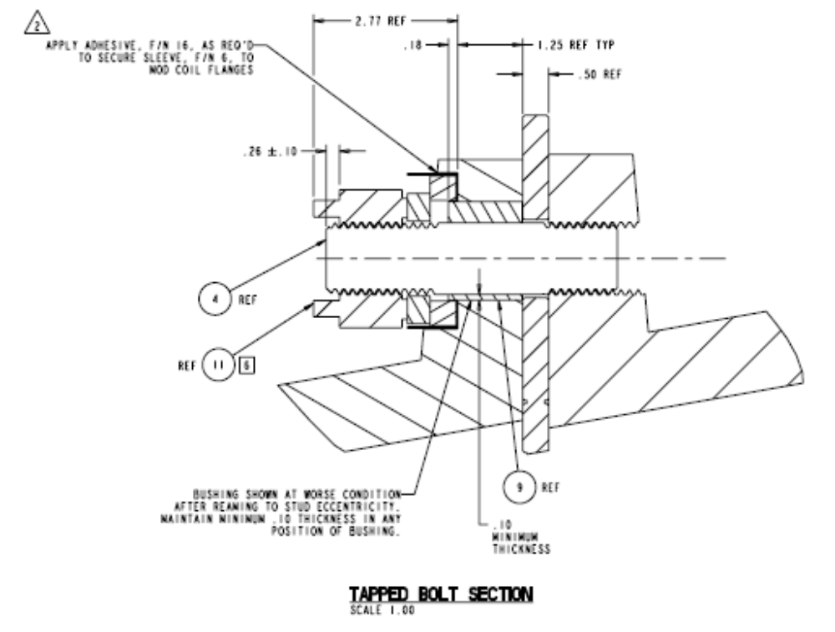
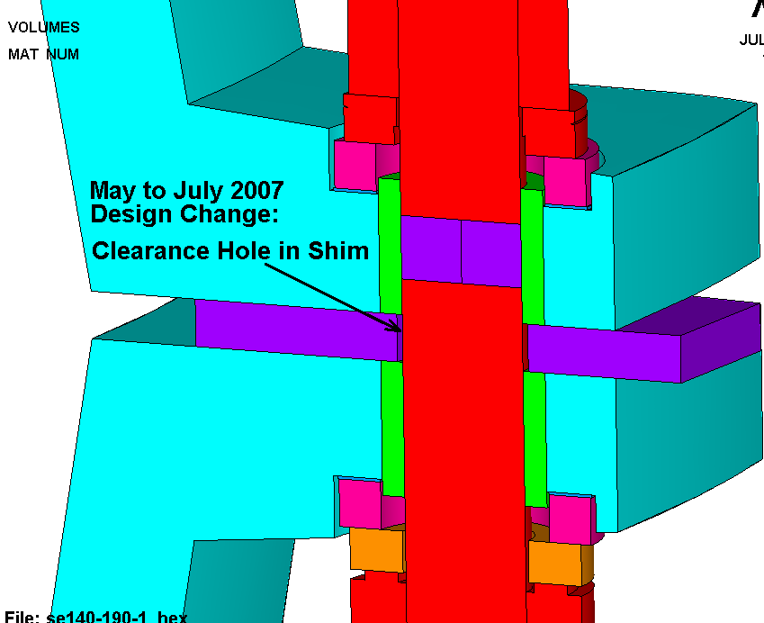
Fig. 4.3-2 ANSYS Model, Type 1 Bolted Connection

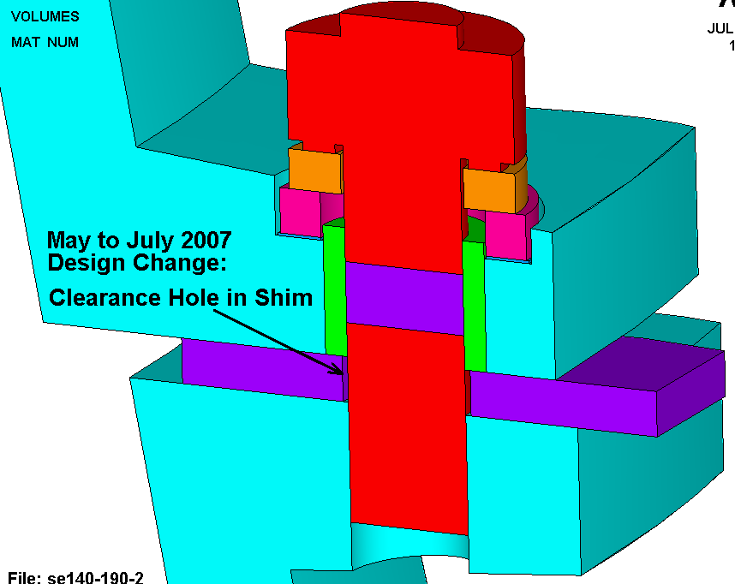
Fig. 4.3-3 ANSYS Model, Type 2 Bolted Connection

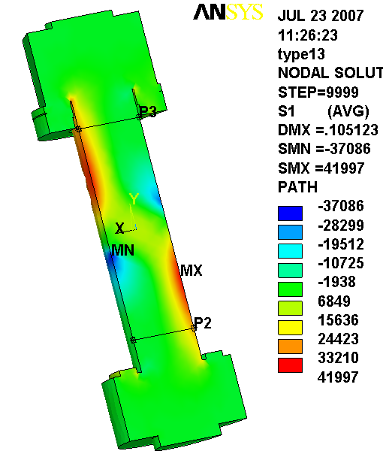
Fig. 4.3-4 1st Principal Stress Range in Type 1 Bolt from 20 kip Shear Load

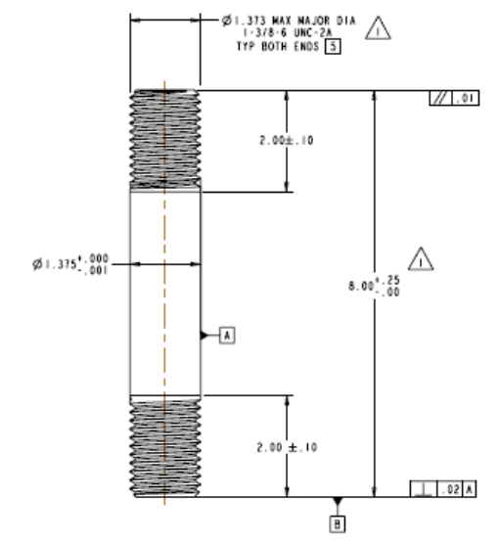
Note: Sections taken 2" from bolt ends (per SE 140-191 Rev1)

Table 4.3-1 Type 1 Section Stress Range from 20 kip Shear Load, G-11 Bushing

Linearized (Membrane + Bending) Stress Across Section P2

** MEMBRANE PLUS BENDING ** I=INSIDE C=CENTER O=OUTSIDE
SX SY SZ SXY SYZ SXZ
I 4.203 -0.3430E+05 -572.2 -2085. 7.300 -3.512
C -55.31 -2521. 18.66 -2314. 1.576 -1.693
O -114.8 0.2926E+05 609.5 -2542. -4.148 0.1249
S1 S2 S3 SINT SEQV
I 130.5 -572.2 -0.3443E+05 0.3456E+05 0.3421E+05
C 1334. 18.65 -3910. 5243. 4725.
O 0.2948E+05 609.5 -333.2 0.2981E+05 0.2935E+05

** PEAK ** I=INSIDE C=CENTER O=OUTSIDE
SX SY SZ SXY SYZ SXZ
I 7.727 718.6 252.2 2069. -6.175 -2.994
C -59.75 -254.8 -20.80 -1297. 8.614 -1.127
O 101.7 394.3 -169.8 2501. -25.14 -0.9168
S1 S2 S3 SINT SEQV
I 2462. 252.1 -1736. 4198. 3637.
C 1144. -20.82 -1458. 2602. 2257.
O 2754. -169.8 -2258. 5011. 4360.

Linearized (Membrane + Bending) Stress Across Section P3

SX SY SZ SXY SYZ SXZ
I -19.80 0.3047E+05 708.5 -1836. 10.32 0.1745
C -31.87 -2450. -88.57 -1628. 2.318 -1.448
O -43.95 -0.3537E+05 -885.7 -1420. -5.681 -3.070
S1 S2 S3 SINT SEQV
I 0.3058E+05 708.5 -130.0 0.3071E+05 0.3030E+05
C 787.3 -88.57 -3269. 4056. 3697.
O 13.09 -885.7 -0.3543E+05 0.3544E+05 0.3500E+05

** PEAK ** I=INSIDE C=CENTER O=OUTSIDE
SX SY SZ SXY SYZ SXZ
I -6.206 354.1 -238.3 1828. -11.85 10.73
C -48.88 -225.4 -50.34 -1074. -5.461 11.61
O 67.58 603.5 419.8 1406. 13.68 17.46
S1 S2 S3 SINT SEQV
I 2010. -238.1 -1663. 3673. 3208.
C 940.8 -50.48 -1215. 2156. 1869.
O 1768. 419.5 -1096. 2864. 2481.
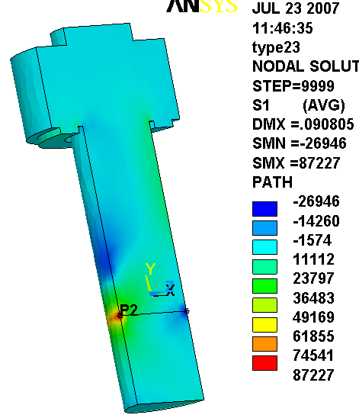
Fig. 4.3-5 1st Principal Stress Range in Type 2 Bolt from 20 kip Shear Load

Note: Sections taken at edge of hole (also max stress location) since threads are certain to be there.
Table 4.3-2 Type 2 Section Stress Range from 20 kip Shear Load, G-11 Bushing

Linearized (Membrane + Bending) Stress Across Section P2

** MEMBRANE PLUS BENDING ** I=INSIDE C=CENTER O=OUTSIDE
SX SY SZ SXY SYZ SXZ
I -0.2595E+05 -0.4633E+05 -0.1892E+05 0.1013E+05 824.6 -171.2
C 2114. -2644. 105.2 0.1075E+05 72.58 -67.66
O 0.3017E+05 0.4105E+05 0.1913E+05 0.1136E+05 -679.4 35.87
S1 S2 S3 SINT SEQV
I -0.1889E+05 -0.2178E+05 -0.5054E+05 0.3165E+05 0.3031E+05
C 0.1074E+05 106.1 -0.1127E+05 0.2201E+05 0.1907E+05
O 0.4821E+05 0.2306E+05 0.1908E+05 0.2913E+05 0.2736E+05

** PEAK ** I=INSIDE C=CENTER O=OUTSIDE
SX SY SZ SXY SYZ SXZ
I -0.1089E+05 -0.3404E+05 -0.1273E+05 0.1285E+05 2072. -1305.
C -892.1 -88.25 -107.5 -1794. -95.14 108.6
O 0.1352E+05 0.3147E+05 0.1203E+05 0.1388E+05 -998.8 -930.4
S1 S2 S3 SINT SEQV
I -5161. -0.1253E+05 -0.3997E+05 0.3481E+05 0.3177E+05
C 1362. -121.0 -2329. 3692. 3217.
O 0.3908E+05 0.1198E+05 5952. 0.3313E+05 0.3057E+05
Fig. 4.3-6 Allowable Number of Shear Load Cycles (N) v. Bolt Shear Load
circa July 2007 Bolted Joint Configurations
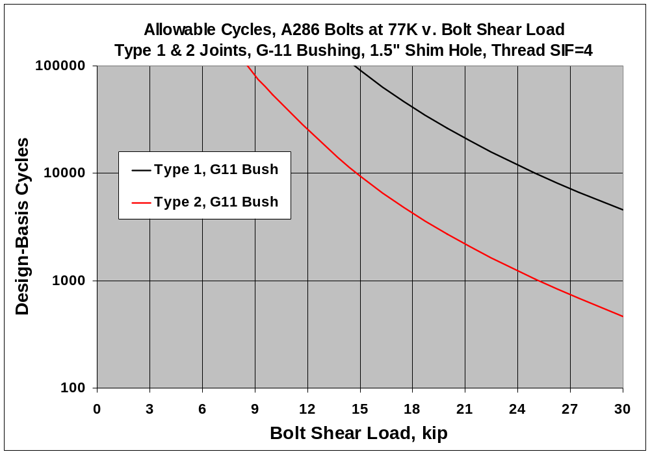

Assumptions:
1. Stresses scale with applied bolt shear load.
2. Stress Intensification Factor of 4.0 applicable to bolt threads.
3. Design-Basis Cycles obtained from Design-Basis fatigue curve-fit and FE model stresses.

ANSYS Release 10.0A1, UP20060105, WINDOWS x64, ANSYS, Inc., Canonsburg, PA.

