FINAL REPORT

NCSX CRYOSYSTEM
DESIGN AND ANALYSIS

June 24, 2008
Bagley Associates
7 Bagley Avenue
Lowell, MA 01851

- BACKGROUND

The National Compact Stellarator Experiment (NCSX) construction project was begun in April, 2003, at the Princeton Plasma Physics Laboratory (PPPL). The design of the magnet systems for the stellarator utilizes inertially cooled copper magnet coils operating at a temperature of approximately 80 Kelvin. This design approach reduces the electrical resistance of the magnet coils to approximately 20 percent of the room temperature value, thus lowering the power systems requirements and allowing higher field pulsed operation. This design approach has proven to be effective in several previously constructed fusion research devices, including the Alcator series of tokomak reactors, as well as in a number of other high field pulsed magnet applications.

Some of the NCSX magnet coils (the MC, or modular coils) are wound on and continuously supported by massive stainless steel structures. Other coils (the TF, or toroidal field coils and PF, or poloidal field coils) are structurally self – supporting, with the net loads and moments on each coil being carried by the coil itself to discrete supports. All magnet structural supports, including the MC support structure are designed to operate at cryogenic temperatures (80 K), The vacuum vessel, which is located inside the MC structure, is intended to operate near room temperature, and to experience temperatures as high as 350 C for bake out. The cold structures and coils are thermally insulated on the outer surfaces by an external cryostat which serves two purposes. The first is thermal isolation from the surrounding room temperature environment, and the second is to contain the cold dry nitrogen gas atmosphere surrounding the structure and coils. The inner surface of the cold mass at the interface with the vacuum vessel is thermally insulated with a silica aerogel insulation system to minimize the heat leak from the warm vacuum vessel to the cold structure and coils.

The NCSX cryosystem includes all the liquid and gaseous nitrogen systems which are necessary to cool the cold mass safely and efficiently from room temperature to the operating temperature and to maintain that temperature during operation. The cryosystem also is used to recool the cold mass between magnet pulses. In addition, the cryosystem includes the gaseous nitrogen system which provides the cold nitrogen atmosphere inside the cryostat.

During the course of the construction, the U. S. Department of Energy held a number of reviews of the project. The latest of these reviews was held in April, 2008. In part, the review panel found that the “cryogenic system is at pre-conceptual design level and requires further development to obtain a reliable cost and schedule estimate”. The panel issued a recommendation that the detailed design of the cryogenic system be advanced to identify any required changes to core components in time to prevent schedule delays. They further recommended that the cryogenic system be included in overall system integration and be evaluated as a part of a comprehensive review of cryostat and core region.

In order to begin to address these issues, PPPL held a workshop / peer review of the NCSX cryogenic systems two weeks later, on April 23, 2008. This review generally supported the findings and recommendations of the earlier DOE review, particularly with respect to the need to develop an integrated design with supporting evaluation.

Following the April 23 review, PPPL began an intensive effort to acquire the necessary resources to do the design and analysis of the NCSX cryosystem, with the goal of advancing the design to the PDR stage by August, 2008. As a part of this effort, PPPL negotiated a contract with Bagley Associates of Lowell, MA, for the Engineering Design and Analysis of the NCSX Cryosystems. This contract was signed on May 14, 2008, and work began immediately. Bagley Associates staff members have extensive background in the design, analysis, construction, and operation of large cryogenic magnet systems. These magnet systems include the Alcator series of three tokomak reactors, large pulsed cryocooled copper magnets for high energy physics experiments, and large superconducting magnets, including the ITER central solenoid model coil inner module.

Recognizing the very tight schedule called for in the contract, Bagley began a two pronged approach to the task. Work was begun to analyze the existing design and supporting analyses in order to determine whether that design could be advanced to the point where success could be assured. In parallel, Bagley began the development of alternatives to the existing design with the goal of producing a design concept which could be shown by engineering analysis to meet the performance requirements with a very high degree of certainty.

Unfortunately, on May 22, 2008, DOE announced that the NCSX project would be stopped. On June 2, 2008, PPPL issued a Stop Work Order to Bagley Associates, with later authorization to complete this Final Report. This report summarizes the work performed by Bagley during the nineteen days that the contract was active.

- APPROACH

The approach taken for the cryosystem design included the self - imposed requirement that performance be assured by design and supporting analyses. Prototype testing would be done to confirm or benchmark analysis results; however, prototype testing alone was not considered to be a substitute for analysis. The performance of complex systems cannot be guaranteed by the performance of simple prototypes in tests.

It was recognized that much of the hardware has been fabricated, and that significant modification of that hardware could be very difficult. For example, the MC and MC structures are near completion. On the other hand, the cryostat design has not yet been finalized, and we had planned to work with the designers of the cryostat to influence that design if it appeared to be appropriate. This effort had just begun, and the details are discussed below.

There are several interfaces with other NCSX systems which must be considered and integrated into the design. These include the external cryostat, which provides both thermal insulation and gas barrier. Other interfaces include the vacuum vessel insulation system, the machine support system, the electromagnetic systems with their requirements on eddy currents, the diagnostic access, and the instrumentation and control systems.

The cryostat was planned as a glass reinforced polymer structure with foam insulation. The heat leak through the cryostat must be considered and the design of the cryogenic systems must account for and deal with this heat leak. Earlier estimates of the heat load through the cryostat were based on the published data for the foam insulation which was being considered (NCSX Cryostat WBS171 Preliminary Design Review, April 22, 2005); however, it appears that no detailed thermal analysis of the cryostat had been done, and it is likely that the early estimates of heat load represented a lower bound on the actual value.

Similarly, the heat load from the vacuum vessel was estimated by using the conductivity of the silica aerogel insulation. Inasmuch as the insulation thickness varies with toroidal and poloidal location, it may be important to consider the effect of this varying heat load on the temperature distribution, thermal deformation, and resultant stress distribution in the MC structures, particularly during high temperature bake out of the vacuum vessel.

- EVALUATION OF EXISTING DESIGN

There was no comprehensive NCSX design description document available which fully described the existing cryosystems design and results of the supporting analyses. The information which was made available consisted of design description documents and review presentations dated variously 2003, 2005, and 2008. In addition, a zero – dimensional Excel spreadsheet and a two dimensional Ansys calculation of cool down of the MC coils and structure done by NCSX personnel were made available. No calculations of cooling of the remainder of the cold mass were made available; however, the same approach as that taken with the MC system would likely have been employed.

The general approach taken for cooling down involved supply of controlled temperature nitrogen gas to the coil cooling circuits combined with forced convection cooling of the structure using controlled temperature nitrogen gas. We discovered that the analysis which was presented in the Excel spread sheet (see Appendix a) contained two somewhat offsetting but significant errors in the calculation of the time dependence of the structure and coil temperature; however, because the temperature was taken down in small steps, the effect on overall time – temperature behavior was not large enough to change the final conclusion that the design approach could be made to work. The results of the two dimensional Ansys calculation supported this conclusion. No calculations of flow rates or resultant pressure drops were available. No drawings, sketches, or descriptions of the gas supply and circulating systems were available, with the exception of a one line drawing of a forced convection gaseous nitrogen loop which was connected to the cryostat at unspecified locations and which was intended to assist in cooling the cold mass. This drawing was supplied at the April 23, 2008 review. No external heat load (either vacuum vessel or cryostat) was included in either of these analyses.

The existing design of the cryosystems includes a forced convection cold nitrogen gas loop. The requirements for the performance of this loop were not presented; however, NCSX personnel suggested that calculations indicated that the flow rate requirements could exceed 10,000 CFM. This would require ductwork of significant cross section which could impede diagnostic access.

Based upon review of the PPPL calculations referenced above, we believe that this approach could be made to work; however, this has not yet been shown to be the case, and a significant analysis effort would be required to show with a high degree of certainty that this approach would work and would not result in excessive deformations or stresses in the structural components. A simple spread sheet calculation showing the heat transfer from the structure to the flowing cold nitrogen gas is included in Appendix b. This spread sheet uses standard correlations for forced convection heat transfer in geometry similar to the external annular space between the NCSX device and the cryostat, and the resultant temperature drops indicate that it might be possible to use this approach to cool the NCSX. The actual geometry is much more complex, and numerical FEA calculations would be required to confirm that this approach would work.

We do note that the present cool down approach requires two controlled temperature forced convection cold gas loops, one a high volume flow rate system operating at a slight positive pressure and flowing through the cryostat, and the other a higher pressure (several Bar) system flowing through the coil cooling passages. Note that these cooling passages are also used to recool the coils between pulses and that they carry liquid nitrogen during that phase of operation.

Once operating temperature is reached, the coil cooling system is switched to sub cooled pressurized liquid nitrogen for the recool of coils between pulses. The low pressure cryostat cooling flow would be maintained at a rate adequate to remove the external heat load entering through the cryostat. The flow rate requirement of this gas loop depends on the allowable temperature rise of internal components above the inlet temperature. It appears that the flow rate required can be reasonably achieved (Appendix b).

The April 23, 2008 review participants noted that the control of the flow distribution and resultant heat transfer within the cryostat had not been described nor analyzed. There was concern expressed about assuring that excessive temperature differences and attendant excessive thermal deformation and stress did not occur during cool down of the structure. We had planned to perform a preliminary axisymmetric gas flow and heat transfer analysis utilizing straw man supply and return ducts at the top and bottom center of the cryostat, and the tools for performing this analysis were being readied. One area of concern was the region near the axis of the machine, where the clearance between components is small and there was the possibility of inadequate flow. In order to perform these analyses, it was necessary for us to have access to the solid models of the NCSX device. Obtaining these models proved to be difficult, and we worked with PPPL personnel for over two weeks to gain access to the engineering database on the PPPL computer system. As of June 2, 2008, we still did not have access to that database. As a result no detailed analysis of the existing forced convection loop within the cryostat was possible.

- ALTERNATE DESIGN CONCEPT

The existing cryosystem design made use of a pressurized sub cooled liquid nitrogen loop to recool the MC, TF, and PF coils between pulses. This design provides well defined and easily calculable flow rates, pressure drops, and heat transfer coefficients, provided that the heat flux and fluid temperatures remain below the critical values so that boiling of the liquid does not occur. Unfortunately, these quantities would greatly exceed the critical values if initial cool down of the coils from room temperature were attempted using this system. The resulting thermal stresses could easily exceed the allowable values, and the flow distribution in the multiple parallel channels would be unpredictable during the cool down. We decided retain the sub cooled liquid loop and to make use of it for the cool down of the MC structure, which makes up approximately half of the cold mass. This approach is similar to that used for temperature control of the vacuum vessel. Tracer tubes would be added to the NCSX MC structure to provide a means of heat removal, both during the cool down from room temperature and during operation. The fluid tube would be thermally connected to the structure at well defined discrete points with an engineered thermal resistance to control the rate of heat transfer. The cooling rate is determined by the thermal resistance and the temperature difference between the structure and the fluid (which is maintained at approximately 80 K in this case). A model of one such connection is shown below in Figure 1. The tube carrying the cryogen is connected to the structure by means of a stud which is welded to the structure by an electrical discharge stud welding gun.

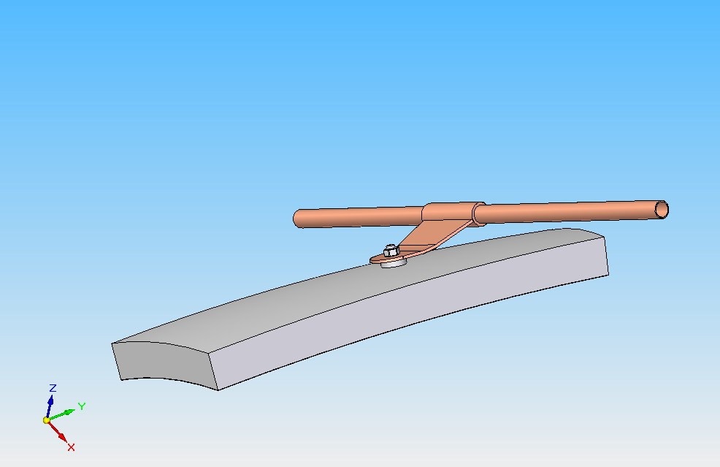
Figure 1
The length of the copper clip which connects the tube to the stud is designed to provide the appropriate thermal resistance to control the heat removal rate at the connection point. The width of the clip is designed to control the heat flux at the liquid nitrogen interface to avoid boiling at the surface of the tube in that region. This approach provides a well defined rate of heat removal and thus limits the resulting thermal deformation and thermal stress. Preliminary calculations indicate that the connection points should be spaced approximately 30 centimeters apart. The tube would attach to the structure at up to 50 points along its length, with the tube being bent in a serpentine manner to allow for thermal contraction of the tube during initial cool down. There would a number of cooling paths in parallel, the final number and routing to be determined during the detailed design phase. The uniformity of flow rate and resultant uniformity of the cooling rate of the structure is assured by the design, which limits heat flux at the fluid interface and therefore assures single phase flow and well defined pressure drop in the cooling tube.

Hand calculations (Appendix c) indicate that the liquid flow can be established and maintained without difficulty. In order to confirm this calculation, a small prototype test was done, using a block of stainless steel equivalent to a 30 centimeter square of the MC structure and a thermal attachment as shown in Figure 1. The tube was supplied with sub cooled liquid (80 Kelvin) at 5 Bar supply pressure. The temperature of the attachment lug at a point near the tube was measured to determine whether the forced convection heat transfer was appropriate to liquid cooling (as opposed to film boiling at the tube wall, for example). The results are plotted in Figure 2.

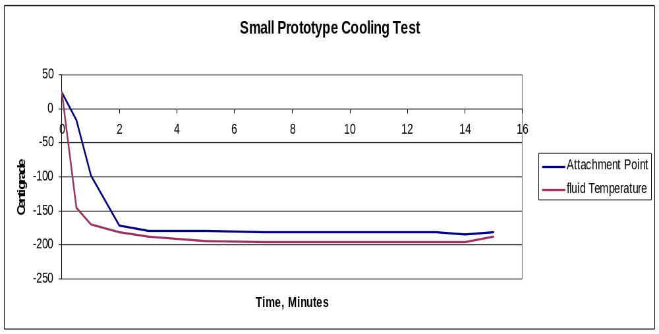
Figure 2

The test was run for fifteen minutes, and it is clear that good heat transfer was established within two minutes. Note that the curve labeled Attachment Point represents the temperature of the copper lug near the cooling tube. The stainless steel temperature follows much more slowly, and the temperature of the stainless steel near the stud decreased only about 20 degrees during this short test. The calculated time dependence of this temperature is shown in Figure 3. A larger scale prototype employing multiple thermal connection points was being prepared for testing. This effort had not been completed at the time the stop work order was issued, so no results are available.

A finite element transient thermal analysis and corresponding stress analysis of one such thermal connection was done using the Algor computer code. The model was a rectangular stainless steel plate with an attachment modeled to represent the thermal resistance of a typical connection like that in Figure 1. A surface heat load equivalent to that expected from the vacuum vessel at bake out temperature was applied to the inner surface of the structure. The temperature of the stainless steel structure at the stud attachment and that at the corner of the 30 centimeter square section of MC structure were probed and the time dependence of those temperatures is shown in the graph Figure 2.

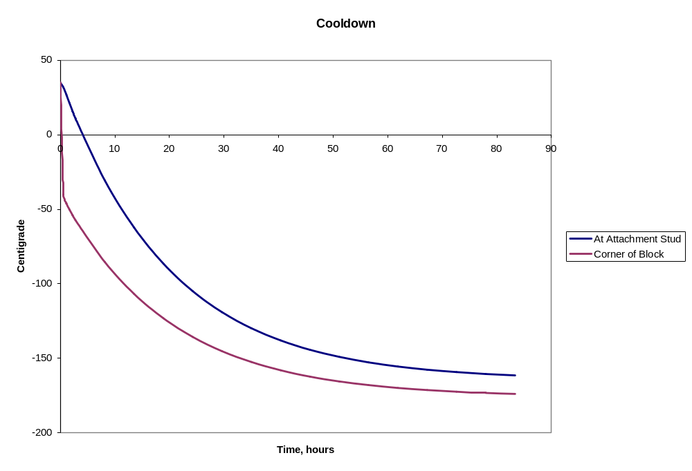
Figure 2
Thermal stress analysis indicates a maximumVon Mises stress of 154 MPa at the stud connection immediately after cooling is begun. This stress is highly localized and the stress decreases with time as the bulk of the structure cools down.

Work had begun to qualify the tools for full three dimensional analysis of the cool down transient temperature and stress distributions. A representation of this work is included in this document as Appendix e. This shows the thermal stress distribution resulting from only a few attachment points for the cooling tubes. The solid model was an early version which had been used for seismic calculations, and the purpose of this particular calculation was to qualify the tools and methods used to model the NCSX cool down. When we finally gained access to the NCSX engineering database, we planned to import the current model and then to model the actual thermal attachments (of order one hundred per 1/3 of the device. We would then calculate the effect of the cool down on deformations and stresses. In addition, we could include natural convection to simulate the complete cryosystems effect on temperatures, deformations, and resultant stresses. In addition to the calculation in Appendix e, we have included as an attachment a file showing the temperature evolution with time for this simplified model. (See attachment to cover email)

As the structured is cooled down by conduction to the liquid loops, the MC coils are cooled by conduction at the winding interfaces. This interface has a poorly defined thermal resistivity; however, the maximum thermal resistivity can be calculated as gas conduction through a stagnant layer of nitrogen gas in a gap between the coil and the structure. This gap, d_{gap}, will be less than one millimeter, and the time constant for cooling of the coil by conduction through the gap, assuming that the gap is uniform over the entire interface area , A_{contact}, is given by

T = M_{coil}(kg) c_{p}(J/kg K) d_{gap}(m) / A_{contact}(m^2) k_{nitrogen}(W/m K)

This time constant is less than 2 hours for the MC, indicating that the coils will be cooled down adequately by conduction to the MC structure, lagging by only a few degrees.

The cooling of the remainder of the cold mass will be achieved by natural convection cooling. We have been discussing a modification to the design of the external cryostat panels with the cognizant NCSX personnel. By integrating thin panels of a thermally conductive material (for example, 2 – 3 mm. thick aluminum) on the inner wall of the cryostat, it is possible to cool those panels by conduction to their mounting structure or vertical ribs to which they are bolted, which would be traced with sub cooled pressurized liquid nitrogen lines identical to those used for cool down of the MC structure. No demountable fluid connections to the cryostat panels would be required. Cooling is achieved by conduction at the structural mounting locations along the vertical joints between the cryostat panels. This approach would intercept the heat leaking through the cryostat walls and remove it by conduction toroidally along the panel to the tracing tubes and into the forced liquid convection to the external heat exchanger. In addition, it provides a nearly continuous cold surface to exchange heat with the dry nitrogen gas within the cryostat and thus by natural convection to the reminder of the cold mass within the cryostat. We had begun to do the natural convection heat transfer calculations to confirm the expected performance of this method of cooling. For completeness, a memorandum relating to this method of cooling is included as Appendix d. Please note that this was a work in progress, and that further calculations would be required to support this design.

The cryostat panels are bolted to the support ribs along each edge. The thermally conductive plates extend from each vertical edge almost to the vertical centerline of the cryostat panel. There is then an electrical break at the centerline of each panel, greatly reducing the eddy current effects of the aluminum plates. It will be necessary to confirm the electromagnetic effect of these panels by calculation. It would be possible to slit the plates horizontally if that were necessary to further reduce the electromagnetic effects. No calculations were performed prior to termination of this work.

A small gaseous nitrogen supply would be required to provide slight positive pressure within the cryostat. Gaseous nitrogen would not be used for cooling or required otherwise. Only one major cooling loop is required, supplying sub cooled liquid nitrogen at approximately 10 Bar, with a return pressure of 5 Bar. The two internal manifolds shown in the existing design would remain as presently designed, and there would be two additional manifolds with the first supplying the MC structure tracing, and the other supplying the cryostat panel support tracing. A combination of remotely controlled valves and fixed orifices would be used to control the flow in the four internal loops
.

- INTERIM CONCLUSIONS

We have developed the concept for a simplified method of cool down of the cold mass of NCSX which utilizes the existing coil recool system design components. Two controlled temperature gas loops are eliminated, and the cool down rates are controlled by the engineering design of the thermal conduction elements. This concept does require modification to the MC structure by the addition of a few hundred studs welded in place by means of an electrical discharge stud welding gun. The exact placement of the studs is not critical, and we could easily develop criteria for their placement. In addition, the cryostat design will be required to incorporate thin thermally conductive plates on the inner surfaces, as well as liquid nitrogen tracing of the vertical support ribs for the cryostat panels. The preliminary analyses indicate with a high degree of certainty that this design approach will meet the performance requirements.

- APPENDICES

  - NCSX Gas Cooling embedded Spreadsheet (with original errors)
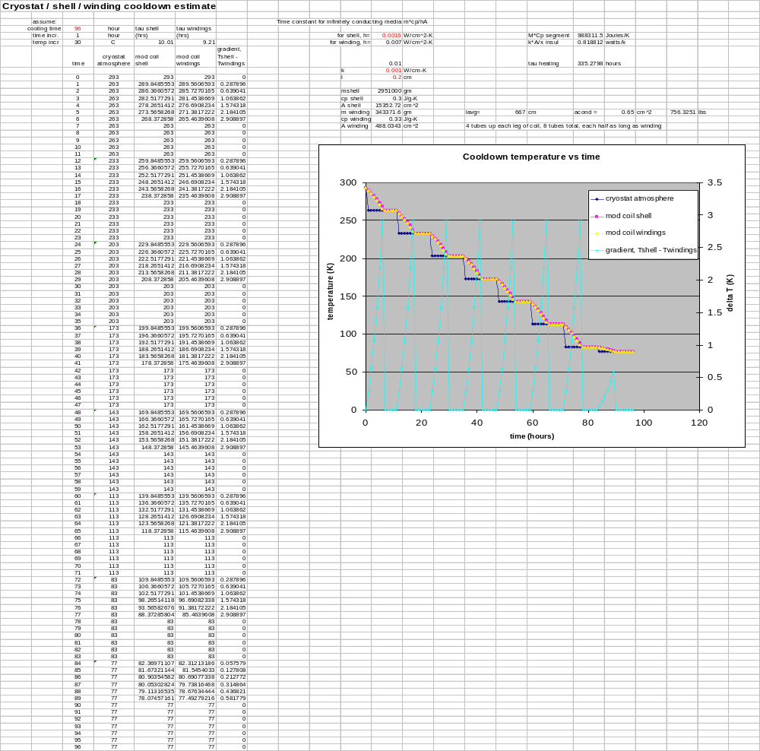
  - Forced Convection embedded Spreadsheet 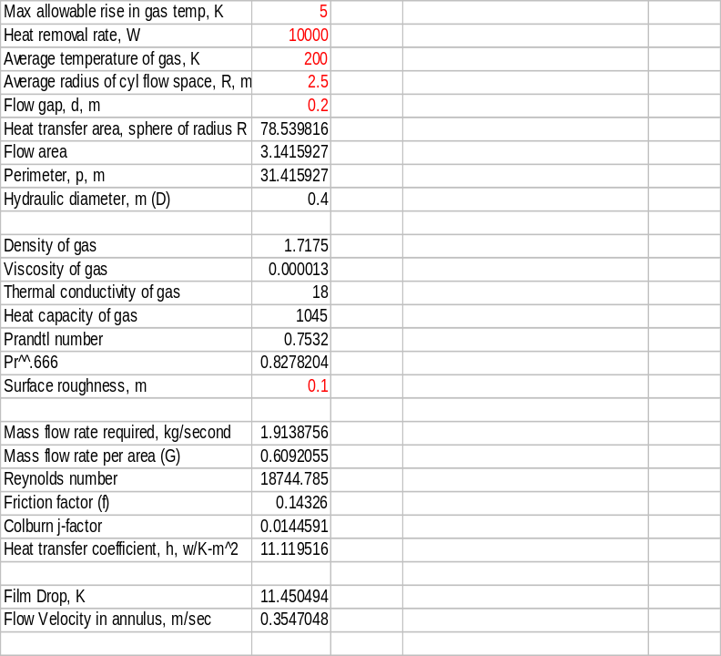

  - Hand Calculation of Liquid Cool Down with Discrete Attachment Points

From: A. Zhukovsky
To: D. Gwinn
Date: May 16, 2008
To: NCSX cooling system file

Cooling of NCSX Modular Coil Structure by a tracer with LN₂ flow connected to the Structure by discrete thermal anchors

Approximate parameters of LN₂ at T_{f}=80K and p=5 atm are:
Density – ρ = 800 km/m³ (795)
Thermal conductivity k = 0.14 W/m-K. (0.1406)
Specific heat – c_{p} = 2000 J/kg-K. (2051)
Absolute viscosity – ν = 141*10⁻⁶ Pa-s. (146)
The parameters from NIST Tables are given in brackets [1].

For a turbulent flow in tubes the heat transfer coefficient h [W/m²-K] is calculated from [2]:

Nu = 0.023*Re^{0.8}*Pr^{0.4}, (1)
h = k/d * Nu, (2)

where Nu = hd/k Nusselt number,
Re = wdρ/ν - Reynolds number,
Pr = c_{p}ν/k - Prandtl number,
d [m] – inner diameter of the tube,
w [m/s] – velocity of the flow in the tube.

For calculations we take: d = 10 mm = 0.01 m and w = 10 m/s (which is a very high velocity for liquid nitrogen) and get Re = 6.66*10⁵, Pr = 1.71. From (1) Nu = 1300, and from (2) h = 18190 W/m²-K.

The difference between temperature of the tube inner wall T_{w} and the nitrogen flow T_{f} is:

ΔT_{w-f} = T_{w} –T_{f} = Q/h-A, (3)

where Q [W] – heat transferred through the tube wall, taken as 10 W,
A = 3.14*d L_{n}, [m²] - heat transfer surface area,
L_{n} [m] – length of the tube, at which the heat is taken from the heat transfer anchor, taken as 0.1 m,
A = 3.14*10⁻³ m².

From (3) ΔT_{w-f} = 10/(18190*3.14*10⁻³) = 0.175 K.

Heating of the nitrogen flow in one discrete place of the heat transfer due to the heat supply is ΔT_{Q} [K]:

ΔT_{Q} = Q/M-c_{p}, (4)

where the mass flow rate is:
M [kg/s] = A_{f} ρ w = 0.785d² ρ w (5)

For w=10 m/s M = 0.785*10⁻⁴*800*10 = 0.63 kg/s and ΔT_{Q} = 10/(0.63*2000) = 0.008 K.

Pressure drop ΔP_{fr} due to a friction in a smooth tube for a turbulent flow is calculated as:

ΔP_{fr} = ς* L/d* ρw²/2 [N/m²], (6)
where L [m] – length of the tube,
ς - coefficient of friction,
at Re<10⁵ ς = 0.316/Re^{0.25}, (7)
at Re>10⁵ ς = 0.0032 + 0.221/Re^{0.273}. (8)

According to (8) and (6) the pressure drop in L=10 m tube with diameter d=0.01 m and velocity of liquid nitrogen w=10 m/s is: at Re=6.66*10⁵ ς=0.0089, but for the tube with industrial roughness we take ς=0.014 and ΔP=0.014* 10/0.01* 800*10/2 = 5.6*10⁵ N/m². This figure doesn’t include additional pressure drops in the curved tubes, local resistances, and pressure drops in the full liquid nitrogen circuit. Additionally we can calculate local pressure drops due outlets and inlets in the inlet and outlet manifolds. The local pressure drop coefficient at the inlet into 10-mm tube is ς_{in} = 0.5 and at the outlet from the tube into the manifold is ς_{out} = 1.0. The pressure drop due to local losses is ς_{l} ρw²/2. The inlet and outlet pressure drops are:

ΔP_{in+out} = (0.5+1.0)*800*10²/2 = 6*10⁴ N/m².

The “full” pressure drop ΔP for 10-m line between inlet and outlet manifolds is
ΔP=ΔP_{fr} + ΔP_{in+out} = 6.2*10⁵ N/m² = 6.12 atm.

The other important part of cryogenic liquid flow heating is ΔT_{fr} [K] due to the inner heat dissipation at transformation of compression forces into the heat due to a friction [3].

ΔT_{fr} = ΔP/ρc_{p} (9)

For 10 m/s flow rate of liquid nitrogen ΔT_{fr} = 6.2*10⁵/(800*2000) = 3.875 K.
Increase of temperature of liquid nitrogen flow in this case is ΔT = ΔT_{Q} + ΔT_{fr} = (0.008*n+3.875) K, where n – amount of heat removal studs connected to 10-m long tube. Take n=50 for 200 mm of the stud pitch. In this case the full ΔT = 0.4 + 3.9 = 4.3 K.

The consideration of the results for cooling by liquid nitrogen flow with velocity of 10 m/s shows that 10-W heating can be removed with a very small temperature wall-to-liquid head and a very small increase of nitrogen temperature due to outer heating. At the same time the pressure drop in the flow is huge and most of the nitrogen heating is connected with a friction work. In the following Table I show that the cooling by the flow with velocity 1 – 2 m/s is much more attractive, providing a low pressure drop and acceptable increase in all temperatures.

Calculations are made for the liquid nitrogen inlet temperature - 80 K, nitrogen pressure – 5 atm, tube diameter - 0.01 m, discrete heat to 0.1 m length of the tube – 10 W, length of the tube 10 m, amount of discrete heating places (studs) to supply heat to the 10-m tube – 50. The pitch between studs is 0.2 m, which leave the tube length between thermal anchors of 0.1 m. This length is very small considering the tube bends between thermal anchors to accommodate differential thermal contractions of the tube and the cooled Structure (and welded studs). The more reasonable heat anchor length is 50 mm = 0.05 m. In this case the distance between thermal anchors increased to 0.15 m and for 1.0 m/s flow velocity ΔT_{w-f} = 2.22 K, which is also acceptable.

Table

W, m/s | M, kg/s | Re 10⁻⁵ | k,  W/m²-K | ΔT_{w-f}, K | ΔP_{fr}, atm | ΔP, atm | ΔT_{fr}, K | nΔT_{Q}, K | ΔT, K
10.0 | 0.63 | 6.66 | 18200 | 0.175 | 5.527 | 6.12 | 3.9 | 0.4 | 4.3
5.0 | 0.315 | 3.33 | 10460 | 0.304 | 1.579 | 1.73 | 0.10 | 0.8 | 0.9
2.0 | 0.126 | 1.332 | 5022 | 0.634 | 0.284 | 0.308 | 0.196 | 2.0 | 2.2
1.0 | 0.063 | 0.666 | 2885 | 1.108 | 0.079 | 0.085 | 0.014 | 4.0 | 4.0

The optimization of cooling tracers can be made only at consideration of the actual design of the Structure cooling. At the minimal pressure of 5 atm in the Structure cooling tracers the nitrogen saturation temperature is T_{s} = 95 K. It means that even twice-longer tracers of 20-m long at 1.0 m/s are acceptable to provide a single-phase flow at the outlet nitrogen temperature of about 88.0 K and pressure drop in the tracer below 0.2 atm. At the same time increasing of the tracer length decreases the amount of parallel tracers, which is very important.

The velocity of transportation of a cryogenic fluid in the pipe, which causes the minimal increase in the temperature of the nitrogen flow, can be determine from [3]:

w = 1.17{Qn/(πdL ςρ[1 + 0.8Σς_{l}/(ςL/d)])}^{0.33} (10)

For Qn = 10*50 = 500 W per one tracer L=10-m long with d= 0.1 m, ς_{l} = 1.5, ς = 0.015 the “optimal” flow velocity, which provide the minimal increase in the nitrogen temperature is 5.7 m/s. The real optimization should consider also the pressure drop in the tracers as well as in connecting corrugated hoses and in manifolds, and amount of parallel tracers and so on. The mass flow also increases proportional with the flow velocity. It means that the liquid nitrogen pump should be more powerful for higher velocities of flow in traces. Simultaneously pressure drops in the line outside of the considered tracers increase, or it would require the bigger diameter of the pipes to keep the same as for the lower velocity pressure drop. It means that the process of optimization of cooling tracers for the Structure will be a complex process with consideration of the full cooling system of NCSX.

References
[1] http://webbook.nist.gov/chemistry/fluid/
[2] Kraussold H., Forschung, 1933, 4, Nu 1, p.39
[3] Filin N.V., Bulanov A. B., Liquid cryogenic system, Mashinostroenie, Leningrad, 1985 (in Russian)

  - Natural Convection Memorandum

From: A. Zhukovsky
To: D. Gwinn
Date: May 28, 2008
Subject: NCSX cryostat vapor cooling heat transfer. Revision 1

It is the revision of [1] with new calculations of the heat transfer to the nitrogen vapor flow cooling the NCSX cryostat wall. I have found the exact recommendations for calculations of the heat transfer coefficient (h) to the turbulent flow of gas in an annulus or in a flat gap at only one wall heating [2].

h = h_{tube} [1 – 0.45/(2.4 + Pr)] (D_{in}/D_{out})^{0.6}, (1)
h_{tube} = Nu_{tube} k/2δ
Nu_{tube} = 0.023Re^{0.8}Pr^{0.4}, (2)

where h_{tube} is the heat transfer coefficient for the round tube for the turbulent flow at 0.5 < Pr < 5.
Temperature of the adiabatic wall (T_{w,ad}) of the cooling passage (wall facing the machine) can be determined from:

ΔT_{(w,ad)} = [5.94(D_{in}/D_{out})² – 22]Pr^{-1.05} Re ^{-0.87} = k(T_{(w,ad)} – T_{f})/(q*2δ) (3)

The flow cross-sectional area and other cryostat and cooling vapor parameters are taken from [1].
A_{ins} = 52 m² - the surface area of the cryostat insulating panels
Q = 5.0 kW – heat leak through the cryostat insulating panels,
k_{ins} = 0.027 W/m-K – thermal conductivity of panels,
δ_{ins} = 16 cm – thickness of insulating panels,
T_{out} = 300 and T_{in} = 80 – outer and inner temperatures of the insulating panels at Q = 5 kW.
For δ = 10 mm = 0.01 m – width of the flow passage,
A_{f} = 0.118 m² - the flow cross sectional area is.

Heat flux through the cryostat panels is
q = Q/A_{ins} = 5000/52 = 96.15 W/m².

The mass flow rate of vapor from the heat exchanger is m = 0.28 kg/s and the cryostat inlet vapor temperature T₁ = 78 K. The approximate outlet temperature of the vapor flow is taken as T₂ = 98 K. The mean parameters of the nitrogen vapor between 78 K and 98 K at pressure of 1.0 atm are [(n₇₈ + n₉₈)/2]:
ρ = 4.064 kg/m³ – density,
v = 0.250 m³/kg – specific volume,
i = 88.81 kJ/kg - enthalpy
k = 0.008615 W/m-K – thermal conductivity,
c_{p} = 1097.6 J/kg-K - specific heat capacity,
ν = 6.1565*10⁻⁶ Pa-s – absolute viscosity,
Pr = 0.804 –Prandtl number.
All the properties for Re, Pr numbers are taken as mean values between values for T₁ and T₂. The flow average temperature is (T₁ + T₂)/2 = T_{av} = 88 K.

The mass flow velocity for 10 mm gap is
wρ = m/A_{f} = 0.28/0.118 = 2.37 kg/s-m².

The flow velocity of vapor is
w = w ρ /ρ = 2.37/4.064 = 0.583 m/s (it is a very low velocity for a gas flow)

The characteristic size (hydraulic diameter for a flow in tubes) for the flow in an annulus or between two parallel plates is 2*δ, when D_{in}/D_{out} = 1.0 (the last one is practically our case at D_{in}/D_{out} = 4980/5000 = 0.996).

Reynolds number for the flow in the gap is
Re = wρ2δ/ν = 2.37*2*0.01*10⁶/6.1565 = 7699.

From (2) the heat transfer coefficient in the round tube is
Nu_{tube} = 0.023*7699^{0.8} 0.804^{0.4} = 27.09
h_{tube} = 27.09*0.008615/0.02 = 11.67 W/m²-K

From (1) the heat transfer coefficient to the heated side of the cryostat wall is
h = 11.67[1 – 0.45/(2.4 + 0.804)] = 11.67*0.86 = 10.04 W/m²-K

From (3) the adiabatic wall temperature is
ΔT_{(w,ad)} = [5.94(D_{in}/D_{out})² – 22]Pr^{-1.05} Re ^{-0.87} = k(T_{(w,ad)} – T_{av})/(q*2δ),
T_{(w,ad)} – T_{f} = 0.008*96.15*0.02/0.008615 = 1.79 K
T_{(w,ad)} = 1.79 + 88 = 89.8 K

The adiabatic wall temperature of the cooling passage is very close to the flow temperature.

The temperature of the inner cryostat wall, cooled by nitrogen vapor flow is
T_{w,av} = Q/h*A + T_{av} = 5000/(10.04*52) + 88 = 9.6 + 88 = 97.6 K.

After several iteration the resulting heat leak for the gap 0.01 m is Q=4669 W at the average inner wall temperature T_{w,av} =94.6 K, outlet flow temperature T₂ = 93.2 K, average flow temperature T_{av} = 85.6 K.

The results of calculations for flow gaps of 0.01 m, 0.02 m, and 0.03 m are given in the Table. The inlet flow temperature is 78 K as well as the mass flow rate 0.28 kg/s for all cases. The Re and Nu_{tube} numbers don’t change for different gaps. I didn’t recalculate the results with parameters of nitrogen corrected according to the change of the average flow temperature. The nitrogen parameters are mean between 78 K and 98 K. The changes in nitrogen parameters are relatively small. The adiabatic wall temperature increased from 89.8 K to 91.6 K and to 93.4 K with increase of the gap from 0.01 m to 0.02 m and 0.03 m, respectively.

Table
Heat transfer and vapor flow parameters for different width of the cooling gap

δ, m | A_{f}, m² | w, m/s | h, W/m²-K | T₂-T₁, K | T_{w,av}, K | ΔT_{(w-f)}, K | Q, W
0.01 | 0.118 | 0.583 | 10.04 | 15.2 | 94.6 | 205.4 | 4670
0.02 | 0.236 | 0.292 | 5.02 | 14.6 | 102.5 | 197.5 | 4485
0.03 | 0.354 | 0.194 | 3.89 | 14.3 | 107 | 193 | 4400

The Table shows that increase of the flow gap decreases the heat leak to the nitrogen flow. The worse the heat transfer to the nitrogen flow is the less heat is supplied to the flow, and the less is the temperature of the cooling nitrogen at the exhaust. It is a paradox result: usually people try to increase heat transfer to a cooling flow. At the same time the temperature of the wall facing the machine is increasing with the size of the gap. It means that the bigger part of the heat is supplied into the machine. The size of the gap can be optimized. It looks that the gap of 2 cm would be reasonable for vapor flow cooling of the cryostat wall.

Reference

[1] A. Zhukovsky, Memo NCSX cryostat vapor cooling heat transfer, May 27,2008.
[2] S.S Kutateladze, Heat transfer and Hydrodynamic Friction, Handbook, Energoatomizdat, Moscow, 1990 (in Russian).

  - Preliminary Three Dimensional Stress Analysis



