NCSX
Design Basis Analysis

Analysis of Stray Magnetic Field on Plasma From
High Permeability Modular Coil Winding Form

NCSX-CALC-82-001-dB

Draft B

14 May 2004

Prepared by:

_______________________________________
Chang H. Jun, PPPL Engineer

I have reviewed this calculation and, to my professional satisfaction, it is properly performed and correct. I concur with analysis methodology and inputs and with the reasonableness of the results and their interpretation.

Reviewed by:

_______________________________________
Art Brooks, PPPL Engineer
Controlled Document
THIS IS AN UNCONTROLLED DOCUMENT ONCE PRINTED.
Check the NCSX Engineering Web prior to use to assure that this document is current.
I. Executive Summary

The purpose of this analysis is to examine the stray magnetic field caused by the magnetization of modular coil winding form (MCWF). The modular coil is sat down on the T section shaped MCWF enveloping plasma like PF coil. These 18 modular coils are very close to the plasma. Therefore, if the MCWF has a magnetic permeability (mu) more than 1.0, the plasma control might be disturbed. The requirement value of mu is less than 1.01 for MCWF. But after welding on MCWF for repair, some parts could have a little higher mu than 1.01. The purpose of this analysis is that this higher mu zone or total higher mu MCWF will affect how much magnetic field on the plasma surface. The analysis is performed with 2-D axi-symmetric Ansys model simplifying the modular coil geometry.
The results show that the B field affection is around 1gauss on the closest plasma surface when only a tip of MCWF has 1.02 of mu. (The plasma is 10cm away from the tip of MCWF.) But, if the whole MCWF has 1.02 of mu, the B field affection is up to 6 gausses on the plasma surface. These results are very conservative one because the high mu value was applied on the whole 18 coils and whole region along the MCWF. More results with various mu values will be obtained by linear proportion of the above results because of linear characteristics of the problem.

II. Assumptions
- The modular coils have simple ring shape, not twisted.
- The model have cylindrical axi-symmetric. It means spherical shape effect is not considered.
- Only a half of one modular coil is modeled with symmetry condition.
- The boundary condition between coils is normal flux condition. It means the whole 18 coils were taken into account with same condition.
- The boundary condition on the plasma side is parallel flux condition. It means there is no flux leakage.

III. Analysis Methodology and Inputs

Software and data files
The model is constructed in Ansys 8.0 and all of the preprocessing and post processing is done within the Ansys environment. The analysis is done with axi-symmetric magnetic solution with Plane13 element (4 nodes rectangular element). A special feature is that this analysis is performed as permanent magnet case to enhance the accuracy of magnetic field generated from high mu material. It will be explained clearly on the Procedure of Analysis part.

Drawings & Documents Referenced
This analysis is referenced the Design Description Modular Coils (WBS 14) to have a size and section shape of MCWF. The document can be reached from the following Web address. http://ncsx.pppl.gov/NCSX_Engineering/Technical_Data/SDDs/sdd_wbs_14_final_A.doc

Material Properties
Magnetic permeability is assumed as linear. The MCWF has mu=1.02 partially or wholly.

Model Setup
The simplified solution domain used in this analysis is shown below in Figure 1. The spherical shape of NCSX system is straightened into cylindrical shape. The modular coils are also straightened into perfect circles. Because of symmetry, the solution domain is selected only a half of MCWF and coil.
Plasma
θ
r
θ
r
Solution Domain

Figure 1: The simplified solution domain including half of MCWF and modular coil.

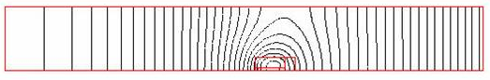

Figure 2: Solution Domain (0.25m*2m) and Magnetic Flux by Modular Coil Current (300kA).
3.7m
3.2m

Input

Current input value of modular coils is 300kA/coil

Special Feature of Analysis

In this problem, the modular coil carrying 300kA magnetizes the MCWF having relative magnetic permeability of 1.02. The interesting zone affected by magnetic field is only 10cm away from the current. Theoretically this problem can be solved by the comparison of two cases of analysis. The one case is with 1.02 mu MCWF and another is 1.00 mu MCWF. If the differences of these two magnetic values are compared, we can get the magnetic field influence of high mu material. But, in reality, this comparison is not adequate. The magnetic field by coil is 1~2 tesla (10k gauss) on the plasma surface. And the difference between two materials is 1~10 gauss level. The trivial round-off error in the two main analyses could be very significant difference in the comparison. So, instead of direct comparison, we used the method of permanent magnet analysis technique as explained in the Procedure of Analysis.
(Ansys has permanent magnet analysis option.)

Procedure of Analysis

1) Model build and Ansys analysis with 1.02 mu of MCWF.
2) Plot B value and H value in the MCWF.
3) Find average magnetization value inside MCFW by the equation of B=μo*(H + M)
μo=4pi*10⁻⁷ ≈ 1/795775; M=magnetization
4) When the whole MCWF has 1.02 of mu, the MCWF is divided as 4 different sections to allow different magnetization value.
5) Local coordinates have to be created to put the direction of magnetization in each section.
6) In material property input, MURX=1.02 and MGXX=m are filled (MGXX: coercive magnetic field in permanent magnet. In this problem, vector sum of magnetization is this value)
7) Run Ansys again without current source. (Only with material property of MGXX, Ansys will calculate magnetic field by permanent magnet)

The important part of this analysis is to decide the magnetization value in MCWF. B and H value is not uniform in MCWF, so the reasonable average value with well divided section according to magnetic characteristics is required.

IV. Results

Case 1: High Mu on the Tip of MCWF

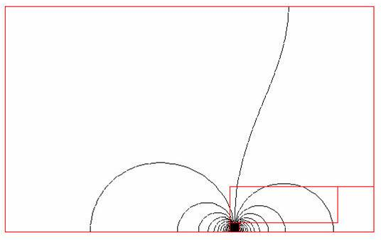

Figure 3: Magnetic flux lines around MCWF when only the tip of MCWF has been magnetized.

The tip of MCWF in the above result has 1cm*1cm size. So, in real situation, the all 18 MCWF tips have a high mu region with 1cm*2cm*2pi*100cm.

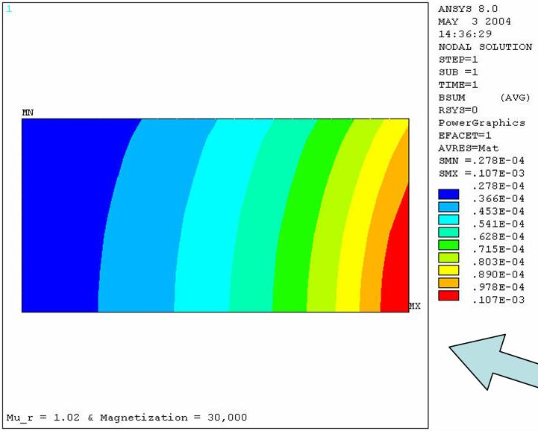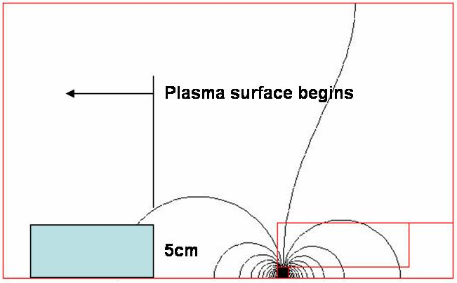

Figure 4: Vector summed B field on the interesting region (near plasma surface, 5cm*10cm) when the tip of MCWF has 1.02 of mu. (maximum B field = 0.1E-3Tesla or 1gauss)

The right boundary of above plotted area is 10cm left from the tip of MCWF. So, the right part of above region is the starting position of plasma surface. The bottom line of above square is middle plane line.

Case 2: High Mu for Whole MCWF

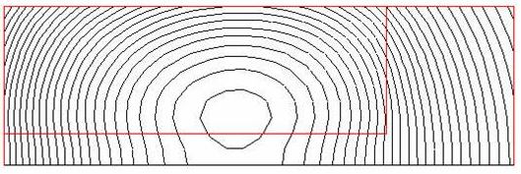

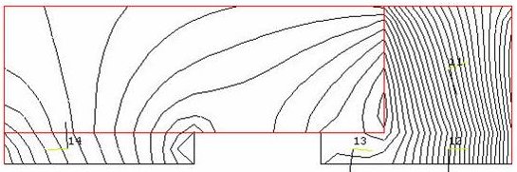

Figure 5: Comparison of flux lines in MCWF
(Up: flux lines with current, Down: flux lines with magnetized MCWF only.)

The MCWF is divided as 4 sections and 1 empty section according to magnetized pattern and values. The magnetized value in the empty section is very low because of two opposite field. The magnetization values are as follows:
Left part (14) = 18k A/m
Right under part (12 & 13) = -18k A/m
Right part (11) = -20k A/m
This magnetization value is around 2% of H field by coil current.

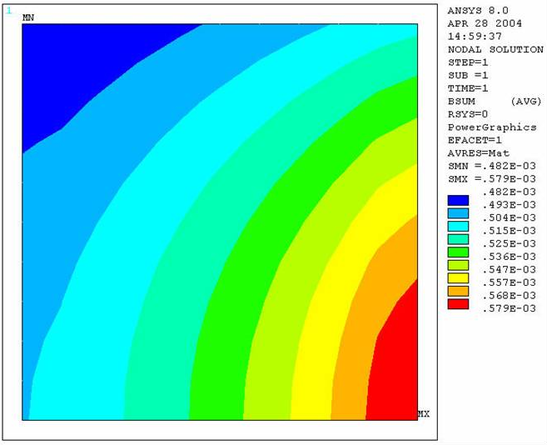
Figure 6: Vector Summed B Field near Plasma Surface (5cm*5cm; Maximum is 5.8gauss)
The position of above plot zone is right half of Figure 4. The right line of above plot boundary is starting position of outer surface of plasma.

V. Summary and Recommendations

The stray magnetic field due to high mu of MCWF is up to 6gausses on the plasma surface, when the whole material of MCWF has 1.02 of relative magnetic permeability. The stray field is around 1 gauss, when only the tip of MCWF has 1.02 of mu. If the mu value goes down to 1.01, the stray field will be half of above results due to linear property.

Ansys Model, Fortran Codes & Plasma Surface Nodes Data

Ansys model used is in below directory:

P:/public/anonymous ftp public/cjun/NCSX01/

The file name is: HighMu0514.db
{End}

