PPPL-NCSX Memorandum

To: Project Engineer (PPPL)
From: Leonard Myatt (Myatt Consulting, Inc.)
Date: August 16, 2004
Subject: Effects of Modular Coil Fields at S3 State on TF Coil Structural Continuity

1.0 Executive Summary

A 3D coupled electromagnetic-structural ANSYS model of the NCSX toroidal field (TF) and Modular Coil (MC) systems is assembled and used to determine Lorentz forces, deformations and stresses within the TF magnet from some equilibrium current sets. The analysis focuses on the Modular Coil Fields at S3 state, when TF currents are low and MC currents are high but negative in some or all coils. Field analyses using current-sticks has shown that some of the TF coils have a positive net radial force. This analysis is designed to check those earlier results [Error: Reference source not found] and draw a more detailed picture of the stress state.

The ANSYS model confirms the positive net radial forces acting on the TF coils. This net outward load may be of little consequence compared to the complexities of the force distribution in the inner TF legs. The analysis shows that there is an average compressive toroidal stress of ~0.4 MPa from Lorentz forces and the reference outboard preload. This is sufficient, on-average, to develop a friction force which is much larger than the radial coil force. The friction force would drop considerably if not for the preload applied to the TF coil. However, this approach appears to be too simplistic.

A closer look at the interface stresses from a bonded model identifies non-uniformities in the stress field which include modest tensile stresses (would-be gaps) in some regions. Detailed analysis of the local compression and shear stresses on these wedged surfaces indicates that ~20% of the area could remain “stuck” while the other 80% produce small gaps or relative motion. Clearly, a nonlinear analysis with contact elements is required to accurately capture this behavior.

Simulations which include frictional contact between wedged faces of just two coils indicate that without the nominal 2000 lb per bracket preload, these faces will experience scissor-like relative motion with maximum slippage on the order of ±0.28 mm. When the 2000 lb per bracket preload is applied and a coefficient of friction (μ) of 0.3 is assumed, the adjacent coils hit hard against each other at the top and bottom of the interface and remain stuck. However, the average ratio of friction to normal forces is 0.27, indicating that there is little margin in the design if a μ of 0.3 is the design basis value. Intermediate locations separate, resulting in small (0.05 mm) coil-to-coil gaps.

However, when the preload is increased to 4000 lb/bracket, the threshold friction coefficient is a mere 0.18, which should be easy to achieve. The stress in the side wall insulation peaks at these extremes of the interface, but at 80 MPa is well below the 280 MPa RT design stress of a typical high-pressure laminate. Similarly, the maximum smeared winding pack stress is <20 MPa, which is well bellow the stress levels produced by more demanding load conditions.

In summary, the 4000 lb per bracket preload is sufficient to maintain a no-slip condition in the TF coil system, at least for the subject equilibrium currents, while imposing minimal stresses in the coil and sidewall insulation.

2.0 Assumptions and Notable Concerns

2.1 The stability of the TF coil system under light TF operating currents will rely on a mechanical preload and friction at the wedged surfaces to hold back the TF coils with a positive radial Lorentz force. An assumed friction coefficient of 0.3 is used in the analysis, which should be relatively easy to achieve. Most materials have friction coefficients greater than 0.3, and achieving a low friction surface usually takes some special effort. The subject coil currents push the minimum friction coefficient requirement to 0.18 when a 4000 lb/bracket preload is applied, which provides plenty of margin for other (if any) more demanding operating conditions.

2.2 The coil currents used here are chosen because they produce positive radial forces on some TF coils, tending to eject them from the coil system. It is assumed that A. Brooks’ design-space search has identified the worst-case condition for producing slippage between coils.

2.3 The computational demands of modeling six contact surfaces for this 120˚ field period model are too great for the resources available to Myatt Consulting, Inc. However, the EM analysis shows that a single contact surface in the middle of the six-coil model is the most likely place for slippage based on poloidal torque summations. The nonlinear structural analysis shows that this interface remains “stuck” during the reference equilibrium S3 field state.
3.0 Analysis

The analysis is based on the 3D model shown in Fig. 3.0-1. There are six TF coils and six MCs which make up one 120˚ “field period.” Smeared TF coil winding packs (WP) are surrounded by ground-wrap insulation. Side-wall insulation separates the inner legs in the wedged region.

The electromagnetic (EM) model is loaded by applied currents. The structural model is loaded by importing the Lorentz forces calculated by the EM model and the applied radial preload (located at ±52” about the equatorial plane). The model is very similar to the one described in [Error: Reference source not found] with the addition of MCs which are also fully described in a previous memo.

Deformations and stresses are postprocessed in order to assess the stability of the wedged surfaces (i.e., conditions which produce stick-slip behavior). Some results are supplemented with hand calculations for confirmation.
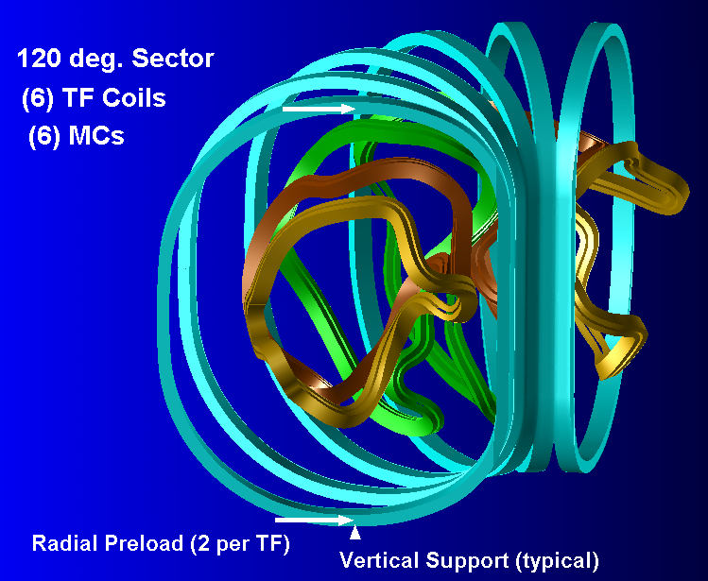
Fig. 3.0-1 Isometric View of One Field Period of TF & Modular Coils
For discussion purposes, we will refer to the six TF coils in the 120˚ model as TF1 through TF6, where TF1 is at θ=-50˚, TF2 is at θ=-30˚, TF3 is at θ=-10˚, TF4 is at θ=+10˚, TF5 is at θ=+30˚, TF6 is at θ=+50˚ and θ=0 is parallel to the global X axis.

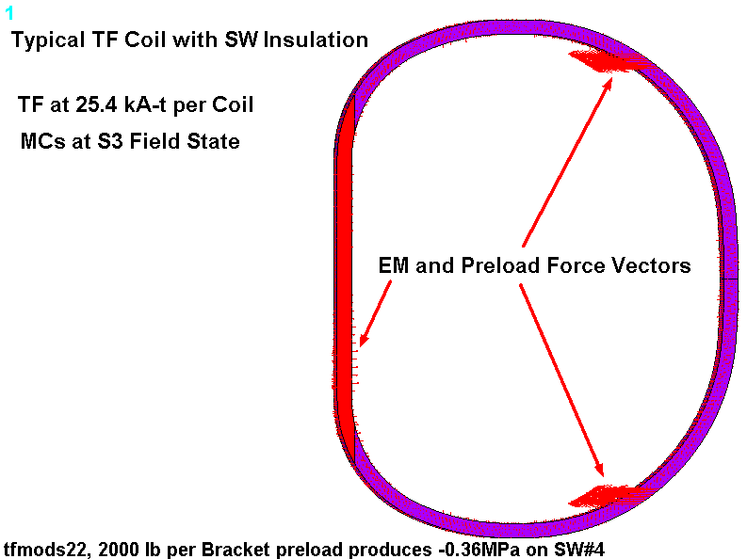
Fig.3.0-2 is a plot of a single TF coil. It shows the smeared WP (blue), side wall (SW) insulation (red), and nodal force vectors. Notice that for this particular EM loading, the preload forces are much larger than the Lorentz forces as denoted by their vector length.

Fig. 3.0-2 Typical TF Coil with EM & Preload Force Vectors
4.0 Results

The results of the analyses are summarized in the sections below. Sect. 4.1 shows results for the case when only TF coils are energized (B₀=0.5 T). This case is benchmarked against a previous analysis [Error: Reference source not found] for checking purposes. Sections 4.2 and 4.3 shows results for the subject loading (MC at S3 state and TF coils at 25.4 kA-t) when all wedged surfaces are bonded together (linear analysis), and when the inner coil pair have contact surfaces with friction and all other wedged surfaces bonded (nonlinear model). Within section 4.3, there are two analyses; one with a zero applied preload and a second with the nominal 2000 lb/bracket preload. This last section contains the most important findings, while the others are simply included to show the entire analysis chain and thought-process.

4.1 Model Benchmark, B₀=0.5 T

When the TF coils are energized to 194.4 kA-t/coil, the on-axis toroidal field is 0.5 T. The parametric ANSYS model uses a single TF coil and 1/18th symmetry to simulate this operating condition.

Fig. 4.1-1 is a plot of the flux density in the smeared winding pack. The plot is annotated with various salient results. The peak field is reported to be 1.77 T and the “MX” symbol signifies that it appears just above equatorial plane. The magnitude of the field is perfectly consistent with 1/r scaling which would be 1.75 T at this location of the inboard leg.

The plot title also lists ∫JxBdV forces. The results are rounded to integers and all figures are reported. The net radial force acting on the coil is -373 kN which is ~5% higher than the -358 kN reported in [Error: Reference source not found]. The out-of-plane force sums to exactly zero, and the net vertical force is a mere 62 N which of course should be zero. These results produce some level of confidence that the model is reasonably accurate.

Fig. 4.1-2 is a plot of the smeared stress intensity in the TF winding pack from this 0.5T operating condition. The results are included here for reference only, and show good agreement with results presented in an earlier memo [Error: Reference source not found].

4.1-1 Flux Density in Smeared TF Coil Winding Pack, 0.5 T Operating Condition
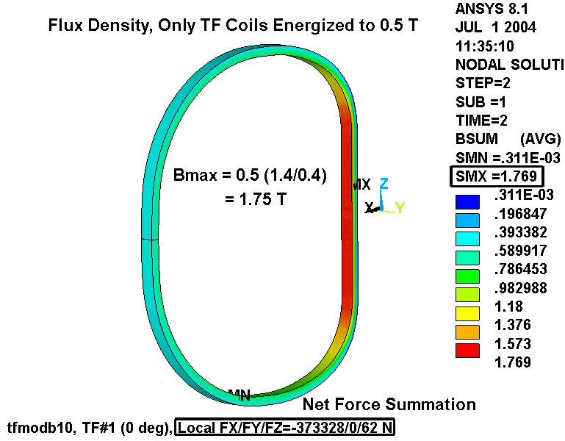
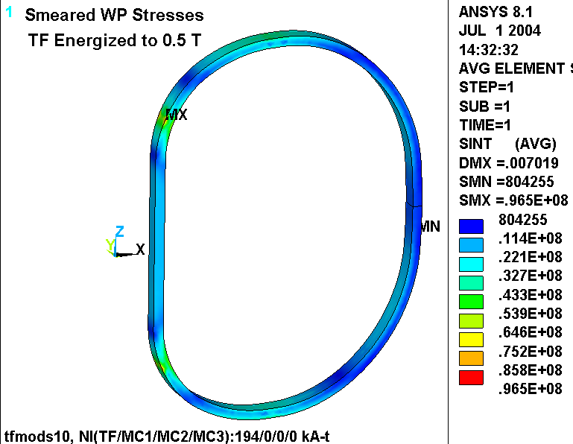
Fig. 4.1-2 Stress Intensity in Smeared Winding Pack, 0.5 T Operating Condition

4.2 Modular Coil at S3 state, TF coils at 25.4 kA-t (Bonded Inner Legs)

When fields from the MCs are included in the analysis the field period increases to 120˚. Now, the model must include 6 TF coils, 6 MCs and invoke 1/3rd electromagnetic symmetry.

Fig. 4.2-1 is a plot of the flux density in the TFCs and MCs from the subject operating condition; total currents are embedded in the plot title. The maximum field of 4.7 T occurs in MC3. It is worth noting that the MCs are modeled with a rather coarse mesh, which may not be sufficient to capture the actual peak field. However, the element density is probably sufficient to serve as current sources for the Biot-Savart field calculation within the denser TF winding pack mesh.

Fig. 4.2-2 is a plot of the force density in TF coil #3 (θ=-10˚). Again, net forces are embedded in the plot title, which shows a 2.3 kN net radial force acting on this (and the θ=+10˚) coil. The radial forces acting on three typical TF coils are listed below.

ANSYS Solid Model [kN]: Fr(TF1)=-4.5 Fr(TF2)=-14.7 Fr(TF3)=+2.3
Brooks’ Stick Model [kN]: Fr(TF1)=-3.4 Fr(TF2)=-17.3 Fr(TF3)=+6.1

The two models produce qualitatively similar results. On a percentage basis, there is some disparity, particularly with TF3. On an absolute value basis, the average disparity is about 2.5 kN (~600 lb). One might expect accuracy in the ANSYS model to be on the order of 100 N (based on its ability to produce a near zero net vertical force from the TF-only case, Fig. 4.1-1). However, only a mesh refinement or another code would provide a reasonable second benchmark. The present 270,000 node model has a 6+ hour run-time which makes a mesh-refinement study more of a luxury than a necessity.

The model is also used in a linear structural analysis. Magnetic elements are replaced with structural elements, boundary conditions are applied and Lorentz forces are imported from the field analysis.

The EM loads associated with this reference case produce a non-symmetric loading in the toroidally continuous inboard legs. Fig. 4.2-3 is a view looking down the coil system axis (Z). Toroidal stresses are superimposed on the greatly exaggerated model deformations. EM forces drive some portions of the arc into “flats” and other portions into “tight bends.” Of course these terms are loosely used to illustrate the nature of the deformations as no cross-section through the six-coil inner leg region actually becomes flat or tightly bent. That said both of these deformations lead to tension on one side of the WP and compression on the other side, superimposed on an average distribution. It’s worth noting that these toroidal stresses are generally very light, typically ±1 MPa.

Another way to illustrate this result is shown in Fig. 4.2-4. In this case the contours are binary, highlighting regions of tension (grey) and compression (red). Look closely at the right (or left) edge of the right contour plot. This area represents the contact surface between this 120˚ sector and the next. The grey (tension) areas would pull apart unless the inner legs were bonded at assembly. Instead, small (tiny) gaps will open up between the adjacent TF sidewall insulation layers. An import question remains unanswered by this linear analysis: Will the gaps be extensive enough to lead to relative motion and irreversible changes in the coil positions? Before jumping to the obvious path to answer this question (i.e., a nonlinear model with contact elements on the surfaces of adjacent inner TF legs), let’s do some simple calculations.
Let’s calculate the average toroidal stress, σ_{θ}, on the wedged surfaces. This stress is simply the total force normal to the wedged surface (F⊥) divided by the contact surface (A_{wedged}). In this analysis, the normal force can be obtained by summing the average magnetic force (from the three typical coils) and the applied preload force and then dividing by the sine of the wedge half-angle (10˚). For simplicity, we’ll use half of the coil force and react it over one wedged face.

σ_{θ} = {(F_{magnetic}) + (F_{preload})}/(sin10˚)/(A_{wedged})
= {(-4500 N – 14700 N + 2300 N)/3 + (-2000 lb/0.2245 lb/N)}/( sin10˚)/(0.1804 m²)
= {(-5600) + (-8900)}/( sin10˚)/(0.1804 m²)
= -0.46 MPa

From the 3D analysis, when the stress normal to the side wall insulation is averaged over the entire wedged surface the average toroidal stress is -0.37 MPa. This is in reasonably good agreement with -0.46 MPa from the hand-calculation. Its worth noting, however, that the hand calculation must be correct. The difference between the two values is probably due to finite element effects (i.e., steep stress gradients over a coarse mesh).

Maintaining an average toroidal compression, despite the positive radial EM force on six of 18 coils, does not guarantee a slip-free structure. Another analysis approach would be to multiply the average toroidal compressive stress by a friction coefficient (μ) and surface area to obtain the nominal radial force which can be carried by friction:

F(friction) = μ σ_{θ} A_{wedged} = (~0.3) (0.1804 m²) (0.46 MPa) = 25 kN

Since 25 kN is greater than both 2.3 kN and 6.1 kN, it would appear as if friction on the wedged faces is sufficient to keep these coils with positive radial force stuck to their neighbors. It is interesting to note that more than 60% (8900/14500) of the average toroidal compression is a result of the preload (2000 lb/bracket x 2 brackets per TF coil). If the preload is omitted, the friction force drops to 10 kN, which is far more marginal (depending on which radial force is correct). Also, when the TF coils carry their full (0.5 T) current, the radial force per coil is ~373 kN (84,000 lb) or 21 times the mechanical preload. So, the preload is only of value at these very low TF coil currents.

Yet another approach to analyzing the stability of the coil-to-coil interfaces is to examine normal and shear stresses. This is a far more accurate measure of the wedging surface characteristics since it uses local shear and normal stresses from the model and not surface-wide average values. The analysis goes as follows. At each inner leg side-wall surface, the local shear stress is subtracted from a friction coefficient multiplied by the normal stress to create the so-called Shear Margin.

Shear Margin = Shear Capacity – Shear Stress = (-μσ_{θ}) - (τ_{θz}²+τ_{rθ}²)^{0.5}

A minus sign in front of the μσ_{θ} term converts toroidal compressive stresses into positive shear capacity and toroidal tensile stresses into negative shear capacity. Values of Shear Margin which are greater than zero signify that local friction is greater than local shear.

This methodology is applied to the six wedging interfaces in the model. However, only one set of normal, shear and shear margin stress contour plots are presented in plot form.
Fig. 4.2-5 is a plot of the normal (toroidal) stress in the sidewall insulation located between TF3 & TF4. Contours are limited to small negative values which helps illustrate the nominal compressive stress distribution. The plot shows that the middle portion of the inner leg sees compressive stresses of about 0.2 MPa. Immediately above and below this middle region, the normal stresses become mildly tensile, with a maximum value reported to be ~3 MPa. A narrow band of contours close to the extremes of the wedged interface signify a sharp transition from these modest tensile values to large compressive values at the tips. Since the model assumes a bonded interface, these tensile values are “false” and the compressive stress is overestimated. The ANSYS plot title captures the integrated average normal stress: -0.36 MPa.

Even without bonding, a compressive normal stress and friction could support shear stress at the wedged interface. However, the capacity of the surface to carry a shear stress without slipping will be a function of the local compression, shear and friction coefficient. As long as the product of the compressive stress and friction coefficient is greater than the local shear stress, the interface will remain “stuck.” Fig. 4.2-6 is a plot of the shear stress modulus (τ_{rθ}² + τ_{θz}²)^{0.5} on this particular sidewall insulation layer. Again, contour values are carefully chosen to provide the most insight into the distribution. Notice that the shear stress peaks at the tips of the interface, but is generally <0.2 MPa over the bulk of the area. The plot title also captures the average shear: 0.15 MPa.

Aside: If these stresses were uniform, then a friction coefficient of at least 0.15/0.36 or 0.42 would be required to maintain a stuck interface.

Now we can combine these two results. Shear stresses are subtracted from the normal compressive stress multiplied by a friction coefficient. Positive values represent a shear margin or excess frictional capacity relative to shear stresses. Fig. 4.3-7 shows two plots which represent the shear margin assuming friction coefficients of 0.3 (top) and 0.6 (bottom). The titles list the area fraction in which the shear margin is a positive value: 0.16 for μ=0.3 and 0.24 for μ=0.6.

A review of the other five interfaces indicates that a positive shear margin value occurs over 15% to 29% of the wedged interfaces. So, this θ=0 interface represents one of the worst locations. In any case, the results show that most of the interface areas do not have sufficiently high compression to support the shear stresses developed by the coil deformations. This means that local movement between TF coils is likely.

This approach is somewhat more convincing than the previous two analyses which are based on average surface conditions. However, this bonded interface model overestimates the magnitude and extent of toroidal compression which are artificially augmented by tensile stresses that cannot develop. A more rigorous approach would be to model general contact surfaces at the wedging interfaces and look for relative motion. This is complicated by the importance of friction, which makes the analysis not only nonlinear, but path-dependent. The result is a very long computer run.
Fig. 4.2-1 Flux Density in TFCs & MCs from 0.065T, S3 Field State
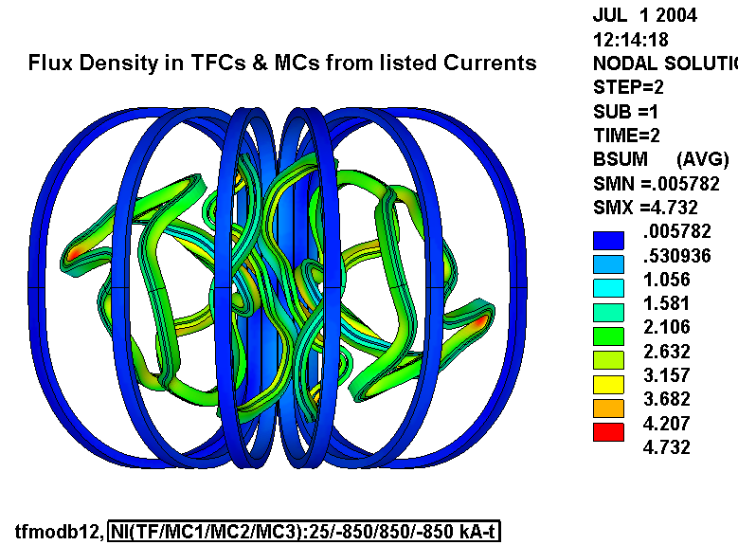
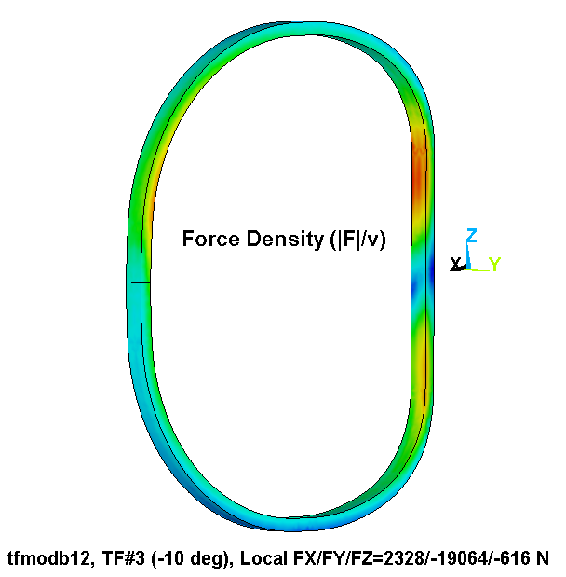
Fig. 4.2-2 Force Density in TF Coil #3 (θ=-10˚), TFCs & MCs from 0.065T, S3 Field State

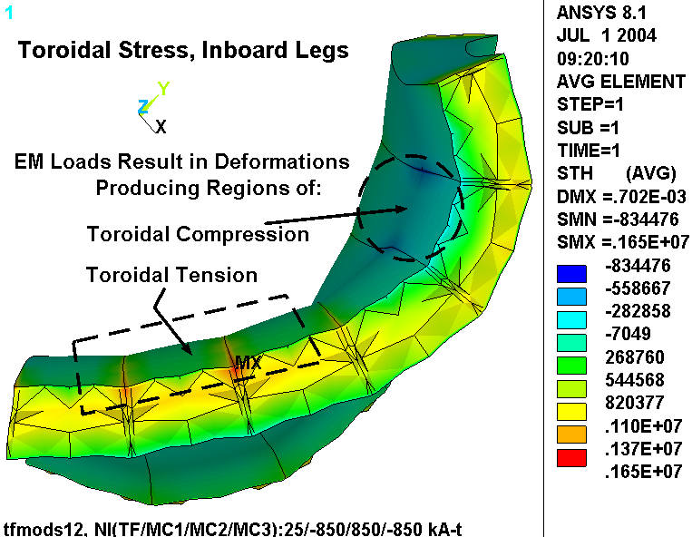
Fig. 4.2-3 Toroidal Stress, Inner Legs, TFCs & MCs from 0.065T, S3 Field State

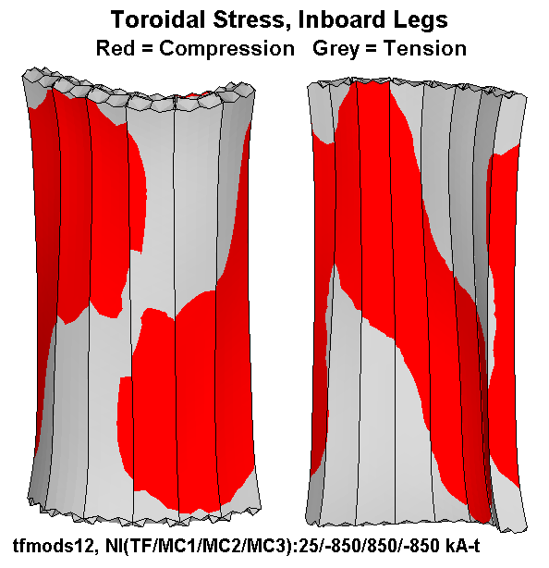
Fig. 4.2-4 Binary Toroidal Stress Contours, Inner Legs, TFCs & MCs from 0.065T, S3 Field State

Fig. 4.2-5 Normal Stress Contours Typical Wedged Surface
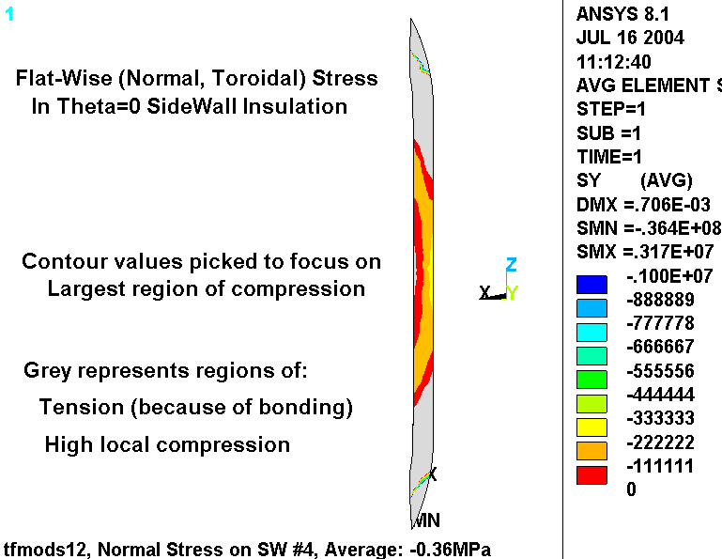
TFCs & MCs from 0.065T, S3 Field State

Fig. 4.2-6 Shear Stress Contours Typical Wedged Surface
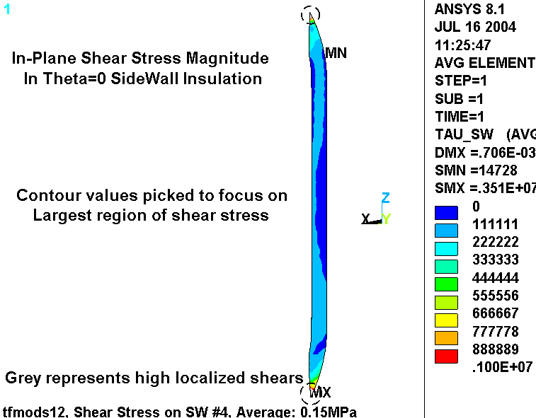
TFCs & MCs from 0.065T, S3 Field State

Fig. 4.2-7 Shear Margin Contours Typical Wedged Surface (top: μ=0.3, bottom: μ=0.6)
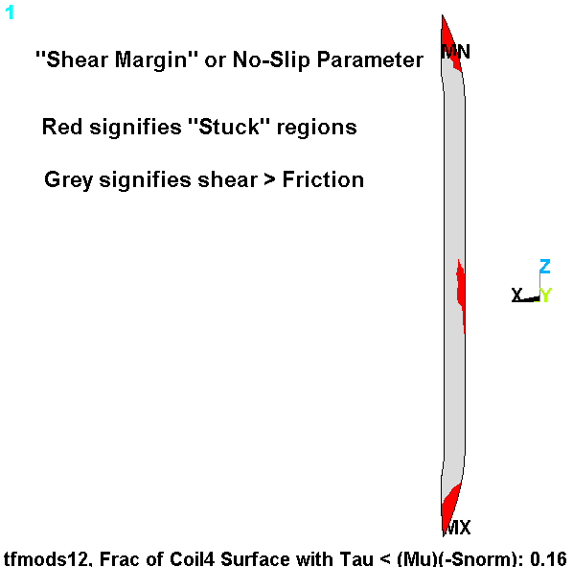
TFCs & MCs from 0.065T, S3 Field State
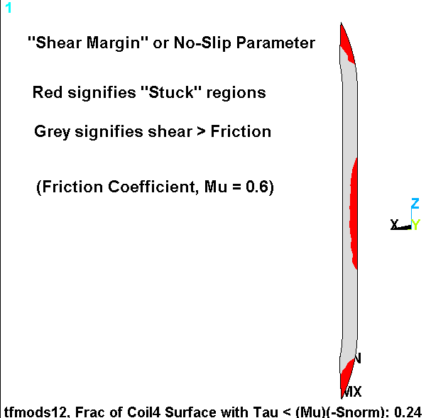

4.3 Modular Coil at S3 state, TF coils at 25.4 kA-t (Friction at TF3/4 Contact Surface)

The linear (no-slip) analysis presented above is inherently unconservative. Artificial toroidal tensile stresses develop in certain regions (recall Figs. 4.2-4 & 4.2-5) and lead to artificially high toroidal compression in other regions. In an effort to perform a more representative analysis, node-to-node contact elements are added to the wedged faces of the inner legs. However, this approach resulted in a multi-day computer run that showed no signs of converging and was terminated before completion. As a compromise, the model is reworked to reduce the number of elements by eliminating the ground wrap elements, and limiting the node-to-node contact to the single TF3/4 interface. This simplified model is shown in Fig. 4.3-1 and is again used to evaluate the EM forces for the reference equilibrium currents. However in this case, the “stuck” or “sliding” result will appear in a simple deformation plot, not postulated from postprocessing shears and normal stresses.

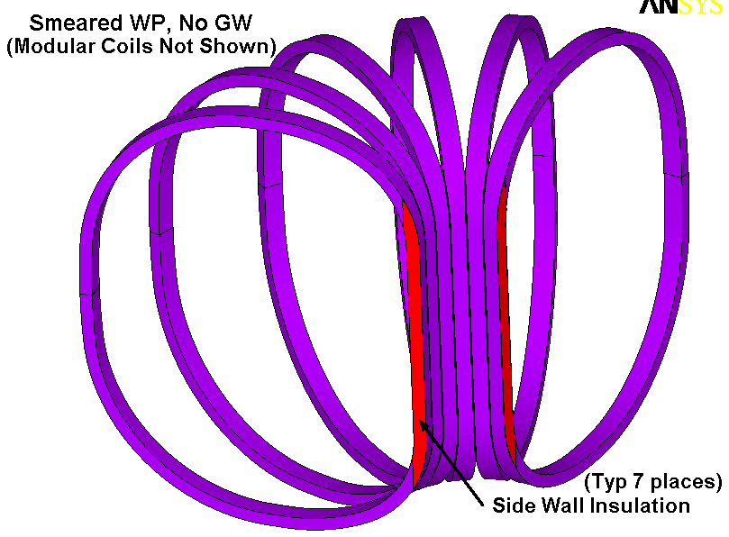
Fig. 4.3-1 Simplified TF Coil Model, Ground Wrap Eliminated, Contact at A-A Interface Only
Zero Preload

Fig. 4.3-2 is a plot of the radial displacement contours on a greatly exaggerated deformed coil. There is no radial preload in this analysis. Notice the following:
- the outboard legs of Type-A and B coils tend to separate (pull away from the Y=0 plane)
- the –Y coils tend to move radially in at the top (and out at the bottom)
- the +Y oils tend to move radially out at the top (and in at the bottom)

These displacement trends are consistent with the linear (fully bonded) analysis reported in the previous section as shown in Fig. 4.2-3. Unlike the bonded configuration, the TF3/4 interface can demonstrate relative motion or scuffing as a result of these EM loads. Relative motion at the contact surface is postprocessed and determined to be 0.55 mm at the extremes of the inner legs. That is, the top of TF3 moves radially inward about 0.28 mm while the top of the TF4 moves radially outward about 0.28 mm. This particular analysis does not have a radial preload, which is evident by the integrated toroidal compression listed in the plot title: -0.08 MPa. Analysis of the other interfaces shows similar results, with average toroidal stresses of ~0.1 MPa. Recall that the toroidal compression is 0.36 MPa in the linear model with 2000 lb/bracket preload.

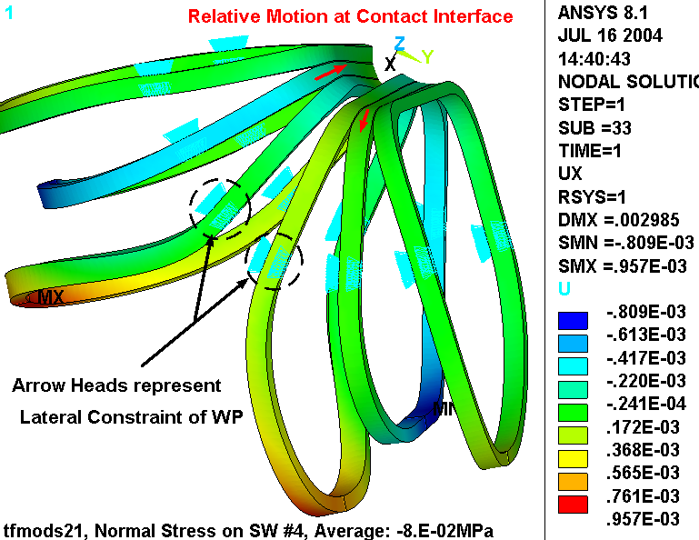
Fig. 4.3-2 Radial Displacements, TFCs & MCs from 0.065T S3 Field State
(μ=0.3 Friction at A-A surface)
2000 lb Preload

Fig. 4.3-3 is a plot of the loaded coil system with greatly exaggerated deformations (300x). In this case, a 2000 lb/bracket radial preload is applied. That’s 4000 lb per coil with preload hardware located 52” above and below the equatorial plane.

The plot shows that the preload causes the coils to hit hard against each other at the top and bottom of the contact surface (TF3/4 interface) and open a gap in between. With a friction coefficient of 0.3, this analysis shows that the coils do not move relative to each other as they did when only low-level EM forces provided a 0.08 MPa toroidal interface pressure. Here, the EM and preload combine to produce an average toroidal pressure of 0.36 MPa, as shown in the ANSYS plot title. The largest gap is reported to be ~0.05 mm.

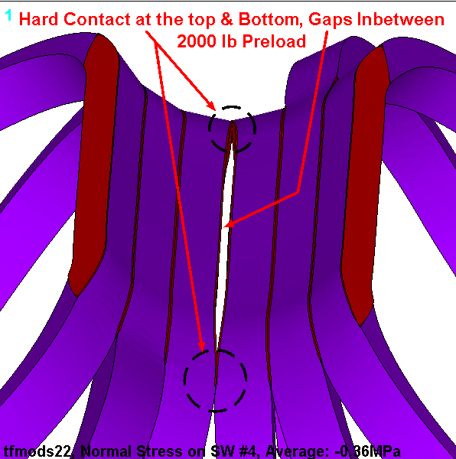
Fig. 4.3-3 Deformations in the Preloaded TF Coil System, TFCs & MCs from 0.065T S3 Field State (μ=0.3 Friction at TF3/4 interface)
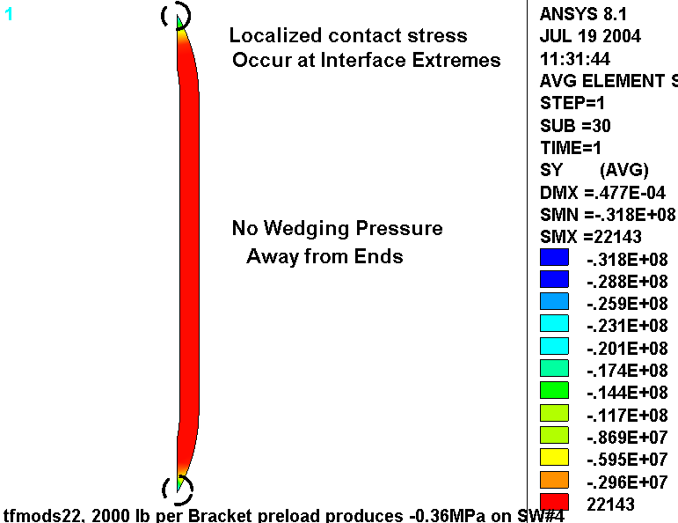
As shown in Fig. 4.3-4, the average surface toroidal stress is composed of a “high” contact stress (~32 MPa) at the extremes and zero in between.

Fig. 4.3-4 Wedging Pressure in SW Insulation at TF3/4 Interface
TFCs & MCs from 0.065T S3 Field State (μ=0.3 Friction at TF3/4 surface)

Fig. 4.3-5 is a plot of the relative motion at the TF3/4 contact surface. The contour values represent the amount of relative motion and indicate a maximum of 27 μm or 1 mil. This maximum occurs in the red regions slightly above and below the Z=0 equatorial plane. Sliding at the extremes of the interface is nil, as represented by the “MN” symbol which correspond to slip of 10⁻²⁰ m.

The plot includes the deformed shape. Nodes on one side of the interface which move relative to nodes on the other side of the interface trace the motion relative to the unloaded position. This plot shows how the inboard legs are bent into an “S” with one side going in one direction while the other side goes in the opposite direction.

The ANSYS plot title also lists some interesting results about the status of the contact element: 2.6% are stuck, 2.6% are sliding, and 94.8% are open. In addition, of the contact elements which are closed (i.e., in contact and sliding or stuck) the average ratio of friction force to normal force is 0.27. This represents the friction coefficient required to maintain these displacements.
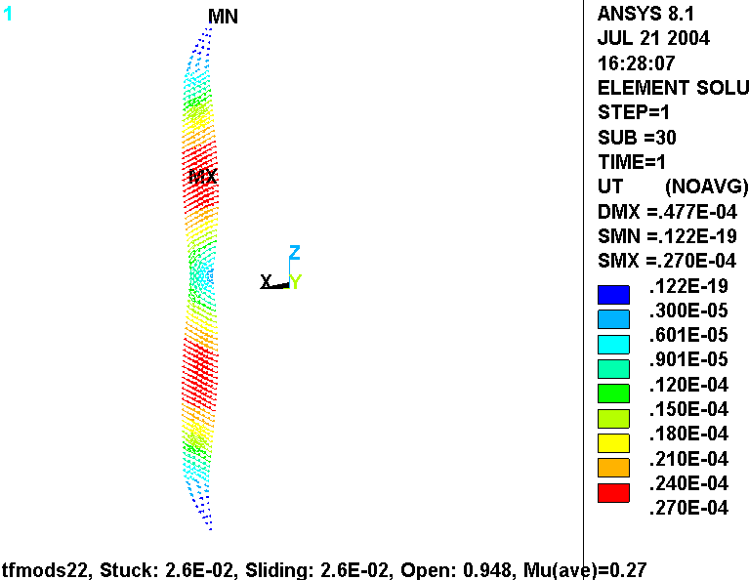

Fig. 4.3-5 Relative Motion at TF3/4 Interface
TFCs & MCs from 0.065T S3 Field State (μ=0.3 Friction at TF3/4 surface)
Fig. 4.3-6 is included to show the stress intensity in the smeared WP as a result of this equilibrium plus mechanical preload operating condition. The plot shows that the highest stresses appear at the lateral displacement boundary conditions, which make the 32 MPa value suspect. Away from these lateral constraints, the plot indicates larger regions at a stress level of 15-20 MPa (in the transition region of the TF2 & TF5 coils). Even with the understanding that these are smeared stresses which must be “marked-up” to determine the stress in the Cu conductor, the magnitude is probably low enough to not be a concern.
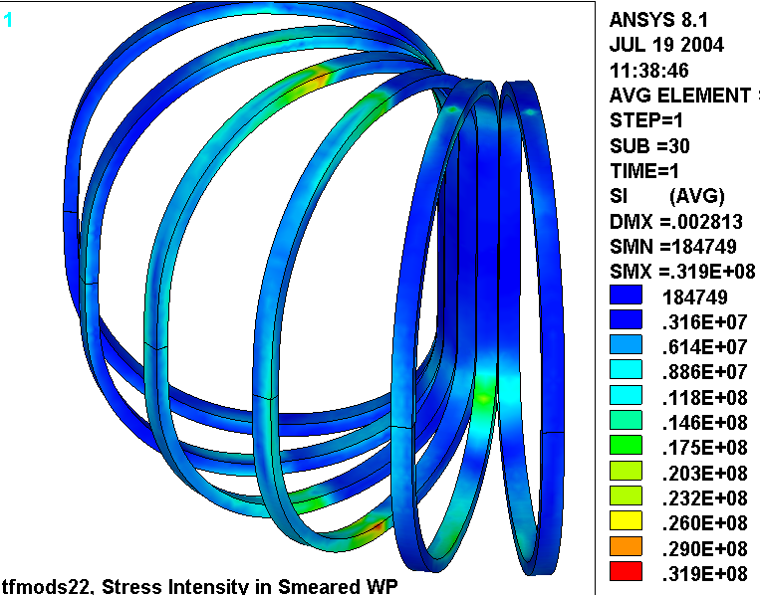

Fig. 4.3-6 Stress Intensity in the Smeared TF WP
2000 lb per bracket Preload, TFCs & MCs from 0.065T S3 Field State

4000 lb Preload (and revised coil currents)

The results reported above for the 2000 lb per bracket preload indicate that the ratio of frictional forces-to-normal forces (μ_{ave}) is 0.27. This might be considered marginal since it is close to the assumed coil-to-coil friction coefficient of 0.3. It is worth noting that this assumed friction coefficient is from engineering judgment based on a survey of numerous materials with sliding contact (Marks’ Handbook).

That said the TF preload is doubled to 4000 lb per bracket. Along with this change, A. Brooks revised his search for the maximum positive radial load on any TF coil and found the following coil currents:

Modular Coil 1 (i.e. ~10 deg) 820 kA-t
Modular Coil 2 (i.e. ~30 deg) 830 kA-t
Modular Coil 3 (i.e. ~50 deg) 730 kA-t
TF Coils -18.43 kA-t
Net Radial Force per TF Coil +3274 N

The analysis is re-run with these revised coil currents and higher TF preload. Fig. 4.3-7 is a plot of the normal stress in the inboard leg sidewall insulation resulting from this new operating condition. The plot indicates that most of the surface is stress-free at this low TF coil current (18.4 kA-t/coil, ~0.05 T), but has regions of “high” contact stress (~80 MPa) at the extremes. The epoxy-glass sidewall insulation is G-10-like, which has a compressive stress limit of 420 MPa at 295K. This puts the design stress at 280 MPa for flat-wise compression. So, even the local stresses from the 4000 lb/bracket preload will not exceed the compressive stress limits for the insulation. Incidentally, at 85K, the design stress increases to 460 MPa.

Fig. 4.3-8 is a plot of the relative motion at the TF3/4 contact surface. The contour values represent the amount of relative motion and indicate a maximum of 87 μm or 3 mil. This maximum occurs in the red regions mid-way between the Z=0 equatorial plane and the two extremes of the interface. Sliding at the extremes of the interface is nil, as represented by the “MN” symbol which correspond to slip of 10⁻¹⁵ m.

The plot includes the deformed shape. Nodes on one side of the interface which move relative to nodes on the other side of the interface trace the motion relative to the unloaded position. This plot shows how the inboard legs are bent into an “S” with one side going in one direction while the other side goes in the opposite direction, pivoting about the mid-height.

The ANSYS plot title also lists some interesting results about the status of the contact element: 3% are stuck, 0.9% are sliding, and 96.1% are open. In addition, of the contact elements which are closed (i.e., in contact and sliding or stuck) the average ratio of friction force to normal force is 0.18. This represents the friction coefficient required to maintain these displacements. Clearly, the larger (4000 lb/bracket) preload has reduced the minimum acceptable friction coefficient requirement relative to the 2000 lb/bracket preload results reported above. It should be easy enough to achieve a coil-to-coil interface with a friction coefficient above this 0.18 threshold value.

Fig. 4.3-7 Wedging Pressure in SW Insulation at TF3/4 Interface
TFCs & MCs from 0.048T S3 Field State, 4000 lb/bracket Preload (μ=0.3 Friction at TF3/4 surface)
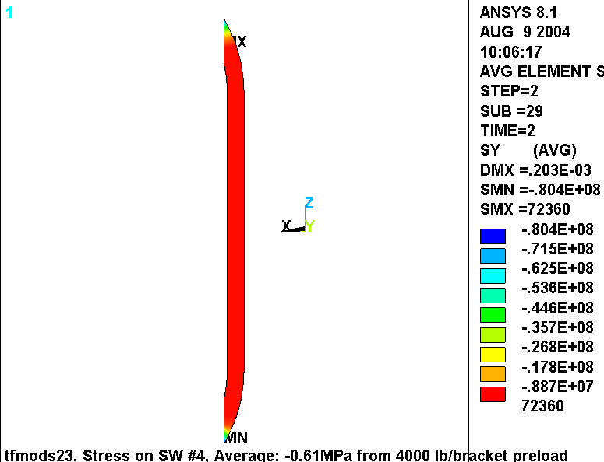
Fig. 4.3-8 Relative Motion at TF3/4 Interface
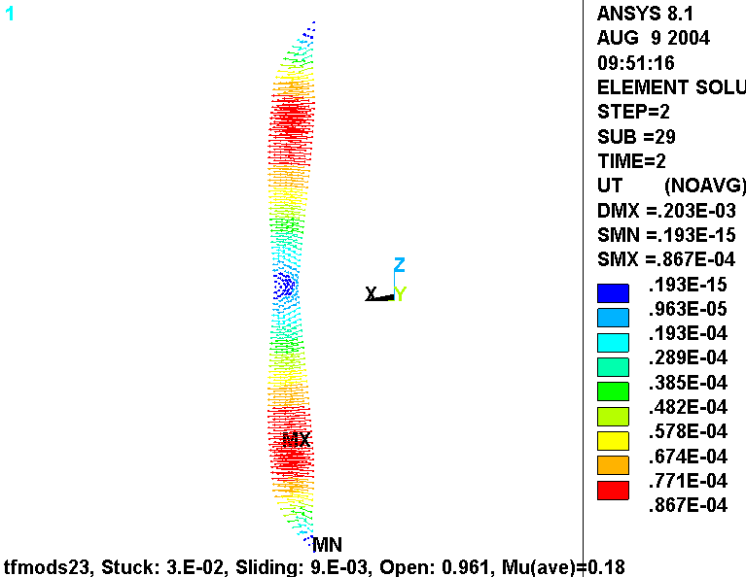
TFCs & MCs from 0.048T S3 Field State, 4000 lb/bracket Preload (μ=0.3 Friction at TF3/4 surface)

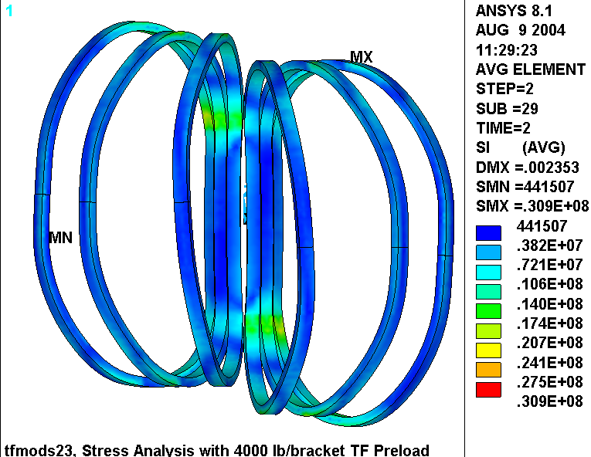
Fig. 4.3-9 is included to show the stress intensity in the smeared WP as a result of this particular coil current set plus the 4000 lb/bracket mechanical preload operating condition. The plot shows that the highest stresses appear at the lateral displacement boundary conditions, which make the 31 MPa value suspect. Away from these lateral constraints, the plot indicates larger regions at a stress level of 15-20 MPa (in the transition regions of all TF coils). Even with the understanding that these are smeared stresses which must be “marked-up” to determine the stress in the Cu conductor, the magnitude is low enough to not be a concern (Local Primary Membrane limit: 165 MPa).

Fig. 4.3-9 Stress Intensity in the Smeared TF WP
TFCs & MCs from 0.048T S3 Field State, 4000 lb/bracket Preload (μ=0.3 Friction at TF3/4 surface)

Is this the correct interface to model as a stick-slip plane?

As we have already discussed, computational limitations have lead to the use of a single stick-slip plane at θ=0˚ in this nonlinear analysis. It might seems apparent from Figs. 4.2-3 and 4.3-2 that there is a general twist in which the three –θ coils (TF1, 2 & 3) tend to rotate in one poloidal direction while the three +θ coils (TF4, 5 & 6) tend to rotate in the opposite poloidal direction. Fig. 4.3-2 illustrates this best since slippage occurs and the two sets of coils are displaced relative to each other. We will call this a poloidal twist, and the load which drives these displacements a poloidal torque.

It is not [yet] clear that the critical slip plane has been chosen to be analyzed. It is possible, for example, that poloidal torques on TF1 & TF3 are opposite to TF2, and their sum is a small negative value. Likewise, the poloidal torques on TF4 & TF6 are opposite to TF5, and their sum is a small positive value. If this were the case, then stick-slip planes on either side of TF2 or TF5 would be more important to model since this would be the location of the largest torque sign change.

A poloidal torque (T_{θ}) is calculated for each coil relative to a local coordinate system aligned with the coil mid-plane (i.e., at θ=-50˚, -30˚, -10˚, and so on):

T_{θ} = F_{x} Z + F_{z}(R₀-X)

where R₀ is the major radius, X is the radial in-plane coordinate, Z is the vertical in-plane coordinate, and Z=0 is the equatorial plane of the TF magnet system. F_{x} & F_{z} are Lorentz forces ∫JxBdV from the EM analysis. Table 4.3-1 lists the poloidal torques for each of the six TF coils. There are a few things to notice from these results:

- Stellarator-symmetry is evident (T_{θ1} = -T_{θ6}, T_{θ2} = -T_{θ5} T_{θ3} = -T_{θ4})
- The EM calculation produces consistent results (T_{θ1} ≈ -T_{θ6}, T_{θ2} ≈ -T_{θ5} T_{θ3} ≈ -T_{θ4})
- Most importantly, coils 1, 2 & 3 torques carry the same sign

The fortunate conclusion is that the stick-slip plane separating TF3 and TF4 is where the maximum torque gradient appears. If the slip is to occur from this EM loading, it will happen at this interface. The analysis with μ=0.3 on this interface shows that no slip occurs and that the coils remain “stuck.”
Table 4.3-1 Summary of Poloidal Torque Values (about R₀)
Coil Number | Poloidal Torque Summation  [N-m]
1 | -3234
2 | -6004
3 | -2596
4 | +2608
5 | +6017
6 | +3247

5.0 Summary & Commentary

The EM and linear structural model indicate that the conditions at the TF inner leg wedged surfaces are a strong function of the local EM force distribution created by TF and MC current sources. An analysis of normal and shear stresses at these surfaces in the linear model indicates that <30% of the area might remain “stuck” due to friction. However, toroidal tensile stresses are an artifact of the linear model, and to some extent, augment the toroidal compression producing nonconservative results. That is, there is less toroidal compression in the unbonded coil system than predicted by the linear model.

A nonlinear analysis with frictional contact elements is presented. When no preload is applied, shear stresses generally exceed the frictional capacity of the wedged surfaces resulting in relative motion between coils. The scuffing is on the order of ±0.28 mm at the top and bottom of the interface. When a 2000 lb/bracket preload is applied, high localized wedging pressures develop and the coils stick without sliding, although the margin appears small. A friction coefficient of >0.27 is required to ensure a stuck configuration. Contact stresses in the sidewall insulation and smeared stresses in the WP appear to be well below other operating conditions.

When the preload is increased to 4000 lb/bracket and a more demanding set of coil currents are postulated, then the threshold friction coefficient decreases to 0.18. In general engineering terms, this is a relatively low value, and should be easy to achieve with possibly no design effort. The additional preload increases the normal stress in the insulation, but it is still well below the allowable. The maximum stress in the winding pack is essentially unaffected by the revised preload, since EM forces were relaxed somewhat by the new coil currents.

Computational limitations restrict the model to a single unbonded surface between coils TF3 & TF4. A torque summation indicates that this is indeed the location most susceptible to slippage as all of poloidal torque from TF1, 2 & 3 coils oppose the poloidal torque from TF4, TF5 & TF6.

It is worth noting that while the reference EM load case produces the largest positive radial force on a TF coil [Error: Reference source not found], it is not certain that this current scenario produces the worst condition for slippage. There may be another load case which could result in vertical slippage even though the preload is well-sized to handle radial slippage.
6.0 Attachments

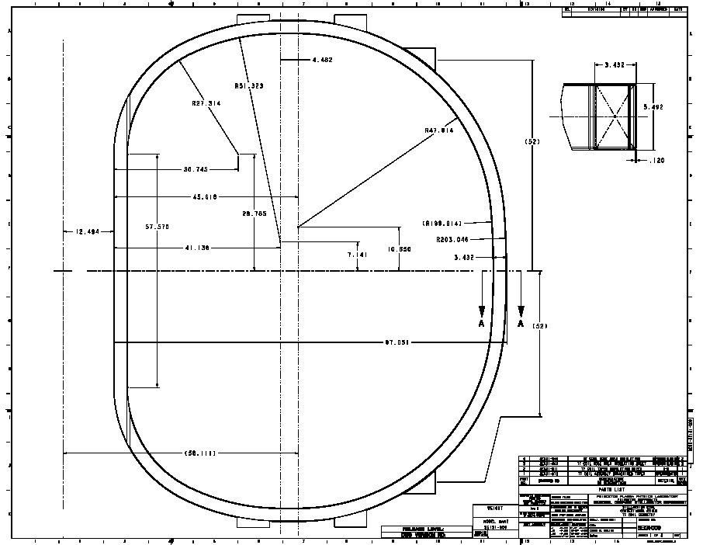
6.1 Drawings

6.1 ANSYS Input File

/batch
rn=1
/filnam,tfmodb2%rn%
/show,tfmodb2%rn%a,grp
!/filnam,tfmods2%rn%
resume
*if,1,eq,1,:1000
/prep7
/com
/com Electromagnetic analysis of the NCSX TF and Modular Coil System
/com Structural analysis of the TF Coil System (No OOP structure...just inboard wedging and BCs)
/com Geometry defined by: se131-092, se131-091, tf_cond
/com Solve the Conduction and field problem, then solve the structural problem
/com Derived from tfmod1.dat, Coils made as smeared without ground wrap or sidewall insulation.
/com This coarser model designed to run with wedging contact elements to determine potential for stick-slip
/com
/com
/com Model by Leonard Myatt, Myatt Consulting, Inc.
/com leonard.myatt@myattconsulting.com, 508-520-4590
/com
/com
/com Run History
/com
/com 20: TF Only...looks OK
/com 21: EM Only: TF & MC currents from Art Brooks (TF:+25.4 kA-t, M1/M2/M3:-850/+850/-850 kA-t)
/com
/com
/com Contact and Mesh Density Parameters
k_nl=1 ! 0: Wedged surfaces held to UY=0, 1: Generate Flex-Rigid Contact Interface
k_dens=3 ! number of elements across WP (5 is good, smaller can cause meshing problems)
mu_sw=0.3 ! sidewall-to-sidewall friction coefficient

/com Misc Parameters
k=0.0254 ! english to si conversion factor
pi=acos(-1) ! pi
mu0=4*pi*1e-7 ! Mu0
*afun,deg ! use degrees in trig functions
t=0.0001 ! a tiny length
th=0.1 ! a tiny angle

/com Nominal Performance Parameters
f_preload=2000/0.2248 ! applied radial preload per TF Bracket x 2 brackets per coil
z_preload=52*k ! vertical location of applied preload
b0=0.5 ! nominal flux density (one way of specifying TF current)
r0=1.4 ! major radius
ntf=18 ! number of tf coils
nsym=3 ! toroidal symmetry
arc=360/ntf ! angular extent of 1 tf coil
emsym,nsym ! electromagnetic symmetry about Z
dtmp=0!-215 ! differential temperature (WRT room temp)

/com
/com Coil Currents
/com
i_tf=25.4e3 !5e6*b0*r0/ntf ! total current in each smeared tf winding pack, A-turns/coil
i_mc1=-42500 ! conductor current in MC1, Amps
i_mc2=+42500 ! conductor current in MC2, Amps
i_mc3=-47222 ! conductor current in MC3, Amps

/com
/com element types
/com
et,1,98,2 ! Insulation (UX, UY, UZ)
et,2, 5,1 ! Modular Coil WP (TEMP, VOLT, MAG)
et,3,98,1 ! TF WP (TEMP, VOLT, MAG)

/com
/com graphics keys
/com
/pnum,mat,1
/num,1
/dist
/focus
/vup,1,z
/view,1,,-1

/com
/com tf conductor, ignoring radii (in local CS vernacular)
/com
n_lay=6 ! number of radial layers
n_pan=2 ! number of pancakes
dr_con=0.434*k ! Conductor build in thickness
dz_con=2.513*k ! Conductor build in height
dri_con=0.190*k ! inside thickness of cooling channel
dzi_con=1.130*k ! inside height of cooling channel
a_con=dr_con*dz_con-dri_con*dzi_con ! conductor metal area

/com
/com Insulation
/com
t_tw=0.049*k ! turn wrap insulation thk
t_pan=0.03*k ! pancake insulation thk (can be 0.0)
t_lay=0.0*k ! layer insulation thk (can be 0.0)
t_gw=0.12*k ! module over-wrap thickness
t_sw=0.16*k ! sidewall insulation thickness
t_gap=t_gw/10 ! height of gap in outboard leg for load application

/com
/com WP Build
/com
dr_wp=n_lay*(dr_con+2*t_tw)+(n_lay-1)*t_lay ! radial build of WP
dz_wp=n_pan*(dz_con+2*t_tw)+(n_pan-1)*t_pan ! toroidal build of WP
dr_iwp=dr_wp+2*t_gw ! radial build of ground-wrapped WP
dz_iwp=dz_wp+2*t_gw ! toroidal build of ground-wrapped WP
cel=sqrt(dr_wp**2+dz_wp**2)/k_dens ! characteristic element size

/com
/com Centers of sweep and inside radii
/com
x11=r0 ! x position of local 11
z11=0.0 ! z position of local 11
ri11=r0-(12.494*k+dr_iwp) ! inside radius of coil in local 11
/com
x12=43.239*k ! x position of local 12
z12=28.785*k ! z position of local 12
ri12=27.314*k ! inside radius of coil in local 12
/com
x13=53.629*k ! x position of local 13
z13=7.141*k ! z position of local 13
ri13=51.323*k ! inside radius of coil in local 13
/com
x14=53.629*k ! x position of local 14
z14=0.000*k ! z position of local 14
ri14=ri13+z13 ! inside radius of coil in local 14
/com
x15=58.111*k ! x position of local 15
z15=10.850*k ! z position of local 15
ri15=47.614*k ! inside radius of coil in local 15
/com
ri16=199.614*k ! inside radius of coil in local 16
x16=(97.051+12.494-203.046)*k! x position of local 16
z16=0.000*k ! z position of local 16
/com
x17=58.111*k ! x position of local 17
z17=-10.850*k ! z position of local 17
ri17=47.614*k ! inside radius of coil in local 17
/com
x18=58.111*k ! x position of local 18
z18=0.000*k ! z position of local 18
ri18=ri14 ! inside radius of coil in local 18
/com
x19=53.629*k ! x position of local 19
z19=-7.141*k ! z position of local 19
ri19=51.323*k ! inside radius of coil in local 19
/com
x20=43.239*k ! x position of local 20
z20=-28.785*k ! z position of local 20
ri20=27.314*k ! inside radius of coil in local 20

/com
/com Swept Angles (and straight-lengths)
/com
dy11=2*z12
dy12=abs(atan((z12-z13)/(x13-x12)))
dy13=90-dy12
dy14=4.482*k ! length of section 14
dy15=90-abs(atan((z15-z16)/(x15-x16)))
dy16=2*abs(atan((z15-z16)/(x15-x16)))
dy17=dy15
dy18=dy14
dy19=dy13
dy20=dy12

/com
/com material properties
/com
/com TF Coils
mp, kxx,2,1
mp,murx,2,1
mp,rsvx,2,1
mp,alpx,2,14e-6 ! roughly (no reference or calc)
mp, ex,2,125E9
mp, Gxy,2, 45E9
mp,nuxy,2,0.39

/com
/com Side Wall insulation (Y is through thickness)
/com
mp,murx,3,1
mp, ex,3,24e9
mp,alpx,3,8e-6
mp, gxy,3,10e9
mp,nuxy,3,0.2
mp, kxx,3,1

/com
/com coordinate systems
/com
/com Local 11
csys
wpcsys
wpoff,x11,,z11
wprot,,-90
wprot,180
cswpla,11
/com Local 12
csys
wpcsys
wpoff,x12,,z12
wprot,,-90
wprot,180
cswpla,12,1
/com Local 13
csys
wpcsys
wpoff,x13,,z13
wprot,,-90
wprot,180
wprot,dy12
cswpla,13,1
/com Local 14
csys
wpcsys
wpoff,x14,,z14
wprot,,-90
wprot,180
wprot,90
cswpla,14
/com Local 15
dy1215=90
csys
wpcsys
wpoff,x15,,z15
wprot,,-90
wprot,180
wprot,90
cswpla,15,1
/com Local 16
csys
wpcsys
wpoff,x16,,z16
wprot,,-90
wprot,180
wprot,90+dy15
cswpla,16,1
/com Local 17
csys
wpcsys
wpoff,x17,,z17
wprot,,-90
wprot,180
wprot,180+dy16/2
cswpla,17,1
/com Local 18
csys
wpcsys
wpoff,x18,,z18
wprot,,-90
wprot,180
wprot,180+90
cswpla,18
/com Local 19
csys
wpcsys
wpoff,x19,,z19
wprot,,-90
wprot,180
wprot,180+90
cswpla,19,1
/com Local 20
csys
wpcsys
wpoff,x20,,z20
wprot,,-90
wprot,180
wprot,180+90+dy19
cswpla,20,1

/com
/com Smeared Winding Pack
/com

/com Straight Leg
csys,11
wpcsys
block,ri11,ri11+dr_iwp,-dy11/2,,-dz_iwp/2,dz_iwp/2
!block,ri11+t_gw,ri11+dr_iwp-t_gw,-dy11/2,,-dz_wp/2,dz_wp/2
!vovlap,all
block,ri11,ri11+dr_iwp,,dy11/2,-dz_iwp/2,dz_iwp/2
!block,ri11+t_gw,ri11+dr_iwp-t_gw,,dy11/2,-dz_wp/2,dz_wp/2
!vovlap,all

/com Local 12,13 Arc
*do,j,12,13
csys,j
wpcsys
ksel,s,loc,x,0.99*ri%j%,1.01*ri%j%
*get,ri%j%,kp,,mnloc,x
vsel,none
cylind,ri%j%,ri%j%+dr_iwp,-dz_iwp/2,dz_iwp/2,,dy%j%
!cylind,ri%j%+t_gw,ri%j%+dr_iwp-t_gw,-dz_wp/2,dz_wp/2,,dy%j%
!vovlap,all
*enddo

/com Top Straight
csys,14
wpcsys
ksel,s,loc,x,0.99*ri14,1.01*ri14
*get,ri14,kp,,mnloc,x
vsel,none
block,ri14,ri14+dr_iwp,,dy14,-dz_iwp/2,dz_iwp/2
!block,ri14+t_gw,ri14+dr_iwp-t_gw,,dy14,-dz_wp/2,dz_wp/2
!vovlap,all

/com Local 15,16,17 Arc
*do,j,15,17
csys,j
wpcsys
ksel,s,loc,x,0.99*ri%j%,1.01*ri%j%
*get,ri%j%,kp,,mnloc,x
vsel,none
cylind,ri%j%,ri%j%+dr_iwp,-dz_iwp/2,dz_iwp/2,,dy%j%
!cylind,ri%j%+t_gw,ri%j%+dr_iwp-t_gw,-dz_wp/2,dz_wp/2,,dy%j%
!vovlap,all
*enddo

/com Bot Straight
csys,18
wpcsys
ksel,s,loc,x,0.99*ri18,1.01*ri18
*get,ri18,kp,,mnloc,x
vsel,none
block,ri18,ri18+dr_iwp,,dy18,-dz_iwp/2,dz_iwp/2
!block,ri18+t_gw,ri18+dr_iwp-t_gw,,dy18,-dz_wp/2,dz_wp/2
!vovlap,all

/com Local 19,20 Arc
*do,j,20,19,-1
csys,j
wpcsys
ksel,s,loc,x,0.99*ri%j%,1.01*ri%j%
*get,ri%j%,kp,,mnloc,x
vsel,none
cylind,ri%j%,ri%j%+dr_iwp,-dz_iwp/2,dz_iwp/2,,dy%j%
!cylind,ri%j%+t_gw,ri%j%+dr_iwp-t_gw,-dz_wp/2,dz_wp/2,,dy%j%
!vovlap,all
*enddo

/com
/com Glue Up WPs
/com
allsel
vglue,all

/com
/com Trim to make wedged region
/com
allsel
csys
*get,zmx,kp,,mxloc,z
ksel,s,loc,x,,x12
lslk,,1
asll,,1
vsla,,1
cm,tf,volu
csys
wpcsys
wprot,arc/2
wpoff,,-t_sw
cswpla,21
block,.01,r0,,r0,-1.5*zmx,1.5*zmx
csys
wpcsys
wprot,-arc/2
wpoff,,+t_sw
cswpla,22
block,.01,r0,-r0,,-1.5*zmx,1.5*zmx
btol,t_tw/20
vsbv,tf,all
btol

/com
/com Add Wedged-Region Insulation
/com
csys,21
asel,s,loc,y
vext,all,,,,t_sw
csys,22
asel,s,loc,y
vext,all,,,,-t_sw

/com
/com Slit Outboard Leg for Volt BC
/com
csys
wpcsys
allsel
cm,tf,volu
block,r0,3*r0,-dz_wp,dz_wp,,t_gap
btol,t_gap/2
vsbv,tf,all

/com
/com Cut Model in half for reflection later
/com
allsel
csys
wpcsys
cm,tfcoil1,volu
block,,3*r0,-dz_wp,,-10,10
vsbv,tfcoil1,all

/com
/com Set Attributes
/com
csys
ksel,s,loc,y
lslk
asll
vsla
vatt,2,,3

/com Attributes of SW Insulation
vsel,s,mat,,0
vatt,3,,1

/com
/com Mesh the smeared WP Volumes
/com
MSHAPE,1,3D
/com Insulation (could be improved)
esize,cel
vsel,s,mat,,3
vmesh,all
esize,cel
vsel,s,mat,,2
vmesh,all

/com
/com Reflect other half
/com
allsel
*get,dn1,node,,num,max
csys
nsym,y,dn1,all
esym, ,dn1,all
numm,node

/com
/com Make all TF Coils
/com
allsel
*get,dn2,node,,num,max
csys,1
ngen,ntf/nsym,dn2,all,,,,360/ntf
egen,ntf/nsym,dn2,all
*get,thmn,node,,mnloc,y
*get,thmx,node,,mxloc,y
modmesh,detach
ngen,2,,all,,,,-(thmn+thmx)/2
*get,thmn,node,,mnloc,y
*get,thmx,node,,mxloc,y

/com Fix ESYS in Straight Leg Wedged Faces
esel,s,mat,,3
local,101,1
emodif,all,esys,101
csys

/com
/com Couple & Ground Volts and Apply Current to TF WP
/com
*do,j,1,ntf/nsym
esel,s,mat,,2
nsle
csys,1
nsel,r,loc,x,r0,12
nsel,r,loc,z
nsel,r,loc,y,-(360/nsym/2)+(360/ntf)*(j-1),-(360/nsym/2)+(360/ntf)*(j-0)
cp,next,volt,all
*get,n_tf%j%,node,,num,min
f,n_tf%j%,amps,i_tf
/com Ground other end
esel,s,mat,,2
nsle
csys,1
nsel,r,loc,x,r0,12
nsel,r,loc,z,t_gap
nsel,r,loc,y,-(360/nsym/2)+(360/ntf)*(j-1),-(360/nsym/2)+(360/ntf)*(j-0)
d,all,volt
*enddo

/com
/com Modular Coil Model
/com
/input,modcoils1,cdb ! pull in PDR modular coils from HM Fan's file-1.7t.db

n_mcoils=3 ! number of Modular Coil Pairs
tpmc1=10 ! turns per MC1 winding pack, 2 WP per coil, 4 in-hand
tpmc2=10 ! turns per MC2 winding pack, 2 WP per coil, 4 in-hand
tpmc3=9 ! turns per MC3 winding pack, 2 WP per coil, 4 in-hand

/com Node numbers for current application
n_m11=13599
n_m12=13609
n_m13=13619
n_m14=15619
n_m21=21639
n_m22=21649
n_m23=21659
n_m24=23659
n_m31=29679
n_m32=29689
n_m33=29699
n_m34=31699

/com Make nodal components out of Modular Coil Current Nodes
*do,jj,1,n_mcoils
nsel,none
*do,j,1,4
nsel,a,node,,n_m%jj%%j%
*enddo
cm,n_m%jj%,node
*enddo

/com
/com Modular Coil Currents
/com
cmsel,s,n_m1 $f,all,amps,i_mc1*tpmc1 ! MC1
cmsel,s,n_m2 $f,all,amps,i_mc2*tpmc2 ! MC2
cmsel,s,n_m3 $f,all,amps,i_mc3*tpmc3 ! MC3

/com Nix MAG DOF
esel,s,type,,2,3
nsle
d,all,mag
/com Set TEMP
d,all,temp,dtmp
allsel
bfunif,temp,dtmp

allsel
/psym,csys
nit=nint(i_tf/1000)
nim1=nint(i_mc1*tpmc1*2/1000)
nim2=nint(i_mc2*tpmc2*2/1000)
nim3=nint(i_mc3*tpmc3*2/1000)

/title,tfmodb2%rn%, NI(TF/MC1/MC2/MC3):%nit%/%nim1%/%nim2%/%nim3% kA-t
allsel
/edge,1,1
eplo
esel,s,mat,,2
esel,a,mat,,103,105
nsle
eplo
/edge
allsel
save
fini

/solu
tref,0
/com Solve for the conduction problem
allsel
esel,u,type,,1
*if,i_mc1+i_mc2+i_mc3,eq,0,then
esel,u,mat,,103,105 ! Nix MCs
*endif
nsle
solve

/com Solve for the fields
esel,s,mat,,2
*if,i_mc1+i_mc2+i_mc3,ne,0,then
esel,a,mat,,103,105
*endif
nsle
biot,new
allsel
solve
fini

:1000
/post1
/auto
/title,tfmodb2%rn%, NI(TF/MC1/MC2/MC3):%nit%/%nim1%/%nim2%/%nim3% kA-t
esel,s,mat,,2
esel,a,mat,,103,105
nsle
/view,1,1
/edge,1,1
eplo
/edge
/com Modular Coil Fields
esel,s,mat,,103,105
nsle
plns,b,sum
/com TF Coil Fields
esel,s,mat,,2
nsle
plns,b,sum
/com TF Coil Forces
*dim,f_t,,6,ntf/nsym

*do,j,1,ntf/nsym
th%j%=-(360/nsym/2)+arc/2+(360/ntf)*(j-1)
local,1000+j,,,,,th%j%
/psym,csys
esel,s,mat,,2
nsle
csys,1
nsel,r,loc,y,th%j%-arc/2,th%j%+arc/2
esln,,1
rsys,1000+j
etab,fx,fmag,x
etab,fy,fmag,y
etab,fz,fmag,z
csys,1000+j
etab,xc,cent,x
etab,yc,cent,y
etab,zc,cent,z
sadd,eccx,xc,,-1,,r0
/com Calculate Torques from each coil
/com Tx
smult,tx1,fy,zc,-1
smult,tx2,fz,yc,+1
sadd,tx,tx1,tx2
/com Ty
smult,ty1,fx,zc,+1
smult,ty2,fz,eccx,+1
sadd,ty,ty1,ty2
/com Tz
smult,tz1,fy,xc,+1
smult,tz2,fx,yc,-1
sadd,tz,tz1,tz2
ssum
*get,fx,ssum,,item,fx
*get,fy,ssum,,item,fy
*get,fz,ssum,,item,fz
*get,tx,ssum,,item,tx
*get,ty,ssum,,item,ty
*get,tz,ssum,,item,tz
f_t(j,1)=fx
f_t(j,2)=fy
f_t(j,3)=fz
f_t(j,4)=tx
f_t(j,5)=ty
f_t(j,6)=tz
nfx=nint(fx)
nfy=nint(fy)
nfz=nint(fz)
kfx=0.01*nint(fx/10)
kfy=0.01*nint(fy/10)
kfz=0.01*nint(fz/10)
thj=th%j%
/title,tfmodb2%rn%, TF#%j% (%thj% deg), Local FX/FY/FZ=%kfx%/%kfy%/%kfz% kN
/title,tfmodb2%rn%, TF#%j% (%thj% deg), Local FX/FY/FZ=%nfx%/%nfy%/%nfz% N
/view,1,,1
plns,b,sum
*enddo

*vwrite,
(' F(radial) F(OOP) F(Vertical) T(radial) T(R0) T(Vertical)')
*vwrite,f_t(1,1),f_t(1,2),f_t(1,3),f_t(1,4),f_t(1,5),f_t(1,6)
(1p6e12.4)

allsel
fini
/exit,nosa
/eof

:2000
srn=2
/filnam,tfmods2%srn%
/show,tfmods2%srn%,grp

/com 21: Contact interface at theta=0 only (others merged), No Radial Preload (missing fcum)
/com 22: Contact interface at theta=0 only (others merged), No Radial Preload (include fcum)

/prep7
shpp,off
dtmp=0
k_nl=1 ! 0: Wedged surfaces held to UY=0, 1: Generate Flex-Rigid Contact Interface
mu_sw=0.3 ! sidewall-to-sidewall friction coefficient

/com Change to structural elements
et,1,92
et,3,92

/com Delete MC elements
esel,s,type,,2
nsle
edele,all
ndele,all
etdele,2

/com Apply Temps to TF Coil
esel,all
nsle
bfunif,temp,dtmp

/com Apply Wedged Face BCs
*if,k_nl,eq,0,then
/com Couple adjacent nodes and cyclicly couple wedged surfaces at theta edges
csys,1
nsel,s,loc,x,,r0
cpintf,ux
cpintf,uy
cpintf,uz
allsel
nsel,u,loc,y,thmn+th,thmx-th
nrotate,all
/com Cyclic Coupling at inboard legs
cpcyc,ux,0.1*k,1,,thmx-thmn,,1
cpcyc,uy,0.1*k,1,,thmx-thmn,,1
cpcyc,uz,0.1*k,1,,thmx-thmn,,1
*else
/com Generate Node-Node Contact surfaces between Wedged Surfaces for nonlinear analyses
et,11,178,,,1,1,0 ! contact elements
mp,mu,11,mu_sw
mat,11
type,11
*do,j,1,ntf/nsym-1
/gopr
csys,1000+j
wpcsys
wprot,+arc/2
cswpla,2000+j
nsel,s,loc,y,-t,t
csys,1
*get,thmn%j%,node,,mnloc,y
*get,thmx%j%,node,,mxloc,y
th%j%=(thmn%j%+thmx%j%)/2
esel,s,mat,,3
!*if,j,ge,ntf/nsym/2-1,and,j,le,ntf/nsym/2+1,then
*if,j,ge,ntf/nsym/2,and,j,le,ntf/nsym/2,then
real,10+j
r,10+j,,0,2,,,-sin(th%j%)
rmore,cos(th%j%),,2,2 ! 9 & 10 are scale factors on toln & ftol
eint,,,low
*else
cpintf,ux
cpintf,uy
cpintf,uz
*endif
*enddo
/com Cyclic Coupling at inboard legs
csys,1
nsel,s,loc,x,,r0
allsel
nsel,u,loc,y,thmn+th,thmx-th
nrotate,all
/com Cyclic Coupling at inboard legs
cpcyc,ux,0.1*k,1,,thmx-thmn,,1
cpcyc,uy,0.1*k,1,,thmx-thmn,,1
cpcyc,uz,0.1*k,1,,thmx-thmn,,1
*endif

/com Restrain TF Coil in Z
*do,j,1,ntf/nsym
csys,1000+j
nsel,s,loc,y,-cel/2,cel/2
*if,j,le,ntf/nsym/2,then
*get,zgrnd,node,,mnloc,z
*else
*get,zgrnd,node,,mxloc,z
*endif
nsel,r,loc,z,zgrnd-t,zgrnd+t
*get,xmn_bot,node,,mnloc,x
*get,xmx_bot,node,,mxloc,x
xav_bot=(xmn_bot+xmx_bot)/2
nsel,r,loc,x,xav_bot-cel/2,xav_bot+cel/2
d,all,uz
*enddo

/com Apply Coupling at Equatorial Slit
csys,1
nsel,s,loc,x,r0,2*r0
nsel,r,loc,z,-t,2*t_gap
cpint,ux,2*t_gap
cpint,uy,2*t_gap
cpint,uz,2*t_gap

/com
/com Apply Radial Preload and lateral constraint
/com
f_preload=2000/0.2248 ! applied radial preload per TF Bracket x 2 brackets per coil
z_preload=52*k ! vertical location of applied preload
*do,j,1,ntf/nsym
csys,1000+j
esel,all
nsel,ext
nsel,r,loc,y,-dz_iwp,dz_iwp
nsel,r,loc,x,r0,12
nsel,r,loc,z,z_preload-cel,z_preload+cel
*get,nnodes,node,,count
nrotate,all
f,all,fx,-f_preload/nnodes
nsle
nsel,ext
nsel,r,loc,y,-dz_iwp,dz_iwp
nsel,r,loc,x,r0,12
nsel,r,loc,z,-z_preload-cel,-z_preload+cel
*get,nnodes,node,,count
nrotate,all
f,all,fx,-f_preload/nnodes
/com Lateral Constraints
allsel
nsel,ext
nsel,r,loc,y,-dz_iwp/2-t,dz_iwp/2+t
nsel,r,loc,x,r0-0.1,r0+0.1
nsel,u,loc,y,-dz_iwp/2+t,dz_iwp/2-t
nrotate,all
d,all,uy
*enddo

allsel
save
fini
/solu

allsel
fcum,add
ldread,forc,2,,,,tfmodb2%rn%,rst

*if,k_nl,eq,0,then
solve
*else
nsubst,25000,50000,10
autots,on
kbc,0
nropt,unsym ! bombs on "Insufficient memory error during solution" with -m 128/64
!eqslv,pcg ! PCG solver fails to solve problems with Lagrange multiplier method.
eqslv,sparse
!nropt,full,,off
!lnsrch,on
solve
*endif

fini
:3000
/show,tfmods2%srn%,grp
/post1
/auto
/psym,csys
/cont,,,auto
/title,tfmods2%srn%, Stress Analysis
/view,1,,-1
pldi
esel,s,mat,,2
nsle
plns,s,int
rsys,1
plns,u,x

/com Sidewall Insulation Stresses
*do,j,1,ntf/nsym
csys,1000+j
wpcsys
wprot,-arc/2
cswpla,2000+j
esel,s,mat,,3
nsle
nsel,r,loc,y,-t_sw-t,t_sw+t
esln,,1
rsys,2000+j
etab,sy,s,y
etab,v,volu
etab,sxy,s,xy
etab,syz,s,yz
smult,sxy2,sxy,sxy
smult,syz2,syz,syz
sadd,sxy2syz2,sxy2,syz2
sexp,tau_sw,sxy2syz2,,0.5
sadd,tau_marg,sy,tau_sw,-mu_sw,-1
smult,syv,sy,v
smult,tauv,tau_sw,v
ssum
*get,v_sw,ssum,,item,v
*get,syv,ssum,,item,syv
*get,tauv,ssum,,item,tauv
msy=0.01*nint(syv/v_sw/1e4)
mtau=0.01*nint(tauv/v_sw/1e4)

esel,r,etab,tau_marg,,1e12
ssum
*get,v_oksw,ssum,,item,v
fr_oksw=0.01*nint(100*v_oksw/v_sw)
esln,,1
/title,tfmods2%srn%, Normal Stress on SW #%j%, Average: %msy%MPa
plet,sy,avg
/title,tfmods1%srn%, Shear Stress on SW #%j%, Average: %mtau%MPa
plet,tau_sw,avg

/CONT,1,1,0, ,10e7
/title,tfmods2%srn%, Frac of Coil%j% Surf Stuck: %fr_oksw%
/view,1,,1
WPSTYLE,,,,,,,,0
plet,tau_marg,avg
/cont,1,9
*enddo

*if,k_nl,eq,1,then
/title,tfmods2%srn%, Relative Motion Across
esel,s,type,,11
etab,uty,nmisc,6
etab,utz,nmisc,7
smult,uty2,uty,uty
smult,utz2,utz,utz
sadd,uty2utz2,uty2,utz2
sexp,ut,uty2utz2,,.5
plet,ut,avg
*endif

allsel
/cont
fini
/exit,all
/eof

ANSYS Release 8.1, UP20040329, INTEL NT, ANSYS, Inc., Canonsburg, PA.
A. Brooks, Excel file: TF Centering Forces with Modular Coils.xls, ~06/30/04.
Leonard Myatt, “Detailed Electromagnetic-Structural Analysis of the NCSX TF Coils,” 03/17/04.
Leonard Myatt, NCSX-CALC-14-002-00, “Linear Structural Analysis of the NCSX Modular Coil & Shell,”05/17/04.
M. B. Kasen, et. al., “Mechanical, Electrical, and Thermal Characterization of G-10CR and G-11CR Glass-Cloth/Epoxy Laminates Between Room Temperature and 4K,” NBS, Boulder, CO, Advances in Cryogenic Engineering Materials, Vol. 26, 1980.

