ELECTROMAGNETIC LINEAR STRUCTURAL ANALYSIS OF THE
NATIONAL COMPACT STELLARATOR EXPERIMENT (NCSX) MODULAR COIL SYSTEM

Leonard Myatt¹, D. E. Williamson² & HM Fan³

¹Myatt Consulting, Inc., Norfolk, MA, 02056, Leonard.Myatt@myattconsulting.com
²Oak Ridge National Laboratory, Oak Ridge, TN, 37831
³Princeton Plasma Physics Laboratory, Princeton, NJ, 08543

A detailed electromagnetic-structural ANSYS analysis of the NCSX Modular Coil (MC) system is presented. The simplified (linear) model is used to provide some insights into the essential behavior of the modular coil. In the actual device, the winding packs are Vacuum Pressure Impregnated (VPI’d) in-place and restrained by 50+ clamps per coil. In general, JxB Lorentz forces press the WP onto the structure which makes the linear (“glued”) approach justifiable. The benefit, of course, is relatively fast computer run-times and a modeling tool which is able to perform numerous design studies. However, there are regions where the electromagnetic (EM) forces point away from the structure and locally invalidate the glued approximation.

The results of a variety of design studies are presented, such as the structural stiffness and worst case running loads at the poloidal breaks, non-ideal coil center displacements from thermal contractions and structural loads, smeared winding pack and winding form stresses, and the effects of supporting the convoluted MC “wings” with the neighboring shell. Critical results are illustrated with contour plots, and where possible, compared to the requirements of the NCSX structural design criteria.

I. INTRODUCTION

The Modular Coils are the heart of this Stellarator. From a design and analysis perspective, they represent the most technically challenging part of the NCSX coil system. The combination of complex geometries and large Lorentz forces lead to a magnet which is both difficult to design, model, analyze and manufacture. However, a concerted team effort from a number of institutions has lead to excellent progress on all fronts.

This work focuses on a global finite element analysis (FEA) of these MCs and their accompanying support structure. The linear model (no sliding surfaces) is designed to “run” quickly in order to produce a number of design studies, some of which are presented below. Other project members have engaged in the more difficult task of including contact surfaces where relative movement is most likely to occur (i.e., between the MC winding pack (WP) and cast winding form (WF)). Their analyses produce more realistic results in the WP with the obvious cost of longer run-times² and convergence issues.

II. ANALYSIS

The stress analysis is based on the FE ANSYS¹ model shown in Fig. 1. The 120˚ Stellarator-symmetric model is composed of the complex MC winding forms and coils, shell-to-shell insulated shims, conventional coil sources (Central Solenoid, Poloidal Field and Toroidal
Field coils) plus a simplistic representation of the plasma.

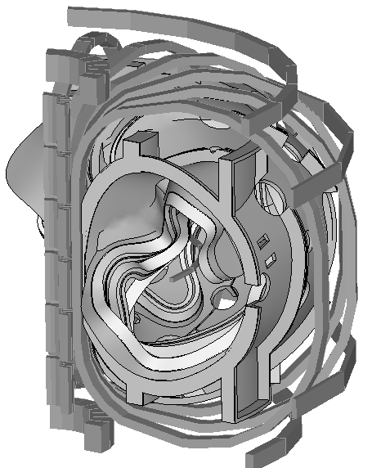
Fig. 1. Electromagnetic-Structural FE Model
Cross-face displacement (U) coupling in the global cylindrical coil system forces this six-coil subset to deform as if the other 12 modular coils are present. For each node (i) on the θ=+60˚ flange face, there is a corresponding node (j) on the θ=-60˚ flange face, and

U_{i}(r_{i},θ_{i},Z_{i}) = U_{j}(r_{i},θ_{i}-120˚,Z_{i}) (1)

Vertical displacement constrains are also added to provide numerical stability and prevent unrestrained motion even though all Lorentz forces sum to ~zero in this 120˚ sector.

The most critical material properties used in these analyses are listed below. While these values are either estimated from data sheets of similar materials or calculated by the rule of mixtures, it should be noted that the project is performing material property tests in order to determine more accurate values.

- Elastic moduli (E):
  - 193 GPa for the SS MC Shell
  - 79 GPa for the smeared MC WP
  - 153 GPa for the inter-module shims
- Coefficient of Thermal Expansion (CTE):
  - 13 μ/K for the SS MC Shell
  - 15 μ/K for the smeared MC WP
  - 17 μ/K for the inter-module shims

Coil currents and temperatures serve as the only applied loads, and are defined by the project’s reference scenarios. Of the seven reference scenarios established to meet the project operational requirements, the analysis evaluates a handful of limiting time points, focusing on when the currents are a maximum early in the pulse and when the temperature rise is a maximum late in the pulse. The 2T High-β scenario immerges as the most limiting current wave form for these MCs, with a peak WP current density of ~80 MA-t/m² and an end of pulse temperature rise of 38˚C.

III. RESULTS

The model is fully exercised in order to answer a number of important questions relative to the structural characteristics of the MC system. For example, the model is used to:
- Determine the running load at bolted flanges for bolt-sizing calculations.
- Determine the stiffness of the individual WFs from deformations in the poloidal break regions.
- Determine the maximum strain in the MC WP and stress history.
- Determine the maximum shear stress in the MC WP.
- Determine the stress distribution in the MCWF in order to perform a stress evaluation consistent with the project’s structural design criteria³.
- Provide deformed coil position for field error analysis.
- Determine the effects of various mechanical constraints (bolts, shear keys, or neither) in the crowded inboard flange region on WP stresses.
- Evaluate the effects of stiffening the WF shell on reducing deformations.
- Evaluate the effects of wing supports on stresses and deformations.
- Determine the mechanical requirements of the wing support structure.

The results of most of these studies are presented below. Brief descriptions of the analysis methodology and results are supplemented with graphics.

III.A. Flange Loads

The most substantial stresses develop in the MC WF when the coils are energized. EM loads produce compressive loads at some flanges and tensile loads at others. The model is used to determine the maximum loads which occur at the Poloidal Break and Coil-Coil joints. Principal stresses in the shell normal to each flange are plotted to determine the dominant load direction and integrated. Poloidal Breaks and Coil-Coil joints are exposed to tensile running loads of up to 1.6 and 0.5 MN/m, respectively. Bolts must be sized to provide at least this much preload.

III.B. MCWF Stiffness at Poloidal Breaks

MCWF manufacturers perform various operations which require cutting, spreading and machining the castings in the region of the poloidal breaks. Knowing the stiffness of the three different WFs helps them perform these operations.
Unit deformations are applied to the model in the region of the poloidal breaks and the reaction forces required to achieve those deformations are recorded. The stiffness of each MC shell is 10, 4 and 6 MN/m for Coils A, B & C, respectively.

III.C. Modular Coil Winding Pack Stress & Strain

The MCWP stress field is driven by EM and thermal loads. The most demanding time point of all reference scenarios is at t=0s of 2T High-β. There is no other occasion when the MCs are driven to higher currents.
A contour plot of the 1st principal strain in the Coil-A is shown in Fig. 2.

Fig. 2. 1st Principal Strain (%) in WP (2T, High-β, t=0s)

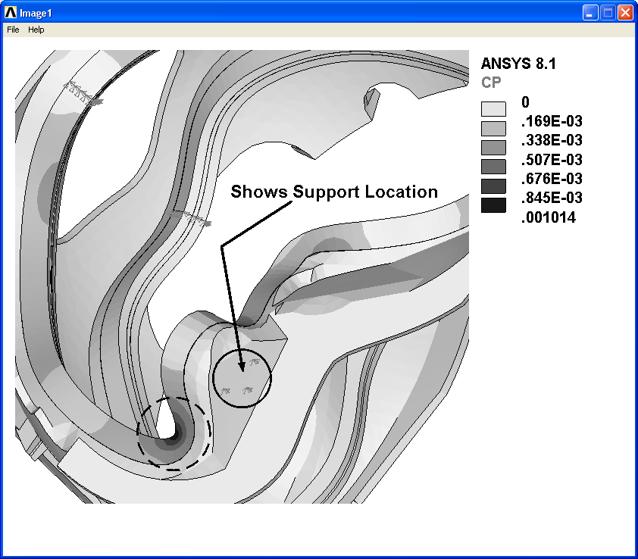
The legend indicates a maximum strian value of 0.1%, and its location is highlighted by a dashed circle. Notice that this occurs at the base of a Coil-A wing and is primarily due to the bending effect of the cantilevered structure. The solid circle locates the region where three wing surface nodes are coupled to the neighboring shell. This simulates the mechanical continuity achieved by a baldder shim which is pumped with glass-filled epoxy.

The maximum strain is indeed an important result. However, if the strain where constant over the life of the machine, there would be no fatigue life issues. Therefore, it is also important to characterize the stresses in the WP as a function of time.

Fig. 3 is a plot of the stress intensity history at the MCWP maximum stress location over two 2T High-β cycles. Stress values at some intermediate time points are omitted since they do not indicate a stress reversal and are bracketed by the t=0.0 s and the end of pulse (EOP) stresses. The histogram shows the following:

- The maximum stress occurs at t=0 s during the pulse.
- Cool-down to 85K produces a maximum stress of almost 30 MPa at the high-stress location.
- The slightly elevated WP temperature (~123K) at the EOP produces compressive stresses which results in a higher stress range compared to the room-temperature (RT) to t=0 stress pairing.
- The conditions produced at 85K are inconsequential to the cyclic stress history as they are within the larger stress range produced by t=0 and EOP.
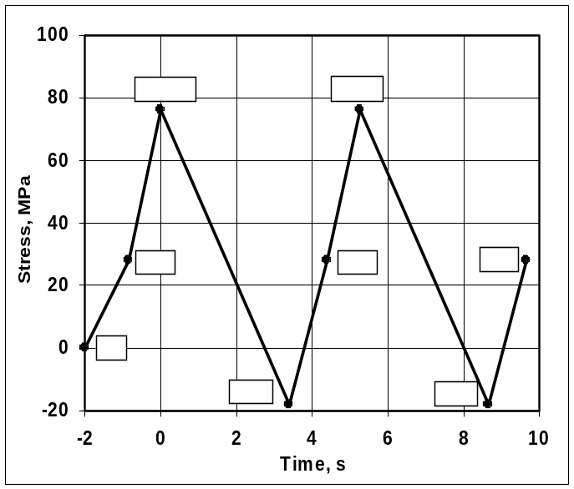
Fig. 3. Stress Histogram, 2T High-β, Max Stress Location
This stress hisogram is used to design fatigue tests of a prototypical racetrack coil. Although not completely conclusive, these tests lend credability to the cyclic robustness of the modular coil.

III.D. Modular Coil Winding Pack Shear Stress

Another critical parameter used to qualify large-scale electromagnets is shear stress in the insulation. Excessive shear stresses can lead to a structural failure of the insulation system and ultimately to an electrical short. The WP in this model is crudely represented as an orthotropic smear of Cu and glass insulation. This makes extracting accurate insulation stresses nearly impossible. It is a common practice, however, to determine the magnitde of the shear stress and compare it to some representative shear stress test on a prototypical conductor or coil pack; model-based smeared stresses are compared to test-based smeared stresses.

Fig. 4 is a contour plot of the shear stress modulus, SRSS(τ_{xy}, τ_{yz}, τ_{xz}), within the MCWP. In grey-scale, the plot is rather bland, but does show the location of the maximum stress. Again, the location is highlighted by a dashed circle. This time, the maximum stress is located at the tip of the large Coil-B wing. Most of the coil is below 20 MPa, with a volumetric average of 5 MPa.

The accuracy of these results can be called into question since they are in a smeared WP which is bonded to the WF. These preliminary results serve as a rough check compared to the projects preliminary RT shear stress test data which indicate a failure at 32 MPa. More testing is in-process.
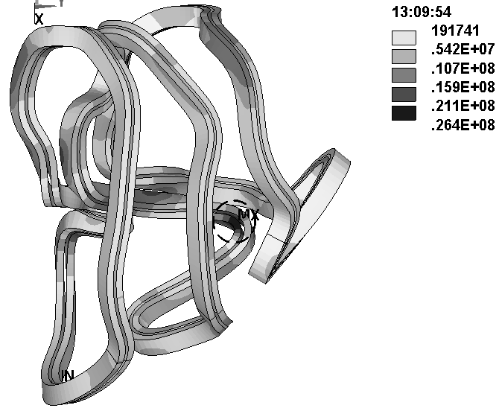
Fig. 4. MCWP Shear Stress Modulus (Pa)

III.E. Modular Coil Winding Form Stress

Stresses in the MCWF are a maximum when the MC currents are a maximum. Fig. 5 is a plot of the stress intensity in the Type-B SS shell as a result of the 2T, High-β, t=0.0s time-point. The legend indicates a maximum stress of 192 MPa and the dashed circle highlights its location. It occurs at the base of the Type-B wing, where there is a confluence of surfaces and a significant change in cross-section. Local inspection and detailing could extend the fatigue life of this WF.

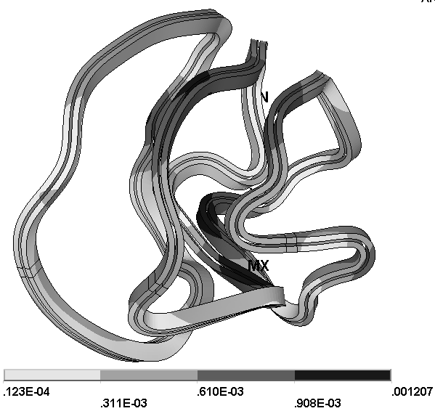
The maximum stress in the MCWF must be used to estimate the fatigue life and crack growth of the shell. Such data for the cast SS (CF8M) is still to be determined by project R&D.
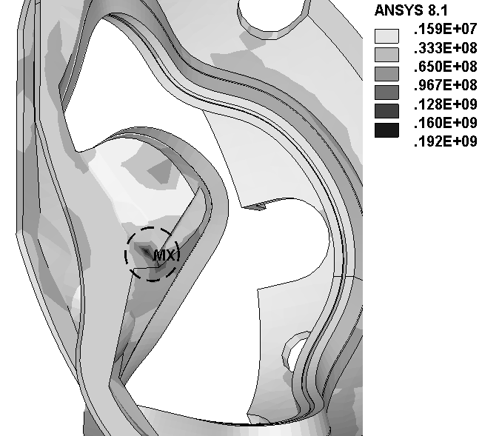
Fig. 5. Stress Intensity in the Type-B MCWF (Pa)
Also consistent with the project’s structural design criteria, static stresses must be categorized and compared to the design stress allowable values (multiples of S_{m} [3]). The largest primary stress is ~75 MPa which appears at the inboard leg of the Type-C shell. Preliminary data on the cast material has allowed the project to adopt an S_{m} value of 240 MPa (34.8 ksi). This is a factor of three above this primary membrane stress.

The inboard leg of Type-C is also the location of the maximum primary membrane plus bending stress at about 125 MPa. In this case, the allowable stress is 1.5S_{m} or 360 MPa, and another factor of three above the operating stress.

III.F. Coil Position for Field Error Analyses

Structural deformations from EM loads and non-uniform thermal contractions force the WP into a location and shape which is not precisely consistent with the ideal. Of course the project has a tolerance on coil position, which is intended (in part) for these types of anomalies. Here the model results (displaced WP element centroids) are exported to other project analysts in order to evaluate the effects of this “as-energized” coil position on field quality.

Fig. 6 is a plot of the Coil A, B & C deformed shape resulting from the now familiar 2T High-β t=0 currents. In this particular analysis, the large external Coil-C wing is supported by constraint equations which tie it to a symmetric location within its own shell. The legend shows a maximum deformation of ~1.2 mm, which is within the reference 1.5 mm requirement.
Fig. 6. WP Deformations (m) from Energized State
III.G. Effects of Constraints at Inboard Flange Region

When the MCs are assembled, the inboard region of the C-C joints will be difficult (if not impossible) to access. Therefore, the present plan is to omit mechanical fasteners from this region. A number of analyses are performed in which the cross-face coupling is varied to represent:

- No-slip coupling (tight-fitting bolts & shear keys).
- No continuity (poor fit up at assembly).
- Toroidal continuity only (no shear capacity).

The analysis indicates that ensuring toroidal continuity in the congested inboard is essentially as effective as achieving perfect (no-slip) coupling with bolts and shear keys. The maximum stress in the MCWF and WP are almost identical for these two configurations.

If, however, the fit-up at assembly is poor, and even toroidal continuity cannot be ensured, then the maximum stress in the WP will increase by ~12%.

Fortunately, the natural tendency of the MCs (fault cases excluded) is to pull towards the centerline of the machine, which forces toroidal continuity (wedging) at their inboard legs. This is illustrated (albeit poorly in grey scale) by Fig. 7 which contours the toroidal stress in the inter-WF shims. Here, black means compression and grey means tension. Clearly, these pieces are generally in compression.
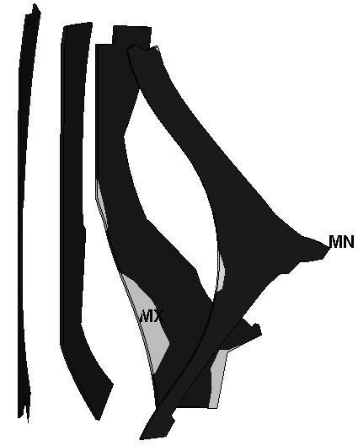
Fig. 7. Toroidal Stress in Inter-WF Shims (black = <0)
III.H. Requirements of the wing support structure

The MCWF “wings” carry varying EM load. While some wings extend well beyond their nominal “boundaries” or flange faces, others just scarcely break the plane. A number of analyses have been designed to demonstrate the importance of the wing support structure. In this analysis, continuity between a wing surface and the surface of the nesting adjacent shell is achieve by simply coupling the three displacement degrees of freedom at a few close-proximity nodes. This is shown in Fig. 2.

The forces normal to the surface at these coupled nodes are then summed to determine the normal compressive stress which must be carried by the actual epoxy-filled bladder structure. The analysis indicates that the most highly-stressed wing transmits about 0.6 MN. If this load passes through a shim which measures say 30 cm x 10 cm, then the average compression will be 20 MPa (~3ksi). This stress level is well within the capacity of a filled epoxy at 85K.

III. CONCLUSIONS

In conclusion, numerous and extensive analysis of the NCSX Modular Coil system using a very efficient and robust linear model have provided some valuable insights into its structural characteristics. Results such as stresses, deformations and loads have allowed the project to proceed with materials testing, preliminary structural and magnetic qualifications, and design improvements.

ACKNOWLEDGMENTS

The authors would like to thank Stephen Scampoli of ANSYS, Inc., for his knowledge and efforts towards meshing this very complex geometry. Without his advice, we may still be struggling with the model rather than producing useful analyses. We would also like to thank ORNL and PPPL management who have been supportive, helpful and patient through this very challenging task.

REFERENCES

[1] ANSYS, Release 8.1, UP20040329, INTEL NT.
[2] K. D. FREUDENBERG, et al., “Non-linear Analysis of the Modular Coil Windings for the National Compact Stellarator Experiment,” presented at ANS Technology of Fusion Energy, Madison, Wisconsin, 09/14-16/2004.
[3] Irving Zatz, (PPPL) “NCSX Structural Design Criteria, Draft E,” 5/10/04.

