Single–Circuit First Plasma Option

Wayne requested that we look into the possibility of generating a first plasma using a single circuit powering the modular coils in series. Here I report briefly on the results of this study.

First Plasma requires 25 kA plasma current at 0.5T with at least 50% of the transform coming from the coils. The 0.5T field requirement with the modulars run in series implies I1:I2:I3 = 200:200:180 kA-turns for the current in the modular coils.
A necessary requirement is that a vacuum state with good flux surfaces exists with these coil current ratios. Below, we show puncture plots on the 2 symmetry planes for a variety of initial conditions. The runs were made with PIES by Don Monticello.

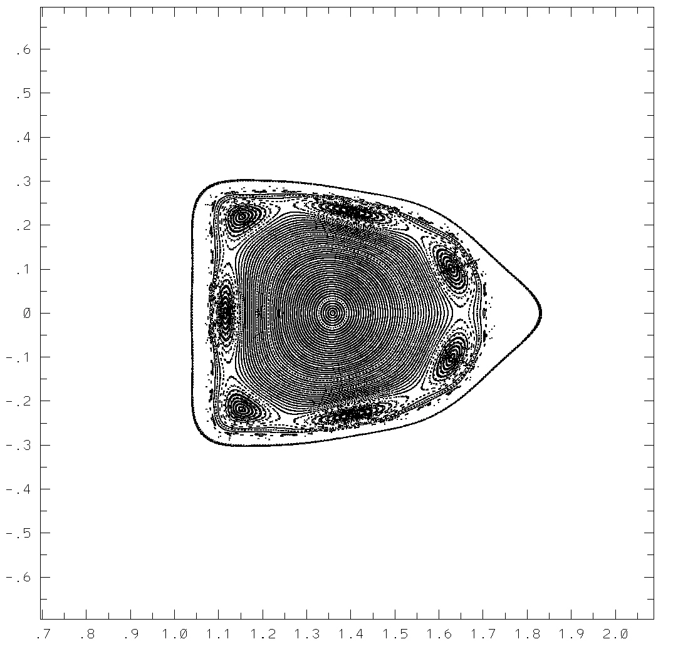
Puncture plot for Vacuum Configuration with modulars in series
V=1 symmetry plane
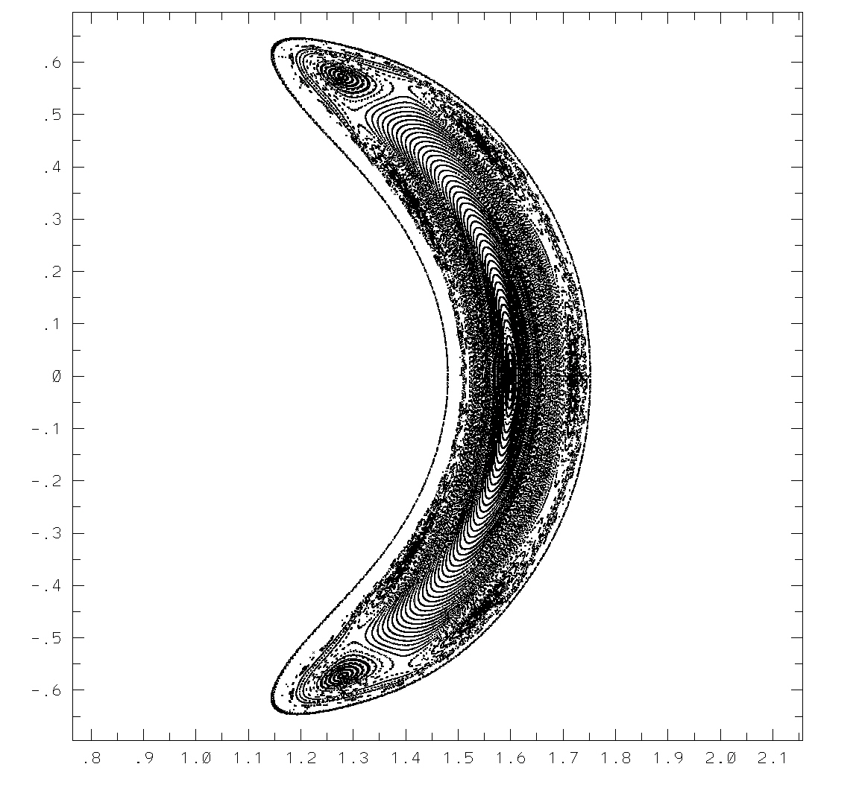
Puncture plot for Vacuum Configuration with modulars in series
V=0 symmetry plane

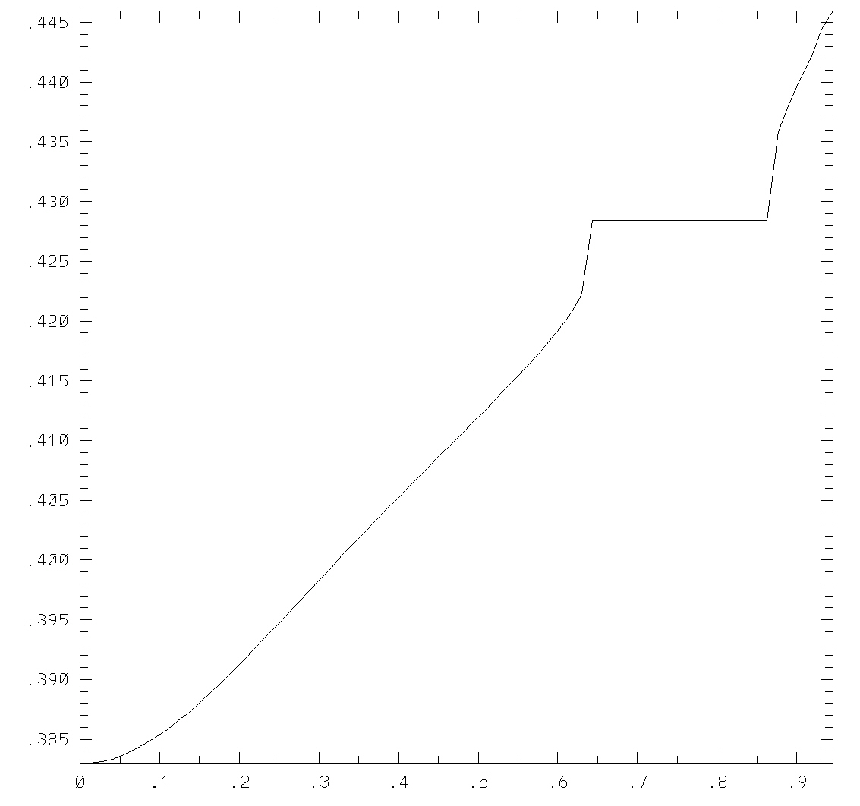
Iota profile for Vacuum Configuration with modulars in series
Iota-axis = 0.383. Iota-edge = 0.445
We note an extensive region of good surfaces, with the attractive feature of a 1/7 island chain (associated with iota = 0.429) near the plasma edge.

VMEC was run for the vacuum configuration and showed good agreement with the PIES iota profile albeit, of course, showing no island chain.

VMEC was also run with 25kA plasma current and a parabolic current profile at zero beta. A comparison of plasma boundaries between the VMEC vacuum state (black) and the VMEC 25kA state (red) are shown (at v=0 and v=1) below.
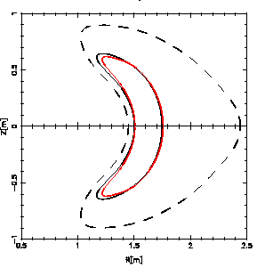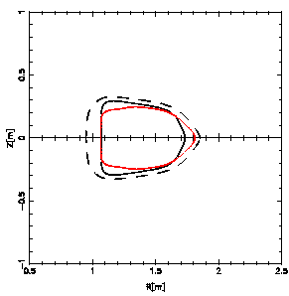

We see a significant change in shape as a result of the addition of the 25kA plasma current
The iota profile calculated by VMEC for the 25kA configuration is shown below (in red) . The iota profile is quite flat, with Iota –axis = 0.65 = Iota-edge, and Iota-max = 0.66 near the center. The relative contribution to iota from the coils and the plasma can be determined from a fixed-boundary VMEC calculation using the 25kA free-boundary plasma shape (the red boundary shown above). This results in the iota profile shown in green below. For this run Iota-axis = 0.50, Iota-edge = 0.57. Thus the coil contribution to the total transform varies between 7% at the axis and 88% at the edge.
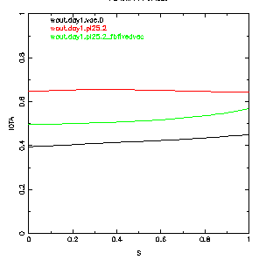
Finally, TERPSICHORE was run on the 25kA configuration and the external kink was found to be stable for the n=0 and n=1 families.

