15 January 2005

From: Wayne Reiersen
To: Distribution

Subject: Concerns about doing the TRC right and finishing it on time

We all recognize that completion of the Twisted Racetrack Coil (TRC) winding assembly is extremely important to do right and is schedule critical ( a Joule Milestone). Last week, Chrzanowski developed a detailed schedule in which we had a mere 1 week of schedule contingency on our Joule milestone. Subsequently, he went back and by going to 2-shift operations, found he could increase the schedule contingency to 2-3 weeks. That is a great improvement. His schedule is of course based on everything he needs being there when he needs it. His improved schedule requires that things be completed even sooner. I am nervous about that not happening…
Let’s review what Jim is going to need and then, what it is going to take to see that he gets it on time. I went over the test cell this morning and saw that the ground wrap was being applied. Once the ground wrap is in place, we can begin winding. That is going to happen soon. Permit me to ramble about the things I am nervous about...
Let me start with controlling the location of the current center. The winding operation is predicated on the assumption that no shimming is required in the direction normal to the tee. We are betting that we can get by simply by adjusting the tightness in the winding clamps or doing nothing at all. It is not clear to me what the basis is for the assumption that we can get by without shimming in this direction and still meet our tolerance for the location of the current center. Recall that the installed tolerance is +/- 0.060” (1.5mm). This tolerance has been allocated in thirds - 0.020” for coil fabrication, 0.020” for coil assembly into field periods, and 0.020” for final assembly (ref. Nelson, MCWF FDR). That means that the required tolerance for controlling the location of the current center is 0.020”. That is half the nominal thickness of the cladding and needs to account for errors in two directions – normal to the base and normal to the tee. If we split them evenly, we would have to control each within 0.014”. Anybody feeling comfortable?
This is just an aside, but I went to the TRC spec and could not find a tolerance requirement for the location of the current centroid. I could not use Intralink or ProductView to go to the drawings directly because they would not let me on. The TRC spec will be used as a template for the production winding spec and should include all appropriate requirements (Section 3) and identify how these requirements will be verified (Section 4). It needs to be expanded to include things like the tolerance for controlling the current center and how the location of the current center will be determined; coil resistance; temperature rise and cooldown for a specified current waveform; voltage test requirements; etc. The verifications prescribed in Section 4 should be sufficient to assure that the coil will work as expected when installed in the device. Major work is needed on the TRC spec. It does not have the required content. This is not news, but we needed to get it signed so that it was under change control prior to the start of fabrication. With Williamson’s consent, I will take the lead in drafting the next revision because I know the changes I would like to see and he has a very full plate right now (which represents no change in five years near as I can tell).
Back to controlling the location of the current center... An interesting metric would be to determine how much the trial winding distorted from the nominal cross-section. That was actually the purpose of the trial winding exercise and would answer the question of whether we would have to do any shimming at all in the direction normal to the tee. It would also tell us how much shimming we should expect to provide in the direction normal to the base. Unfortunately, we have not been able to make that determination yet. The Pro/E models that we have constructed for the winding from the metrology data of the winding form and outside of the winding “do not make sense”. We need to figure this out ASAP.
Recall that the TRC winding form surface is way out of spec with a maximum deviation greater than 0.080” which is 4x the winding center tolerance for coil fabrication. A fundamental question is this – when we wind the TRC, what defines the current center we are trying to hold? It would seem that because of the deficiencies in the winding form surface, we cannot possibly hold the “as designed” current center. If not, we must define a new winding geometry to shoot for during winding that is consistent with the flawed “as manufactured” winding form surface. Has this new winding geometry been developed? What is the plan?
The metrology procedure calls for measuring the windings as follows:

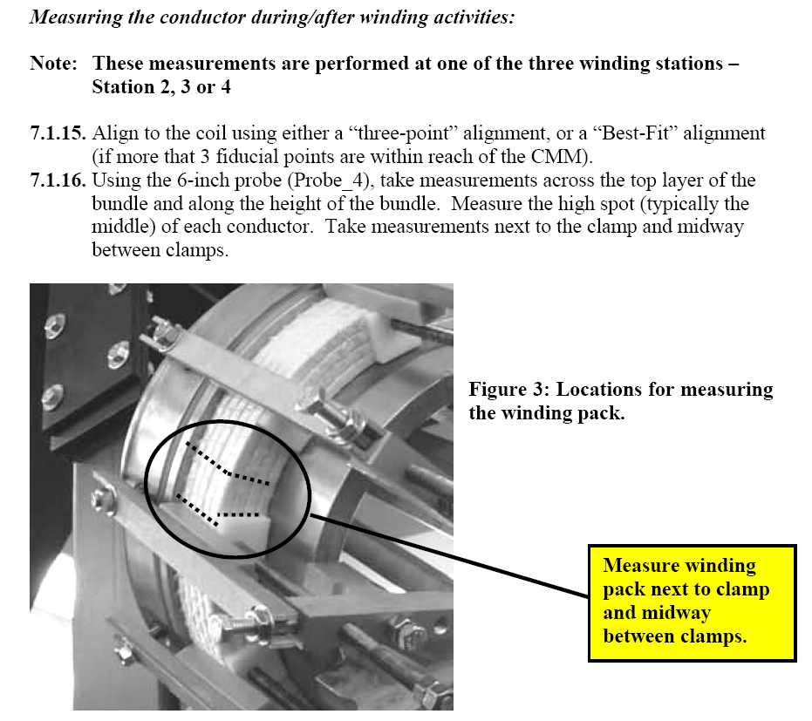
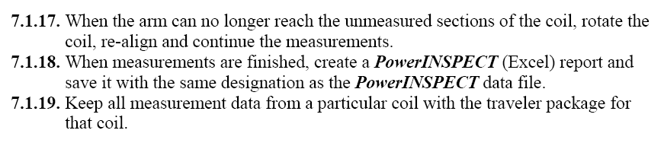

That is it. The output of the measurements per the metrology procedure is a PowerINSPECT report. The fact is that we are planning to add hard shims when winding the TRC between the third and fourth layers and between the sixth and seventh layers. (There are nine layers altogether in the TRC.) We need to know what size shim to put in at each location. We need to compare the data of where the top surface is to where the top surface should be (based on a CAD model of a partially completed winding). Have the CAD models required to support the metrology effort been generated yet? What is the plan? Do the engineers/technicians who will be making the measurements know exactly how to load the CAD models, register the CAD models to the part, and determine the required shim thickness each step of the way? Chrzanowski provided Dudek with a table of shims to be fabricated. Will they be available on time?
The winding procedure is also light on metrology-related detail. The relevant steps are shown below. The first metrology-related task is under the general winding notes, as shown below. The use of a Go/No-Go gauge is prescribed. The tolerance requirement has to be measured in absolute coordinates whereas a Go/No-Go gauge is a measurement relative to the winding form (which may be a challenge in itself). It is unclear to me what the value of the Go/No-Go measurement will be. In straight sections, I could imagine spotting gross out-of-tolerance conditions in a very straightforward way. In the curved and twisted regions, I am not sure I would trust my alignment of the gauge to sufficient accuracy to make a judgment.

The real guidance comes under the section on metrology measurements and tolerance control. In reading through the procedure, I saw that I was charged with determining the location and frequency of measurements for tolerance control. This should rightly fall to the individual responsible for Modular Coils who is much better informed to make this decision than myself, i.e. Dave Williamson. As previously mentioned, we are betting on being able to do this by using hard shims between two layers. The procedure should be updated to reflect our plan. Note that this procedure also does not state how we will use the metrology data to determine the required shim thickness. I suggest we work through this ahead of time so that when we have to do it for real, we will not be slowing completion of the TRC.
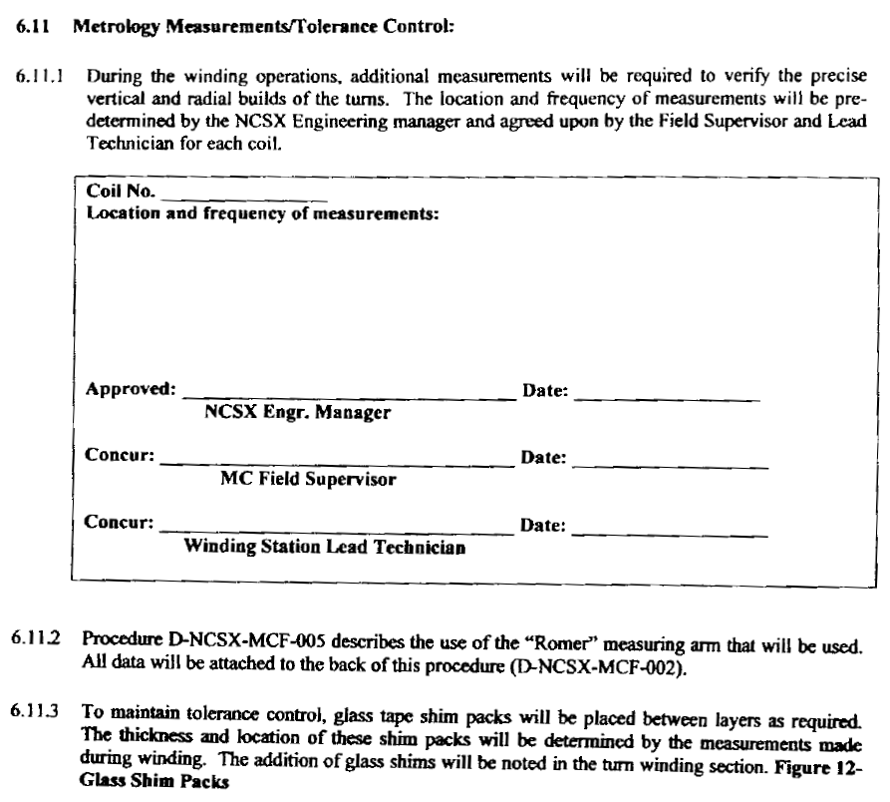
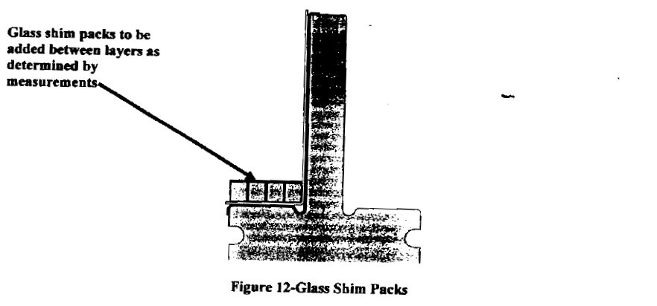

Getting back to the big picture, my next concern would be having the chill plates ready to install when they are needed. Chrzanowski indicated that he needed fabrication drawings by 01 February to have the parts made up by 01 March. (That was before he went to 2-shift operation.) He did offer some relief in that the chill plates for the second side were not needed as soon as the chill plates for the first side were, allowing staged completion of the fabrication drawings. In a telecon with Chrzanowski, Williamson expressed concern that Tom Hargrove (the cognizant designer for the chill plates) might not be able to finish them that quickly.
Let me suggest the following. We should have a meeting this week to review and finalize the changes in the chill plate and winding clamp concepts; review the results of the soldering trials and confirm their success; and develop a schedule for getting the required new parts fabricated and procedures written by when they are needed. We will process an ECP (and open an ECN) based on the outcome of that meeting to approve changing the TRC fabrication drawings accordingly. When ORNL finishes the drawings, they need to be checked, signed, approved for fabrication, and sent to PPPL ASAP. Assuming we are going to water-jet cut them here, Dudek needs to make a water-jet cutter available to support the cutting of the chill plates. Additional technicians will be required for de-burring. Procurement of the pre-tinned copper tubing will also be required. Modified production clamps will also be required, but not until after the winding assembly (i.e. Joule milestone) is completed.
Bottom line is there is a lot that needs to be done in the near term that needs tight coordination. Each day is important. Please consider the concerns expressed in this note and be pro-active in developing solutions where needed so we are not scratching our heads when we should be completing assembly of the TRC. Thanks for your cooperation.

Cc: Chrzanowski, Williamson, Nelson, Cole, Brooks, Brown, Raftopoulos, Neilson, Heitzenroeder, Dudek, Simmons

