NCSX Procurement Highlights Report – August 25, 2005

1. MCWF Procurement
- Frank Malinowski (PPPL QA) visited MTK with Peter Djordjevich and Roy Sheppard of EIO and Rosa Mediana from DCMA. The visit was useful in clarifying several open quality issues; this week’s Quality conference call was made while they were there. Frank’s findings are included in the comments below as appropriate..
- Machining of the C1 continues on schedule. MTM found that they can reach more areas on the 5 axis “U5” than they anticipated. This may eliminate the need to return to the 3 axis machine.

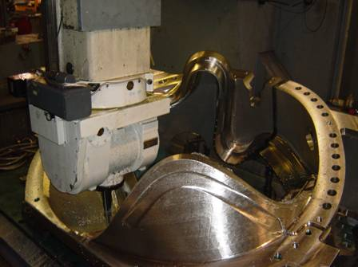
C1 on the 5 Axis “U5”

- A conference call was held with MTM and EIO Friday to discuss metrology and preparations for the final inspection of C1. As a result of these discussions, Tom Brown will visit MTM on Monday, 8/29 to coordinate the dimensional inspection verification process preparations. Phil Heitzenroeder will work out schedules for NCSX personnel required for support of final inspections during his visit to MTK next Thursday.
- Machining of C2 continues to progress smoothly. The poloidal break has been machined.
- A1 is ready for welding of the defects, but is awaiting welders. The welding will be followed by RT at MTK.
- Welding on C3 was completed, die Penetrant inspections were completed, and X-ray inspections at MQS were completed. The same truck will pick up C5.
- Grinding of defects found by RT in C4 is underway. This will be followed by sandblasting, mapping of the weld excavations, and weld repairs.
- EIO notes that C5 appears to be the equal of C4, which had been reported to be the “best casting to date”. As noted above, it will be shipped to MQS for RT (by Monday).
- MTK started building the C6 pattern, and expect to pour it by the end of the month.
- All of the modeling was completed on the Type B Pattern. The drag portion is down to final assembly work. Lawton has 2 major core boxes remaining along with some minor neck boxes. The final box is scheduled for the large router during the last week of August.
- 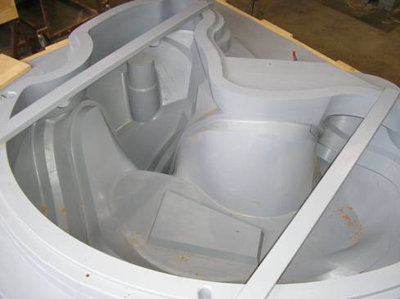
Part of the Type B Pattern

2. NCSX Vacuum Vessel
- Mike Viola visited Major Tool last week, and returned this week to observe first hand the alignment of the first two 60 degree sectors.
- MTM in the process of joining the two 60 degree sectors. Alignment issues have been identified and are being addressed. This may take another week to complete.
- The inspection file for the out of tolerance area on the first 60 degree segment was sent to Tom Brown and Mike Cole; they determined that these areas are not an issue.
- The second 60 degree sector is completely in tolerance.
- All 6, 8, and 10” ports were received.
- The 31/2” ports were rolled; they need to be welded, shaped, and polished. They should be finished in time to meet schedule.
- Panel production still requires close oversight – progress is not uniform.
- The upper section of the 3rd 60 degree segment has been completed; the lower section is now being worked on.



