Statement of Work for

NCSX Modular Coil Cable

Vacuum Impregnation

Plus

Mechanical and Thermal Testing

NCSX-SOW-142-02-00

approvals

Prepared by:_______________________________________ Date___________________

I. Zatz, NCSX Coil Engineer

Concur: ____________________________________________ Date ___________________

D. Williamson, NCSX Coil Systems Mgr.

Concur: ____________________________________________ Date ___________________

J. Chrzanowski, NCSX Coil Engineer

Concur: ____________________________________________ Date ___________________

B. Nelson, NCSX Stellarator Core WBS 1 Mgr.

Concur: ____________________________________________ Date ___________________

F. Malinowski, PPPL Quality Assurance Engr.

Approved by: _______________________________________ Date ___________________

W. Reiersen, NCSX Engineering Project Manager

REVISIONS

Revision No. | Affected Pgs. | Date
0 (Initial Release) | All

Table of Contents
 | Page

1. GENERAL INFORMATION
1.1 Introduction | 1
1.2 Background | 1
1.3 Scope | 5
1.4 Applicable Documents | 5

2. Work Requirements
2.1 Vacuum Impregnation of the Modular Coil Cable | 5
2.2 Test Specimen Preparation | 8
2.3 Mechanical and Thermal Testing | 8
2.4 Subcontractor’s Recommendations | 10
2.5 Additional Manufacturing Development and Testing Activities | 10
2.6 Firm Fixed Cost and Schedule Proposal | 10

3. Quality Assurance
3.1 Inspection / Surveillance / Audit by PPPL | 10
3.2 Subcontractor’s Responsibility for Conformance | 10
3.3 Subcontractor’s Quality Assurance Program | 11
3.4 Processing Plans | 11
3.5 Inspection and Test Procedures | 11
3.6 Document Traceability and Records | 11
3.7 Equipment / Material Identification and Status | 11
3.8 Calibration of Test and Measuring Equipment | 11
3.9 Control of Special Processes | 12
3.10 Release for Shipment Form | 12
3.11 Process History | 12
3.12 PPPL Receiving and Inspection | 12

4. DELIVERABLES
4.1. Weekly Reports | 12
4.2. Technical Reports | 12
4.3. Prototype Processing Plans | 12
4.4. Documentation | 12

1. GENERAL INFORMATION

1.1 Introduction

Stellarators are a class of magnetic fusion confinement devices characterized by three dimensional magnetic fields and plasma shapes and are the best-developed class of magnetic fusion devices after the tokamak. The stellarator concept has greatly advanced since its invention by Dr. Lyman Spitzer, the founding director of the Princeton Plasma Physics Laboratory (PPPL), during the 1950’s. A traditional stellarator uses only external magnetic fields to shape and confine the plasma. The National Compact Stellarator Experiment (NCSX) is the first of a new class of stellarators known as “compact stellarators.” The differentiating feature of a compact stellarator is the use of plasma current in combination with external fields to accomplish shaping and confinement. This combination permits a more compact device. The NCSX project is managed by PPPL in partnership with the Oak Ridge National Laboratory. This Subcontract will be administered by PPPL. Operation of NCSX is scheduled to begin in July 2007.

In preparation for fabrication of critical components, PPPL is initiating manufacturing development and testing activities. This Statement of Work is for two of these activities - the vacuum impregnation of the modular coil conductor cables followed by the mechanical and thermal testing of these cables, both individually and in bundles.

1.2 Background

Figure 1 is a sectional view of the NCSX device showing its major components. Note the modular coil set with an integral shell; the vacuum impregnation and testing of these modular coil cables are the subjects of this SOW.

The modular coil windings are shown in Figure 2 without their associated winding forms to permit the complex shape of the windings to be more readily seen. There are three distinct shapes; six of each make up the complete modular coil set. To fabricate these windings to the precise shapes required, stranded copper cable conductor is wound on the machined stainless steel winding forms, as shown in Fig. 3. In addition to defining the shape of the coils, the winding forms also provide the strong structural support necessary to react electromagnetic loads as high as 7000 lbs. / in. Note: Figures 1-3 are only for illustration and should not be used in the performance of this Scope of Work.

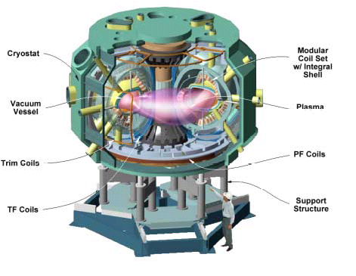

Fig. 1. The NCSX Device and Definition of its Major Components

Note in particular the Modular Coil Set with Integral Shell. This integral shell is comprised of the (18) winding forms that are the subject of this SOW. A typical winding form is shown in Fig. 3.

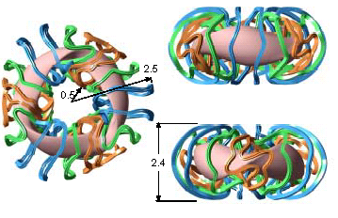

Fig. 2. The NCSX Modular Coil Windings

The windings are shown without their associated winding forms so their complex shapes can be easily seen. In order to manufacture these windings to their precise shapes, stranded copper conductor is wound on the machined winding forms (shown in Fig.3), which are the subject of this Statement of Work. Six of each of the three winding form shapes are required. (Dimensions in meters)

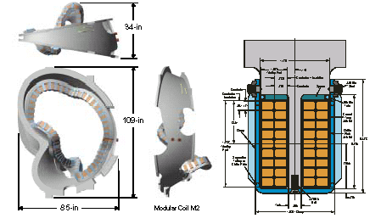

Fig. 3. NCSX Modular Coil Details

Shown is one of the three winding form shapes. The left view shows a sectional view of the form with the stranded cables conductors wound in place on both sides of the “T” section. The winding form serves two very important functions: it defines the precise shape of the winding and provides the required structural support.

1.3 Scope

The scope of this SOW includes three separate tasks. First, a fabrication process and procedure shall be developed for the production of vacuum impregnated modular coil cable. This will be followed by fabricating a sufficient quantity of vacuum impregnated specimens which will then be used to perform mechanical and thermal testing of the cables. The final task, the actual test program, shall conform to ASTM standards as rigorously as possible and be used to determine specified properties of the cables in various configurations. The Subcontractor shall submit a firm fixed price and schedule proposal for these efforts.

1.4 Applicable Documents

Further details about the design and specifications for NCSX are currently available on the NCSX Manufacturing and Engineering Websites at

http://www.pppl.gov/me/NCSX_MFG/ and

http://www.pppl.gov/me/NCSX_Engineering/

In the event of any inconsistency between this SOW and the information on the websites, this SOW shall govern. Please note that some of the web information is preliminary and is to be used only for planning and proposal preparation.

2. WORK REQUIREMENTS: The tasks described below should be performed approximately in the order indicated. It is expected that the Subcontractor may be working on several in parallel. Schedule requirements are described in the Subcontract. Subcontractor suggested variations in these requirements are discussed in Section 2.4.

2.1 Vacuum Impregnation of the Modular Coil Cable

2.1.1 Process Development: The Subcontractor shall develop a comprehensive fabrication process and written procedure for the production of vacuum impregnated modular coil cable in lengths of approximately 45 inches. PPPL will provide the mold, the necessary coil cable, and the proper glass tape and Kapton. Process development will involve the following:
- Adaptation of the PPPL's provided mold with the Subcontractor’s vacuum impregnation fixturing
- Development of a wrapping and insulating technique to apply the glass fabric tape and Kapton to the cable
- Development of procedures of vacuum impregnation of the cable
- Performance of trial vacuum impregnations with liquid resin
- Visual and microscopic evaluation as to the degree of impregnation

2.1.2 Materials: The vacuum impregnated modular coil cables are comprised of the following components:

• Compacted copper conductor cable (provided by PPPL)

(4) Individual ropes 2 x 2 [0.250" x 0.3125"]

• Turn Insulation scheme as noted on Figure 4

- (1) 1/2 lapped layer 0.007 inch thick glass tape

- (2) 1/2 lapped co-wound layers glass/Kapton insulation

• 0.007 inch thick glass insulation

• 0.003 inch thick Kapton insulation

• Ground insulation (Multiple turns)

(2) 1/2 lapped layer 0.01 inch thick glass tape

• Epoxy

Product "CTD-101K (Composite Technology Development Inc.)

Mixing Ratio's

Resin (Part A) 100.0 pbw

Hardener (Part B) 90.0 pbw

Accelerator (Part C) 1.5 pbw

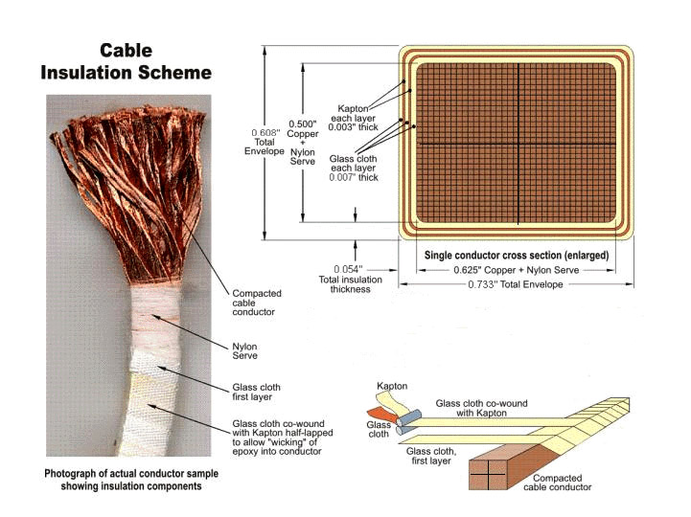

Fig. 4. NSCX Modular Coil Cable Turn Insulation Scheme

Shown above are the components and sequence of assembling the modular coil cables

2.1.3 Impregnation Process: Preheat components to 40 degrees C. After mixing, degas components. Vacuum impregnate copper insulated samples using the materials and epoxy system as described in Sect. 2.1.2.

2.1.4 Cure Cycle:

• Following VPI, ramp up specimen from starting point of 40-45 degrees

• Ramp up 20 degrees per hour to a temperature of 110 degrees C (Gel temperature)

• Hold at 110 degrees C for 5 hours

• Ramp up to 125 degrees C (Cure temperature)

• Hold at 125 degrees C for 16 hours

• Ramp down slowly until sample reaches room temperature

2.1.5 Final Inspection: Describe the final inspection methods proposed to assure that the impregnated modular cables meet all of the requirements of this SOW. The degree of epoxy penetration within the cable body shall be noted.

2.2 Test Specimen Preparation: The Subcontractor shall recommend changes to the design or Specification that could make the winding fabricate a sufficient quantity of specimens for tension and flexural testing of a single modular coil cable at four different temperatures. Six specimens of each type will be needed at each temperature, resulting in a total of 24 specimens each. Additionally, the Subcontractor shall produce specimens for measurement of thermal conductivity and specific heat. Assuming a 45-inch, useable section of insulated cable is produced from a single impregnation run, the following number of production runs will needed:
- Tension specimens – assumed to be 15 inches long, 10 production runs
- Flexural specimens – assumed to be 10 inches long, 6 production runs
- Thermal Conductivity and specific heat – specimen size TBD (in coordination with PPPL), 1 production run

The Subcontractor shall produce two-by-two bonded cable bundle (four cables) specimens for shear and flexural testing. Production of these specimens will require the fabrication of a mold capable of ensuring adequate resin impregnation to all four cables. The Subcontractor shall test these specimens in shear and in flexure, if possible. As with the single modular coil cable above, 24 specimens of each type will need to be produced. A mold approximately 30-inch long is envisioned, enabling multiple specimens to be taken from one production run. Vendor shall recommend mold size. The following number of production runs will needed:
- Shear specimens – assumed to be 7 inches long, 6-7 production runs
- Flexural specimens – the necessary specimen size is estimated to be approximately 16-18 inches. The Subcontractor is unable to test specimens of this size; therefore, specimens will not be produced.

2.3 Mechanical and Thermal Testing: The Subcontractor shall conduct testing at four temperatures: 76 K, 100 K, 150 K, and 295 K. Six (6) specimens of each type shall be tested at each temperature. The tests to be performed are described below:

2.3.1 Mechanical Tests on a Single Modular Coil Cable

2.3.1.1 Tension Tests: The Subcontractor shall perform these tests in accordance with an applicable ASTM test standard (such as ASTM D3039), modified as necessary to conform to the specimen’s insulated nature. The Subcontractor shall fabricate appropriate grips as required to grip the cable and assure uniform load distribution. Two strain gages shall be bonded to each specimen, on opposing sides, to determine elastic modulus and Poisson’s ratio. Yield strength, ultimate strength (if attainable), modulus, Poisson’s ratio, and failure mode shall be reported. Failure criteria shall be determined through consultation with PPPL prior to the start of testing.

2.3.1.2 Flexure Tests: The Subcontractor shall perform flexure in accordance with ASTM D790, which uses a 3-point bend fixture. The Subcontractor shall fabricate test fixturing as required to support the specimen. The flexural strength and the flexural modulus of the specimens shall be reported. The Subcontractor shall perform a brief evaluation of the results to determine if the properties are dependent on cable orientation.

2.3.1.3 Thermal Expansion Tests: The Subcontractor shall determine the coefficient of thermal expansion for a temperature range from 76 K to 295 K.

2.3.2 Thermal Properties of a Single Modular Coil Cable

2.3.2.1 Thermal Conductivity and Specific Heat: The Subcontractor shall subcontract these test measurements to Precision Measurements and Instruments Corporation (PMIC) in Corvallis, Oregon. The Subcontractor shall fabricate specimens for testing by PMIC at the four temperatures listed above. Thermal conductivity shall be determined in two directions - within the cross section and axially.

2.3.3 Mechanical Testing of a Two-by-Two Bonded Cable Bundle

2.3.3.1 Shear Tests: The Subcontractor shall perform shear tests will be conducted on a two-by-two cable bundle in accordance with ASTM 2344, which is a Short-Beam Shear test using a three point bend test fixture. The Subcontractor shall fabricate test fixturing as required to support the specimen. The apparent shear strength and flexural modulus shall be reported.

2.3.3.2 Flexural Tests: Due to the size of the two-by-two cable bundle specimen, flexural tests shall not be performed.

2.4 Subcontractor’s Recommendations: The Subcontractor shall recommend changes to the vacuum impregnation process and test program outlined in Sections 2.1-2.3 that could make the modular coils easier to manufacture, reduce costs, improve performance, or improve the fabrication schedule. The Subcontractor shall also recommend an alternate plan for performing the two-by-two bonded cable bundle flexural test discussed in Sections 2.2 and 2.3.3.2. PPPL reserves the right to accept or reject any or all of the Subcontractor’s change recommendations, or to incorporate them into the coil design in whole or in part, even in the event that the contract award for modular coil production is to another supplier.

2.5 Additional Manufacturing Development And Testing Activities: The Subcontractor shall perform and document any additional agreed upon manufacturing development and testing activities that are necessary to develop the knowledge required to produce the vacuum impregnated modular coil cables and reduce the technical, cost, and schedule risk. (These additional activities are to be defined in the Subcontractor’s Proposal and shall be set forth in the Subcontract.)

2.6 Firm Fixed Price and Schedule Proposal: The Subcontractor shall provide a firm fixed price and schedule proposal for the vacuum impregnation of the modular coil cables and test program as outlined in Sections 2.1-2.3 and provided in the Subcontract.

3. Quality Assurance

3.1 Inspection/ Surveillance/Audit by PPPL: Authorized representatives of PPPL and the U. S. Government shall have the right at all reasonable times to visit the Subcontractor's premises and those of Subcontractor's suppliers during the performance of the Subcontract for the purposes of inspection, surveillance, audit and/or obtaining any required information as may be necessary to assure that items or services are being furnished in accordance with specified requirements. Such visits shall be coordinated with the Subcontractor's personnel to minimize interference with the normal operations of said premises. The Subcontractor shall make available records and documentation necessary for this function and shall provide all reasonable facilities and assistance for the safety and convenience of PPPL and/or U. S. Government representatives in the performance of their duties. PPPL and the U. S. Government recognize the Subcontractor's right to withhold information concerning proprietary processes. The Subcontractor agrees to insert the paragraph above in each lower-tier procurement issued hereunder.

3.2 Subcontractor's Responsibility for Conformance: Neither PPPL review and/or approval of Subcontractor's documents nor PPPL inspection of Subcontractor's items or services shall relieve the Subcontractor of responsibility for full compliance with requirements of the purchase order/contract. The Subcontractor is responsible for assuring that all requirements and restrictions are imposed on any subtier suppliers.

3.3 Subcontractor’s Quality Assurance Program: The Subcontractor shall establish and maintain an effective Quality Assurance Program to assure that the Subcontractor’s work meets the required quality and is performed in accordance with contractual requirements. Subcontractor’s quality assurance function shall be organized to have sufficient authority and independence to identify quality problems, verify conformance of supplied items or services to specified requirements and obtain satisfactory resolution of conflicts involving quality.

3.4 Processing Plans: The Subcontractor shall prepare Manufacturing/Inspection Test (MIT) and Quality Assurance (QA) Plans for PPPL review and approval.

3.4.1 Within the MIT plan, the Subcontractor shall identify processes and materials and show their integrated flow into end items. The plan shall also identify critical manufacturing operations and inspections and tests. Procedures and/or protocols for contaminant control and cleanliness shall be included with the MIT. Preparing the Plan may include developing a flow chart and generating Process Sheets/Shop Travelers, etc. PPPL may designate selected manufacturing, inspection and/or test operations as mandatory “witness” points based on the MIT plan. Subcontractor shall provide PPPL with a minimum of five (5) working days notice in advance of witness points described in the MIT plan. Such witness points shall be mutually planned to minimize delays.

3.4.2 The Quality Assurance Plan shall describe the specific quality assurance and quality control procedures and practices to meet the requirements of this subcontract and associated specification.

3.5 Inspection and Test Procedures: Inspections and tests shall be performed in accordance with written procedures referencing criteria for acceptance or rejection. Actual data and accept/reject status for each inspection and test shall be documented for each winding form.

3.6 Document Traceability and Records: The Subcontractor shall maintain a system of documentation whereby objective evidence of required operations, inspections, examinations, and tests is systematically compiled, indexed and stored. Such objective evidence may include "travelers"; and material test, certification, inspection, examination, test and discrepancy reports; which shall be complete, legible, and validated by responsible personnel and shall be traceable to subject items.

3.7 Equipment/Material Identification and Status: Material and equipment identification shall be maintained throughout the program and be traceable to the records. Status of acceptability shall be readily discernible through the Subcontractor's use of tags, stamps, serial numbers or other positive means.

3.8 Calibration of Test and Measuring Equipment: Inspections and tests shall be performed using properly calibrated measuring and test equipment. Subcontractor shall have in its possession the necessary equipment to perform the required inspections and tests. Calibration standards shall be traceable to the National Institute for Standards and Technology (NIST) or equivalent acceptable to PPPL and shall not be used for shop inspections, but instead be protected against damage or degradation.

3.9 Control of Special Processes: Subcontractor shall use trained and qualified personnel and qualified written procedures in accordance with specified requirements for the performance of certain special processes, including but not limited to, soldering, electronic assembly, brazing, welding, plating, heat treatment, nondestructive examination, etc. Copies of special process procedures shall be available for review by PPPL and submitted to PPPL for review and approval if requested.

3.10 Release for Shipment Form: Subcontractor shall have a signed "Product Quality Certification and Shipping Release" Form ( Attachment 1 of this SOW) prior to NCSX Project acceptance of procured items or services for full or partial shipment. NCSX Project reserves the right to refuse to accept shipments unless accompanied by a signed "Shipping Release Form”.

3.11 Process History: Subcontractor shall provide to PPPL, with the shipment release request, a Process History, which includes a compilation of documents, detailing the objective evidence of the acceptability of the work performed. The Process History shall include as a minimum, but not be limited to, the following:

3.11.1 Material Certifications: The Subcontractor shall submit Material Test Reports showing actual relevant chemical, mechanical, and electrical properties of materials used and providing traceability to the actual material. Material certifications from sub-tier suppliers shall also be submitted. One copy is to be submitted upon Subcontractor acceptance for use.

3.11.2 Inspection and Test Reports: Copies of the original reports of all required inspections, tests and examinations, which have been properly validated by authorized personnel.

3.12 PPPL Receiving and Inspection: PPPL will perform Receiving Inspection on items or services supplied by Subcontractor, using either a sampling plan or 100% inspection. Discrepant items or services will be rejected and returned to Subcontractor or reworked by PPPL at the Subcontractor’s expense.

4. DELIVERABLES

4.1. Weekly Reports: Weekly status reports covering technical, administrative, and Quality activities shall be provided to Princeton’s Technical and Administrative Representatives by e-mail every Friday during the period of performance.
  - Technical Reports: Provide (3) printed copies and (1) electronic copy in Adobe Acrobat (.pdf) format of all technical reports by the dates specified in the Subcontract.

4.3 Prototype Processing Plans: MIT & QA Plans for the vacuum impregnation (Sect. 2.1)

4.4 Documentation: As described in Sect. 3.11 of this SOW.

PRINCETON UNIVERSITY

Ata ATTACHMENT 1.

PLASMA PHYSIC LABORATORY—PPPL

PRODUCT QUALITY CERTIFICATION AND SHIPPING RELEASE
PROJECT | ITEM DESCRIPTION |  |  |  | SHIPMENT NUMBER
PPPL Subcontract / Order No. | REV. | ITEM NO. | SUPPLIER REFERENCE NO. |  | REV. | QUANTITY SHIPPED

SUPPLIER'S CERTIFICATION

This is to certify that the products and services identified herein have been produced under a controlled quality assurance program and are in conformance with the procurement requirements including applicable codes, standards and specifications as identified in the above-referenced documents unless noted below. Any supporting documentation will be retained in accordance with the procurement requirements.

SIGNED: _________________________________________ DATE: __________________________

TITLE: _________________________________ COMPANY: _______________________________

PPPL (AUTHORIZED REPRESENTATIVE) SHIPPING RELEASE

This is to certify that evidence supporting the above Supplier's Certification statement has been audited and no product/service nonconformances from procurement requirements have been found unless noted below. This product/service is hereby released for shipment.

This section serves as the Quality Assurance release for the above described product for shipment. It does not constitute an acceptance thereof and does not relieve the Vendor, Manufacturer or Contractor of any and all responsibility or obligation imposed by the purchase contract. It does not waive any rights the Purchaser may have under the purchase contract, including the Purchaser's right to reject the above described material upon discovery of any deviations from requirements of the purchase contract, drawings and specifications.

NONCONFORMANCES FROM PROCUREMENT QUALITY REQUIREMENTS:

REMARKS/PRODUCT SERIAL NUMBERS:

BY PPPL QA REPRESENTATIVE (OR DESIGNEE) |  |  |  | DATE

