A review of the modular coils has been made to identify any floating hardware that may exist in the completed coils or those yet to be completed. Three areas or locations have been found where there exists floating components inside of the modular coil. These include cladding, copper chill fingers or strips, and stainless lead block hardware. These types of floating components are described in the sections below the table. The table identifies which modular coils have these floating components. The floating hardware concerns were addressed during the review of the C1 lead area problems. Most of these were external and were easy to address. However, several of these floaters were already installed in the coils and cannot be corrected without rebuilding these coils [see table].

Identification of Floating Hardware in Modular Coils
Modular Coil Name | Cladding-Lead Area [floating] | Cladding- Poloidal Break [floating] | Copper Lead Strips [floating] | G-11 Lead Block Hardware [floating]
A1 | No | No | No | Yes
A2 | No | No | No | Yes
A3 | No | No | No | Yes
A4 | No | No | No | Yes
A5 | No | No | No | Yes
A6 | No | No | No | Yes
B1 | No | No | No | Yes
B2 | No | No | No | Yes
B3 | No | No | No | Yes
B4 | No | No | No | Yes
B5 | No | No | No | Yes
B6 | No | No | No | Yes
C1 | Yes | Yes | Yes | Yes
C2 | Yes | Yes | Yes | Yes
C3 | Yes | Yes | No | Yes
C4 | Yes | Yes | No | Yes
C5 | No | No | No | Yes
C6 | No | No | No | Yes

Description of Floating Hardware

1) The first type of floating components is the inner copper cladding located in both the lead area and Poloidal break. These were identified during the C1 lead area review, but were already installed on modular coils C1 thru C4. For those coils beyond C4, the copper cladding was replaced with G-11CR fillers. Figure 1 shows original cladding in Poloidal break area of C1.

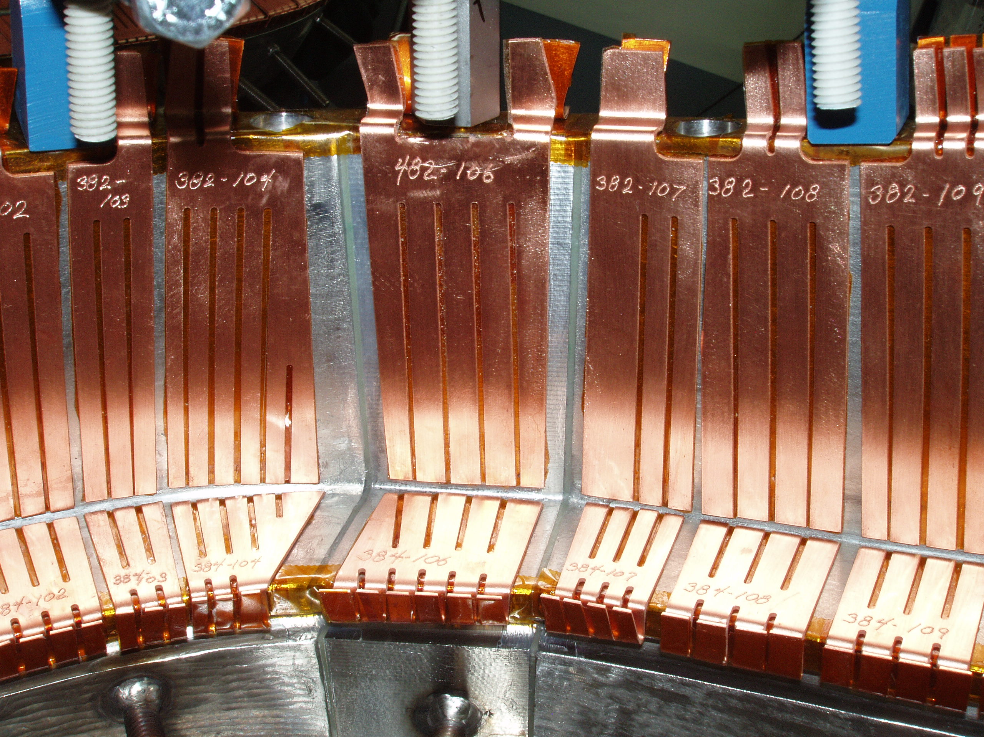
Figure 1- Poloidal break cladding

2) The second type of floating hardware is the copper lead filler strips that are used to cool the lead area [Figure 2]. These copper strips were originally insulated with Kapton insulation on all surfaces. As a result of the findings from the C1 review the insulation scheme on the copper strips was modified. Kapton insulation remained at the interface between the leads and copper strips, but the insulation was removed on the chill plate interface so that they strips were no longer isolated from ground [Figures 3 & 4].
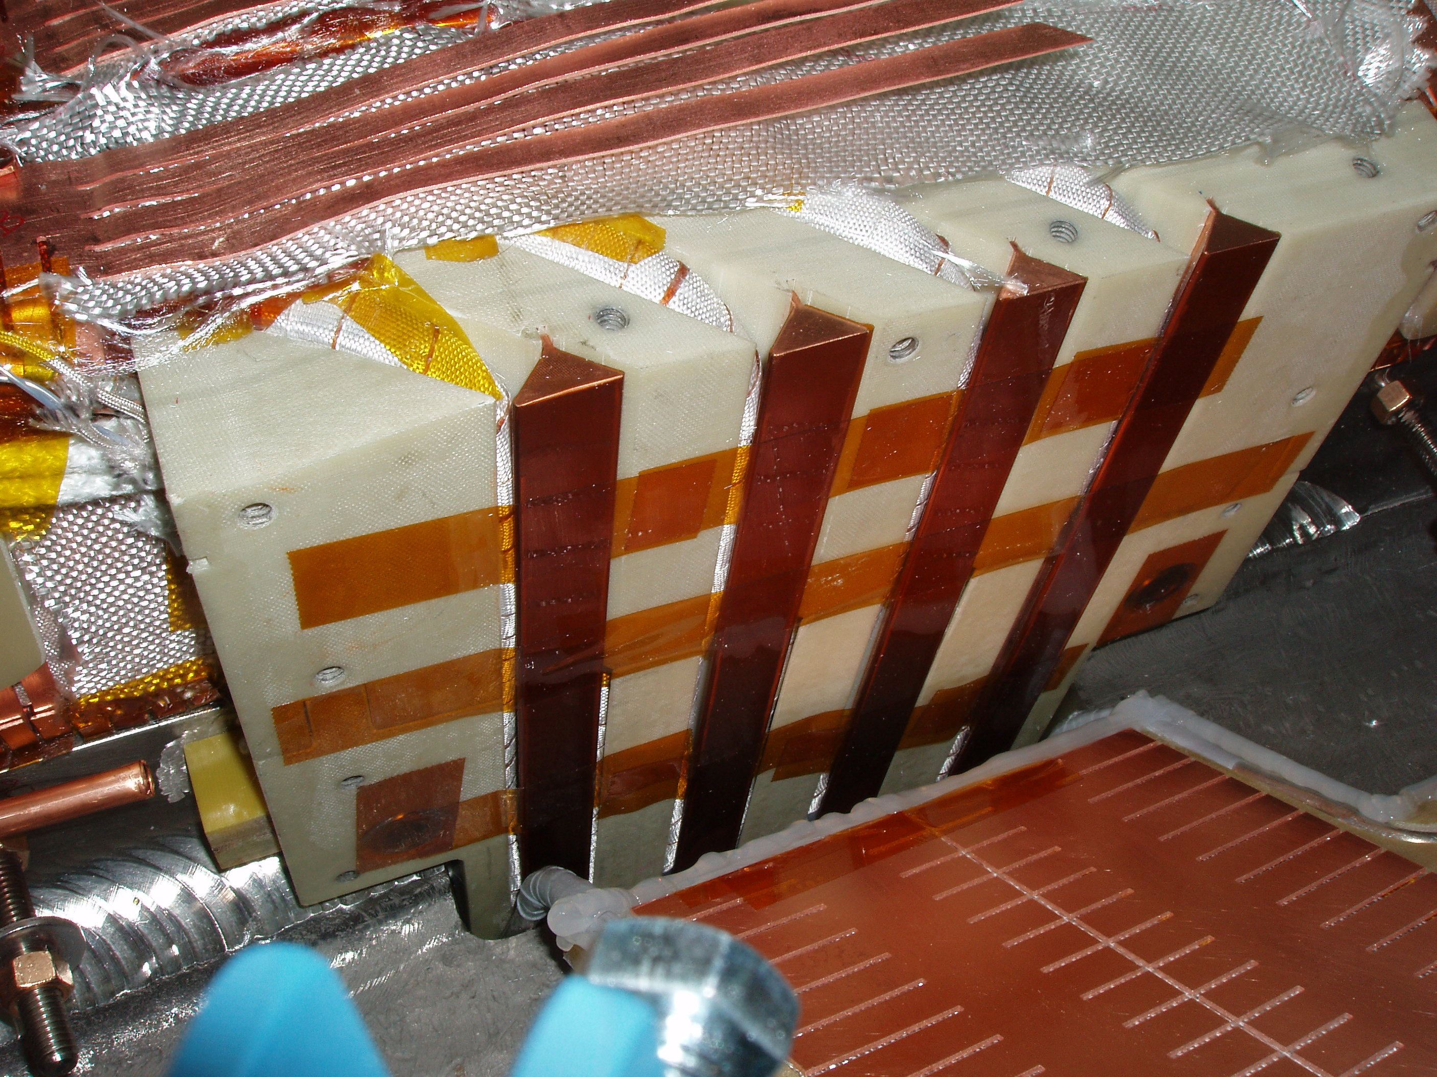
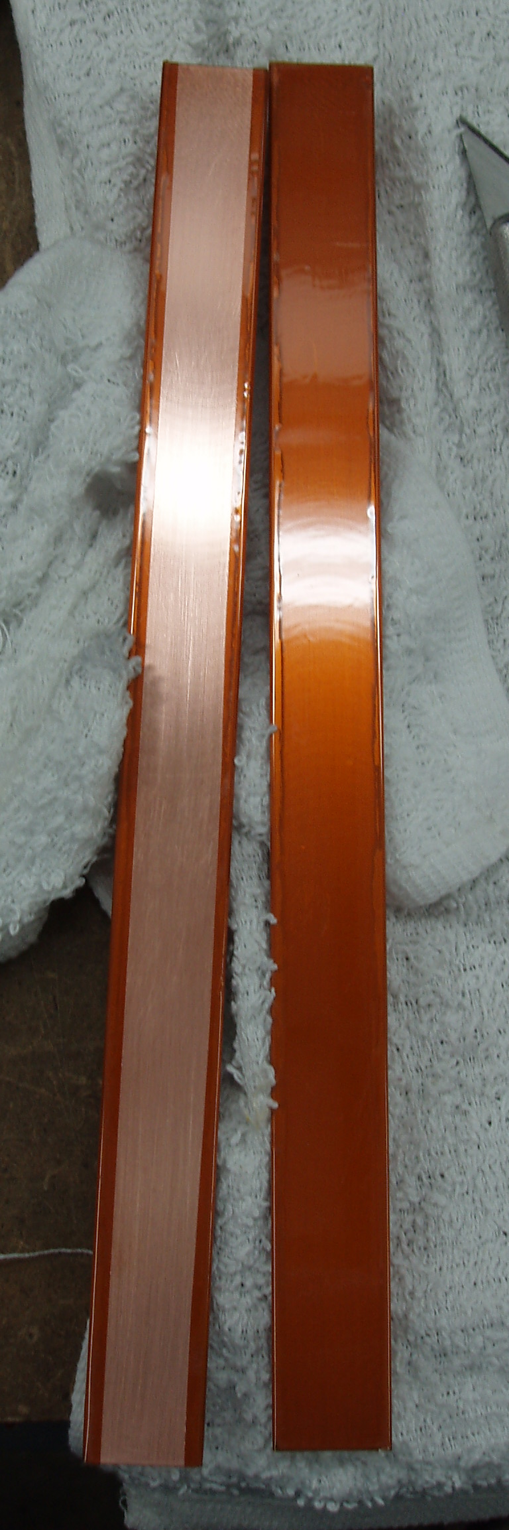
Figure 3- Copper strip fully insulated with Kapton
Figure 4- Copper strip insulation modified
Figure 2- Location of copper strips

3) The third type of floating hardware are the stainless steel socket head cap screws that secure the G-11CR lead box components together. On each coil there are a total of [32] ¼-20 x 0.75 inch and [4] 3/8-16 x 1.26 socket head cap screws that secure the lead box components together. This occurs on all coils [Types A, B and C]. There are no plans to address these hardware components.

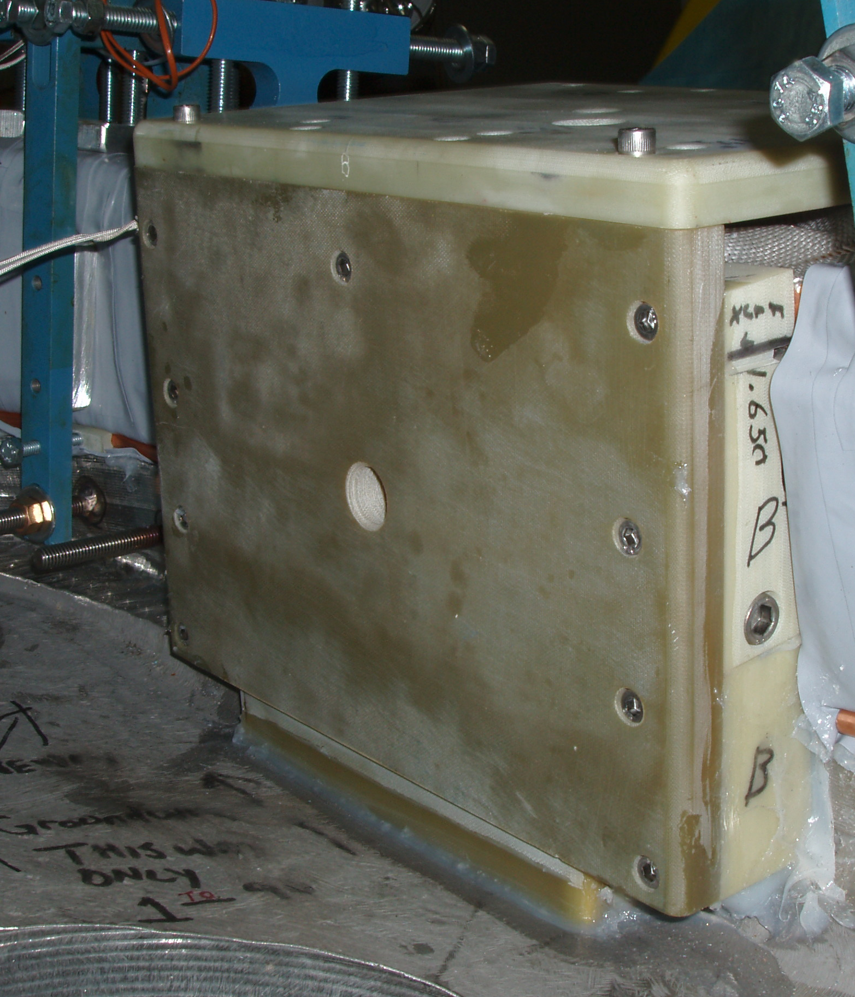
¼-20 socket head cap screws
3/8-16 socket head cap screws
Figure 5- Location of socket head hardware

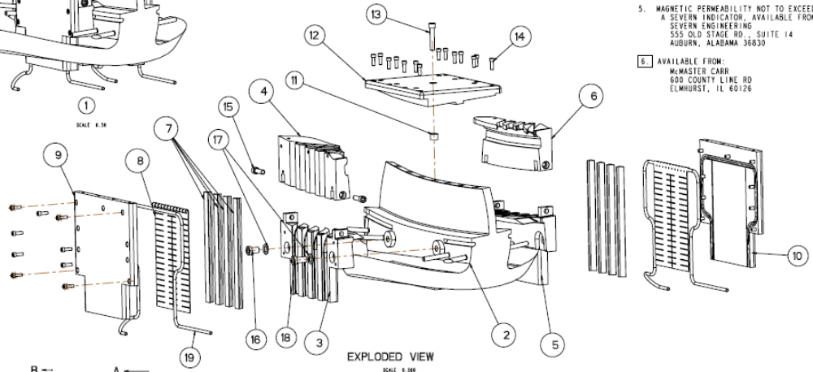
Floating socket head screws
Floating copper chill strips
Floating inner cladding
Figure 6- Exploded View of Lead Area

J. Chrzanowski

