NCSX Engineering Design Document

Auxiliary Systems (WBS 2) Design Description

NCSX PDR

October 7-9, 2003

Lead Author: Larry Dudek

Table of Contents
1 Introduction 1
2 Fueling Systems (WBS 21) 1
3 Torus Vacuum Pumping System (WBS 22) 2
4 Neutral Beam Injection (NBI) System (WBS 25) 4

Table of Figures
Figure 3-1 Auxiliary Systems Duct 3
Figure 4-1 Neutral beamlines connected to Auxiliary Systems duct 6
Figure 4-2 Plan view of beam injection into plasma 7

Tables
Table 2-1 Fueling Systems (WBS 21) costs by expense class (WBS Level 3) 2
Table 2-2 Fueling Systems (WBS 21) costs by year of expenditure (WBS Level 2) 2
Table 3-1 TVPS (WBS 22) costs by expense class (WBS Level 3) 4
Table 3-2 TVPS (WBS 22) costs by year of expenditure (WBS Level 2) 4
Table 4-1 NBI System (WBS 25) costs by expense class (WBS Level 2) 8
Table 4-2 NBI System (WBS 25) costs by year of expenditure (WBS Level 2) 8

Introduction
The Auxiliary Systems scope includes several subsystems, which are critical to plasma performance. The NCSX MIE project includes gas fueling, torus vacuum pumping, and neutral beam injection heating subsystems. Future upgrades that can be accommodated include glow discharge cleaning, pellet injection, boronization, lithiumization, and radio frequency wave heating subsystems, as well as an augmented neutral beam system.

Fueling Systems (WBS 21)
NCSX will re-use the existing Gas Fueling System from PBX-M. In its initial configuration, the Gas Fueling System will have 2 to 4 injectors capable of providing about 200-400 torr-liter/s of H₂, D₂, or He fueling. This initial configuration will have the flexibility to allow the easy changing of gas plenum volumes, or the adding of additional injectors, at selected vessel locations, as required by the experimental program.
NCSX will be designed to accommodate a pellet injector as a future upgrade. Guide tubes can be installed to facilitate pellet launch from the inboard (high field) side of the plasma. The PBX-M pellet injector has been saved for future use on NCSX.
The existing PBX-M Gas Fueling System hardware will be used as much as possible for the configuration needed for NCSX. This hardware consists of fast pulsed valves, control valves, instrumentation, manifolds, miscellaneous vacuum hardware, and an optional hydrogen purification system. The controls, however, will be upgraded with a modern PLC using the proven NSTX design. As in the case of NSTX, this PLC will also control the vacuum vessel pumping system, glow discharge cleaning (GDC) system, and (as a future upgrade) the boronization system.
PBX-M hardware will be repaired and refurbished. The NSTX Gas Fueling System drawings and design materials will be reviewed to determine the modifications needed for application to NCSX. Procurement and fabrication records used to implement the operational NSTX Gas Fueling System will be used to expedite a similar system for NSCX. Based on experience on PBX-M and NSTX, the Gas Fueling System should operate reliably and be readily maintainable.
The cost of the Fueling Systems (WBS 21), tabulated in Table 2-1, is $195K in year-of-expenditure dollars and is based on the cost of implementing the Gas Fueling System (WBS 211). The predominant expense class is labor. The contingency for WBS 21 is 10%. Substantial cost savings are realized by re-using existing equipment and capitalizing on recent NSTX experience in designing, procuring, and installing a similar system. The schedule for implementing the Gas Fueling System (WBS 211) may be seen in the project Master Schedule, provided as part of the Preliminary Design Report. Title II design will be completed by the end of FY05. Installation will be completed by the end of FY06.
Technical, cost, and schedule risks have been minimized by re-using existing equipment, testing the equipment off-line before it needs to be installed, and capitalizing on the recent NSTX experience in designing, procuring, and installing a similar system.

Table 2-1 Fueling Systems (WBS 21) costs by expense class (WBS Level 3)
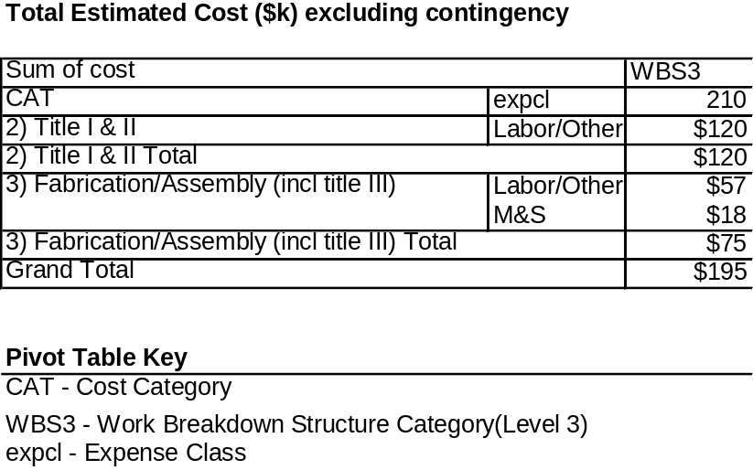

Table 2-2 Fueling Systems (WBS 21) costs by year of expenditure (WBS Level 2)

Torus Vacuum Pumping System (WBS 22)
NCSX requires a Torus Vacuum Pumping System in order to achieve the base pressure requirements. The device is required to produce high vacuum conditions with a base pressure of less than or equal to 2x10⁻⁸ torr. In order to achieve these pressures, the device will be equipped with the four PBX-M 1500 l/s turbo-molecular pumps, configured to provide a total pumping speed at the torus of at least 2600 l/s.
The required NCSX base pressure was achieved at room temperature during PBX-M operations using the proposed pumping system with a total net pumping speed of 2600 l/s. Three additional design features will actually improve the pump-down rate to this base pressure on NCSX. First, the pumping port, located at the bottom of the Auxiliary Systems Duct (Figure 3-1), will increase the gas conductance to the 4 turbo-molecular pumps by about a factor of 1.8. Second, the planned electro-polishing of the vacuum vessel inner wall surface will reduce the ratio of the atomic surface area to geometric surface area. This will significantly decrease the amount of surface adsorbed gas, and also surface metallurgical impurities ("mill slag") that become chemically reduced to release the predominant residual gases observed during operations (H₂0 and CO). The effectiveness of electro-polishing the vessel inner surface to accelerate pump-down to low base pressures, and to also accelerate the removal of fueling gas between discharges was demonstrated most recently on the Phaedrus ST. Finally, the 150°C bakeout of the vessel, and the 350°C bakeout of the PFCs will greatly accelerate the removal of mass 18 (H₂0) and mass 28 (CO) from the residual gas spectrum.
The NCSX Torus Vacuum Pumping System will use as much as possible of the existing PBX-M vacuum pumping system hardware. The PBX-M Torus Vacuum Pumping System consists of:
- Four (4) Leybold Heraeus TMP 1500 turbo-molecular pumps (TMPs)
- Four (4) Model 1398 belt driven backing pumps
- One (1) Kinney KT 500 belt driven roughing pump
- Gate valves, flanges, and instrumentation
Initially, only two of the four available TMPs will be installed.
A new Residual Gas Analyzer (RGA) will be provided. In addition, the existing pumping system controls will be replaced with a PLC based system, which will also control the gas fueling GDC (a future upgrade), and a future boronization system. The design will adopt as much as possible of the recently engineered, proven and operational NSTX Torus Vacuum Pumping System.
Work will be performed to repair and refurbish the PBX-M hardware. The NSTX Torus Vacuum Pumping System drawings will be reviewed to determine the modifications needed for the NCSX application. Procurement and fabrication records used to implement the operational NSTX Vacuum Pumping System will be used to expedite a similar system for NSCX. The Torus Vacuum Pumping System will be assembled and tested off-line prior to first operation on NCSX in order to eliminate uncertainties associated with re-using the existing hardware. Based on experience on PBX-M and NSTX, the Torus Vacuum Pumping System should operate reliably and be readily maintainable.

Figure 3-1 Auxiliary Systems Duct
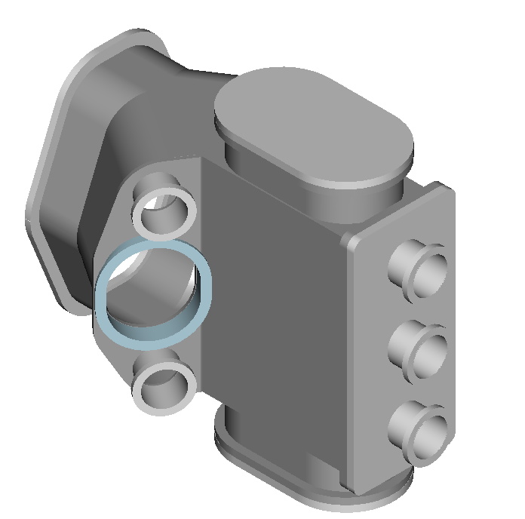

The cost of the Torus Vacuum Pumping System, tabulated in Table 3-3, is $317K in year-of-expenditure dollars. The contingency for WBS 22 is 14%. Substantial cost savings are realized by re-using existing equipment and leveraging off the recent experience on NSTX in designing, procuring, and installing a similar system. The schedule for implementing the Torus Vacuum Pumping System (WBS 22) may be seen in the project Master Schedule, provided as part of the Preliminary Design Report. Title II design will be completed by the end of FY04. Repair and testing of existing components will take place in FY05. Installation will be completed by the end of FY06.
Technical, cost, and schedule risks have been minimized by re-using existing equipment, testing the equipment off-line before it needs to be installed, and capitalizing on the recent NSTX experience in designing, procuring, and installing a similar system.

Table 3-3 TVPS (WBS 22) costs by expense class (WBS Level 3)
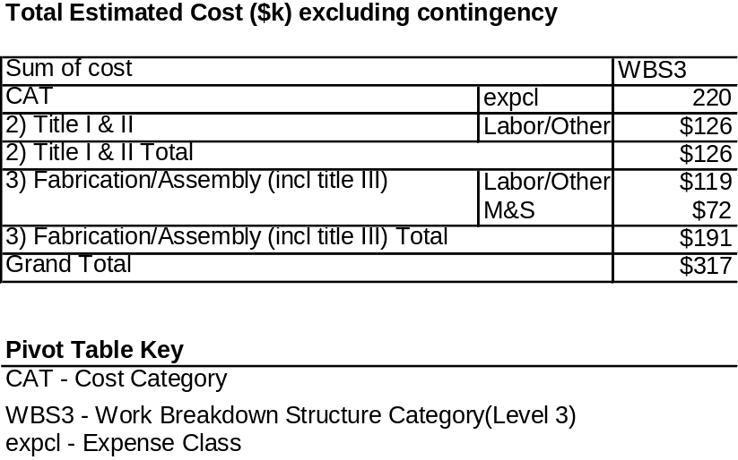

Table 3-4 TVPS (WBS 22) costs by year of expenditure (WBS Level 2)

Neutral Beam Injection (NBI) System (WBS 25)
Requirements and Design Constraints
One of the four beamlines previously used on the PBX-M project will be installed and tested as part of the NCSX MIE Project, configured in the co-direction (the nominal direction of the plasma current). These beams have an energy of 50 keV, a power of 3 MW H° (4 MW D°), and an initial pulse length of 0.3s at maximum power. The tangency radius will be inside the magnetic axis for the nominal 1.7T high beta equilibrium and located such that the beam does not intercept the inboard first wall.
The facility shall be designed to accommodate neutral beam heating using the four (4) beamlines previously used on PBX-M (as a future upgrade) in two possible configurations: [1] 2 co- and 2 counter-directed beamlines and [3] co- and 1 counter-directed beamlines. The facility shall also be designed to accommodate an extended heating pulse duration of 1.2 s.
Design Description and Performance
The NCSX Neutral Beam Injection system will re-use the C-site NBI system in its entirety. This system was used very successfully on the PBXM project. The NCSX system will initially consist of one beamline with one ion source and associated internal components to condition and inject a neutral beam into the vessel proper through an interconnecting duct.
The source is powered by a filament, arc, decel, and accel power supply. The source uses an electrostatic accelerator grid system to accelerate ions and focus them into a particle beam. The neutralizer in the beamline allows for electron exchange with the background feedstock gas, creating neutral beam particles. The remaining unneutralized beam is stripped away using a bending magnet to sweep unusable ions into an ion dump. The remaining neutral beam on its ballistic trajectory impinges either a calorimeter within the beamline for conditioning, or, via the duct, the beam will transit the vessel and interact with the plasma.
To connect and power the source, the outputs of the power supplies are combined into a bundle of cables within the table room and conveyed to the source through the transmission line which will float at the accel potential. The accel system is comprised of high voltage switchgear and transformers, pole transformers, a rectifier chamber with an ignitron rectifier, modulators using tetrodes, and filament and arc power supplies that float with accel to power the source. A decel power supply and grid is provided to suppress backstreaming electrons from entering the source. The bending magnet supply powers the magnet coils at the end of the neutralizer to create a magnetic deflection field to strip ions and deposit them on the dump. The accel system provides 50 kilo-electron Volt (keV) ions for injection once they are neutralized in the beamline.
The beamline and source require a cooling water system, vacuum system, feedstock gas injection system, pneumatic system and a cryogenics system to operate. The water system removes heat. The vacuum system maintains high vacuum in the beamline and source and removes regenerated feedstock gases after regeneration. The gas system provides pure feedstock gas to the source from which a beam is formed. The pneumatic system cycles valves. The cryogenics system holds the LN2 panels at 77 K and the LHe panels operate at 4.5 K to pump hydrogen isotopes.
The beamline rests on a support stand to bring the beam injection level to midplane height. The source, beamline, and support stand must be precisely aligned to shoot at the correct angle into the plasma.
The power system, beamline, auxiliary services, and source require a control system to integrate functions and provide operating staff with adequate feedback to perform NBI operations and experiments. The controls consist of instrumentation and annunciation of all relevant data via a LabView based computer system and associated electronics, fault detection, fiber optic telemetry for high voltage applications, timing and control, and data management in conjunction with and providing input to the physics computing system and database.
Interfaces include duct, water, vacuum, cryogenics, controls, timing, interlocks, and physics data. A design to provide for two but place one beam lineup will be considered wherever practicable for first plasma.
The NCSX NBI system will be installed at the time of first plasma but will not be operational. Subsystems will be tested to a pre-operational level. System testing, integrated systems tests, and commissioning will occur during operations phase after first plasma and in parallel with NCSX initial machine operations.
Legacy equipment has been evaluated in FY 2003 to reduce risk and quantify cost and schedule estimates. AC power switchgear and high voltage equipment was inspected, cleaned, refurbished, and prepared for operations. Rectifiers were checked for water leaks, cleaned, and hi-potted to test integrity. Modulators were brought on at low voltage levels to test. High voltage switch tubes were tested and hi-potted to determine status. Water systems were made operational for the power supplies to support testing. Two beamlines were evacuated, leak checked and repaired to obtain operating vacuum in the beam boxes. Ion sources were removed and saved prior to the removal of the beamlines to their storage locations. Evaluation of controls, electronics, and fault detection schemes was completed.
For the controls, a PC based LabView system will be established to provide all control, operating, and annunciation functions. Fault detection and fiber optics will borrow existing technology from the TFTR NBI design and legacy equipment will be used from spares stored for the NSTX NBI program. Thus, the same repair shop and procedures for NBI electronics can be used for both NCSX and NSTX. Controls installation will happen concurrently with NBI fabrication and installation but will only be made fully operational during the integrated system testing and first NBI operating phase.
The beamlines will be connected to the torus through the Auxiliary Systems Duct (Figure 4-2). The Auxiliary Systems duct serves several functions:
- Accommodates Transition Ducts for 2 beamlines,
- Accommodates a Torus Vacuum Pumping System pumping port,
- Provides view ports for diagnostics, and
- Provides ports for personnel access into the torus.

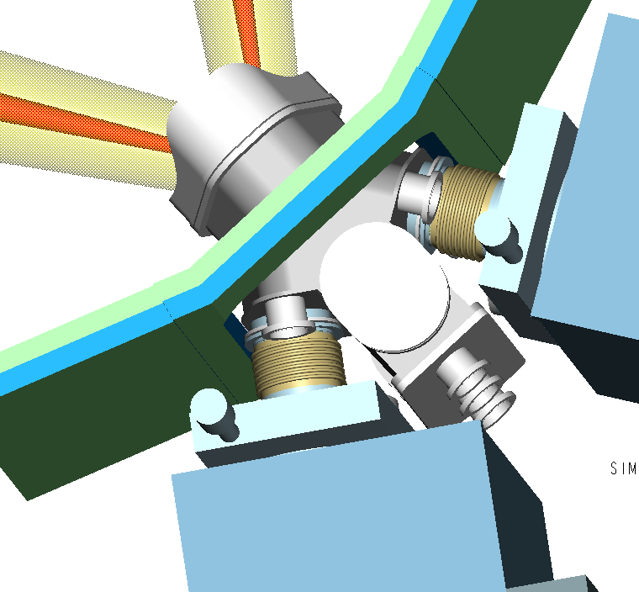
Figure 4-2 Neutral beamlines connected to Auxiliary Systems duct

The NBI Transition Duct connects the beamline to the Auxiliary Systems Duct, as shown in Figure 4-2. The beam first passes through the Torus Interface Valve (TIV). The duct has a ceramic break providing electrical isolation of about 3 kV, and a bellows to decouple vessel motion during operation and bakeout. The bellows is shielded with a metal liner fastened to the vessel and floating on the beam side.
All vacuum seals will be bakeable to 150°C. Ports will be provided for a duct ion gauge to monitor re-ionized power losses, for species measurements, beam emission spectroscopy calibrations, etc. The NCSX design will include a GDC electrode to facilitate duct conditioning. The far wall beam armor design will include beam power and position diagnostics.
The location and design of the NB ports was influenced by several considerations:
- Maximizing the absorption of injected beam power over the desired plasma region. The absorbed power is determined by the beam focusing (perveance), the distance of the ion source from the deposition region, the aiming angle, and target plasma parameters.
- Minimizing effects on injected neutral particle species. Neutral Beam ion sources produce three ionic species [H⁺(E), H⁺(E/2), H⁺(E/3), or D⁺(E), D⁺(E/2), D⁺(E/3)]. The ion source and neutralizer, which are operated so as to maximize the full energy operation, determine the net neutral species fractions entering the transition duct [H⁰(E), H⁰(E/2), H⁰(E/3), or D⁰(E), D⁰(E/2), D⁰(E/3)].
- Minimizing beam power deposition on ports on the opposite wall. The port locations will allow the mounting of far-wall armor to absorb shine-through power and allow full-power, short-pulse beam injections in the absence of plasma for calibrations. Hence, far-wall armor provides wall protection and functions as an instrumented NBI diagnostic (IR camera views and thermocouples).
Balanced co- and counter-tangential NB injection is needed to provide control of the neutral-beam driven currents, and to provide control of the driven rotation (and thus electric field) for transport studies. The initial NBI installation will have 1 co-injecting NBI mounted on an Auxiliary Systems Duct. Figure 4-3 shows a candidate configuration for the final upgraded 2 Co and 2 Counter NBI System. The facility will also accommodate beam configurations with three co- and one counter-injected beam.

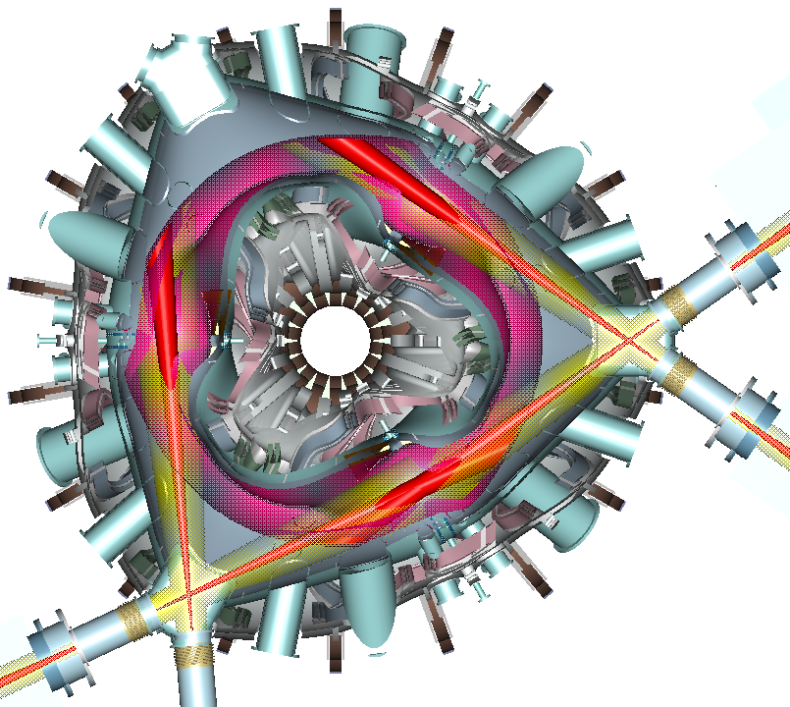
Figure 4-3 Plan view of beam injection into plasma

The work in implementing this design concept involves repairing, refurbishing, and re-installing existing PBX-M hardware. Methodologies and procedures developed during the previous 17 years of operating history of the NBI System, including re-orientation (1983 conversion from PDX to PBX), will be applied. Procurement and fabrication records used to implement operational NSTX subsystems (vacuum, cryo, water, etc.) will be used to expedite similar NBI subsystems for NSCX. The NBI systems will be installed. All required mechanical and electrical connections would be made. Commissioning of the NBI System will be performed during NCSX operations. Based on experience on PBX-M, the NBI System should operate reliably and be readily maintainable.
The cost of the NBI System, tabulated in Table 4-5, is $1095K in year-of-expenditure dollars. The contingency for WBS 25 is 14%. Re-using the existing NBI System rather than developing a new system realizes major cost savings. The schedule for implementing the NBI System (WBS 25) may be seen in the project Master Schedule, provided as part of the Preliminary Design Report.
Technical, cost, and schedule risks in the NBI System have been minimized by re-using existing equipment and testing the equipment off-line before it needs to be installed.

Table 4-5 NBI System (WBS 25) costs by expense class (WBS Level 2)
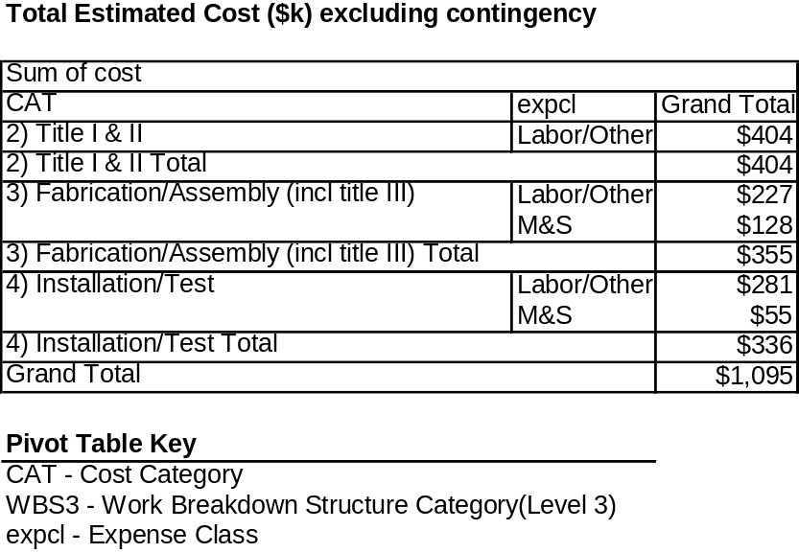

Table 4-6 NBI System (WBS 25) costs by year of expenditure (WBS Level 2)

