NCSX Engineering Design Document

Design Description
Conventional Coils and Structure
(WBS 13, 15)

NCSX Preliminary Design Review

October 7-9, 2003

Table of Contents
1 Design Overview 1
2 Design Requirements and Constraints 3
2.1 Conventional Coil System 3
2.2 Machine Support Structure 4
3 Design Description and Performance 5
3.1 Toroidal Field Coils 5
3.2 Poloidal Field Coils 7
3.3 External Trim Coils 11
3.4 Support Structure 12
4 Design Basis 15
4.1 Design criteria 15
4.2 Analysis 15
4.2.1 Field errors 15
4.2.2 EM Forces on Coils 16
4.2.3 Stress Analysis Under EM Loads 19
4.2.4 Coil thermo-hydraulic analysis 21
4.3 Vendor input 22
5 Design Implementation 23
5.1 Component Procurement and Fabrication 23
5.2 Subsystem Assembly, Installation, and Testing 23
6 Reliability, Maintainability, and Safety 25
7 Cost and Schedule 26
7.1 Conventional Coils (WBS 13) 26
7.2 Support Structure (WBS 15) 27
8 Risk Management 29
8.1 PF, TF, Trim coils 29
8.2 Support Structure 29

Table of Figures
Figure 1 Cut-Away View of the Stellarator Core Assembly 1
Figure 2 TF and PF coil geometry with modular coils for reference 3
Figure 3 TF coil geometry 5
Figure 4 TF coil plan section showing tapered nose region 6
Figure 5 PF coil geometry 7
Figure 6 Central Solenoid Assembly showing 3 pairs of identical c oils 8
Figure 7 Solenoid (PF1,PF2, PF3) winding details 9
Figure 8 PF 4 winding details 9
Figure 9 PF5 winding details 10
Figure 10 PF6 winding details 10
Figure 11 External trim coils 11
Figure 12 Coil support structure 13
Figure 13 Half-field period TF coil and support structure subassembly 13
Figure 14 Interface Between Coil Support Structure and Modular Coil Assembly 14
Figure 15 Typical Force Distribution (Force density, N/mm3) for PF Coils, 1.7T ohmic 17
Figure 16 Typical Force Distribution (Force density, N/mm³) for TF Coils, 1.7T ohmic 18
Figure 17 FEA Model of Conventional Coils and Structure 19
Figure 18 Preliminary stress and deflection of TF coil for 0.5 T load case 20
Figure 19 Central solenoid coil (PF1, PF2, PF3 for the 1.7T ohmic scenario, stresses represent “smeared” properties for copper/epoxy/glass matrix 20
Figure 20 Support Structure stress distribution for the 1.7T ohmic scenario 21

Tables
Table 1 NCSX Parameters 1
Table 2 Conventional Coil System functions 3
Table 3 TF and PF coil system requirements 4
Table 4 TF coil parameters 6
Table 5 PF coil parameters 8
Table 6 External trim coil parameters 12
Table 7 Material Properties for Conventional Coils and Structure 15
Table 8 Load Cases Analyzed for Fields and Forces On the Coils 17
Table 9 Maximum Net Forces and stresses on TF and PF Coils 18
Table 10 Material Properties Used For Conventional Coils and Structure 19
Table 11 Thermo-Hydraulic Analysis of Coils 22
Table 12 WBS listing for Conventional Coils 26
Table 13 Conventional Coil Costs (WBS 13) 26
Table 14 Conventional Coils cost summary by year of expenditure (WBS Level 2) 27
Table 15 WBS listing for Support Structure 27
Table 16 Support Structure (WBS 15) Costs 27
Table 17 Support Structures cost summary by year of expenditure (WBS Level 2) 28

Design Overview
The stellarator core is an assembly of four magnet systems that surround a highly shaped plasma and vacuum chamber. The coils provide the magnetic field required for plasma shaping and position control, inductive current drive, and error field correction. The vacuum vessel and plasma facing components are designed to produce a high vacuum plasma environment with access for heating, pumping, diagnostics, and maintenance. All of the NCSX coil sets are cryo-resistive and operate at liquid nitrogen temperatures, so the entire system is surrounded by a cryostat. Figure 1 shows a cutaway view of the stellarator core assembly and the overall parameters are listed Table 1. The conventional coils and structure are the subject of this document.

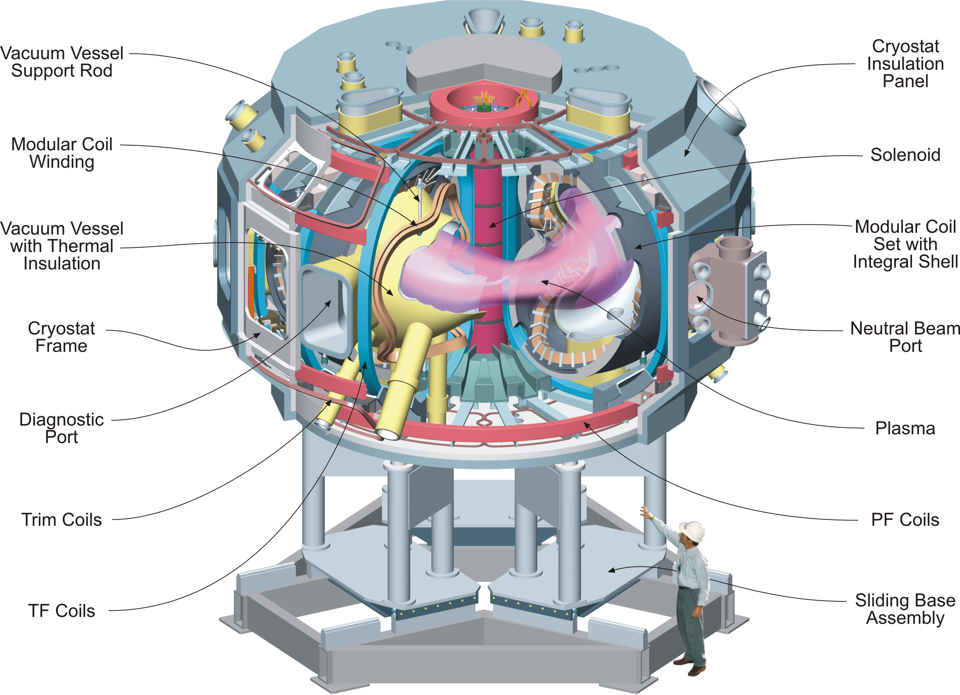
Figure 1 Cut-Away View of the Stellarator Core Assembly

Table 1 NCSX Parameters
Parameter | Value
Major radius | 1.4 m
Minor radius | 0.33 m
B_{max} | 2 T
Plasma current | Up to 320 kA
TF coil configuration | +/- 0.5 T, 1/R (18 coils)
Plasma heating methods | NBI  ICH and ECH (future upgrades)

A set of toroidal field (TF) coils is included to provide flexibility in the magnetic configuration. Adding or subtracting toroidal field is an ideal “knob” for lowering and raising iota. There are 18 identical, equally spaced coils providing a 1/R field at the plasma.
A set of poloidal field coils is provided for inductive current drive and plasma shape and position control. The coil set consists of two inner solenoid pairs (PF 1 and PF 2), and 4 pairs of ring coils. Coil pairs are symmetric about the horizontal midplane and each coil pair is connected in an independent circuit.
External trim coils are provided on the top, bottom and outside perimeter of the coil support structure primarily to reduce n/m=1/2 and 2/3 resonant errors that may result from manufacturing or assembly errors in the modular coil geometry.

Design Requirements and Constraints

Conventional Coil System
The conventional coil system includes all the coils required in addition to the modular coils to provide the magnetic field for plasma shaping, position control, and inductive current drive. Ex-vessel trim coils are added for low poloidal mode number (m=2,3) field error correction. Additional coils may be added inside the vacuum vessel during the operational phase for higher order (m=5,6) field error correction. The coil sets and their primary functions are listed in Table 2, and the coil geometry is shown in Figure 2

Table 2 Conventional Coil System functions
Coil set | Function
Poloidal field coils | Inductive current drive, plasma position control, plasma shaping
Toroidal field coils | Addition or subtraction of toroidal field for control of magnetic transform
Trim Coils | Control of magnetic flux surface quality

Figure 2 TF and PF coil geometry with modular coils for reference

The basic requirements are listed in Table 3. These requirements are extracted from the general machine requirements described in the General Requirements Document, provided as part of the Preliminary Design Report. The overarching requirement is to provide windings that can accurately produce the desired magnetic field configuration. The coil configurations (number of coils, etc.) have been optimized to best meet a combination of physics and engineering constraints.

Table 3 TF and PF coil system requirements
General requirement
A set of PF coils and TF coils shall be provided to support the reference scenarios and meet flexibility, field error, and polarity requirements.
Performance
Operating scenarios:
- 1.7T Ohmic Scenario: 1.7 T for 0.44 seconds , 120 kA Ip
- 1.7T High Beta Scenario: 1.7 T for 0.44 seconds , 175 kA Ip
- 2T High Beta Scenario: 2 T for .20 seconds, 200 kA Ip
- 320kA Ohmic Scenario: 1.7 T for 0.51 seconds, 320 kA Ip
15 minute repetition interval between pulses
Flexibility
- Independent control of all PF coils
- Variable background TF field
Accuracy
Islands from field errors shall be less than 10% of local plasma size
+/- 1.5 mm assumed for installed winding accuracy
·Coils must provide access for tangential NBI, RF, vacuum pumping, diagnostics, and personnel access
·Limit conductor current to ~ 24 kA peak to match with existing TFTR power supplies

Machine Support Structure
The machine structure provides the integrated support for the TF and PF coils. The primary constraints are that it operates at cryogenic temperatures, be non-magnetic and broken electrically to avoid error-field producing eddy currents, and not interfere with diagnostic or heating access.

Design Description and Performance

Toroidal Field Coils
A set of toroidal field coils is included to provide flexibility in the magnetic configuration. Adding or subtracting toroidal field is an ideal “knob” for lowering and raising iota. There are 18 identical, equally spaced coils providing a 1/R field at the plasma. The in-plane TF coil loads are reacted primarily by wedging the inner legs. The overturning loads are reacted primarily by upper and lower shelf structures which connect to each other through the modular coil shell. The coils are located at radial locations coincident with the modular coil locations, both for symmetry and to avoid introducing additional obstructions to access. All of the coils are connected in a single circuit initially, but the capability will exist to connect like coils, e.g. coils in the same location relative to the modular coils within a field period, to be connected in separate circuits. Each coil consists of 12 turns in a single bundle. The coil geometry is illustrated in Figure 3 and Figure 4.

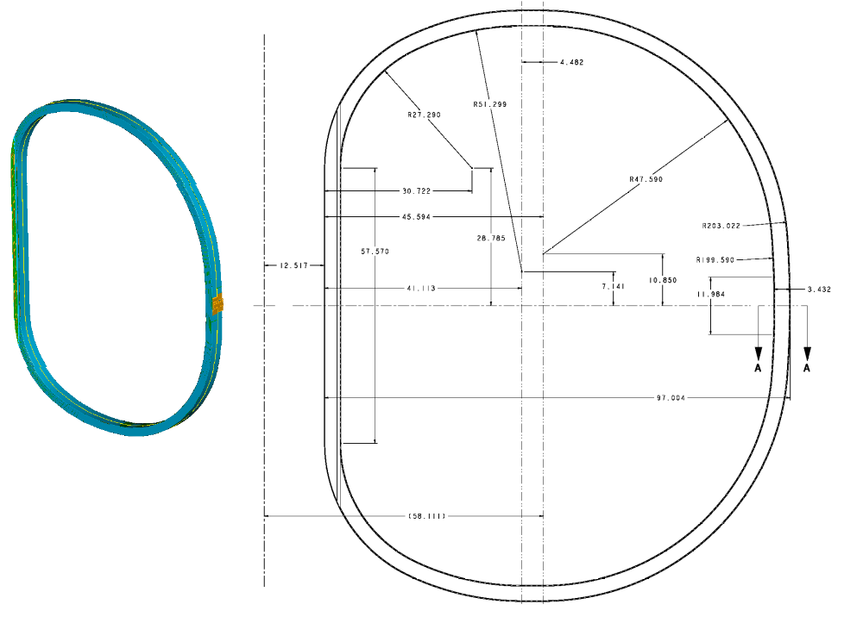
Figure 3 TF coil geometry

The coils are wound from hollow copper conductor and insulated with glass-epoxy. They operate at 80K, cooled by liquid nitrogen, and are connected in series. The leads consist of coaxial conductor to minimize field errors. The nominal TF coil parameters, insulation builds, and details are described in Table 4.

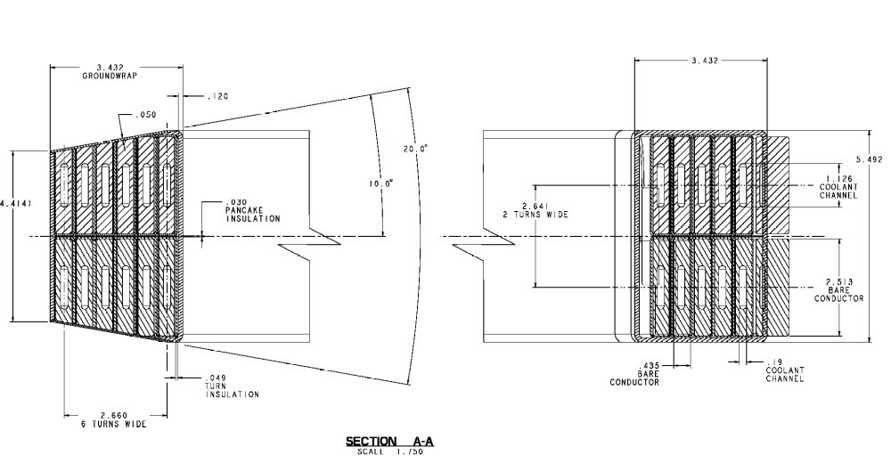
Figure 4 TF coil plan section showing tapered nose region

Table 4 TF coil parameters
Parameter | Unit | Value
Number of TF coils |  | 18
Number of turns per coil |  | 12
Maximum toroidal field at 1.4 m  (TF coils only) | T | ±0.5
Maximum current per turn | kA | 16
Winding length along winding center | m | 8.66
Double pancake length | m | 104
Bundle height | mm | 84.9
Bundle width | mm | 100.8
Bundle area | mm2 | 8560
Conductor height | mm | 11.4
Conductor width | mm | 48.1
Corner radius | mm | 2.5
Cooling hole diameter | mm | 6.8 x 19.25
Conductor area | mm2 | 419.9
Weight/coil, | kg | 604
Max current in reference scenario | kA | 16
Maximum copper current density | kA/cm² | 3.8

Poloidal Field Coils
A set of poloidal field coils is provided for inductive current drive and plasma shape and position control. The basic coil geometry is shown in Figure 5. The coil set consists of three inner solenoid pairs (PF-1, PF-2, and PF-3), one mid-coil pair (PF-4) and two outer coil pairs (PF-4 and PF-5). All the coil pairs are symmetric about the horizontal midplane. The coils are of conventional construction, wound from hollow copper conductor and insulated with glass-epoxy. The PF coils operate at the same temperature as the TF coils - nominally 80K, cooled by liquid nitrogen.
The PF coil parameters are listed in Table 5. As shown in the table, the conductor size and maximum current per turn are almost identical for all the coils. This provides common tooling for manufacture and should help to reduce costs.
The OH solenoid coils, PF1, PF2, and PF 3 are connected in series and assembled into a single unit, as shown in Figure 6. Upper and lower PF coils in a given pair are connected in series, and the PF1, PF2, and PF3 coils are also in series. Thus, there will initially be four independent electrical circuits. The solenoid leads are arranged to allow the PF3 coils to be driven independently later in the operations phase. The PF coils, when independently driven, provide flexibility for plasma shaping and position control. With an OH (nullapole) distribution in the PF coils, the coil set can provide 1.15-Wb (double swung). This capability is adequate, even for the maximum plasma current of 350-kA. The details of the PF coil windings are shown in Figure 7, Figure 8, Figure 9, and Figure 10.

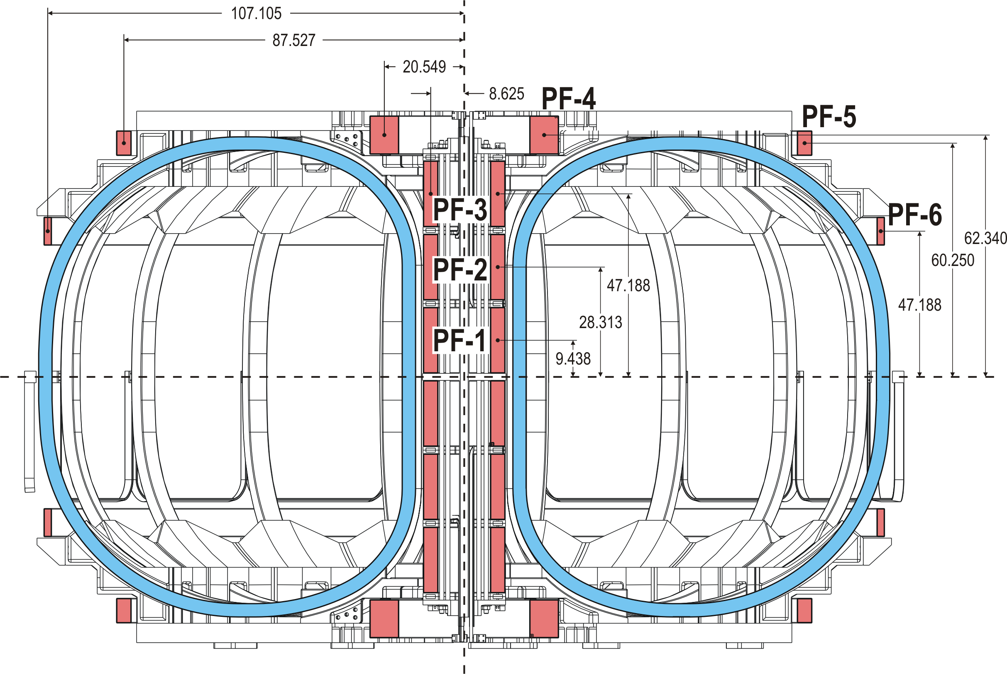
Figure 5 PF coil geometry

Table 5 PF coil parameters
Parameter | Units | PF-1 | PF-2 | PF-3 | PF-4 | PF-5 | PF-6
Max total current | MA-turns | 1.809 | 1.809 | 0.927 | 1.115 | 0.201 | 0.126
Radius | m | 0.22 | 0.22 | 0.27 | 0.52 | 2.22 | 2.72
Installed height, Z | m | 0.24 | 0.72 | 1.2 | 1.58 | 1.53 | 0.95
bundle dr | mm | 96.9 | 96.9 | 96.9 | 188.5 | 96.9 | 51.1
bundle dz | mm | 426.6 | 426.6 | 426.6 | 249.6 | 161.0 | 183.2
gross current density | A/mm² | 43.7 | 43.7 | 22.4 | 23.7 | 12.9 | 13.5
total turns | # | 72 | 72 | 72 | 80 | 24 | 14
turns high | # | 18 | 18 | 18 | 10 | 6 | 7
turns wide | # | 4 | 4 | 4 | 8 | 4 | 2
current per turn | A | -25123 | -25123 | -12877 | -13936 | 8356 | -8997
packing fraction |  | 0.75 | 0.75 | 0.75 | 0.75 | 0.75 | 0.75
length per turn | m | 1.38 | 1.38 | 1.38 | 3.28 | 13.97 | 17.09
total length of copper, per coil | m | 99.11 | 99.11 | 99.11 | 262.36 | 335.25 | 239.3
turn height | mm | 20 | 20 | 20 | 20 | 20 | 20
turn width | mm | 20 | 20 | 20 | 20 | 20 | 20
coolant hole width | mm | 9 | 9 | 9 | 9 | 9 | 9
conductor area | mm^2 | 335.2 | 335.2 | 335.2 | 335.2 | 335.2 | 335.2

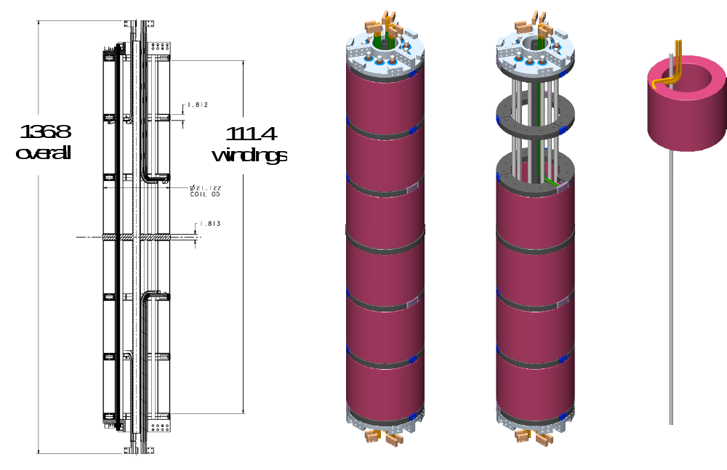
Figure 6 Central Solenoid Assembly showing 3 pairs of identical c oils

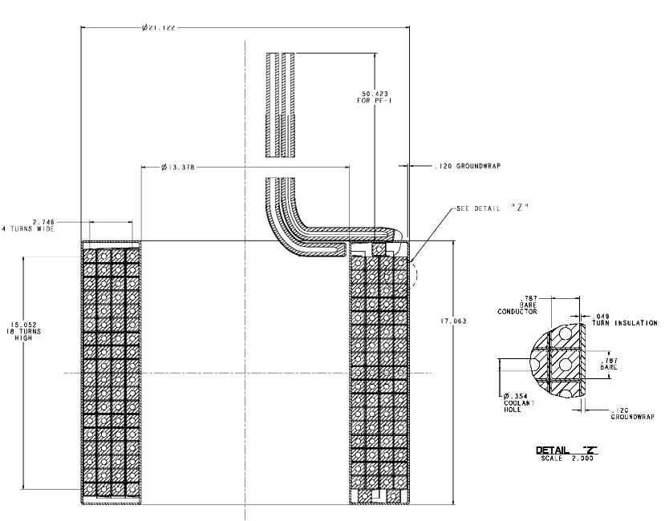
Figure 7 Solenoid (PF1,PF2, PF3) winding details

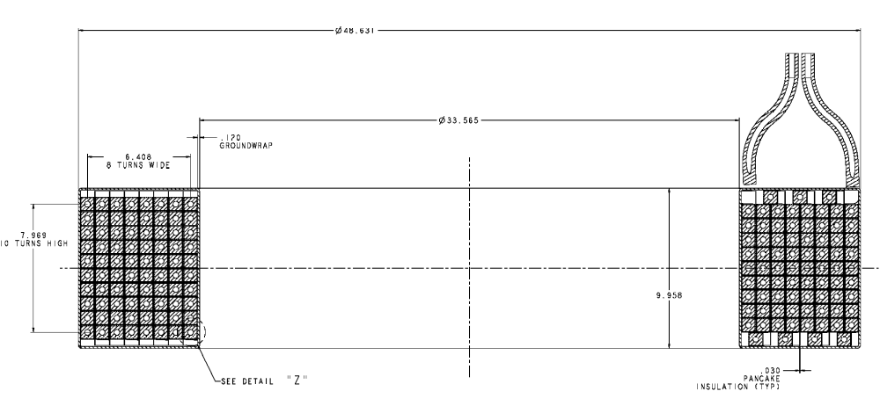
Figure 8 PF 4 winding details

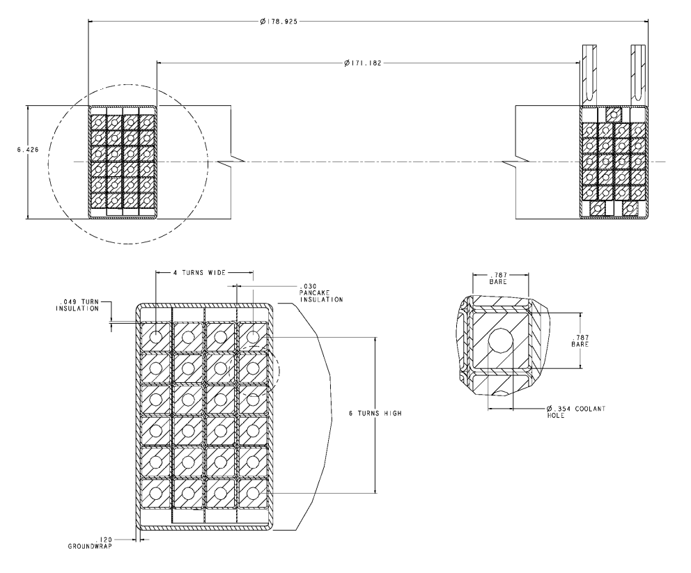
Figure 9 PF5 winding details
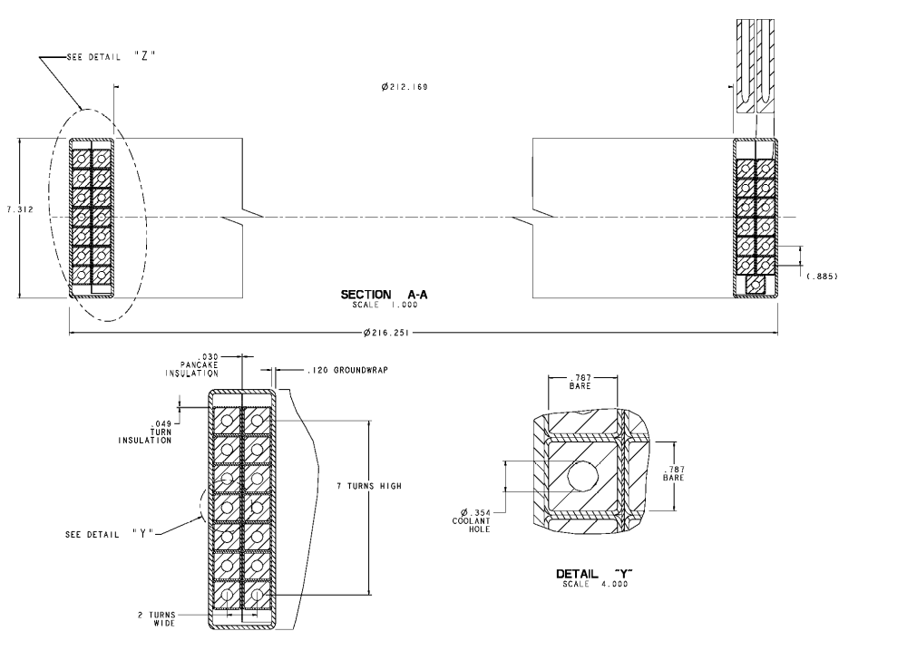
Figure 10 PF6 winding details

External Trim Coils
Two types of correction coils are envisioned for NCSX, external and internal trim coils. The external trim coils are provided on the top, bottom and outside perimeter of the coil support structure primarily to reduce n/m= ½ and 2/3 resonant errors that may result from manufacturing or assembly errors in the modular coil geometry. These coils will be installed during the initial assembly of the machine because it is much more cost effective than retrofitting them later. However, the power supplies will be provided later, after the current requirements are determined.
Figure 11 illustrates this set of coils. The coil parameters are listed in Table 6. These coils are wound from conventional, hollow copper conductor and vacuum pressure impregnated with epoxy. They are supported by the External Coil Support Structure, and operate at liquid nitrogen temperatures. Each coil must be independently powered to provide the flexibility needed for correcting field errors.

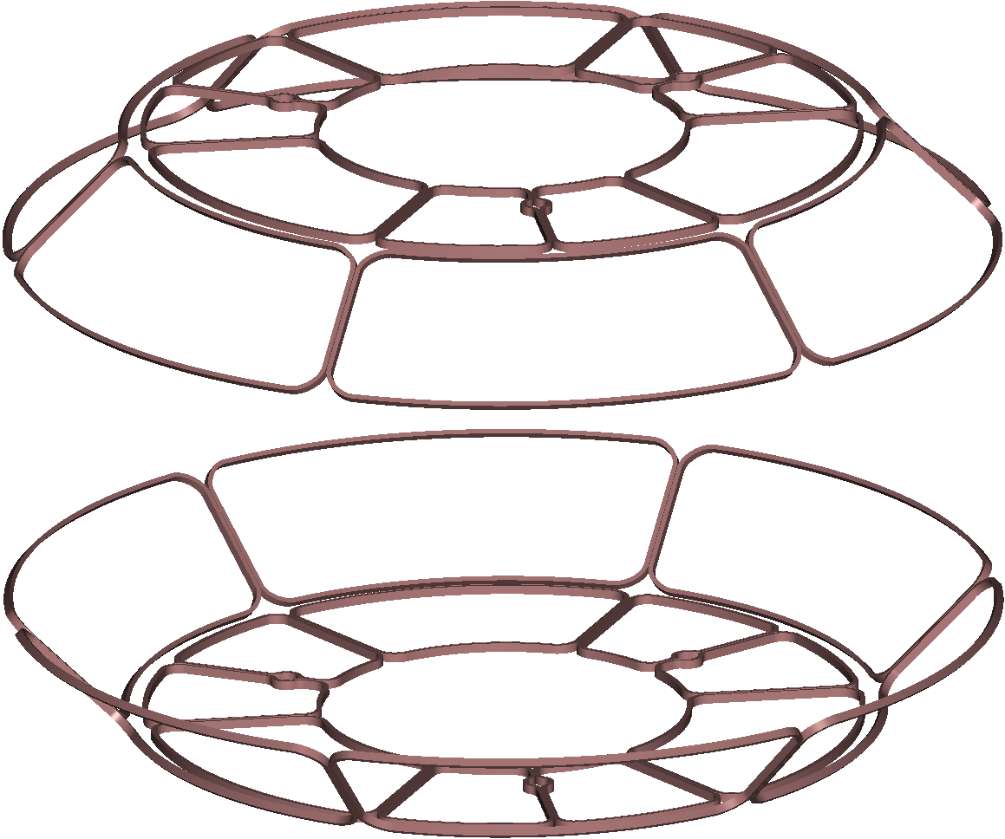
Figure 11 External trim coils

Table 6 External trim coil parameters
Parameter | Units | Top and Bottom Coils | Outer perimeter Coils
Max total current | MA-turns | 1.34 | 1.63
Coil size | m x m | 2.2 x 1.6 wide | 1.7 x.2.7 wide
bundle dr | mm | 21.8 | 21.8
bundle dz | mm | 43.6 | 43.6
gross current density | A/mm² | 84.3 | 84.3
total turns | # | 8 | 8
turns high | # | 4 | 4
turns wide | # | 2 | 2
current per turn | A | 10000 | 10000
packing fraction |  | 0.75 | 0.75
length per turn | m | 8.5 | 5.1
total length of copper, per coil | m | 67.9 | 40.9
turn height | mm | 9 | 9
turn width | mm | 9 | 9
Net conductor area | mm^2 | 60 | 60

Support Structure
The coil support structure provides an integrated shell structure for accurately locating and supporting the TF and PF coils, the modular coil assembly, and the external trim coils. This structure is illustrated in Figure 12. The structure consists of segmented upper and lower shelf assemblies, with integral, upper and lower support crowns on both the inboard and outboard regions. The solenoid is a self-standing assembly hung from the upper TF crown structure.
The shelf assembly for each field period consists of two inboard castings (30 degrees each), six radial beams, and six identical outboard “crown” structures. A half field period is shown in Figure 13. This assembly is identical top and bottom. Dielectric breaks are provided between every casting to break up eddy currents. The joint locations are arranged to correspond to a half field period, such that the upper and lower shelf assemblies can be installed as part of the field period sub-assembly. (Not shown are temporary structures between the upper and lower outer crowns which will only be used during the assembly process before they are connected to the modular coil shell structure). The crown castings have pockets that receive the horizontal legs of the TF coils to provide lateral support for out-of-plane loads. Pads are provided where the lower shelf attaches to the machine base assembly for gravity support; these similar pads on the upper shelf are used for hosting and rigging during assembly. The upper and lower external trim coils are also mounted to the outside of the TF structure.
The modular coil assembly connects the upper and lower shelf assemblies through toroidal stiffener supports, as shown in Figure 14. These supports transfer any net reaction from overturning loads on the TF coils to the modular coil shell, as well as any local vertical loads from the TF. Individual TF coils do have vertical loads due to interaction with the modular coils, but there is no net vertical loading on the TF coil set. These supports are cast into the modular coil 1 and 3 shell segments, and spacers are used to fill the gap between the shell and the shelf assemblies.
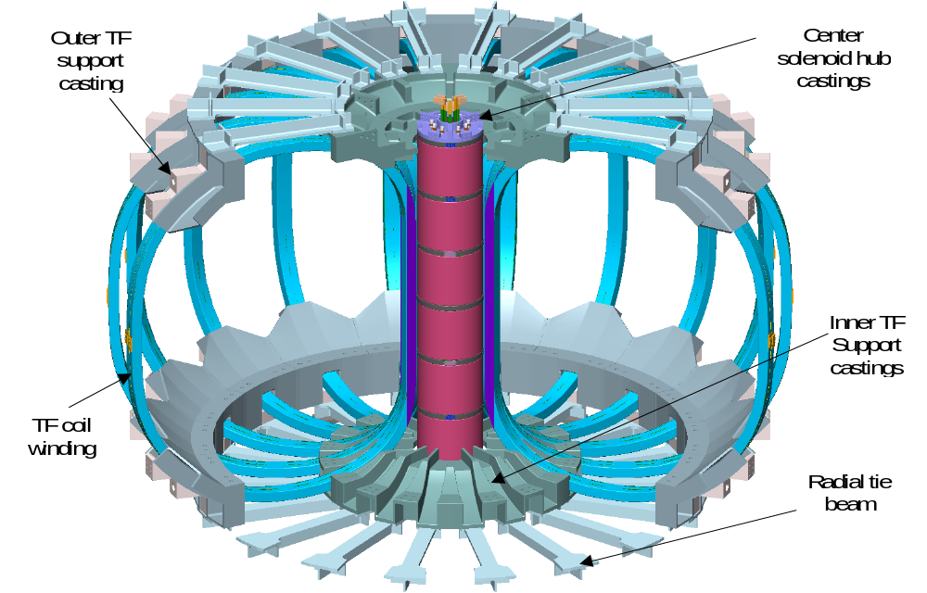
Figure 12 Coil support structure

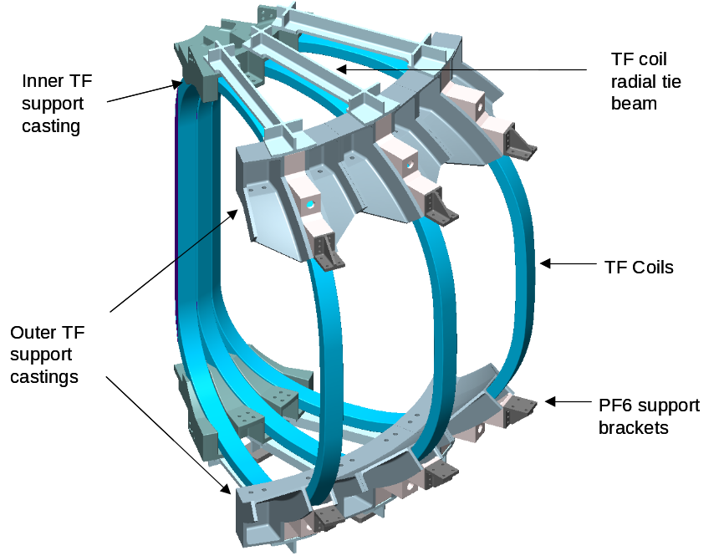
Figure 13 Half-field period TF coil and support structure subassembly

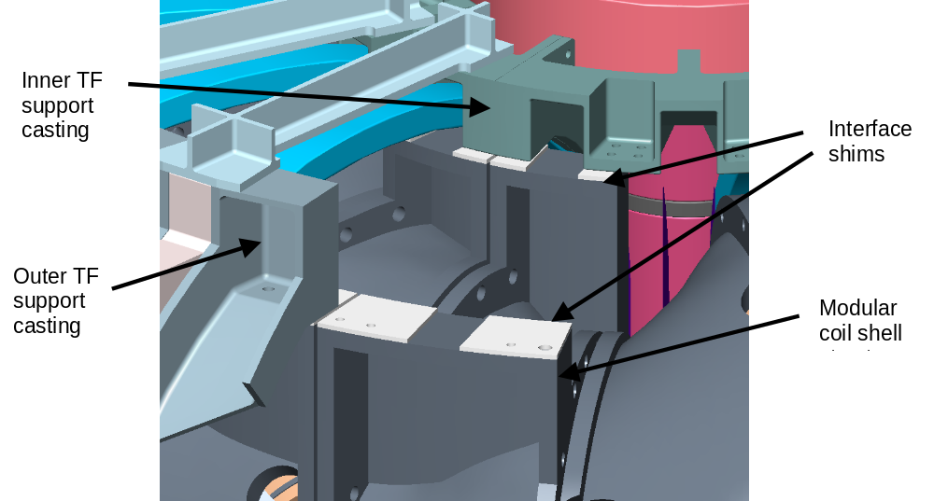
Figure 14 Interface Between Coil Support Structure and Modular Coil Assembly

The upper and lower crowns are connected to the upper and lower shelf assemblies respectively. The center solenoid assembly is attached (hung) to the upper crowns. A positioning ring is provided on the bottom to center the solenoid.
The center solenoid assembly consists of the PF1, PF2, and PF3 coils (upper and lower), spacer assemblies and tie rods. Spacers between each of the PF coils permits the return leg of each winding to transit across the top of each coil and join up to the start lead. The lead pairs are routed through the bore of the solenoid (upper coils to the top; lower coils to the bottom) where the bus connections are made.
The PF ring coils are attached to the shelf structures with brackets that can be adjusted to accurately align the coils. Since large ring coils are often out-of-round, these brackets will also serve to bring the coils into an acceptably round shape.

Design Basis
The conventional coil system design is based on design criteria and analysis.

Design criteria
The conventional coils and support structure will be designed according to the NCSX Structural Design Criteria, which is based on the ASME Code, Section VIII, Division 2. The code provides a conservative but prudent approach to design stresses, fatigue, buckling, welding, and inspection of components.

Table 7 Material Properties for Conventional Coils and Structure
Material | Structure material  316L at 4 K | Copper winding pack  @ RT
Yield strength | 122 - 138 ksi | 19 - 24 ksi (compression)
Ultimate Tensile Strength | 141 - 207 ksi | 22 - 27 ksi (compression)
Allowable stress, Sm | 47 ksi | 12 ksi (compression)
Young’s modulus | 25 - 28 x 10⁶ psi | 1.2 – 1.7 x 10⁶ psi
Total Elongation | 22 – 55 % | TBD
Poisson’s ratio | .28 - .30, temp dependent | 0.29 (in-plane)

Analysis
The design has been analyzed for field errors, forces, stresses and thermal response.

Field errors
The first analysis concerns field errors. For design purposes, the center of the current within any coil winding is nominally specified to be within 1.5 mm of its theoretical position, except in regions around leads and crossovers. In these regions the conductor steps from layer to layer or from pancake to pancake, introducing local field errors within the windings. These errors have been analyzed in detail . Three design rules are used to minimize these errors:
- Arrange the joggles from layer to layer within a winding pack such that the pattern of turn to turn joggles on one pie form an X shape with the pattern of joggles on the adjacent pie.
- Make sure the lateral cross over from pie to pie occurs in opposite directions on multiple winding packs within a coil. This reverses the field errors from the lateral current paths and cancels them to first order.
- Minimize the errors at the lead connection by immediately tying the leads together into a coaxial arrangement.

In addition to the errors from the coil geometry perturbations around leads and crossovers, the field errors associated with fabrication and assembly tolerances have also been studied in detail. Assessing the impact of coil fabrication and assembly errors a priori requires examining a large number of potential coil perturbations. A large number of possible perturbations to the coil geometries were chosen for detailed evaluation.
A perturbation field for each is calculated by subtracting the field from the unperturbed coils from the field from the perturbed coils. The reference plasma configuration was used to provide as the background field to show the effect of the coil perturbations using both analytic expressions for island size and field line tracing. The use of a perturbation field applied to a reference plasma configuration - as apposed to using the full field from the perturbed coil set by itself - was chosen to separate the influence of coil tolerances from islands inherent in the free boundary plasma configuration of the unperturbed coils. It also allowed for accurate benchmarking of analytic results with field line tracing for both symmetric and symmetry breaking field errors.
In general, most of the large islands induced were symmetry breaking m=2 islands. The worst case for TF coils showed a 2.7% island. The PF coils were all less than 4% for the cases considered.

EM Forces on Coils
The fields and forces on all the coils have been calculated for each of the various operating scenarios . Table 8 summarizes the load cases that were considered and the time snapshot for the currents where the currents are either at their maximum positive or negative values. The worst case for forces in the modular coils appears to be the 2T high beta at the zero beta point in the discharge.
The force distributions for all the PF coils and TF coils for a typical case (with and earlier, albeit similar, set of coils) are illustrated in Figure 15 and Figure 16. As shown in these figures, the loading on the TF and PF coils is somewhat complicated due to the interaction with the modular coils. For example, the TF coils on one half of a field period experience a net vertical force upwards, and the corresponding TF coil on the other half of a field period experiences a net vertical force downward.
The net forces on each coil were also calculated for all the cases listed in Table 8 and are shown in Table 9, along with the peak stresses.

Table 8 Load Cases Analyzed for Fields and Forces On the Coils
Load Case | 1 | 2 | 3 | 4 | 5
Scenario | 0.5 T TF | 1.7T Ohmic | 2T High Beta | 320kA Ohmic | 320kA Ohmic
Time, s | 0.0 | 0.0 | 0.0 | 0.206 | 0.506
M1 (A/turn) | 0 | 38141 | 40908 | 34200 | 34200
M2 (A/turn) | 0 | 35504 | 41561 | 32057 | 32057
M3 (A/turn) | 0 | 35453 | 40598 | 32184 | 32184
PF1 (A/turn) | 0 | -25123 | -15274 | 11354 | 21858
PF2 (A/turn) | 0 | -25123 | -15274 | 11354 | 21858
PF3 (A/turn) | 0 | -9698 | -5857 | -11802 | -5975
PF4 (A/turn) | 0 | -7752 | -9362 | -13936 | -9441
PF5 (A/turn) | 0 | 8284 | 1080 | 4563 | 4634
PF6 (A/turn) | 0 | -8997 | -24 | 5068 | 5705
TF (A/turn) | 16200 | -3548 | -1301 | 2191 | 2191
Plasma (A/turn) | 0 | 0 | 0 | -320775 | -320775
Red and blue fields represent maximum and minimum coil currents

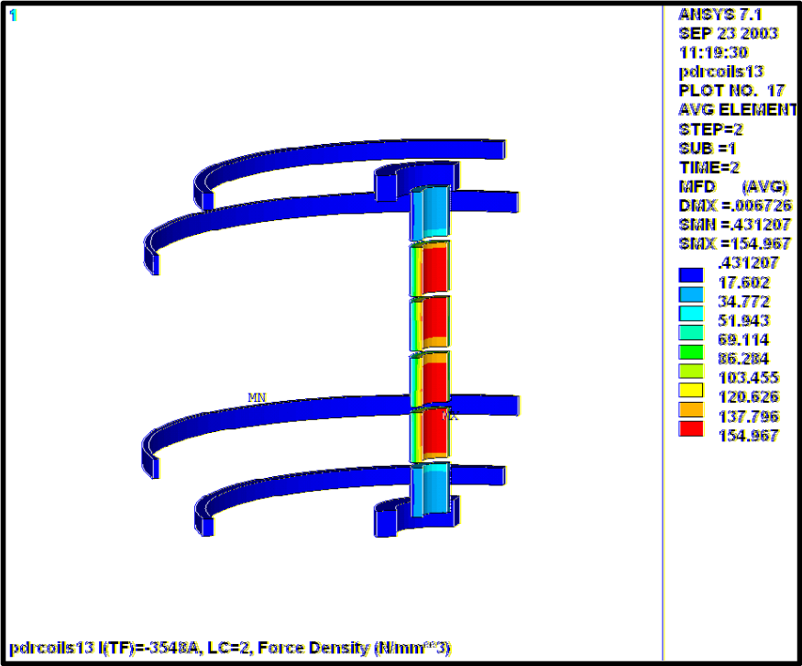
Figure 15 Typical Force Distribution (Force density, N/mm3) for PF Coils, 1.7T ohmic

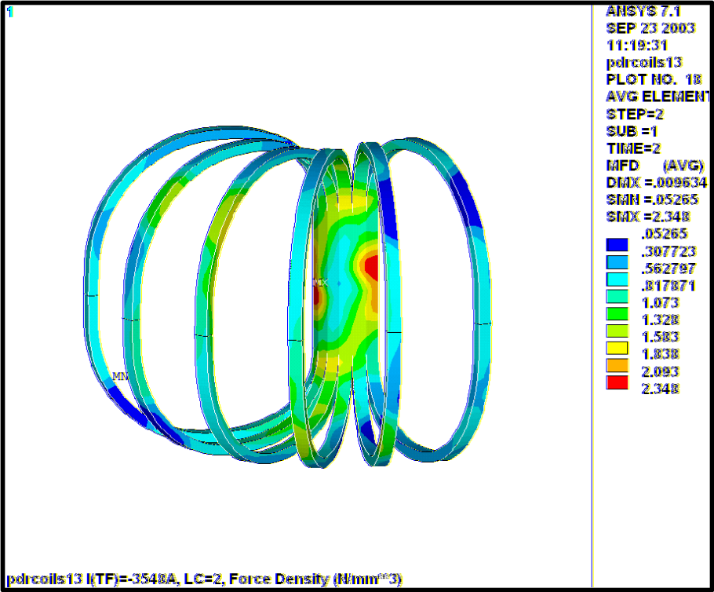
Figure 16 Typical Force Distribution (Force density, N/mm³) for TF Coils, 1.7T ohmic

Table 9 Maximum Net Forces and stresses on TF and PF Coils
Item | Load Parameter | 1 | 2 | 3 | 4 | 5
TF | σ_{vM}, MPa | 130 | 42.2 | 16.7 | 26.1 | 26.0
Central Solenoid | F_{z}, kN | 0 | 468 Attract | 24 Attract | 67 Attract | 778 Attract
Central Solenoid | σ_{vM}, MPa | 0 | 31.5 | 12.1 | 9.6 | 25.9
Central Solenoid | σ_{Z+}, MPa | 0 | 1.4 | 0.9 | 4.0 | 3.7
PF4 | F_{z}, kN | 0 | 182 Attract | 117 Attract | 142 Attract | 39 Repel
PF4 | σ_{vM}, MPa | 0 | 5.4 | 6.7 | 11.8 | 4.7
PF5 | F_{z}, kN | 0 | 215 Repel | 19 Repel | 52 Repel | 43 Repel
PF5 | σ_{vM}, MPa | 0 | 9.3 | 1.6 | 7.0 | 7.2
PF6 | F_{z}, kN | 0 | 149 Attract | 0 | 58 Repel | 62 Repel
PF6 | σ_{vM}, MPa | 0 | 11.9 | 0.4 | 6.1 | 6.9
Supp. Struct. | σ_{vM}, MPa | 0 | 44.4 | 9.4 | 24.2 | 26.6

Stress Analysis Under EM Loads
The TF and PF coils are supported from the external coil support structure. The primary load case for the analysis was the low iota vacuum phase of the 2T High Beta scenario (Case 3). An analysis is underway using the ANSYS finite element package. Figure 17 shows the model, which consisted of a 120-degree assembly of the shell, coil windings, and spacer between the windings and shell. The properties used assumed that the structure is made of stainless steel, the coil windings consist of a hollow copper conductor in an epoxy/glass matrix, and the shims and spacers are made of G-10. The properties are listed in Table 10

Table 10 Material Properties Used For Conventional Coils and Structure
Component | Material | Modulus of  elasticity (MPa) | Poisson’s ratio | Comment
Structure | Cast stainless steel | 206,000 | .29 | Similar to 317 cast alloy
Coil windings | Copper / insulation mixture | ~95,000 | .30 | Ratio of Cu / insulation cross section
Shims and spacers | Epoxy glass laminate | 206,000 | .30 | Conservative if assumed to be stiff

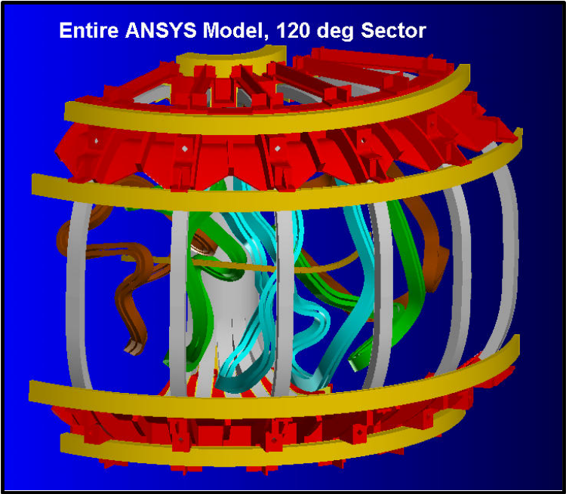
Figure 17 FEA Model of Conventional Coils and Structure
Initial results have been obtained for all cases. As illustrated in Table 9, the worst case for the TF coils is case 1. This is not a planned load case for NCSX but represents the maximum flexibility limit desired of the TF coil system. The results, shown in Figure 18, illustrate a peaking of stress above the wedged region of the coils. This stress concentration can easily be reduced by extending the wedged portion of the structure.

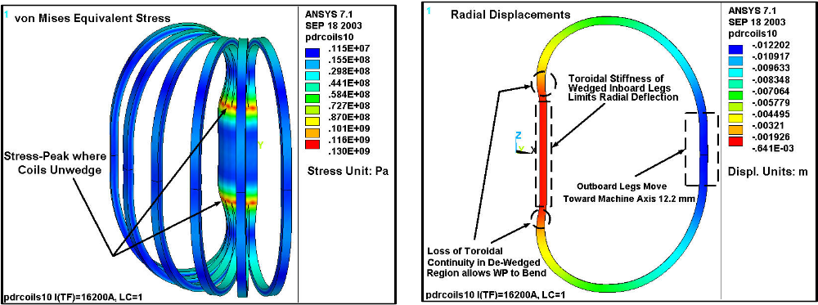
Figure 18 Preliminary stress and deflection of TF coil for 0.5 T load case
The peak stress conditions in the other coils are benign. All the reported cases use smeared copper properties, so the stress in the copper will be about 50% higher. Even with that adjustment, all the stresses are well below the 165 Mpa allowable. Figure 19 Illustrates the central solenoid stress distribution for case 2 and Figure 20 illustrates the support structure stress distribution, both for the 1.7 T ohmic operation scenario.

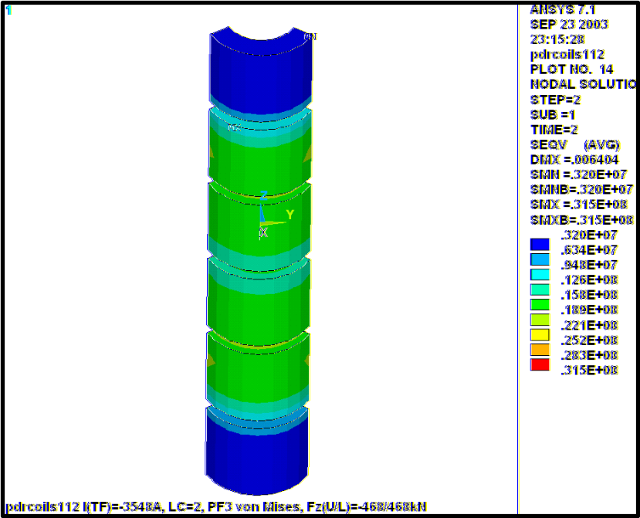
Figure 19 Central solenoid coil (PF1, PF2, PF3 for the 1.7T ohmic scenario, stresses represent “smeared” properties for copper/epoxy/glass matrix

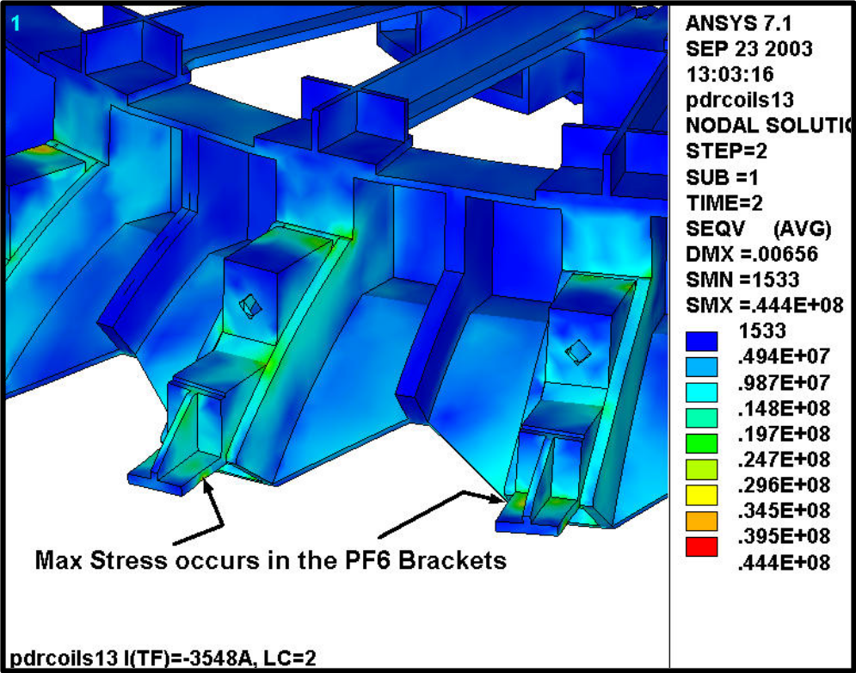
Figure 20 Support Structure stress distribution for the 1.7T ohmic scenario

Coil thermo-hydraulic analysis
A preliminary thermo-hydraulic analysis was performed for all three coil systems (PF, TF, and Modular). The present design calls for forced flow LN2 cooling of all coil systems with a prescribed inlet temperature of 80 K at 200 psi. The prescribed equivalent square wave (ESW) used was 1.2-3.5 sec. at the maximum rated current Iat the time of the analysis) for each coil system. The duty cycle (cool-down period) was specified as 15 minutes (900 sec.). A summary of the results is shown in Table 11. The total LN2 flow requirements for the main coil systems will be 46 GPM. The TF and PF coils use internally cooled solid copper conductor, and a pressure drop of only 2 psi is sufficient to cool the coils back to the initial conditions after every shot with not ratcheting. As shown in the table, there is a negligible temperature rise in these coils.

Table 11 Thermo-Hydraulic Analysis of Coils
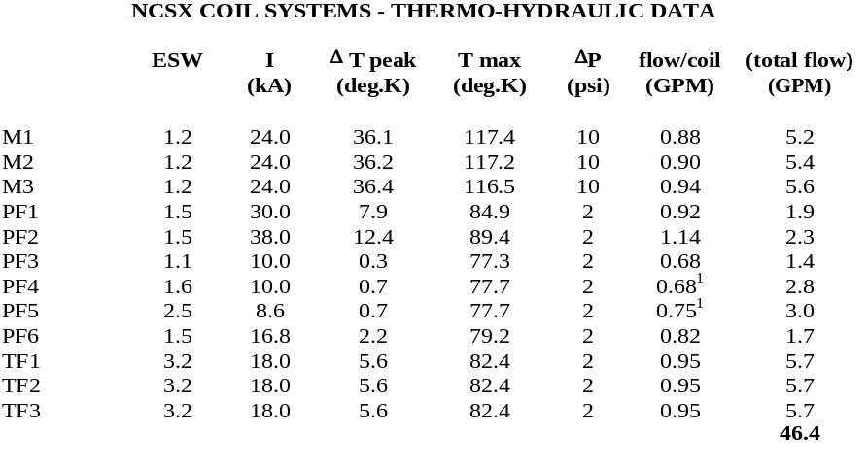

Vendor input
In order to obtain feedback from potential fabricators concerning the feasibility, methods, and cost for fabricating the conventional coils and structure, several vendors were contacted. The conventional coils do not represent any technical issues beyond what is normally encountered in conventional, hollow copper condutor coils. The structure is assumed to be made from castings, finished machined, pre-assembled and fit-checked. The casting vendors suggested a concept with less machining, which has been adopted. The studies were based on a set of CAD models and a draft procurement specification.

Design Implementation

Component Procurement and Fabrication
TF and PF coils The TF and PF coils are relatively simple, conventional, wound coils using hollow copper conductor and vacuum pressure impregnated with epoxy. One or more fixed price contracts will be awarded, based on a best value analysis of the submitted bids. The contract(s) will be structured similar to that successfully used by the NSTX project. The vendors will be given a specification and a basic set of drawings that specify important features such as tolerances, transitions, crossovers, and lead details.
The vendor will be responsible for developing the manufacturing detail drawings and a Manufacturing/Inspection Test Plan. These documents are subject to review and approval by the NCSX prior to release for fabrication.
Coil support structure The coil support structure consists of three types of components. The first type includes the shelf segments, center solenoid hub segments and outboard TF coil supports, which are all cast and machined elements that must be bolted together into a precision assembly. This assembly could be split among several vendors, for example casting and machining vendors. However, a better choice may be to award a contract to a single vendor who would supply a pre-assembled and fit-checked unit that included all the components, insulation, shims, bolts, etc. The contract would be awarded on an evaluated fixed price basis and would be build-to-print.
The second set of components in the coil support structure consist of the spacers, clamps, bucking plate assembly, etc. that are smaller and ideally integrated with the PF1/PF2 centerstack assembly. The intent here would be to include these components as part of the centerstack assembly procurement, which would be on an evaluated fixed price basis and build-to-print.
Coil-to-Bus Leads All the coils have nearly the same peak operating current, so all the coil leads can be essentially the same. These will consist of slightly modified, commercial “kickless” cable, whose insulation has been replaced with reinforced Teflon to operate safely at liquid nitrogen temperatures. The cables will be purchased as assemblies in the correct length, via fixed price contract.
Local I&C The local I&C consists only of temperature and strain sensors, which will be procured via a fixed price subcontract.

Subsystem Assembly, Installation, and Testing
Modular coils The modular coils will be assembled first into field periods in the D-site pre-assembly area, and the field periods will then be installed on the support frame in the NCSX test cell at C-site.
PF and TF coils The TF coils will be assembled in the same sequence as the modular coils, first as part of the field period subassembly in the D-site pre-assembly area, then the field periods will be installed in the NCSX test cell at C-site. The lower PF coils will be pre-positioned below the field period assemblies and raised into position, while the upper PF coil assemblies will be lowered into position, after the three field period subassemblies are brought together.
Coil support structure The coil support structure will be assembled as part of the field period subassembly operations in the D-site pre-assembly area. Two sub-assemblies, each with one sixth of the TF coils, shelf segments, and crown structures will be pre-assembled. Pillow shims will be provided between the TF coils and the crown structure to insure good fit for centering loads. The two subassemblies will then be rotated over the completed modular coil/vessel field period subassembly, one from each end. The connection is then made between the external coil structure and the modular coil shell, using the toroidal stiffener spacers. Since these spacers lie between flat, parallel, and horizontal planes, they can be shimmed to mitigate tolerance buildup and provide the exact relative position of the TF coils and modular coils.
Once the field period subassemblies have been completed, they are placed on the machine base structure. The carriages in the base structure are simultaneously moved inward to avoid interference between the interlocking modular coils, and the field period connections are made. After the field periods are joined, the centerstack assembly, the PF3 coils, and crown structures are installed and secured with the tie rods.
Coil-to-Bus Leads The lead pairs for the modular and TF coils will be installed on the field period subassemblies, while the leads for the PF coils must be installed after the field periods have been brought together in the test cell. As previously mentioned, these leads will be fabricated from commercially available “kickless” cable.
Local I&C The strain and temperature sensors will be installed on the modular and TF coil windings just prior to or during the field period subassembly operation. The PF coils sensors can be installed at any time after receipt of the PF coils but prior to the cryostat installation. PPPL technicians will install these sensors.

Reliability, Maintainability, and Safety
A formal Failure Mode, Effects, and Criticality Analysis will be completed for the magnet systems prior to closeout of the preliminary design phase. Nevertheless, several design features have been included to enhance the reliability of the coil systems or to simplify inspection and repair of obvious trouble spots.
Conventional Coils A coil fault detection system will be provided to prevent operation of the coils outside their design envelope. The system would guard against control errors, shorted buswork, etc. All the coil connections are intended to be accessible with only minor disassembly of external components. This also allows each circuit to be individually tested in the event of a leak.
The PF and TF coils are of conventional construction and operate at relatively low current density. This results in benign thermal cycles and stress levels. The coil structure provides almost continuous support for these windings as well to further reduce cyclic deflections.
Coil support structure The coil support structure must stay in alignment with the modular coils, which is accomplished by tying the two structures together at robust interfaces. The coil support structure can also be re-aligned by removing the interface spacers and shimming.

Cost and Schedule

Conventional Coils (WBS 13)
The costs for the TF and PF coils were developed as a bottoms up estimate using recent experience on the NSTX coil sets. The WBS structure and costs are summarized in Table 12 and Table 13. Cost savings have been realized by using the same, standard, conductor in all the coils except PF2. This allows the same forming tooling to be used for virtually all the coils. The TF Coils (WBS 131) are estimated to cost $1725K. The PF Coils cost slightly less, $1437K. The recommended contingencies are 24% for the TF and 21% for the PF.
Trim coil costs were estimated assuming small conductor and simple winding forms. There are only two shapes for these coils, one shape for the top and bottom coils and the other for the outer perimeter coils. The costs are based on engineering judgment and recent experience with the NSTX coil windings. Standard sized conductor is used to help keep the cost down. The cost estimate for the Trim Coils is $278K. The recommended contingency is 40%, due primarily to uncertainties in performance requirements at this early stage of design.

Table 12 WBS listing for Conventional Coils
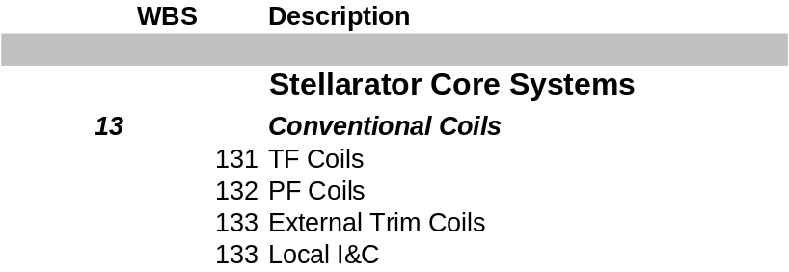

Table 13 Conventional Coil Costs (WBS 13)
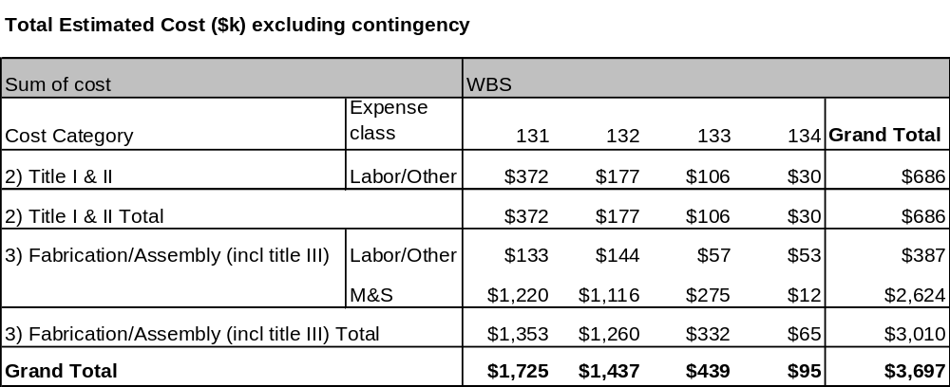

The schedule for implementing the Conventional Coils may be seen in the project Master Schedule, provided as part of the Conceptual Design Report. Title I design begins in mid FY03. Title II design is scheduled to be finished by mid FY04. Production contracts will be awarded shortly thereafter. Production articles should be delivered in mid FY05. TF coils are needed in time to be assembled with the first field period. The lower PF coils need to be placed on the floor of the Test Cell prior to installation of the first field period in the Test Cell. The spending profile for the conventional coils is summarized in Table 14

Table 14 Conventional Coils cost summary by year of expenditure (WBS Level 2)

Support Structure (WBS 15)
The WBS structure and cost estimate for the machine structure is summarized in Table 16. This estimate was developed as a bottoms-up estimate, and includes input from potential vendors. Most of the cost is in the conventional coil support system, and these estimates were consistent with vendor input. The Support Structure (WBS 15) costs $1165K. The recommended contingency is 32%.

Table 15 WBS listing for Support Structure
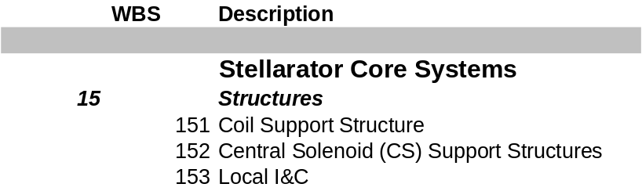

Table 16 Support Structure (WBS 15) Costs
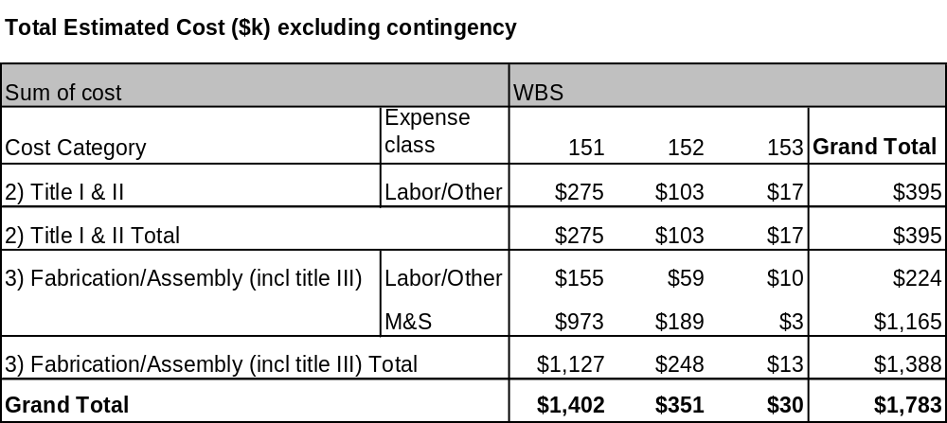

The schedule for implementing the Support Structure (WBS 15) may be seen in the project Master Schedule, provided as part of the Preliminary Design Report. The coil support structure is assembled as part of the field period assembly in the TFTR test cell. Title I design will begin at the start of FY04. Title II design will be completed late in FY04. Procured components should all be delivered late in FY05. The spending profile for the support structure is summarized in Table 17

Table 17 Support Structures cost summary by year of expenditure (WBS Level 2)

Risk Management

PF, TF, Trim coils
These coil sets do not have any specific technical, schedule, or cost risks that have been identified, other than the general concern about relatively few known, qualified domestic coil fabricators. The coils are all of conventional design and fabrication processes are well known and established. The operating current densities, temperature rise, forces, etc. are conservative. They are well supported and with features for adjusting alignment individually. None of these coil sets is on the critical path.

Support Structure
The primary element of risk for the support structure is cost growth. The main drivers for cost growth are changes to the design concept during preliminary design as a result of changes to the requirements, unfeasible fabrication, or lack of functional performance.
These have been addressed for the machine structure by adopting a simple concept that is very robust to changes in coil loads because it is based on a “cast-and-machined” fabrication whose cost is relatively insensitive to section depth. Tolerances and accuracy for this type of structure have been demonstrated for other devices, so there should be no fundamental problem with alignment or other functions. Finally, there is no new technology to develop for this concept, so no R&D should be required.

J. Chrzanowski, “NCSX Preliminary Modular Coil Procurement Specification”, PPPL, November 2002
A. Brooks, A. V. Georgiyevskiy, W.U.Reiersen, V.A.Rudakov, “Current Feeds And Connection Part Perturbation Study On Magnetic Configuration Of NCSX Stellarator, (M45 coils c01r00), April 2002
A. Brooks, “NCSX Coil Tolerance Study, Impact on Plasma Surface Quality”, April 2002, PPPL
H.M. Fan, “EM Analysis of NCSX Coils”, PPPL, February 2001
D. E. Williamson, “Fields and forces from multi-turn model of modular coil”, April 2002
D. E. Williamson, “Field and force comparison for modular coils”, April 2002
L. Myatt, “Electromagnetic Stress Analysis of the NCSX TF and PF Coil Systems”, September 2003, work in progress
ANSYS Release 7.1, UP20030501, INTEL NT, ANSYS, Inc., Canonsburg, PA.
F. Dahlgren, “NCSX Coil Thermo-Hydraulic Analysis”, April 4, 2002, PPPL

