NCSX Engineering Design Document

Design Description
Stellarator Core Systems (WBS 1) Introduction

NCSX Preliminary Design Review

October 7-9, 2003

Table of Contents

1 Design Overview 1

Table of Figures

Figure 1 Cut-Away View of the Stellarator Core Assembly 1
Figure 2 Space Allocations between Plasma and Modular Coils 3

Tables

Table 1 NCSX Parameters 2

Design Overview
The stellarator core is an assembly of four magnet systems that surround a highly shaped plasma and vacuum chamber. The coils provide the magnetic field required for plasma shaping and position control, inductive current drive, and error field correction. The vacuum vessel and plasma facing components are designed to produce a high vacuum plasma environment with access for heating, pumping, diagnostics, and maintenance. All of the NCSX coil sets are cryo-resistive and operate at liquid nitrogen temperatures, so the entire system is surrounded by a cryostat. Figure 1 shows a cutaway view of the stellarator core assembly.

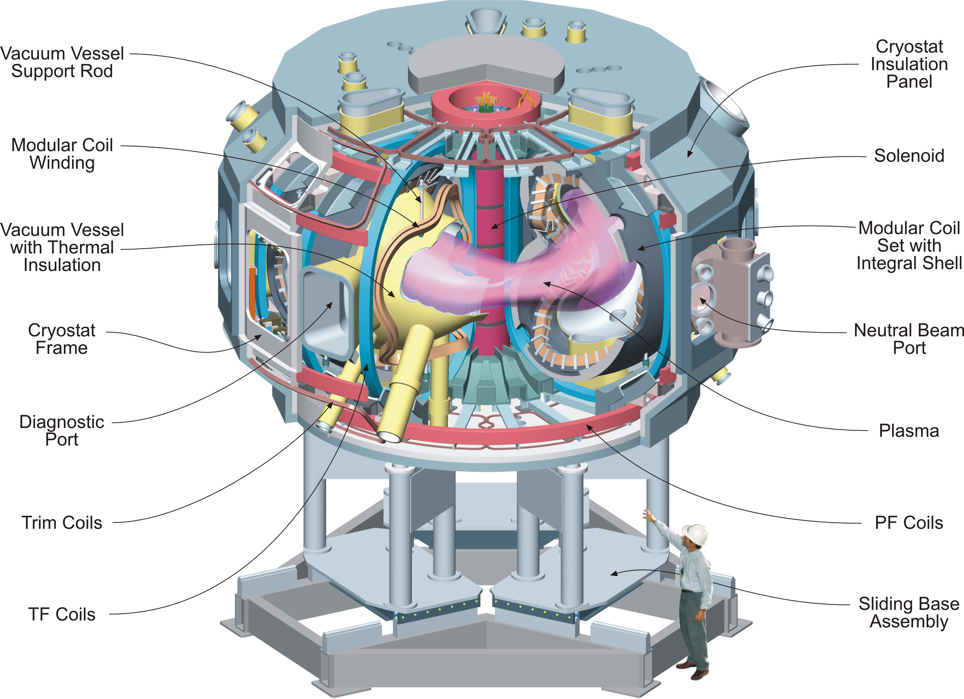
Figure 1 Cut-Away View of the Stellarator Core Assembly

The overall parameters of NCSX are listed in Table 1. The principal feature of NCSX is the set of modular coils that surround and shape the plasma. There are three field periods with 6 coils per period, for a total of 18 coils. Due to stellarator symmetry, only three different coil shapes are needed to make up the complete coil set. The coils are connected electrically in 3 circuits (with all like coils are in series), which are independently powered to provide maximum flexibility. The maximum toroidal field at 1.4 m produced by the modular coils with a toroidal field flattop of ~ 0.2s is 2 T. The toroidal field on axis can be raised above 2 T by energizing the TF coils, which can add ±0.5 T to the field generated by the modular coils.
The windings are wound on and supported by the tee-shaped structural member, which is an integral part of the coil winding form. The winding forms are bolted together to form a structural shell that both locates the windings within the +/- 1.5 mm accuracy requirement and supports them against the electromagnetic loads.
A set of toroidal field (TF) coils is included to provide flexibility in the magnetic configuration. Adding or subtracting toroidal field is an ideal “knob” for lowering and raising iota. There are 18 identical, equally spaced coils providing a 1/R field at the plasma.
Table 1 NCSX Parameters
Parameter | Value
Major radius | 1.4 m
Minor radius | 0.33 m
B_{max} | 2 T
Plasma current | Up to 320 kA
TF coil configuration | +/- 0.5 T, 1/R (18 coils)
Plasma heating methods | NBI
Plasma heating methods | ICH and ECH (future upgrades)

A set of poloidal field coils is provided for inductive current drive and plasma shape and position control. The coil set consists of three inner solenoid pairs (PF 1, PF2 and PF 2), and3 pairs of ring coils. Coil pairs are symmetric about the horizontal midplane and each coil pair is connected in an independent circuit.
External trim coils are provided on the top, bottom and outside perimeter of the coil support structure primarily to reduce n/m=1/2 and 2/3 resonant errors that may result from manufacturing or assembly errors in the modular coil geometry.
Nestled inside the coil set is a highly shaped, three-period vacuum vessel, which means the geometry repeats every 120º. Stellarator symmetry also causes the geometry to be mirrored every 60º so that the top and bottom sections of the first (0º to 60º) segment can be flipped over and serve as the corresponding sections of the adjacent (60º to 120º) segment. The vessel will be constructed in full field periods and joined together at welded joints. Numerous ports are provided for heating, diagnostics, and maintenance access. Several port sizes and shapes are used to best utilize the limited access between modular coils.
The PFCs inside the vessel will be introduced in stages after initial operation. The first phase will include a simple set of limiter tiles at the three v=1/2 symmetry planes which correspond to the vessel field joints. Later upgrades will provide a contoured liner, constructed of molded carbon fiber composite (CFC) panels mounted on a frame of poloidal rings.
One of the challenges for the design is the allocation of space among the components. Specially developed computer codes have been used to optimize the winding path trajectory to satisfy stringent physics requirements while not violating engineering constraints on bending radii, coil-to-coil spacing, coil-to-plasma spacing, and access for neutral beam injection. The coil cross section is further limited by the space requirements for the PFCs, support ribs, vacuum vessel, thermal insulation, and coil clamping features. The space allocations are shown in Figure 2.

The NCSX stellarator core will be assembled from three individual field period assemblies that are joined by a combination of bolting and welding atop the support stand in the test cell. Each of the three field periods are pre-assembled in a separate area at PPPL, and consist of one third of the vacuum vessel, TF and modular coils, trim coils and in-vessel diagnostics. The modular coils in each half field period will be completely pre-assembled at the factory for fit-up, inspection, and testing prior to shipping. The vacuum vessel will be delivered in three sections plus the port extensions.

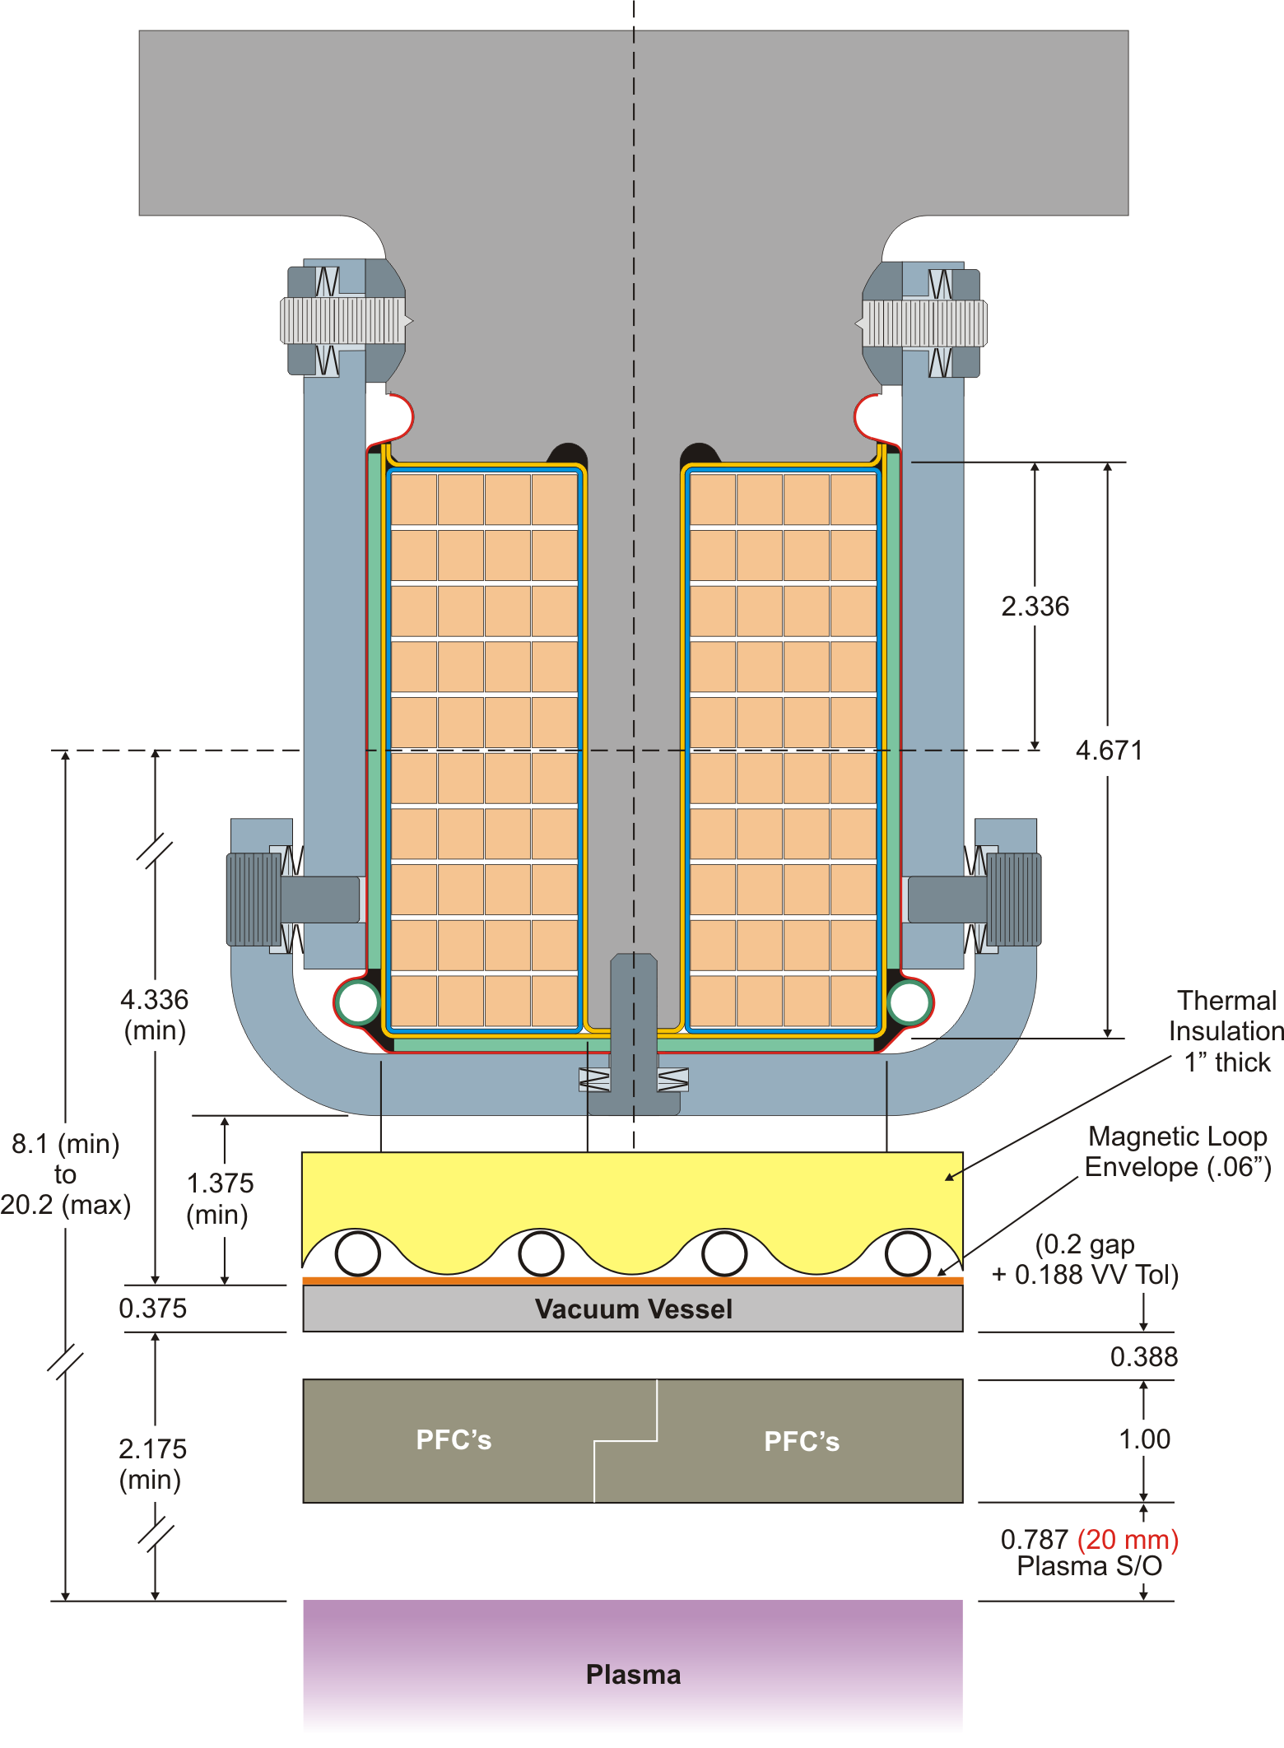
Figure 2 Space Allocations between Plasma and Modular Coils
The modular coils will first be assembled over the vacuum vessel (VV) segment. The vacuum vessel will then be supported (hung) from the modular coil structure. The TF coils will be installed and the port extensions will be welded into place. The vacuum vessel segment will be baked out to more than 150ºC and a vacuum leak check will be performed. The completed field period sub-assembly will be transported to the test cell and placed in a temporary position on the test stand. When all three subassemblies are in place, they are moved radially into final position. All three subassemblies are moved simultaneously to avoid interference with the interlocking modular coil boundaries, which extend past the shell and vessel connecting flanges.
The NCSX project is presently completing the preliminary design phase for the modular coils and vacuum vessel. The general configuration has been selected and baseline concepts exist for all of the primary design features. Scoping analyses have permitted sizing and performance evaluation of the key components. Manufacturing studies have been carried out for the two most critical elements of the design, the modular coils and vacuum vessel and contracts are in place for substantial R&D in these areas. Some analyses, such as the TF and PF structural analyses, have not been completed, but these components are based on conventional concepts and there is high confidence that a successful design solution has been proposed.
Following the preliminary design review, in the balance of FY 2004, the final design of the modular coils and vacuum vessel will be completed. Full scale prototypes of the Type C modular coil winding form will be fabricated, as will full scale partial prototypes of the vacuum vessel. Following the final design review of the modular coils, the production winding forms will be ordered. The prototype winding forms will be used to produce a complete prototype modular coil. The production vacuum vessel contract will also be awarded. In parallel with the effort on the modular coils and vacuum vessel, the preliminary design of the conventional coils will also be completed. Further design refinement will be carried out for all other components, and design suggestions from the preliminary design review panel will be evaluated and incorporated. Highlights in future years include:
FY05 The production modular coil winding will begin. The first and second vacuum vessel field period segments will be completed.
FY06 All the modular coils will be completed. The vacuum vessel field period segments will be shipped to PPPL and assembly of all the field periods will be completed. The final assembly in the test cell will begin.
FY07 Assembly in the test cell will be completed by September 2007 and first plasma will be initiated.

