NCSX

Product Specification
for the
Vacuum Vessel System (WBS 12) Coolant Tubes

NCSX-CSPEC-123-01-00

24 June 2005

Prepared by: __________________________________________________________________________
P. L. Goranson, Vacuum Vessel System (WBS 12) Manager

Concur: ______________________________________________________________________________
M. Viola, Technical Representative for Vacuum Vessel System (WBS 12) Procurements

Concur: ______________________________________________________________________________
B. Nelson, RLM for Stellarator Core Systems (WBS 1) Design and Procurement

Concur: ______________________________________________________________________________
F. Malinowski, Quality Assurance

Approved by: _________________________________________________________________________
W. Reiersen, Engineering Manager
Controlled Document
This is a controlled document. Check the NCSX Engineering Web prior to use to assure that this document is current.
Record of Revisions

Revision | Date | ECP | Description of Change
Rev. 0 | 6/24/05 | --- | Initial Release
Table of Contents
1 Scope 1
2 Applicable Documents 1
3 Requirements 1
3.1 Item Definition 1
3.2 Characteristics 2
3.2.1 Tube Material 2
3.2.2 Dimensions and Tolerances 2
3.2.3 Tube Segmentation 2
3.2.4 End Fittings 2
3.2.5 Free Flow 2
3.2.6 Magnetic Permeability 2
3.3 Design and Construction 3
3.3.1 Fabrication Models and Drawings 3
3.3.2 Cleaning 3
3.3.3 Workmanship 3
4 Quality Assurance Provisions 3
4.1 General 3
4.1.1 Responsibility for Tests 3
4.1.2 Inspection and Test Documentation 3
4.2 Quality Conformance Inspections 4
4.2.1 Verification of Tube Material 4
4.2.2 Verification of Dimensions and Tolerances 4
4.2.3 Verification of Free Flow 4
4.2.4 Verification of Magnetic Permeability 4
4.2.5 Verification of Cleaning 4
4.2.6 Verification of Workmanship 5
5 Preparation for Delivery 5
5.1 Labeling 5
5.2 Packing and Skidding 5
5.3 Marking 5

Table of Figures
Figure 3-1 Tubes installed on Vacuum Vessel Sub-assembly 1

Scope
This specification covers the fabrication of the Vacuum Vessel Coolant Tubes (Tubes) for the National Compact Stellarator Experiment (NCSX), including the supply of all required labor and materials, machining, fabrication, and factory acceptance inspections and tests. The Seller shall deliver the Tubes and constituent components to the Princeton Plasma Physics Laboratory (Laboratory). The Seller will not be responsible for providing mounting hardware for the Tubes. All of the labor for the final installation, mounting, and assembly of the Tubes will be supplied by the Laboratory.

Applicable Documents
ASTM A 213/A 213M-03 Standard Specification for Seamless Ferritic and Austenitic Alloy-Steel Boiler, Superheater, Heat-Exchanger Tubes.
ASTM A 269-04 Standard Specification for Seamless and Welded Austenitic Stainless Steel Tubing for General Service.

Requirements

Item Definition
Background
The NCSX vacuum vessel is a contoured, three-period torus with a geometry that repeats every 120º toroidally. The geometry is mirrored every 60º so that the top and bottom sections of the first (0º to 60º) segment, if flipped over, are identical to the corresponding sections of the adjacent (60º to 120º) segment. Each 120º segment is referred to as a vacuum vessel sub-assembly. The three sub-assemblies are welded together at final assembly to form a complete torus. The vessel outer surface is fitted with coolant tubes contoured to follow the vessel surface. The Tubes are arranged and mounted, in pairs, on brackets bolted to the vacuum vessel surface. The Tube configuration as installed on a vessel period is illustrated in Figure 3-1.
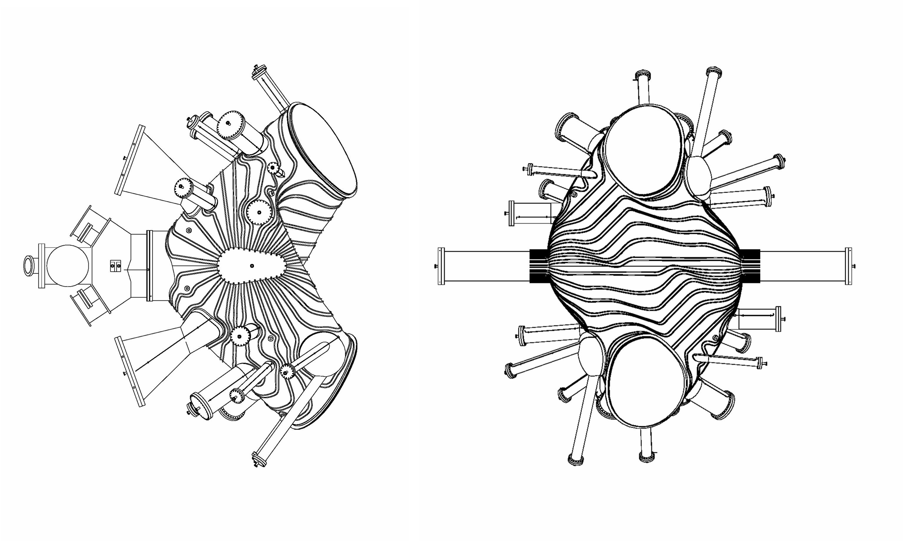
Figure 3-1 Tubes installed on Vacuum Vessel Sub-assembly

There are 32 Tube types on each 60º segment of the vacuum vessel. Due to stellarator symmetry, there are six (6) instances of each type for a total of 192 Tubes.
Requirement
192 Tubes consisting of 32 Type types (with unique part numbers) with 6 instances of each type shall be provided by the Seller.

Characteristics

Tube Material
All Tubes shall be continuous lengths (without weld joints) of annealed seamless Alloy 316L and meet the requirements of ASTM A213 or ASTM A269.

Dimensions and Tolerances
The Tubes shall be formed to conform to the dimensions and tolerance requirements in the fabrication drawings listed in Section 3.3.1.

Tube Segmentation
- The Tubes are shown as continuous formed tubes but the Seller may, as an option, supply any or all of the finished Tube in segments, designed to be brazed together with socket braze fittings.
- The segmentation scheme shall be proposed to the Laboratory for approval.
- A maximum of four segments per Tube will be permitted.
- The Seller shall supply any socket braze fittings required for assembly of the Tube pieces into the complete lengths specified.
- The Seller shall not braze the components together. The Laboratory will perform all brazing and the leak check of the assembled components.

End Fittings
- Whether segmented or not, the Seller shall provide one fitting on each end of the finished Tubes which will be used to splice the Tubes into the adjoining supply and return tubes.
- The Seller shall not braze the components together. The Laboratory will perform all brazing and the leak check of the assembled components.

Free Flow
All tubes shall be free of blockages or flow restrictions which would result in unacceptable heating and cooling performance in service.

Magnetic Permeability
Background
Contamination of the tubes with magnetic material is a prime concern. Tools utilized in bending and general handling operations are preferred to be nonferrous ceramics or nonmagnetic stainless steel, which have never been in contact with materials other than stainless or other non-magnetic alloy.
Requirements
- Magnetic contamination resulting from contact with of ferritic tools shall be removed by a cleaning process (i.e. fine grit abrasive sanding and cleaning) proposed by the Seller and approved by the Laboratory.
- Relative magnetic permeability of the Tubes shall not exceed 1.02.

Design and Construction

Fabrication Models and Drawings
The following table provides the complete listing of zip files which include all models and drawings approved for fabrication. Separate zip files are provided for PDF files, ProE files, and STEP files.

ZIP File | Model Description (from Pro/Intralink database, edited) | Rev
Heating_cooling_pdf_Files_Rev1.zip | ZIP file containing PDF drawing files | 1
Heating_cooling_ProEModels_Rev1.zip | ZIP file containing all ProE models | 1
Heating_cooling_step_Rev1.zip | ZIP file containing all STEP files | 1
Data_point_files_tubes_Rev1.zip | Zip file containing data point files | 1

These files may be accessed on the Supplier FTP site at:

ftp://ftp.pppl.gov/pub/ncsx/manuf/vv_coolant_tubes/

Cleaning
After completion of forming, the tube interior and exterior surfaces shall be cleaned per a mutually agreed upon written procedure. As a minimum this procedure will include:
- Degreasing to remove oils, greases, and die lubricant residues resulting from handling and fabrication of the tubing.
- Solvent (e.g. non-chlorinated) wipe down of the surfaces.
- Blow drying of surfaces with oil-free instrument air.

Workmanship
The Tubes shall be free of defects, e.g. kinks, dents, and cuts.

Quality Assurance Provisions

General

Responsibility for Tests
Tests and inspections shall be conducted at the Seller’s facility or otherwise suitable location. The responsibility for performing all tests and verifications rests with the Seller. The Laboratory reserves the right to witness or separately perform all tests specified or otherwise inspect any or all tests and inspections

Inspection and Test Documentation
Actual data and accept/reject status for each inspection and test shall be documented. The reports shall contain sufficient information to accurately locate the Tube or Tube segment involved and to reproduce the inspection or test performed. This may be accomplished by clear and direct reference to other Seller-provided documents. References to calibrated measuring and test equipment shall include date of latest calibration. Inspection and test reports shall identify the personnel performing the inspection or test. The reports shall be dated and verified by authorized personnel.

Quality Conformance Inspections

Verification of Tube Material
- Material certifications, in accordance with the applicable ASTM specification in Section 3.2.1, showing the actual chemical and physical properties of the materials used shall be provided.
- The Seller is to utilize process controls to assure traceability of materials to their certifications.

Verification of Dimensions and Tolerances
- The Seller will perform dimensional checks on the Tubes using 3-D measurement equipment (e.g. laser tracker or CMM) to ensure that the surfaces are within the prescribed limits per Section 3.2.2. The Tubes may be restrained at the discretion of the Seller.
- The contour shall be dimensionally checked on increments no coarser than 6-inch centers. The minimum resolution of the instruments shall be at least ten times smaller than tolerances being measured.
- Compliance with the dimensions and tolerances shall be verified with the assembly completed, i.e. formed, cleaned, and flow checked. Tubes that are segmented shall be dry fit (not brazed together) for dimensional checking.

Verification of Free Flow
All Tubes shall be checked for free flow to assure no blockages or restrictions are present in the tubing as required in Section 3.2.5. This test may be performed with shop compressed air or nitrogen before final cleaning or combined with the cleaning procedure blow drying step using instrument air. The tubing pressure drop shall not exceed 0.7 inches of water per foot of length at a flow rate of 0.2 cfm. Testing shall be performed per a mutually agreed upon procedure.

Verification of Magnetic Permeability
- To verify conformance to Section 3.2.6, Tube surfaces shall be checked with a calibrated Severn Permeability Indicator.
- All Tubes shall be checked prior to forming at a minimum of three locations (each end and center).
- The first of each Tube type (each part number) shall also be checked after forming is complete. The measurements shall concentrate on bend regions which are susceptible to work hardening and check increments shall be no coarser than 6-inch centers. If checks of the first Tube of a type shows magnetic permeability exceeding the requirements of Section 3.2.6, each Tube of that type shall be also be checked per this section.

Verification of Cleaning
Tubes shall be visually inspected and records examined for compliance with Section 3.3.2.

Verification of Workmanship
The tubes shall be visually inspected for defects i.e. kinks, dents, cuts, etc. and abnormalities reported in a Non-Conformance Report (NCR) to the Laboratory for evaluation

Preparation for Delivery

Labeling
Tubes and Tube segments shall be permanently marked (with vibrating etching tool, for example) with unique serial numbers to provide positive identification. When such markings would impair proper functioning of the equipment, a metal, non-corrosive, non-magnetic tag shall be used. The marking or tagging of tubes shall be done on the tube end corresponding to the starting end of the tube during fabrication, i.e. the end corresponding to (x,y,z) coordinates of (0,0,0). If the tubes are segmented, the segments shall be identified with letters (A,B,C,D) starting with the segment closes to the (0,0,0) coordinates. The labels (markings or tags) will be used to determine positioning of the Tubes or Tube segments during installation at the Laboratory.

Packing and Skidding
All components shall be sealed, packaged, and skidded to provide protection against contamination, deterioration and damage during shipment. A plan shall be provided to the Laboratory prior to shipment which includes a description of methods to be used to preserve, package, skid, and identify equipment. The Seller shall contact the Laboratory ten days prior to shipment of the machine to confirm shipping method and route.

Marking
Each shipping skid shall be marked with the name of the Seller, Laboratory Purchase Order Number, the component name, and gross weight. Boxes containing loose parts, attachments, and accessories shall be marked identifying the assembly to which they belong, and where possible, boxes are to be secured to the skid of the unit.

Severn Engineering Company, Auburn AL, e-mail: SEVERNENGINEER@BELLSOUTH.NET

