NCSX Engineering Design Document

Design Description
Modular Coils (WBS 14)

NCSX Preliminary Design Review

October 7-9, 2003

Table of Contents
1 Design Requirements and Constraints 1
1.1 System Definition 1
1.2 Primary Functions 2
1.3 Configuration Requirements and Essential Features 2
1.4 Performance and Operational Requirements 3
2 Design Description and Performance 4
2.1 Winding Forms 4
2.2 Windings and Assembly 8
2.3 Local I&C 11
2.4 Winding Facility 12
3 Design Basis 12
3.1 Design Criteria 12
3.2 Design Analysis 12
3.2.1 Coil and Lead Field Errors 12
3.2.2 Eddy Currents 14
3.2.3 Thermo-hydraulic analysis 15
3.2.4 Electromagnetic Loads 17
3.2.5 Stress due to Electromagnetic Loads 21
3.2.6 Stress due to Thermal Loads 24
3.2.7 Stress due to Combined Loads 26
3.3 R&D Activities 27
3.3.1 Winding R&D 27
3.3.2 Winding Form Development 34
4 Design Implementation 34
4.1 Component Procurement and Fabrication 34
4.2 Subsystem Assembly, Installation, and Testing 34
5 Reliability, Maintainability, and Safety 34
6 Cost and Schedule 35
7 Risk Management 36

Table of Figures
Figure 1 Modular Coil Assembly 1
Figure 2 - Winding Facility, including overturning fixture and autoclave 2
Figure 3 Winding Form Type 1 5
Figure 4 Winding Form Type 2 5
Figure 5 Winding Form Type 3 6
Figure 6 Winding Form Tee Details 7
Figure 7 Poloidal Break Details, showing triple shim, bushings 7
Figure 8 Nesting of Winding Forms 8
Figure 9 Compacted cable conductor 9
Figure 10 Winding Pack Layout 10
Figure 11 Modular Coil Leads 11
Figure 12 Modular Coil Winding and Turning Fixture 12
Figure 13 Field Error due to Windng Center Displacement 13
Figure 14 Field Error due to Leads 14
Figure 15 Eddy Currents in Structural Shell 15
Figure 16 Windng Pack Temp Distribution after Cooldown 16
Figure 17 Modular Coil Cooldown 17
Figure 18 Magnetic Field at Coil Windings 18
Figure 19 Force Distribution on Modular Coils at 2T 19
Figure 20 Component Forces for Coil M2 (2T case) 20
Figure 21 Structural Shell Finite Element Model 21
Figure 22 Vertical and Total Displacement Contours 22
Figure 23 Von Mises Stress Distribution in Shell (50% Modulus) 23
Figure 24 Von Mises Stress Distribution in Tee (50% Modulus) 23
Figure 25 Von Mises Stress Distribution in Windings (50% Modulus) 24
Figure 26 Thermal Stress Analysis Model 25
Figure 27 Thermal Contraction of Windings 25
Figure 28 Stress due to Cool-Down 26
Figure 29 EM Pressure applied to winding pack 26
Figure 30 Stress in "tee" and winding due to combined thermal and EM loading 27
Figure 31Thermal expansion data for a single modular coil conductor specimen 29
Figure 32 First demonstration coil, wound at the University of Tennessee and vacuum impregnated at PPPL 31
Figure 33 Second racetrack demonstration coil, wound and vacuum impregnated with epoxy at PPPL 31
Figure 34 "Twisted Tee" demonstration coil showing coil assembly, cast winding form, and end view of assembly in vacuum oven 32
Figure 35 Electron beam micrograph of epoxy impregnated cable conductor (strand dia. is 0.005 inches) 33

Tables
Table 1 Maximum Operational Loads on Structural Shell 3
Table 2 Reference Scenarios and Modular Coil Current 3
Table 3 Modular Coil Parameters 8
Table 4 Modular Coil Instrumentation 11
Table 5 Thermo-Hydraulic Analysis of Coils 16
Table 6 Electromagnetic Analysis Load Cases 17
Table 7 Maximum Running Load on Modular Coils 20
Table 8 Material Properties Used For Modular Coils 21
Table 9 Summary of Modular Coils Stress Analysis 22
Table 10 Compression testing of a single modular coil conductor 28
Table 11 Tension testing of a single modular coil conductor, initial results 28
Table 12 Flexural Testing of a single modular coil conductor 28
Table 13 Effect of keystoning on three winding pack configurations 30
Table 14 WBS listing for Modular Coils 35
Table 15 Modular Coil Cost Estimate ($k without contingency) 35
Table 16 Modular Coil Cost Summary by Year of Expenditure 36

Introduction
The National Compact Stellarator Experiment (NCSX) is an experimental research facility that is to be constructed at the Department of Energy’s Princeton Plasma Physics Laboratory (PPPL). Its mission is to acquire the physics knowledge needed to evaluate compact stellarators as a fusion concept, and to advance the understanding of 3D plasma physics for fusion and basic science.
A primary component of the facility is the stellarator core, an assembly of four magnet systems that surround a highly shaped plasma and vacuum chamber. The coils provide the magnetic field required for plasma shaping and position control, inductive current drive, and error field correction.
This document describes the requirements, design concept, design basis, implementation, cost, and risk associated with the construction of the modular coil subsystem of the stellarator core.

Design Requirements and Constraints

System Definition
The modular coil set consists of three field periods with 6 coils per period, for a total of 18 coils. Due to symmetry, only three different coil shapes are needed to make up the complete assembly. The coils are connected electrically with three circuits in groups of six coils, according to type. Figure 1 shows the general arrangement of the coils and structure.
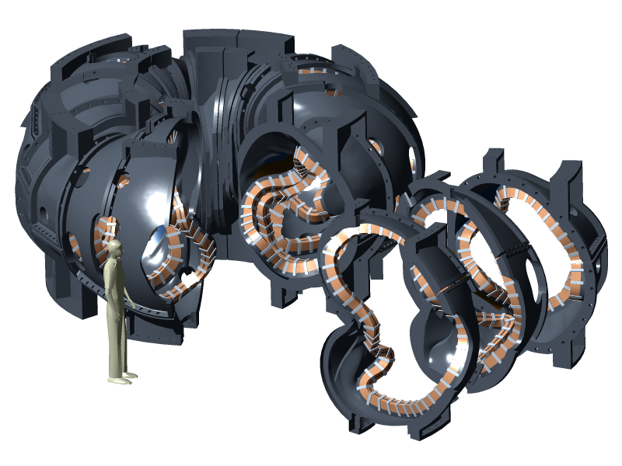
Figure 1 Modular Coil Assembly
The winding facility consists of fixtures and tooling to support the winding form during coil fabrication, an autoclave and associated equipment to perform vacuum pressure impregnation (VPI) of each coil assembly, and limited cryo-electrical test equipment. Figure 2 shows the major components of the winding facility.
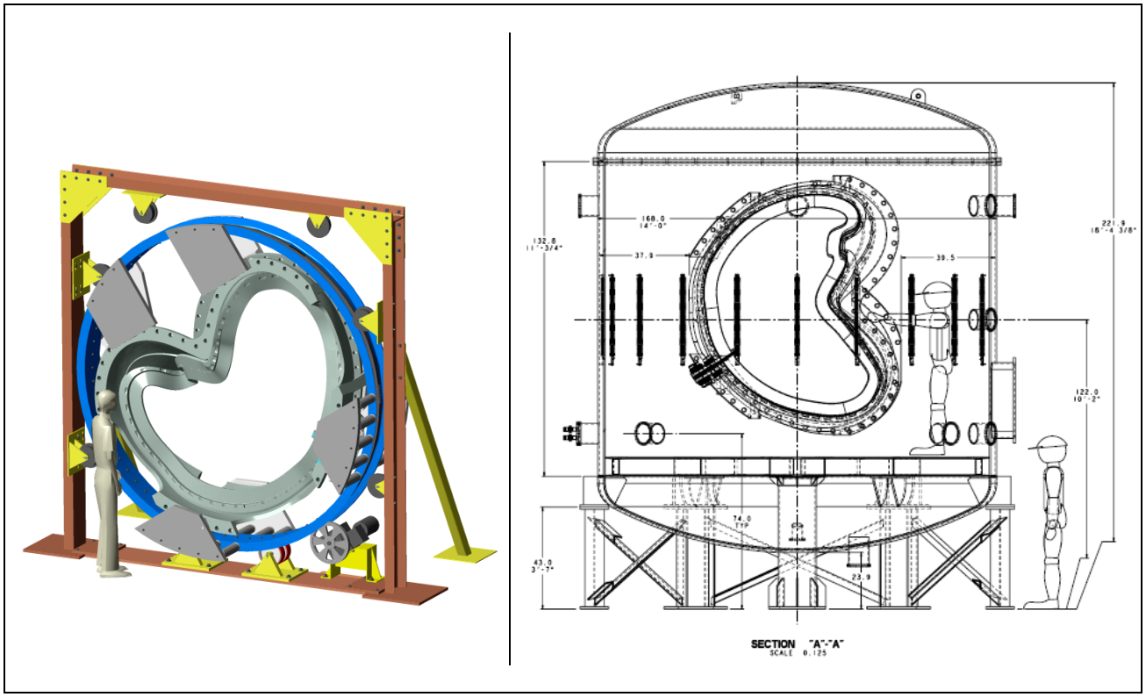
Figure 2 - Winding Facility, including overturning fixture and autoclave
The work breakdown structure (WBS) for the modular coil system includes the winding forms (WBS 141), coil windings and assembly (WBS 142), local instrumentation (WBS 143), and the winding facility and fixtures (WBS 144).

Primary Functions
The function of the winding forms is to provide an accurate means of positioning the conductor during the winding and vacuum-pressure impregnation (VPI) process. The winding forms are permanent structures that also provide mechanical support for the windings during coil operation. The complete assembly of winding forms is referred to as the structural shell.
The function of the modular coil windings is to provide the basic quasi-axisymmetric magnetic configuration for the device. The windings can produce alternate magnetic configurations by varying the current for each coil type independently.
Sensors are required on each coil in order to monitor behavior during operation and provide feedback to the coil protection system. The required data includes voltage, temperature, strain, and flow measurement.
The function of the winding fixtures, tooling, and autoclave is to provide precise support and positioning of the winding form and conductor during the winding process, and to meet the requirements of the VPI process.

Configuration Requirements and Essential Features
The winding forms provide the interface between the windings and both internal and external components of the stellarator core. Essential features include 1) accurately machined surfaces for the conductor, 2) a poloidal break to meet electrical (eddy current) requirements, and 3) construction using a low magnetic permeability (<1.02) material. Configuration requirements are 1) to support the vacuum vessel, 2) provide access for tangential NBI, ICRH, vacuum pumping, diagnostics, and personnel, and 3) provide a mechanical interface with the external PF and TF coil support structure.
The most important configuration requirement for the windings is that the final position of the winding center conform to the prescribed geometry within a tolerance of +/- 1.5-mm. Essential features of the windings include 1) compatibility with existing power supplies (determines number of turns), and 2) independent control of each coil type for flexibility.
Configuration requirements for instrumentation include 1) voltage taps at the leads, 2) strain gages along the length the coil, 3) flow sensors at each inlet/outlet, and 4) multiple Resistance Temperature Detectors (RTDs) for pre- and post-pulse monitoring of conductor average temperature.
The winding facility is required to interface with the three coil shapes, provide tooling that is easy to use but also accurately positions the conductor, and meet the temperature and pressure requirements of the VPI process.

Performance and Operational Requirements
When assembled into a structural shell, the main performance requirement for the winding forms is to support the coil electromagnetic loads with a minimum of deflection. Table 1lists the range of loads that are expected:

Table 1 Maximum Operational Loads on Structural Shell
 | Max Radial Load (kip) | Max Vertical Load (kip) | Avg Inboard Pressure (psi) | Avg Outboard Pressure (psi) | Max Coil Radial Load (kip/in) | Max Coil Lateral Load (kip/in)
Segment / Coil 1 | 200 | 10 | 220 | 70 | 3 | 6
Segment / Coil 2 | 320 | 110 | 280 | 75 | 6 | 7
Segment / Coil 3 | 90 | 120 | 170 | 80 | 4 | 6.5

The modular coil windings must be capable of meeting the reference operating scenarios defined in GRD Section 3.2.1.5.3.3 and summarized in Table 2.

Table 2 Reference Scenarios and Modular Coil Current
Scenario | Max Current (kA) | Max I²t (A²-s) | Max ESW (s)
First Plasma (0.5-T) | 225 | 93 E6 | 0.76
Field Mapping | 225 | 450 E6 | 3.6
1.7-T Ohmic | 763 | 1400 E6 | 1.0
1.7-T High Beta | 763 | 1350 E6 | 0.97
2.0-T High Beta | 818 | 1530 E6 | 0.90
1.2-T Long Pulse | 538 | 1300 E6 | 2.0
320-kA Ohmic | 707 | 1270 E6 | 1.0

The winding facility has no specific performance requirements, except for the autoclave. It has several requirements which are described more fully in specification NCSX-CSPEC-142-02-00:
- Achieve vacuum pressure <1-torr in 4-hrs
- Capable of 15-psig positive pressure
- Heat coil assembly from room temperature (RT) to 45-C in 4-hrs
- Heat coil assembly from 45-C to 110-C in 15-hrs
A complete list of system requirements is given in the General Requirements Document, NCSX-ASPEC-GRD-00, and the Modular Coils System Requirements Document, NCSX-BSPEC-140-01-00.

Design Description and Performance
The geometry of the modular coil set has been developed through a physics optimization process that emphasizes both plasma properties and geometric constraints, such as coil-to-coil spacing (a key factor determining the current density) and minimum bend radius. Improvements to the conceptual design were made in these areas and also to the twist of the coil cross-section in regions where the winding packs are close together. It is believed that the present design best minimizes the sharp bends in the conductor while maximizing the available conductor space. A study of the effect of finite-build coils on plasma reconstruction indicates that these small coil adjustments do not significantly affect the magnetic field or plasma properties.

Winding Forms
The overall dimensions of each winding form type are shown in Figure 3, Figure 4, and Figure 5. Due to the complexity of shape, the forms will be fabricated as castings, with a tolerance of +/- 0.25-in over the surface of the part. Machining of only the winding cavity and flanged interfaces is then necessary to achieve the desired accuracy. The main design features of the winding forms are 1) the “tee” structure that forms the winding cavity, 2) a poloidal electrical break, and 3) toroidal segmentation that results in a “nested” assembly of the structure.
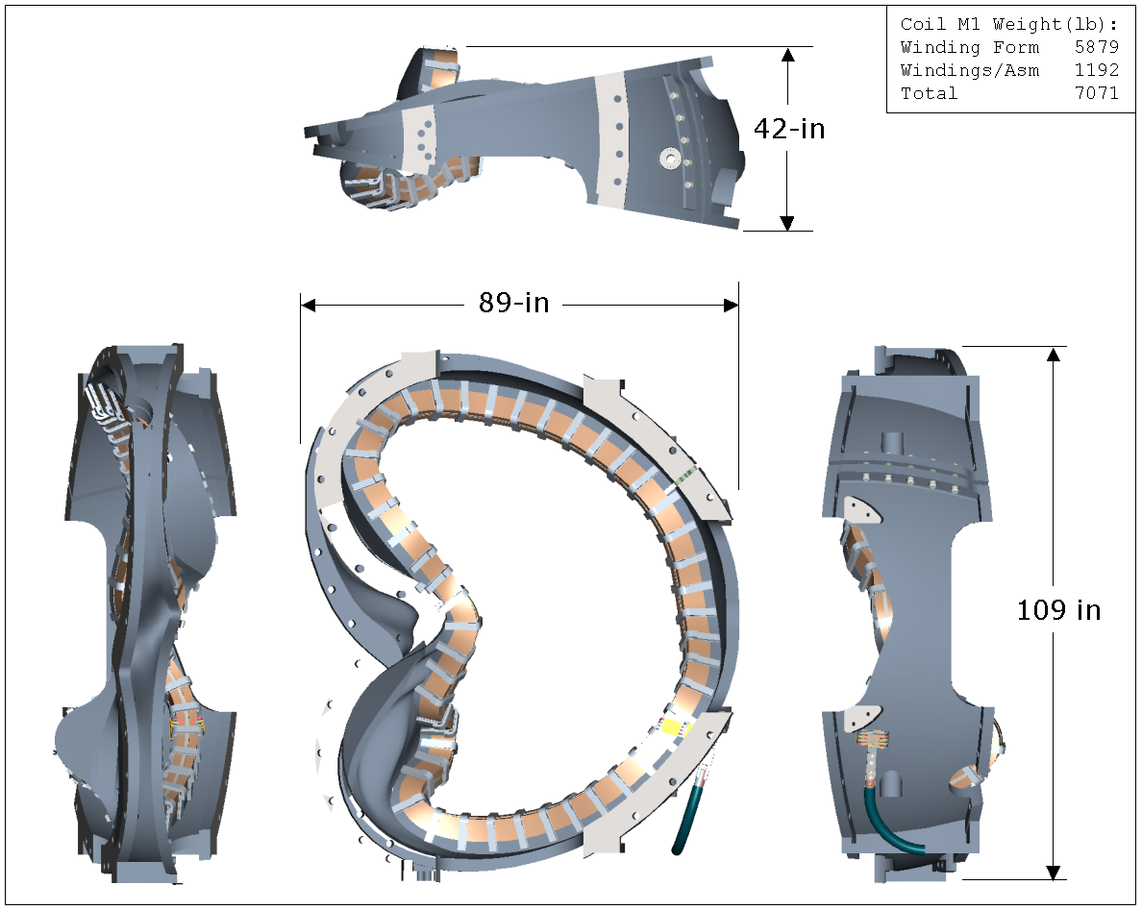
Figure 3 Winding Form Type 1

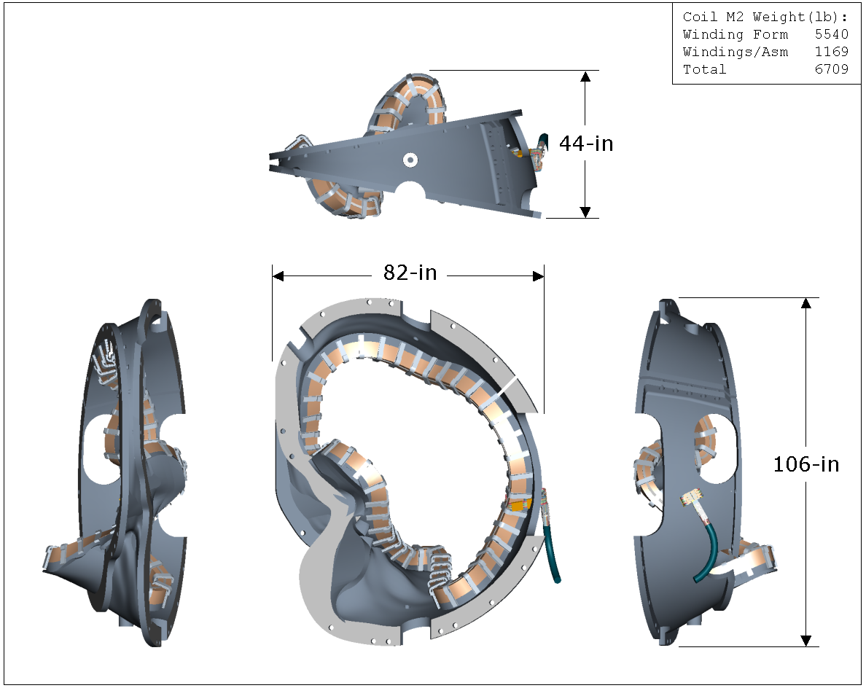
Figure 4 Winding Form Type 2

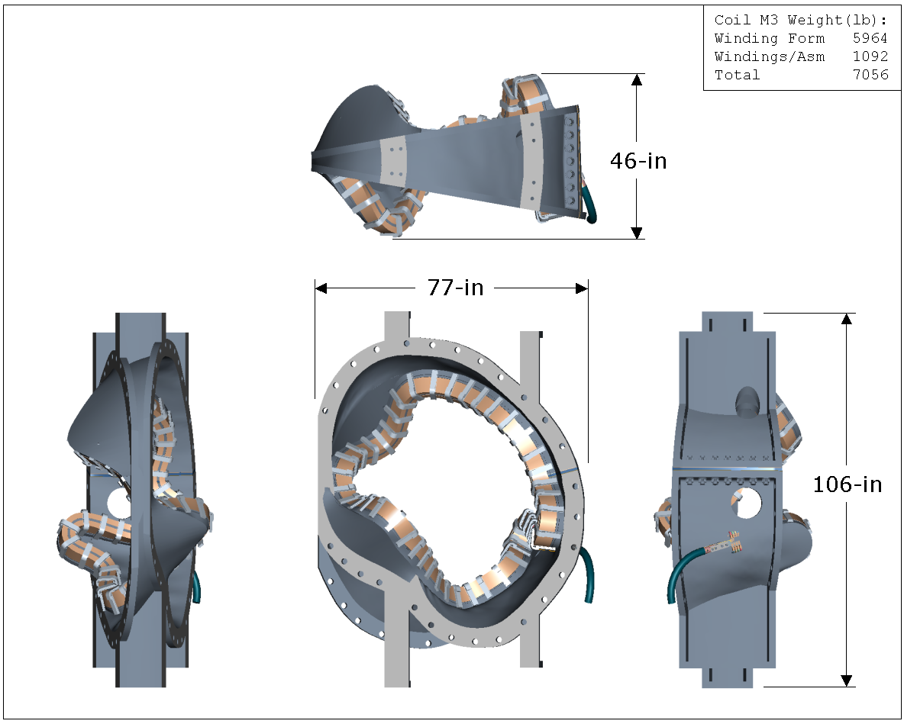
Figure 5 Winding Form Type 3

The first feature, the tee section, is shown in detail in Figure 6. The tee is machined to a profile tolerance of +/-0.010-in and serves as the reference surface on which to locate the conductor. Along the sides of the tee, there is a continuous groove for the VPI bag mold which encloses the tee, winding packs, and cooling system. Outside of this envelope, threaded studs are welded to the sides of the tee for external winding clamps. The clamps are spaced approximately every 6-in, except in some inboard regions where the assembled coils are too close together. Additional work is needed to establish the requirements for clamps in this region and possible design solutions.
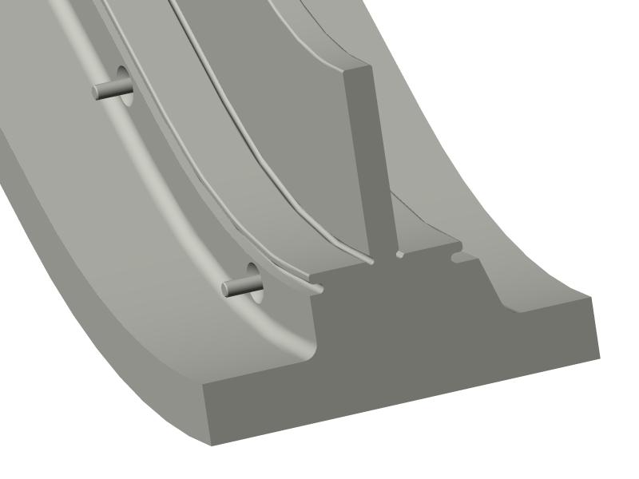
Figure 6 Winding Form Tee Details
The poloidal electrical break is located in the outboard midplane region of each winding form, as shown in Figure 7. The break is accomplished by cutting the casting prior to final machining, then bolting the form together using an insulated metal spacer and bolts. The web of the tee is connected by use of a double-insulated pin or bolt.
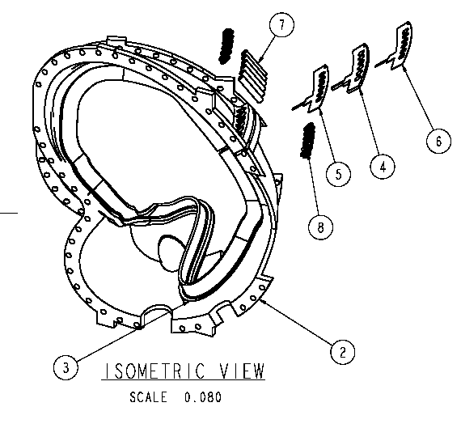
Figure 7 Poloidal Break Details, showing triple shim, bushings
The toroidal segmentation of the winding forms has received considerable attention in design, owing to the “nested” assembly of coils. After the windings are installed, the winding forms are bolted together to form a monolithic shell structure. Insulating shims and bolts are used at each flanged joint in order to prevent circulation of toroidal currents, except the three joints made at final assembly. The complex shape of the coils results in protrusions (aka wings), which extend beyond the flanges of the winding form and must fit underneath the adjacent winding form. In order to use the as-cast shape in these areas, the gap between overlapping structures must be at least 0.5-in. This is illustrated by the section view in Figure 8.

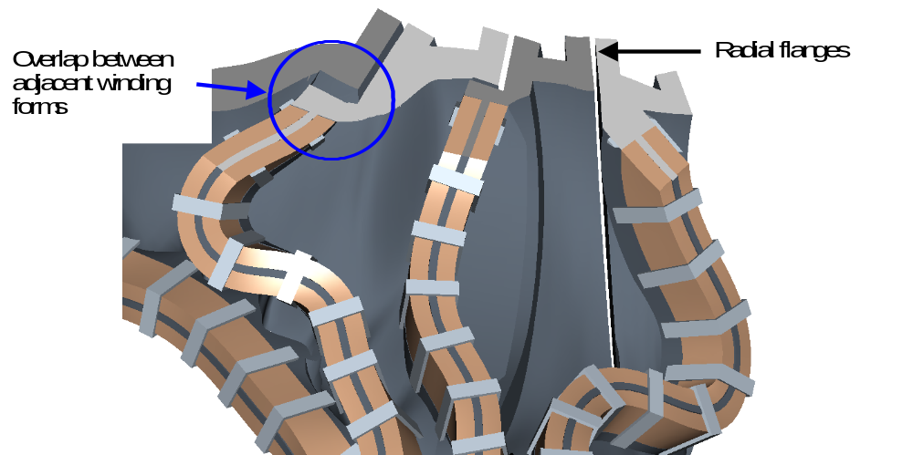
Figure 8 Nesting of Winding Forms

In summary, the winding forms create a robust structure mechanically that should provide the best possible coil accuracy. The coils are wound onto machined winding cavities, which are referenced to machined assembly flanges. The accuracy of the winding cavity with respect to the flanges is expected to be very good, probably within .010 inches. Nevertheless, the coils can be shimmed at the interface flanges to recover tolerance if necessary. No other structure is needed for the modular coils, except the interfaces to the gravity supports.

Windings and Assembly
Table 3 summarizes the main modular coil parameters. Important design features are 1) conductor and insulation, 2) winding pack layout, 3) leads, 4) cooling concept, 5) VPI bag mold, and 6) winding clamps.
Table 3 Modular Coil Parameters
Coil # | 1' |  | 1 |  | 2 |  | 3 |  | 3'
Coil Length (in) |  |  | 290.5 |  | 283.2 |  | 263.0
Min Coil-Coil Dist (in) |  | 7.56 |  | 6.31 |  | 6.09 |  | 6.85
Max Coil-Coil Dist (in) |  | 35.0 |  | 36.4 |  | 30.7 |  | 26.6
Min Rad of Curvature (in) |  |  | 4.15 |  | 4.41 |  | 4.16
Min Coil-Plas Dist (in) |  |  | 8.79 |  | 8.09 |  | 8.98
Max Coil-Plas Dist (in) |  |  | 28.5 |  | 22.6 |  | 20.2
The conductor is fabricated using a flexible copper cable with approximately ~3420 strands of bare AWG 34 (0.0063-in dia) wire. The primary advantage of the flexible cable design is low cost, both to purchase the conductor and to wind it. The primary disadvantage is the loss of copper area compared to a solid conductor. In the present design, the cable is compacted into a rectangular shape, 0.35 x 0.391-in, with a packing fraction of about 78%. The A typical compacted conductor is illustrated in Figure 9 A packing fraction of 75% can be assured, although 80% is theoretically possible. Due to helical twisting of the cable strands, the length of the strands is about 12% greater than the conductor length. The conductor is insulated with two half-lapped layers of 0.004-in glass cloth.
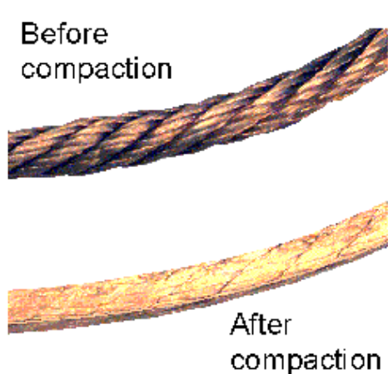
Figure 9 Compacted cable conductor

The winding pack layout has evolved from a double-layer pancake in the conceptual design to a four-in-hand, single layer pancake, as shown in Figure 10. The main benefits of the design change are 1) reduced keystoning due to smaller conductor size, 2) reduced turn-to-turn voltage, and 3) reduced time estimated to wind the conductor. As shown in the figure, each winding pack is 10 layers in height, with a 0.030 to 0.036-in per layer allowance for conductor keystoning. The leads extend from the bottom of the winding pack in a parallel arrangement. A thin chill plate is located on both sides of each winding pack to remove the joule heating in the coil between plasma discharges. The chill plate consists of a .040 inch thick sheet of copper that is cut into the flat developed shape of the winding and then formed to match the winding pack contour. The forming is simplified by cutting the long edge of the plate into multiple strips to avoid the necessity of stretching the copper. The chill plate on the outer side is cooled by running liquid nitrogen through a tube connected to the outer surface, while the chill plate on the structure side of the winding is cooled by conduction to the outside chill plate. The nitrogen will enter the chill plate circuits near the bottom of each coil and exit near the top of each coil.

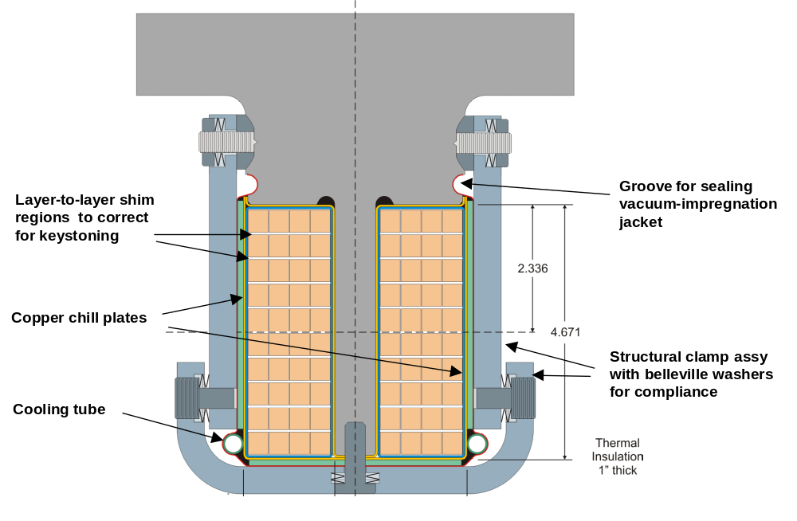
Figure 10 Winding Pack Layout

Figure 11 shows some details of the modular coil leads. The leads for the modular coils consist of commercial, “kickless” cables, which have been modified to operate at liquid nitrogen temperatures by substituting Teflon for the insulation. The cables consist of 6 conductors, 3 of each polarity alternating and twisted together and contained within a common jacket. They are cooled by conduction and by bleeding nitrogen gas through the interspace of the jacket.
The winding packs are clamped in place by discrete bracket assemblies, also illustrated in Figure 10, which preload the winding packs against the structure. The predominant electromagnetic loads are towards the web structure. Outward loads do exist in tight bend areas, and the u-shaped brackets react the loads in these regions. The brackets also guide the winding in the desired direction during cooldown, when the winding pack shrinks somewhat more than the steel winding form. This is discussed in more detail in section 3.
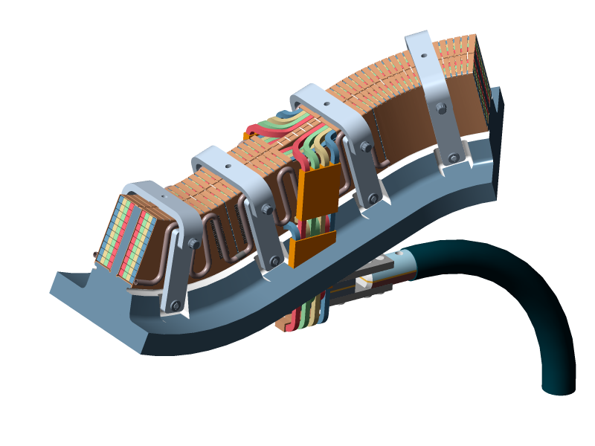
Figure 11 Modular Coil Leads

Local I&C
Table 4 lists the preliminary number and location of sensors, which are necessary to monitor behavior during operation and provide feedback to the coil protection system. The gages will have “back-to-back” elements that cancel transient electromagnetic fields to first order to reduce noise during operation.

Table 4 Modular Coil Instrumentation
Instrumentation | Total Number | Comment
Voltage Tap | 36 | 2 per coil
Strain Gages | 72 | 4 per coil
Flow Sensor | 36 | 2 per coil
RTD / Thermocouples | 72 | 4 per coil

Winding Facility
The winding facility is located in the TFTR test cell and includes all the fixtures and tooling for winding the coils, an autoclave and associated equipment to perform VPI operations, and a cryo-electrical test station.
Figure 12 shows the overall dimensions of the turning fixture, which is used to position the winding form during conductor installation. As shown, the winding form is attached to an external ring that permits rotation without limiting access to the winding surface. The turning fixture is adaptable to all three types of coils.
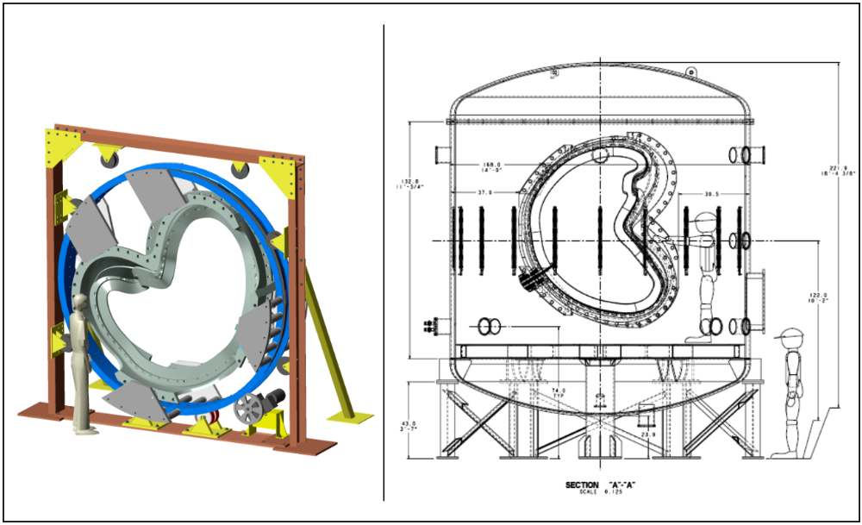
Figure 12 Modular Coil Winding and Turning Fixture

Design Basis
The modular coil design is based on design criteria, preliminary analysis, R&D activities, and input from manufacturing development teams.

Design Criteria
The modular coils have been designed according to the NCSX Structural Design Criteria, which is based on the ASME Boiler and Pressure Vessel Code, Section VIII, Division 2. This document provides guidance on general structural criteria, cryogenic applications, and high temperature / high heat flux environments. It represents the consensus of experts in fusion and plasma science through meetings held in 1990-92.

Design Analysis
The design has been analyzed for coil and lead field errors, eddy currents in the structural shell, thermal and thermo-hydraulic response, electromagnetic (EM) forces, and stress due to thermal and EM loads. All design basis analysis results will be documented and formally checked during final design.

Coil and Lead Field Errors
Previous analyses have shown that the modular coil assembly must be very accurate to produce flux surfaces of sufficient quality. The Conceptual Design Report documented a study of the effect of small perturbations of the modular coils in the vertical and toroidal directions. The study found that coil displacements of 10-mm produced magnetic islands of a size that exceeded 10% of the total toroidal flux in the plasma. In all cases, the errors could be corrected by external trim coils.
Since then, additional studies have been performed to determine the effect of individual coil winding tolerances on island formation. An analysis was performed in which random errors in the position of a coil winding center were introduced. Three types of error were considered: 1) a Fourier representation in which the local tolerance varies with coil-to-plasma separation, 2) a short wavelet type displacement in orthogonal directions to the winding center, and 3) a broad displacement of the winding center over a significant length of the coil. A typical result of the analysis is the graph of island size versus coil-to-plasma separation distance for a broad winding center displacement (Figure 13). The graph indicates that while errors in the regions of the coil within 30 cm of the plasma (typically the inboard region) have a significant impact on flux quality, errors in the regions of the coil more than 30 cm away from the plasma are more tolerable.
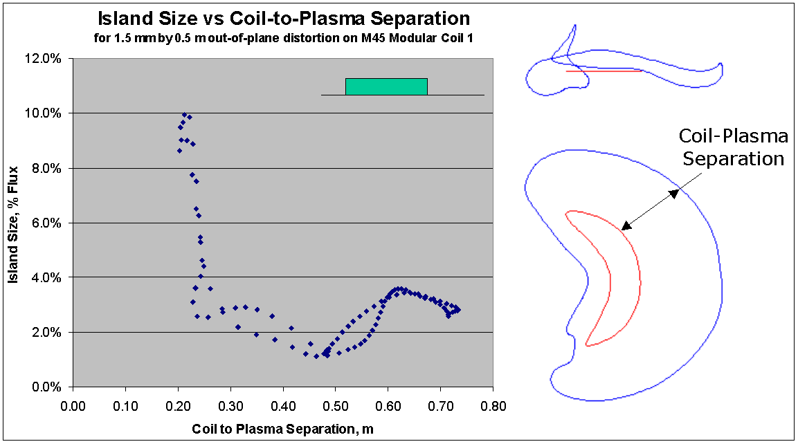
Figure 13 Field Error due to Windng Center Displacement
A second area of concern for field errors involves the modular coil leads. A study of the double-layer pancake winding used in the conceptual design showed that field errors can be minimized by:
- Arranging the joggles from layer to layer so that the pattern of turn to turn joggles on one pie form an “X” shape with the pattern of joggles on the adjacent pie.
- Making sure the lateral crossover from pie to pie occurs in opposite directions on the two winding packs within a coil. This reverses the field errors from the lateral current paths and cancels them to first order.
- Minimizing the errors at the lead entrance by immediately tying the leads together into a coaxial arrangement.
Such design rules have been considered for the present four-in-hand design, but the resulting configuration still has larger current loops than the earlier concept.

An analysis of the effect of multiple-in-hand options was performed using the VACISLD code. Estimates of island size were computed for the leads of one, two, and three-in-hand winding configurations at different positions on each coil. A typical result is shown in Figure 14, where island size is shown to vary strongly with poloidal location. The results of the study indicate that field errors from multiple-in-hand leads are relatively low, and that the location of the leads can be optimized. The error in the multiple in-hand configurations is highest for two in hand and decreases for 3 and 4-in-hand because the 2-in-hand configuration has the largest conductor size. The larger conductor has a corresponding larger bend radius, which results in larger error producing current loops. The actual lead location is very close to the 90% poloidal length region shown in Figure 14, so the error fields will not be an issue.
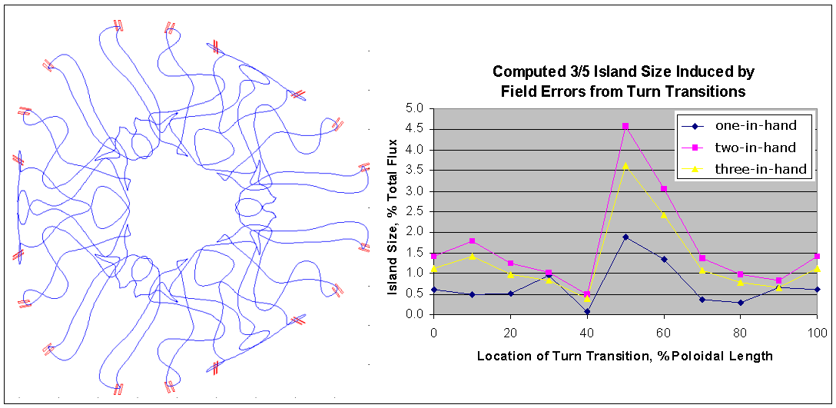
Figure 14 Field Error due to Leads

Eddy Currents
An analysis of the eddy currents induced in the structural shell due to varying modular coil currents has been performed using the SPARK code. Figure 15 shows the finite element mesh of the shell and tee. Design details that were investigated include 1) toroidal and poloidal electrical breaks at the flanges and outboard midplane, and 2) segmentation of the copper chill plates attached to the winding packs.
Figure 15 also shows a typical eddy current pattern on the shell structure. The results indicate that the longest time constant without a poloidal break is >50-ms, a value that would likely cause field errors and flux penetration issues for the design. However, by incorporating a poloidal break and electrically insulating the toroidal flange joints, the time constant is reduced to <20-ms. The analysis also indicated the level of segmentation required for the winding pack chill plates.
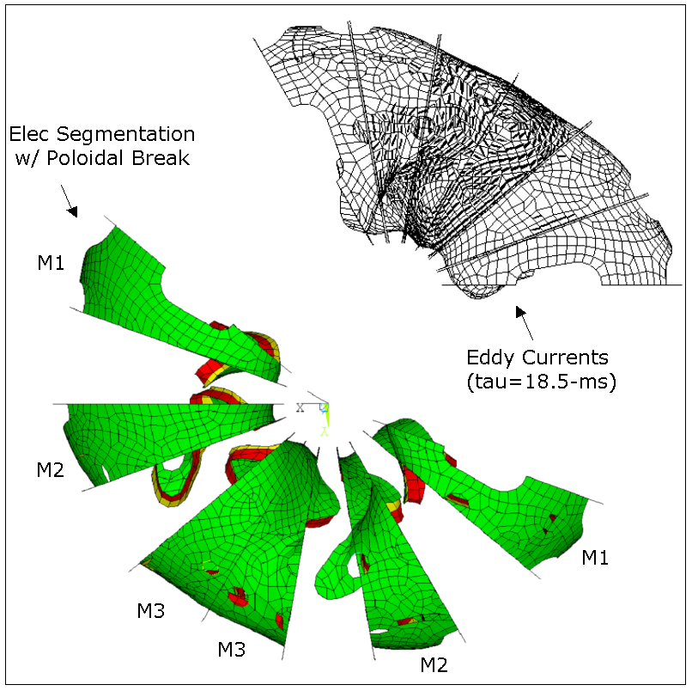
Figure 15 Eddy Currents in Structural Shell

Thermo-hydraulic analysis
An analysis of several chill plate configurations was performed using the ANSYS code. Figure 16 shows the finite element model for a case that is very close to the present design. It models the heat conduction through a 2x9 winding pack to inner and outer chill plates, which are cooled by discrete copper clamps. The present design, in contrast, is cooled directly by the outer chill plate and uses thinner turn insulation, which should compensate for the lack of direct contact between the chill plates and interior turns of the 4x10 configuration.
A transient analysis was performed using temperature dependent material properties. Of the standard operating scenarios, the worst case is the initial ohmic operation at 1.7T, which has a current density of 12 kA/cm^2 in the copper and an ESW of almost 1.4 s. For a starting temperature of 85 K, the temperature rises about 40-K during the pulse. Figure 16 shows the temperature distribution after ten heating and cooling cycles. After ten cycles, the starting temperature has stabilized at about 86-K with a coolant temperature of 80-K.

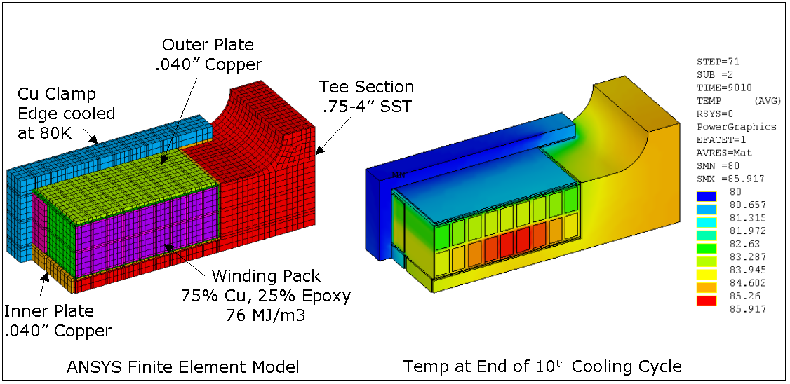
Figure 16 Windng Pack Temp Distribution after Cooldown
A thermo-hydraulic analysis was performed for all three coil systems (PF, TF, and Modular). The present design calls for forced flow LN2 cooling of all coil systems with a prescribed inlet temperature of 80 K at 200 psi. The prescribed equivalent square wave (ESW) used was 1.2-3.5 sec. at the maximum rated current for each coil system. The duty cycle (cool-down period) was specified as 15 minutes (900 sec.). A summary of the results is shown in Table 5. The total LN2 flow requirements for the main coil systems for the modular coils will be 16 GPM. The cool-down of the M1 modular coil is illustrated in Figure 17. The modular coil stops ratcheting after about 4 pulses.

Table 5 Thermo-Hydraulic Analysis of Coils
 | ESW | I  (kA) | ΔT peak  (deg-K) | Tmax  (deg-K) | ΔP  (psi) | flow/coil  (GPM) | total flow  (GPM)
M1 | 1.2 | 24 | 36.1 | 117.4 | 10 | 0.88 | 5.2
M2 | 1.2 | 24 | 36.2 | 117.2 | 10 | 0.90 | 5.4
M3 | 1.2 | 24 | 36.4 | 116.5 | 10 | 0.94 | 5.6
Total |  |  |  |  |  |  | 16.2
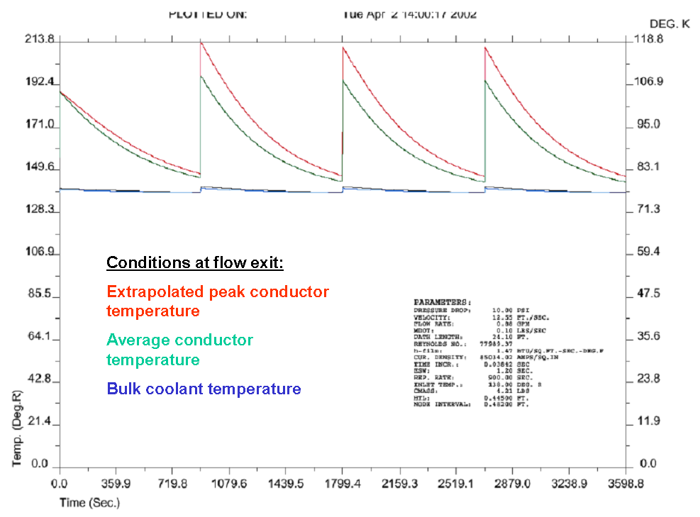
Figure 17 Modular Coil Cooldown

Electromagnetic Loads
Calculations to determine the fields and forces acting on all of the stellarator core magnets have been completed for seven reference operating scenarios. Table 6 summarizes the coil currents for all coils at a time step when the modular coils are at their maximum positive or negative value. The worst case for determining forces in the modular coils appears to be the 2T high beta scenario at time=0.197-s.
Table 6 Electromagnetic Analysis Load Cases
Circuit | Coil Set | 0.5-T 1st Plasma | Field Mapping | 1.7-T Ohmic | 1.7-T High Beta | 2-T High Beta | 1.2-T L. Pulse | 320-kA Ohmic
1 | TF | 13 | 13 | 43 | 45 | 53 | 30 | 26
2 | PF1 | 673 | 0 | 1479 | 1120 | 1340 | 1191 | 1632
--- | PF2 | 673 | 0 | 1479 | 1120 | 1340 | 1191 | 1632
3 | PF3 | 673 | 0 | 1286 | 998 | 1208 | 980 | 1082
4 | PF4 | 749 | 734 | 374 | 416 | 287 | 313 | 1191
5 | PF5 | 0 | 0 | 204 | 209 | 82 | 148 | 128
6 | PF6 | 32 | 13 | 104 | 101 | 115 | 72 | 73
7 | M1 | 224 | 224 | 763 | 763 | 818 | 539 | 695
8 | M2 | 209 | 209 | 710 | 710 | 831 | 501 | 707
9 | M3 | 188 | 188 | 638 | 638 | 731 | 451 | 621
 | PLAS | 35 | 0 | 120 | 178 | 210 | 126 | 321

Two independent field calculations have been performed, one with the ANSYS code and the other with MAGFOR. A comparison of magnetic flux density at 2-T (Figure 18) indicates that the models are in good agreement, with only a 4% difference in peak field due primarily to mesh and integration differences.

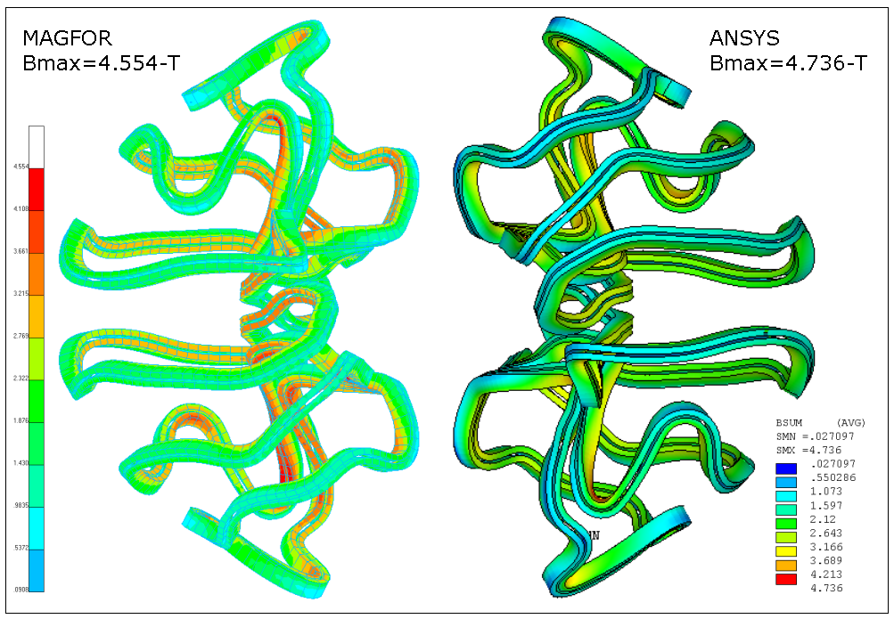
Figure 18 Magnetic Field at Coil Windings
The force distribution for the modular coils is illustrated for the 2-T case in Figure 19. As shown, the net radial centering force per coil varies from 86 to 317 kips, while the vertical force is much smaller. Table 7 lists the net forces and maximum running loads for each of the cases studied.
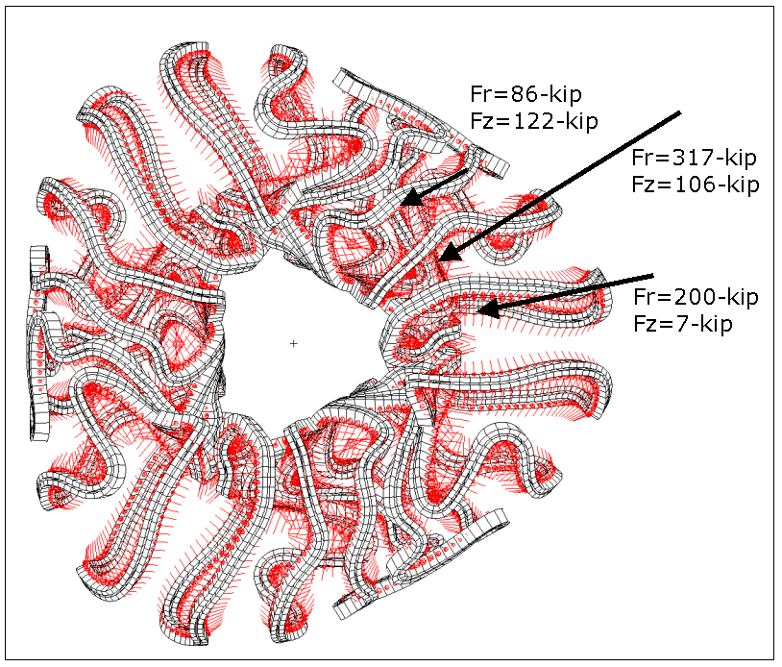
Figure 19 Force Distribution on Modular Coils at 2T

Table 7 – Net EM Force on Modular Coils
Coil | Field/Force Component | 0.5-T 1st Plasma | Field Mapping | 1.7-T Ohmic | 1.7-T High Beta | 2-T High Beta | 1.2-T L. Pulse | 320-kA Ohmic
 | Max Field at Coil (T) | 1.2 | 0.2 | 4.2 | 4.2 | 4.9 | 2.9 | 4.2
M1 | Net Radial Load (kip) | 13 | 1 | 152 | 152 | 200 | 76 | 147
M1 | Net Vert Load (kip) | 0.5 | 0 | 9 | 9 | 7 | 5 | 7
M2 | Net Radial Load (kip) | 20 | 1 | 228 | 228 | 317 | 113 | 230
M2 | Net Vert Load (kip) | 7 | 0 | 84 | 84 | 106 | 42 | 79
M3 | Net Radial Load (kip) | 5 | 0 | 57 | 57 | 86 | 29 | 62
M3 | Net Vert Load (kip) | 8 | 0 | 95 | 95 | 122 | 47 | 89

In order to better understand the forces on the modular coils, they have been resolved into local coordinates in the radial and lateral direction relative to the winding form structure. The lateral forces are in the direction normal to the surface of the supporting “web” structure and the radial forces are those directed outward against the shell. Figure 20 plots these force components as a function of coil perimeter for the M2 coil. As shown in the figure, the largest lateral force is about 5500 lbs per linear inch, but this is countered nearby with a similar force on the other side of the web from the other winding. Table 7 lists the maximum component forces for each case.
What is also illustrated in the figure is the very local problem of the winding pack force being away from the web. This occurs primarily in regions of sharp lateral curvature, and is due to the local peak fields. For the condition shown, there is a local force peaking at 3000 lbs acting over a distance of about 8 inches. The force will be reacted partially by the coil clamps and partially by the winding acting as a beam in this region. For the present spacing of clamps, at least two clamps will act to restrain this region.
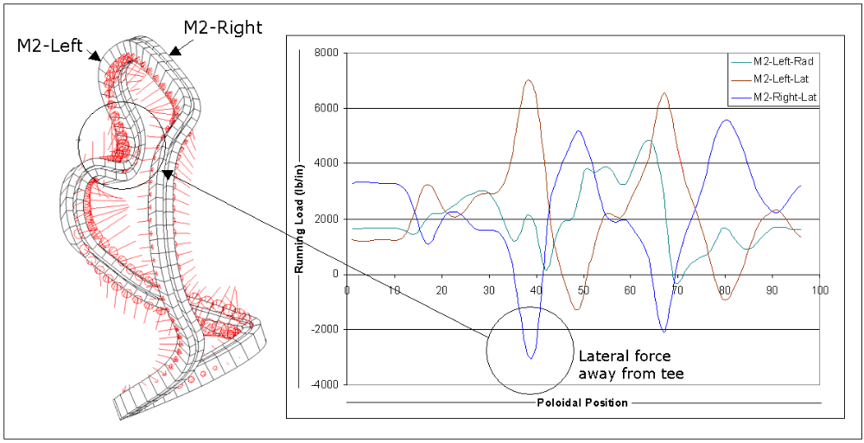
Figure 20 Component Forces for Coil M2 (2T case)

Table 7 Maximum Running Load on Modular Coils
Coil | Field/Force Component | 0.5-T 1st Plasma | Field Mapping | 1.7-T Ohmic | 1.7-T High Beta | 2-T High Beta | 1.2-T L. Pulse | 320-kA Ohmic
M1 | Rad Load (lb/in) | 200 | 8 | 2272 | 2279 | 2869 | 1134 | 2053
M1 | Lat Load (lb/in) | 434 | 17 | 4995 | 4997 | 5831 | 2490 | 4163
M2 | Rad Load (lb/in) | 351 | 14 | 4077 | 4076 | 5591 | 2031 | 4050
M2 | Lat Load (lb/in) | 430 | 17 | 4982 | 4983 | 6982 | 2483 | 5059
M3 | Rad Load (lb/in) | 233 | 9 | 2698 | 2698 | 3540 | 1344 | 2615
M3 | Lat Load (lb/in) | 418 | 17 | 4830 | 4830 | 6405 | 2407 | 4552

Stress due to Electromagnetic Loads
The modular coils are structurally supported by the integral shell structure, and its analysis is reported here. The TF and PF coils are supported from the external coil support structure. The modular coil shell structure and coils were modeled and connected with multi-point constraints. The primary load case for the analysis was the 2-T High Beta scenario. Figure 21 shows the model, which consisted of the full 360-degree assembly of the shell, coil windings, and spacer between the windings and shell. The properties used assumed that the shell is made of stainless steel for the shell, the coil windings consist of a homogeneous copper/epoxy mixture, and the spacers are made of G-10. The properties are listed in Table 8.
Table 8 Material Properties Used For Modular Coils
Component | Material | Modulus of  elasticity (MPa) | Poisson’s ratio | Comment
Tee/shell casting | Cast stainless steel | 206,000 | .29 | Similar to 317 cast alloy
Modular coil windings | Copper epoxy mixture | 65,500  6550 | .30 | Two stiffnesses tried, 50% and 5% solid Cu
Spacer | Epoxy glass laminate | 206,000 | .30 | Conservative if assumed to be stiff

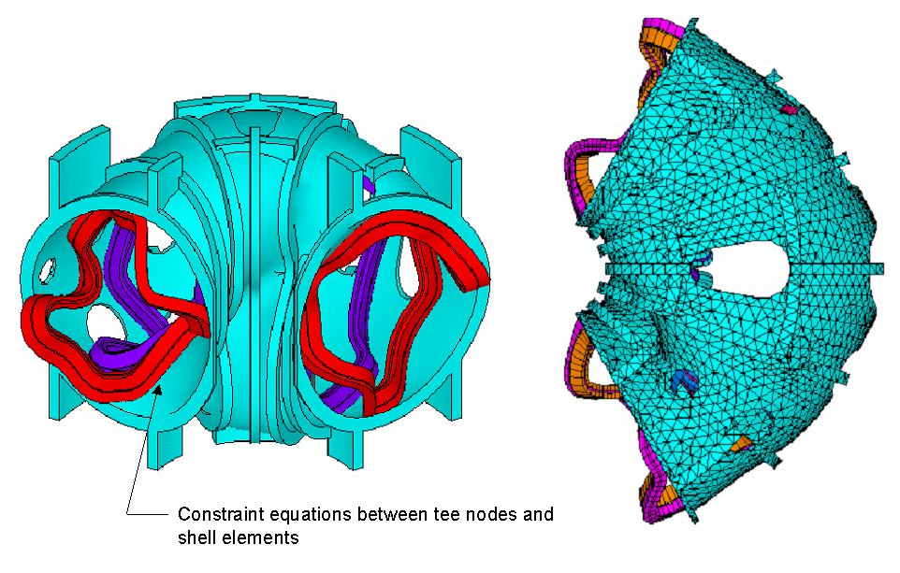
Figure 21 Structural Shell Finite Element Model

Two cases were run assuming different copper stiffnesses; [1] the modulus of the winding pack was assumed to be 50% of the modulus of copper and [2] 5% of the modulus of copper. Early tests conducted on epoxy-impregnated samples of the compacted cable conductor indicated the actual compression modulus is about 10% of copper, which is toward the soft side of the analysis. However, subsequent tests have indicated a tensile modulus as high as 80 % of copper and a compression modulus as high as 30% of copper at low temperatures. The higher stiffness tends to put less load into the shell structure, and increases the mechanical load carried in the windings.
The model was constrained only at the toroidal stiffeners on the bottom side of the shell, so the vertical deflection is not stellarator symmetric. As shown in Figure 22, the vertical and total deflections are nearly the same, indicating that most of the deflection is in the vertical direction, localized and stellarator symmetric The peak deflection is only about 0.02 inches, well within the expected limits for these locations. The stress picture is summarized in Table 9. The stress picture in the shell is relatively benign, as indicated in Figure 23, with a localized area of high stress in the inner folds of the shell structure of 13 ksi, which is far less than the allowable of 47 ksi. There are also some locally high stresses in the tee structure upon which the coil is wound (Figure 24), which are not well resolved due to the coarseness of the model, although they appear to be well within allowable limits. The higher stress regions in the shell and tee can be eliminated by making these components thicker in the regions of high stress. Peak stresses in the winding due to EM loads are below 7 ksi, which is below the anticipated allowable of 12 ksi.

Table 9 Summary of Modular Coils Stress Analysis
Winding Pack Modulus (MPa) | Shell (ksi) | Coil (ksi) | Tee (ksi) | Spacer (ksi)
65500 | 12.7 | 7.2 | 20.2 | 1.8
6550 | 13.0 | 2.6 | 32.1 | 2.2

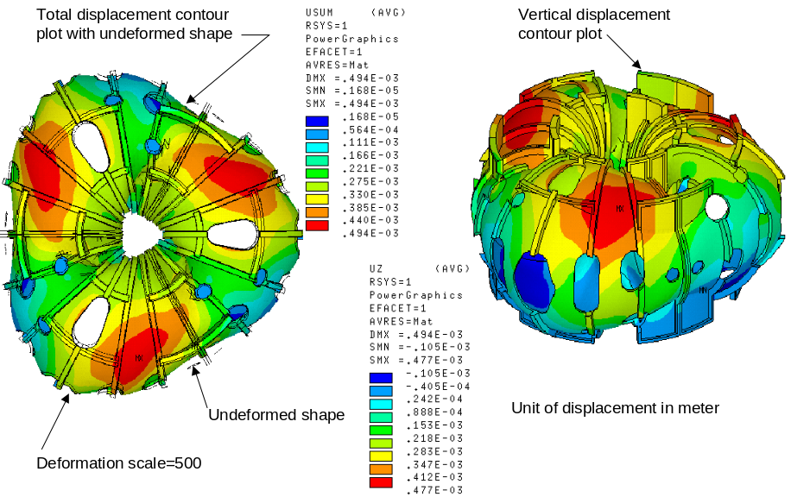
Figure 22 Vertical and Total Displacement Contours

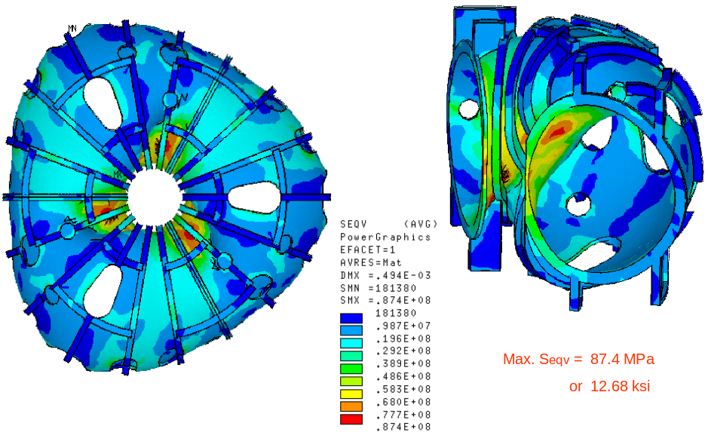
Figure 23 Von Mises Stress Distribution in Shell (50% Modulus)

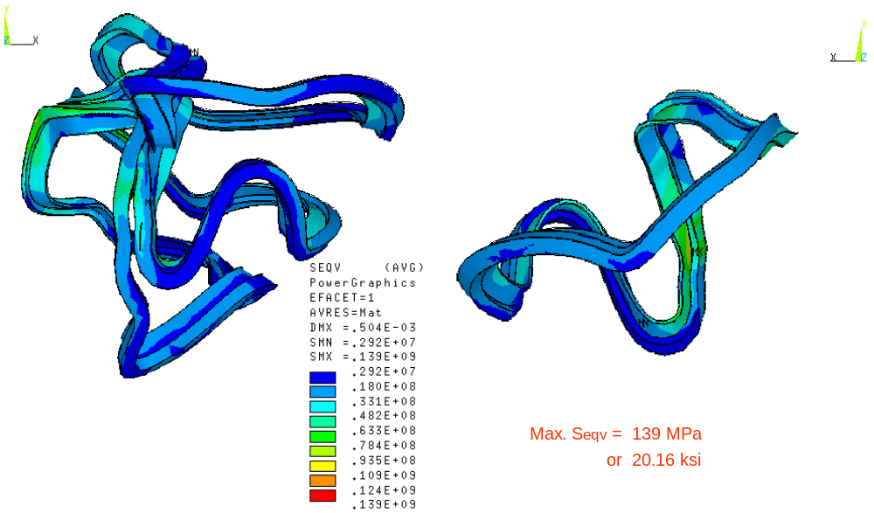
Figure 24 Von Mises Stress Distribution in Tee (50% Modulus)

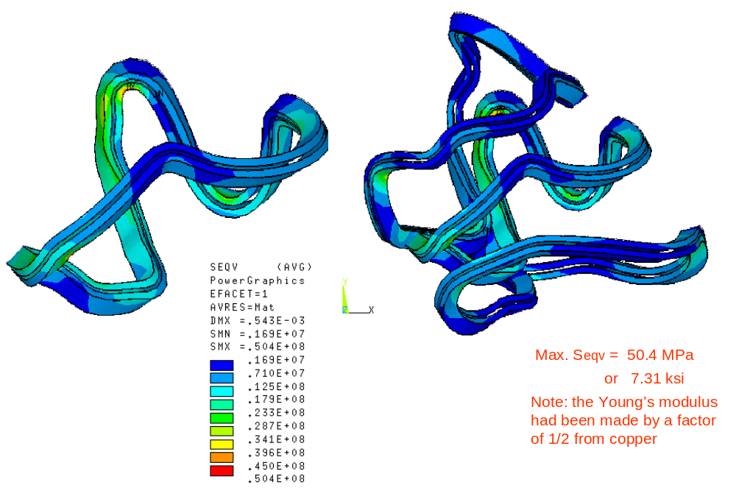
Figure 25 Von Mises Stress Distribution in Windings (50% Modulus)

Stress due to Thermal Loads
In addition to the stress arising from electromagnetic (EM) loads, there are thermal stresses due to the epoxy cure cycle, cool-down from room temperature to 80-K, and the sudden increase in winding temperature relative to the structure during a pulse. The maximum temperature rise expected is 40K, but a higher allowable temperature rise would provide more headroom on pulse length and / or field capability. A non-linear Pro/MECHANICA analysis was performed for coil #2 by modeling the tee structure, fixed at the shell boundary, and the winding pack with 48 pseudo clamps. Figure 26 shows the details of the clamps, which are represented by material placed into cuts on the side and ends of the winding pack. The outer surfaces of the blocks are restrained in their respective normal directions and have properties which mimic the stiffness of the spring washers under the clamps. The winding is thus able to slide along the tee but is unable to move past the block/clamp.
The modulus of the winding pack, which has been determined by testing, is 5.3e6-lb/in2 in compression and 14.4e6-lb/in2 in tension. Dimensional changes relative to the winding form are a function of both thermal expansion and shrinkage during the epoxy cure cycle. As illustrated in Figure 27, the shell and winding expand during the VPI process, but the conductor experiences about 0.04% shrinkage upon return to room temperature. During cool-down, the windings shrink another .0.04% for a total of 0.08% relative to the shell. The clamps will keep the winding pushed against the shell in the inboard regions where winding perturbations can effect the fields, so this provides a design knob to”tune” the deflections for minimum field error. The advantage of net shrinkage is the lack of thermal compressive stress that would otherwise occur when the winding heats up relative to the shell.
Figure 28 shows the Von Mises stress in the windings due to cool-down to 80-K. The average stress is 3 to 5-ksi and the peak stress is about 10-ksi. This compares to the allowable strength of 24 ksi (based on measured strength at that temperature of 48-ksi).

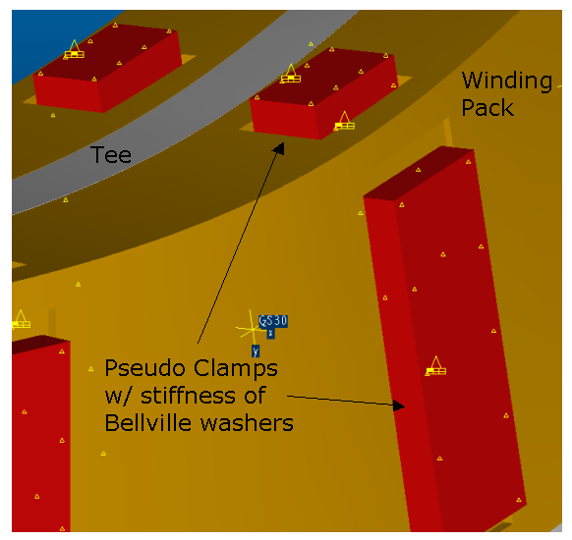
Figure 26 Thermal Stress Analysis Model

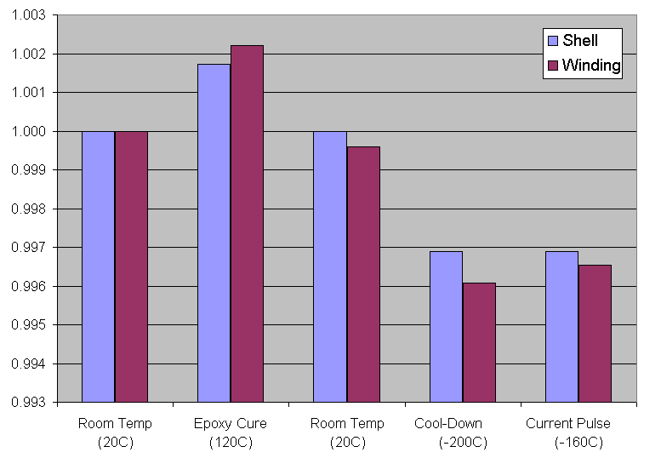
Figure 27 Thermal Contraction of Windings

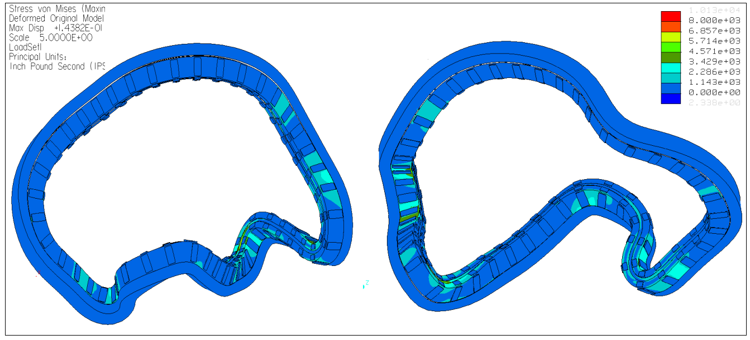
Figure 28 Stress due to Cool-Down

Stress due to Combined Loads
The same model of coil #2 used in the thermal stress analysis was also used to estimate the combined stress due to electromagnetic and thermal loads. Figure 29 shows the distribution of electromagnetic pressure corresponding to the 2-T high beta scenario. The model was also modified to allow the protruding tee section of the coil (the wings) to be unrestrained, simulating the reduced stiffness of the region.

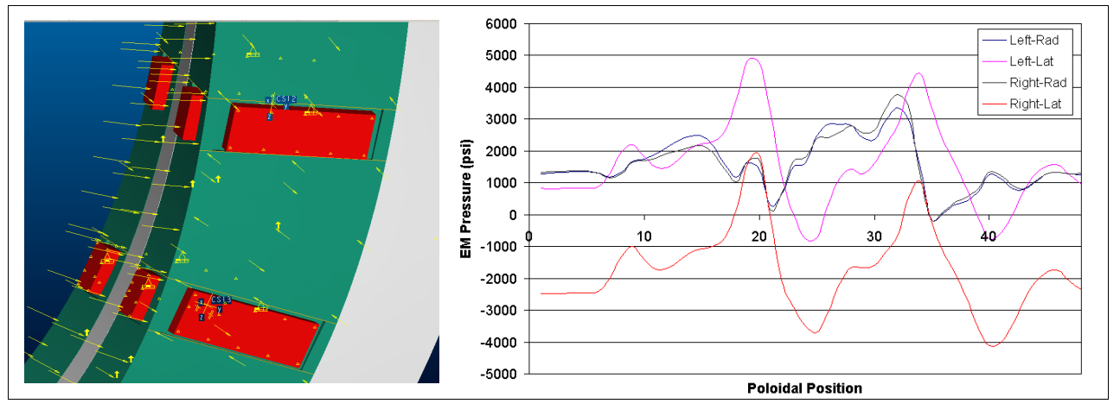
Figure 29 EM Pressure applied to winding pack

The results, shown in Figure 30, indicate that stress in the winding increases to 15.4-ksi.

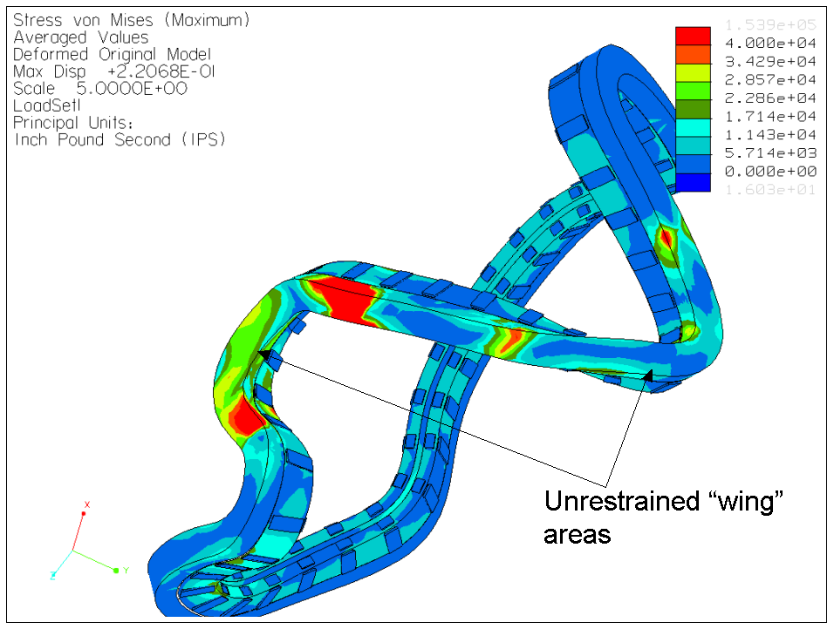
Figure 30 Stress in "tee" and winding due to combined thermal and EM loading

R&D Activities

Winding R&D
Material Properties
The primary element for analysis is the modular coil set. The material properties for the composite cable conductor are the most critical to understand and a significant test program has been and is still being carried out to characterize the properties of the baseline design conductor. Numerous conductor bundles have been fabricated for use in determining the tension, compression, flexural and shear strengths of the copper conductor matrix. The samples were supplied to Composite Technology Development, who are finishing the testing and documentation at the time of this report. As reported above, initial tests of conductor modulus show the surprising result that the composite is stiffer in tension than compression. On further reflection, however, this may make sense since the composite acts somewhat like a rope or cable, which is also much stiffer in tension than compression. The preliminary results of the testing are shown in Table 10, Table 11, and Table 12. The tests indicate relatively high strength in tension and compression. Typical thermal expansion data is plotted in Figure 31

Table 10 Compression testing of a single modular coil conductor
TEMPERATURE (K) | COMP. MODULUS (MSI) | STRENGTH (KSI)
76 | 5.3 | 48.2
100 | 6.8 | 45.8
150 | 7.9 | 40.9
295 | -* | 26.6 (tentative)
*Testing performed at room temperature (295 K) was inconclusive with 6 test samples. Additional testing will be performed to establish usable values at 295 K.

Table 11 Tension testing of a single modular coil conductor, initial results
TEMPERATURE (K) | TENSION MODULUS (MSI) | Tensile STRENGTH (KSI)
76 | 14.4 | 33.6
100 | 12.4 | 32.0
150 | 14.1 | 27.4
295 | 13.2 | 25.0

Table 12 Flexural Testing of a single modular coil conductor
 | FLATWISE | FLATWISE | EDGEWISE | EDGEWISE
TEMP (K) | MODULUS  (MSI) | STRENGTH  (KSI) | MODULUS  (MSI) | STRENGTH  (KSI)
76 | 4.3 | 43.0 | 4.0 | 44.8
100 | 4.3 | 39.8 | 4.5 | 43.4
150 | 4.3 | 39.4 | 4.1 | 38.9
295 | 3.9 | 27.7 | 3.7 | 29.5

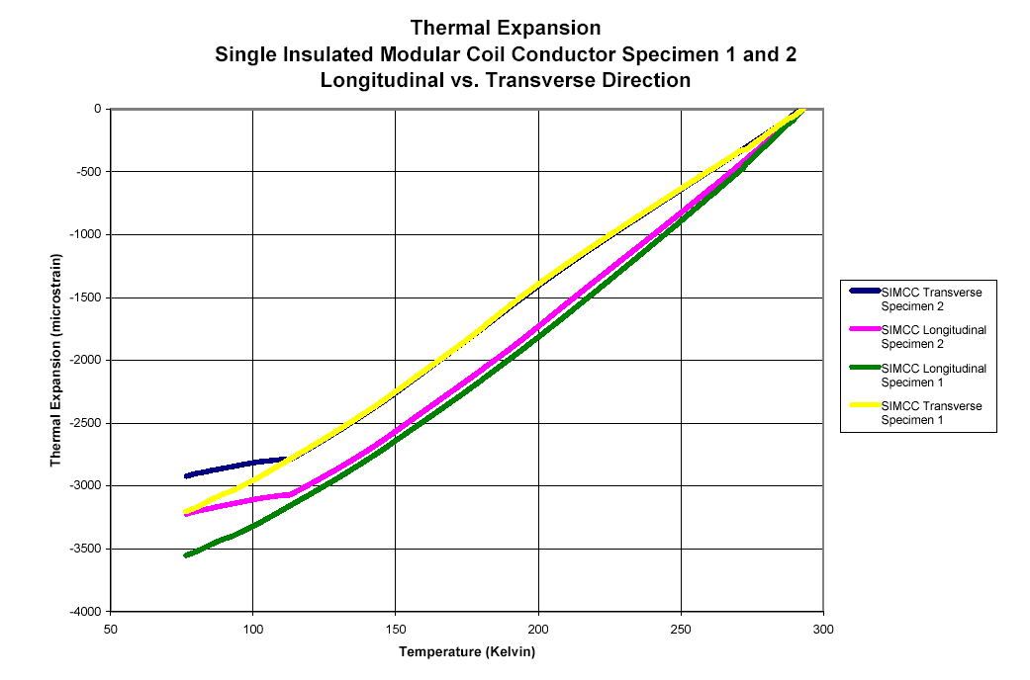
Figure 31Thermal expansion data for a single modular coil conductor specimen

VPI Process Development
The NCSX engineering team has developed processes for winding and vacuum pressure impregnation (VPI) of the modular coils at PPPL. Initial preparations for the R&D facility in the TFTR test cell basement have been completed. Additional copper conductor and several short coils forms have been procured for VPI trials. The trial forms have a tee-shaped cross section and are contoured in various patterns representative of the actual NCSX winding form design. The VPI process uses self-fusing silicon tape followed by a wet wrap of the winding pack to form a pressure boundary. The molding process has been tested on ingle turn and 4-turn straight samples and on samples with the actual coil cross section. A fully insulated 36 turn coil cross-section was assembled and successfully vacuum impregnated. Preliminary inspections indicate a good penetration and wicking of epoxy through the outer ground wrap and turn insulations. Section cuts were made through the bundle, and preliminary reviews show that the copper rope conductor appears well impregnated. The bag mold method was quite successful with no indications of any leaks at the seams or around the sprues (epoxy flow channels). The epoxy for this tee section was fed through machined holes into the tee or tail section of the mold. The epoxy flowed as expected through the areas of least resistance, in some cases bypassing sequentially located sprues. A dry area did occur above the uppermost sprue where a possible air pocket may have been trapped. The sprue was located approximately 2.5 inches from the dry area. The final coil impregnations will require an exit sprue at the highest point on the coil to avoid this problem. Overall the impregnation results were very good. The bag mold method and the epoxy delivery system worked well.

A small oven has been used for the VPI processing to date, but a large autoclave, or vacuum oven, is currently being procured that will be used for the prototype and production coils.

Keystoning
Numerous keystoning tests have been completed to quantify the problem of bending the conductor around tight radii. The effect is to make the cross section trapezoidal and spoil the dimensional build of the coil. The solution is to provide a shim space between layers of conductor that allows the build to be recovered at every turn, eliminating the stackup around tight corners. The penalty is a loss of copper fraction in the winding. The tests prove that the conductor cross section must be significantly smaller than the bend radius to keep the shim thickness small. The practical significance of the effect of keystoning on the selection of the winding pack design is shown in Table 13. As shown, the current density is degraded significantly for the conventional, one-in-hand winding pack design compared to the multiple in hand designs that use smaller conductor. The effect has diminishing returns, however, due to the increase in insulation fraction as the number of turns increases. The four-in-hand design chosen as the baseline is the best compromise of low keystoning, lower current density, and lower field errors in the leads due to tighter allowable bend radius.

Table 13 Effect of keystoning on three winding pack configurations
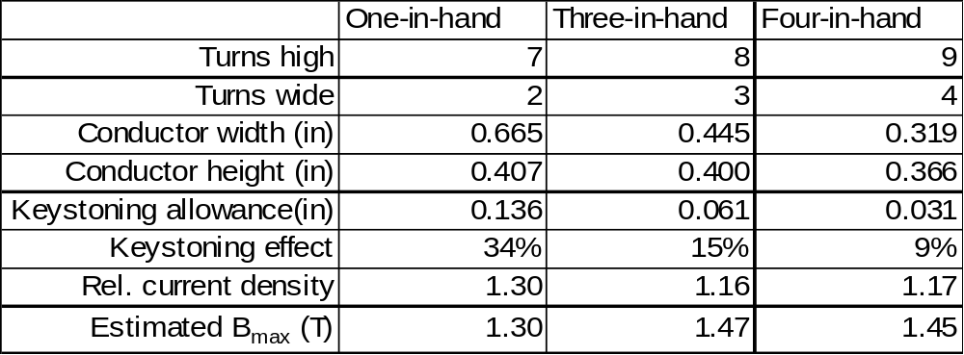

Demonstration / Test Coils
At least four demonstration / test coils are planned or have been completed as part of the R&D effort. The first coil was a small racetrack coil wound at the University of Tennessee. This coils was successfully vacuum impregnated with epoxy at PPPL and tested at ORNL. The coil operated successfully to 10 kA. The pulse length was adjusted to provide a 40C temperature rise and the coil was cooled back down in a relatively short period of time. The cooling was accomplished with copper chill plates, but was otherwise not prototypical. The coil is illustrated in Figure 32.

The second coil was a larger, more prototypic racetrack coil wound at PPPL This coil has two complete winding packs of 14 turns each, copper cladding, a prototypic “tee” shaped winding form, and structural clamps. The coil has been wound and vacuum impregnated with epoxy and will be tested within two weeks. The coil is shown in Figure 33.

At third demonstration coil is planned that will integrate all the major features of the baseline design, including the most severe regions of twist and curvature, the four-in-hand winding configuration, the chill plates, and the structural clamps. The challenge for this coil was to design it to fit in the 23 inch autoclave, since the large autoclave will not be available for timely vacuum impregnation. This coil is shown in Figure 34.

The final demonstration coil will be a full scale prototype coil based on the Type 3 coil forms procured as part of a separate R&D contract. The prototype coils will be completed and fully tested at cryogenic temperature.
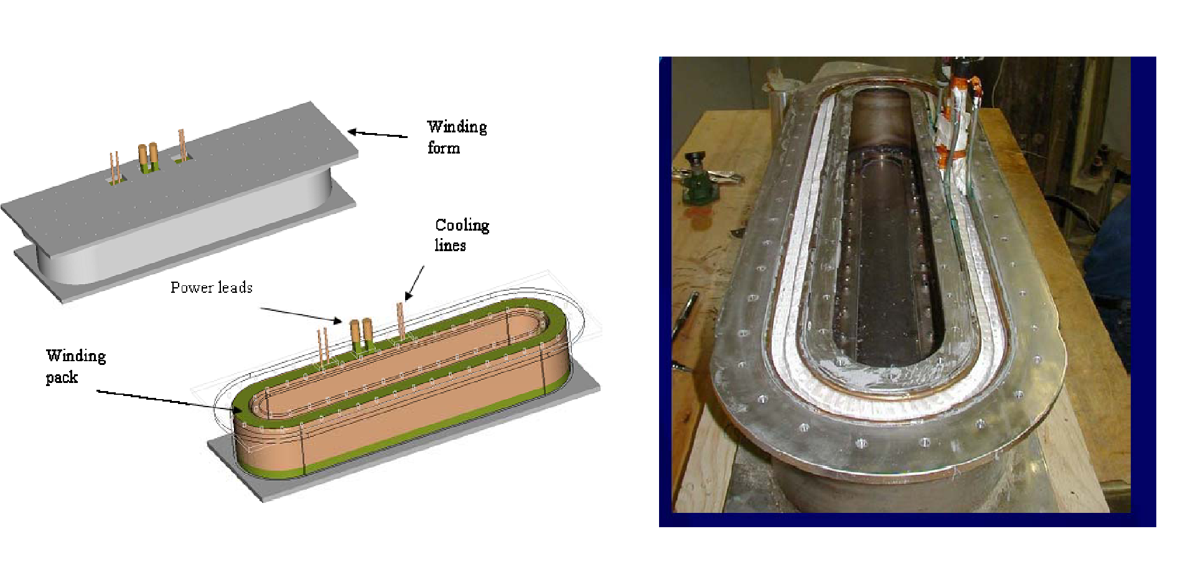
Figure 32 First demonstration coil, wound at the University of Tennessee and vacuum impregnated at PPPL

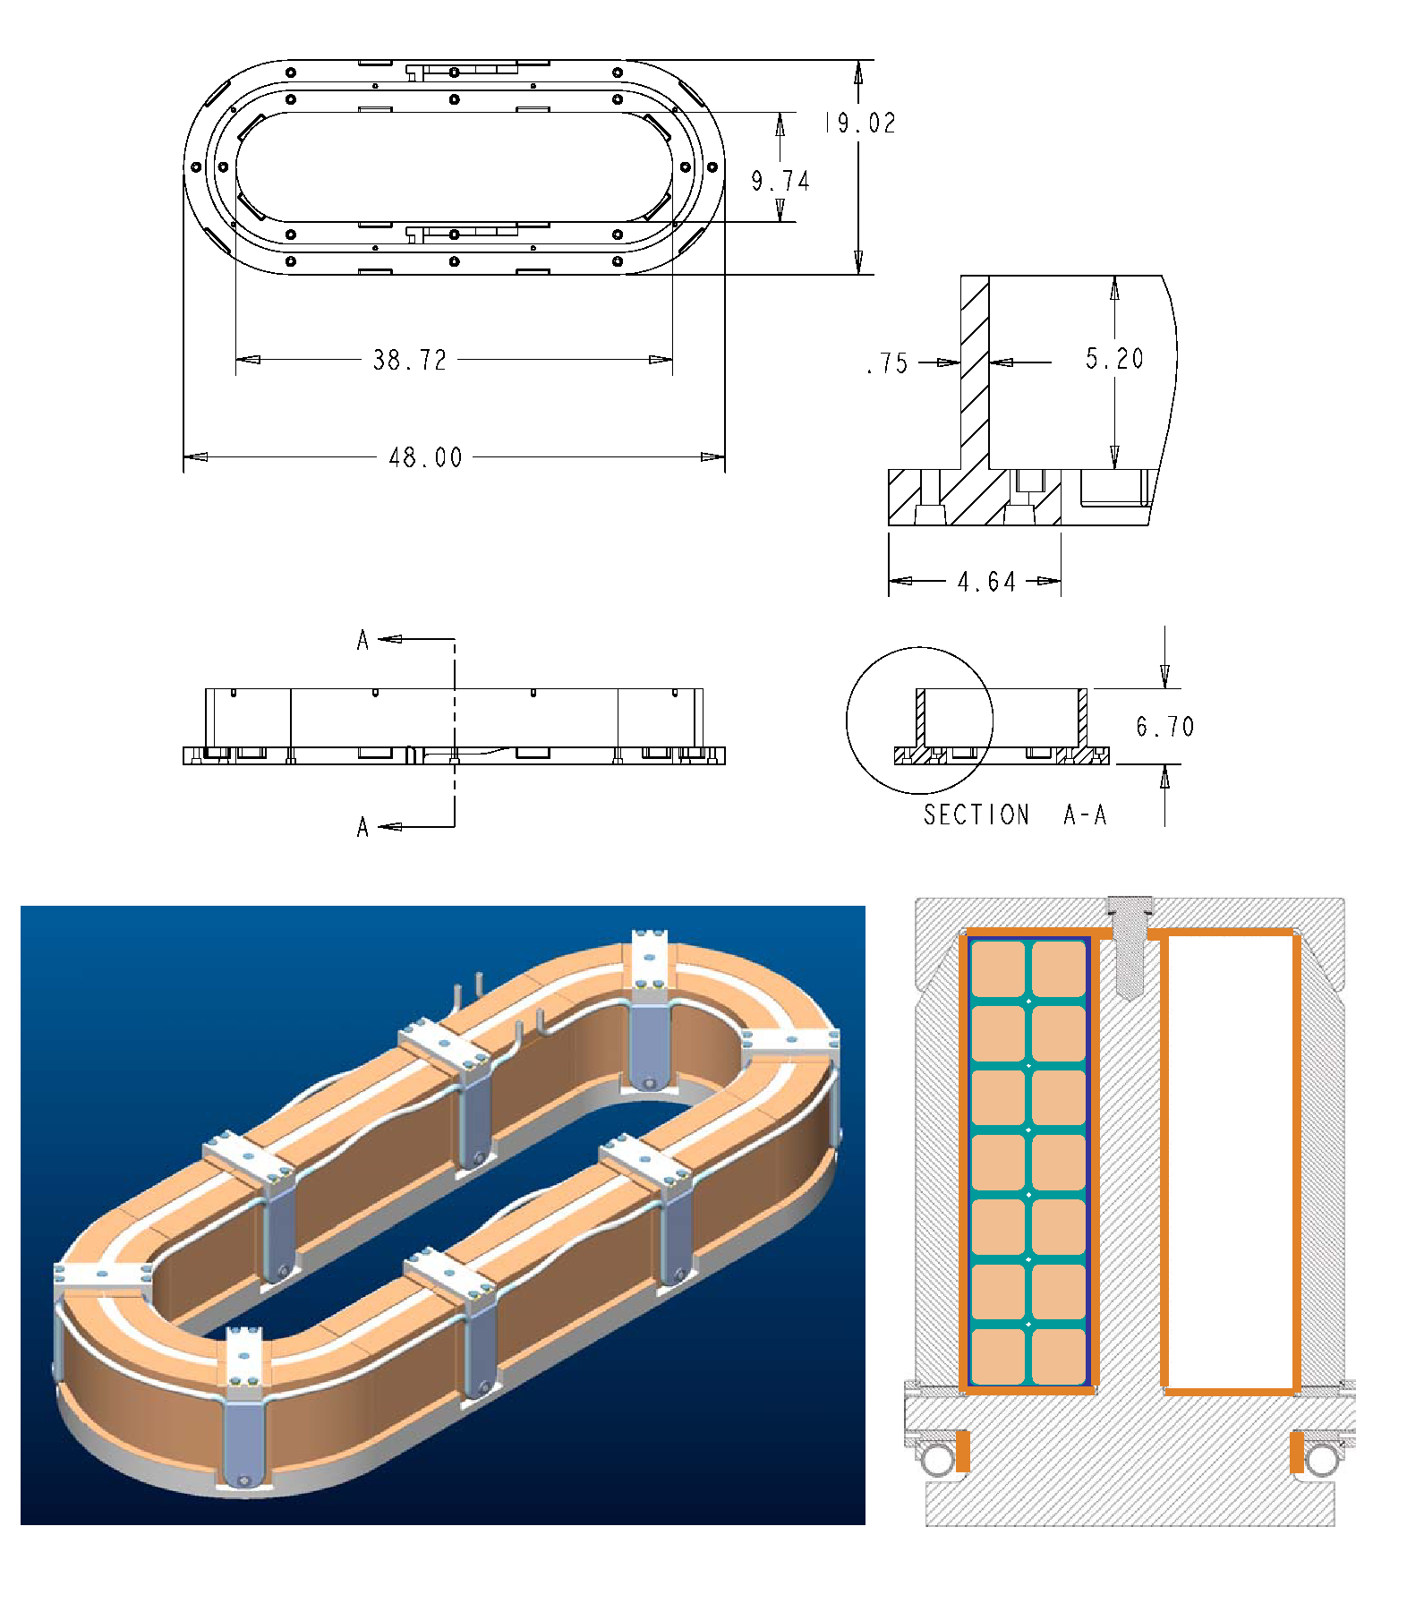
Figure 33 Second racetrack demonstration coil, wound and vacuum impregnated with epoxy at PPPL

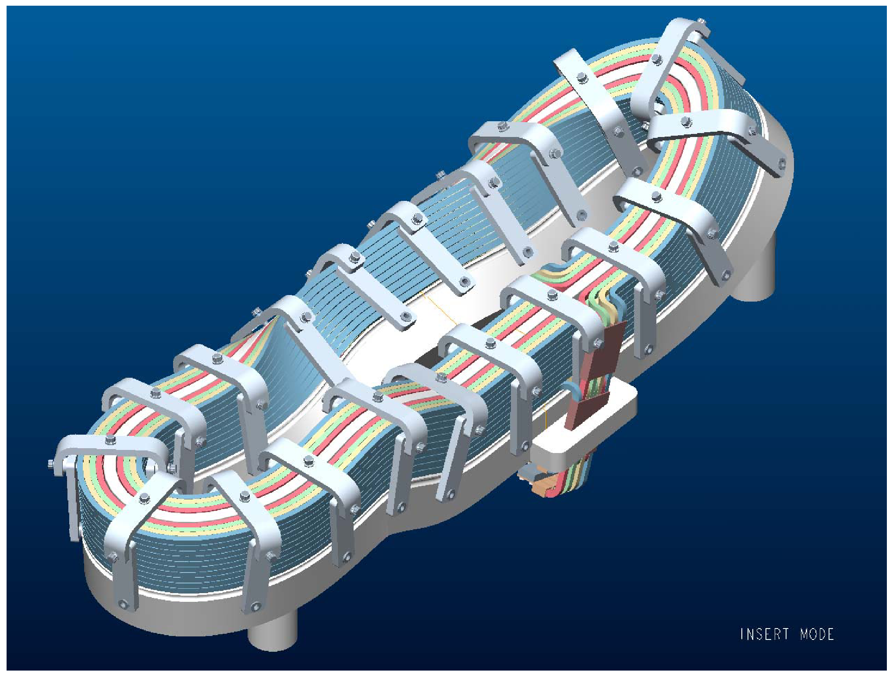
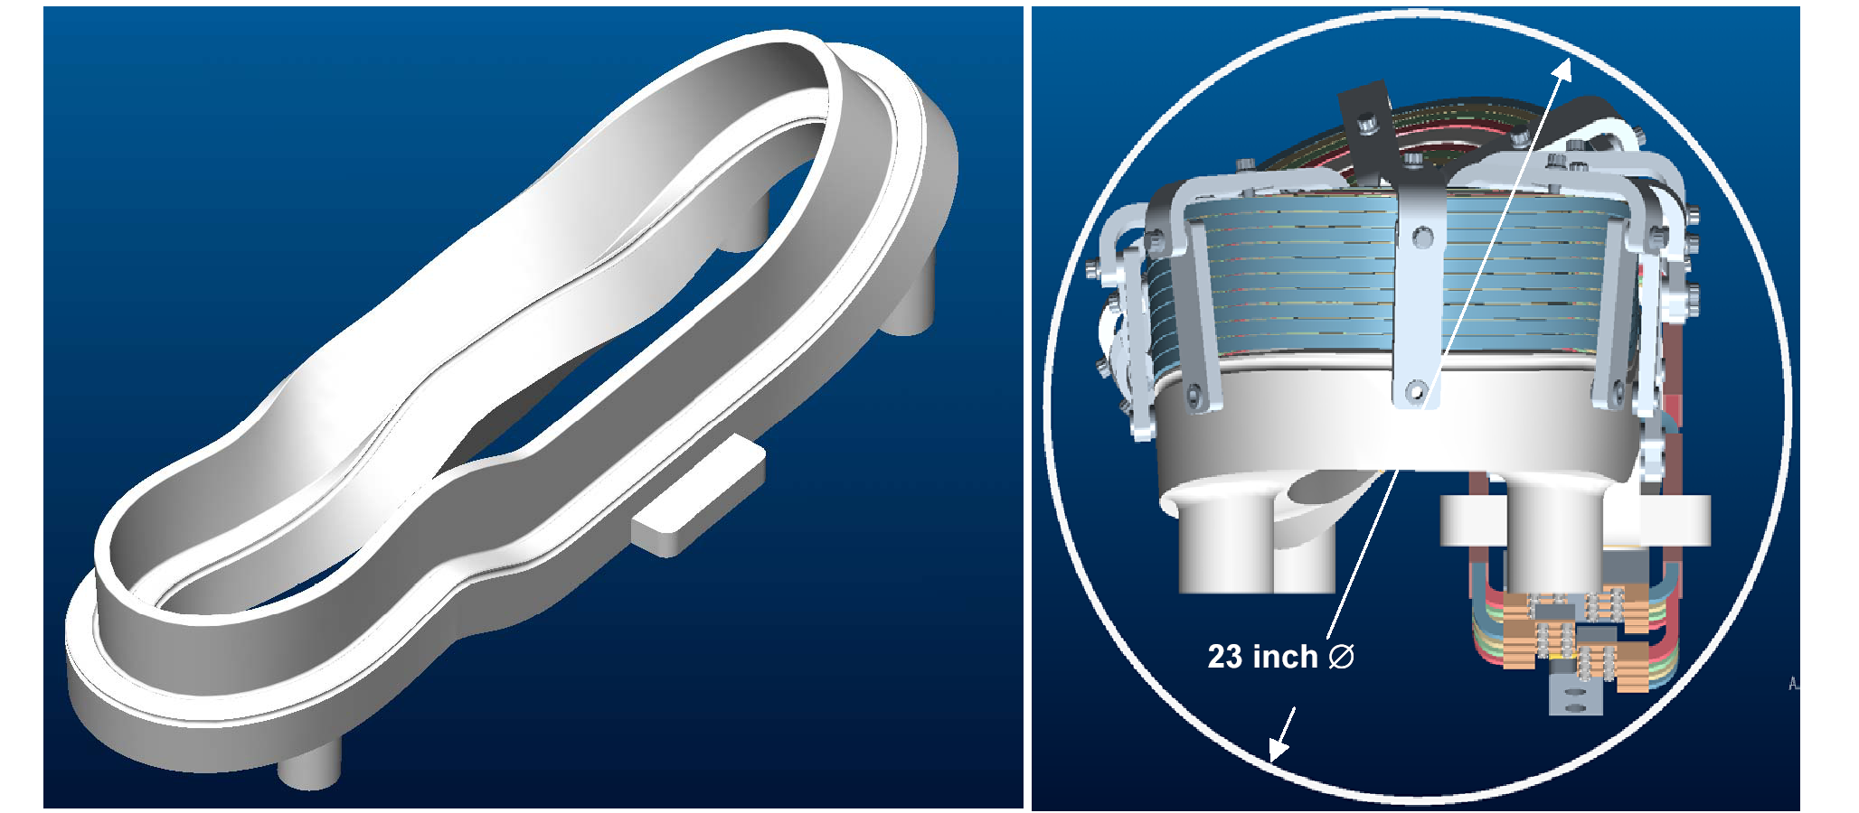
Figure 34 "Twisted Tee" demonstration coil showing coil assembly, cast winding form, and end view of assembly in vacuum oven

Vendor input and Manufacturing studies
In order to obtain feedback from potential fabricators concerning the feasibility, methods, and cost for fabricating the modular coils, four small contracts were awarded during conceptual design to qualified vendors to provide manufacturing studies of the coil winding and coil winding form manufacture. The studies were based on a set of CAD models and a draft procurement specification. The vendors made comments on the design, the specification, and the CAD models. Several suggestions were made concerning the winding form details, such as clamp machining, winding path machining, pre-assembly operations, etc. Additional suggestions were made for the winding; some in considerable detail, concerning items such as the chill plate design, winding order and lead arrangement, and vacuum impregnation method. As was the case with the vacuum vessel study, all the vendors recommended significant R&D, but all said the coil shape, tolerances, and other requirements were difficult but feasible.
Additional R&D studies
Some other, miscellaneous R&D has been performed to investigate the behavior of the cable conductor.
Cable handling: The cable was tested with respect to general handling characteristics typical of winding processes. The cable is extremely flexible, but repeated bending and manipulation cause it to “unpack”.
Cable resistance measurements: The cable resistance was measured and found to be, on average, about 12% higher than one would expect for a straight copper conductor of the same area as contained in 12,240 strands of 36 AWG wire14. This is believed to be due primarily to the twist in the cables before they are compacted and the fact that the wire may have been on the low side of the 36-gage specification (nominal diameter of a single wire = 0.005 inches).
Epoxy fill measurements: Electron beam microscope measurements at 12,000 X magnification show good epoxy fill between the individual copper strands. This provides high confidence that the compacted copper cable to be used by NCSX can be successfully impregnated. A typical result is illustrated in Figure 35
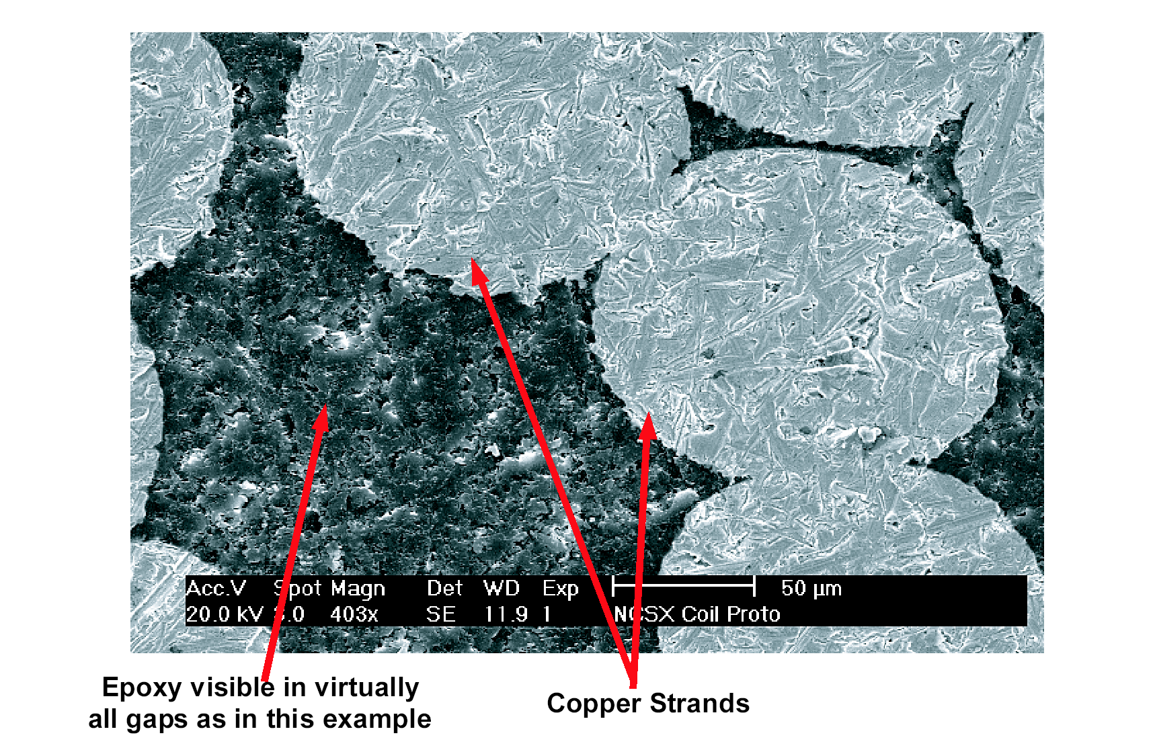
Figure 35 Electron beam micrograph of epoxy impregnated cable conductor (strand dia. is 0.005 inches)

Winding Form Development
During this preliminary design phase, the Project awarded contracts to two industrial teams for manufacturing development of the modular coil winding forms. The purpose of the contracts is to develop the manufacturing processes for the forms through fabrication of full-scale prototypes. The team led by Energy Industries of Ohio includes Metaltek International (Missouri) for casting the forms, Magna Machine Co. (Ohio) for machining the precision surfaces, with buyCASTINGS.com (Ohio), Atlantic Technical Components (New York), C. A. Lawton Co. (Wisconsin), Deformation Control Technology, Inc. (Ohio), Finite Solutions, Inc. (Ohio), Altair Engineering (Ohio), and ARACOR, Inc. (Ohio) providing technology and management services. The team led by J. P. Pattern of Butler, WI, includes Waukesha Foundry, Inc. (Wisconsin) for casting, Remmele Engineering, Inc. (Minnesota) for machining, and TKS Innovation, LLC (Wisconsin) for management services.
The teams have prepared manufacturing studies for the winding forms and completed detailed Manufacturing, Inspection, and Test (MIT) Plans which identify the materials, processes, inspection, and quality control provisions necessary to produce them.

Design Implementation

Component Procurement and Fabrication
Procurement and fabrication of the modular coils is following a multi-step process. The first step was to award R&D contracts to procure two cast-and-machined coil forms, one each from two different vendors. Upon the successful completion of the prototype coil forms, the production forms will be ordered via evaluated fixed price contracts. The prototype coil castings will then be used to wind at least one prototype modular coil at PPPL.
The R&D described in section 3 should fully develop and characterize the processes and tooling required for the production coils, which will also be wound and vacuum pressure impregnated with epoxy at PPPL. The logic is to retain as much control as possible over schedule and processes, and avoid as much as possible the integrating contractor costs. In addition, this logic permits an accelerated schedule, since it avoids the typically 3 month cycle required to advertise, vendor preparation of bid responses, bid evaluations, and contract placement. Since the flexible cable is very easy to wind, the specialized equipment that would normally be necessary to wind a solid conductor is not needed, nor are the associated talents of a conventional coil fabrication vendor. The conductor for the coils will be procured on a fixed price subcontract.

Subsystem Assembly, Installation, and Testing
The modular coils will be assembled first into field periods in the D-site pre-assembly area, and the field periods will then be installed on the support frame in the NCSX test cell at C-site.

Reliability, Maintainability, and Safety
Several design features have been included to enhance the reliability of the modular coil system or to simplify inspection and repair of obvious trouble spots. The most important active feature is a fault detection system, comprised of sensors and power systems logic, that would prevent operation of the coils outside their design envelope. Other, passive features, include:
- The modular coil windings are composite structures of copper and epoxy, which could degrade if subjected to large deflections during operation. To prevent overloads that could damage the windings, they are continuously supported against magnetic loads by the stainless steel winding form. Clamps are provided to keep the winding in close contact with the structure.
- The crossovers and leads are located in a relatively straight section of each winding to simplify the crossover geometry and minimize the local forces on this critical area.
- The leads are collected into a coaxial arrangement immediately adjacent to the winding pack to reduce forces further. This arrangement also mechanically connects the two exiting ends of the winding to reduce the possibility of shear failure between the exiting conductor and the winding pack. The coaxial leads are brought all the way outside the shell as hard conductor before transitioning to the flexible coaxial cables that connect the coils to the buswork system.
- All the connections are intended to be accessible and with only minor disassembly of external components. This also allows each circuit to be individually tested in the event of a leak.
- Finally, all the coils will use the same flexible, coaxial cable for the leads, which minimizes loads on the coil terminals and standardizes the lead design and analysis.
A formal Failure Mode, Effects, and Criticality Analysis (FMECA) for the modular coils will be documented prior to close-out of the comments and response phase of this review.

Cost and Schedule
The cost estimate for the modular coil system is summarized in Table 15 and totals $18357K in FY03 dollars. This estimate was developed as a bottoms-up estimate, and includes significant input from potential vendors. The cost is split almost equally between the coil winding, to be done at PPPL, and the coil winding forms. The winding costs are based largely on a detailed schedule-based estimate of R&D, tooling, winding, and vacuum impregnation costs. The cost of the cast-and-machined coil forms is based on vendor estimates from two vendors under contract to fabricate the prototype winding form. These estimates included limited R&D and production unit costs. Despite the significant ongoing R&D program, the developmental nature of the system requires a large contingency (40%) for the winding forms and windings. The balance of system costs have a 24-34% contingency.
Table 14 WBS listing for Modular Coils
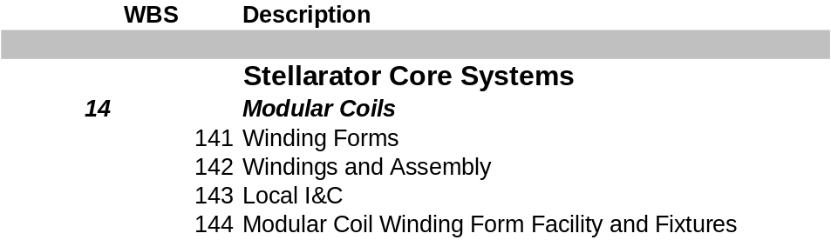

Table 15 Modular Coil Cost Estimate ($k without contingency)
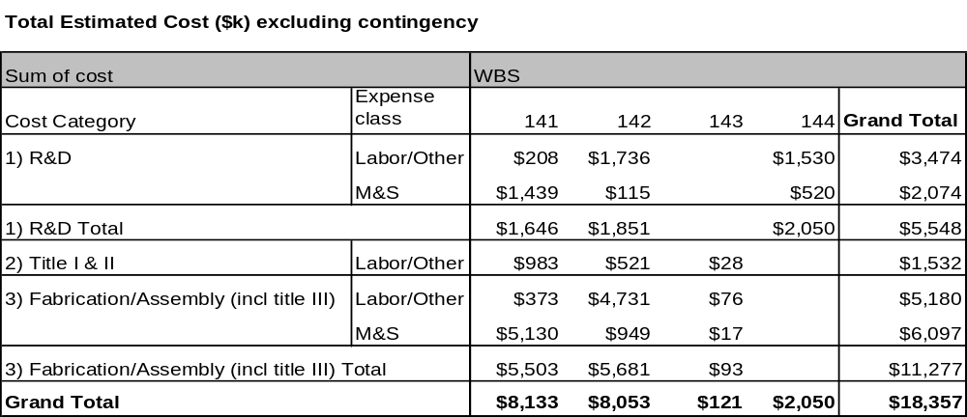

The schedule for design and fabrication of the modular coils indicates that Title I and II design of the winding forms will be completed in April 2004, and design of the windings in October-2004. The first production winding form is scheduled to be delivered in early FY05. Coil winding will begin immediately after receipt of the first winding form and the modular coils will be completed in June-2006. The budgeted cost per year is shown in Table 16.
Detailed cost and schedule information may be found in the Project Master Schedule.

Table 16 Modular Coil Cost Summary by Year of Expenditure

Risk Management
The modular coils have potential technical, cost and schedule risks. The technical risks can be listed, as well as the way in which each has been addressed:
Potential Technical Risk #1. The coils do not have the correct geometry and tolerance
The first potential risk, that the coils will not have the specified geometry and accuracy, is addressed in the design, R&D, the fabrication process, assembly process, and operation.
Design: The coils are designed around a cast and machined winding form that is very accurate, with the winding surfaces and mounting features integrated into a single unit. The coils are wound directly onto this form and vacuum pressure impregnated with epoxy. The casting is massive (just like the frame of a high precision machine tool) and deflections due to the winding and assembly process should be negligible. Since the windings are not removed from the winding form, the distortions that would normally occur during this operation are avoided.
In addition to the basic design concept, the coil leads and bus interfaces are designed for minimum field errors.
R&D Significant R&D is planned to demonstrate and test all operations connected with the modular coil fabrication. This includes procurement of two cast and machined winding forms, winding up to 12 partial coil packs and at least one full prototype coil, and performing thermal, and fatigue tests on critical features. This will all occur with sufficient time to incorporate any changes to the design suggested by the R&D.
Fabrication The coil forms are dimensionally stabilized prior to machining to an accuracy of +/- 0.25 mm anywhere on the winding surface. The forms can be readily and independently inspected by NCSX personnel with conventional laser tracker or multi-link coordinate measuring systems to confirm compliance with specifications.
Once acceptable coil forms are delivered, the coils will be wound at PPPL with total control over all processes by NCSX personnel. The use of the modern 3-D measurement equipment mentioned above will allow the conductor placement to be continuously measured and corrections made throughout the winding process. Once the coils are completed, additional measurements of the as-built geometry can be entered into codes and the relative placement of each coil can be optimized, if necessary, for best control of error fields.
Assembly Continuous measurements will be made during the assembly process to ensure that the coils are aligned correctly. Each coil will be located to a global reference frame that is continuously updated for the best fit to the coil array.
Potential Technical Risk #2. The coils will fail mechanically
The second potential risk, that the modular coils will fail mechanically, is mitigated by analysis, conservative design criteria, and by an active coil protection system. Independent groups using different codes and models will perform critical analysis, such as electromagnetic load calculations, stress and deflection calculations, and thermal stress analysis. The stresses will be compared to the ASME code allowables, which provide a safety factor of 1.5 on yield for primary membrane stresses at the operating temperature. The materials chosen for the cast coil form have been demonstrated to have reliably high tensile strength, which adds additional margin. The winding is continuously supported in the cast form, so the winding and coil forms will have approximately the same strain. Since the coil modulus of elasticity is lower than the steel, the winding should have relatively low stresses. The only caveat to this point is the thermal stress, where the coil form restraint adds stress to the winding. Again, a lower stiffness mitigates this problem significantly. Nevertheless, R&D testing will be performed to determine thermal stress limits during the preliminary design phase. If necessary, a compliant layer will be added to the design to mitigate the thermal stresses.
In addition to designing and analyzing expected loading conditions, the coils will be evaluated for and protected from fault conditions by an active coil protection system. A coil fault detection system would prevent operation of the coils outside their design envelope. The system would be programmed to monitor the signals from voltage, strain, temperature, and possibly magnetic field sensors on or around the various coil windings and structures as the coils were being energized. If any of the sensor signals were out-of-bounds for the specific current scenario being run, the fault system would crowbar all the power supplies. The system would guard against control errors and physical faults such as shorted buswork.
Potential Technical Risk #3 The coils will fail electrically
The third potential risk, that the coils will fail electrically, is mitigated by a redundant insulation system and non-conducting coolant. The ground insulation will consist of 2 overlapping layers of Kapton tape in addition to multiple layers of interlaced glass tape. The fiberglass/epoxy matrix is adequate by itself, but just in case there are small dry areas between turns the Kapton will provide more than adequate insulation strength. The turn-to-turn insulation must only stand off 1/10 of the terminal voltage, since the coils are layer wound four in hand.
Potential Technical Risk #4 The modular coil cooling will be inadequate
The fourth potential risk, that the coils will not cool down in the specified time, will be mitigated by providing two chill plates for each winding. The outside chill plate will be well cooled with tracing, and will be connected to both ends of the inner chill plate.
Potential Technical Risk # 5 The coil structure will introduce static or transient field errors
The fifth potential risk, that the modular coil structure will introduce field errors, is mitigated by including insulating breaks at the flanges in the shell structure and by strict adherence to stellarator symmetry.
Potential Technical Risk #6 The cable conductor will not behave as planned
The final potential technical risk is that the compacted cable conductor will not behave as planned. This problem is mitigated by design and R&D. The design approach, as explained in detail above, is to full support the windings against electromagnetic forces, nearly eliminating the cyclic bending strain in the conductor that would normally occur in a free standing coil. Extensive R&D is planned and already underway to test one or more small racetrack-shaped coils that can be electrically and thermally cycled. The winding, vacuum impregnation, and restraint conditions would be matched as closely as possible to the planned design.
Cost and schedule risks
The cost and schedule risks associated with the modular coils could also be significant, but steps have been and are being taken to reduce those risks substantially. Manufacturing studies were carried out during the conceptual design process to obtain advice from manufacturing engineers on ways to make the design easier or less expensive to fabricate. Four different studies of the modular coils were carried out, and various methods for winding, vacuum impregnation, casting and machining were investigated. Vendor has continued during preliminary design with an extensive R&D program. This effort has been carried out concurrently with the modular coil design process such that the results to date have been included in the preliminary design. Two different vendors will fabricate full-scale cast and machined coil forms. At the conclusion of the R&D phase, one or more fixed price contracts will be awarded for the production castings. The selection of two vendors for the R&D phase will result in at least two qualified vendors for the production articles, and provides an extra incentive to keep production costs (and bids) low.
This approach also mitigates the schedule risk by starting the R&D process as soon as possible and incorporating any needed design changes as they are uncovered. Two qualified vendors will be available at the end of the R&D process, so schedule pressures could be relieved by adding more capacity. It should be noted that the present schedule for procurement of the winding forms is completely consistent with vendor input, and no specific schedule issue is apparent. The coils will be wound in-house at PPPL, which affords more control over the schedule and resource allocation than would be possible with an outside vendor. Slight in-process changes could be made without ponderous approval cycles.

A. Brooks, A. V. Georgiyevskiy, W.U.Reiersen, V.A.Rudakov, “Current Feeds And Connection Part Perturbation Study On Magnetic Configuration Of NCSX Stellarator, (M45 coils c01r00), April 2002
Private Communication, Art Brooks, December, 2002
SPARK D. Weissenburger, "SPARK Version 1.1 Reference Manual", Princeton Plasma Physics Lab Report No. PPPL-2494 (1988)
HM Fan, “NCSX Modular Coil Cooling”, May 19, 2003.
ANSYS Inc, 275 Technology Drive, Canonsburg, PA 15317
W.D. Cain, “MAGFOR: A Magnetics Code to Calculate Field and Forces in Twisted Helical Coils of Constant Cross-Section”, 10th IEEE/NPSS Symposium on Fusion Engineering, 1983
Composite Technology Development, August 2003
Composite Technology Development, August 2003.
Composite Technology Development, Inc., Littleton, Colorado
J. Chrzanowski, Peer Review of Modular Coil VPI, Jan 2003
W. Reiersen, “Effect of Keystoning on Winding Pack Design”, July 30, 2003.

