Coil Support Structure
The coil support structure provides the means for accurately locating and supporting the TF and PF coils, and the external trim coils. This structure is illustrated in FIG.1. The TF coil support structure consists of welded, gusseted brackets attached to the MCWF (Modular Coil Winding Form) on both the inboard and outboard regions. In addition, these brackets and the MCWF provide the main gravity load path for the TF coils during field period assembly and machine operation. The outer TF support brackets also have “outriggers” which are brackets cantilevered radially outboard to help support the outer PF5 & PF6 coils. The main vertical (gravity and EM) loads from the outer PF5 & PF6 will be reacted through the outer coil frame structure. The cast MCWF provides a parallel internal load path tying the upper and lower PF coils together. The central solenoid is a self-standing assembly hung from the upper TF pre-load ring structure. The TF pre-load ring also provides the vertical support for the PF4 coil.
The inner and outer bracket assemblies for each TF coil will be bolted to the reinforcing shelves on the MCWF. A half field period is shown in FIG.1 and bracket assembly in FIG. 2. These assemblies are identical top and bottom. Dielectric breaks are provided between bracket and MCWF where necessary to insure electrical isolation and disrupt any possible eddy currents induced by transient fields. The TF coils will have G11 block mounting pads bonded to the inner and outer radius of the coil at the bracket support locations. Thin Teflon sheets attached to the G11 pads will provide low friction surfaces and radial compliance to the support to accommodate thermal expansion. Lateral TF (EM) loading will be transmitted to the brackets through G11 shims, which again will have a thin Teflon low friction interface attached.

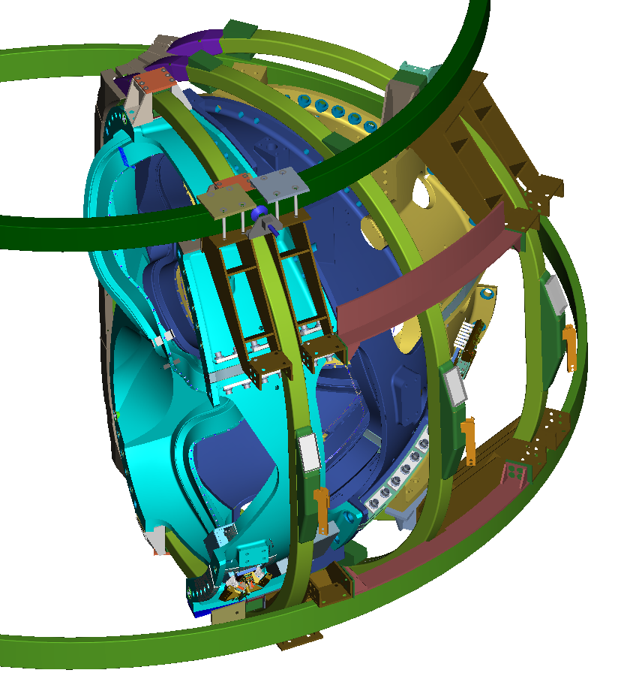

FIGURE 1. PF5&6 AND TF COIL SUPPORT STRUCTURE

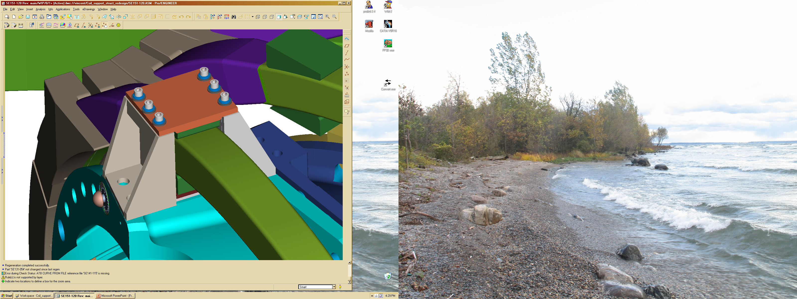
The outer PF coils will be supported from brackets cantilevered off the
FIGURE 2. TF COIL SUPPORTBRACKETS

outer TF support brackets and will also have continuous vertical support from the outer PF support frame which ties the top and bottom coils together. This outer frame assembly is shown in FIG. 3. All the PF coils will be self-supporting in the radial direction with the radial EM loads being reacted by hoop tension within the coil conductor.
PF4 and the CS (Central Solenoid) assembly will be attached to the TF pre-load rings which are located near the top and bottom inner radius of the TF coils as shown in FIG. 4.

The outer PF coils will be supported from brackets cantilevered off the outer TF support brackets and will also have continuous vertical support from the outer PF support frame which ties the top and bottom coils together. This outer frame assembly is shown in FIG. 3 along with the cantilevered PF5&6 brackets. All the PF coils will be self-supporting in the radial direction with the radial EM loads being reacted by hoop tension within the coil conductor.

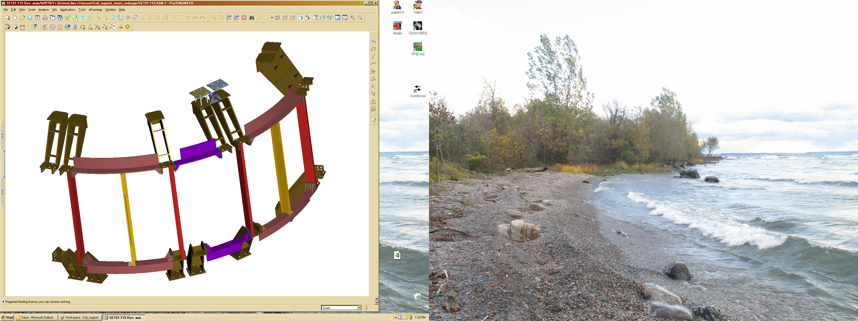
FIGURE 3. OUTER PF COIL SUPPORT FRAME & BRACKETS

PF4 and the CS (Central Solenoid) assembly will be attached to the TF pre-load rings which are located near the top and bottom inner radius of the TF coils as shown in Figure 4.

The upper and lower crowns are connected to the upper and lower shelf assemblies respectively. The center solenoid assembly is attached (hung) to the upper crowns. A positioning ring is provided on the bottom to center the solenoid.
The center solenoid assembly consists of the PF1a upper & lower coils spacer assemblies and tie rods, shown in FIG. 5. The lead pairs are routed through the bore of the solenoid as illustrated in FIG. 6.
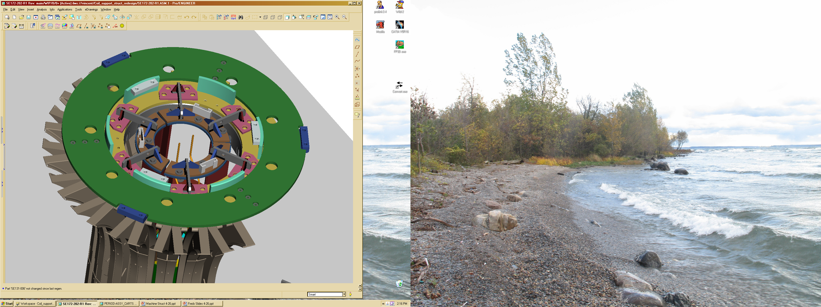
FIGURE 4. TF COIL PRE-LOAD RING


FIGURE 5. CS – CENTER SOLENOID ASSEMBLY

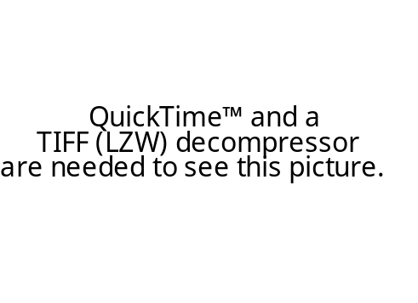

FIGURE 7. PF COIL ADJUSTING/POSITIONING
LN2 tube with insulating break
-
PF1a bus polarity for a vertical-up B-field
PF1a Upper
PF1a Lower
+
Silver braze jumper to connecting bus
A
Section A-A
(no scale)
G11CR Clamp
LN2 tube with insulating break

FIGURE 6. BUS ROUTING LAYOUT FOR PF1A UPPER & LOWER
A

The PF ring coils are attached to the shelf structures with brackets that can be adjusted to accurately align the coils. Since large ring coils are often out-of-round, these brackets will also serve to bring the coils into an acceptably round shape. The adjusting bracket assembly is shown in FIG 7. above.

  - Base Support Structure/machine interface
The transition structure between the MCWF, TF, and PF Coil supports must provide the structural load path from the main machine assembly to the base support structure which in turn attaches to the test cell floor. Functionally it must also act as the thermal transition from 80 K to room temperature, and provide radial compliance to accommodate the thermal contraction of the MCWF and coil support structure which will be operating at 80 K. In addition to radial compliance the attaching mechanism must alsoallow for some (small amount of rotational compliance about the radial axis to relieve stresses that would otherwise develop in the MCWF flange joints (if fully constrained). Fig. 8 below is a conceptual sketch of the support.

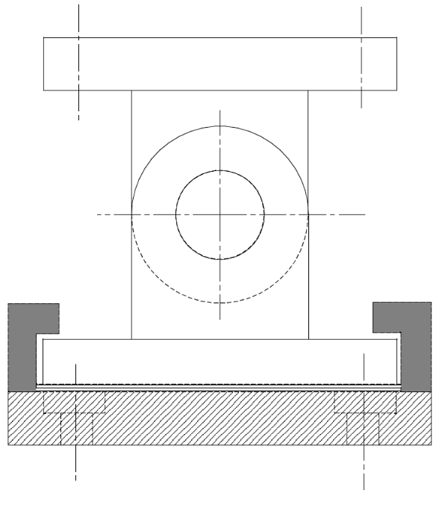
FIGURE 8. Base Support Structure/machine interface

