NCSX Engineering Design Document

Design Description
Conventional Coils and Structure
(WBS 13, 15)
Rev. 1-29-05

NCSX Preliminary Design Review

Table of Contents
1 Design Overview 3
2 Design Requirements and Constraints 3
2.1 Conventional Coil System 3
2.2 Machine Support Structure 3
3 Design Description and Performance 3
3.1 Toroidal Field Coils 3
3.2 Poloidal Field Coils 3
3.3 External Trim Coils 3
3.4 Support Structure 3
4 Design Basis 3
4.1 Design criteria 3
4.2 Analysis 3
4.2.1 Field errors 3
4.2.2 EM Forces on Coils 3
4.2.3 Stress Analysis 3
4.2.4 Coil thermo-hydraulic analysis 3
4.3 Vendor input 3
5 Design Implementation 3
5.1 Component Procurement and Fabrication 3
5.2 Subsystem Assembly, Installation, and Testing 3
6 Reliability, Maintainability, and Safety 3
7 Cost and Schedule 3
7.1 Conventional Coils (WBS 13) 3
7.2 Support Structure (WBS 15) 3
8 Risk Management 3
8.1 PF, TF, Trim coils 3
8.2 Support Structure 3

Table of Figures
Figure 1 Cut-Away View of the Stellarator Core Assembly 3
Figure 2 TF and PF coil geometry with modular coils for reference 3
Figure 3 TF coil geometry 3
Figure 4 TF Coil Wedging and TF Coil Plan Section Views 3
Figure 5 PF coil geometry 3
Figure 6 Central Solenoid Assembly showing 3 pairs of identical c oils 3
Figure 7 Solenoid (PF1,PF2, PF3) winding details 3
Figure 8 PF 4 winding details 3
Figure 9 PF5 winding details 3
Figure 10 PF6 winding details 3
Figure 11 External trim coils 3
Figure 12 Coil support structure 3
Figure 13 Half-field period TF coil and support structure subassembly 3
Figure 14 Upper and Lower TF Supports 3
Figure 15 Typical Force Distribution (Force density, N/mm3) for PF Coils, 1.7T ohmic (LC2) 3
Figure 16 Typical Force Distribution (Force density, N/mm³) for TF Coils, 1.7T ohmic (LC2) 3
Figure 17: Global FEA Model of Conventional Coils and Structure 3
Figure 18: Hybrid FEA Model of TF Coil 3
Figure 19 Global Model Stress (top) and Deflection (bottom) in the TF coil from 0.5 T Load Case 3
Figure 20: Hybrid Model TF Conductor Stresses from 0.5 T Load Case 3
Figure 21 Support Structure stresses, LC1Hybrid (top) and LC2 Global (bottom) 3
Figure 22 Thermo-Hydraulic Analysis of TF Coil 3

Tables
Table 1 NCSX Parameters 3
Table 2 Conventional Coil System functions 3
Table 3 TF and PF coil system requirements 3
Table 4 TF coil parameters 3
Table 5 PF coil parameters 3
Table 6 External trim coil parameters 3
Table 7: Most Significant Load Cases Analyzed for Fields Forces on Coils 3
Table 8: Maximum Net Forces on PF Coils [kN] 3
Table 9: Material Properties, Conventional Coils and Structure 3
Table 10 Design Stress Values at 80K, Metallic 3
Table 11 Design Stress Values at 80K, Epoxy-Glass Insulation 3
Table 12 Global Model Stress Summary 3
Table 13 SummaryTF Coil Cost Estimate 3
Table 16 WBS listing for Support Structure 3
Table 15 Support Structure (WBS 15) Costs 3

Design Overview
The stellarator core is an assembly of four magnet systems that surround a highly shaped plasma and vacuum chamber. The coils provide the magnetic field required for plasma shaping and position control, inductive current drive, and error field correction. The vacuum vessel and plasma facing components are designed to produce a high vacuum plasma environment with access for heating, pumping, diagnostics, and maintenance. All of the NCSX coil sets are cryo-resistive and operate at liquid nitrogen temperatures, so the entire system is surrounded by a cryostat. Figure 1 shows a cutaway view of the stellarator core assembly and the overall parameters are listed Table 1. The conventional coils and structure are the subject of this document.

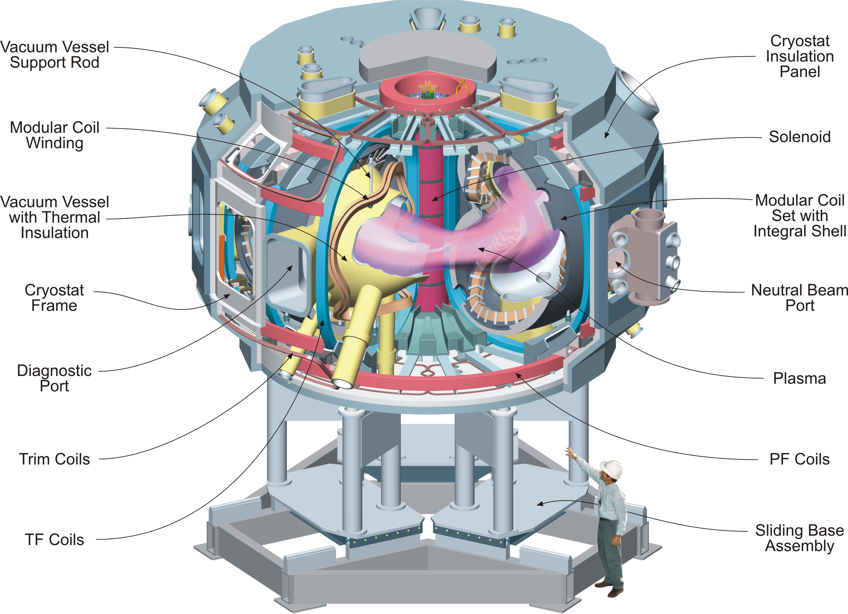
Figure 1 Cut-Away View of the Stellarator Core Assembly

Table 1 NCSX Parameters
Parameter | Value
Major radius | 1.4 m
Minor radius | 0.33 m
B_{max} | 2 T
Plasma current | Up to 320 kA
TF coil configuration | +/- 0.5 T, 1/R (18 coils)
Plasma heating methods | NBI  ICH and ECH (future upgrades)

A set of toroidal field (TF) coils is included to provide flexibility in the magnetic configuration. Adding or subtracting toroidal field is an ideal “knob” for lowering and raising iota. There are 18 identical, equally spaced coils providing a 1/R field at the plasma.
A set of poloidal field coils is provided for inductive current drive and plasma shape and position control. The coil set consists of three inner solenoid pairs (PF 1, PF 2, and PF3), and 3 pairs of ring coils. Coil pairs are symmetric about the horizontal midplane and each coil pair is connected in an independent circuit.
External trim coils are provided on the top, bottom and outside perimeter of the coil support structure primarily to reduce n/m=1/2 and 2/3 resonant errors that may result from manufacturing or assembly errors in the modular coil geometry.

Design Requirements and Constraints

Conventional Coil System
The conventional coil system includes all the coils required in addition to the modular coils to provide the magnetic field for plasma shaping, position control, and inductive current drive. Ex-vessel trim coils are added for low poloidal mode number (m=2,3) field error correction. Additional coils may be added inside the vacuum vessel during the operational phase for higher order (m=5,6) field error correction. The coil sets and their primary functions are listed in Table 2, and the coil geometry is shown in Figure 2

Table 2 Conventional Coil System functions
Coil set | Function
Poloidal field coils | Inductive current drive, plasma position control, plasma shaping
Toroidal field coils | Addition or subtraction of toroidal field for control of magnetic transform
Trim Coils | Control of magnetic flux surface quality

Figure 2 TF and PF coil geometry with modular coils for reference

The basic requirements are listed in Table 3. These requirements are extracted from the general machine requirements described in the General Requirements Document, provided as part of the Preliminary Design Report. The overarching requirement is to provide windings that can accurately produce the desired magnetic field configuration. The coil configurations (number of coils, etc.) have been optimized to best meet a combination of physics and engineering constraints.

Table 3 TF and PF coil system requirements
General requirement
A set of PF coils and TF coils shall be provided to support the reference scenarios and meet flexibility, field error, and polarity requirements.
Performance
Operating scenarios:
- 1.7T Ohmic Scenario: 1.7 T for 0.44 seconds , 120 kA Ip
- 1.7T High Beta Scenario: 1.7 T for 0.44 seconds , 175 kA Ip
- 2T High Beta Scenario: 2 T for .20 seconds, 200 kA Ip
- 320kA Ohmic Scenario: 1.7 T for 0.51 seconds, 320 kA Ip
15 minute repetition interval between pulses
Flexibility
- Independent control of all PF coils
- Variable background TF field
Accuracy
Islands from field errors shall be less than 10% of local plasma size
+/- 3mm assumed for installed winding accuracy inboard and +/- 6mm on the outer leg of the TF Coil in plane and +/- 3mm on the outer leg out of plane
·Coils must provide access for tangential NBI, RF, vacuum pumping, diagnostics, and personnel access
·Limit conductor current to ~ 24 kA peak to match with existing TFTR power supplies

Machine Support Structure
The machine structure provides the integrated support for the TF and PF coils. The primary constraints are that it operates at cryogenic temperatures, be non-magnetic and broken electrically to avoid error-field producing eddy currents, and not interfere with diagnostic or heating access.

Design Description and Performance

Toroidal Field Coils
A set of toroidal field coils is included to provide flexibility in the magnetic configuration. Adding or subtracting toroidal field is an ideal “knob” for lowering and raising iota. There are 18 identical, equally spaced coils providing a 1/R field at the plasma. The in-plane TF coil loads are reacted primarily by wedging the inner legs through stainless steel castings that attach to the forward edge of the coils. The overturning loads are reacted primarily by upper and lower shelf structures which connect to each other through the modular coil shell. The top and bottom of the coil rides in channels that allow radial movement but restrict vertical movement (Figure 14). Just outboard of the upper and lower vertical supports are adjustable out of plane supports. These adjustable screw jacks allow for out of plane positioning and provide out of plane support while allowing vertical and radial movement (purple structure in Figure 12 and 13). On the outboard leg of the TF Coil pusher mechanisms, one top and one bottom, provide inward radial force to counteract transient outward EM loads (blue screw jack mechanism Figure 13). The coils are located at radial locations coincident with the modular coil locations, both for symmetry and to avoid introducing additional obstructions to access. All of the coils are connected in a single circuit initially, but the capability will exist to connect like coils, e.g. coils in the same location relative to the modular coils within a field period, to be connected in separate circuits. Each coil consists of 12 turns in a single bundle. The coil geometry is illustrated in in Figure 3 and Figure 4.
The coils are wound from hollow copper conductor and insulated with glass-epoxy and Kapton. Ground wall thickness is .125 inch on the inner leg and .375 inch on the outer leg. They operate at 80K, cooled by liquid nitrogen, and are connected in series. The leads consist of coaxial conductor to minimize field errors. The nominal TF coil parameters, insulation builds, and details are described in Table 4.

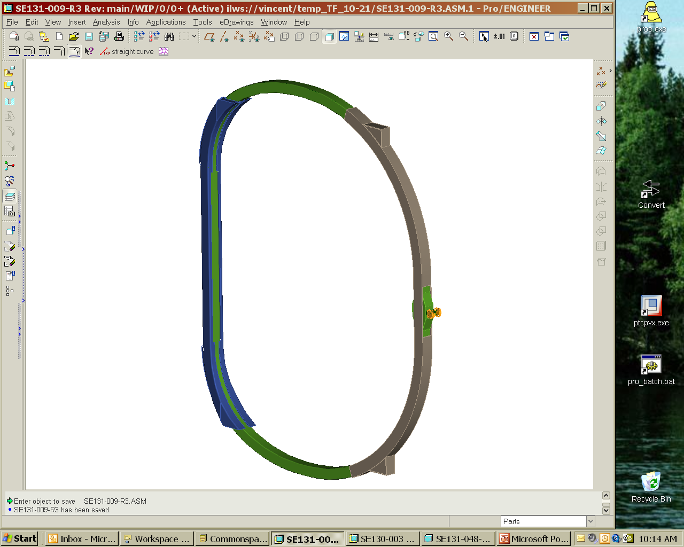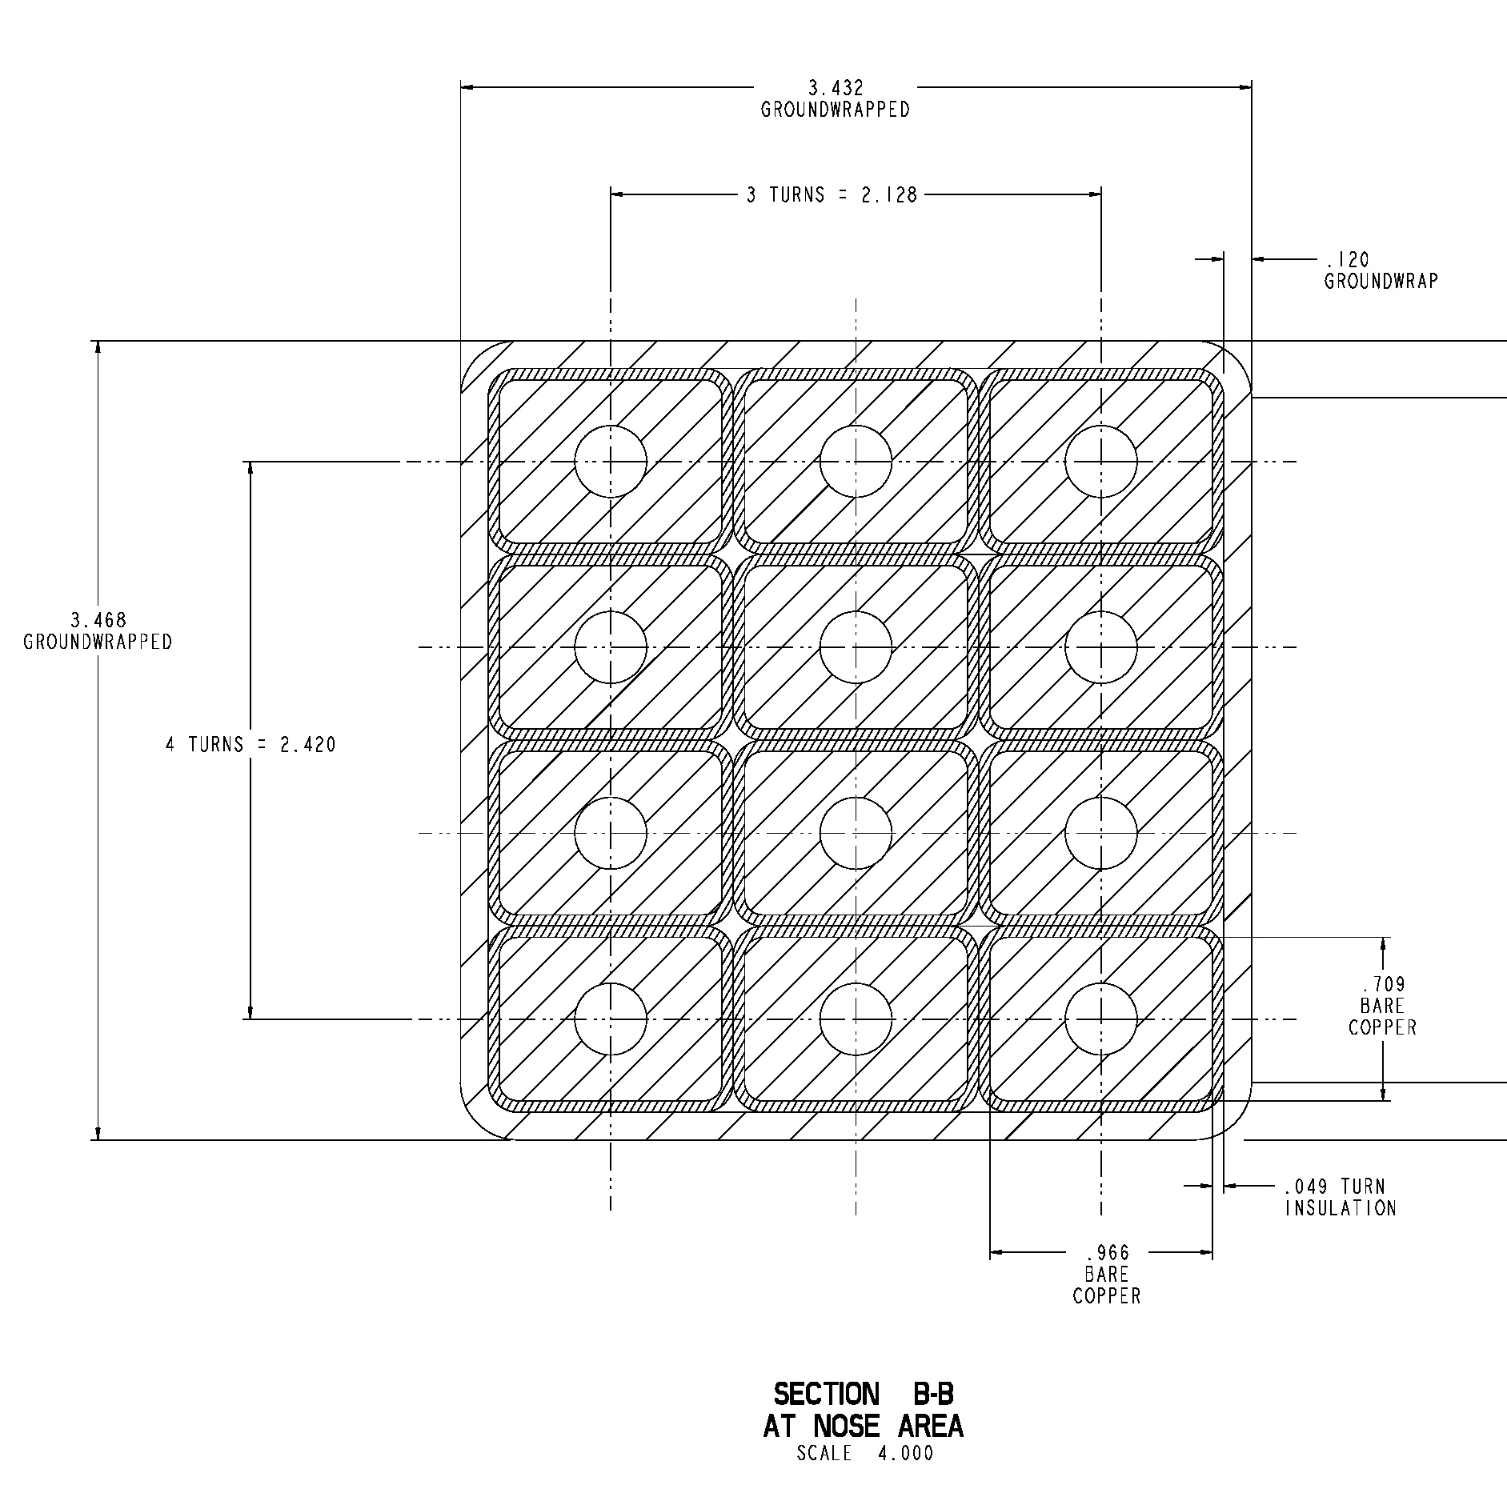
Back Leg
SS Brace
SS Wedge
Castings

Figure 3 TF coil geometry

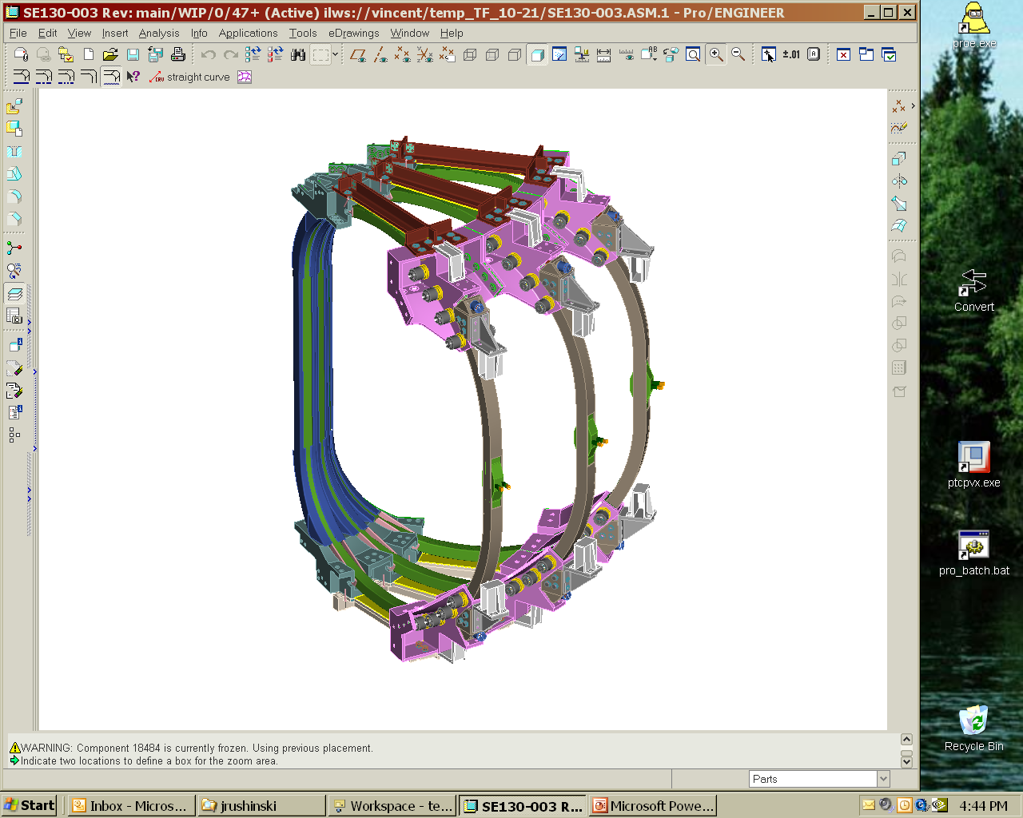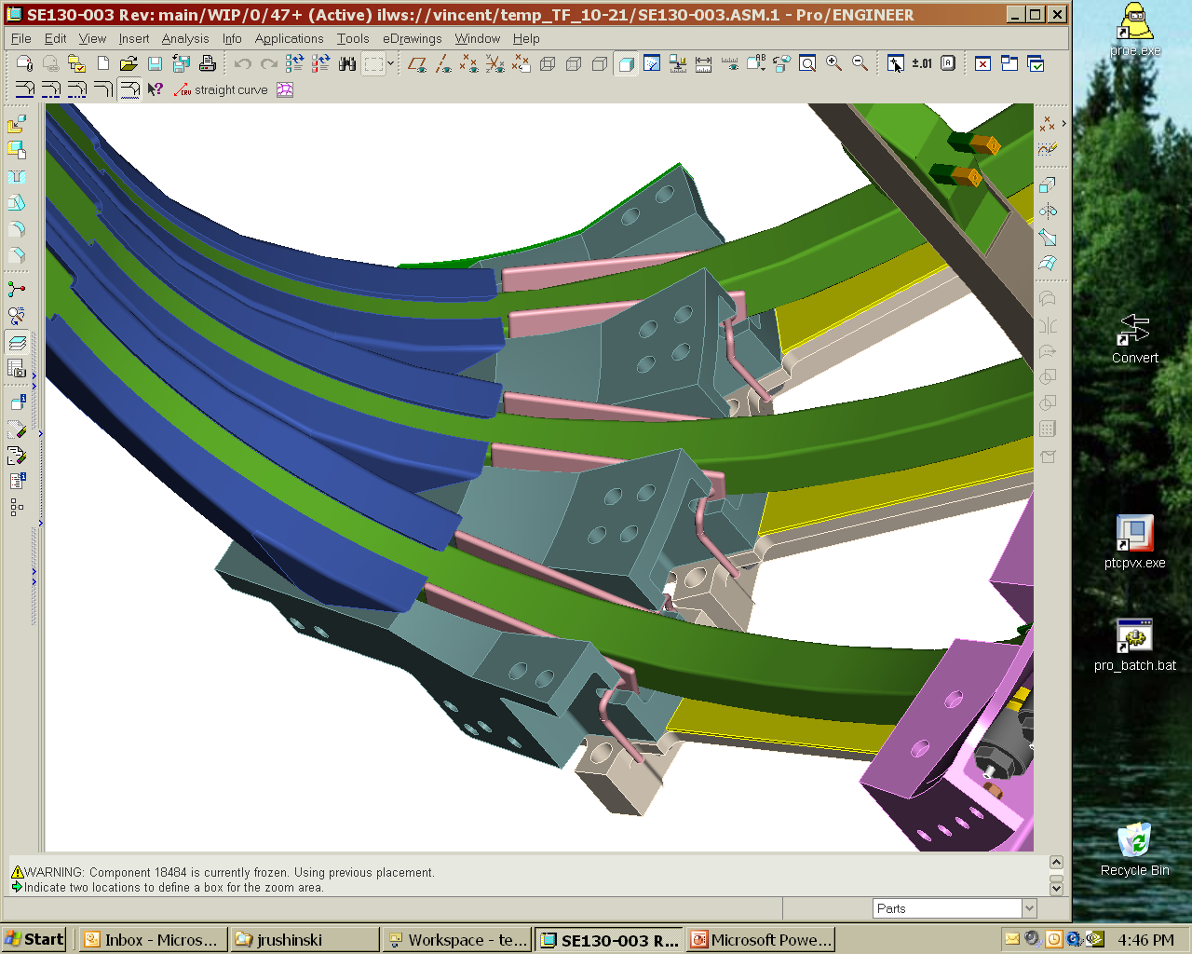

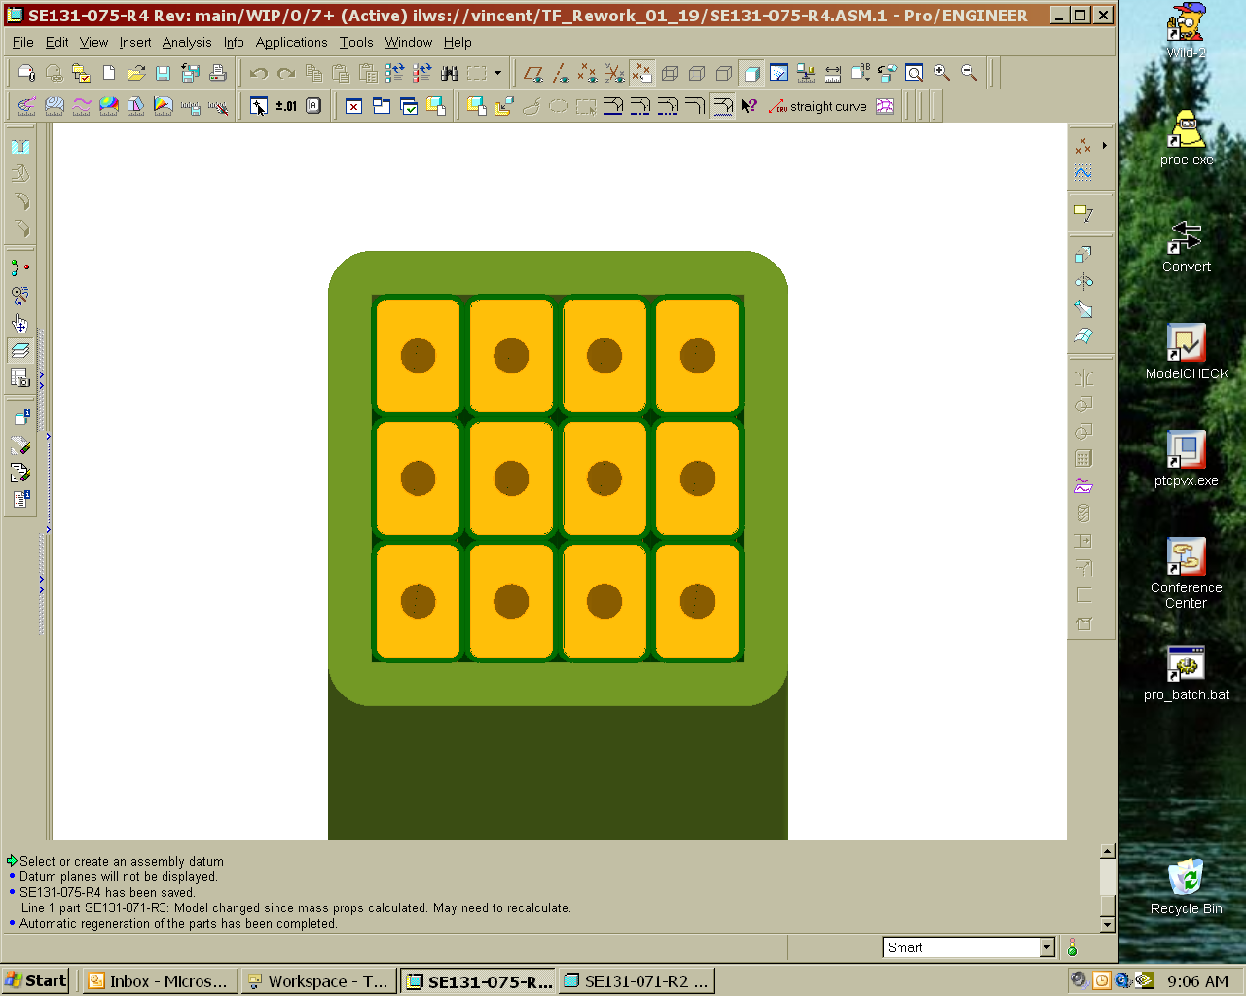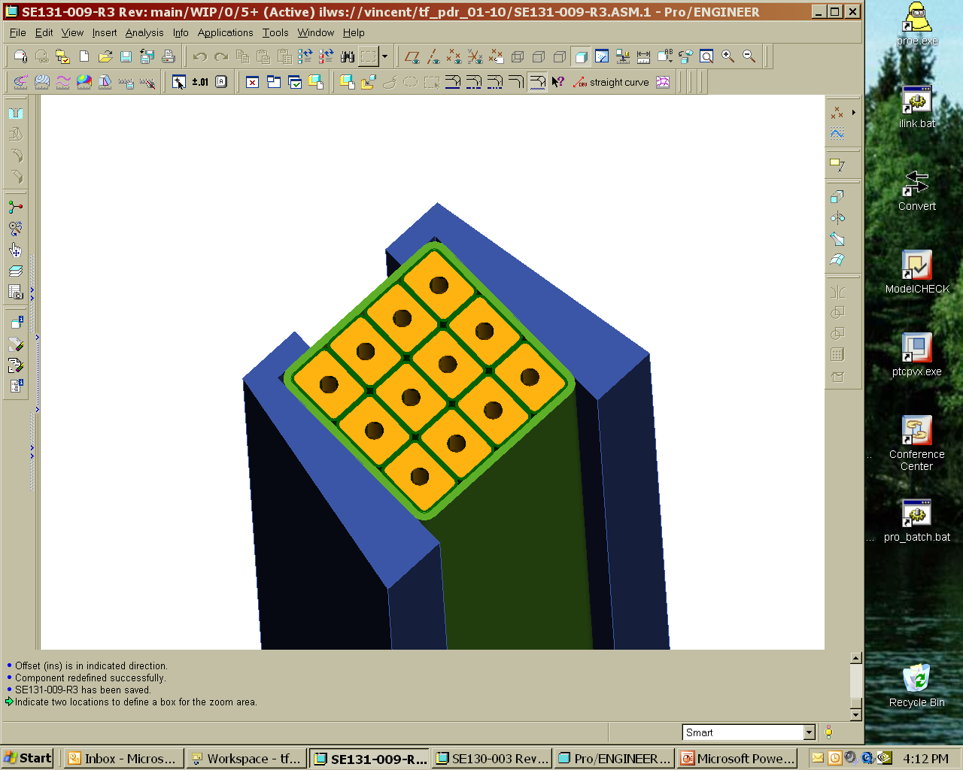
3/8” Groundwrap on outboard leg
1/8” Groundwrap on inboard wedging leg

Figure 4 TF Coil Wedging and TF Coil Plan Section Views

Table 4 TF coil parameters
Parameter | Unit | Value
Number of TF coils |  | 18
Number of turns per coil |  | 12
Maximum toroidal field at 1.4 m  (TF coils only) | T | ±0.5
Maximum current per turn | kA | 16
Winding length along winding center | m | 8.66
Conductor Length | m | 107.7
Bundle height | mm | 100.8
Bundle width | mm | 99.8
Bundle area | mm2 | 10,066
Conductor height | mm | 18.0
Conductor width | mm | 24.5
Corner radius | mm | 2.5
Cooling hole diameter | mm | 8.0
Conductor area | mm2 | 392
Weight/coil, | kg | 414
Max current in reference scenario | kA | 16
Maximum copper current density | kA/cm² | 3.8

Poloidal Field Coils
A set of poloidal field coils is provided for inductive current drive and plasma shape and position control. The basic coil geometry is shown in Figure 5. The coil set consists of three inner solenoid pairs (PF-1, PF-2, and PF-3), one mid-coil pair (PF-4) and two outer coil pairs (PF-4 and PF-5). All the coil pairs are symmetric about the horizontal midplane. The coils are of conventional construction, wound from hollow copper conductor and insulated with glass-epoxy and Kapton. The PF coils operate at the same temperature as the TF coils - nominally 80K, cooled by liquid nitrogen.
The PF coil parameters are listed in Table 5. As shown in the table, the conductor size and maximum current per turn are almost identical for all the coils. This provides common tooling for manufacture and should help to reduce costs.
The OH solenoid coils, PF1, PF2, and PF 3 are connected in series and assembled into a single unit, as shown in Figure 6. Upper and lower PF coils in a given pair are connected in series, and the PF1, PF2, and PF3 coils are also in series. Thus, there will initially be four independent electrical circuits. The solenoid leads are arranged to allow the PF3 coils to be driven independently later in the operations phase. The PF coils, when independently driven, provide flexibility for plasma shaping and position control. With an OH (nullapole) distribution in the PF coils, the coil set can provide 1.15-Wb (double swung). This capability is adequate, even for the maximum plasma current of 350-kA. The details of the PF coil windings are shown in Figure 7, Figure 8, Figure 9, and Figure 10.

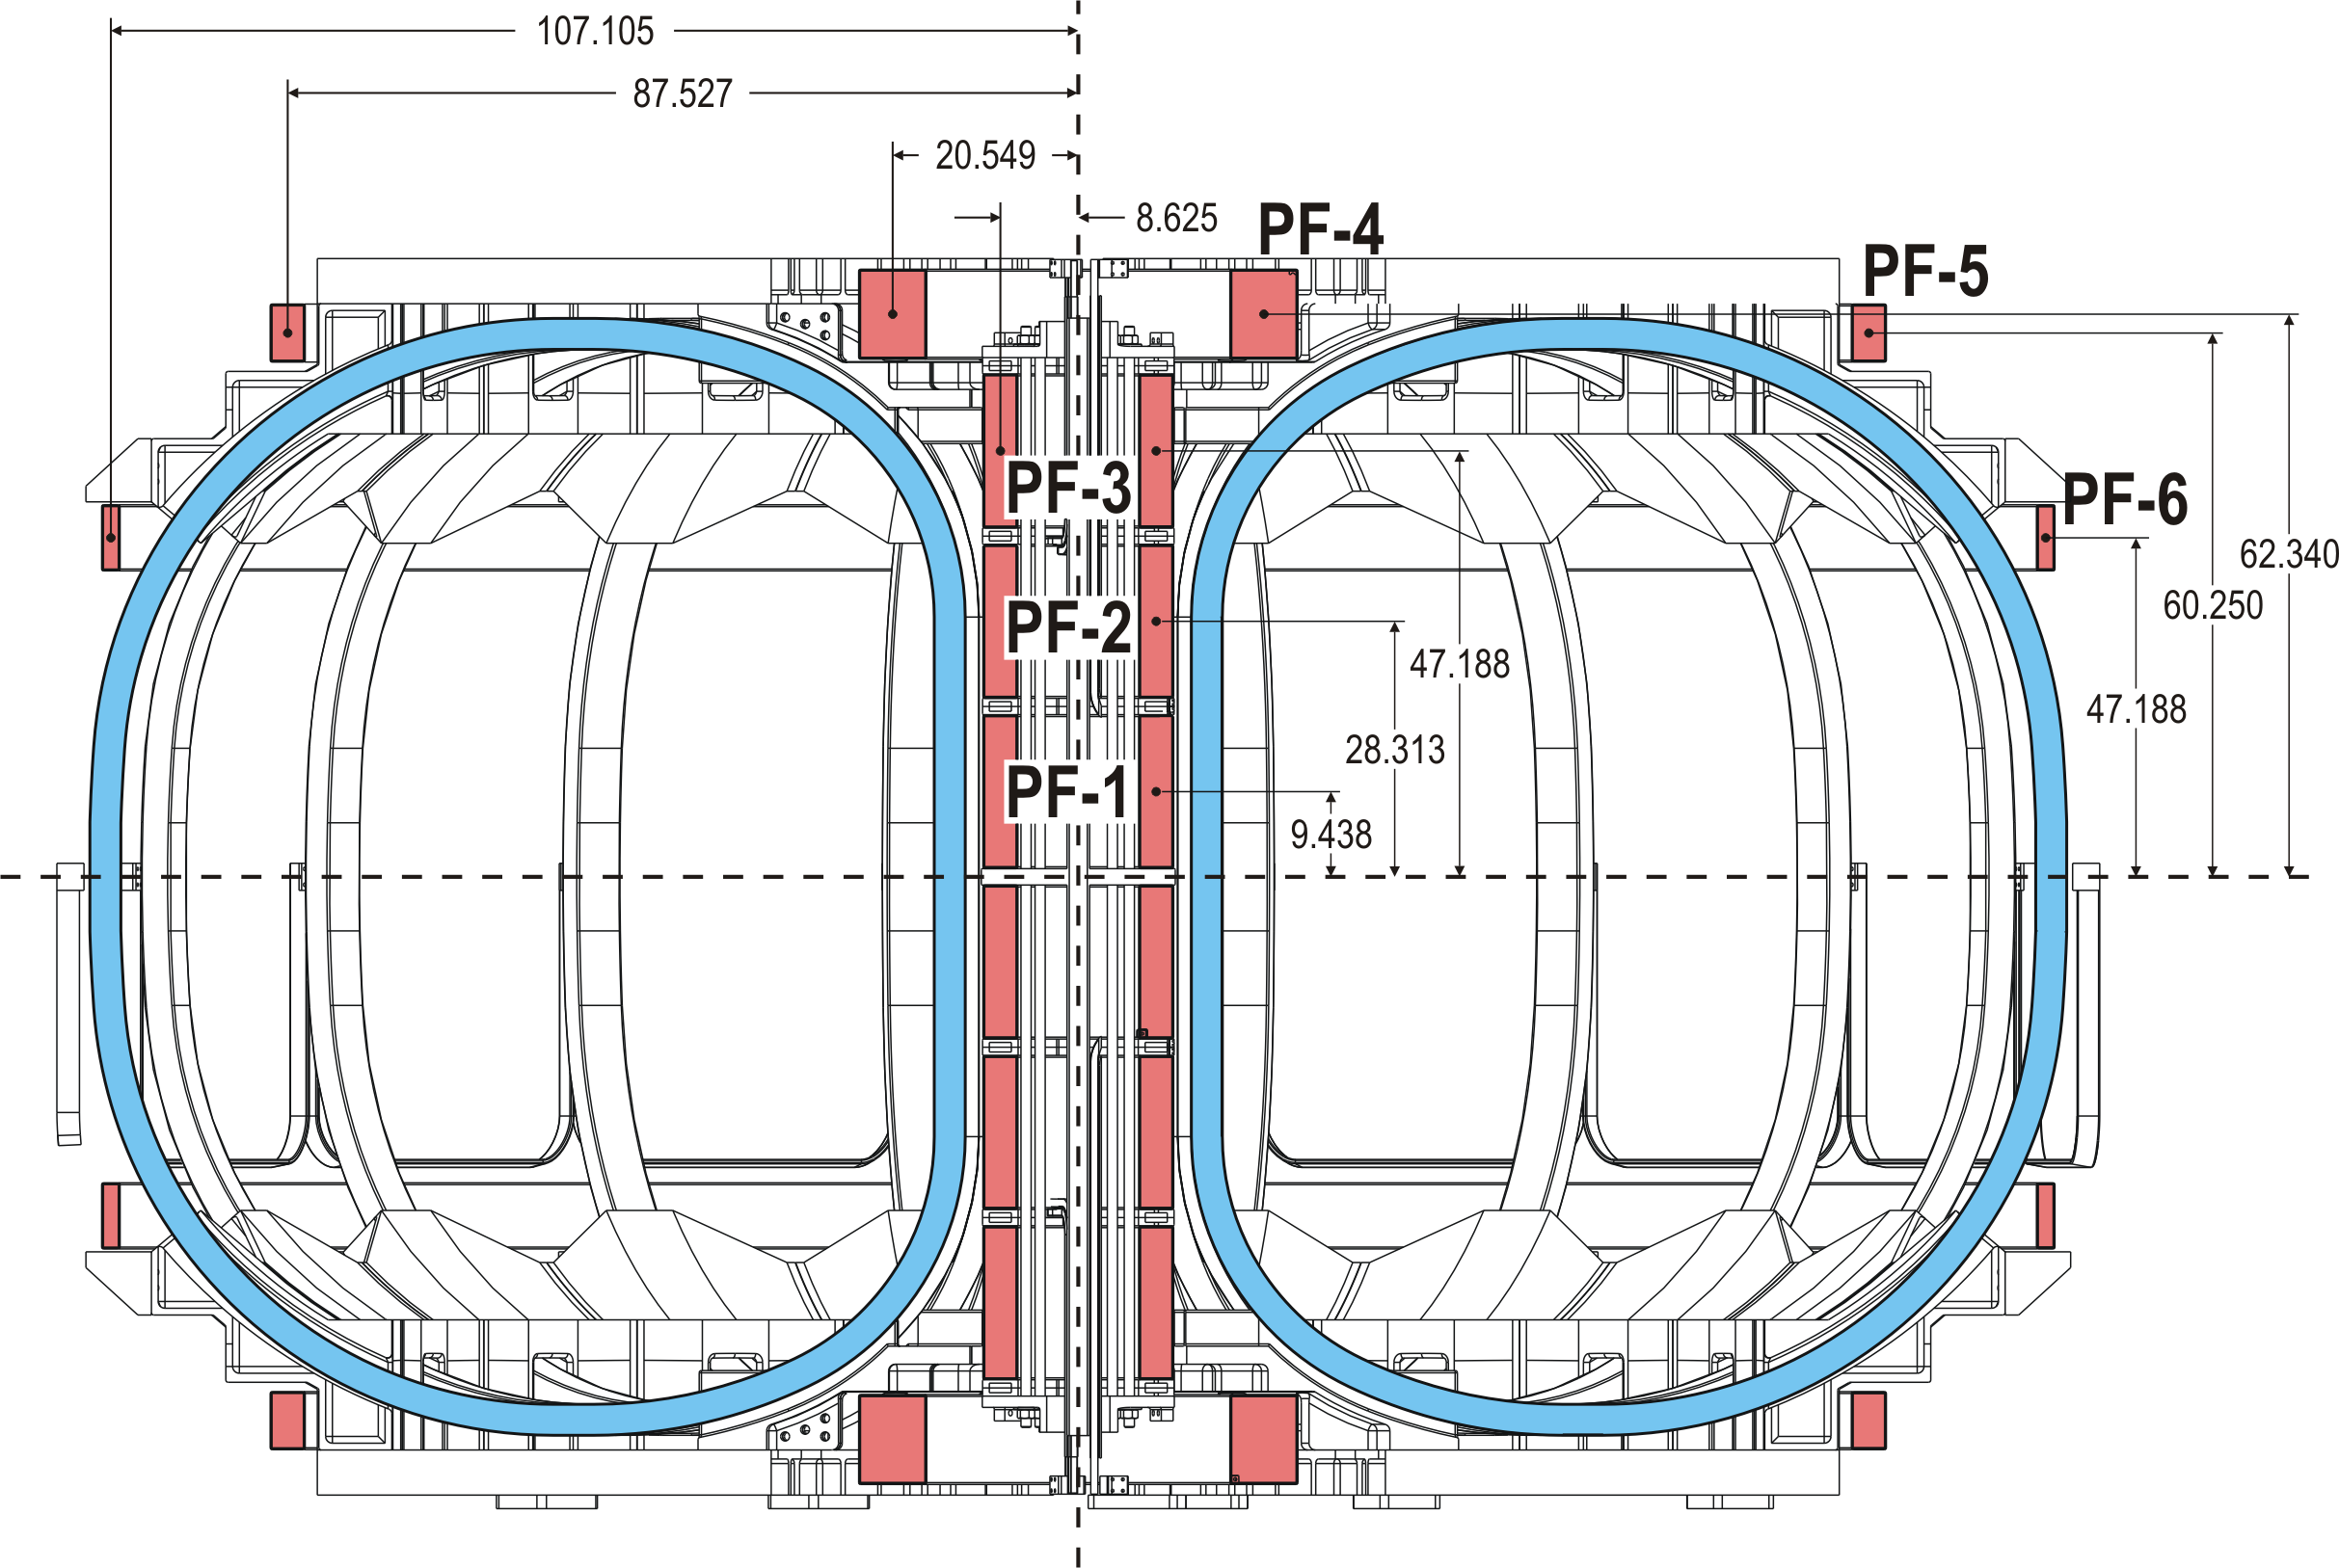
Figure 5 PF coil geometry

Table 5 PF coil parameters
Parameter | Units | PF-1 | PF-2 | PF-3 | PF-4 | PF-5 | PF-6
Max total current | MA-turns | 1.809 | 1.809 | 0.927 | 1.115 | 0.201 | 0.126
Radius | m | 0.22 | 0.22 | 0.27 | 0.52 | 2.22 | 2.72
Installed height, Z | m | 0.24 | 0.72 | 1.2 | 1.58 | 1.53 | 0.95
bundle dr | mm | 96.9 | 96.9 | 96.9 | 188.5 | 96.9 | 51.1
bundle dz | mm | 426.6 | 426.6 | 426.6 | 249.6 | 161.0 | 183.2
gross current density | A/mm² | 43.7 | 43.7 | 22.4 | 23.7 | 12.9 | 13.5
total turns | # | 72 | 72 | 72 | 80 | 24 | 14
turns high | # | 18 | 18 | 18 | 10 | 6 | 7
turns wide | # | 4 | 4 | 4 | 8 | 4 | 2
current per turn | A | -25123 | -25123 | -12877 | -13936 | 8356 | -8997
packing fraction |  | 0.75 | 0.75 | 0.75 | 0.75 | 0.75 | 0.75
length per turn | m | 1.38 | 1.38 | 1.38 | 3.28 | 13.97 | 17.09
total length of copper, per coil | m | 99.11 | 99.11 | 99.11 | 262.36 | 335.25 | 239.3
turn height | mm | 20 | 20 | 20 | 20 | 20 | 20
turn width | mm | 20 | 20 | 20 | 20 | 20 | 20
coolant hole width | mm | 9 | 9 | 9 | 9 | 9 | 9
conductor area | mm^2 | 335.2 | 335.2 | 335.2 | 335.2 | 335.2 | 335.2

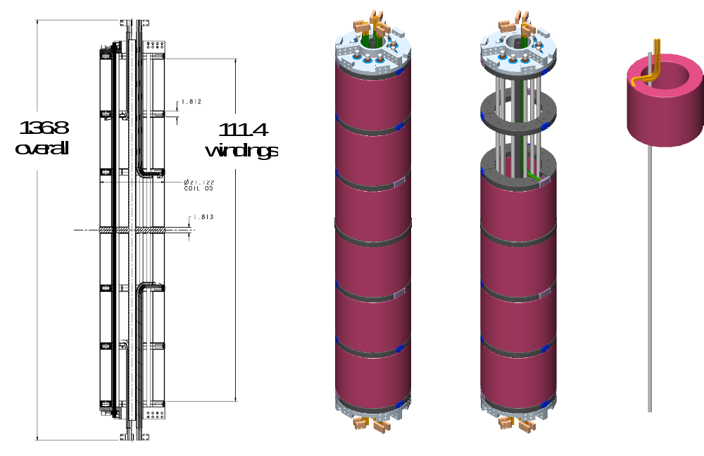
Figure 6 Central Solenoid Assembly showing 3 pairs of identical c oils

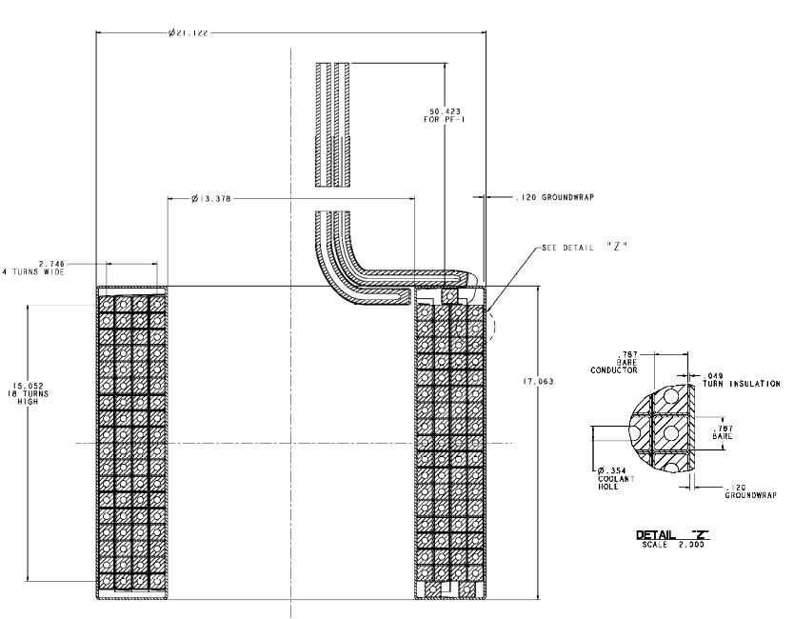
Figure 7 Solenoid (PF1,PF2, PF3) winding details

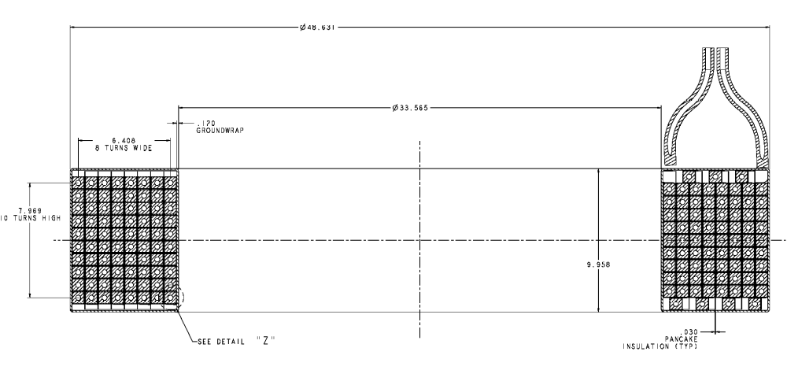
Figure 8 PF 4 winding details

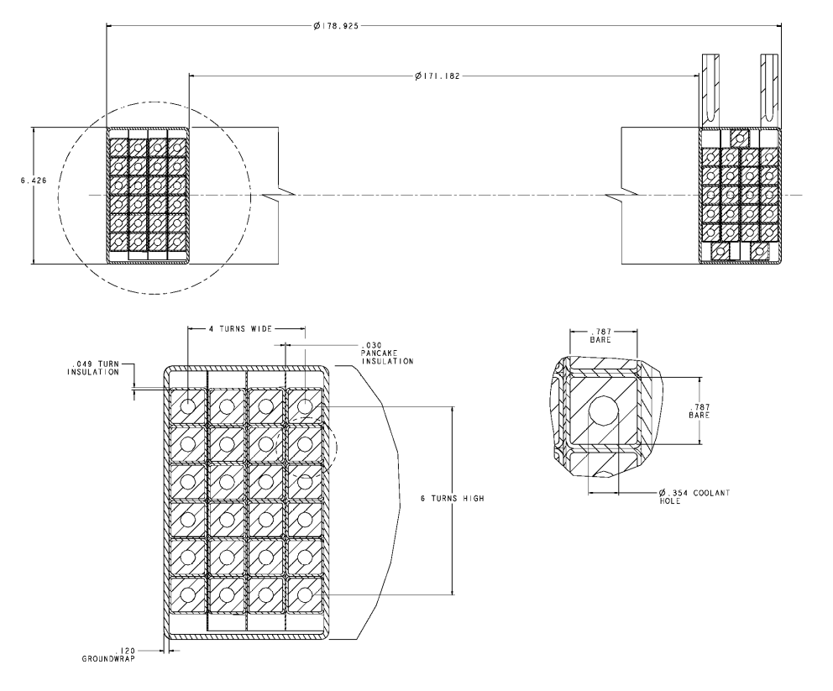
Figure 9 PF5 winding details
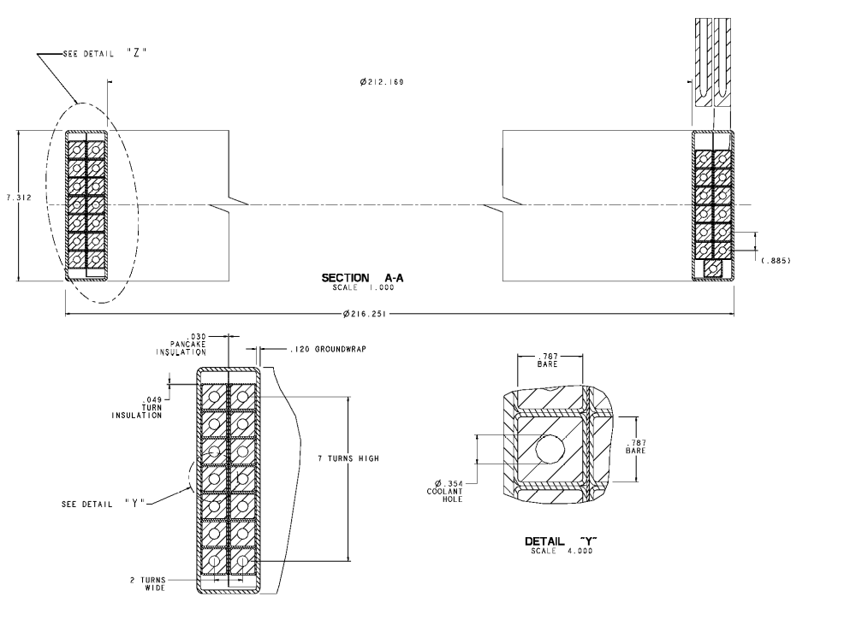
Figure 10 PF6 winding details

External Trim Coils
Two types of correction coils are envisioned for NCSX, external and internal trim coils. The external trim coils are provided on the top, bottom and outside perimeter of the coil support structure primarily to reduce n/m= ½ and 2/3 resonant errors that may result from manufacturing or assembly errors in the modular coil geometry. These coils will be installed during the initial assembly of the machine because it is much more cost effective than retrofitting them later. However, the power supplies will be provided later, after the current requirements are determined.
Figure 11 illustrates this set of coils. The coil parameters are listed in Table 6. These coils are wound from conventional, hollow copper conductor and vacuum pressure impregnated with epoxy. They are supported by the External Coil Support Structure, and operate at liquid nitrogen temperatures. Each coil must be independently powered to provide the flexibility needed for correcting field errors.

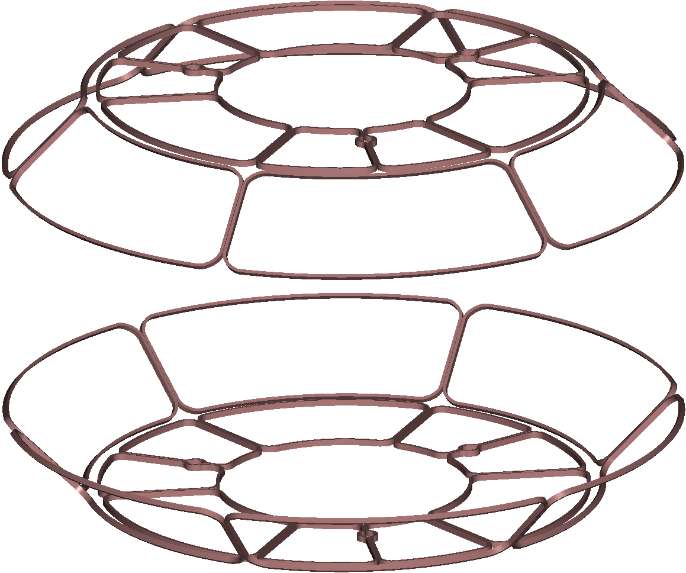
Figure 11 External trim coils

Table 6 External trim coil parameters
Parameter | Units | Top and Bottom Coils | Outer perimeter Coils
Max total current | MA-turns | 1.34 | 1.63
Coil size | m x m | 2.2 x 1.6 wide | 1.7 x.2.7 wide
bundle dr | mm | 21.8 | 21.8
bundle dz | mm | 43.6 | 43.6
gross current density | A/mm² | 84.3 | 84.3
total turns | # | 8 | 8
turns high | # | 4 | 4
turns wide | # | 2 | 2
current per turn | A | 10000 | 10000
packing fraction |  | 0.75 | 0.75
length per turn | m | 8.5 | 5.1
total length of copper, per coil | m | 67.9 | 40.9
turn height | mm | 9 | 9
turn width | mm | 9 | 9
Net conductor area | mm^2 | 60 | 60

Support Structure
The coil support structure provides an integrated shell structure for accurately locating and supporting the TF and PF coils, the modular coil assembly, and the external trim coils. This structure is illustrated in Figure 12. The structure consists of segmented upper and lower shelf assemblies, with integral, upper and lower support crowns on both the inboard and outboard regions. The solenoid is a self-standing assembly hung from the upper TF crown structure.
The shelf assembly for each field period consists of two inboard castings (30 degrees each), six radial beams, and six identical outboard “crown” structures. A half field period is shown in Figure 13. This assembly is identical top and bottom. Dielectric breaks are provided between every casting to break up eddy currents. The joint locations are arranged to correspond to a half field period, such that the upper and lower shelf assemblies can be installed as part of the field period sub-assembly. The crown castings have pockets that receive the horizontal legs of the TF coils to provide lateral support for out-of-plane loads. Pads are provided where the lower shelf attaches to the machine base assembly for gravity support; the similar pads on the upper shelf are used for hoisting and rigging during assembly. The lower pads capture the TF coil vertically but allow radial movement. The upper pads may be used to apply upward or downward vertical force to position the coil within the required tolerance Figure 14. The upper and lower external trim coils are also mounted to the outside of the TF structure.
The modular coil assembly connects the upper and lower shelf assemblies through toroidal stiffener supports. These supports transfer any net reaction from overturning loads on the TF coils to the modular coil shell, as well as any local vertical loads from the TF. Individual TF coils do have vertical loads due to interaction with the modular coils, but there is no net vertical loading on the TF coil set. These supports are cast into the modular coil 1 and 3 shell segments, and spacers are used to fill the gap between the shell and the shelf assemblies.
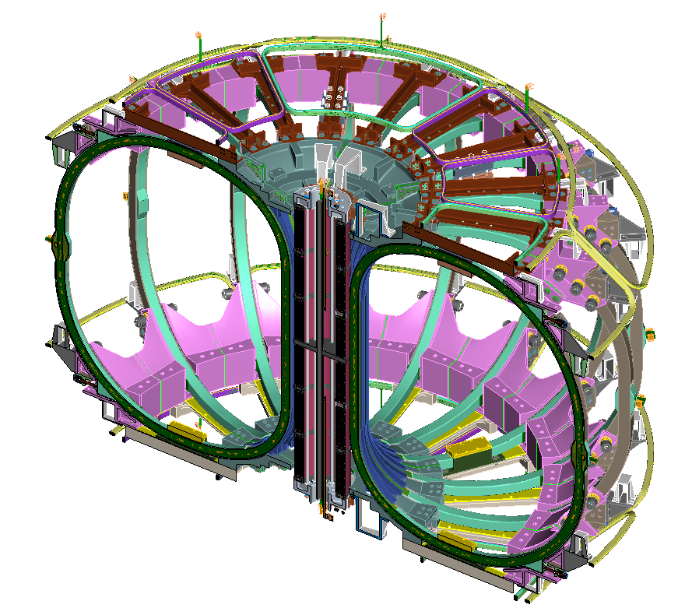
Figure 12 Coil support structure
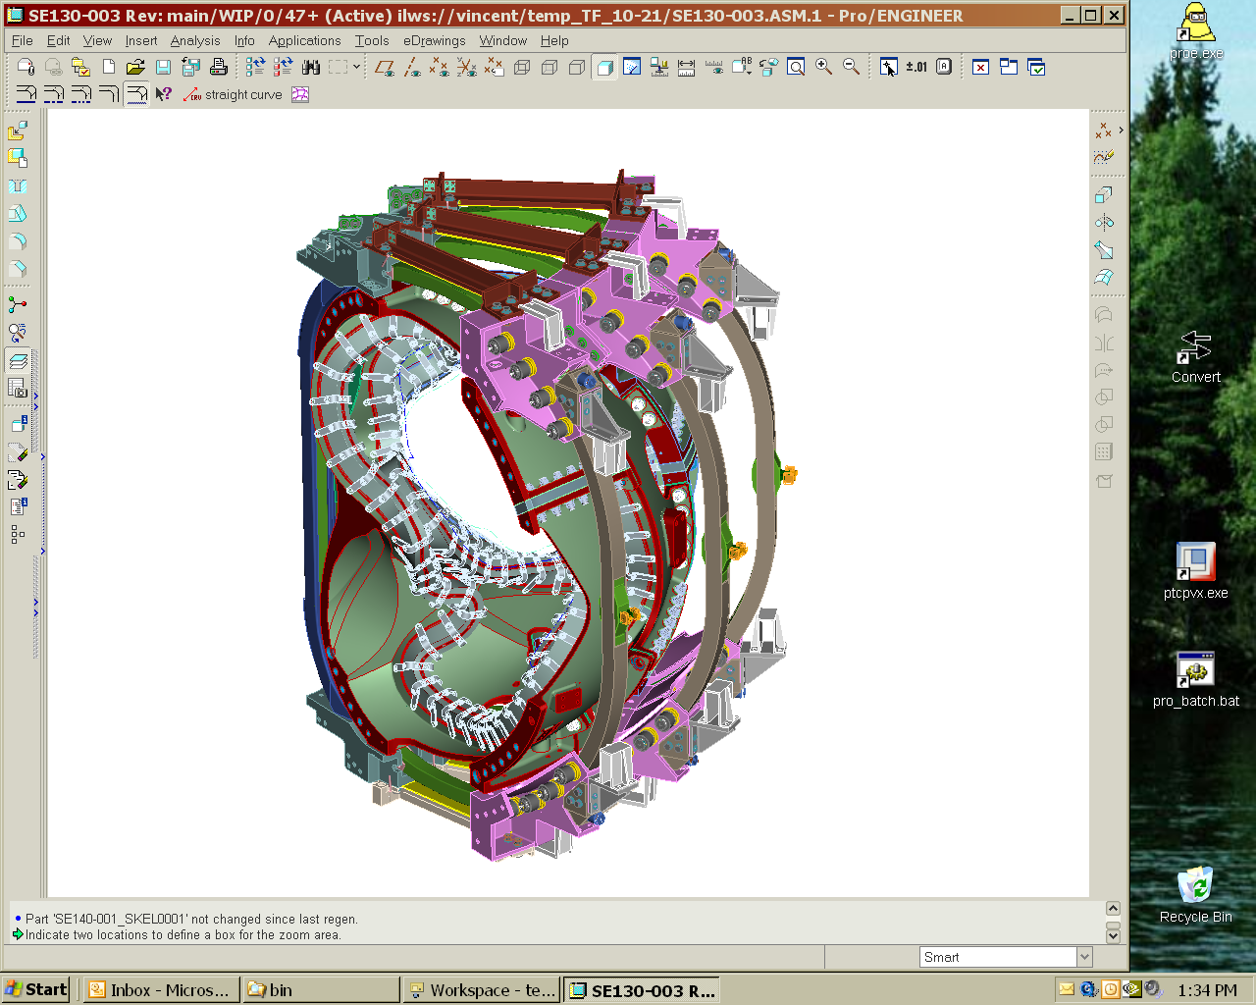
Pusher mechanisms provide inward radial load
Out of plane supports
Figure 13 Half-field period TF coil and support structure subassembly

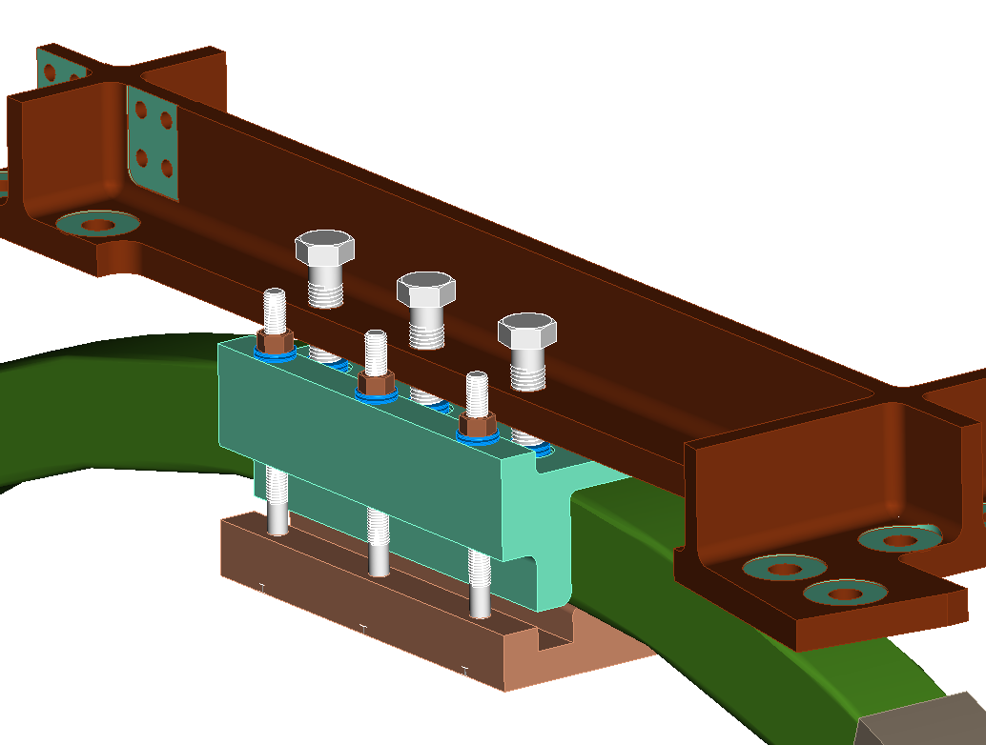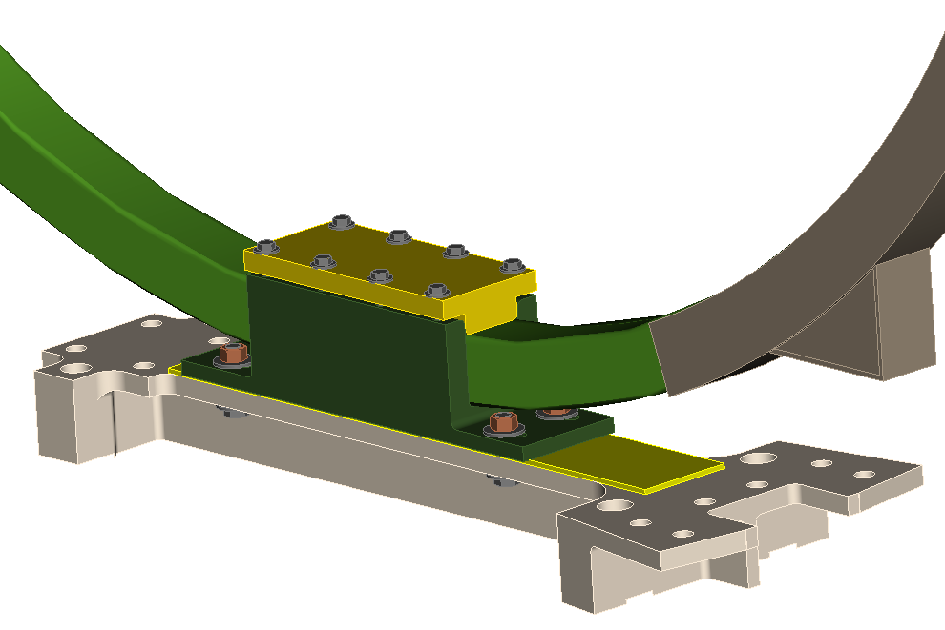

Figure 14 Upper and Lower TF Supports

The upper and lower crowns are connected to the upper and lower shelf assemblies respectively. The center solenoid assembly is attached (hung) to the upper crowns. A positioning ring is provided on the bottom to center the solenoid.
The center solenoid assembly consists of the PF1, PF2, and PF3 coils (upper and lower), spacer assemblies and tie rods. Spacers between each of the PF coils permits the return leg of each winding to transit across the top of each coil and join up to the start lead. The lead pairs are routed through the bore of the solenoid (upper coils to the top; lower coils to the bottom) where the bus connections are made.
The PF ring coils are attached to the shelf structures with brackets that can be adjusted to accurately align the coils. Since large ring coils are often out-of-round, these brackets will also serve to bring the coils into an acceptably round shape.

Design Basis
The conventional coil system design is based on design criteria and finite element analysis.

Design criteria
The conventional coils and support structure is designed according to the NCSX Structural Design Criteria, which is based on the ASME Code, Section VIII, Division 2. The code provides a conservative but prudent approach to design stresses, fatigue, buckling, welding, and inspection of components.

Analysis
The response of the coil systems to EM, thermal and mechanical (preload) design-basis loads are quantified by magnetic field and structural analyses. Results include field errors, EM force summaries and stresses.

Field errors
The first analysis concerns field errors. For design purposes, the center of the current within any coil winding is nominally specified to be within +/- 3mm of its theoretical position. For inplane radial motion of the outer TF coil that tolerance is relaxed to +/- 6mm. In regions around leads and crossovers the conductor steps from layer to layer or from pancake to pancake, introducing local field errors within the windings. These errors have been analyzed in detail . Three design rules are used to minimize these errors:
- Arrange the joggles from layer to layer within a winding pack such that the pattern of turn to turn joggles on one pie form an X shape with the pattern of joggles on the adjacent pie.
- Make sure the lateral cross over from pie to pie occurs in opposite directions on multiple winding packs within a coil. This reverses the field errors from the lateral current paths and cancels them to first order.
- Minimize the errors at the lead connection by immediately tying the leads together into a coaxial arrangement.

In addition to the errors from the coil geometry perturbations around leads and crossovers, the field errors associated with fabrication and assembly tolerances have also been studied in detail. Assessing the impact of coil fabrication and assembly errors a priori requires examining a large number of potential coil perturbations. A large number of possible perturbations to the coil geometries were chosen for detailed evaluation.
A perturbation field for each is calculated by subtracting the field from the unperturbed coils from the field from the perturbed coils. The reference plasma configuration was used to provide as the background field to show the effect of the coil perturbations using both analytic expressions for island size and field line tracing. The use of a perturbation field applied to a reference plasma configuration - as opposed to using the full field from the perturbed coil set by itself - was chosen to separate the influence of coil tolerances from islands inherent in the free boundary plasma configuration of the unperturbed coils. It also allowed for accurate benchmarking of analytic results with field line tracing for both symmetric and symmetry breaking field errors.
In general, most of the large islands induced were symmetry breaking m=2 islands. The worst case for TF coils showed a 1% island due to tolerance build up. The PF coils were all less than 4% for the cases considered.

EM Forces on Coils
The fields and forces on each coil are calculated for the most significant operating time points during the reference scenarios. Table 7 summarizes the load cases (LC) that are considered and the time snapshot for the currents where the currents are either at their maximum positive or negative values. The worst case for forces in the modular coils appears to be the 2T high beta at the zero beta point in the discharge.
The force density distributions in the PF and TF coils for a typical time point are illustrated in Figure 15 and Figure 16. As shown in these figures, the loading on the TF and PF coils is somewhat complicated due to the interaction with the modular coils. For example, the TF coils on one half of a field period experience a net vertical force upwards, and the corresponding TF coil on the other half of a field period experiences a net vertical force downward. The net forces on each coil are also calculated as shown in Table 8.

Table 7: Most Significant Load Cases Analyzed for Fields Forces on Coils
Load Case | 1 | 2 | 3 | 4 | 5
Scenario | 0.5 T TF | 1.7T Ohmic | 2T High Beta | 320kA Ohmic | 320kA Ohmic
Time, s | 0.0 | 0.0 | 0.0 | 0.206 | 0.506
M1 (A) | 0 | 38141 | 40908 | 34200 | 34200
M2 (A) | 0 | 35504 | 41561 | 32057 | 32057
M3 (A) | 0 | 35453 | 40598 | 32184 | 32184
PF1 (A) | 0 | -25123 | -15274 | 11354 | 21858
PF2 (A) | 0 | -25123 | -15274 | 11354 | 21858
PF3 (A) | 0 | -9698 | -5857 | -11802 | -5975
PF4 (A) | 0 | -7752 | -9362 | -13936 | -9441
PF5 (A) | 0 | 8284 | 1080 | 4563 | 4634
PF6 (A) | 0 | -8997 | -24 | 5068 | 5705
TF (A) | 16200 | -3548 | -1301 | 2191 | 2191
Plasma (A) | 0 | 0 | 0 | -320775 | -320775
Red and blue fields represent maximum and minimum coil currents

Table 8: Maximum Net Forces on PF Coils [kN]
Coil | LC2 | LC3 | LC4 | LC5
Central Solenoid | 468 Attract | 24 Attract | 67 Attract | 778 Attract
PF4 | 182 Attract | 117 Attract | 142 Attract | 39 Repel
PF5 | 215 Repel | 19 Repel | 52 Repel | 43 Repel
PF6 | 149 Attract | 0 | 58 Repel | 62 Repel
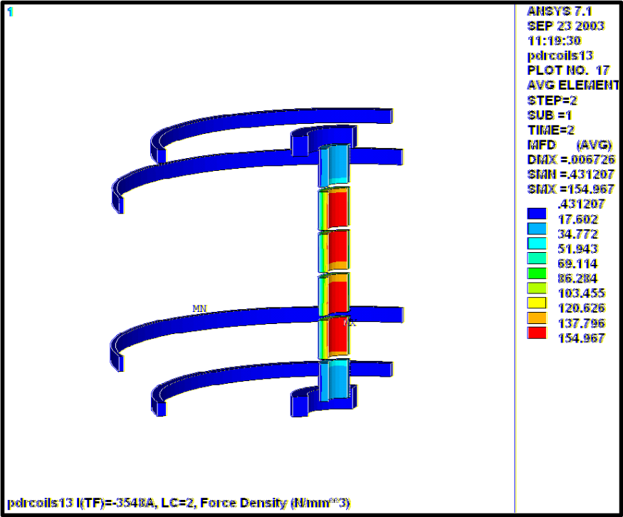
Figure 15 Typical Force Distribution (Force density, N/mm3) for PF Coils, 1.7T ohmic (LC2)
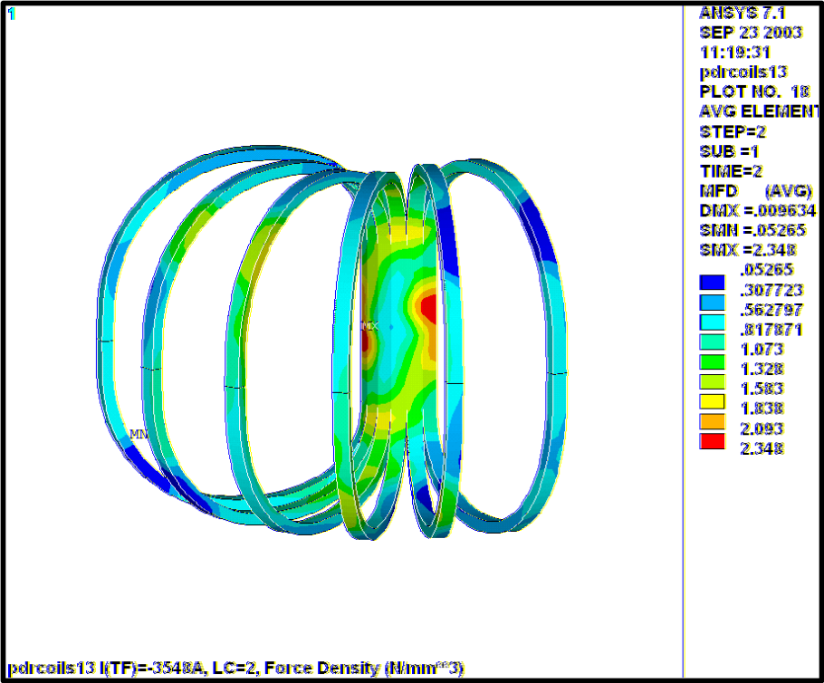
Figure 16 Typical Force Distribution (Force density, N/mm³) for TF Coils, 1.7T ohmic (LC2)

Stress Analysis
A global structural analysis of the TF and PF coils is performed using the 3D coupled-field ANSYS model shown in Figure 17. The 120-degree (one field period) model includes all of the major field sources (TF, PF and Modular coils and the plasma) and the external support structure (shown in red). Material properties used in the model are listed in Table 9. Although this model is quite complete, the smeared winding pack representation does not include the level of detail necessary to qualify the coil constituents (i.e., Cu conductor and insulation). Figure 18: Hybrid FEA Model of TF Coil shows a close-up of the so-called hybrid model which is used to determine the stress in a single TF coil from the limiting 0.5T operating condition. A subset of the model is plotted to expose the explicit coil pack elements and support wedges.
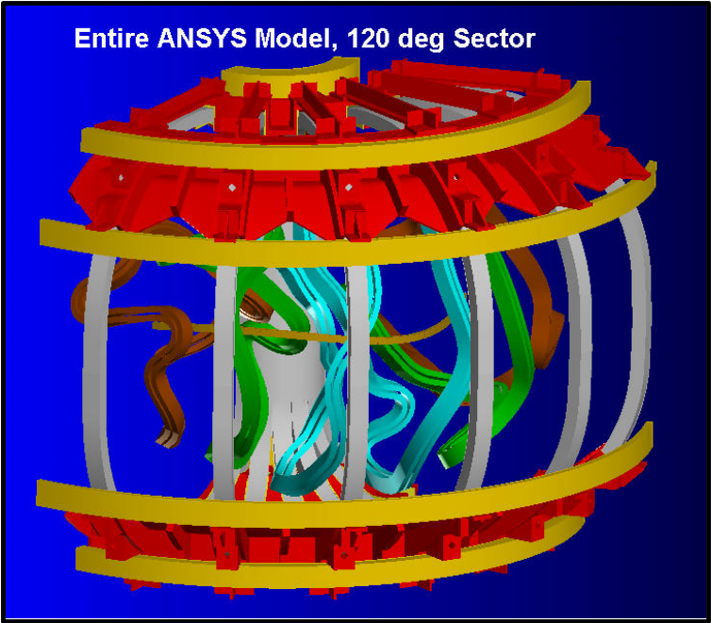
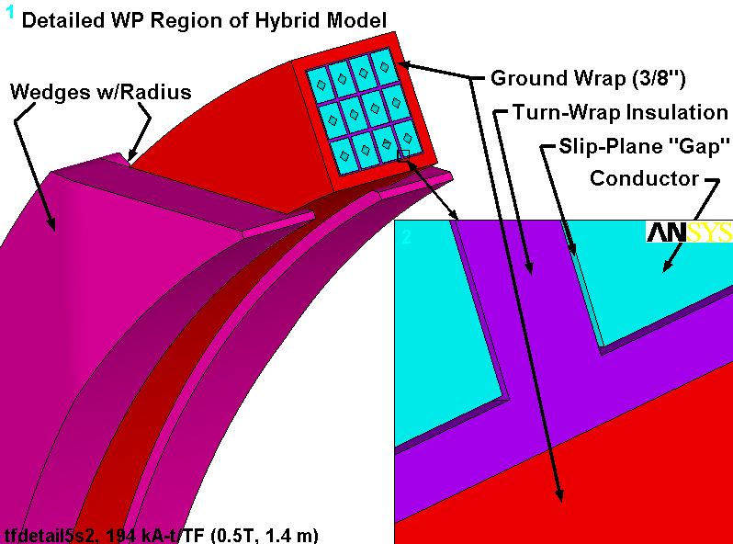
Figure 17: Global FEA Model of Conventional Coils and Structure
Figure 18: Hybrid FEA Model of TF Coil
Table 9: Material Properties, Conventional Coils and Structure
Material | Ex  [GPa] | Ey  [GPa] | Ez  [GPa] | αx  [μ/K] | αy  [μ/K] | αz  [μ/K] | Gxy  [GPa] | Gxz  [GPa] | Gyz  [GPa] | υ_{xy}  [-] | υ_{yz}  [-] | υ_{xz}  [-]
Stainless Steel | 209 |  |  | 13 |  |  | 81 |  |  | 0.283
Cu Conductor | 136 |  |  | 14 |  |  | 51 |  |  | 0.34
VPI S-Glass | 21 | 28 |  | 22 | 7.9 |  | 6.9 |  | 9.6 | 0.2
VPI S-Glass + Kapton | 19 | 26 |  | 21 | 7.9 |  | 4.2 |  | 6.0 | 0.2
Smeared TF Coil with:  3/8” GW, Slip-Plane + S-Glass | 42.3 | 76.6 | 41.2 | 9.5 | 13 | 9.6 | 2.1 |  |  | 0.28 | 0.28 | 0.32
Note:
1. Orthotropic Insulation coordinate system:
- x is the through-thickness direction
- y is in the direction of the wrap (i.e., around the conductor perimeter)
- z is parallel to the conductor axis
2. Orthotropic Smeared WP coordinate system:
- x is the (minor) radial direction in a toroidal system
- y is in the poloidal direction in a toroidal system (i.e., parallel to current flow )
- z is in the toroidal direction in a toroidal system
Stresses and deflections in the coil and support structure are quantified by a series of analyses using these global and hybrid models. This involves applying the structural design criteria to the metallic and insulation materials. Table 10 and Table 11 list the design values for metallic and epoxy-filled glass-insulation. Stresses are categorized and compared to various allowable stress requirements, such as monotonic and fatigue in metals, and tensile, compression and shear in the insulation. Deflections are included in field error analyses as described in section 4.2.1.
Global model results are obtained for load cases 1-5. Typical results are illustrated in Figure 19, which plots the stresses and deformations in the TF coil from this worst-case loading (LC1). The plot shows that a maximum smeared stress of 57 MPa occurs where the inboard legs transition between wedged and free-standing. Analysis of the same load case using the hybrid (smeared/detailed) model produces the stress plot of Figure 20. The reported 196 MPa is more than three times the smeared stress value, but is still below the allowable limit of 270 MPa defined by 1.5S_{m}.
The hybrid and global models also produce stresses in the TF wedges and TF/PF coil support structures as shown in Figure 21. The stress plots show high stresses in the lip of the TF wedge, which must carry the large EM loads over a relatively small section. Conversely, the TF/PF support structure which carries out of plane TF loads and vertical ring coil loads has a relatively low stress. Both are well below the membrane plus bending stress limit for SS (~400 MPa).
Table 12 lists the stresses in the smeared TF and PF coils from the global model. Although these smeared stresses are less than the Cu conductor values, it is useful to note that the 0.5T TF (LC1) is the limiting case. And since these load case is qualified by the hybrid model, the stresses produced by other load cases are satisfied implicitly.

Table 10 Design Stress Values at 80K, Metallic
Material | Yield, σ_{y}  [MPa] | Ultimate, σ_{u}  [MPa] | Design Stress, S_{m}  (2/3σ_{y} or ½σ_{u}) [MPa] | Fatigue Stress
Stainless Steel | 410 | 1300 | 270 | Design-Basis Curve
Cu (1/4-Hard) | 290 | 360 | 180 | Design-Basis Curve

Table 11 Design Stress Values at 80K, Epoxy-Glass Insulation
Material | Flat-Wise Compression  [Mpa] | Normal Tension  [MPa] | In-Plane Tension/Compression  [MPa] | Shear/Compression  τ_{o} and c₂
VPI’d S-2 Glass + Kapton | 2/3(600)=400 | 0.02% Strain  0.0002 x 19 GPa = 3.8 MPa | 0.5% Strain  0.005 x 26 GPa = 130 MPa | 40 MPa and 0.32
VPI’d S-2 | Better Than VPI’d S-2 Glass + Kapton
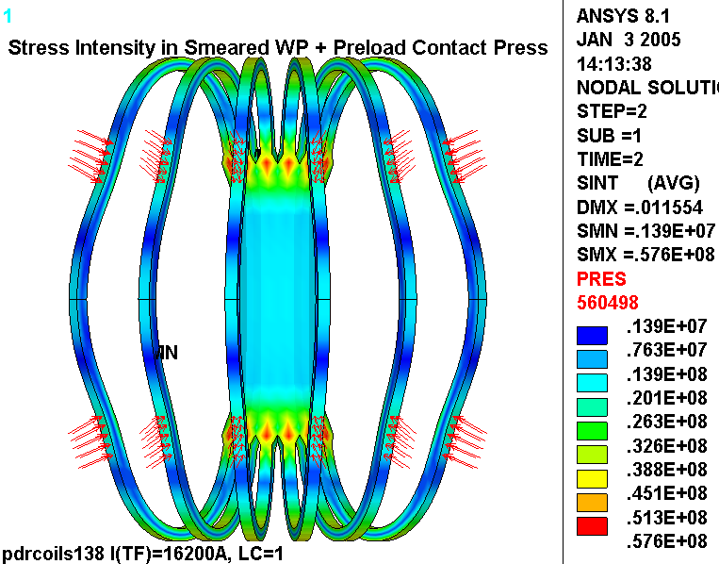
Figure 19 Global Model Stress (top) and Deflection (bottom) in the TF coil from 0.5 T Load Case
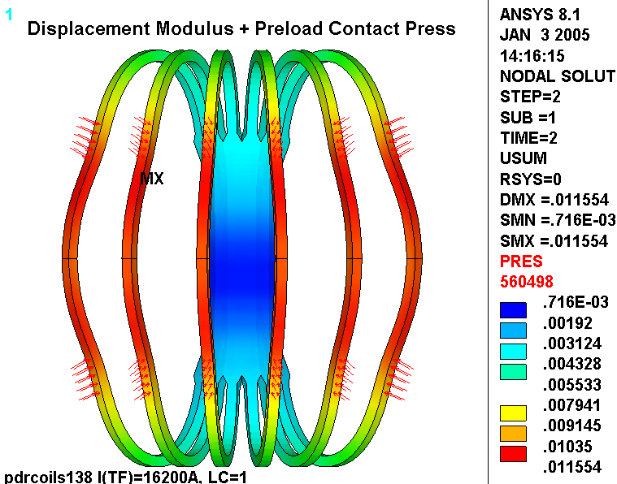
Figure 20: Hybrid Model TF Conductor Stresses from 0.5 T Load Case
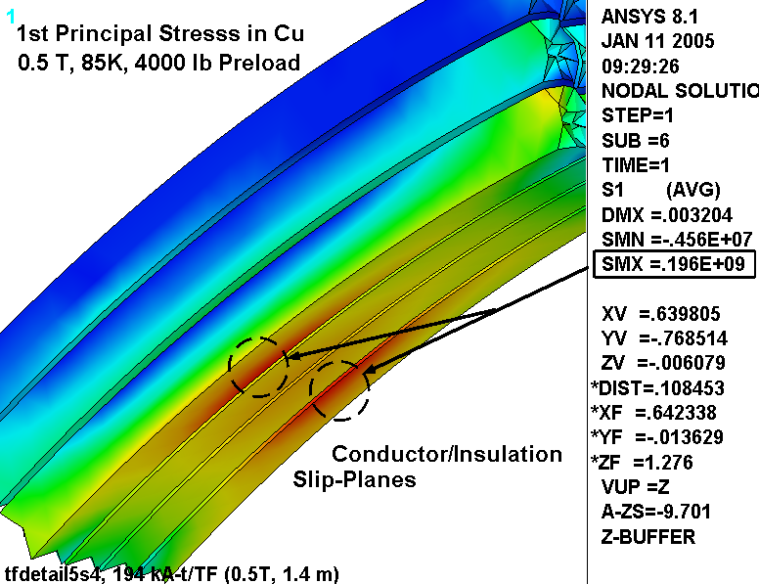
Figure 21 Support Structure stresses, LC1Hybrid (top) and LC2 Global (bottom)
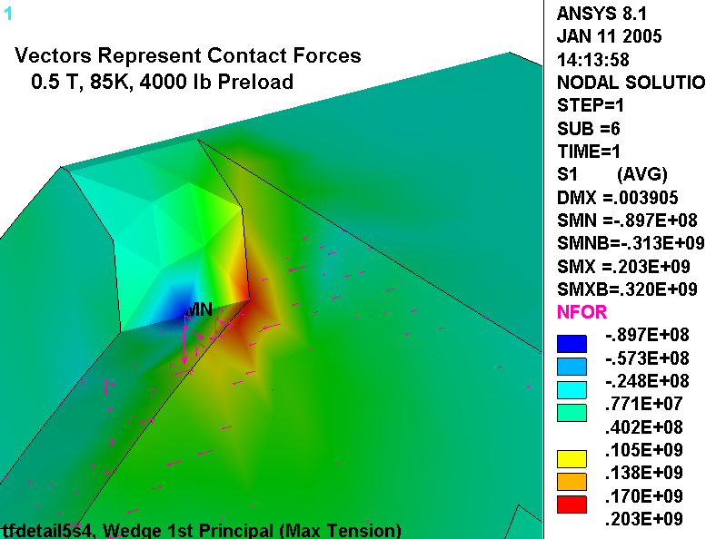
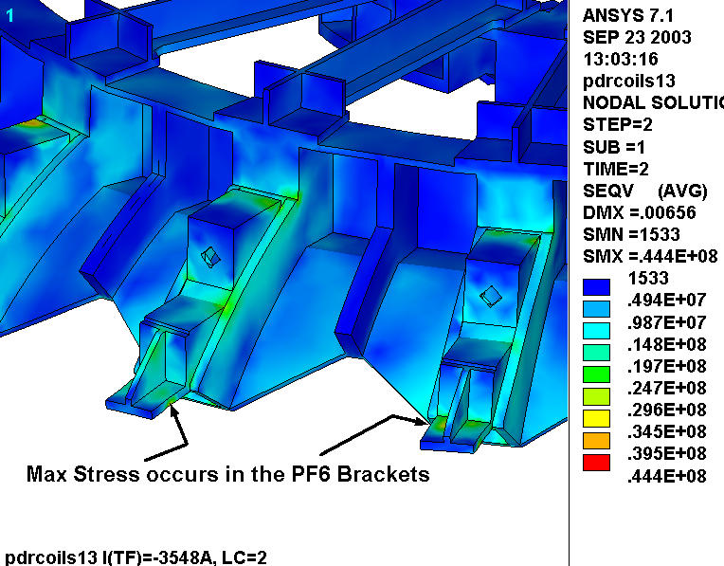

Table 12 Global Model Stress Summary
Coil | Stress Parameter | LC1 | LC 2 | LC 3 | LC 4 | LC 5
TF | σ_{vM}, MPa | 58 | 30 | 22 | 25 | 25
Central Solenoid | σ_{vM}, MPa | 0 | 31.5 | 12.1 | 9.6 | 25.9
Central Solenoid | σ_{Z+}, MPa | 0 | 1.4 | 0.9 | 4.0 | 3.7
PF4 | σ_{vM}, MPa | 0 | 5.4 | 6.7 | 11.8 | 4.7
PF5 | σ_{vM}, MPa | 0 | 9.3 | 1.6 | 7.0 | 7.2
PF6 | σ_{vM}, MPa | 0 | 11.9 | 0.4 | 6.1 | 6.9
Support Structure | σ_{vM}, MPa | 0 | 44.4 | 9.4 | 24.2 | 26.6

Coil thermo-hydraulic analysis
The present design calls for forced flow LN2 cooling of all coil systems with a prescribed inlet temperature of 80 K. A transient analysis was performed to determine the thermal response of the NCSX TF Coils to a maximum required pulse (0.5 Tesla TF field). The peak conductor temperature rise was 8.5 ºK for a 16.2 kA peak current with a 1.64 second equivalent square wave (ESW). The thermal recovery time was roughly 720 seconds providing a margin of 180 seconds for the stipulated duty cycle of 900 seconds (15 minute rep. rate). This performance was obtained with a 60psi pressure drop across the coil resulting in a flow of 1.6 GPM per TF coil (Figure 22).
A preliminary analysis was performed for the PF Coils for prescribed equivalent square waves of between 1.1 and 2.5 sec. at the maximum rated current for each coil system. Maximum temperature rise in the PF Coils does not exceed 12.4 K. The maximum flow requirement for any one of the PF coils does not exceed 1.2 GPM
To prevent flashing or cavitation of the single phase LN2 at the pump supply the return pressure of the liquid nitrogen system will have to be maintained above approximately 100 psi. This return pressure requirement may be higher when the modular coil peak temperatures are considered.

Figure 22 Thermo-Hydraulic Analysis of TF Coil
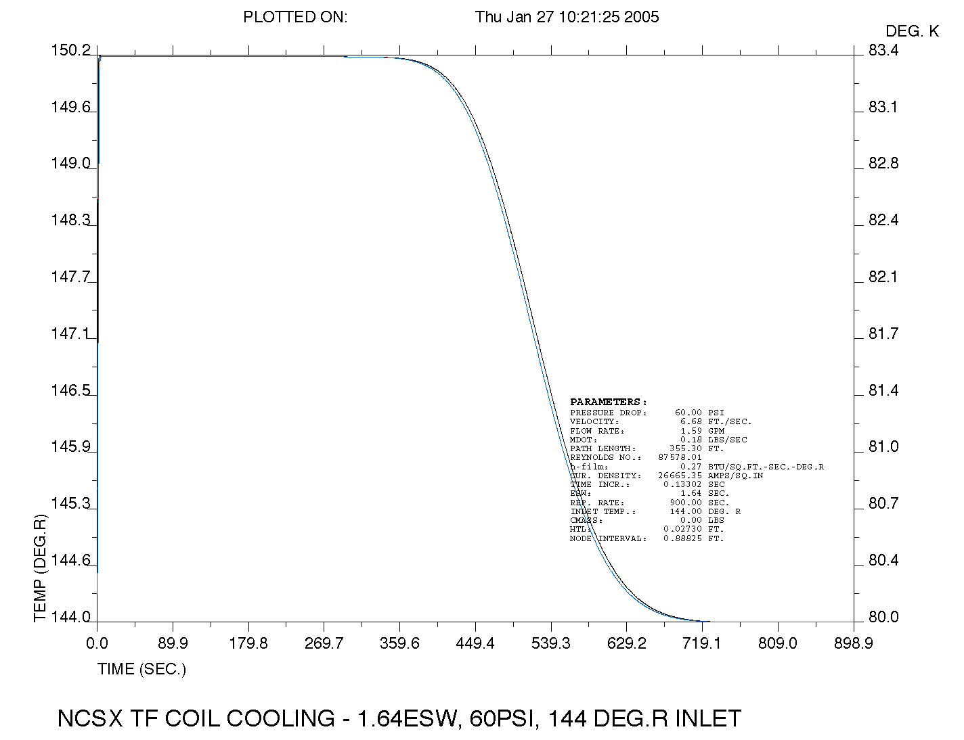

Vendor input
In order to obtain feedback from potential fabricators concerning the feasibility, methods, and cost for fabricating the conventional coils and structure, several vendors were contacted. The conventional coils do not represent any technical issues beyond what is normally encountered in conventional, hollow copper conductor coils. The structure is assumed to be made from castings, finished machined, pre-assembled and fit-checked. The casting vendors suggested a concept with less machining, which has been adopted. The studies were based on a set of CAD models and a draft procurement specification.

Design Implementation

Component Procurement and Fabrication
TF and PF coils The TF and PF coils are relatively simple, conventional, wound coils using hollow copper conductor and vacuum pressure impregnated with epoxy. One or more fixed price contracts will be awarded based on a best value analysis of the submitted bids. The TF Coils will be procured in parallel with the TF Coil Wedge Castings. The contract(s) will be structured similar to that successfully used by the NSTX project. The vendors will be given a specification and a basic set of drawings that specify important features such as tolerances, transitions, crossovers, and lead details.
The vendor will be responsible for developing the manufacturing detail drawings and a Manufacturing/Inspection Test Plan. These documents are subject to review and approval by the NCSX prior to release for fabrication.
Coil support structure The coil support structure consists of three types of components. The first type includes the shelf segments, center solenoid hub segments and outboard TF coil supports, which are all cast and machined elements that must be bolted together into a precision assembly. This assembly could be split among several vendors, for example casting and machining vendors. However, a better choice may be to award a contract to a single vendor who would supply a pre-assembled and fit-checked unit that included all the components, insulation, shims, bolts, etc. The contract would be awarded on an evaluated fixed price basis and would be build-to-print.
The second set of components in the coil support structure consist of the spacers, clamps, bucking plate assembly, etc. that are smaller and ideally integrated with the PF1/PF2 centerstack assembly. The intent here would be to include these components as part of the centerstack assembly procurement, which would be on an evaluated fixed price basis and build-to-print.
The third set of components concerns the wedge castings. The contract for these casting must be placed in parallel with the procurement of the TF Coils so that they are available to be assembled to the TF Coils when the coils arrive at PPPL. It is possible that we would allow the TF Coil vendor to include the castings within the scope of the TF Coil Procurement.
Local I&C The local I&C consists only of temperature and strain sensors, which will be procured via a fixed price subcontract.

Subsystem Assembly, Installation, and Testing
PF and TF coils The TF coils with the wedge castings attached will be assembled in the same sequence as the modular coils, first as part of the field period subassembly in the D-site pre-assembly area, then the field periods will be installed in the NCSX test cell at C-site. The lower PF coils will be pre-positioned below the field period assemblies and raised into position, while the upper PF coil assemblies will be lowered into position, after the three field period subassemblies are brought together.
Coil support structure The coil support structure will be assembled as part of the field period subassembly operations in the D-site pre-assembly area. Two sub-assemblies, each with one sixth of the TF coils, shelf segments, and crown structures will be pre-assembled. Pillow shims will be provided between the TF coils and the crown structure to insure good fit for centering loads. The two subassemblies will then be rotated over the completed modular coil/vessel field period subassembly, one from each end. The connection is then made between the external coil structure and the modular coil shell, using the toroidal stiffener spacers. Since these spacers lie between flat, parallel, and horizontal planes, they can be shimmed to mitigate tolerance buildup and provide the exact relative position of the TF coils and modular coils.
Once the field period subassemblies have been completed, they are placed on the machine base structure. The carriages in the base structure are simultaneously moved inward to avoid interference between the interlocking modular coils, and the field period connections are made. After the field periods are joined, the centerstack assembly, the PF3 coils, and crown structures are installed and secured with the tie rods.
Local I&C The strain and temperature sensors will be installed on the modular and TF coil windings just prior to or during the field period subassembly operation. The PF coils sensors can be installed at any time after receipt of the PF coils but prior to the cryostat installation. PPPL technicians will install these sensors.

Reliability, Maintainability, and Safety
A formal Failure Mode, Effects, and Criticality Analysis will be completed for the magnet systems prior to closeout of the preliminary design phase. Nevertheless, several design features have been included to enhance the reliability of the coil systems or to simplify inspection and repair of obvious trouble spots.
Conventional Coils A coil fault detection system will be provided to prevent operation of the coils outside their design envelope. The system would guard against control errors, shorted buswork, etc. All the coil connections are intended to be accessible with only minor disassembly of external components. This also allows each circuit to be individually tested in the event of a leak.
The PF and TF coils are of conventional construction and operate at relatively low current density. This results in benign thermal cycles and stress levels. The coil structure provides almost continuous support for these windings as well to further reduce cyclic deflections.
Coil support structure The coil support structure must stay in alignment with the modular coils, which is accomplished by tying the two structures together at robust interfaces. The coil support structure can also be re-aligned by removing the interface spacers and shimming.

Cost and Schedule

Conventional Coils (WBS 13)
The costs for the TF and PF coils were developed as a bottoms up estimate using recent experience on the NSTX coil sets. Cost savings have been realized by using the same, standard, conductor in all the PF coils. This allows the same forming tooling to be used for virtually all the coils. Procurement cost for the TF Coils excluding contingency is estimated to be $1,166K. The additional cost of adding the TF Wedge Castings is $381K for a total cost of $1,547K for the Procurement of the 18 TF Coils. The PF Coils cost slightly less, $1437K .
Trim coil costs were estimated assuming small conductor and simple winding forms. There are only two shapes for these coils, one shape for the top and bottom coils and the other for the outer perimeter coils. The costs are based on engineering judgment and recent experience with the NSTX coil windings. Standard sized conductor is used to help keep the cost down. The cost estimate for the Trim Coils is $278K. The recommended contingency is 40%, due primarily to uncertainties in performance requirements at this early stage of design. There may still be major design modifications to the Trim Coil concept.

Table 13 SummaryTF Coil Cost Estimate
Engineering & Oversight |  |  | $133,200.00 | 15.73% | 18.44%
Brazing qualification |  |  | $22,900.00 | 2.70%
Equip. & Tooling |  |  | $53,930.00 | 6.37% | 9.53%
Area Preparation |  |  | $26,764.10 | 3.16%
Materials & supplies |  |  | $370,612.80 | 43.77% | 43.77%
Conductor prep |  |  | $17,160.00 | 2.03%
Coil winding |  |  | $63,470.00 | 7.50% | 28.26%
Ground wrap/mold |  |  | $22,000.00 | 2.60%
VPI |  |  | $120,780.00 | 14.27%
Testing |  |  | $15,840.00 | 1.87%
TF Fabrication |  |  | $846,656.90 | 100.00%
Total Billed by Vendor |  |  | $1,015,988
Includes Vendor 10% Contingency+10% Profit *
Total With PPPL G&A |  |  | $1,165,988
Additon of Castings |  |  | $381,000
TF Coils With Castings |  |  | $1,546,988

The schedule for implementing the Conventional Coils may be seen in the project Master Schedule. Title I design began in mid FY03. Title II design for the TF Coils is scheduled to be finished by early FY05. Production contracts will be awarded shortly thereafter. TF production will be complete by Dec. 06. TF coils are needed in time to be assembled with the first field period. Titel II design for the PF Coils follows the TF design. Contracts are scheduled to be awarded in Sept. 06 with a staggered delivery ending in Aug. 07. The lower PF coils need to be placed on the floor of the Test Cell prior to installation of the first field period in the Test Cell.

Support Structure (WBS 15)
The WBS structure and cost estimate for the machine structure is summarized below. This estimate was developed as a bottoms-up estimate, and includes input from potential vendors. Most of the cost is in the conventional coil support system, and these estimates were consistent with vendor input. The Support Structure (WBS 15) costs $1165K. The recommended contingency is 32%.

Table 14 WBS listing for Support Structure
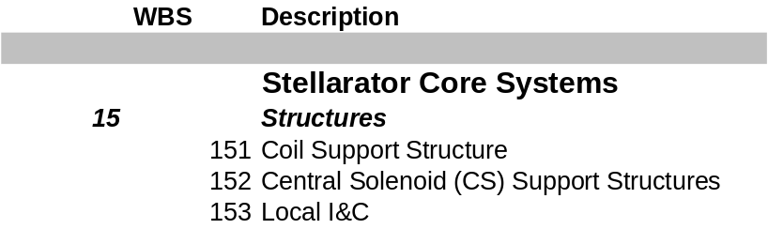

Table 15 Support Structure (WBS 15) Costs
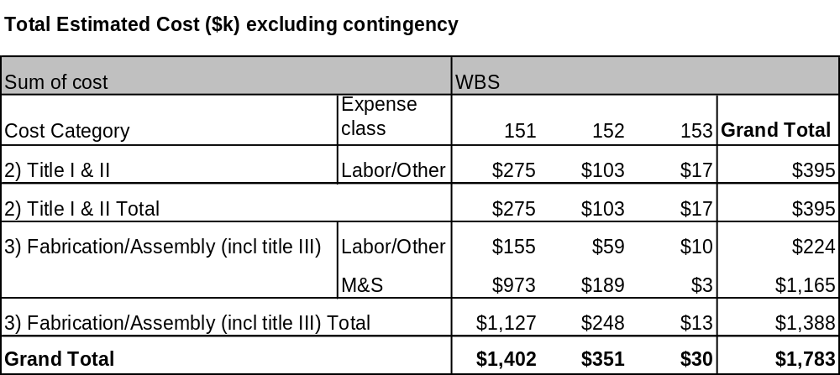

The schedule for implementing the Support Structure (WBS 15) may be seen in the project Master Schedule, provided as part of the Preliminary Design Report. The coil support structure is assembled as part of the field period assembly in the TFTR test cell. Title I design will begin at the start of FY04. Title II design will be completed late in FY04. Procured components should all be delivered in July 07.

Risk Management

PF, TF, Trim coils
These coil sets do not have any specific technical, schedule, or cost risks that have been identified, other than the general concern about relatively few known, qualified domestic coil fabricators. The coils are all of conventional design and fabrication processes are well known and established. The operating current densities, temperature rise, forces, etc. are conservative. They are well supported and with features for adjusting alignment individually. None of these coil sets is on the critical path. Due to the fact the TF coil is trapped and repair after project completion is difficult to impossible extra effort will be applied to ensuring high quality and reliability from these coils. Attention to QC issues, PPPL oversight, and large design margins are applied to mitigate this risk.

Support Structure
The primary element of risk for the support structure is cost growth. The main drivers for cost growth are changes to the design concept during preliminary design as a result of changes to the requirements, unfeasible fabrication, or lack of functional performance.
These have been addressed for the machine structure by adopting a simple concept that is very robust to changes in coil loads because it is based on a “cast-and-machined” fabrication whose cost is relatively insensitive to section depth. Tolerances and accuracy for this type of structure have been demonstrated for other devices, so there should be no fundamental problem with alignment or other functions. Finally, there is no new technology to develop for this concept, so no R&D should be required.

A. Brooks, A. V. Georgiyevskiy, W.U.Reiersen, V.A.Rudakov, “Current Feeds And Connection Part Perturbation Study On Magnetic Configuration Of NCSX Stellarator, (M45 coils c01r00), April 2002
A. Brooks, “NCSX Coil Tolerance Study, Impact on Plasma Surface Quality”, April 2002, PPPL
ANSYS Release 8.1, UP20040329, INTEL NT, ANSYS, Inc., Canonsburg, PA.

