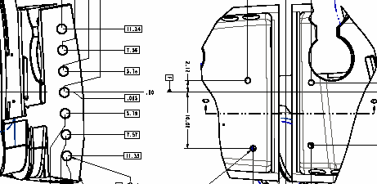
Flange area of poloidal break finished machined .100” off location to this side.
The area of the T section inward including the area highlight in red has been undercut into this surface approximately .08”. This area has been cut on location.
PROPOSED REPAIR
Machine the left side of the break above to the correct location per the drawing. This will blend into the area of the T that is currently undercut. Machine the T section on the right side of the break to match the flange surface that was cut off of location (approximately .100”). The slot width will finish at 2.350” rather than 2.250”. In order to accommodate the oversized slot, the shim thickness will need to be machined to 2.225 rather than 2.125”. The additional .100” of stock will be added to only one surface on the shim and profile machined accordingly (see picture on next page).

