

Verisurf Access Code

Customer: Princeton Plasma Physics Laboratory

(exp. 9/30/07)

SIM# 103661 VERISURF Access Code: 2FBD8D4-ACDBD5-2ED4BF6

Updating Verisurf Code:
To manually update type in the code start Verisurf/File/Edit/ACC/Chooks/verisurf.acc open the verisurf.acc file with Notepad and delete all the contents and then type in the code (case sensitive).

UPDATING SIM: To update the USB/Parallel Sim use the code below. Use HASPX.exe (HASPX application to update. You only need to update the Sim one time) First you will need to follow this link and download the drivers. Make sure your SIM/Dongle is NOT attached when you download and run. Read the read.txt first. http://www.verisurf.com/drivers.zip

To update your SIM/HASP you will need to run the attached HASPX program. Most email filters will not accept an executable file so it has been named HASPX.doc. You will need to rename with .exe prior to running.

SIM UPDATE CODE (MC): 190237213524139 144087569924283+144087577305258

Troubleshooting:
If you receive a message upon starting Verisurf: HASP not found - Use the Windows Start/Run, browse and locate the Verisurf or MCAM9 folder/Common/hinstall. Once you have selected the hinstall you will need to type (space) -i

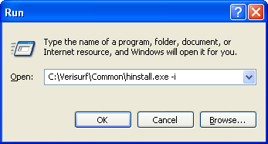
If you have any problems installing software please call: Verisurf Software (714) 970-1683 ext. 28, 24, 25, 37 or email: support@verisurf.com

