

To Update Verisurf Sim/HASP/Dongle

To update your SIM/HASP you will need to run the HASPX.exe program. Sim must connected before beginning update. Go to the Windows Start menu/Verisurf/HASPX application. Click on Run.

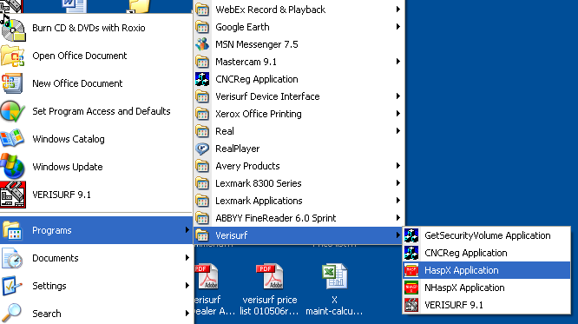

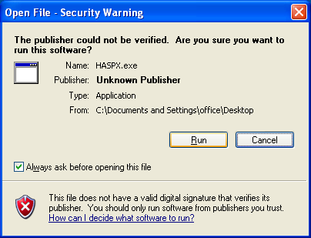

In the blank white update box paste or enter your Mastercam X code (including spaces and + sign. Once you have entered the code Click on Update (NOT UPDATE CODE). You will then see your Products listed in the box and at the bottom of box you will see the message HASP Updated successfully. The Maintenance Expiration date will also be listed.
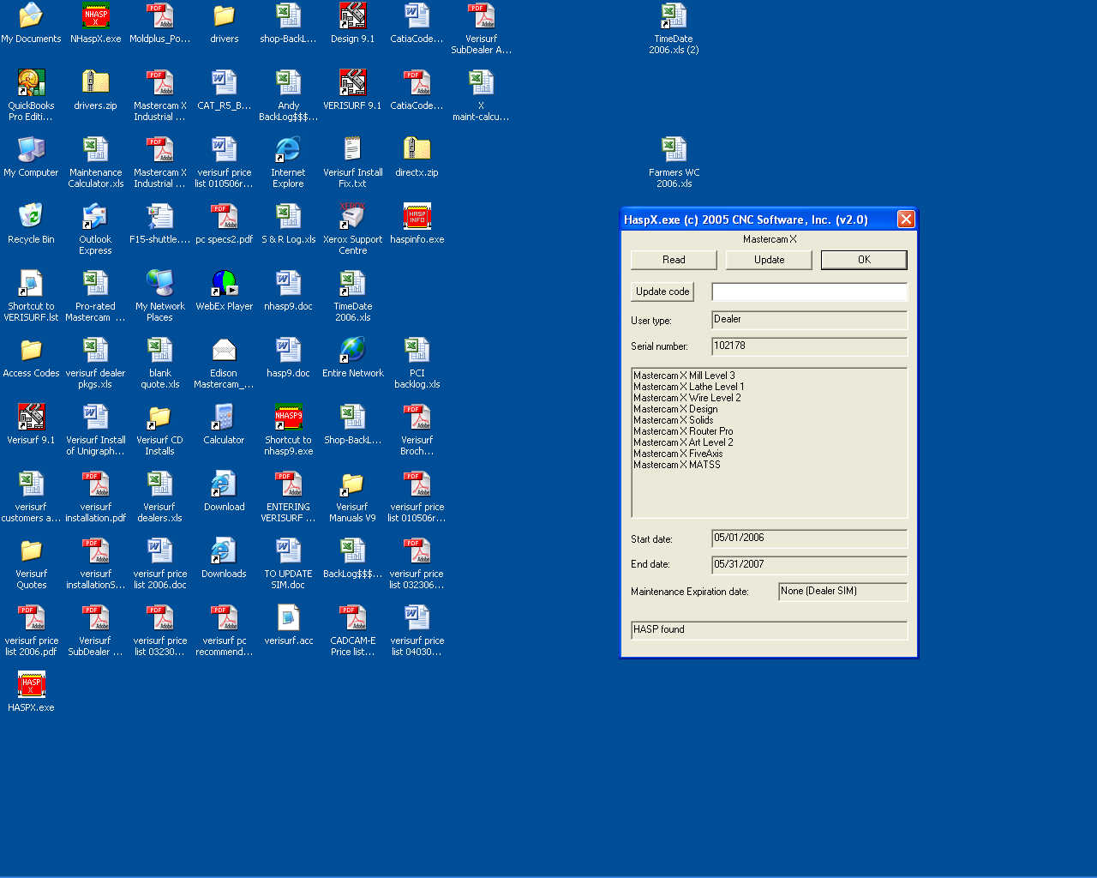

Troubleshooting:

If you receive a message upon starting Verisurf: HASP not found
Use the Windows Start/Run, browse and locate the Verisurf or MCAM9 folder/Common/hinstall. Once you have selected the hinstall you will need to type (space) -i

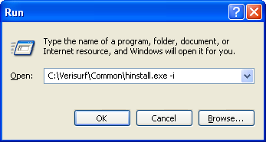

If you need the driver: You will need to follow this link and download the drivers. Make sure your SIM/Dongle is NOT attached when you download and run. Read the read.txt first.
http://www.verisurf.com/drivers.zip

