Trip Report Part 1-
Travel To:Geneva, Switzerland CERN and Griefswald, Germany IPP W7-X
Report Date: 11/2/2007
Dates of Travel: 10/6-13, 2007 06,00,13-06,00,13
Traveler Information (All travelers on this trip)
Last Name | First Name | Middle Name | Position/Title of Traveler
Viola | Michael | Edward | Mechanical Engineer
Raftopoulos | Steve |  | Mechanical Engineer
Sands | William | Raymond | Mechanical Engineer

Employing Organization: Princeton Plasma Physics Laboratory

Employment Address: Post Office Box 451

Princeton, NJ 08543

Trip Itinerary
FTMS Trip Number 200717788 (Viola); 200718380 (Raftopoulos); 200718597 (Sands)
Destination/Organization | Facility | Facility Address
Geneva | CERN | Geveva Switzerland
Wedelstein Germany | W7-X | Greifswald Germany

Primary Topic (include justification from Foreign Travel Request)
Will share requirements of the National Compact Stellarator Experiment (NCSX) and will discuss metrology capability of photogrammetry and laser trackers, welding techniques and also methods of distortion control.

Highlights/Benefits of Trip, People Contacted, Results of meetings or discussions, facilities visited and their locations

ABSTRACT

Three Engineers from Princeton University working on the Princeton Plasma Physics Laboratory National Compact Stellarator Experiment visited CERN and Wendelstein W7-X Experiment from October 6, 2007 until October 13, 2007 to discuss state of the art equipment for accurately measuring components including laser trackers and Photogrammetry. Also new welding techniques which minimized weld distortion (shrinkage) were discussed including new advances in Metal Inert Gas (MIG) equipment and narrow gap techniques including the newly patented “ENGUS” weld head.

October 6, 2007: PPPL group flew to Geneva arrive 10-7-2007 and visited CERN until October 10. From Geneva, the group flew to Hamburg on October 10 and drove to Greifswald to visit the Max Plank Institute for Plasma Physics. The group returned to Hamburg on October 12 and flew back to the United States on October 13, 2007.

Trip Report Part 2

Travel to: Wendelstein W7-X
Report Date: 11/2/2007 Dates of Travel 13,10,07-13,10,07

Result of meeting or discussions with representatives of Foreign Government(s) and/or company(ies)

October 6, 2007: PPPL group fly to Geneva arrive 10-7-2007

October 8, 2007: At CERN the PPPL group met with Christian Lasseur and Raphael Goudard and was given a presentation on photogrammetric equipment and software, talks include aspects of calibration and camera use demonstrations pursue on a calibration bench made at CERN. Demonstrations are cared out showing repeatability, use of equipment and software. PPPL group participates in doing actual photogrammetric measurements learning elementary techniques and practical application.

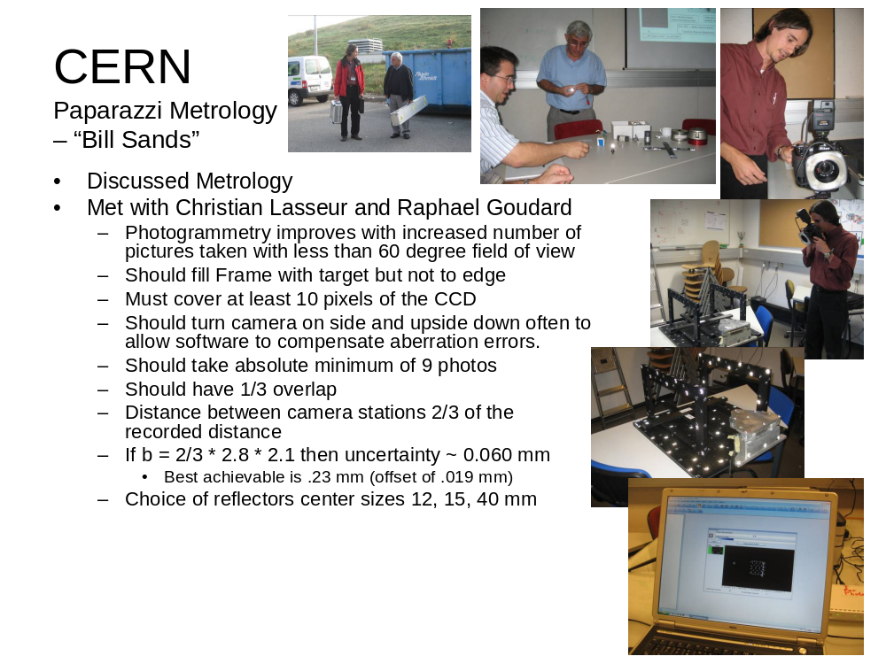

The photogrammetric system uses reflective targets, adhered to the component being measured. Targets, both simple and coded are adhered onto the component prior to the measurement processes. The targets establish a unique pattern that the software will recognize in multiple images. The coded targets have a unique identifying ring and are used by software to greatly speed up the bundle calculation. A calibrated length bar is placed onto the part and is used by the software to establish true scale. Of course, there are specific techniques that the operator must employ to ensure optimal results; however these techniques are relatively few and are simple in concept, so that they can be readily understood in a short amount of time. At the conclusion of the calculation, the tabularized coordinate data is presented so that the operator can review the results and make corrections as necessary. Additionally, the software provides feedback on the quality of the determination of the target locations, giving the operator the opportunity to either take additional photographs or remove “weak” points.

The “photogrammetric hardware” consists of a Nikon D2X, a 12 megapixel DSLR with a 20mm manual focus lens (manual focus lens is preferred due to its more robust construction), a Sunpak DX-12R Macro ring flash and other standard photographic accessories. In order to provide the software a base coordinate system and scale, several calibrated length bars, and an “X”-shaped graphite cross (approximately one-foot square) are used. The length bars and cross have coded targets that are automatically recognized by the software (after the operator identifies the specific cross and bars that are being used).

The AICON system is impressive in its ease of use and processing speed. The wireless feature of the Nikon camera is advantageously utilized by the software to begin processing the data while the test object is still being photographed. The base coordinate system established buy the cross can be transformed into a desired coordinate system by the operator.

October 9, 2007: PPPL group again meets with photogrammetry experts and are shown practical applications on a medium scale, an approximately 8’ x 18’ wall was targeted and measured using photogrammetry at this point single camera shoots could not encompass the entire field and overlapping was stressed for the accuracy of the shots and discussion on how it was handled by the software was ensued. Once again the PPPL group was invited to do the photogrammetry and use the learned techniques.

The PPPL group used the AICON system to determine the position of several detectors that were installed on the wall. Regardless of inexperience of the PPPL users, the AICON software was able to locate the detector targets with a high level of precision ~RMS value of 0.0023 meters.

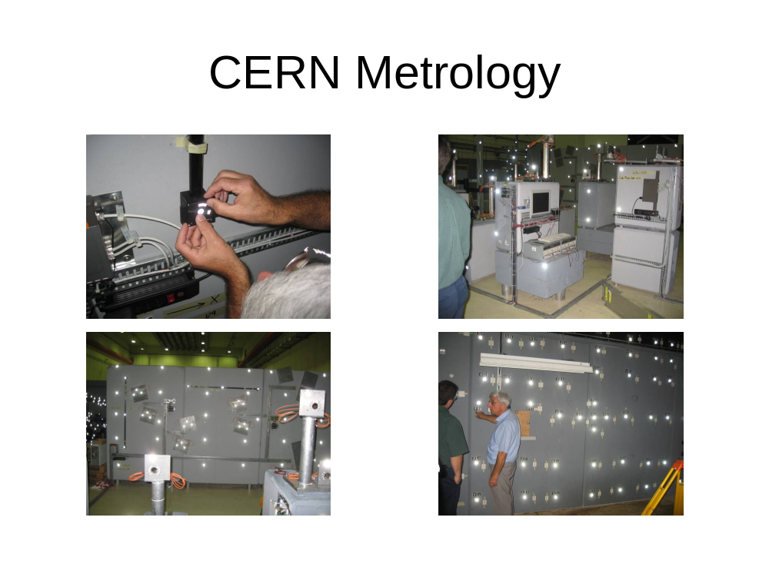
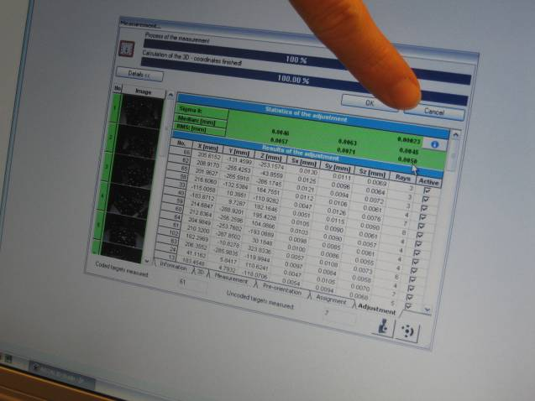

A decision was made to invite Raphael Goudard to visit NCSX, he agreed to bring some photogrammetry equipment with him so that needs of NCSX could be better evaluated.
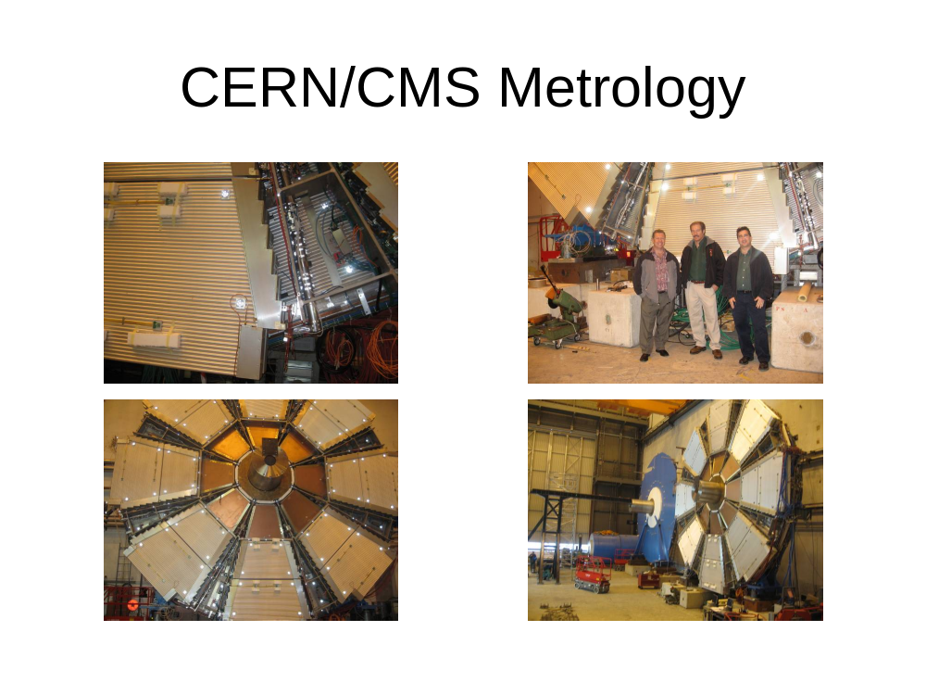
CERN Metrology Team is able to take a full set of photogrammetry in about 10-15 minutes and process the data in about 20 minutes.

The afternoon was spent with Alain Herve and a group of welding experts to discuss the NCSX problems of welding distortion, the group came away with a great deal knowledge regarding welding procedures and setup. It was strongly suggested that MIG welding over TIG would be preferable in the NCSX case.
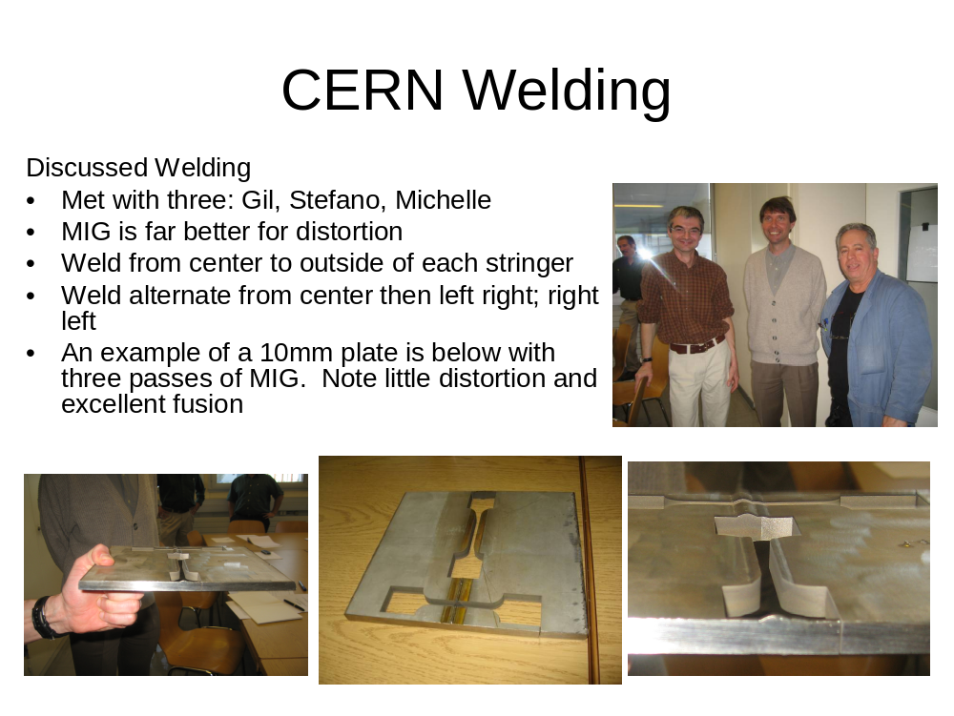

The end of the day featured a tour of CMS (Compact Muon Solenoid) here the group saw the engineering feats of installing a large accelerator experiment and how some of the metrology was done in placing large detectors.
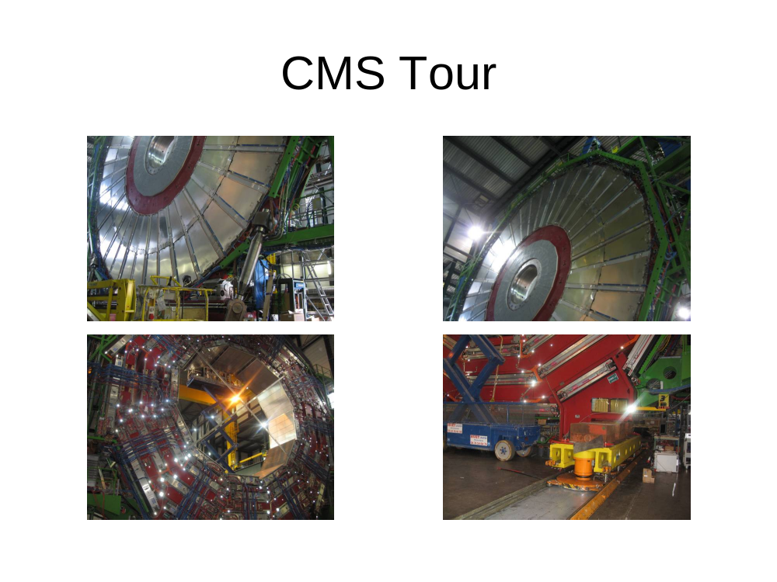

October 10, 2007: Travel day, flight to Hamburg and drive to Greifswald to Wendelstein Lab

October 11, 2007: PPPL group meet with Lutz Wegener and became acquainted with the various heads of operations on WX7. After lengthy discussions with the project heads the meeting moved to hall 22 where component preparation, vessels and support structures were housed here we learned of similar problems that faced WX7 relative to NCSX . The group retired back to the meeting room to discuss the NCSX welding problems again a wealth of knowledge was revealed by the experts at Wendelstein many reinforcing what was learned at CERN and some new information such as CO2 cooling were added. Tours of the welding facility followed where again the technicians on the job offered more insight on welding techniques.

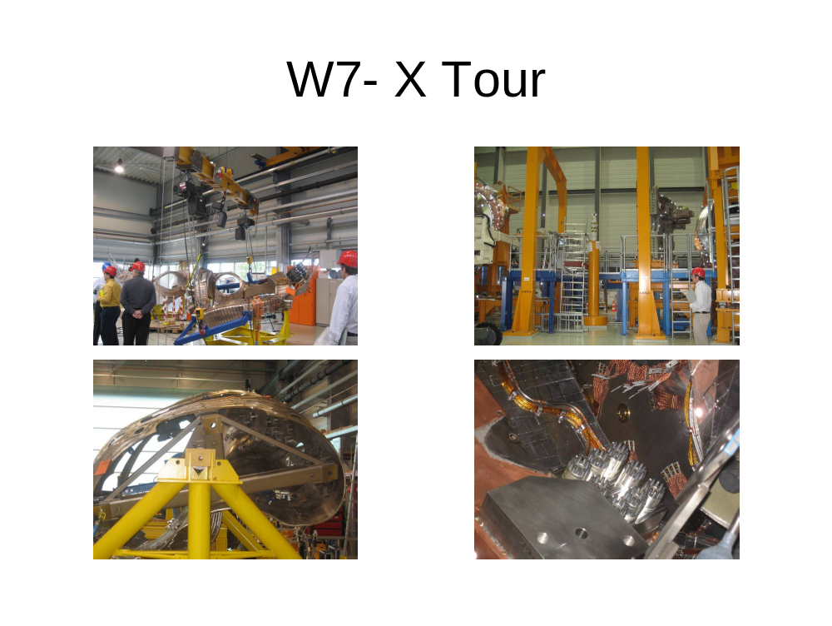

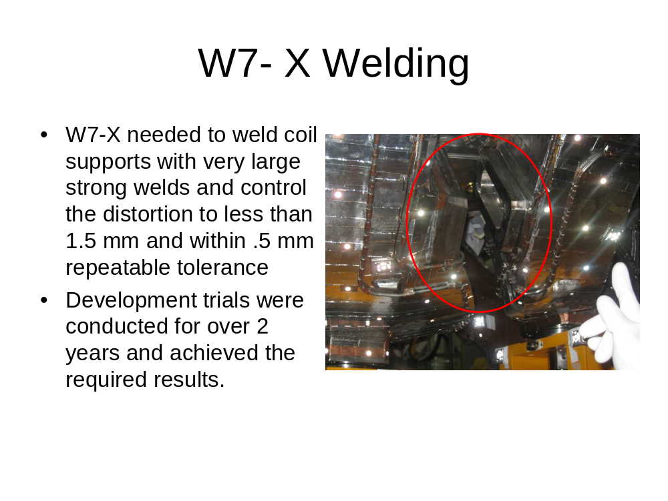

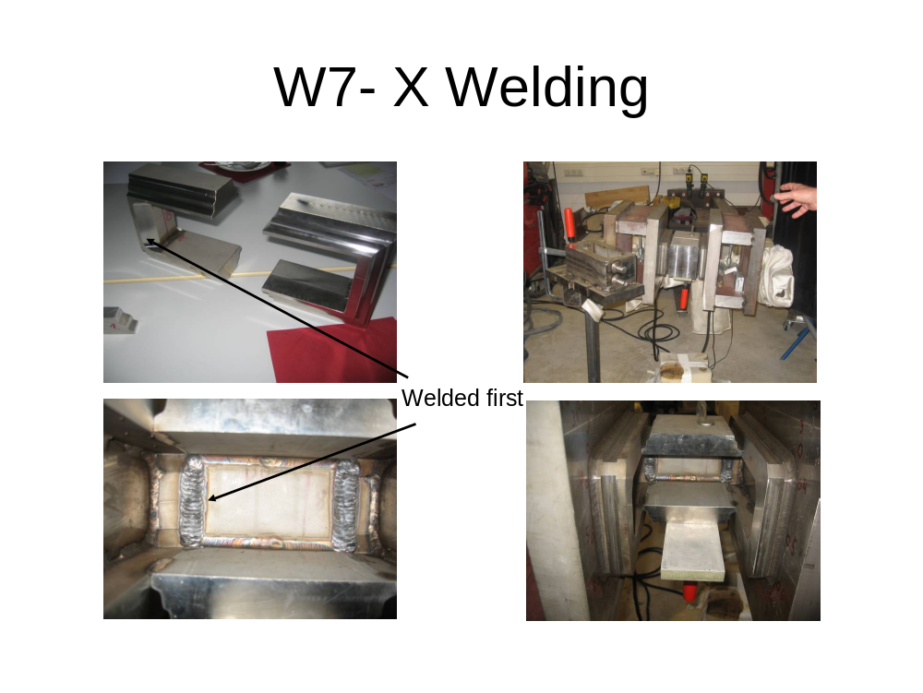
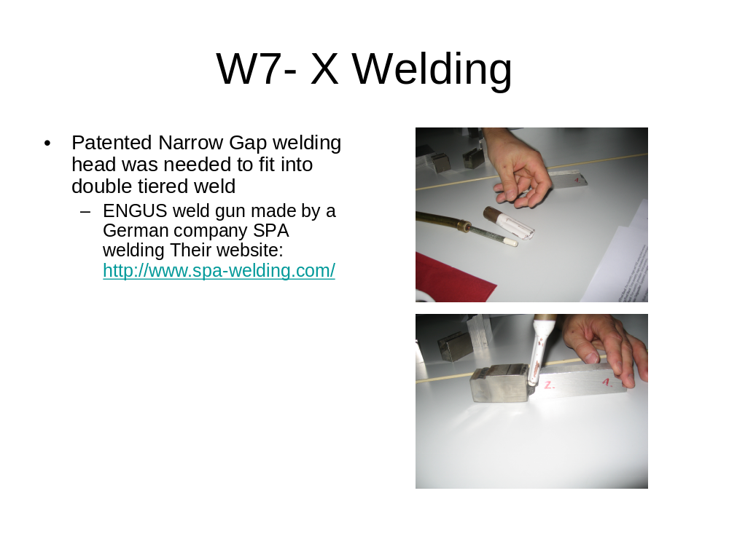

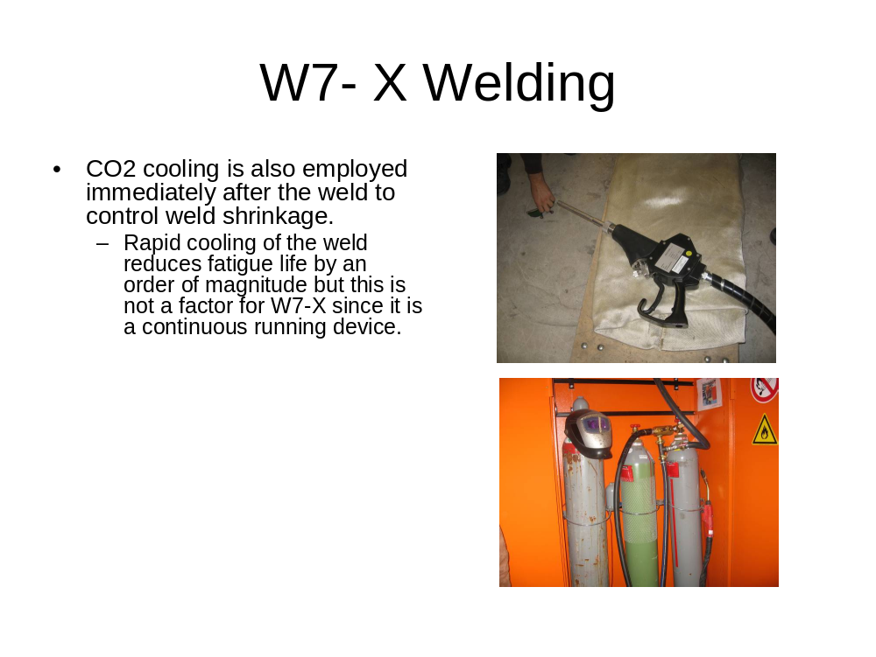
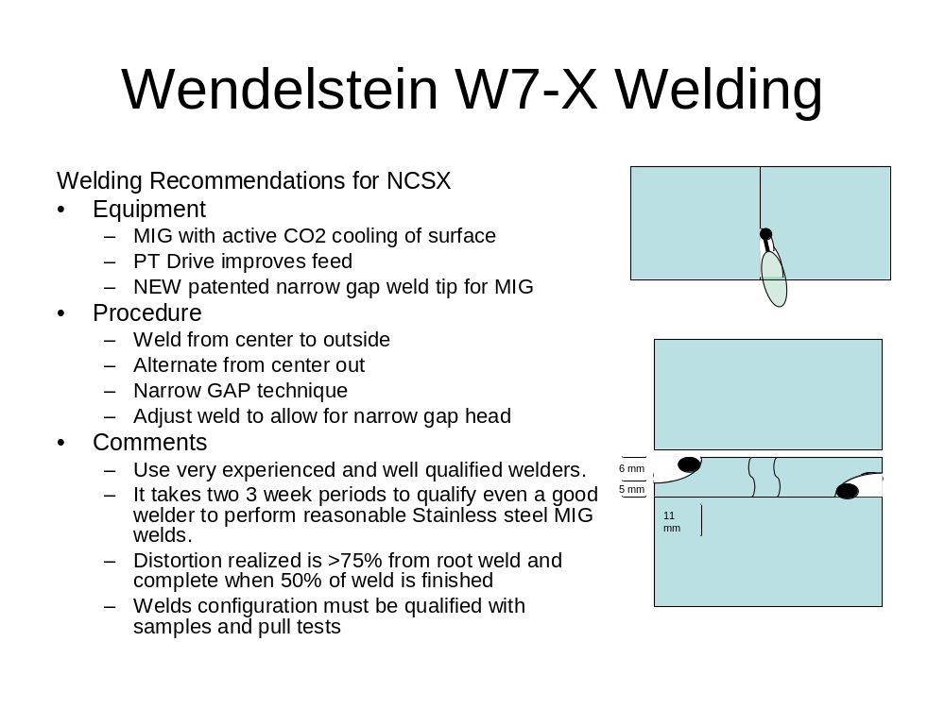

October 11, 2007: The morning at Wendelstein started with the metrology expert Torsten Brauer who explained the use and accuracy of their laser trackers and photogrammetry equipment. The group was shown how the WX7 coils, castings and narrow support elements were surveyed. The photogrammetry equipment at Wendelstein is different than that at CERN and the differences were discussed and pro’s and con’s brought forward. The group was taken to the assembly hall where the practical applications of the Wendelstein metrology could be seen.

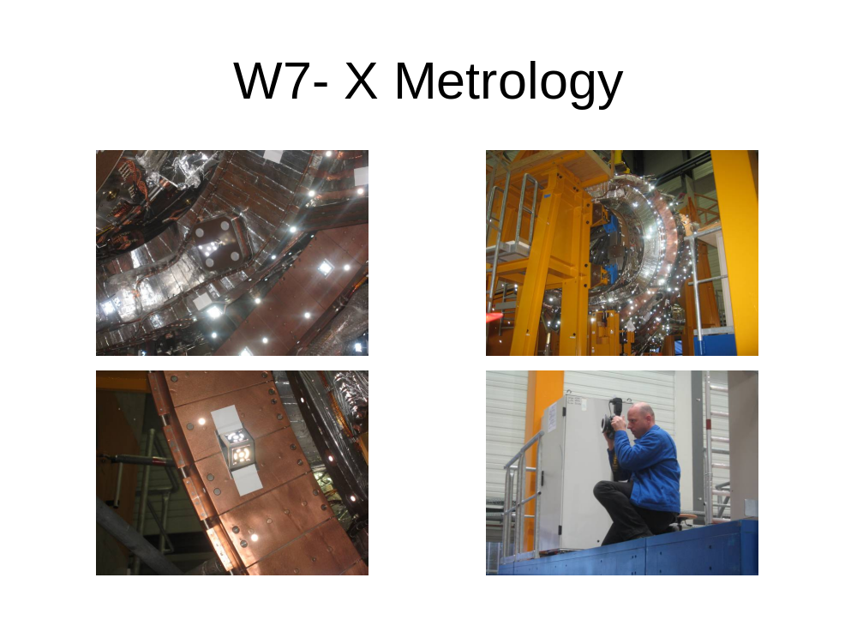

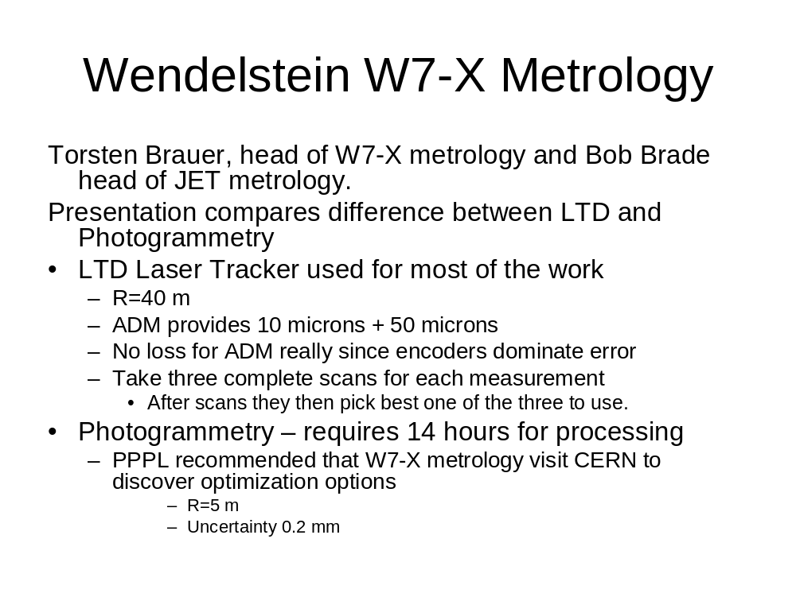
Several hours in the afternoon were spent with Lutz Wegener and some operation heads discussing the upcoming NCSX review at which Lutz is a reviewer. Some of the possible pitfalls were discussed and how to overcome them. Some of the problems that have befallen WX7 that have similarities to NCSX were talked about and some insight on how to avoid them were readily given. The information gained on this trip from both CERN and WX7 is invaluable.

October 13, 2007: PPPL group flies home from Hamburg to Newark.

Observations, Conclusions, Speculations & Information relating to Safety, Health & Security of Future Travelers

Security considerations were more stringent in Europe than in the US. We were given personal attention when checking into our flights in the Hamburg, Germany Airport. An attendant stood in front of the desk and handled each traveler individually; asking questions about the reason for travel and handling of baggage.

Total Cost to DOE $11620.47
Non-DOE Funding Amount

