Assembly Steps/Major Activities
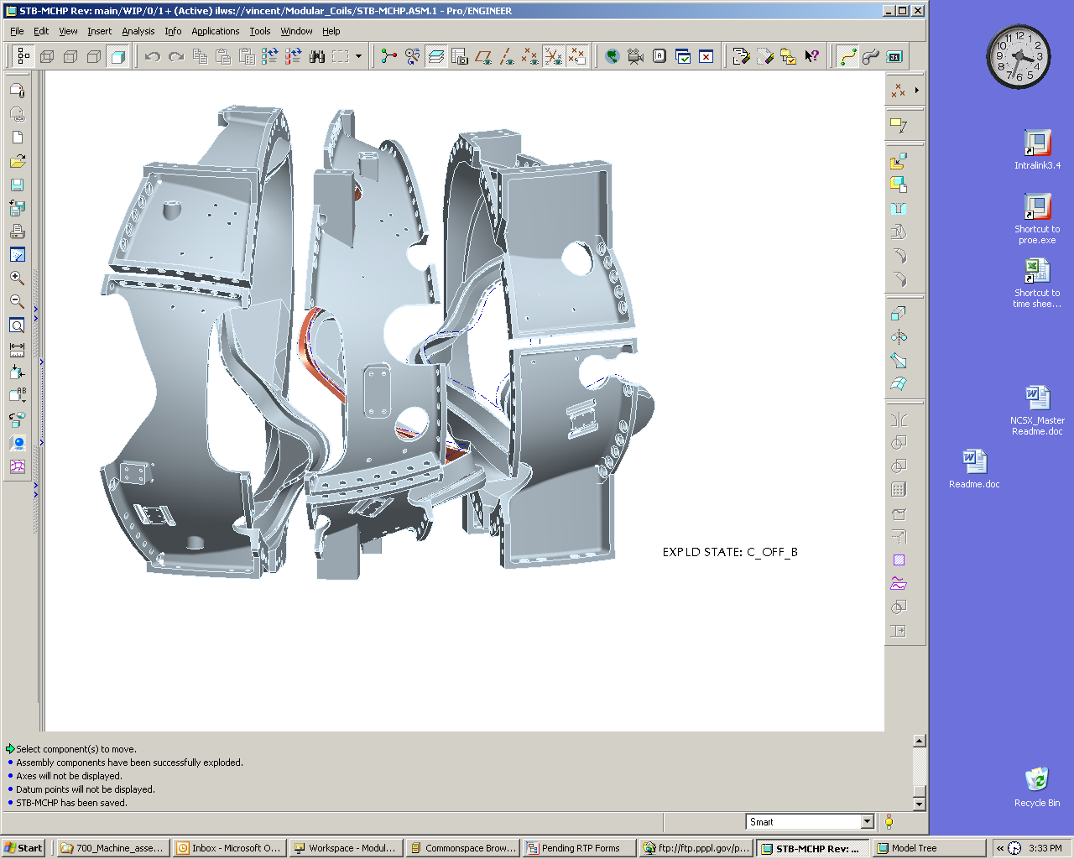
Potential Issues
Type-A
Type-B
Type-C
Figure 2. MCHP Component Winding Forms
Side-A
Side-B
SideB
Side-A
- MC Fit-up Check & Surface Insulation
√ Verify MC’s of MCHP will come together (Gross Fitup)

- Pre-Measurement of MHCP Type A/B/C Coil Flanges & Interfacing Type Type A Coil Flange
√ Verify that the individual coils can be racked into proper shape.
√ Verify that metrology measurements can be accurately taken and reproduced.

- Alumina Shim Sizing & Preparation
- Define shim sizes and compress to arrive at satisfactory shim set for MCHP assembly.

- Pre-Installation Station 2 Set-up (for First Article Only)
- Tooling/fixtures setup.

- Pre-Assembly A-A - (DELETED – ACCOMPLISHED IN STEP 2.0)

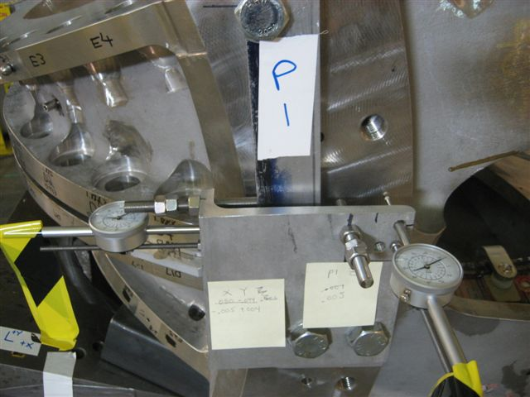
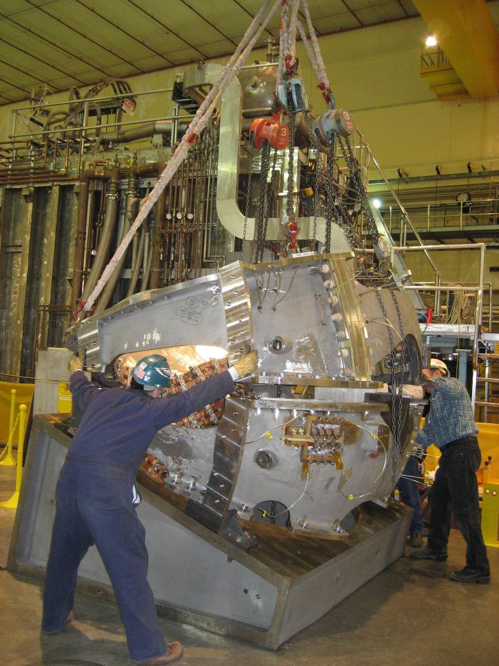
Mitigation Plans
- Tooling not rigid enough - RETIRED

- Coils still to flexible - RETIRED

- Alignment not within tolerances bars- RETIRED

- Shim thiucknesses do not match inventory
- Tooling Rigidity – wedges determined to be adequate
- Coil Flexibility – physically racked (twisted) coils to re-establish coordinate system
- Alignment – iterated until met requirements

- Shims – fabricate/order new shims

Assembly Steps/Major Activities
Potential Issues
- A-B Modular Coil Assembly
- Rack A coil & measure fiducials.
- Using templates, mark nose shim & puck locations.
- Place shims (4-8) onto A coil, lower B coil into place, & align B coil to A coil (± 0.060” X-Y /±0.002”Z).
- Measure shim puck height at a number of points around puck, raise B coil & install nose shims, lightly tack weld flex nose shims.
- Lift B & flip to ready for nose welding.
- Install remaining shims, studs, supernuts and torque to 50%.
- Adjust B coil to install nose shims and measure.
- Recheck A alignment during these processes
- Re-measure A coil fiducials – weld Type A flex shims to plasma side, recheck fiducials. Back Office assess part for compliance.
- Once initial A welding & alignment efforts completed, Back Office assess part for compliance.
- Measure B coil fiducials – weld Type B flex shims to plasma side, recheck fiducials. Back Office assess part for compliance.
- Remove alumina shims on A coil as needed to facilitate re-mating of B coil to A coil. Re-measure alignment.
- One hole at a time, remove supernut & measure hole eccentricity. Select bushing & machine as necessary & install and re-tighten to 50% torque and recheck alignment.
- Install wing support hardware & tighten all bolts to final torque.
- Weld A/B nose region solenoid side & re-measure.

Mitigation Plans
- Alignment not within tolerances
- Weld distortion excessive

- Alignment – iterate until meet requirements
  - Weld distortions
    - Install wing chairs to offset distortions
    - Project determine path forward if unable to meet tolerance requirements.
    - If required, coil welds can be ground out & coil separated

Assembly Steps/Major Activities
Potential Issues
- A-B Coil Assembly to C Coil
- Attach A-B assembly & fixture to another 20° wedge.
- Using templates, mark nose shim & puck locations on B coil.
- Place shims (4-8) onto B coil, lower C coil into place, & align C coil to A-B assembly (± 0.060” X-Y /±0.002”Z).
- Measure shim puck height at a number of points around puck, raise C coil & install nose shims, lightly tack weld flex nose shims.
- Lift C & flip to ready for nose welding.
- Install remaining shims, studs, supernuts and torque to 50%.
- Adjust C coil to install nose shims and measure.
- Recheck A-B assembly alignment during these processes
- Re-measure B coil fiducials – weld Type B flex shims to plasma side, recheck fiducials. Back Office assess part for compliance.
- Once initial B welding & alignment efforts completed, Back Office assess part for compliance.
- Measure C coil fiducials – weld Type C flex shims to plasma side, recheck fiducials. Back Office assess part for compliance.
- Remove alumina shims on B coil as needed to facilitate re-mating of C coil to A-B assembly. Re-measure alignment.
- One hole at a time, remove supernut & measure hole eccentricity. Select bushing & machine as necessary & install and re-tighten to 50% torque and recheck alignment.
- Install wing support hardware & tighten all bolts to final torque.
- Weld A/B nose region solenoid side & re-measure.

Mitigation Plans
- Alignment not within tolerances
- Weld distortion excessive

- Alignment – iterate until meet requirements
  - Weld distortions
    - Internally Reinforce/Rack MC
    - Back Office determine path forward if unable to meet tolerance requirements.
Assembly Steps/Major Activities
Potential Issues

- Inflate All Shim Bags
- Fill wing bladders & cure

- Install Trim Coils – (MOVED TO STATION 5)

- Complete Local Services & Interface Details
- Inject sealant to fill all shim spaces to trap VV/MC insulation.

- Final Measurements & Transfer MCHP to Holding Area
- Measure all tooling balls & record/save data & run copies of installation procedures.
- Install/identify 3 primary fiducials to be used on Station 3.
- Do final measurements & record results. Measure bolt lengths on all tension fasteners & record/save results.
- Mark part, install base supports, remove from stand & measure weight of completed MCHP. Remove to holding area.

REPEAT FOR EACH SUBSEQUENT MCHP

Mitigation Plans
Shim bags rupture when filling

- Each shim bag will be pre-qualified
- Wing chair could be installed in compression
- Determine if replacement of shim bags needed => will require taking coil all apart.

NONE IDENTIFIED
- Rescan components & perform “best fit” of MCHP.
- Back Office assess tolerance recovery by realignment
- Investigate mitigation by trim coil design
Alignment not within tolerances

