PPPL Quality Notes for the Week of December 12, 2005
Tuesday Teleconference 9 AM EST
(877) 952-1506, Passcode: 833648

- Closed Items:

  - A-1 chemical analysis page for documentation package has been updated and posted. It needs to be included in the documentation package and the values reflected on the spreadsheet. This is now considered closed.
  - G-11 flat sheet certification listed as round bar in MTM portion of C-2 documentation package is considered correct by EIO since flat sheet used to machine round bar. Prefer this info be added, but this is now considered closed.

- Pending from EIO:

  - (EIO, MTK) Update MetalTek CA1323 - for erroneous reported chemistry (sulfur and phosphorous values for C-1 through C-4, A-1 & 11 shims, and Manganese on those castings, plus C-5). As of 11/22, MTK did not like the initial results from Stellalloy button and wants to obtain more test results prior to utilizing button for calibration of spectrograph. Note that C-1 & C-2 packages will not be complete until this NCR is closed.
Status: (Open - No update) Chuck Ruud reported on 12/6 that the new button is expected back from the 3rd lab on 12/12 Pete has preliminary results – should be resolved in the next few days. Range 0.023-0.040 for P. Based on this, 2-3 castings may be slightly out of range for P. Mn 2.3-2.8 specified; 2.97 is the highest; 1.6 is lowest in the buttons.

  - (EIO, MTM) Address comments from PPPL review (12/8) of revised MTM C-1 data package.
Status: (Open) New package needs to be posted for PPPL review. Awaiting posting; Mike still working on it – hopes to complete this week.

    - For C-1 and future castings, provide completed shop travelers or process sheets
Status: (Open - No update)

    - Include missing C-1 certifications for weld material, identified as Items #8 & #9 (mc106164.tif) in the TOC.
Status: (Open) Metrode cert added but cryogenic test results missing.
    - The Table of Contents (TOC) lists certifications to be added later for the casting and for the shim. These certifications are actually the first part of the package.
Status: (Open - No update)

    - TOC Item #11, G-11 Round Bar C of C is not in the package
Status: (Open until package is posted) In new package as item # 8

    - NC17452 for a tool gouge is not in the package
Status: (Open) To be added

  - (EIO, MTK) Update of CA 1347 with the outcome of EIO investigation into the A-1 casting thin wall and actions to ensure wall thickness consistency on subsequent castings. Note: still open, awaiting A2 and A3 measurements to confirm dimensional consistency.
Status: (Open) EIO Comments: Post cleaning measurements of A-2, & preliminary measurements of A-3 which have now been accomplished, are consistent with the thin wall measurements found on A-1 (same area & thickness). They’re finding consistently similarly thin conditions with A2 and A3. This is preferred by NCSX to preserve stellarator symmetry. MTK is requested to discuss A2 dimensional results and if they feel comfortable that they understand the “root cause” sufficiently to assure that the remaining three A castings will repeat during the 1/3 conf. call. Roy noted that the B castings have a smaller but similarly thin wall section – will advise when it’s posted at the FTP site, and Phil will ask HM to review.

  - (EIO, MTM) Provide a copy of the updated MTM process outline incorporating recent changes
Status: (Open - No update) Promised by 12/9. MTM to provide new completion date. Mike Griffith working on this (at least in draft by this Friday) Note: MTM has people working every day but Christmas and New Years Day.

2.10. (EIO, MTM, MTK) Report back on lessons learned and/or corrective actions for the two (2) C-2 LPI indications found at MTM
Status (New) EIO Comment: Discussed during EIO visit to MTK & during team telecon on 12/16 –Short write up in QA Highlights. Can discuss further if required at QA meeting on 12/20 MTK agrees that they could have missed these. The LPI performer should be at least advised that indications were found where 3 walls intersect so they can concentrate in these areas in the remaining castings. EIO will put together the corrective action.

2.11. (EIO, MTM,MTK) Complete corrective action (RT, UT) for dispositioned MTM NC 18776 (C3) addressing rejectable LPI indications found during machining. Also report any lessons learned and/or actions to prevent recurrence including possible relation to item # 2.10 (above), the original C-6 porosity and/or the A-3 surface porosity.
Status (New) EIO Comment: Added to list on 12/12 by PPPL. Discussed during EIO visit to MTK. Both Joe Edwards & Chuck Ruud feel that the indications uncovered during machining in C-3 are consistent with casting dross and are unrelated to either the indications in C-2 or the gas porosity in the original (scrapped) C-6. They further reiterated that casting indications are not an unexpected circumstance, despite all efforts to avoid them. Appropriate disposition of such indications is dictated by the specification. Can discuss further if required at QA meeting on 12/20
PPPL: Any update from MTM on the RT or UT?
2.12. (EIO, MTM) Develop a UT Technique and submit the procedure and procedure qualification for examining the high stress areas of the casting.
Status (New) EIO Comment: Action has been underway at MTM since November. The challenge is to gather sufficient data to validate the accuracy of the technique for this program. New due date: January ?
- Pending from PPPL

  - (PPPL) Review revised MetalTek casting Quality Plan dated 12-05-05.
Status: (Open) Review by 12/23.

  - Disposition NC 18831 regarding missing actual RT test results for Metrode weld wire. Results from another lot were submitted to PPPL on 12/1 for possible acceptance in lieu of actual results from lot used which are not available.
Status: (Open) NCR under discussion at PPPL. Disposition to be provided by 1/10/06.

  - MTM NC 18830 addressing elongation below spec on Metrode material submitted posted on 12/12.
Status: (Open) NCR has been dispositioned Use-As-Is and will be transmitted to EIO by 12/22. Received by EIO.

- New Specification & Drawing Changes: NONE

EIO Discussion Issue: Recent conversations with PPPL and our team members about the posting of spec changes have encouraged us to take a closer look at the process. One item discovered this week (that has apparently caused confusion in the past) has to do with the document naming scheme used by PPPL in their ftp file directory. At times, Rev. 7 drawings are in a Zip file named Rev. 6, for example!!! Phil will discuss this with Tom and David and try to get a better scheme to eliminate this confusion. Zip file should always increase by one whenever there is a change We noticed that high level directory names aren’t necessarily changing when sub directories, including drawings have been changed. While a new “posting date” appears, if one is simply to do a quick check of the names, it is not evident by the name or the “rev” number that the directory has been updated. We would like to put this forth to PPPL for discussion at an upcoming meeting.
Tom and Dave – please note!

PPPL Discussion Issue: PPPL is asking that DCMA get as much advance notification as is practical. DCMA at both locations said they’d try to work with less than the 5 days PPPL specified, but as much notice as possible will make it more likely DCMA can witness inspections.
PPPL also asks that final inspections, where DCMA witnessing is required, be scheduled for day shift, when DCMA is more likely to be able to witness the inspection.

PPPL Discussion Issue: PPPL would like MetalTek’s clarification/confirmation of the history behind the C-3 LPI indications. It appears from the RT reader sheets that this area, 116-117, was initially rejected for a hot tear. The repair of the hot tear was rejected due to lack of fusion and the subsequent repair was accepted, although Level 1 shrink was noted in the region that now shows LPI indications after machining. Is this accurate? Is Level 1 Shrink acceptable? It appears PPPL has only the final, accepted film. Can PPPL get all film? EIO passed the note along to MTK – there will be a conference call at 2:00 EST to discuss.

Notes from 12/21 call:
*MTK notes that it’s not normal to provide interim film. Joe notes that hot tears are rarely detected radiographically – they’re usually picked up visually.

Joe looked at the photo below and feels that the red “speckles” are the Level 1 indications that were noted in the x-ray reports exposed on the surface. The darker “island” almost directly above is thought to be a burr.
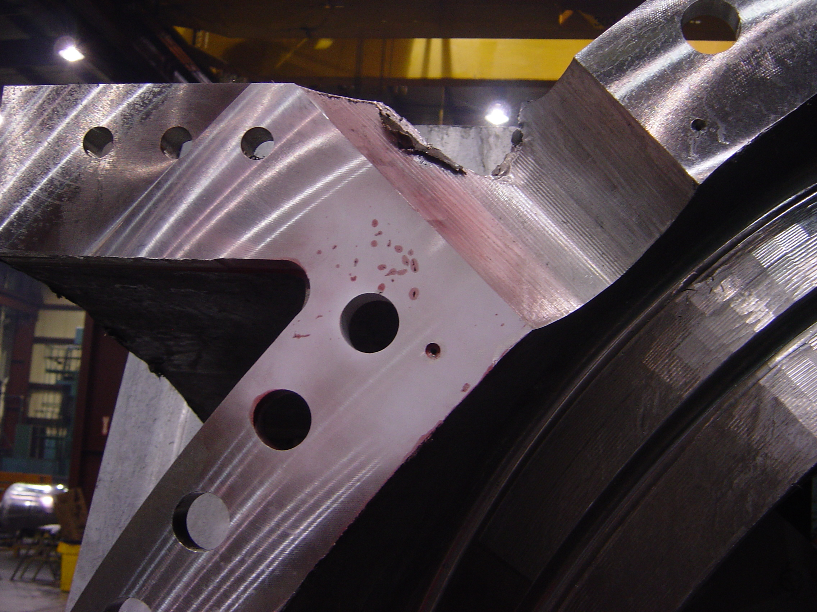
On the Type B castings, Joe noted that MTK feels that they should make mold changes to restore the padding in the T area to nominal thickness. However, they will discuss with MTM first. They also noted that the Type A castings, with caliper checks appear to be repeating consistently. The Romer planned checks will confirm this.

Joe noted that indications in a “triple point” are often shrink indications which go deep into the part. He emphasized that in the future MTM should send the photos to MTK prior to grinding. They might have used a solvent based developer which might have had more sensitivity. MTK passed this info on to the LPI tech.

