Week of 11/6/06
PPPL MCWF Quality Notes
Tuesday Teleconference 11/7 9 AM EST (877) 952-1506, Passcode: 833648

- Closed Items: A3 package was approved Friday.

- Pending from EIO:

  - (EIO, MTM) Provide documentation of completion of corrective action for EIO CA 090606(NCR) for B-3 & B-6 Vacuum Vessel support pads deviations.
Status: (Open) MTM confirms that the center hole position is fixed but the tapped hole pattern is being shifted as needed (applies to all Type B castings). EIO/MTM will provide proposed shifted locations prior to drilling. On B3 & B6 it’s likely that one hole cannot be drilled (corner missing). The CA will remain open until after B6 is completed.

  - (EIO, MTM) Document Corrective Action on NC 20676 for discrepant radii at base of the “T” on B-2 (step 130)
Status: (Open) MTM has completed rework of radii. CA/sign-off of NCR to follow after receipt of PPPL dispositioned NCR. Jim Chrzanowski noted that the T base radii was larger than 0.125 on several of the winding forms that have been received at PPPL. Mike G noted that MTM found that the cause was slippage of the end mills; they have added a step to avoid this and will focus on inspecting these areas while still in the machining process. Mike will send IDC’s with radius check added.

  - EIO to confirm that B-2 through B-6 do or do not have the thin wall conditions seen on B-1.
Status: (Open) EIO’s weekly report confirms that B2 thru B6 also have thin wall sections, but are above the 1.12 minimum formerly agreed to. Pete will send a deviation request tomorrow.

- Pending from PPPL

  - Review Final Documentation Packages
    - B-1
Status: (Open) – in PPPL cycle PPPL will send approval of the B1 package today.

  - Document, likely by Drawing Change, the Rapid Response guidance provided regarding clearance for counter-bored flange holes.
Status: (Open) Engineering Change Notice (ECN) to be issued. ECN was issued – need to check status at PPPL.

  - Spec/Drawing Revision to eliminate use of Thred Guard.
Status: (Open) ECN to be issued. ECN was issued – need to check status at PPPL.

- Discussion Topics For Next Telecon

  - Discussion of the CMM inspection challenges on B-2 and actions taken by MTM to avoid this problem in the future, as mentioned in the Weekly QA notes. Mike discussed with Ed; he thinks the CMM software did not process the information correctly, but not sure why. MTM will “benchmark” some known areas with the CMM before proceeding with the formal winding form inspection.

  - NEW: issue with A4. There is an indication in the T section which Mike feels requires a review – it’s more complex than any seen so far (see photos below). He’s concerned that a weld repair will result in distortion. This is over Hole #28 on the D side. Dave notes that the stress in this area is compressive and ~16 MPa. Pete will check the MTK X-rays; MTM do a full penetrant tonight and will X-ray this area again in the next day or two. Tentatively, final inspection on A4 is around November 15

.

‘

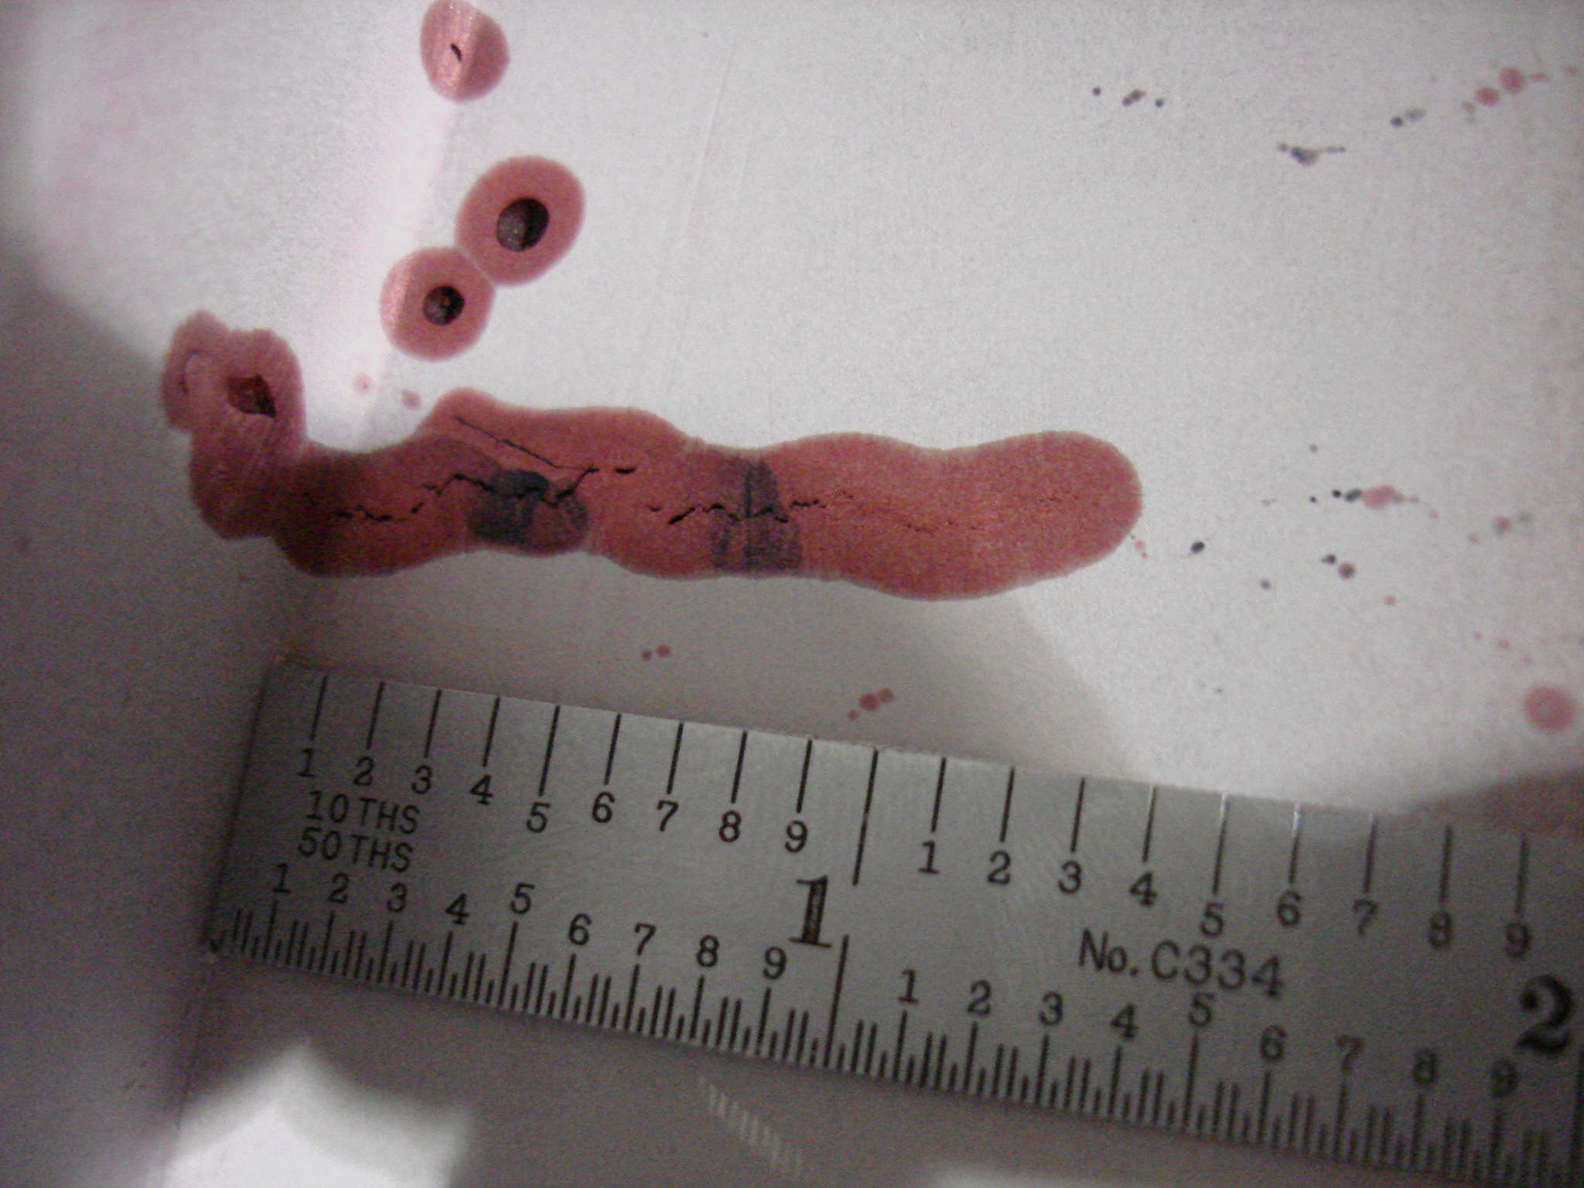

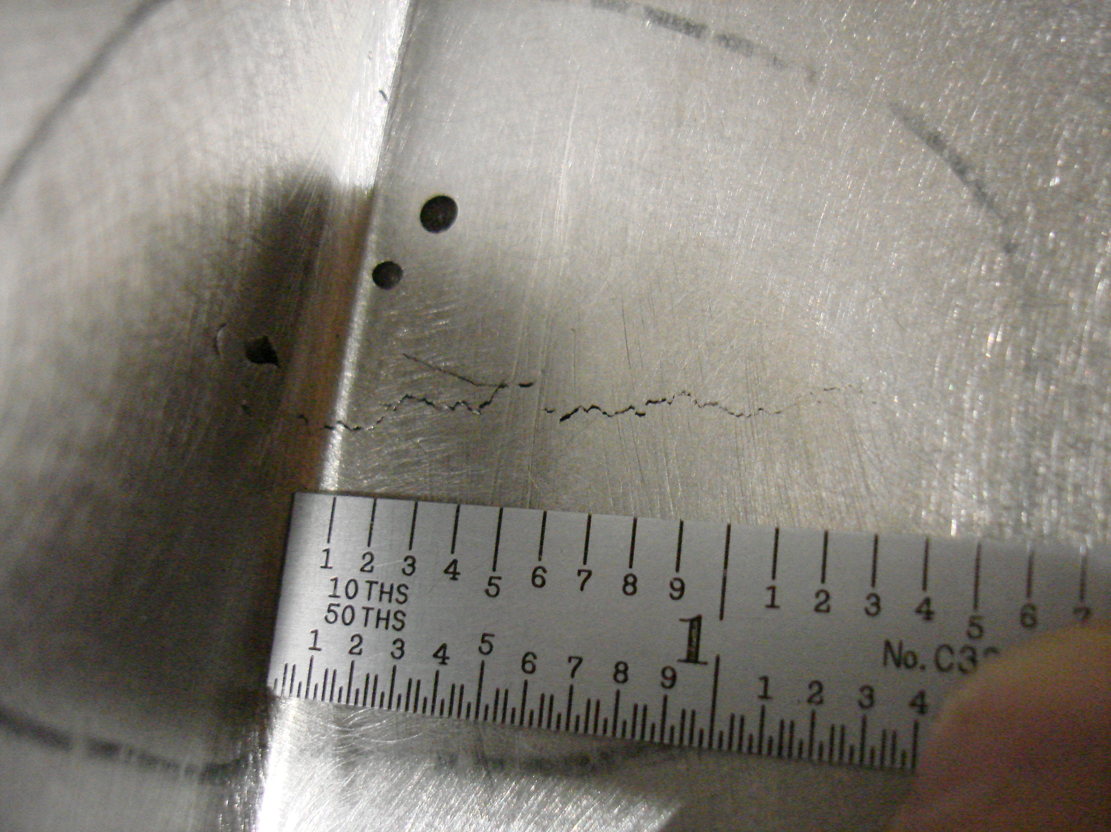

  - B-2 Poloidal Break protrusion. David reviewed the backside poloidal break areas and concluded that only the Type C has wings protruding into this area. Therefore, the protrusion on the A and B, although esthetically not pleasing, are not an issue.

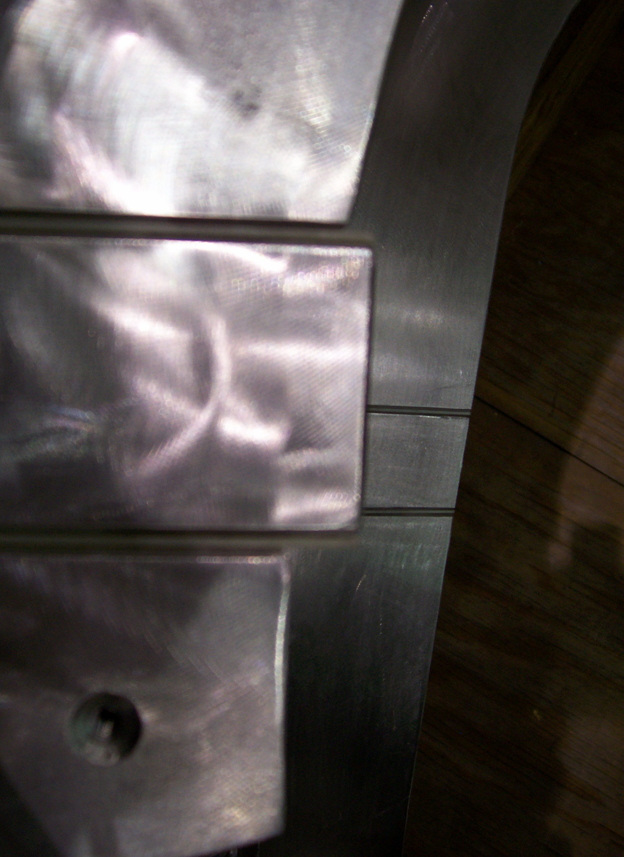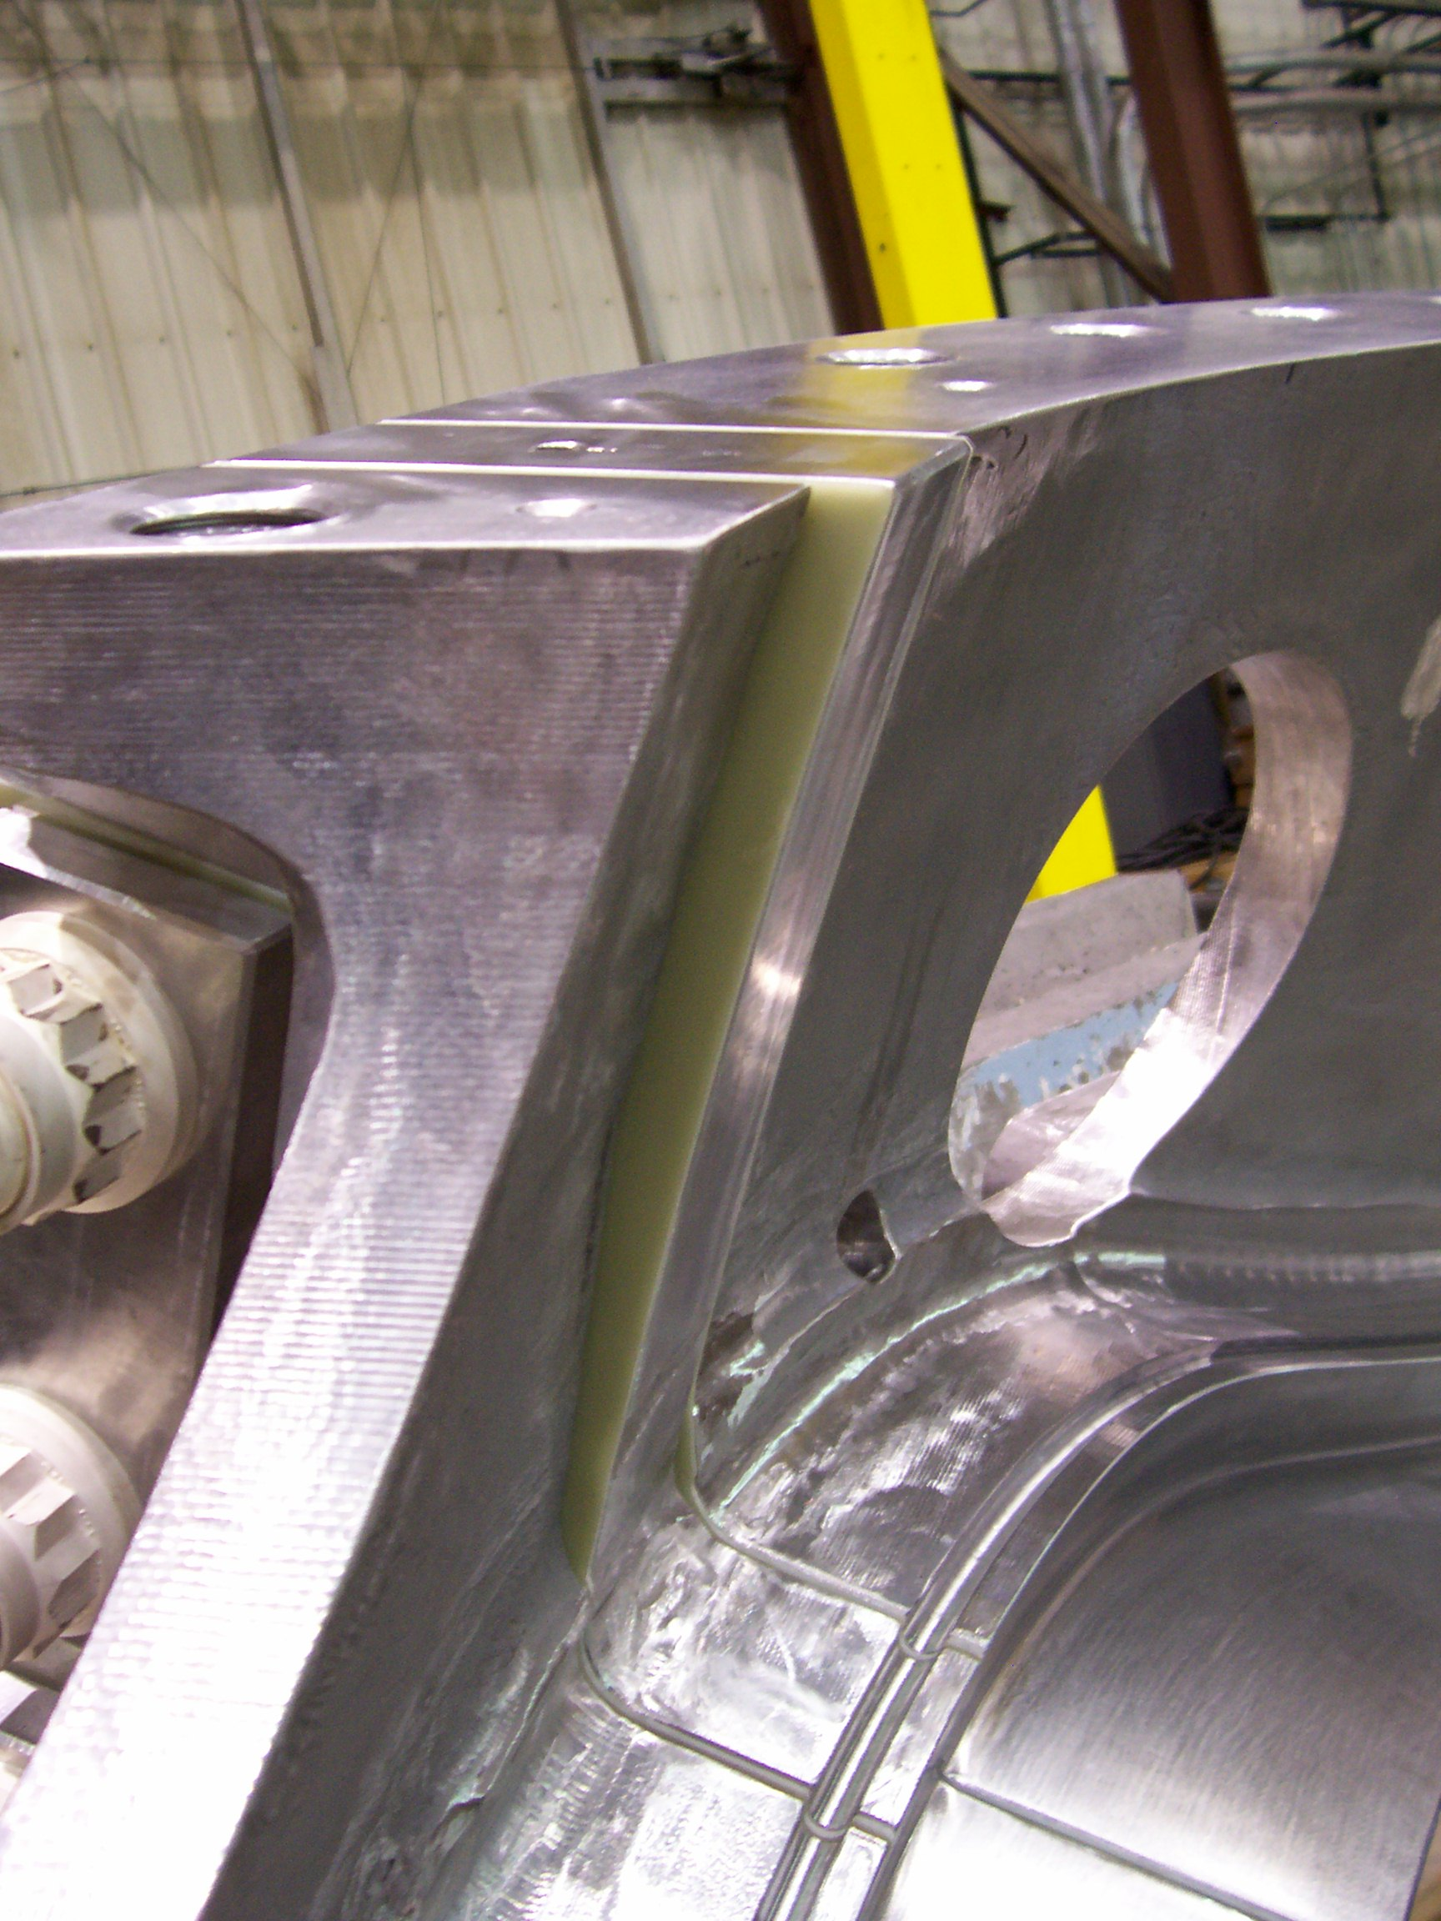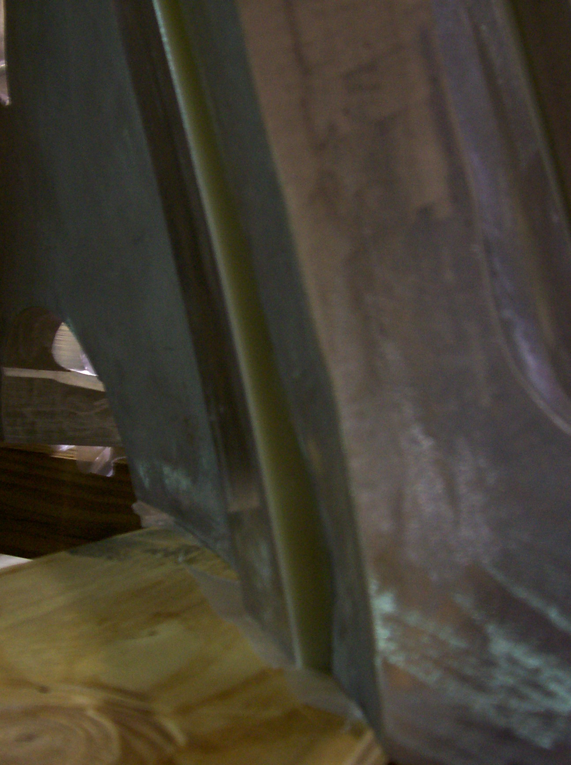

  - New Item: The G11 lead block plate interferes with the support post – see below. EIO is requested to add a notch to accommodate the plate; this will require an ECN (D. Williamson to generate). It will be provided tomorrow.
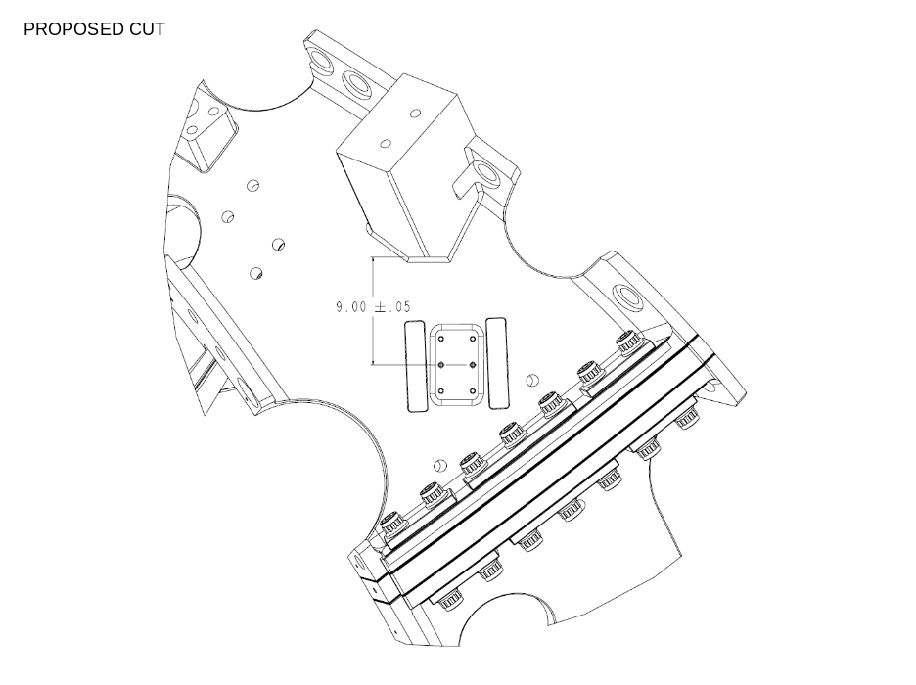

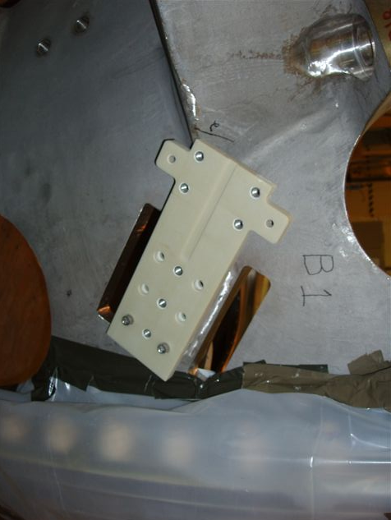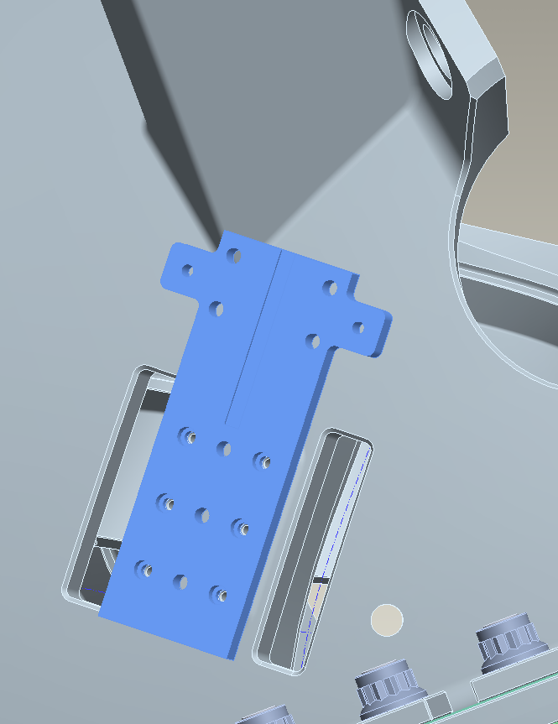

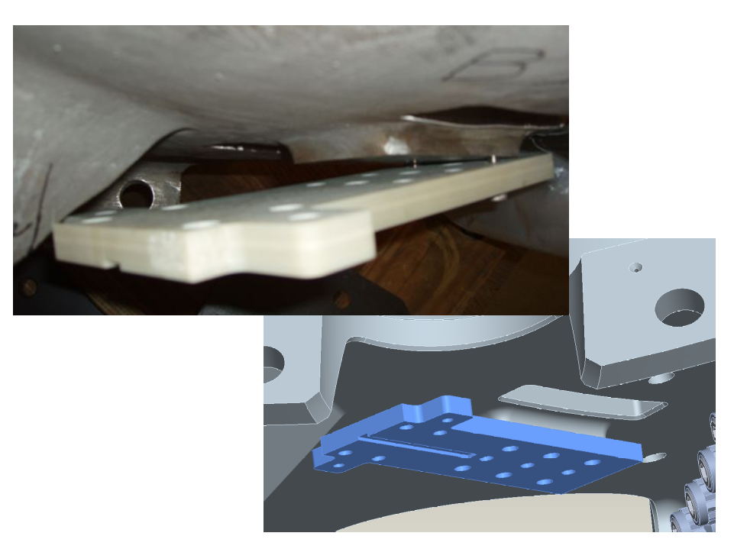

  - Larry Sutton has received film for B2 and the vacuum vessel – they were sent to the Op. Center.

