Our initial review of the casting and comparison to MTM NC18297 identified the following items related to nonconformances:

- IDC #70 is listed on the NCR, but shown as acceptable on the IDC. Is there a nonconformance in this area?
- IDC #90, #180, #210, & #230 are all listed on the IDC as rejected, but do not appear on NC18297.
- IDC #140 & #160 identify out of tolerance conditions at the base of the tee (distance from potting groove to inside of shell too small). (INADEQUATE CLEAR LENGTH) In two locations, the side of the base of the T below the O-ring groove is not machined to the depth specified on SE141-116, Sheet 2 (from the base of the T the machined depth is to be 2.69”). This is needed by PPPL for the stud gun –refer to center picture below-- MTM to assure that this dimension is adhered to in future castings.
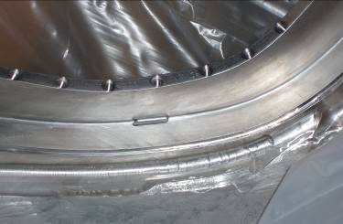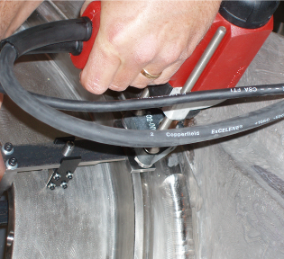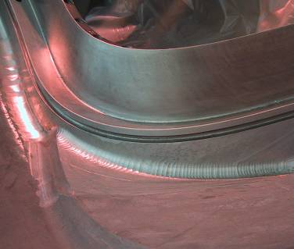
- IDC #250 shows a flange face out of tolerance by .032”. Last Friday we all questioned this, based on the CMM data file, and Kevin was to verify this reported value.
- IDC #300 covers the diameter of the spherical alignment features. These cannot be accepted as-is on future castings. They are now being reworked at PPPL. NOTE: MTM should get a spherical cutting tool made to eliminate the step in the flange. A pilot hole in the bottom would be acceptable.
As previously discussed, the poloidal break features (IDC # 510-540) need to be inspected on subsequent castings. On C-1 the mating flanges are significantly undersized (thinner by roughly 0.5” each). PPPL is currently analyzing the effect of the reduced flange thickness. NOTE: Presently the studs are 9” long.
- The Molycote should be eliminated - drawings need to be revised – Jim C. to recommend a new anti-seize material.
- All Type C castings should be made with the same poloidal break flange thickness as C1. (i.e. 7/8”).. Analysis needs to be performed by NCSX to determine the flange thickness range permissible for Types A and B.
- ¾” thick Type 316 SS bearing plates need to be added by EIO (same permeability requirement applies); approved NCSX drawing available. Washers will be deleted. NCSX needs to specify ASTM standards for the SS.
- Studs on future castings (probably starting with C3) are to be replaced with ASTM A453, Grade 660 B. Add a UNS S66286 also to eliminate any ambiguity. EIO will be asked to procure. (Brad has a quote of $123.50/stud –plan is to replace the studs now and the nuts later (the ones we have now would become brittle at cryo.temperature). NCSX will handle the nuts later and replace on site

Nut generic requirements: Capable of developing 60 ksi in stud at 80 K; permeability <1.02; austenic alloy; Nitronic 40; MTM will search for candidate nuts.
Action: ORNL to prepare revised stud drawings; length to be 9 ½” long. NCSX will request a proposal from EIO to supply the new studs and 12 point nuts.
- The CSPEC has to be revised to add a specific section on hardware addressing permeability of fasteners.
- Spec revisions to be more descriptive – ie, if a drawing changes, add descriptive documentation as Dave has done in the past. These will be added as appendices to the spec.
- IDC#1040 reports all surface finishes and gives a range of 31-500 micro-inches.
- Please report the areas with different requirements (125 & 250) separately and provide information to locate out of tolerance areas. Also the very rough areas around the base of the tee cannot be accepted as-is on future castings. PPPL is reworking those areas on C-1. Surface finish needs to be at least hand ground in the area specified on SE141-116, Sheet 2 (from the base of the T the machined areas.
- depth is to be 2.69”). This is needed for PPPL to be able to stud weld in these
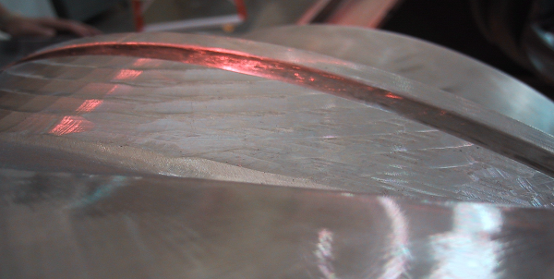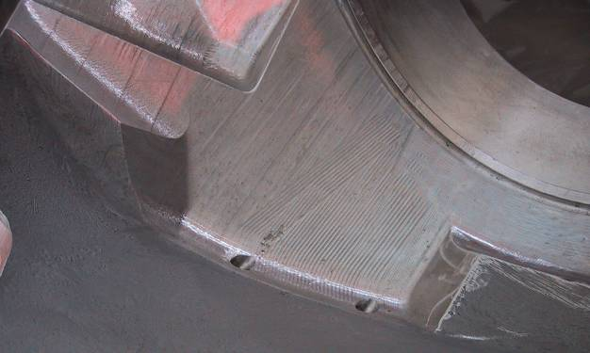
- The poloidal break shim does not conform to the shape of the casting or to the model. PPPL will issue an NCR for this condition. Future shims should conform to the model. NOTE: New shim drawings have been posted. Art will review, but if an issue, PPPL will shim the outside portion of the winding to hold the centroid of the winding. C2 should be the same as C1 – MTM to hold on machining any new shims until Art’s analysis is completed and we advise.
PPPL would like to have all edges of the shim and winding form ground with a 1/16” chamfer to permit sealing with silicon rubber in the T area and the flanges. ORNL will add to drawings.
G-11
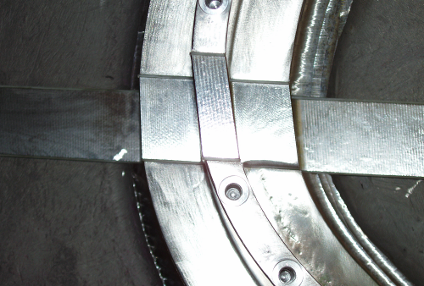
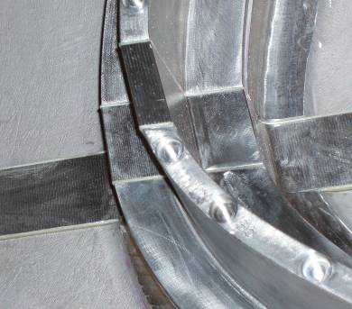
- The magnetic permeability of the poloidal break nuts and studs exceeds the limit of NCSX-CSPEC-141-03-09, par. 3.1.1.5 and is higher than any of our gages can read (they are magnetic). PPPL will issue an NCR for this condition.
- Back spot facing of one flange was done in large cuts, rather than just a spot face around each flange hole. This resulted in loss of thickness on a larger area of the flange than expected. PPPL needs to understand if this is necessary or if local spot facing, as was done for the other flange, can be done.
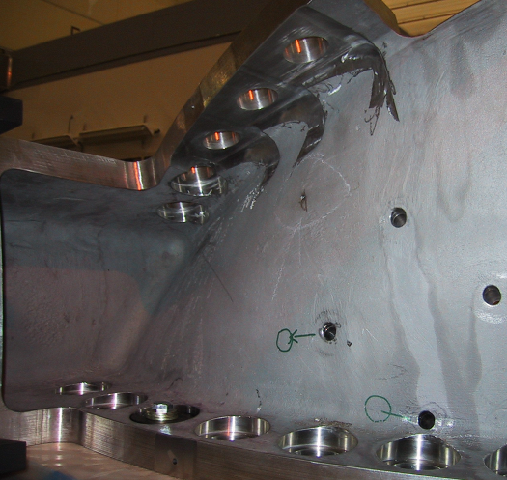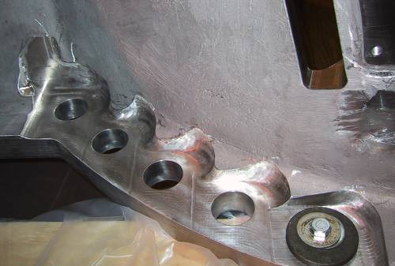
NCSX would prefer to leave flange thickness as thick as possible,
3 Holes have to be changed to 1”
4 new holes have to be added both sides of pol. break– NCSX has to get to EIO and ask for cost proposal.

Relocate this hole
- There is a large flange counterbore/through-hole interference (Sheet 1, D-4) where back spotface is inadequate. The model does not have this problem. PPPL is generating an NCR and reworking this area.
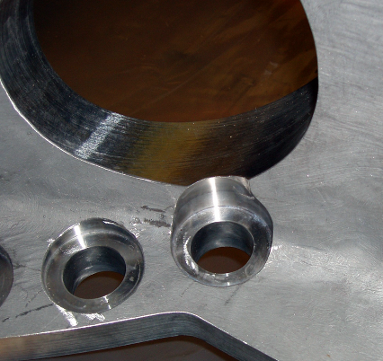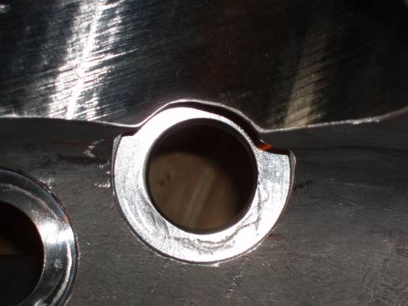
MTM will grind this on future castings

- A cooling tube hole (sht.3, C-6 & sht. 9, C-7) appears to have been drilled at the wrong angle. It intersects with the base of the tee on the casting, but not on the model. PPPL is generating an NCR and reworking this area. (MTM will check this)
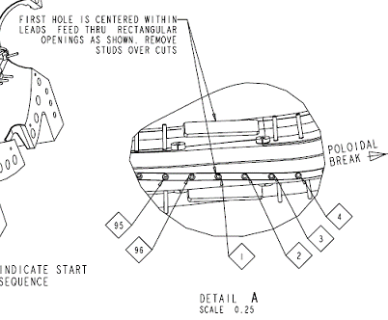
- Web holes are mis-numbered. PPPL is renumbering. Numbering on future castings should comply with that shown on email guidance provided 9/7/2005.
MTM will correct on future castings.

14) The poloidal break flanges on C1 are ½”
- 2 Flange holes near VV port hole #IDC380 : PPPL will re-drill (E8 , dwg. 116, sheet 5) after VPI. MTM will re-drill these holes in C2. (Note: these hole locations were revised, so all other Type C’s will match now to the C1 and C2 corrected in this way).
- Steve requests that there be at least two metrology points on the width of the base of the T. Right now with a 2” grid only one point is provided.
- Tom and Dave will provide info on the spherical seat requirements, finished hole, and hole prior to lapping early next week.
- With that info, Dave and Tom will issue a revised drawing for C1.
- Tom and Dave will provide an IGES file of the C1 wing surface. Profile will be reduced form 0.5” to I’m not sure of that number.

