NCSX RFD  Part I | Number: 14-020 |  | RFD Description: Type A1 MCWF Flange Hole Modifications
Initiator: Mike Griffith |  | Organization: Major Tool
List of Impacted Documents: (Specification, MIT/QA Plan, SOW, drawing, etc.):
SE141-114

Cost Impact: (If none, so state): NONE
Schedule Impact: (If none, so state: NONE
Quality Impact: (If none, so state): NONE
State Requirement Deviation is Requested For: (Specification, MIT/QA Plan, SOW, drawing, etc.): SE141-114
Full Description of the Deviation Requested: (Use continuation pages, e-mails, letter, sketches, etc. as needed and include amplifying information as appropriate to support deviation request.):

Major Tool noted casting interference at the bolt locations shown in the attached figures for the Type A MCWFs (See Attachment 1). RFD-14-018 addressed the resolution for the Type A2 through A6 MCWFs. This casting interference is similar to what was noted on the type C winding forms, but more severe in these areas.

After some discussion (teleconference the evening of March 29th), it was decided that this interference condition will be accepted “as is” for these locations on the A1 MCWF. NCSX will need to weld in threaded “pucks” and bolt through from the opposite side. However, the one exception to this is as shown on the annotation on SE141-114 for the two holes which will be filled with weld and tapped for the A1 Casting (Attachment 2).

Attachments:
- Pictures showing interference details.
- Annotated SE141-114 all the proposed changes to the Type A1 MCWF.

Initiator Signature: Mike Griffith/Phil Heitzenroeder

Attachment (1)
Type A MCWF Interferences

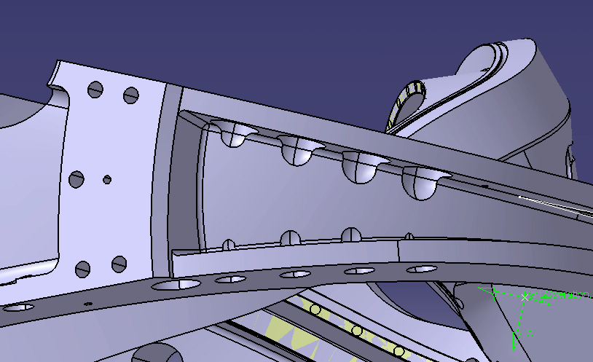

Relief area cut into cast wall
The pictures below illustrate how much casting wall interference there will be on the type A casting. The current machining models for all three winding forms have this interference problem to some degree. The models have a 3” counterbore that extends .75” from the face and the remainder of the feature is a 1.5” radius (see below). This is why Major Tool had to perform the grinding around the counterbores on C4 in order to get the 3” diameter gage to fit.

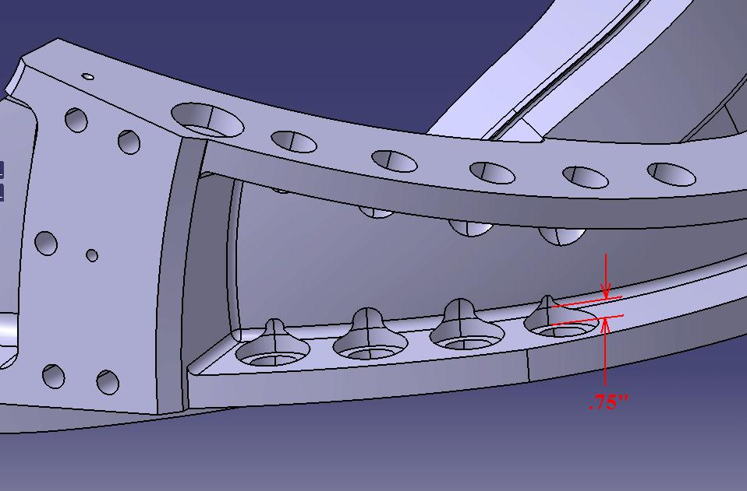

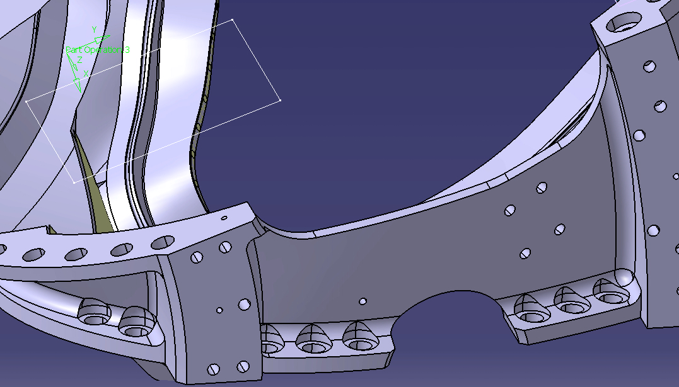

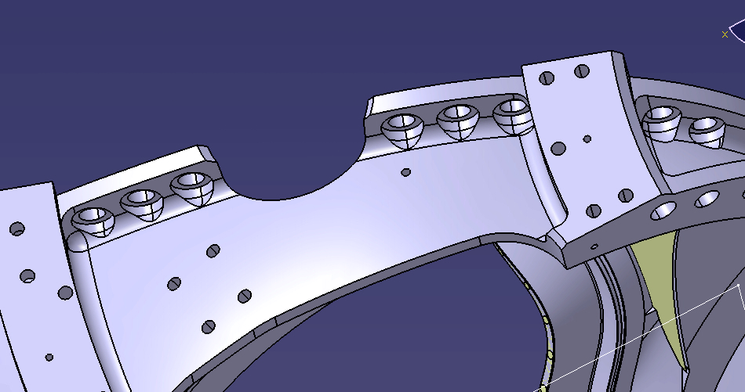

Attachment (2)
Proposed Resolution to Type A MCWFs

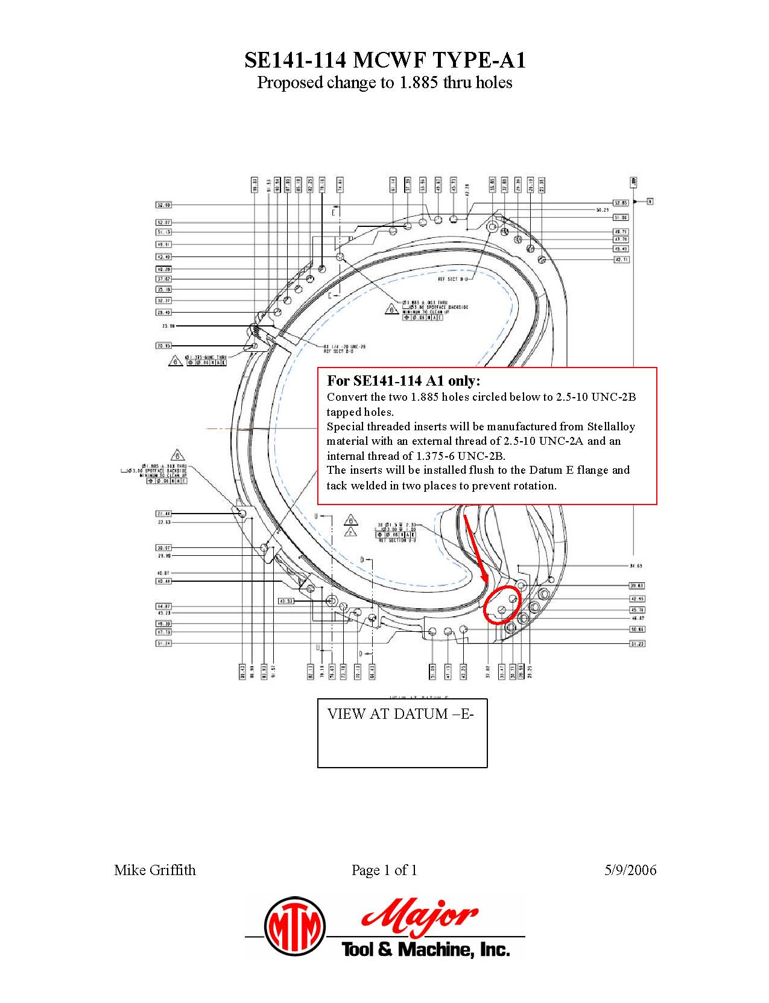
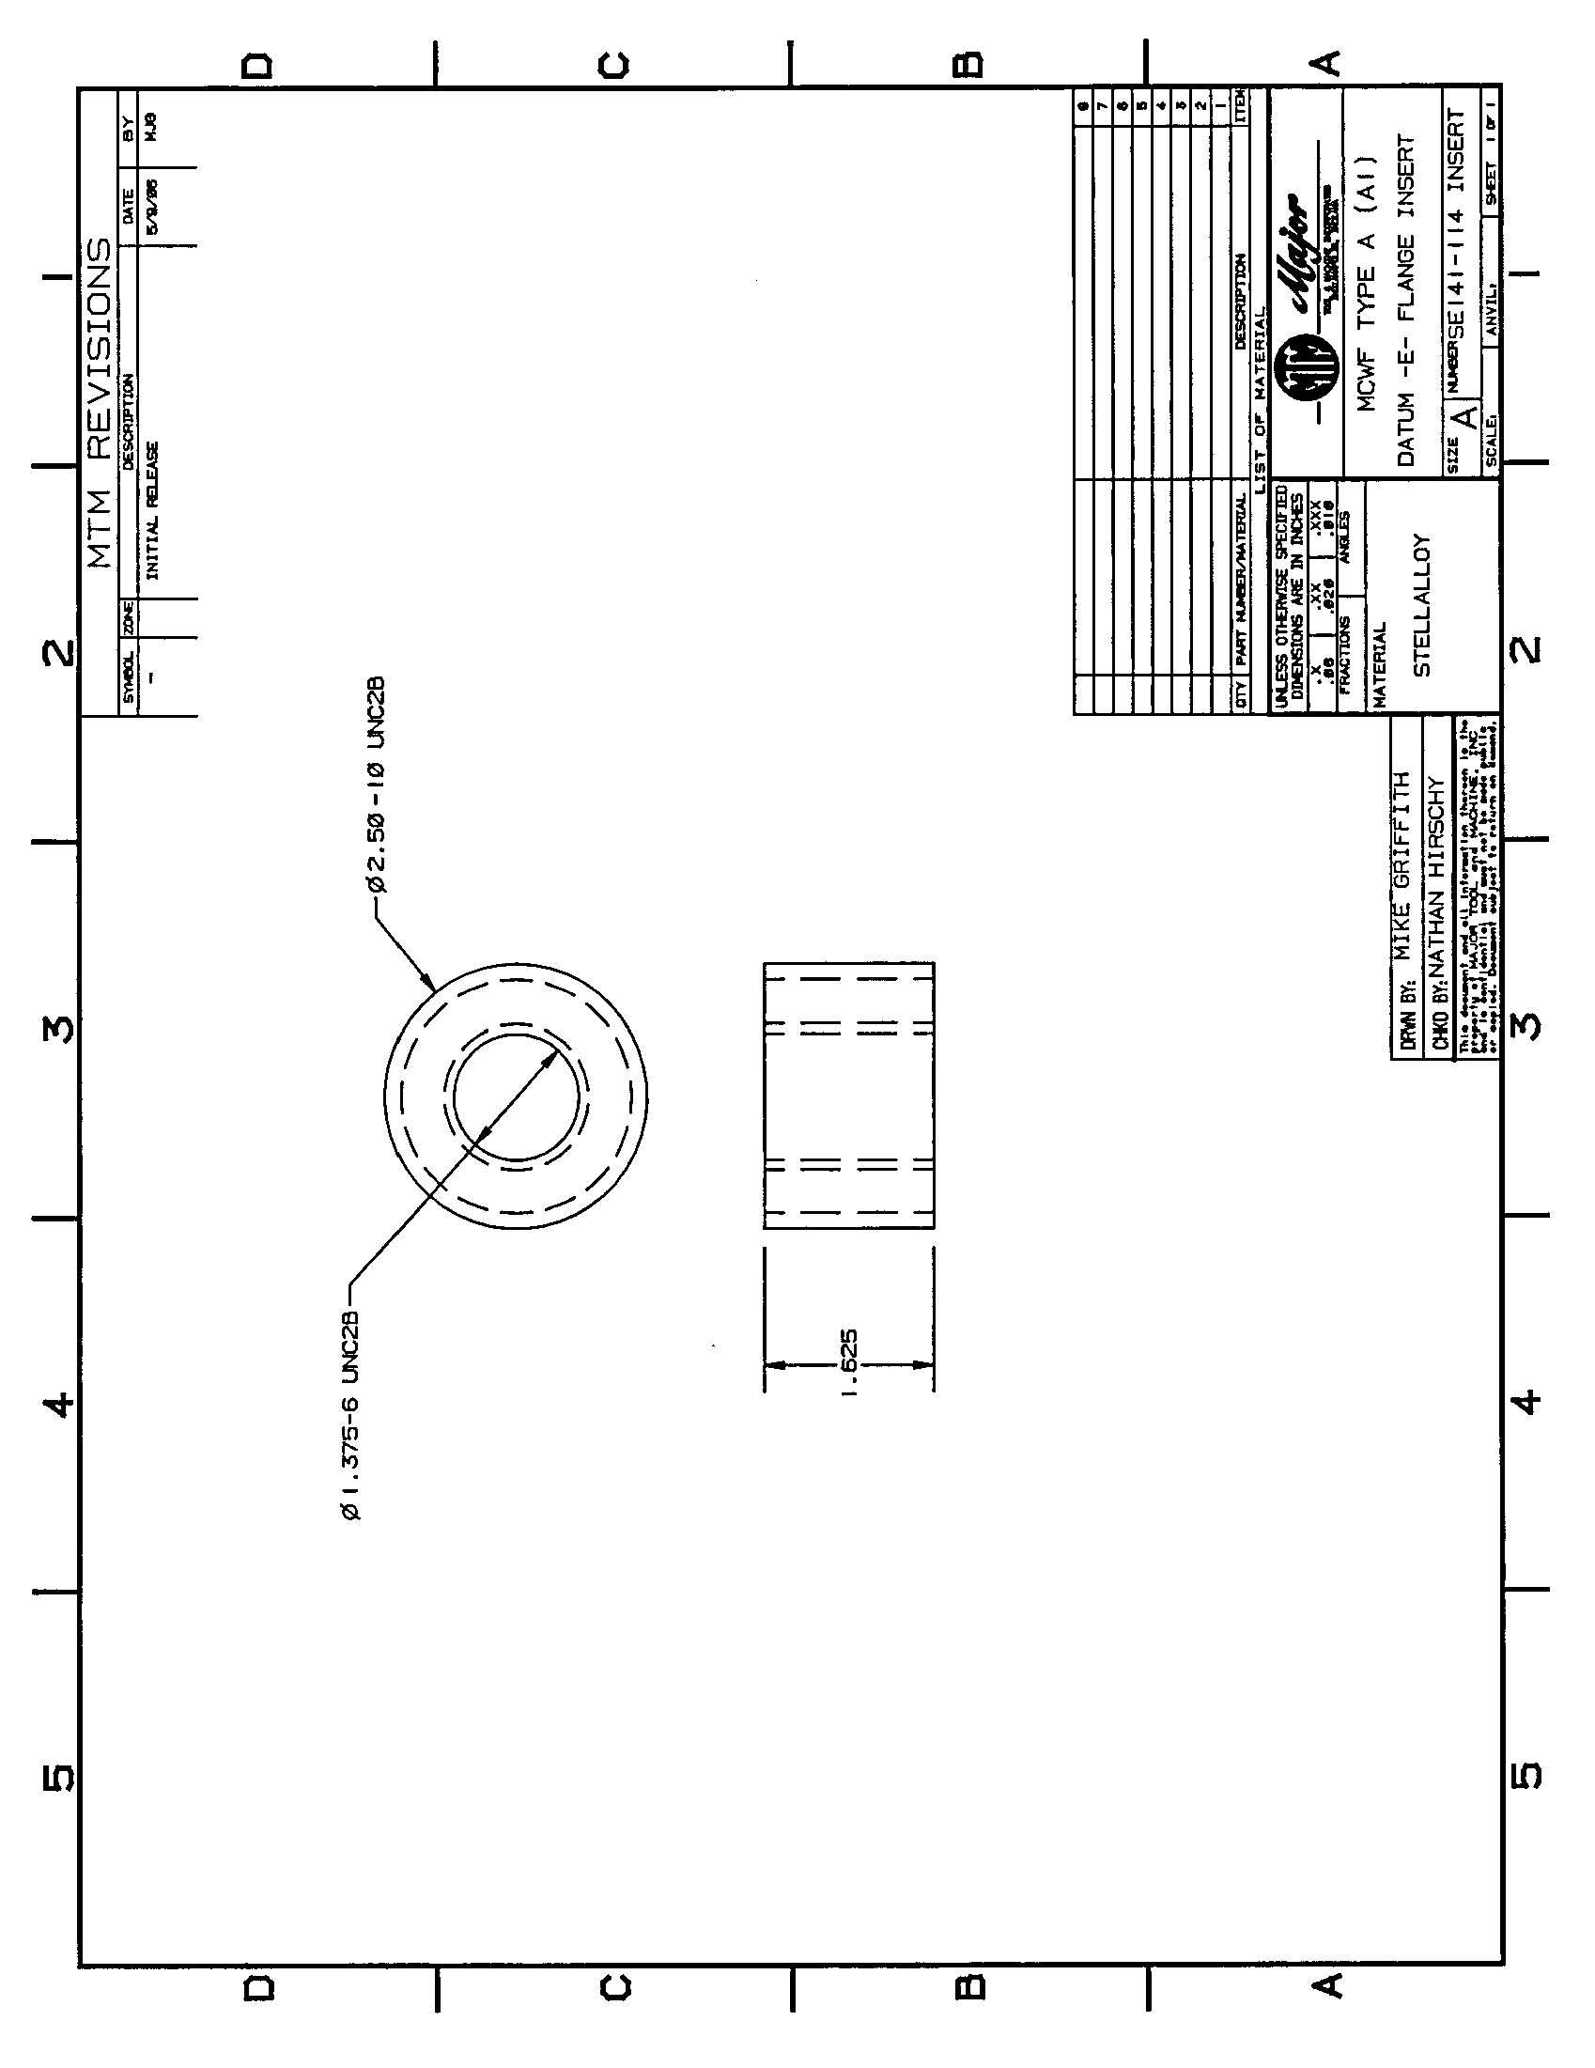

NCSX RFD  Part II | Number: 14-020 |  | RFD Description: Type A1 MCWF Flange Hole Modifications
RLM: Brad Nelson |  | Organization: ORNL
Impact on Interfaces with Other WBS Elements/Items: (If none, so state): NONE
RLM Recommendation:

Approve Do Not Approve

Additional remarks:

These modifications will be incorporated in a future revision to this drawing. In the interim that “stamp” process will be used to annotate SE141-114.

Does this Change Impact Material Already Procured or Parts/Assemblies Already Assembled/Manufactured using this Material: Yes No

If “Yes”, what is the recommended disposition of this material/part/assembly? A1 Casting will be accepted “as is” with the exception of the two holes shown.

RLM Signature:

Project Disposition:

Approved. No ECP required.

NCSX Systems Engineering Support Manager
Approved. ECP will be assigned and processed.

Not Approved. Reason(s) for disapproval:

