Quick response deviation request for A Type a MCWFs
Majortool noted casting interference at the bolt locations shown in the attached figures. A conference call attended by Ray Sheppard of EIO, Mike Griffith of MTM, David Williamson of ORNL, and Phil Heitzenroeder of PPPL was held at approximately 5:30 p.m. on 3/29/06. This casting interference is similar to what was noted on the type C winding forms, but more severe in these areas. After some discussion, it was decided that this interference condition will be accepted as is for these locations on A1 - NSTX will need to weld in threaded “pucks” and bolt through from the opposite side.

MTM will submit a deviation request after the clearance condition for all of the holes is known. They feel that it is possible that others may have to be included in the deviation request.

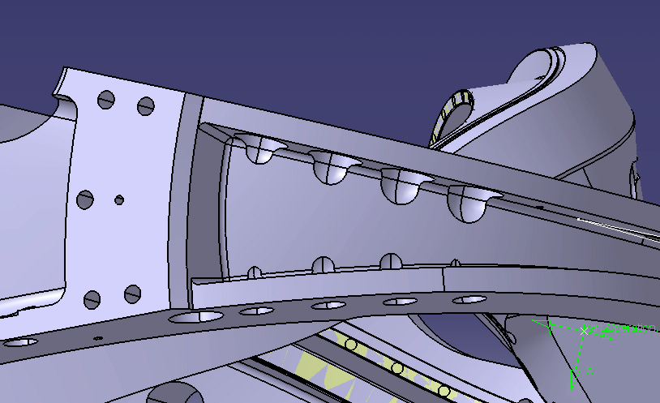

Relief area cut into cast wall
The above pictures illustrate how much casting wall interference there will be on the type A casting. The current machining models for all three winding forms have this interference problem to some degree.
The models have a 3” counterbore that extends .75” from the face and the remainder of the feature is a 1.5” radius (see below). This is why Major Tool had to perform the grinding around the counterbores on C4 in order to get the 3” diameter gage to fit.



