OPER. # | STATION | DESCRIPTION OF PROCESS | Name | Date
10 | QUALITY RELEASE | REVIEW AND APPROVE MTS. RECEIVED APPROVAL FROM EIO ON ____________ FROM ____________  SIGNED QUALITY MANAGER
15 | PATTERN  NPAT SOP 0100REV2 | APPLY APPROPRIATE PART NUMBER, SERIAL NUMBER, AND FOUNDRY MARK, TO THE PATTERN. CAST ON BARS REQUIRED. Place numbers on the bars as to their location.
20 | COREMAKE  CORE SOP 0100 REV 6  CALIBRATION PER CORE SOP 0200R4/0300R6 | MAKE CORES IN SAND MIXTURES AS DESCRIBED BY METALTEK ENGINEERING AND VERIFIED IN MODELING TRIALS. METALTEK CORE SOP 0100 REV 6) CORE WASH WITH ZIRCONIUM CORE WASH.  (CALIBRATION OF EQUIPMENT REQUIRED PER CORE SOP 0200,R4 / 0300,R6)  VERIFY COUNT AND INSPECT.
30 | MOLD  MOLD SOP 0400 REV 8  CALIBRATION PER MOLD SOP 0900 REV 5  PREPARATION PER MOLD SOP 1100R2/1200R2/1300R1  SAND TESTING PER MOLD SOP 1400R2/1500R3/1600R2 | MOLD PER WORK INSTRUCTIONS IN MAPICS ROUTING AND SOPS REFERENCED. ENGINEER OF RECORD – ROGER BROMAN, CONSULT ON MOLD-RELATED CONCERNS.  MOLD MATERIALS REQUIRED PER MAPICS BOM. NOTIFY ENGINEER OF ANY SUBSTITUTIONS.
40 | POUR  MELT SOP 0100R5  MELT SOP 0700R2  MELT SOP 0600R2 | METAL MUST BE AOD REFINED OR AOD INGOT. VIRGIN METAL ADDITIONS ALLOWED.  RECORD POURING TEMPERATURE: __________ CASTING POURED AT: ________________  DATE: _______________ HEAT #”s: _____________________________  ELAPSED POUR TIME_____________  KEEL BLOCKS POURED: ____________  Sample from ladle to be analyzed for final chemical analysis and reported on material certifications.  Sample Taken by:_______________ Analyzed: _________________Date: ________________
50 | MELT SOP 0800R2 | SHAKEOUT
60 | ARC  RISE SOP 0100R1 | REMOVE RISERS AS DIRECTED BY SUPERVISOR.
70 | HEAT TREAT  HEAT SOP 0103R5 | SOLUTION ANNEAL. MAKE SURE TO BLOCK ALL FLANGES OF FORM AND RACETRACK TO MINIMIZE CREEP DISTORTION. Soak Temp: 2050F, Soak Time: 4HR + 1/2 HR/IN, Quench Type: Air Cool
75 | PHYSICAL TESTING | OBTAIN TEST SPECIMENS AND SUBMIT FOR PHYSICAL TESTING. REPORT RESULTS AS PART OF STEP 510.
NOTE |  | THE ORDER OF CLEANING PROCESSES MAY BE ALTERED DUE TO CAPACITY CONSTRAINTS. HOLD POINTS AND COMPLIANCE WILL NOT BE COMPROMISED. EIO WILL BE ADVISED OF ALL CHANGES THAT MAY RESULT IN A REQUEST FOR DEVIATION FROM REQUIREMENTS.
80 | GRIND  GSWA SOP 0100R3 | SWING GRIND TO REMOVE RISER REMAINS AND FLASH IF REQUIRED.
85 | GRIND  GCHI SOP 0100R2 | CHIP AND HAD GRIND SURFACE OF PART AS REQUIRED FOR CONTOUR.
90 | SAND BLAST  BLAS SOP 0100R6 | SANDBLAST (REMOVE ALL BLAST MATERIAL FROM CASTING) SANDBLASTING WILL BE DONE USING RECYCLED SHARP ANGULAR AGGREGATE.
NOTICE | WITNESS  NOTIFICATION  HOLD FOR EIO APPROVAL | PROVIDE NOTICE TO EIO AND DCMA AT LEAST FIVE DAYS IN ADVANCE OF LAYOUT.  EIO NOTIFIED ON _____________ DCMA NOTIFIED ON _______________  APPROVAL RECEIVED ON ___________________ | Q ENG OR QA MGR
100 | LAYOUT  SOP LAYOUT 0100 | INSPECT CASTING TO VERIFY DIMENSIONS. THIS STEP MAY BE DELAYED.  DIMENSIONED _________________ DATE _____________ RELEASED ____________(ENGINEER ONLY)  NOTE: THE FIRST PART PRODUCED OF EACH TYPE A, B AND C WILL BE DIMENSIONED BY LAWTON PATTERN. IF DIMENSIONED BY LAWTON IT WILL BE DOCUMENTED HERE.  Subsequent casting done internally per Romer Arm.
110 | VISUAL INSPECTION  CQP-500 REV 4 | VISUALLY INSPECT 100% of COMPONENT ACCORDING TO ASTM A802 LEVEL 3 ALL CONDITIONS.  IF OK CHECK HERE _______ .  IF REJECTED CHECK HERE ____ . MARK AND REPAIR AT STEP 120. | VT - LEVEL II
NOTICE | WITNESS  NOTIFICATION | PROVIDE NOTICE TO EIO AND DCMA AT LEAST FIVE DAYS IN ADVANCE OF LP STEP.  EIO NOTIFIED ON _____________ DCMA NOTIFIED ON _______________ | Q ENG OR QA MGR
115 | 100% L.P.  CQP 0300  REV 10 | L.P. 100% OF COMPONENT. ACCEPTANCE PER ASTM A903. ACCEPTANCE CRITERIA-LEVEL 1 FOR HIGH STRESSED AREAS, LEVEL 2 FOR ALL OTHER AREAS. SEE LP DRAWING.  IF OK CHECK HERE ________  IF REJECTED CHECK HERE __________ MARK AND REPAIR AT STEP 120. | LP - LEVEL II
120 | WELD SOP 0100  REV 7 | EXCAVATE ANY DEFECTS FOUND DURING 100% VISUAL AND LP INSPECTION.
125 | GRIND  GCHI SOP 0100R2 | CHIP AND HAND GRIND EXCAVATION AS REQUIRED.
130 | L.P. EXCAVATION  CQP-300  REV 10 | L.P. ALL EXCAVATIONS PRIOR TO WELDING TO ENSURE REMOVAL OF DEFECT.  ACCEPTANCE PER A903. ACCEPTANCE CRITERIA-LEVEL 1 FOR HIGH STRESSED AREAS, LEVEL 2 FOR ALL OTHER AREAS. SEE LP DRAWING.  IF OK CHECK HERE ________ IF REJECTED SEND BACK TO STEP 125. | LP - LEVEL II
165 | SAND BLAST  BLAS SOP 0100R6 | SANDBLAST (REMOVE ALL BLAST MATERIAL FROM CASTING) SANDBLASTING WILL BE DONE USING RECYCLED SHARP ANGULAR AGGREGATE.
170 | HOLD POINT  WELD MAP | MAP ALL WELDS WITH DIGITAL PHOTO/MAPS INDICATING LOCATION. SERIALIZE DEFECTS ON CASTING, USE SCALE IN PHOTOS AND DOCUMENT SIZE. THIS IS TO BE PERFORMED BY SUPERVISOR, INSPECTION LEAD MAN OR THEIR DESIGNEE, FILE WITH QA. USE YELLOW MARKER.  MUST SEND REPORT ON ALL WELDS OVER 10% OF NOMINAL WALL THICKNESS TO CUSTOMER.  DEFECTS>10% YES ______, REPORT SENT BY _____________________ DATE______________  DEFECTS < 10 % __________________SIGN BY QA ENG.  MAJOR WELD REPAIRS MAY NOT PROCEED UNTIL INFORMATION IS SUBMITTED.
NOTICE | WITNESS  NOTIFICATION | PROVIDE NOTICE TO EIO AND DCMA AT LEAST FIVE DAYS IN ADVANCE OF X-RAY AND DIMENSIONAL STEPS.  EIO NOTIFIED ON _____________ DCMA NOTIFIED ON _______________ | Q ENG OR QA MGR
190 | X-RAY AT MQS  MQS PROCEDURE  20.H.010  REV 0 | X-RAY PER TECHNIQUE # 12726 USE CALIBRATED DENSITOMETER FOR DENSITY VERIFICATION. WHEN MARKING USE BLACK MARKERS.  ATTACH TECHNIQUE, READER SHEET FOR ALL RADIOGRAPHS. MUST INDICATE RADIOGRAPHER AND ASNT CERTIFICATION LEVEL ON READER SHEET. | RT – LEVEL II
210 | X-RAY  CQP 401  REV 5 | X-RAY INTERPRETATION. ACCEPTANCE MSS SP 54.  ATTACH TECHNIQUE, READER SHEET FOR ALL RADIOGRAPHS. MUST INDICATE RADIOGRAPHER AND ASNT CERTIFICATION LEVEL ON READER SHEET.  IF OK CHECK HERE ______ AND SEND TO STEP 340.  REJECTED CHECK HERE ________ MARK UP DEFECTS AND SEND THE CASTING TO STEP 220. | RT – LEVEL II
220 | WELD SOP 0100  REV 7 | EXCAVATE ANY DEFECTS FOUND DURING RADIOGRAPHY.
225 | GRIND  GCHI SOP 0100R2 | CHIP AND HAND GRIND EXCAVATION AS REQUIRED.
230 | L.P. EXCAVATION  CQP-300  REV 10 | L.P. ALL EXCAVATIONS PRIOR TO WELDING TO ENSURE REMOVAL OF DEFECT.  ACCEPTANCE PER A903. ACCEPTANCE CRITERIA-LEVEL 1 FOR HIGH STRESSED AREAS, LEVEL 2 FOR ALL OTHER AREAS. SEE LP DRAWING.  IF OK CHECK HERE ________ IF REJECTED SEND BACK TO STEP 225. | LP - LEVEL II
240 | HOLD POINT  WELD MAP | MAP ALL WELDS WITH DIGITAL PHOTO/MAPS INDICATING LOCATION . SERIALIZE DEFECTS ON CASTING, USE SCALE IN PHOTOS AND DOCUMENT SIZE. THIS IS TO BE PERFORMED BY SUPERVISOR, INSPECTION LEAD MAN OR THEIR DESIGNEE, FILE WITH QA.  MUST SEND REPORT ON ALL WELDS OVER 10% OF NOMINAL WALL THICKNESS TO CUSTOMER.  DEFECTS>10% YES ______, REPORT SENT BY _____________________ DATE______________  DEFECTS < 10 % __________________SIGN BY QA ENG.  MAJOR WELD REPAIRS MAY NOT PROCEED UNTIL INFORMATION IS SUBMITTED.  MUST SEND REPORT ON ALL WELDS OVER 10% OF NOMINAL WALL THICKNESS TO CUSTOMER PRIOR TO REPAIR. ONCE THE REPORT IS SENT, WELDING MAY START.
NOTICE | WITNESS  NOTIFICATION | PROVIDE NOTICE TO EIO AND DCMA AT LEAST FIVE DAYS IN ADVANCE OF WELD STEP.  EIO NOTIFIED ON _____________ DCMA NOTIFIED ON _______________ | Q ENG OR QA MGR
260 | QA APPROVAL  HOLD POINT | QA TO APPROVE ELECTRODE PRIOR TO USE.  PROCEDURE USED: ____________________ MATERIAL/LOT USED:__________________________  QUALITY ENG. Name: ____________________ Date: ____________
270 | WELD SOP 0100  REV 7 | WELD REPAIR DEFECTS AS MARKED.  FOR WELDS <2” - WPS 10-SMAW-CF8MNMN MOD REV 1  FOR WELDS <8” - WPS 15-GMAW-CF8MNMN MOD REV 2  ADD WPS FOR VERTICAL WELDS.
280 | GRIND  GCHI SOP 0100R2 | HAND GRIND WELDS.
290 | L.P. WELD  CQP 0300  REV 10 | L.P. WELD REPAIRS ACCEPTANCE PER ASTM A903. ACCEPTANCE CRITERIA-LEVEL 1 FOR HIGH STRESSED AREAS, LEVEL 2 FOR ALL OTHER AREAS. SEE LP DRAWING.  IF OK CHECK HERE __________ WASH AND SEND TO STEP 300.  IF REJECTED CHECK HERE __________ | LP - LEVEL II
 | Repeat | Repeat steps __220 to 290___as required till clear through Visual Inspection & Penetrant Inspection. Document rework ON STEPS S220 TO S290 ON LAST PAGE OF MTS.  IF OK CHECK HERE ____________AND PROCEED TO STEP 295.
295 | TEST MAG PERM  SOP MAG PERM 100, REV 1 | TEST MAG PERMEABILITY REPAIR AREAS RECORD ON WELD MAP LIST. TEST AT LEAST 5 POINTS PER WELD.  ACCEPTANCE 1.02.  IF OK CHECK HERE _______AND GO TO STEP 300. IF REJECTED CHECK HERE _______.
296 | GRIND GCHI SOP 0100R2 | GRIND AREAS OF NON COMPLIANCE AND RETURN TO STEP 295.  REPEAT UNTIL COMPLIANCE IS ACHIEVED.
300 | X-RAY ( NOTE) | IF RADIO GRAPHED AREAS ARE GREATER THAN FOUR TO FIVE INCHES THE CASTING WILL BE SENT TO MQS.  SEND TO MQS CHECK HERE_____________.  RADIOGRAPH AT CAF CHECK HERE ___________. | QA ENGINEER
310 A | MQS  X-RAY DEFECTS REPAIRED BY WELDING | X-RAY PER TECHNIQUE # 12726 USE CALIBRATED DENSITOMETER FOR DENSITY VERIFICATION.  ATTACH TECHNIQUE, READER SHEET FOR ALL RADIOGRAPHS. MUST INDICATE RADIOGRAPHER AND ASNT CERTIFICATION LEVEL ON READER SHEET. | LEVEL II
310 B | CAF  X-RAY DEFECTS REPAIRED BY WELDING  CQP 401  REV 5 | X-RAY PER TECHNIQUE # 12726 USE CALIBRATED DENSITOMETER FOR DENSITY VERIFICATION.  ATTACH TECHNIQUE, READER SHEET FOR ALL RADIOGRAPHS. MUST INDICATE RADIOGRAPHER AND ASNT CERTIFICATION LEVEL ON READER SHEET. | RT - LEVEL II
320 | X-RAY  CQP 401  REV 5 | X-RAY INTERPRETATION. ACCEPTANCE MSS SP 54.  ATTACH TECHNIQUE, READER SHEET FOR ALL RADIOGRAPHS. MUST INDICATE RADIOGRAPHER AND ASNT CERTIFICATION LEVEL ON READER SHEET.  IF OK CHECK HERE ______ AND SEND TO STEP 340.  REJECTED CHECK HERE ________ MARK UP DEFECTS AND SEND THE CASTING TO STEP 220. | RT - LEVEL II
 | Repeat | Repeat steps __220 TO 320____as required till welds clear X-RAY. Document rework on a supplemental MTS | QA ENG.
340 | SAND BLAST  BLAS SOP 0100R6 | SANDBLAST (REMOVE ALL BLAST MATERIAL FROM CASTING) SANDBLASTING WILL BE DONE USING RECYCLED SHARP ANGULAR AGGREGATE.
NOTICE | WITNESS  NOTIFICATION | PROVIDE NOTICE TO EIO AND DCMA AT LEAST FIVE DAYS IN ADVANCE OF VISUAL AND LP STEPS.  EIO NOTIFIED ON _____________ DCMA NOTIFIED ON _______________ | Q ENG OR QA MGR
350 | FINAL VISUAL INSPECTION  CQP-500 REV 4 | VISUALLY INSPECT 100% of COMPONENT ACCORDING TO ASTM A802 LEVEL 2 ALL  CONDITIONS.  IF OK CHECK HERE _______.  IF REJECTED CHECK HERE __________ . MARK AND REPAIR AT STEP 385.  MUST BE PERFORMED BY LEVEL II in VT. | VT - LEVEL II
360 | FINAL L.P.  CQP 0300  REV 10 | FINAL L.P. 100% OF COMPONENT. ACCEPTANCE PER ASTM A903. ACCEPTANCE CRITERIA-LEVEL 1 FOR HIGH STRESSED AREAS, LEVEL 2 FOR ALL OTHER AREAS. SEE LP DRAWING.  IF OK CHECK HERE __________ WASH AND SEND TO STEP 455.  IF REJECTED CHECK HERE __________ | LP - LEVEL II
380 | WELD SOP 0100  REV 7 | EXCAVATE ANY DEFECTS FOUND DURING FINAL PENETRANT INSPECTION.
385 | GRIND  GCHI SOP 0100R2 | CHIP AND HAD GRIND EXCAVATION AS REQUIRED.
390 | L.P. EXCAVATION  CQP-300  REV 10 | L.P. ALL EXCAVATIONS PRIOR TO WELDING TO ENSURE REMOVAL OF DEFECT.  ACCEPTANCE PER A903.  IF OK CHECK HERE ________ IF REJECTED SEND BACK TO STEP 385. | LP - LEVEL II
400 | HOLD POINT WELD MAP | MAP ALL WELDS WITH DIGITAL PHOTO/MAPS INDICATING LOCATION. SERIALIZE DEFECTS ON CASTING, USE SCALE IN PHOTOS AND DOCUMENT SIZE. THIS IS TO BE PERFORMED BY SUPERVISOR, INSPECTION LEAD MAN OR THEIR DESIGNEE. FILE WITH QA. MUST SEND REPORT ON ALL WELDS OVER 10% OF NOMINAL WALL THICKNESS TO CUSTOMER. DEFECTS.>10% YES ______, REPORT SENT BY ________________________ DATE____________  DEFECTS < 10 % __________________SIGN BY QA ENG.  MAJOR WELD REPAIRS MAY NOT PROCEED UNTIL INFORMATION IS SUBMITTED.  MUST SEND REPORT ON ALL WELDS OVER 10% OF NOMINAL WALL THICKNESS TO CUSTOMER PRIOR TO REPAIR. ONCE THE REPORT IS SENT, WELDING MAY START.
420 | QA APPROVAL  HOLD POINT | QA TO APPROVE ELECTRODE PRIOR TO USE.  PROCEDURE USED: ____________________ MATERIAL/LOT USED:__________________________  QUALITY ENG. Name: ____________________ Date: ____________
430 | WELD SOP 0100  REV 7 | WELD REPAIR DEFECTS AS MARKED.  FOR WELDS <2” - WPS 10-SMAW-CF8MNMN MOD REV 1  FOR WELDS <8” - WPS 15-GMAW-CF8MNMN MOD REV 2  ADD WPS FOR VERTICAL WELDS.
440 | GRIND  GCHI SOP 0100 REV 2 | HAND GRIND WELDS.
450 | L.P. WELDS  CQP 0300  REV 10 | L.P. WELD REPAIRS ACCEPTANCE PER ASTM A903.  IF OK CHECK HERE __________ WASH AND SEND TO STEP 460.  IF REJECTED CHECK HERE __________AND RETURN TO STEP 440. | LP - LEVEL II
 | Repeat | Repeat steps ___350 TO 450_____as required till welds clear Final Liquid Penetrant Inspection. Document rework on a supplemental MTS | qa eng.
NOTICE | WITNESS  NOTIFICATION | PROVIDE NOTICE TO EIO AND DCMA AT LEAST FIVE DAYS IN ADVANCE OF VISUAL AND LP STEPS.  EIO NOTIFIED ON _____________ DCMA NOTIFIED ON _______________ | Q ENG OR QA MGR
460 | FINAL VISUAL INSPECTION  CQP-500 REV 4 | VISUALLY INSPECT 100% of COMPONENT ACCORDING TO ASTM A802 LEVEL 2 ALL  CONDITIONS.  IF OK CHECK HERE _______.  IF REJECTED CHECK HERE __________ . MARK AND REPAIR AT STEP 390.  MUST BE PERFORMED BY LEVEL II in VT. | VT - LEVEL II
470 | FINAL L.P.  CQP 0300  REV 10 | FINAL L.P. 100% OF COMPONENT. ACCEPTANCE PER ASTM A903. ACCEPTANCE CRITERIA-LEVEL 1 FOR HIGH STRESSED AREAS, LEVEL 2 FOR ALL OTHER AREAS. SEE LP DRAWING.  IF OK CHECK HERE __________ WASH AND SEND TO STEP 455.  IF REJECTED CHECK HERE __________ | LP - LEVEL II
480 | TEST MAG PERM  SOP MAG PERM 100, REV 1 | TEST MAG PERMEABILITY REPAIR AREAS. RECORD ON WELD MAP LIST. TEST AT LEAST 5 POINTS PER WELD.  ACCEPTANCE 1.02.  IF OK CHECK HERE _______AND GO TO STEP 430. IF REJECTED CHECK HERE _______.
490 | GRIND GCHI SOP 0100R2 | GRIND AREAS OF NON COMPLIANCE AND RETURN TO STEP 451.  REPEAT UNTIL COMPLIANCE IS ACHIEVED.
NOTICE | WITNESS  NOTIFICATION | PROVIDE NOTICE TO EIO AND DCMA AT LEAST FIVE DAYS IN ADVANCE OF MAG PERM STEPS.  EIO NOTIFIED ON _____________ DCMA NOTIFIED ON _______________ | Q ENG OR QA MGR
500 | FINAL MAG PERM  INSPECTION  SOP MAG PERM 100, REV 1 | PERFORM MAG PERM TESTING WITH SEVRIN GAUGE. ACCEPTANCE 1.02. CHECK THE ENTIRE SURFACE ON A 6”BY6” GRID. REPORT RESULTS. USE A 6” SQUARE BLOCK TO INDICATE TEST LOCATIONS AND RECORD RESULTS. COMPLIANT AREAS WILL NOT BE MARKED. MARK NONCOMPLIANT AREAS WITH AN “X” FOR REPAIR.  OK CHECK HERE _____AND GO TO STEP 530.  IF REJECTED CHECK HERE ______.
510 | GRIND  GCHI SOP 0100  REV 2 | HAND GRIND WITH SUITABLE CONE OR OTHER SIMILAR GRINDER AS REQUIRED TO ENSURE REMOVAL OF MATERIAL TO ACHIEVE MAG PERM REQUIREMENT. CIRCLE AREA REMEDIATE FOR RETEST.
520 | RETEST MAG PERM  SOP MAG PERM 100, REV 1 | RETEST MAG PERMEABILITY AT FAILED TEST POINTS. MARK NONCOMPLIANT AREAS WITH AN “X” FOR REPAIR.  ACCEPTANCE 1.02.  IF OK CHECK HERE _______. IF REJECTED CHECK HERE _______RETURN TO STEP 510.
530 | DOC. REVIEW | REVIEW DOCUMENTS AS REQUIRED IN CAF CHECKLIST, ALL DOCUMENTS NOTED TO BE ACCESSIBLE FOR AUDITING. (SHIPPER, C OF C, M.T.R., M.T.S., INSPECTION REPORT, X-RAY READER SHEETS AND HEAT TREAT CHARTS)
NOTICE | RELEASE FROM EIO | PROVIDE DOCUMENTS TO EIO. SENT ON ____________ BY __________________.  RECEIVED RELEASE FROM EIO ON _________________. | Q ENG OR QA MGR
540 | PACK AND SHIP | PACKAGE AND SHIP TO MAJOR TOOL.
1000 | REVISION HISTORY | ORIGINAL 12-14-04. Approved 12-14-04. Revision level 1- Revised 1-26-05 new page 8, correct High stress areas, Revision level 2 3-16-05, delete LO step 455. Revision 3 3-28-05 Added note regarding hold point at weld step 400. Revision level 4 written for C-2 casting 4-18-05. Rev 5 added Layout SOP# and note regarding first casting layout responsibility. 5-10-05. Rev 6 added word LOT to weld material steps. 5-29-05. | CARUUD

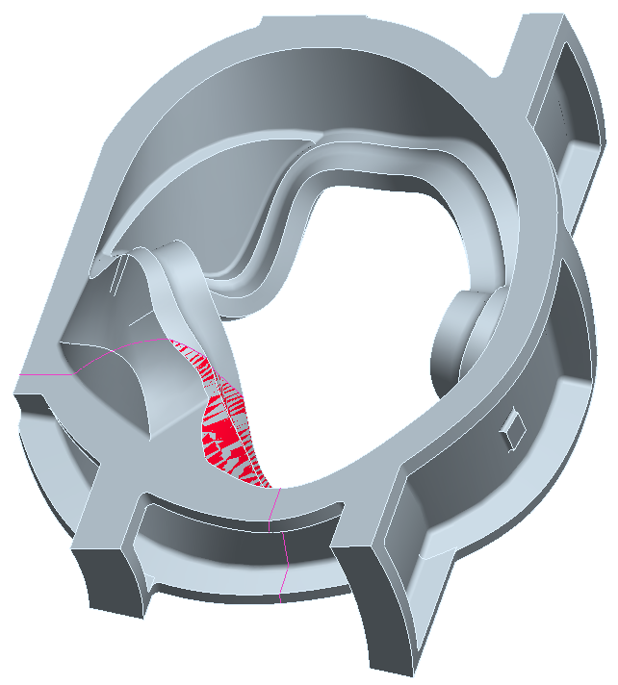 RED AREA INDICATES HIGH STRESSED AREA
TABS DESIGNATE CRITICAL AREA

GENERAL ISOMETRIC

VIEW FROM TOP SIDE

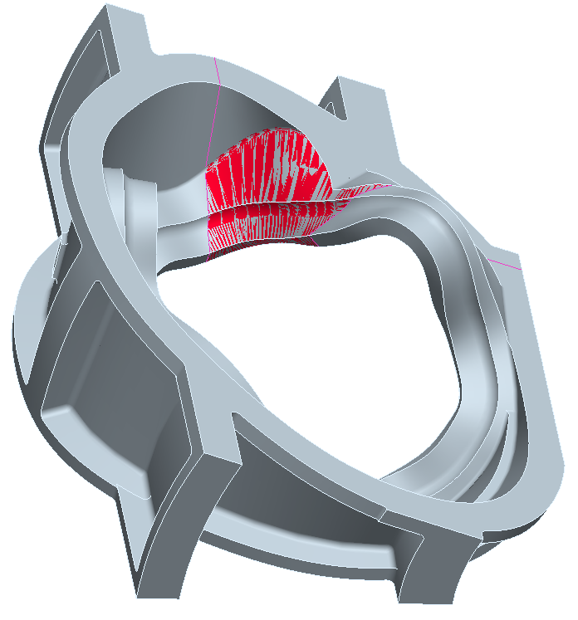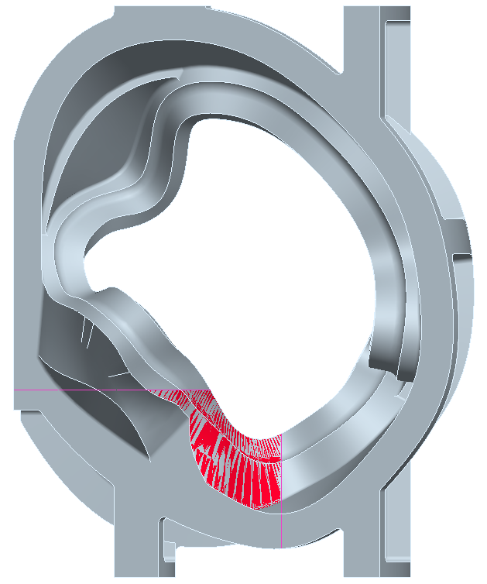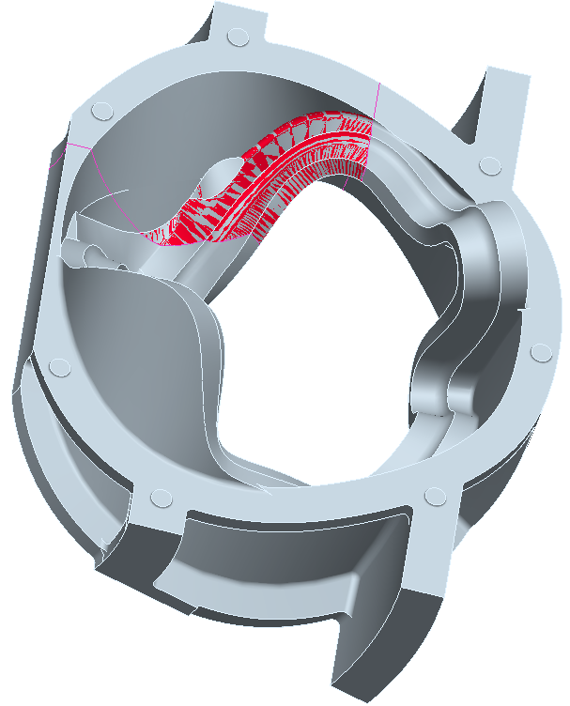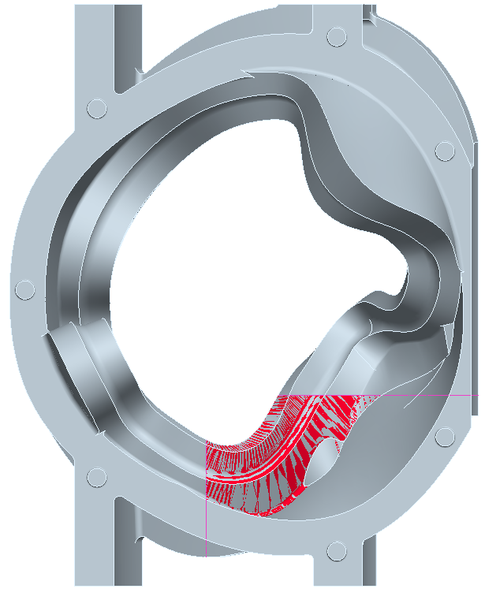

TOP SIDE ISOMETRIC TOP SIDE VIEW BOTTOM SIDE ISOMETRIC BOTTOM SIDE VIEW

 | REPEAT STEPS | SUPPLEMENTAL REPAIR STEPS | 1ST | 2ND |  | 3RD |  | 4TH |  | 5TH
S220 | WELD SOP 0100  REV 7 | EXCAVATE ANY DEFECTS FOUND DURING RADIOGRAPHY.
S230 | L.P. EXCAVATION  CQP-300  REV 10 | L.P. ALL EXCAVATIONS PRIOR TO WELDING TO ENSURE REMOVAL OF DEFECT.  ACCEPTANCE PER A903. ACCEPTANCE CRITERIA-LEVEL 1 FOR HIGH STRESSED AREAS, LEVEL 2 FOR ALL OTHER AREAS. SEE LP DRAWING. | LP - LEVEL II
S240 | WELD MAP | MAP ALL WELDS WITH DIGITAL PHOTO/MAPS INDICATING LOCATION . SERIALIZE DEFECTS ON CASTING, USE SCALE IN PHOTOS AND DOCUMENT SIZE. THIS IS TO BE PERFORMED BY SUPERVISOR, INSPECTION LEAD MAN OR THEIR DESIGNEE, FILE WITH QA.  MUST SEND REPORT ON ALL WELDS OVER 10% OF NOMINAL WALL THICKNESS TO CUSTOMER.  DEFECTS>10% YES ______, REPORT SENT BY _____________________ DATE______________  DEFECTS < 10 % __________________SIGN BY QA ENG.  REPAIRS MAY NOT PROCEED UNTIL INFORMATION IS SUBMITTED.
NOTICE | WITNESS  NOTIFICATION | PROVIDE NOTICE TO EIO AND DCMA AT LEAST FIVE DAYS IN ADVANCE OF WELD STEP.  EIO NOTIFIED ON _____________ DCMA NOTIFIED ON _______________ | Q ENG OR QA MGR
S260 | QA APPROVAL  HOLD POINT | QA TO APPROVE ELECTRODE PRIOR TO USE.  PROCEDURE USED: _______________ MATERIAL /LOT USED :_________________  QUALITY ENG. Name: ____________________ Date: ____________
S270 | WELD SOP 0100  REV 7 | WELD REPAIR DEFECTS AS MARKED.  FOR WELDS <2” - WPS 10-SMAW-CF8MNMN MOD REV 1  FOR WELDS <8” - WPS 15-GMAW-CF8MNMN MOD REV 2  ADD WPS FOR VERTICAL WELDS.
S280 | GRIND  GCHI SOP 0100R2 | HAND GRIND WELDS.
S290 | L.P. WELD  CQP 0300  REV 10 | L.P. WELD REPAIRS ACCEPTANCE PER ASTM A903. ACCEPTANCE CRITERIA-LEVEL 1 FOR HIGH STRESSED AREAS, LEVEL 2 FOR ALL OTHER AREAS. SEE LP DRAWING.  IF OK CHECK HERE __________ WASH AND SEND TO STEP 300.  IF REJECTED CHECK HERE __________AND RETURN TO STEP 220. | LP - LEVEL II | OK  REJ |  | OK  REJ |  | OK  REJ |  | OK  REJ
 | Repeat | Repeat steps s220 to S290 as required till clear through Visual Inspection & Penetrant Inspection. Document rework on a supplemental MTS | QA ENG.

