Rapid response NCR disposition for MCWF C5

MTM inadvertently undercut the surface of the T by 0.080 inches as shown in the following figure. A conference call attended by Ray Sheppard of EIO, Mike Griffith of MTM, David Williamson of ORNL, and Phil Heitzenroeder of PPPL was held at approximately 5:30 p.m. on 3/29/06 to discuss this and MTM's proposed resolution. The right hand figure shows their proposed repair, which is to machine up little break slot with 2.350 inches rather than 2.250 inches. The cast shim plate be machined to the 2.350 inch dimension to compensate. Mike Griffith noted that even with this increased slot width the break flange thicknesses will still be within tolerance.
David and Phil agreed with this proposed repair. EIO will write this up as a formal NCR for formal disposition tomorrow.

Flange area of poloidal break finished machined .100” off location to this side.
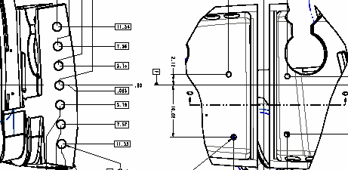
The area of the T section inward including the area highlight in red has been undercut into this surface approximately .08”. This area has been cut on location.
PROPOSED REPAIR
Machine the left side of the break above to the correct location per the drawing. This will blend into the area of the T that is currently undercut. Machine the T section on the right side of the break to match the flange surface that was cut off of location (approximately .100”). The slot width will finish at 2.350” rather than 2.250”. In order to accommodate the oversized slot, the shim thickness will need to be machined to 2.225 rather than 2.125”. The additional .100” of stock will be added to only one surface on the shim and profile machined accordingly (see picture on next page).



