www.3DScanco.com
1143 Barrett Bluff Dr, Lawrenceville GA 30045 – (678) 698 7998

Project # 0412
Fusion Chamber Castings
A Casting
Tim Wenninger
Project Manager
Lawton Pattern Division
1950 De Pere, WI 54115
timw@calawton.com
920-983-4053

This letter is intended to document a tolerance loss observed during dimensional inspection of an A casting and the corrective actions that were used to recover satisfactory tolerances. The tolerance loss occurred due to an unforeseen set of circumstances and Standard Operating Procedures will be updated to prevent future problems even in such a rare occurrence.

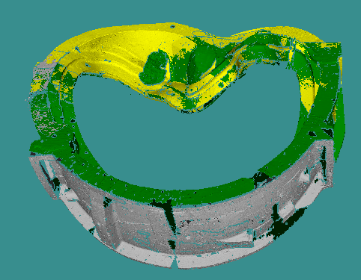
The castings were scanned in three separate “sessions” as shown in yellow, green, and gray. Each session was scanned using a Konica-Minolta 9i/PSC-1 measurement system ISO certified to +/-0.05mm (0.002in).

This system uses a widely accepted technique called Photogrammetry to establish the accuracy of the measurement session. Theoretically only 3 points are required to establish a reference system. When more than three points are used the redundancy allows the system to track error.
For this part, over 300 reference markers were used.

Figure 1: The part was measured in 3 separate measurement sessions.

Each of the three major sessions shown above when considered independently is known to be within the accuracy capabilities of the system. The task of combining the separate measurement sessions typically relies on simply locking in overlapping data to lock in the separate sessions together. The unique geometries provide a 3d “lock and key” that ensures an accurate alignment.

The problem encountered on this casting occurred when trying to locate the bottom session (in grey above) relative to the main session (in green above). The main session was taken with the part resting on the floor such that the entire grey surface was not accessible as shown in Figure 2.

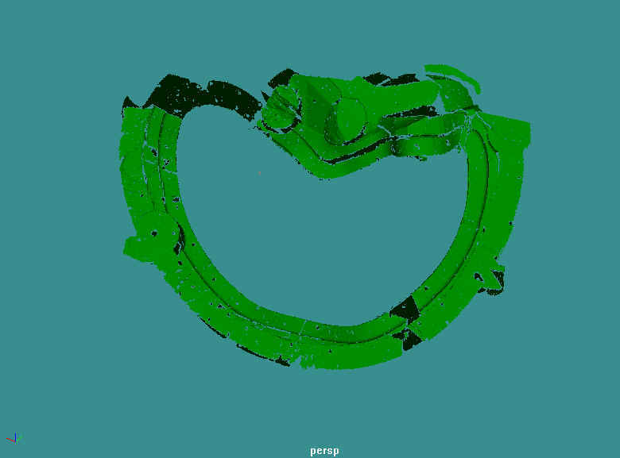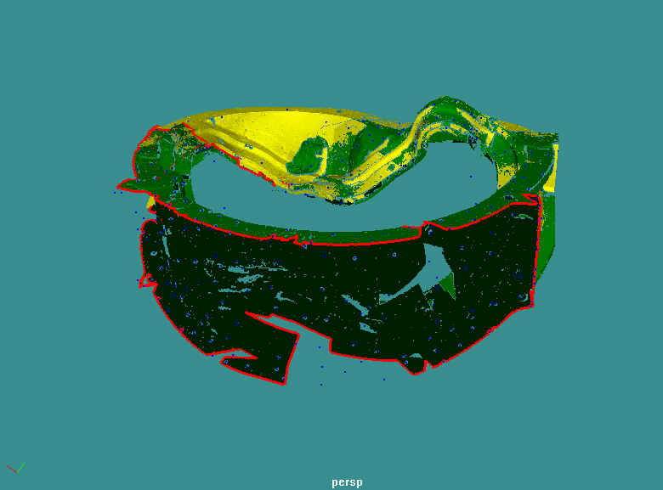
Figure 2: The main scan was performed with the part in an upright orientation. This left the underside of the part un-scanned since it was facing the floor.

Typically the goal is to get enough overlap between any two sessions so as to enable a tight lock between them, as shown between the yellow and green sessions in Figures 2 and 3. When the part was layed down to scan the bottom (grey side) the problem was that the edge of the scan almost exactly matched the edge of the green session. There was some overlap on the left side but the lack of overlap on the right side caused a misalignment to occur that resulted in the grey session not being placed properly and thus producing error in thickness calculations in that area. The fact that the outlines (shown in red) matched so closely is a rare occurrence that caused an unforeseen problem.
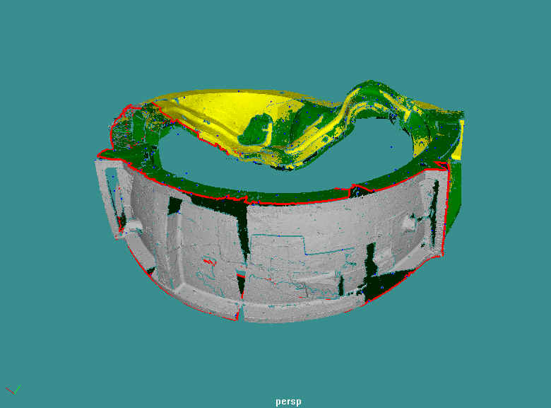
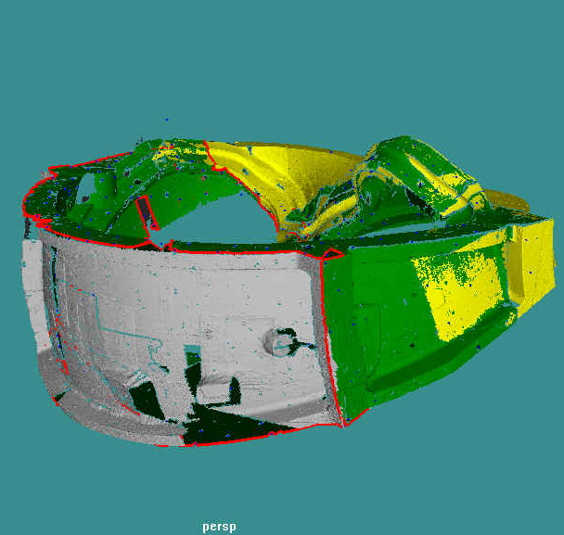
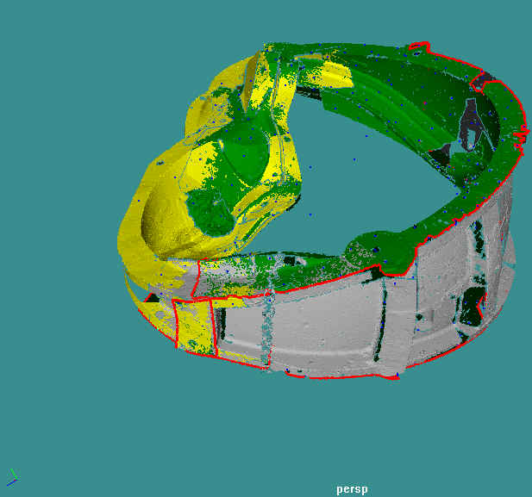

Figure 3: The edges of the green and grey sessions are shown in red.
The Solution:
To rectify the problem, reference marks were recovered from the original data. The points circled in Figure 4 were captured in the background on the opposite side of the part. These reference marks were then able to be used to register the grey session to the green session. Not only did it provide a solution for aligning the two but it also provides an achieved accuracy result. The cluster of reference marks matched from grey to green sessions to within +/- 0.00175 inches! Unfortunately because there were no reference marks in common in the foreground of the grey scan and the fact that these reference marks are on the opposite side of the part, a lever arm effect must be accounted for to compensate for how a small error on the opposite side is magnified before it resolves on the foreground side.
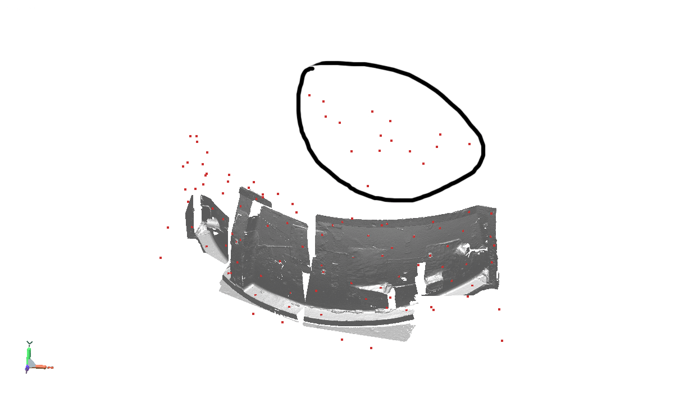
Figure 4: A cluster of reference markers was fortunately recovered in the background of this scan.

Achieved Accuracy:
All three sessions independently remained within working tolerances during the scanning operation and thus the quoted system accuracy of 0.05mm (0.002in) applies. When considering the entire inspection as a whole, the largest error source is from this lever arm effect due to having to use reference marks from across the part. A conservative distance of 120in was used for the lever arm as the part can easily fit inside that distance. Similarly a conservative “platform width” of 24in was used to approximate the width of the “base” of the lever arm since the cluster of reference marks used is at least 24in in the narrowest area. Therefore the achieved accuracy when considering the fact that there is a lever arm effect comes to 120tan(sin^ -1(0.0035/24))=0.018in or +/-0.009in. Therefore the thickness measurements and all other measurements on the inspection should have tolerance of +/- 0.009in taken into consideration at all times. If that achieved accuracy is not sufficient, then it may be necessary to rescan in order to attempt to achieve a higher tolerance.
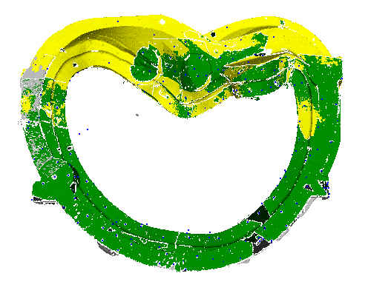
.0035in
24in
120in
Achieved accuracy= 0.018in (+/-0.009in)

3dScanCo
Project | 0412
Measured by | Karol Hatzilias
Dates | 6-7-05 & 7-5-05
Scanner Make | Konica Minolta
Scanner Model Number | 9i
Scanner Serial Number | 1001020
Scanner Last Calibrated | 6-6-05
Scanner Cal Artifact | 1001020
Photogrammetry Make | Konica Minolta
Photogrammetry Model | PSC-1
Photogrammetry Serial | 7281026
Photogrammetry Last Cal | 6-6-05 & 6-16-05
Photog Cal Artifact | 7141013

Disclaimer:

The results of this analysis are believed to be reliable but are not to be construed as providing a warranty, including any warranty of merchantability or fitness for purpose, or representation for which 3dScanCo assumes legal responsibility. Client should undertake sufficient verification and testing to determine the suitability of any information presented. It is the sole responsibility of the Client to review the results and make any determinations. Nothing herein is to be taken as permission, inducement or recommendation by 3dScanCo to practice any patented invention without a license or to in any way infringe upon the intellectual property rights of any other party.

TERMS AND CONDITIONS OF SALE – 3D SCANNING PRODUCTS AND SERVICES

1. AGREEMENT This Quotation is an offer for 3dScanCo, LLC to sell the services/products described herein and is expressly conditioned upon Client's acceptance to be binding upon 3dScanCo. By accepting this offer, Client agrees to and accepts all these terms and conditions; any additional or different terms or conditions contained in any document sent by Client to 3dScanCo shall be of no effect. By acceptance of any services produced hereunder, Client specifically waives any additional, or different terms or conditions. Acceptance hereof shall occur when Client (1) in writing, by facsimile transmittal (FAX), or otherwise authorizes 3dScanCo to perform any of the work, shown on the face hereof, or (II) 3dScanCo delivers any of the services described herein to Client, whichever occurs first. Upon acceptance by Client, this document constitutes the entire agreement ("Agreement") between 3dScanCo and Client and Client’s permitted successors and assigns and supersedes all previous written or oral agreements or understandings between the parties with respect to the subject matter of this Agreement, and may not be assigned by the client without the advance written consent of the 3dScanCo. Any provision hereof prohibited or unenforceable under applicable law shall be ineffective only to such extent and without invalidating the remaining provisions of this document. No order may be canceled or altered by Client except upon 3dScanCo's prior written consent. [Client acknowledges that the work performed by 3dScanCo pursuant to this Agreement is a service, and that although 3dScanCo may produce a product in conjunction with that service, the predominant thrust of 3dScanCo's work is a service.]

Client acknowledges that delivery dates set forth in the Quotation represent estimated delivery dates and are not intended to be binding upon 3dScanCo. Acceptance by Client of services as set forth in the Quotation (or subsequently agreed to by the parties) AND no communication to the contrary by Client to 3dScanCo within ten (10) days after such acceptance constitutes admission by the Client of 3dScanCo's satisfaction of its obligations to Client. 3dScanCo shall not be liable for any damage resulting from any cause beyond 3dScanCo's control, including, without limitation, an act of God, act of the Client, embargo or the government act, regulation or request, fire, accident, strike, slowdown, war, delay in transportation, inability to obtain necessary labor, materials, or manufacturing facilities.

2. RIGHT TO CHANGES 3dScanCo has the right to cancel and declare null and void this Agreement without liability to the Client other than refunding to Client any payment for services tendered prior to cancellation. Any changes in drawings, materials, design specifications, or masters which affect the scope of the project, will entitle 3dScanCo to establish new prices, and if work has been started, 3dScanCo shall be properly reimbursed for work already performed if the work was approved by the client. Client has the right to cancel a product development program at any time by written notice to 3dScanCo. The Client remains obligated to pay for work performed through the date that the cancellation notice is received by 3dScanCo plus a cancellation charge equal to 25% of the quoted fee for the canceled service.

3. PAYMENT Prior to commencement of work, Client will deposit 50% of the quoted fee with 3dScanCo, with the remainder due upon completion of each phase. Invoices are due and payable per the terms so noted on respective invoice ("due date"). Any amount not paid by due date shall be subject to a finance charge of 1.5% per month until paid. Client agrees to pay all 3dScanCo's reasonable attorney fees, collection fees and costs arising out of any breach by Client of this or any subsequent Quotation or Agreement. 3dScanCo shall not be obligated to perform upon any order until 3dScanCo receives any agreed upon deposit. Amounts held on deposit shall not bear interest.

All prices quoted shall be exclusive of transportation from the F.O.B. point, insurance, taxes, license fees, customs fees, duties and other charges related thereto. If 3dScanCo pays any such shipping charges, premiums, taxes, fees, duties, and other charges, Client will promptly reimburse 3dScanCo therefore. Client shall report and pay any and all such shipping charges, premiums, taxes, fees, duties, and other charges related thereto and shall hold 3dScanCo harmless therefrom.

4. PATENTS, COPYRIGHTS: APPROVAL 3dScanCo neither warrants nor represents that any services furnished hereunder may create rights, which may be patentable or copyrightable. Client shall review and approve all plans, drawings, sketches, renderings, diagrams, specifications, models, and prototypes prepared for Client by 3dScanCo (collectively "design work"). Such approval shall constitute Client's warranty and representation to 3dScanCo that no design work or product produced by 3dScanCo for Client infringes upon any patent, copyright, or trade secret. Client acknowledges that 3dScanCo is relying upon Client's representations herein and that 3dScanCo has not made, and is not obligated to make, any independent inquiry or investigation. Upon receipt by 3dScanCo of all payments due under this Agreement, all final designs or concepts presented by 3dScanCo under this Agreement will become the property of the Client. 3dScanCo will assist the Client in protecting any proprietary rights herein upon reimbursement of its charges for time and expenses.

5. INDEMNIFICATION Client will indemnify and hold harmless 3dScanCo from and against any and all product liability claims, including but not limited to any and all claims for personal injuries or property damages caused by any alleged defect in the product. Client understands that 3dScanCo will perform no products testing and that 3dScanCo is not responsible for providing any written warnings or instructions to Client or any other party. 3dScanCo will make best efforts to meet design specifications as set forth by Client but Client is not relying on any advice given by 3dScanCo concerning safety or testing of the products. Client shall obtain and maintain product liability insurance coverage in a sufficient amount to cover all product liability exposure, which insurance shall be primary for any claim arising out of a product. When requested by 3dScanCo, Client agrees to provide 3dScanCo with a certificate of insurance naming 3dScanCo as an additional insured before any final parts or design is completed.

Client will indemnify and hold harmless 3dScanCo from and against any claim that the design work contemplated by this Agreement violates any patent, trademark or other proprietary rights. EXCEPT AS OTHERWISE SPECIFICALLY PROVIDED IN WRITING FROM 3DSCANCO TO CLIENT, 3DSCANCO MAKES NO WARRANTIES WITH RESPECT TO THE GOODS/ITEMS/SERVICES COVERED HEREUNDER, AND SELLER EXPRESSLY DISCLAIMS ANY AND ALL WARRANTIES, EXPRESS, STATUTORY OR IMPLIED, INCLUDING THOSE OF MERCHANTABILITY AND OF FITNESS FOR ANY PARTICULAR PURPOSE.

The parties to this Agreement intend for this indemnity provision to survive the expiration of this Agreement.

6. LIMITATION OF LIABILITY - 3DSCANCO SHALL NOT BE LIABLE TO THE CLIENT OR ANY OTHER PERSON OR ENTITY FOR SPECIAL, INCIDENTAL, INDIRECT, EXEMPLARY, PUNITIVE OR CONSEQUENTIAL DAMAGES RESULTING FROM 3DSCANCO'S FAILURE TO PERFORM UNDER THIS AGREEMENT, SUCH AS, BUT NOT LIMITED TO, LOSS OF OTHER PROPERTY OR EQUIPMENT, LOSS OF PROFITS OR REVENUE, COST OF CAPITAL OR CLAIMS FOR SERVICE INTERRUPTIONS. THE REMEDIES OF THE CLIENT SET FORTH HEREIN ARE EXCLUSIVE, AND THE LIABILITY OF 3DSCANCO WITH RESPECT TO THE QUOTATION, OR ANYTHING DONE IN CONNECTION THEREWITH SUCH AS THE PERFORMANCE OR BREACH THEREOF, OR FROM THE PERFORMANCE, MANUFACTURE OR SALE, DELIVERY OF ANY PRODUCT OR SERVICE COVERED BY OR FURNISHED UNDER THIS QUOTATION, WHETHER IN CONTRACT, IN TORT, UNDER ANY WARRANTY, OR OTHERWISE, SHALL NOT EXCEED THE PAYMENTS RECEIVED BY 3DSCANCO FROM THE CLIENT FOR THE PRODUCT OR SERVICE ON WHICH SUCH LIABILITY IS BASED. THIS LIMITATION SHALL APPLY WHETHER OR NOT THE CLIENT OR SUCH OTHER PARTY HAS BEEN ADVISED OF THE POSSIBILITY OF ANY OTHER DAMAGES.

THE PARTIES TO THIS AGREEMENT INTEND FOR THIS LIMITATION OF LIABILITY PROVISION TO SURVIVE THE EXPIRATION OF THIS AGREEMENT.

7. Professional Credit Upon public release of the product developed under this agreement, Client grants 3dScanCo the right to use the design work in its promotional and advertising materials.

8. NO WAIVER No provision hereof and no breach of any provision hereof shall be deemed waived by any previous waiver of such provision or of any breach thereof, by any previous custom, practice, or course of dealing or by 3dScanCo's failure to object to provisions contained in any communication order from Client.

9. Statute of Limitation. No action arising out of, in connection with, or relating to this Agreement or the subject of this Agreement shall be brought more than one (1) year after the accrual of the cause of action. This period shall not be extended for any reason, except by the written consent of both parties. All statutes or provisions of law which would toll or otherwise affect the running of the period of limitation are hereby waived, and no such statute or provision of law shall operate to extend the period limited in this paragraph.

10. WARRANTY – Equipment is subject to the original manufacturer’s prevailing warranty, terms and conditions. 3dScanCo provides no warranties in any way that extend beyond the original manufacturer’s warranty. The results of any services are believed to be reliable but are not to be construed as providing a warranty, including any warranty of merchantability or fitness for purpose, or representation for which 3dScanCo assumes legal responsibility. Client should undertake sufficient verification and testing to determine the suitability of any information presented. It is the sole responsibility of the Client to review the results and make any determinations.

