Energy Industries of Ohio (EIO) Team Weekly Status Report

Report covers the NCSX Modular Coil Winding Form Activities Including:
- Production Contract S005242-F
- Change Order 5 under the Prototype Development Contract S-04341F
- Purchase Order PE005678-W
Week ending April 8, 2005

- Administrative Highlights

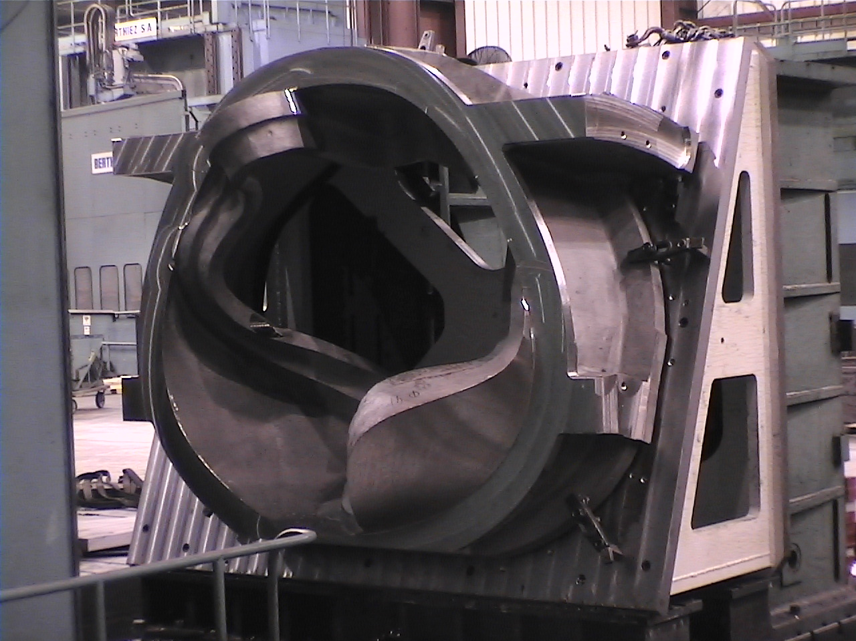

C1 Coil partially machined

The EIO team has now reached the stage where production activities are in full swing at all team member facilities. This week, while the production of C-1 successfully transitioned from Metal Tek to Major Tool where the machining process is well underway, C Pattern upgrades were completed at Metal Tek, which will enable production of C-2 to commence next week.

Meanwhile, the A Pattern successfully passed inspection and with EIO approval was shipped from Lawton to Metal Tek, where it is anticipated that set-up and pouring of A-1 will follow closely behind C-2. Solidification Modeling of B was also reinitiated this week at Metal Tek and with the A Pattern completed, Lawton is eager to move into production of the B Pattern.

With so many activities in progress and/or ready to commence, EIO requested a telecon with PPPL to ensure that all administrative requirements, particularly those related to Quality Assurance, are up to date and in order. The call is scheduled for Monday April 11, 2005 at 10:30am EDT. Call in number is 1-877-952-1506; pass code 833648. PPPL has also suggested that this is an ideal time to assess lessons learned and has invited the EIO team to share ideas about process improvements to facilitate production management.

Administrative Action Items:

- (PPPL) There was discussion at the kickoff meeting about the possibility of providing the Coil C prototype poured by the JP Pattern group (along with any additional raw material they might have) to Metal Tek to use as raw material.
Status: (Open) Per recent update this week from Phil Heitzenroeder, PPPL will need this casting through the end of April for testing. Meanwhile, Phil has been investigating scrap values to enable him to begin the disposition process at PPPL.

- (Metal Tek/EIO/PPPL) Provide scrap value of JP Pattern coil C prototype.
Status: (Closed) Response to PPPL provided via e-mail on 4/8/05

- (PPPL) Revise specification to eliminate the requirement for prior approval on major weld repairs.
Status: (Open) Per e-mail from Frank Malinowski, this change is in process at PPPL.

- (PPPL) All technical and administrative activities related to Purchase Order PE005678-W have been completed by EIO and its team members. Final invoice was submitted to PPPL for payment this week.
Status: (Open) Awaiting PPPL payment of invoice.

- (PPPL) All technical and administrative activities related to Prototype Development Contract S-04341F, including Change Order 5 have been completed. Final invoice was submitted to PPPL for payment.
Status: (Open) Awaiting PPPL payment of invoice.

- (PPPL, Lawton, MTK, MTM) EIO is soliciting comments and feedback regarding the value of Grandview for team member contract management in order to determine whether or not we should continue to populate and maintain this database for the duration of the production contract.
Status: (Open) It has been suggested that Grandview could play an increasing role in the QA management process. This topic will be considered during the upcoming telecon on 4/11/05.

- Technical Highlights

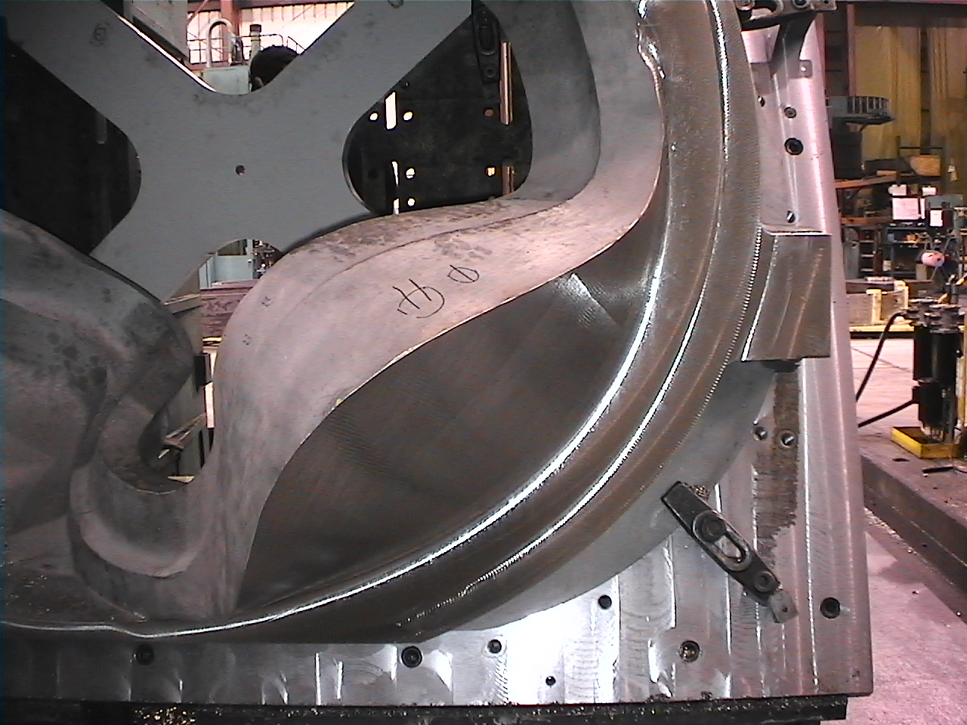
C-1 at Major Tool
Major Tool reports significant accomplishment during the first full week of machining C-1. The first flange face and periphery including the (4) legs are machined to within .250" stock. The pickup holes/qualifiers and the lifting holes as previously submitted are installed. We are now beginning to plunge rough the "T" section. The above photo shows the outside surfaces of the large areas that protrude past the flange faces which are contour-rough-machined to .250" stock as well. Kevin Bowling reports that the machining is progressing very well to date. Some initial vibration was dealt with by “dialing in” the fixture.
Joe Edwards reports that they have finished the modifications to the C pattern. All of the new custom chills have been fabricated and Metal Tek is prepared to start molding the C pattern next week, with the actual “pour” still on track for 4/15. Before molding starts however, Metal Tek will be submitting a revised MIT to EIO.

The A pattern was shipped this week from Lawton’s Pattern Division and arrived at Metal Tek on 4/8/05. If everything goes smoothly with the pouring of C-2, plans are underway to enable pouring of A-1 perhaps as soon as April 22, 2005.

ESI will be starting the solidification modeling process on the stocked B model this week. They estimate that it will take them from 4-6 weeks to complete a successful model based on the amount of iterations needed on the previous 2 coils. At the request of Roger Broman, Lawton re-sent the earlier stocked model to Metal Tek & ESI to make sure we are all working from the latest file. Lawton is now waiting to receive a successful solidification model from Metal Tek before proceeding further with B.

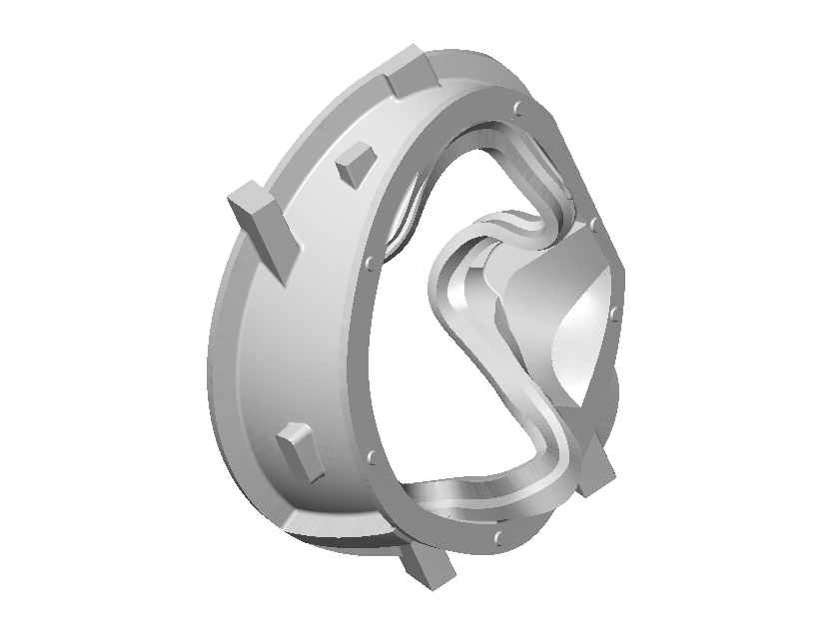

Vital statistics for the stocked model

Volume: 36,767.72 cu in
Mass: 10,651.9160 lb
Material: Stainless Steel 8.02000 g/cm3
Ext Vol: 614,250.48 cu in
Surf Area: 25,508.56 sq in
Center Gravity: (53.18,-1.18,-30.25) in
X Extent: 89.27 in
Y Extent: 113.28 in
Z Extent: 60.74 in
X Mold Area: 6434.54 sq in
Y Mold Area: 4898.79 sq in
Z Mold Area: 7573.04 sq in

Coil B Casting Model

EIO has posted a free 3D Viewer with the B model inserted, for anyone that would like to view this file but does not have CAD software. It is located on Grand View at: \files\files\ coil-b-solid-modeling-file.exe

Technical Action Items

- (Metal Tek) Solidification Modeling of Coil B.
Status: (Open) ESI is starting the 1st iteration this week. Based on past experience, they expect the process to take 4-6 weeks.

- (Metal Tek) New solidification model for Coil C
Status: (Closed) Fluid flow analysis was successful.

- (Major Tool) Machining Schedule for Coil C1
Status: (Open) Machining process was started on 4/1. Current machining operation is estimated at 12 weeks, however MTM has committed to seek efficiencies and improve upon this lead-time if at all possible.
- (Metal Tek) Finalize modifications to C pattern – fabricate chills
Status: (Closed) Modifications are done and pattern is ready to be molded w/o 4/11/05.
- (Metal Tek) Molding & pouring of C2 casting
Status: (Open) Scheduled to begin the week of 4/11/05.

- Quality Activities

The A pattern, was successfully scanned and has passed final inspection. Lawton has certified the results and the pattern was released for shipment. The images scanned by Scanco can be viewed at the following link:

http://www.3dscanco.com/Clients/lawton/A/A_patterns.htm

Other related documents, have all been sent over to PPPL as well posted to Grand View in the \files\quality_Review folder.

PPPL is still expecting to receive the Metaltek MTS for C-2, and expressed concern that PPPL approval precedes work on C-2. The MTS is under review and should be submitted by 4/11/05 at latest. According to Pete Djordjevich and Joe Edwards, release and submittal of the MTS will occur prior to both molding and pouring of C2. This topic will be addressed in the telecon on Monday, 4/11/05 to ensure that all necessary PPPL approvals are in place as production of C-2 commences.

The topic of weld repairs is still open and under review at PPPL. PPPL has requested that documentation related to major weld repairs include the locations of those major weld repairs (as required by A703, S20). EIO Corrective Action Report will be updated to include this language and this requirement will flow down to Metal Tek for inclusion in their MTS.

Chuck Ruud of Metal Tek reports that he doesn’t have a problem with requested MIT changes as long as the release to weld repair is simultaneous with Metal Tek’s sending in the weld info. PPPL has agreed to this procedure and is updating the specification to reflect this concurrent review (see Administrative Action Item #3). Meanwhile, Chuck plans to have the draft out to EIO shortly.
Frank Malinowski also had some questions for Major Tool this week regarding machining sequence and steps at MTM. Several questions were raised when trying to correlate the QA Plan Summary (revised 2-9-2005, dated 3-06-05) with the alignment process discussed in the conference call on 3/29/05.
An email highlighting these concerns was sent to EIO detailing 4 specific questions which were answered by MTM and sent back to PPPL on 4/6. Copies of both emails have been entered as Status Logs in Grand View under the General Comments section. For clarification purposes and to avoid confusion in the future, MTM has agreed to modify their MTS in accordance with this email, per a conversation between Pete Djordjevich & Kevin Bowling.
- Upcoming QA Activities

  - Assembly of required data on C-1 for submission to PPPL (calibration of #D Scanco equipment)
  - Revised MTS from Metal Tek
  - Revised MTS from Major Tool
  - QA Telecon on 4/11/05 at 10:30am EDT

QA Action Items:

- (PPPL) Submitted vertical weld procedure and corrective actions to PPPL concerning Metal Tek on 3-4-05.
Status: (Open) Awaiting response from PPPL.
- (Metal Tek) A graph outlining required data for shipment was sent to Metal Tek for completion. EIO must be informed on 3/28 of any data that cannot be supplied prior to shipment so that EIO can submit a waiver pending data submittal. Waiver will be required to release shipment to MTM
Status: (Open) EIO has received required information from Metal Tek and has submitted information and a waiver request to PPPL. Waiver has been approved pending receipt of the balance of the information on 4/29.
- (EIO) Deviation Request for Approved Processing Plan covering the use of 3D ScanCo for dimensional inspection prior to radiography.
Status: (Open) Various URLs were submitted to PPPL from 3D Scanco. None of these were functional. Pete Djordjevich will contact 3D Scanco and have them send the URLs directly to Frank Malinowski

- (MTM, PPPL) Completion of QA MIT plan and resolution of outstanding PPPL questions & implementation of suggestions.
Status: (Open) Fiducials resolved. Kevin has also agreed to implement the changes to the wording on the electrical test procedure suggested by PPPL. This will not hold up machining activities when C-1 is received, as this testing is done at the end of the process.

We are all in agreement that good communications result in improved productivity. If there are any suggestions or ideas about ways we can make this weekly report more useful for your needs, please don’t hesitate to let us know. You can reach me by phone at 216-496-2314 or e-mail at NKHFlowen@aol.com or contact our Technical Liaison, Roy Sheppard by phone at 800-337-3083 or by e-mail at RoyJRATC@aol.com. We look forward to hearing from you.

Nancy Horton
EIO Program Manager for NCSX

