Energy Industries of Ohio (EIO) Team Weekly Status Report

Report covers the NCSX Modular Coil Winding Form Activities Including:
- Production Contract S005242-F
- Change Order 5 under the Prototype Development Contract S-04341F
- Purchase Order PE005678-W
Week ending April 22, 2005

- Administrative Highlights

EIO team production is now in “full swing.” I am pleased to report that C-2 was successfully poured by Metal Tek over the last weekend and as of Monday morning, April 18, 2005, the cope was already off and the part was cooling. Major Tool also reports considerable progress on the machining of C-1 and with activities underway for the A coils and B pattern development, we are well on our way to successful accomplishment of our contract deliverables. Details of these activities are summarized in the Technical Highlights section of the report.

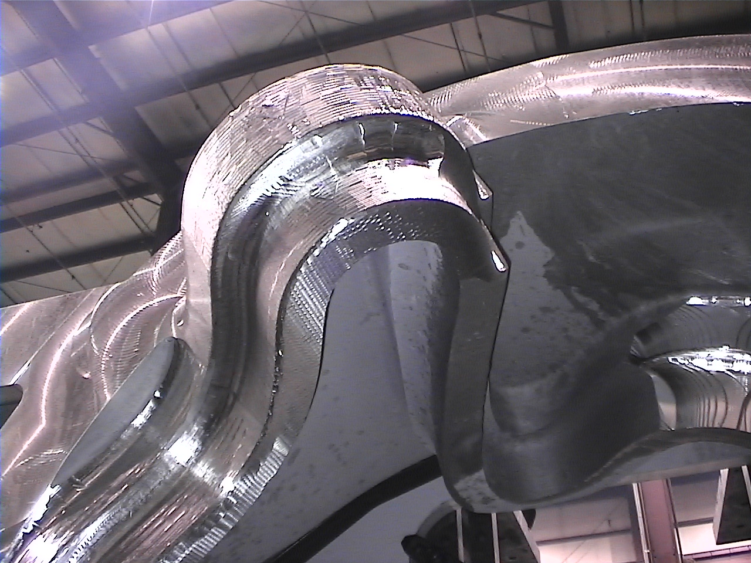

Rough Machining on C1 Racetrack

Based on the recent events, we have updated our schedule in Grand View to reflect: 1) the actual pour date of the C2 casting, 2) progress on the C1 machining and 3) expected pour date of the A1 casting. As part of the monthly reporting process, the schedule will be reevaluated again at the end of the month and if necessary, updated, depending on the feedback from Major Tool regarding machining progress and input from Metal Tek on any accomplishments relative to C-2 and to A-1.
I am also happy to report that our newly implemented procedure to manage outstanding action items is already facilitating coordination and resolution of those actions, as reflected in the notes below. We kicked off the week with an administrative telecon involving Phil Heitzenroeder and Frank Malinowski of PPPL, and Roy Sheppard and Nancy Horton of EIO. Using the most recent weekly report as the basis for discussion, we reviewed the QA and Technical action items to ensure that the status reflected a mutual understanding of the accomplishments and expectations. Notes from the telecon were integrated into the PPPL Quality notes for the week, which now serve as a guide in preparing the EIO weekly report. In addition, Larry Sutton provided formal PPPL approval of Corrective Action 0001 to EIO on April 18, 2005.

Administrative Action Items:

- (PPPL) There was discussion at the kickoff meeting about the possibility of providing the Coil C prototype poured by the JP Pattern group (along with any additional raw material they might have) to Metal Tek to use as raw material.
Status: (Open - No Change) In-process at PPPL.

- (PPPL) Revise specification to eliminate the requirement for prior approval on major weld repairs.
Status: (Open) Changes have been incorporated into the draft version of the specification, which is currently under review at PPPL.

- (PPPL) All technical and administrative activities related to Purchase Order PE005678-W have been completed by EIO and its team members. Final invoice was submitted to PPPL for payment this week.
Status: (Open - No Change) Awaiting PPPL payment of invoice.

- (PPPL) All technical and administrative activities related to Prototype Development Contract S-04341F, including Change Order 5 have been completed. Final invoice was submitted to PPPL for payment.
Status: (Open - No Change) Awaiting PPPL payment of invoice.

- (PPPL, Lawton, MTK, MTM) EIO is soliciting comments and feedback regarding the value of Grandview for team member contract management in order to determine whether or not we should continue to populate and maintain this database for the duration of the production contract.
Status: (Open) Review is still underway and input is still welcome. Recent input seems to confirm that of those individuals who use the system, most currently use it strictly to download pictures and/or documents, which could easily be accomplished through the EIO ftp site.

- Technical Highlights

As highlighted above, C-2 was poured over the weekend. As of 4/22, the casting is mostly cut off with no evidence of the types of shrink seen in the risers on C1. At first glance, it looks like the modifications we made to the pattern may have solved some of our earlier challenges. Obviously, we still need to blast, inspect and radiograph, but as of now Metal Tek is very encouraged. Joe Edwards has promised us some photos next week of C2, as he says “after we’ve had a chance to clean it up a bit.”
Joe Edwards also reports that the final modifications are being made to the A pattern. Molding will begin early next week, with the pour scheduled for the end of the week.

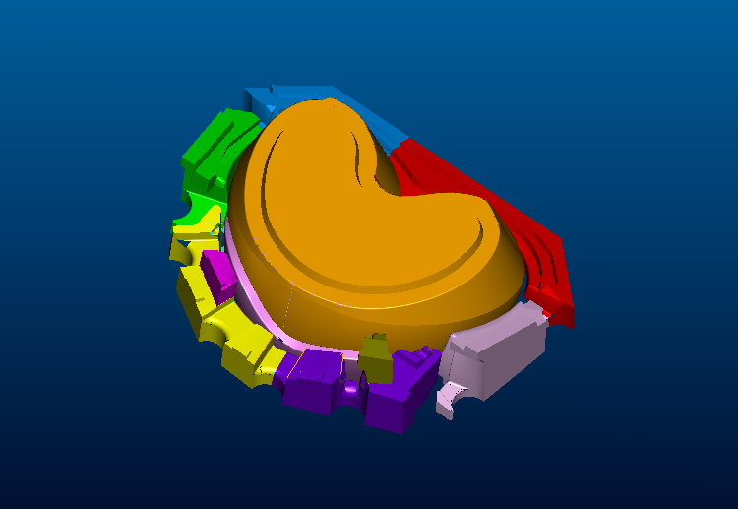

Coil A cores

The above screen shot pictures the Coil A cores. A detailed set of TIF files depicting the cores and the assembly sequence was sent by Lawton to Metal Tek earlier this week. These shots serve as a guide to assembling the pattern on the shop floor. These files have been posted to Grand View in a zip file (\files\pictures\A Pattern\core-set.zip).

Machining of C-1 at Major Tool has also been progressing well. Kevin Bowling informs us that MTM is very happy with both the quality of the casting and their progress to date. The following photo shows some of the rough machining progress.
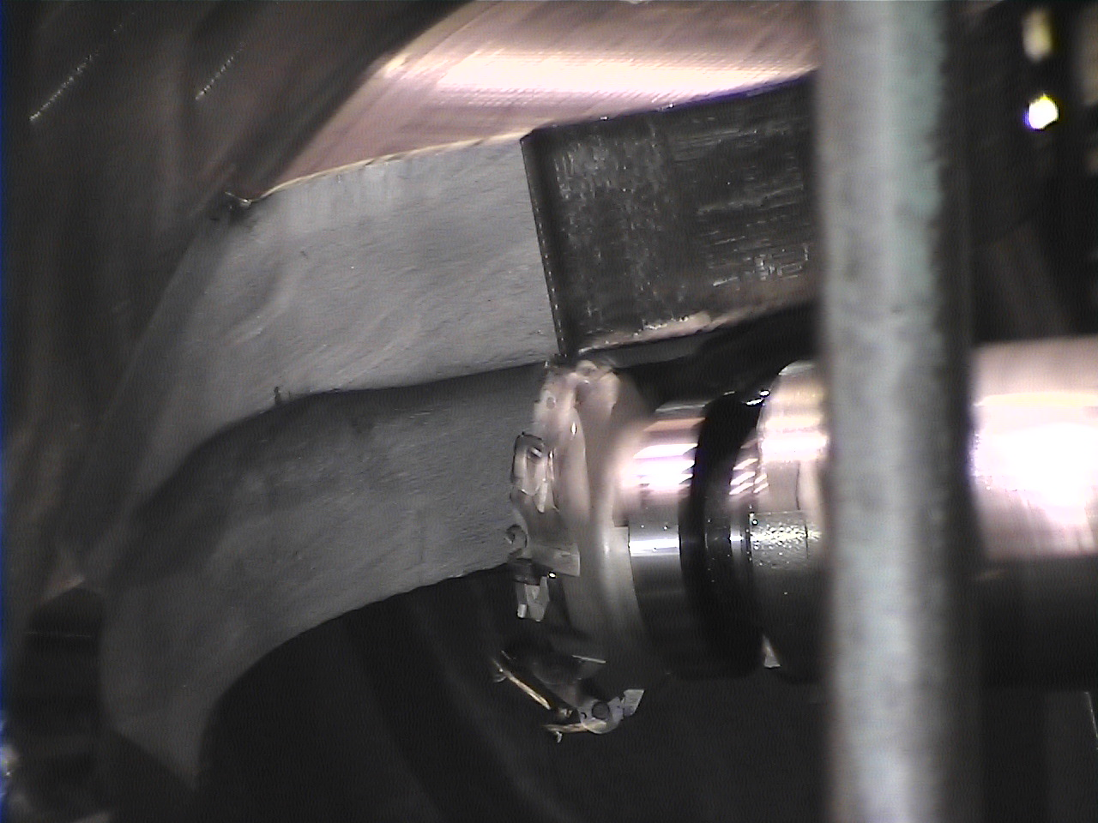

Coil C1 being machined

Additional photos have been placed in Grand View (2 zip files - \files\pictures\C1 Machining\ DVC01238.zip & DVC01279.zip). MTM has plunge-roughed all of the stock that can be removed economically using that method from the side facing the machine. They are now contour roughing the remaining stock with the largest cutting tool. All of the areas that are machined are within .250" from finish. By mid next week, we should be removing the casting from the fixture and flipping it 180º to start rough machining on the other side.

Kevin tells us that the learning gleaned from both the preliminary practice on the prototype and these first three (3) weeks of machining has been invaluable. For the upcoming monthly report, MTM intends to assess progress in order to evaluate whether improvements can be expected in the casting’s delivery date. This topic may also be addressed during PPPL’s visit to Major Tool on 4/28.

Technical Action Items

- (Metal Tek) Solidification Modeling of Coil B.
Status: (Open - No Update) Process initiated week of 4/4/05. Based on past experience, they expect the process to take 4-6 weeks.

- (Major Tool) Machining Schedule for Coil C1
Status: (Open) Machining process was started on 4/1 and to date the process has been proceeding well. Current machining operation is estimated at 12 weeks, however MTM has promised to review that schedule on 4/29 based on 4 weeks of machining data. PPPL approved MTM MIT Plan on April 15, 2005, so machining can proceed through completion.
- (Metal Tek) Molding & pouring of C2 casting
Status: (Closed) C-2 was poured over the weekend of April 16th.

- Quality Activities

Pete Djordjevich has been coordinating a variety of Quality activities this week including 1) working with Chuck Ruud of Metal Tek to finalize their MTS, with particular concentration on developing the calibration scheme for the Romer arm, 2) securing the required documentation from 3D ScanCo to satisfy PPPL inspection control requirements and 3) coordinating with Frank Malinowski to reach closure on any lingering actions.

As presented under the Administrative highlights section of this report, EIO and PPPL have implemented a new procedure to ensure timely resolution of QA action items. One topic in particular that has been open for discussion revolves around submission of data for weld repair. During this week’s telecon, Frank Malinowski clarified that he is expecting the test data being submitted by Metal Tek regarding weld material and base metal to be derived from more than one sample, so as to establish a baseline or “library” of data. If we are unable to furnish published data on the Lincoln weld material we would need to give PPPL additional Charpy V-notch data if we changed heat lots. Follow-up with Pete Djordjevich confirmed that this is aligned with previous instructions to Metal Tek. Currently this data is due to PPPL on April 29, 2005.
Upcoming QA Activities
  - Assembly of required data on C-1 for submission to PPPL (calibration of 3D Scanco equipment)
  - Dimensional inspection SOP for Romer arm
  - Test Data for weld material

QA Action Items:

- (PPPL) Submitted vertical weld procedure and corrective actions to PPPL concerning Metal Tek on 3-4-05.
Status: (Open) CAR was approved by PPPL on 4/18/05. Approval of the weld procedure is still waiting weld test results (promised by 4/29/05). Initial PPPL review raised concern regarding the lack of Charpy V-Notch (CVN) results for procedure 25-SMAW-CF8MnMn MOD qualification (B316NF). PPPL advises that they are prepared to approve this procedure as soon as either satisfactory filler material qualification documentation is received or satisfactory CVN results for this procedure qualification are delivered.
Requirements from EIO/Metal Tek related to this Action due 4/29/05:
- Mechanical properties at 77K, other than Charpy V-Notch, for C-1 casting
- Mechanical properties, other than Charpy V-Notch at 293K for LNM 4455, for all filler material to be used (LNM 4455 and B316NF)

- (Metal Tek, EIO, PPPL) MIT Plan for C-2 casting.
Status (Open) Conditional approval to proceed to step 100 received with the understanding that PPPL requested changes will be incorporated and resubmitted with the next submission. Pete Djordjevich and Chuck Ruud have been coordinating the revisions.
PPPL has offered this guidance: “We suggest that rather than two more planned deviations, the Manufacturing, Inspection and Test (MIT) Plan be written to accommodate the two different dimensional inspections. While the Manufacturing and Test Sequences (MTS’s) will be prepared for each casting, one “master” of this document could be prepared and submitted as the MIT.”

- (PPPL) EIO sent Metal Tek a “graph” outlining the necessary data required to release C-1 for shipment. Since all data was not available at the time, it was agreed that EIO would submit a waiver to PPPL to release shipment to MTM pending later submission.
Status: (Open) EIO received the required information from Metal Tek and has submitted information and a waiver request to PPPL. During our weekly telecon, PPPL clarified that they are processing approval of the deviation request concerning a single dimensional inspection at Metal Tek which will close this specific action item; however, item 4 will remain open pending submission of acceptable data from 3D ScanCo).

- (EIO) Deviation Request for Approved Processing Plan covering the use of 3D ScanCo for dimensional inspection prior to radiography.
Status: (Open) Information sent to EIO by 3D ScanCo did not delineate methodology or calibration methods. We have gone back to ScanCo again with a specific list of required criteria.

- (EIO) PPPL has requested that a specific reference to mapping in the Metal Tek portion (MTS) be included in the EIO MIT/QA Plan.
Status (Open) Pete Djordjevich will update the EIO MIT plan and resubmit to PPPL.

Once again, we appreciate PPPL’s efforts to facilitate communications. If you have any other ideas or comments that have not been covered in these notes, please let us know. You can reach me by phone at 216-496-2314 or e-mail at NKHFlowen@aol.com or contact our Technical Liaison, Roy Sheppard by phone at 800-337-3083 or by e-mail at RoyJRATC@aol.com. We look forward to hearing from you.

Nancy Horton
EIO Program Manager for NCSX

