Energy Industries of Ohio (EIO) Team Weekly Status Report

Report covers the NCSX Modular Coil Winding Form Activities Including:
- Production Contract S005242-F
- Change Order 5 under the Prototype Development Contract S-04341F
- Purchase Order PE005678-W
Week ending May 6, 2005

- Administrative Highlights

Nancy Horton & Roy Sheppard of EIO visited PPPL on Thursday May 5, 2005, meeting with several individuals and organizations throughout the day including the Director, Rob Goldston and Manufacturing, Procurement and Quality personnel. Many thanks go out to the PPPL community for their hospitality and eagerness to meet and discuss our contract activities.

A common theme from our customer was the importance of maintaining schedule. The NCSX program is under intense scrutiny by the DOE and our performance, which includes on-time delivery, is a key factor in securing continued support and credibility for the overall program. We appreciated this candor and provided assurances that EIO, Lawton, Metal Tek and Major Tool are all committed to upholding the schedule, without risking quality.

Touring the facility provided the opportunity to see the coil winding operation including the twisted racetrack, which is “through winding & ready for potting.” PPPL is now gearing up to receive coil C-1, and Jim Chyrzanowski, Coil Winding Manager, stressed the necessity of keeping him advised of news of deliveries of C-1, C-2 & subsequent coils, so that he can schedule work crews to be ready as the coils hit Princeton’s dock. One idea that may be worth pursuing is whether or not there are any activities that PPPL could perform on the casting while it is still at Major Tool. This could enable concurrent processing in the event there are delays during testing. If practical, this idea will be explored more fully.

During a meeting with procurement, EIO raised the issue of disposition of the patterns (which are contract deliverables to PPPL) after we have poured the last casting. Earlier in the week Joe Edwards had shared that due to the size of these patterns, Metal Tek would like to move them out of the foundry as soon as they have finished using them. Since it is feasible that we will have poured the last C casting in August, Metal Tek will need an answer on the disposition of these patterns within the next several months.

We learned from Hutch Nielson that there is an extremely slight potential of needing 1 additional set of coils cast as spares (note: there have not been any additional funds or authorization granted by DOE for this). Larry Sutton wanted to know if there was any scrap value to these tools. According to Tim Wenninger of Lawton, the parts are not salvageable for other projects, so from their perspective, there is no scrap value. This matter will be added to the list of action items for future consideration and tracking.

While visiting Procurement, Rod Templon and Arlene White informed us of an upcoming Small Business conference they are supporting. The 6th Annual Small Business Conference is being sponsored by the DOE and will be held from June 12 - 15, 2005 in Nashville, Tennessee. PPPL extended an invitation to the EIO team members to attend this event. Information about the conference is available at( www.smallbusiness-outreach.doe.gov )or by calling 888-246-2460.

Another upcoming conference is the SOFE (Symposium on Fusion Engineering) which will be held in Knoxville, TN. from Sept. 26-29, 2005 (http://www.ornl.gov/sci/fed/sofe05/ ). According to Phil Heitzenroder, this Symposium is one of the principal ways that the fusion community exchanges information on the engineering of fusion devices. Phil is preparing an abstract on the production of the NCSX winding forms and the current state of the art in industry that made this all possible. If the abstract is accepted by the conference, EIO team members have been asked to coauthor the final paper. Dave Williamson has also advised that there may be opportunities for exhibiting at this conference.

The final stop on our visit to PPPL was a meeting with the QA department. While it was agreed that recent initiatives have facilitated resolution of several open action items, more attention is still required to ensure that on-going inquiries and submissions can be handled expeditiously. Details on these discussions are included in the QA section of this report. EIO intends to follow-up this visit with a team telecon early next week, during which further opportunities for streamlining the QA process will be explored.

Administrative Action Items:

- (PPPL) There was discussion at the kickoff meeting about the possibility of providing the Coil C prototype poured by the JP Pattern group (along with any additional excess material) to Metal Tek to use as raw material.
Status: (Closed) While we were in the Coil Winding department we saw the Coil C prototype poured by JP Pattern group and used the opportunity to inquire about status of this action. We learned that Princeton has completed their tests on this part, and that Phil Heitzenroeder has been investigating requirements for releasing the part as scrap to Metal Tek. They are currently preparing the required paperwork for submission to DOE and if approved, the part will be furnished. As the longest running open action on our Action Item List, it was agreed that this item could now be closed, as all investigations into this matter are complete.

- (EIO, Metal Tek, Major Tool, Lawton) PPPL to revise specification to eliminate the requirement for prior approval on major weld repairs.
Status: (Open) PPPL has issued a contract amendment which includes their proposed revised language. It now reads: “The NCR (or EIO equivalent) shall be delivered to PPPL within 24 hours of the start of welding. PPPL will respond with concurrence or disapproval within 1 working day.” This amendment is now under review by EIO and its subtier contractors and responsibility for the action has been transferred to the EIO team members.

- (PPPL) All technical and administrative activities related to Purchase Order PE005678-W have been completed by EIO and its team members. Final invoice was submitted to PPPL for payment this week.
Status: (Closed) During our visit, Arlene White provided an update on this action. The invoice was approved on 5/3/05 and the check will be issued on 5/6/05. EIO will follow-up in a week if check is not received. Otherwise, this action is considered closed.

- (PPPL, EIO, Metal Tek) All technical and administrative activities related to Prototype Development Contract S-04341F, including Change Order 5 have been completed. Final invoice was submitted to PPPL for payment.
Status: (Open) Larry Sutton requested additional supporting data from Metal Tek which is currently being prepared for submission. During our visit with Procurement, we were advised that PPPL is also preparing requests to DCAA for final audit assistance; however, they did not anticipate that this would delay final payment.

- (PPPL, Lawton, MTK, MTM) EIO is soliciting feedback regarding the value of Grandview for team member contract management in order to determine whether or not we should continue to populate and maintain this database for the duration of the production contract.
Status: (Closed) Feedback on Grandview has been received and as previously noted, most of its use has been to download documents and access pictures. EIO is currently reviewing alternatives, including enhancements to the EIO ftp site which might be more user friendly. Based on feedback from PPPL, we are also still investigating whether or not Grandview could be useful for management of QA activities; however, currently other forms of communication have been more widely practiced and accepted. Any new developments related to reporting and tracking activities will be highlighted in future reports. Otherwise, this action is considered closed.

- (EIO, Lawton, Metal Tek, Major Tool) Submission of monthly report by May 5, 2005.
Status: (Closed) Delivery of the report was postponed until the end of this week. During the visit to PPPL, Ron Strykowsky confirmed that this would be acceptable, since PPPL’s own internal team meeting for this report was also occurring on Friday May 6, 2005. Report is currently being prepared concurrently with this weekly report. Action is considered closed.

- (EIO, Lawton, Metal Tek, PPPL) Disposition instructions for patterns.
When all 6 castings have been poured, Metal Tek has advised that they would like to move the patterns out of their shop. Lawton has advised that the patterns do not carry any scrap value. While storage by EIO could be an option, it was agreed that PPPL would investigate their overall interest in these parts, which are considered contract deliverables. Disposition could be required as early as August 2005.
Status: (Open) PPPL will investigate and advise.
Technical Highlights
The C-1 casting, currently in progress at Major Tool, was “flipped” in the fixture this week. The photo below shows some of the contour machining we are doing on the 2nd side of the C-1 casting (additional photos have been posted to Grand View). According to Kevin Bowling, we have made excellent progress on the machining, although it is proceeding slower than predicted earlier in the week. We are finished with roughing the flanges and outside periphery of the part, and are now contouring the remaining side of the part to .250" envelope. Kevin hopes to make up schedule over the next couple of weeks with improved methods for roughing and finishing, and barring any large unknowns, he remains cautiously optimistic that the June 23, 2005 delivery is still achievable.
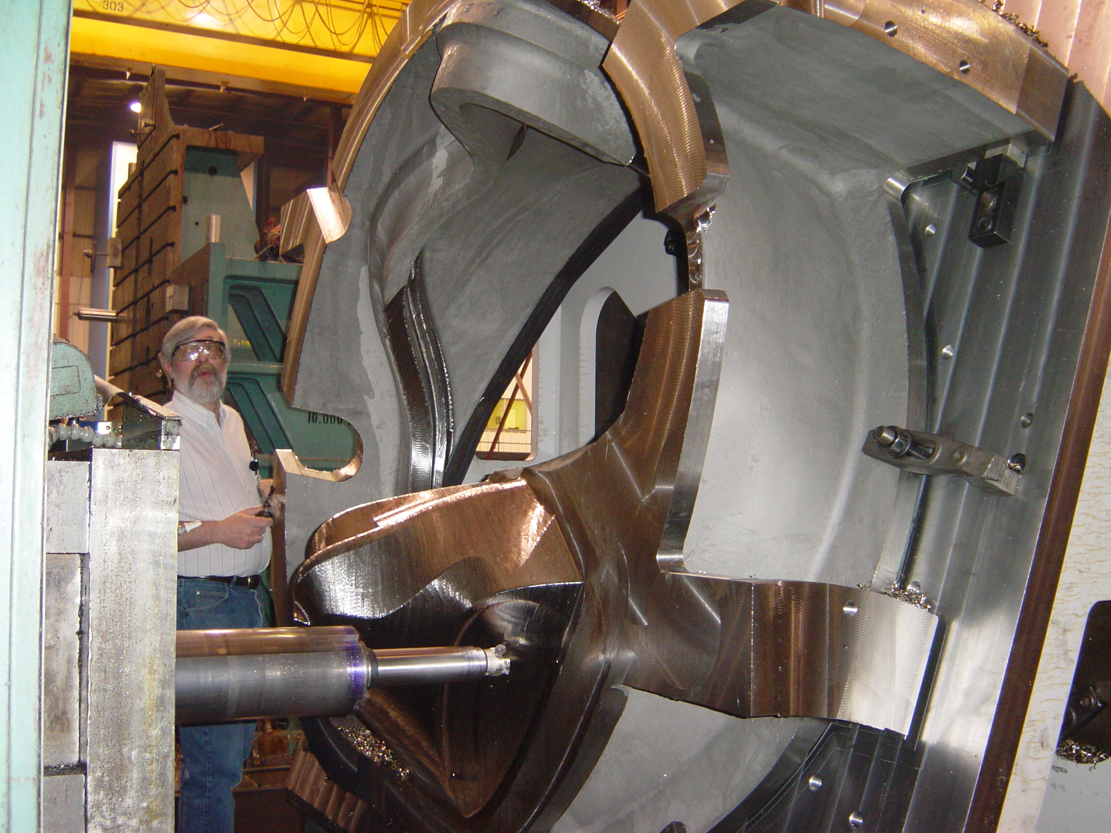
Contour machining C-1
Joe Edwards reports that at the C-2 casting is currently running ahead of schedule and is almost ready for RT. If activities continue to progress at this rate, Metal Tek will be ready to start dimensional inspection on May 10, following which C-2 will be shipped out for X-Ray. Peter Djordjevich has been working with Frank Malinowski to ensure that all approvals are in place to permit progression to these steps.
We learned that as of today (Friday, May 06, 2005) the A-1 pattern is still being molded and is half complete. No real issues to report, just that the set up time on the pattern has taken longer than anticipated. Roger Broman, Engineering Manager, reports: "No problems, it's just big!" The cope will be molded
on Monday with pouring planned for Tuesday. Even with the revised pour date, Metal Tek still intends to deliver the casting to Major Tool on July 18, 2005.
Technical Action Items

- (Metal Tek) Solidification Modeling of Coil B.
Status: (Open) The most recent update indicates that Solidification will be completed by June 1, 2005.

- (EIO, Lawton, Metal Tek, Major Tool) Reassessment of production schedule, based on accomplishments and impediments to date, for inclusion in monthly report to PPPL
Status: (Closed) EIO team members held a telecon on May 4, 2005 to address accomplishment of milestones and assess schedule for upcoming production activities. Updates have been included in the monthly report to PPPL.

- Quality Activities

EIO team members Nancy Horton & Roy Sheppard met with quality representatives of PPPL on Thursday, May 5, 2005. Based on EIO team submissions during the week, PPPL raised several new questions which were passed on to the appropriate team members for comment/response. One question regarded the type of point cloud data file MTM would be giving to PPPL. Roy Sheppard immediately contacted Kevin Bowling to discuss and provided the following update to Frank Malinowski.

We will be using a touch point CMM to record all of the fiducials, target points & to produce a point grid of the entire surface (the size of the grid is called out in the SOW and it varies depending on whether you are mapping a machined or an as cast surface). The points gathered are put into an IGS & a STP file which are given to PPPL - NOTE – this will not be a surfaced file. The grid created does not contain enough points to construct a valid surface. The file generated though can be used as an overlay by PPPL. This information was confirmed with Kevin Bowling and relayed to Frank Malinowski in a phone call subsequent to the meeting and this question is considered resolved.

PPPL also questioned the results on the mechanical testing for C-1. Yield strength at room temperature has a minimum requirement of 34 ksi; however the mechanical test results (dated 3/22) provided to PPPL this week show one reading at 33.3 ksi (below minimum). PPPL perceived this as a deviation from the specification, which would then require a non-conformance report. Pete Djordjevich has been in contact with Frank regarding this matter and will follow-up with Metal Tek as necessary to provide the required explanation and/or paperwork.

PPPL’s quality notes for this week chiefly addressed some missing and incomplete data needed for the C1 casting. EIO needs to clarify if the weld material test results are from published data, and if so, if the values listed are minimums or average values. If these are averages, additional information or actual test data would be needed.

The 3D Scanco calibration procedures submitted on 5/2 lacked the depth needed for a SOP required if this method was to be used for final inspection. Major Tool has confirmed that they do not intend to use 3D ScanCo for their final inspection, as they have concerns about the dimensional accuracy of +/- .002”. The intrinsic accuracy of CMM is generally better than +/-.0005.
In response to MTM’s decision and subsequent notification, 3D ScanCo has requested an opportunity to discuss use of an alternative “high end” scanner with the EIO team members. Should MTM decide to reconsider their decision, this information will be conveyed to PPPL.

As requested by PPPL, the revised MTM, MIT portion showing the minor changes/corrections PPPL identified on 4/15 was submitted to PPPL on May 5, 2005. A copy has also been posted to Grand View → \files\quality_review\MCWFProjectsummary.xls
During the meeting at PPPL, it was agreed that as C-1 nears completion, it is prudent that the parties review all items that will be required for final acceptance to ensure there aren’t any showstoppers or surprises. In particular, they thought it would be helpful to see the package of data from Metal Tek that was provided to Major Tool with the casting. Phil Heitzenroeder also suggested that it would be useful to create a checklist that addresses each item of the Specification, including when the operation was performed, what results were achieved and verification that it passed the inspection. He and Frank offered to sketch out their idea and provide it to the EIO team members early next week.
Upcoming QA Activities
- Additional information needed on Metal Tek in-process dimensional inspection
- Chemical composition of C-1 & C-2
- Preliminary review of C-1 casting data in preparation for final acceptance

QA Action Items:

- (PPPL) Submitted vertical weld procedure and corrective actions to PPPL concerning Metal Tek on 3-4-05.
Status: (Open) CAR was approved by PPPL on 4/18/05. Metal Tek submitted the required data to PPPL on 4/29/05. PPPL has reviewed the data and has requested that Metal Tek provide the actual lab results, including as a minimum test results for 3 specimens, including the heat number of the materials and the test date. If information is not satisfactory, test results on test bar may need to be redone.
Note from Peter D: All metallurgical data was resubmitted to PPPL as one group. Data was sent previously and the finals were sent on 4-29-05 as promised, but PPPL seemed to lack some of the data so it was resent.

- (Metal Tek, EIO, PPPL) MIT Plan for C-2 casting.
Status (Open) Frank Malinowski has reviewed Metal Tek’s draft procedure for dimensional inspection which was submitted on May 2, 2005. Frank feels we need to add procedures for personnel qualifications, post-inspection calibration verification, and monitoring of conditions to ensure a valid inspection. He also feels the procedure should address evaluation and acceptance of results. Response to these concerns is being handled as a HIGH priority since Metal Tek could be ready to commence dimensional inspection on May 10.
Note from Pete D: Dimensional inspection criteria has been submitted to PPPL and unless PPPL requests changes, this completes dimensional. It is the intent of Metal Tek to proceed with dimensional inspection on 4-10-05 unless PPPL advises EIO to continue to hold this process. Upon PPPL acceptance, the MIT will be revised to include first off - 3DScanco/Lawton dimensional, 2nd -6th off - Internal Romer arm.

- (EIO) Deviation Request for Approved Processing Plan covering the use of 3D ScanCo for dimensional inspection prior to radiography.
Status: (Closed) Complete data supplied to PPPL in regards to 3DScanco dimensional and calibrations. According to Frank Malinowski, since their process will not be used for final inspection, PPPL acceptance is not required. Based on this week’s Quality notes from PPPL, it is assumed that all necessary information has been submitted to support the use of 3D ScanCo for the first article, in-process dimensional inspection.

- (EIO/Metal Tek) Mechanical properties for the C-1 casting. PPPL does not have a copy of the chemical composition for the C-1 casting. This analysis would have been performed at the time of the pour. Princeton would like to see these test results in a table that contains the chemical composition detailed in the SOW for easy comparison.
Status: (New) Pete Djordjevich will follow-up.

If you have any questions or comments about EIO’s weekly report, please feel free to contact me at 216-496-2314 or EIO Technical Liaison, Roy Sheppard at 800-337-3083. Your feedback is always welcome.

Nancy Horton
EIO Program Manager for NCSX

