Energy Industries of Ohio (EIO) Team Weekly Status Report

Report covers the NCSX Modular Coil Winding Form Activities Including:
- Production Contract S005242-F
- Change Order 5 under the Prototype Development Contract S-04341F

Week ending May 27, 2005

- Administrative Highlights

Representatives of PPPL & EIO visited with Metal Tek on May 25 & 26, this week, for the primary purpose of discussing open quality actions and the secondary goal of viewing C-2, A-1 and C-3 in process. To kick-off the meeting, Roger Broman presented a slide show of the detailed work instructions for assembling the C coil pattern. This is a step by step procedure developed by Roger, for use in setting up the patterns for pouring to be used in conjunction with the established traveler. The instructions include multiple photographs as well as written instructions, and are readily available to anyone working on the pattern on the shop floor.

After Roger’s presentation, we were given a tour of the Metal Tek foundry, highlighting our parts in process. C-3 was in the initial stages of set up. As it happened, Barry Craig, production manager, was overseeing the setup while holding a copy of Roger’s notes! Next we paused to view the A-1 casting which had been poured late Tuesday night. It was still in the mold, with smoke rising. Finally, we were able to view C2, just back from radiography. Metal Tek is very happy with the results. The problems & shrinks we encountered in C-1 have been greatly reduced. All of this is discussed more in Technical Highlights.

After the tour we commenced a general discussion of the draft revised NCSX specification (version 08). Joe Edwards requested the night to review some of the changes & to articulate his concerns. The primary topics for review included the covered location & makeup of integral & separate test bars, reporting requirements and requests for chemical & mechanical changes. The meeting on the morning of the 26th focused on a general discussion of the revised specification and the changes proposed by Metal Tek. PPPL will consider the recommendations in the upcoming week.

There was also a general discussion on the pending actions captured in the PPPL weekly quality notes, which primarily center around the last few remaining items open on Metal Tek’s MTS, which are discussed further in the Quality Highlights section below.

When the meeting adjourned, Nancy Horton, Roy Sheppard and Peter Djordjevich returned to Metal Tek to meet with Rick Suria, QA manager, who had just returned from Milwaukee with C-2. Peter was able to review the part and discuss the upcoming weld repairs with Rick. Peter’s comments are included in the Technical Highlights below.

On behalf of all of us who visited, we would like to thank Roger Broman, Chuck Ruud, Joe Edwards, Rick Suria and Barry Craig for making the arrangements for our visit, as well as their participation in the frank and open discussions that ensued.

Administrative Action Items:

- (EIO, Metal Tek, Major Tool, Lawton, PPPL) PPPL to revise specification to eliminate the requirement for prior approval on major weld repairs.
Status: (Open) The amendment has been distributed by EIO to Lawton, Metal Tek and Major Tool for signature. While further changes to this section of the spec were discussed at the meeting on 5/26, Larry Sutton emphasized that we are currently working to the version 7, which was issued to us under the changes clause and is therefore already part of our contracts, although acknowledgement (signature) is still required.

- (PPPL, EIO, Metal Tek) All technical and administrative activities related to Prototype Development Contract S-04341F, including Change Order 5 have been completed. Final invoice was submitted to PPPL for payment.
Status: (Open) Still waiting for supporting data from Metal Tek. Follow-up was initiated by EIO and reiterated at the meeting on 5/26/05. Joe Edwards has taken responsibility for ensuring it is completed.

- (EIO, Metal Tek, Lawton) Disposition instructions for C pattern (could be required as early as August 2005).
Status: (Open) EIO has requested that Metal Tek (with assistance from Lawton) provide an estimate of the storage area required for each pattern and the type of storage required (climate controlled, non-stacking, etc) to ensure that patterns are not damaged.
- Technical Highlights

We are now actively producing 4 castings, (C-1, C-2, A-1 and C-3), while preparing for production of our last pattern B. We are continually integrating lessons learned into our various team processes and coordinating our experiences among and between ourselves in order to fully capitalize on efficiencies. As the number of parts in production increases, we look forward to capitalizing on proven methods for production. Until then, each part continues to have unique challenges and accomplishments. This week’s labors are highlighted in the following paragraphs.

C-1
Kevin Bowling of Major Tool reports that the poloidal break is now machined through C-1 and the part is back on the fixture for the start of semi and finish machining after the weld repair is performed. After another demanding week Kevin commented: “we are truly developing a complex and challenging machining process while attempting to maintain a production schedule. We certainly anticipated some learning curve but not to the extent that we have experienced thus far.”

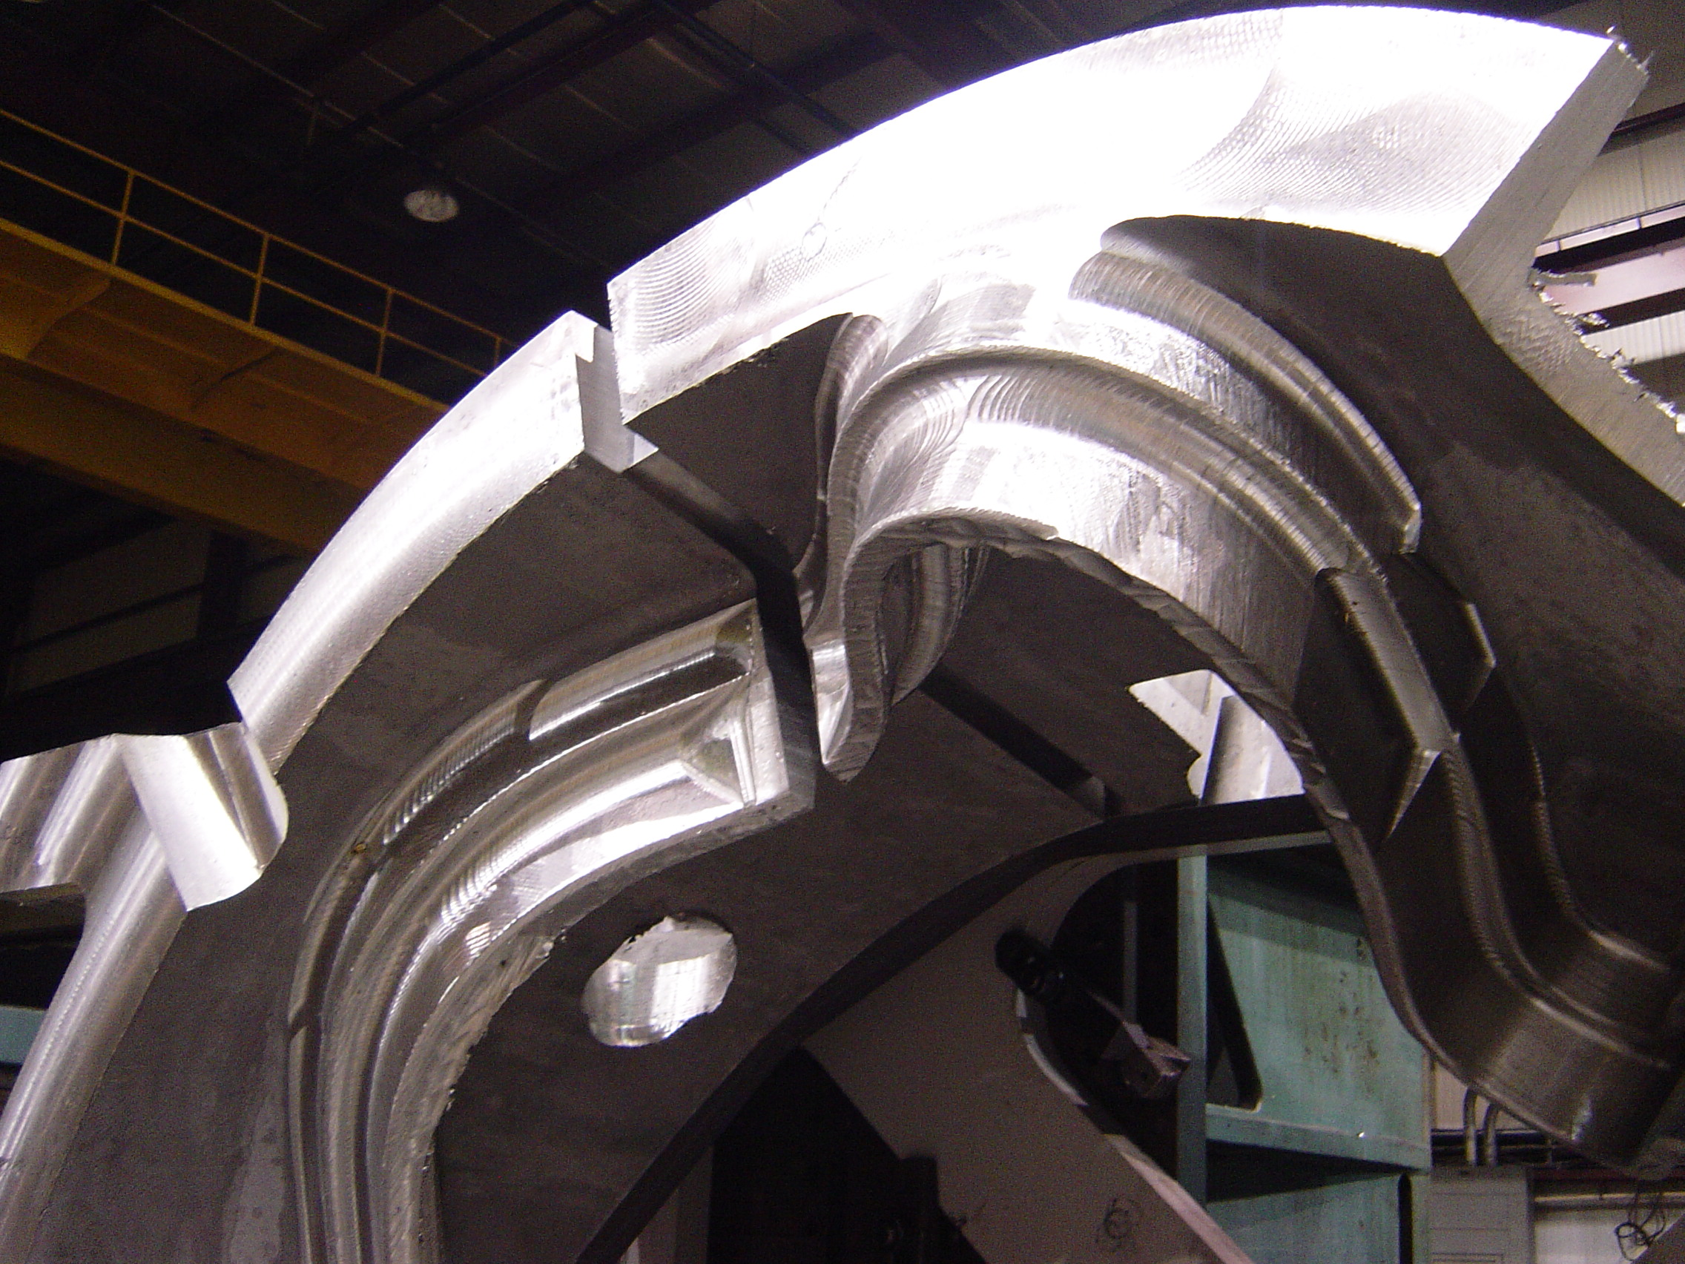

Coil C-1 poloidal break

Recognizing the degree of learning that has been involved, Kevin advised of a few actions MTM has taken to try to minimize the development time for the upcoming 5-axis machining work. In parallel to the remaining 3-axis machining, MTM has added another programmer to the project team. Beginning Tuesday, May 31, 2005, this programmer will start testing the varied 5-axis approaches using the Prototype C casting. MTM will have to define an area on the prototype for the testing, then rough and semi-finish to prepare the part for the 5-axis work. Once this work is performed they will run some finish programs to test the existing approach. This concurrent processing will allow MTM to tweak and modify the 5 axis programming wile the C-1 casting continues through semi-final machining on the 3-axis. We are confident that this will reduce some of the future development time by removing it from the critical path.

Kevin estimates that they will finish the 3-axis machining on June 6, 2005. Final machining will commence on June 7 and should be done by June 20th. This is a compression of 7 days from our original schedule, due to both more extensive semi-final machining and elimination of 5-axis programming verification time by utilizing the prototype casting.

Despite all efforts, the delivery of C-1 to PPPL will likely occur in early July. In order to reduce the impact this will have on PPPL’s internal processing plans, we have offered to investigate ways to enable joint testing of C-1 while the part is still at Major Tool. Kevin has agreed that as long as PPPL’s plans would not disrupt MTM activities, they would be very willing to accommodate such an approach.

Additional C-1 pictures taken this week are available on the EIO ftp site.

C-2
C-2 returned from radiography this week. Rick Suria from Metal Tek QA was on-hand at the facility in Milwaukee for the last few days of processing. There were 13 radiographic failures, only one of which was a “shrink.” This is a significant improvement over C-1, which indicates that our changes to the slush parameters were correct. While the part has “hot tears” that need to be repaired, both Rick and Peter Djordjevich have referred to these as superficial problems that can easily be remedied on the current part and potentially avoided in the future. In his trip report, Peter noted:

“After our meeting yesterday I visited Metal Tek and viewed the C2 casting. From a visual standpoint the C2 casting is quite a marked improvement from C1. The reduction in weld points on C2 after radiography is quite significant. Currently three thru wall areas will have to be repaired in sections with wall thicknesses in the range of about 2 inches. This should not be a factor since the casting will be repaired with parent material rendering these areas structurally comparable to the as-cast material. Although we all would like to see a casting produced without repair, this would in fact be a near impossible feat on a casting of this magnitude. I again would like to stress that C2 is definitely a move in the right direction.”

Rick Suria is working on the weld map which should be ready for the floor by June 1st, when welding is scheduled to commence. Rick tells us that the amount of welding, as well as, the required weld material have been greatly reduced from C-1.

A-1
The A-1 casting was poured on Tuesday night, May 24, 2005. Barry Craig, Production Manager, reports that they poured “approximately 31,000 lbs off, through 3 pour cups. The mold took the metal in about 50 seconds.” Barry estimates the final pour weight will be around 28,000 lbs. As of Friday, May 27, A1 is half out of the mold, and will be broken out completely on Saturday 5/28/05, so it is ready for the initial processing which is scheduled to commence on Tuesday, 5/31/05. Barry anticipates that A1 will be ready for heat treat on June 3, for heat treatment over the weekend of June 4 - 5. The initial indications are good, which means that the part may be ready for dimensional inspection the week of June 10, 2005.

C-3
Following the planned production schedule, the C pattern is being rapidly setup again to produce C-3. Currently Metal Tek is on track to pour C-3 on Friday, June 3, 2005. Based on the learning from C-2, Barry Craig is planning to introduce gussets into the sand adjacent to the areas with hot tearing. These gussets will act as localized cooling fins in these areas, allowing the metal to quickly solidify. This will add strength to these areas during the “mushy phase” – a technical term referring to the point when metal is in a transitional phase and the grain structure is starting to solidify. The gussets will be ground off afterwards.

B Pattern
Roger Broman from Metal Tek expected to have the final iteration of the B solidification back from ESI as early as Friday 5/27/05. He noted that if the final problem area has been solved, the file will be forwarded simultaneously to Lawton and to Metal Tek. Lawton has been advised of this status and they are waiting for this file. Brad Goddard reports that they will be ready to start on the B pattern on Tuesday, May 31, 2005.
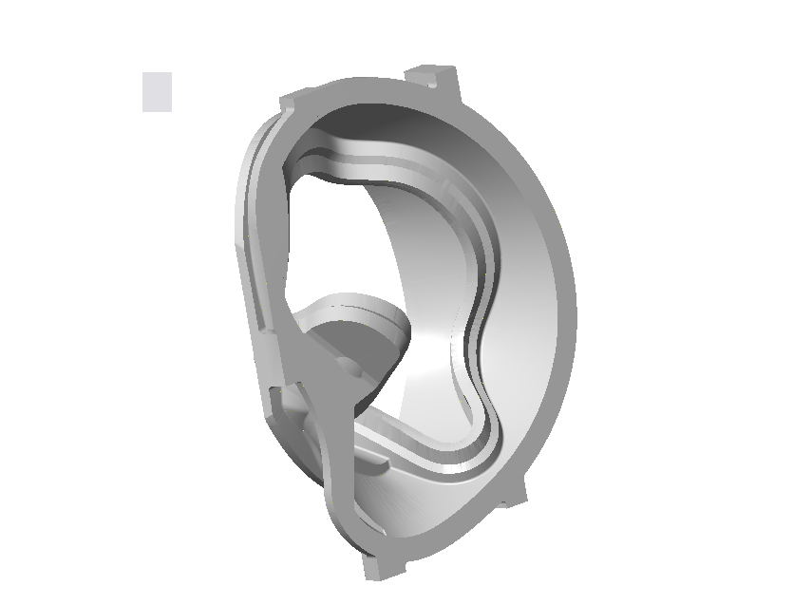

B-Coil Casting

Technical Action Items

- (Metal Tek) Solidification Modeling of Coil B.
Status: (Open) Approval of final solve expected next week.

- (Lawton) B Pattern manufacture
Status: (Open-New) Expect to start 5/31 with completion estimated week of 8/12/05
- (Metal Tek) Pour C-3
Status: (Open) Set-up of pattern underway – Expect to pour 6/3
- (Metal Tek) Upgrading of C-2
Status: (Open) Weld map in progress – Expect to start 6/1
- (Metal Tek) Heat Treat of A-1
Status: (Open) Expect to start 6/4 – finish 6/5

- (Major Tool) Weld Repair & Completion of 3 axis machining of C-1
Status: (Open) Scheduled to start on 5/31 and continue through the weekend.
C. Quality Activities

The meeting this week in St. Louis focused on resolving open QA action items at Metal Tek and reaching mutual agreement on the language in the specifications, particularly related to weld repairs, which would meet the desired intentions of PPPL without adding undue requirements for testing on EIO team members.

In addition to the concerns raised by Metal Tek, and addressed during the meeting, Major Tool also took issue with the PPPL interpretation of the requirements for material testing, and a telecon on the morning of Thursday, May 26, 2005 was held to address and resolve those concerns so that weld repair could commence at MTM. Review of the MTM weld repair procedure and qualifications was accomplished in real time at the meeting.

As an outcome, both Metal Tek and Major Tool will be conducting additional tests in the upcoming week, assuming that they can acquire the proper test specimens and find qualified firms to conduct the tests. If not, this issue will be readdressed in a future telecon.
Upcoming QA Activities
- Weld Map for C-2
- 4 Side bend tests and 1 tension test by Major Tool
- Completion of open QA actions at Metal Tek and submission of documentation
- Weld Repair of C-1 and C-2

QA Action Items:
It is worth noting that over the past month, significant effort has been expended by all of the quality personnel from PPPL and the EIO team members to clarify and resolve quality action items. The following list of actions, which was generated by EIO, has been reconciled to the list generated in the PPPL weekly Quality Notes, so some of the associated verbiage has changed from previous weeks to better clarify the intent. Over time, it is hoped that we will reduce our correspondence to one set of notes that will represent all items. During our meeting in St. Louis, it was agreed that most of the open action items would be completed in the upcoming week. If we are successful at accomplishing this, the following action item list should be reduced significantly to a manageable number.

- (EIO/Metal Tek) Submitted vertical weld procedure and corrective actions to PPPL concerning Metal Tek on 3-4-05.
Status: (Open) Metal Tek will provide 3 actual CVN test results at 77K from deposited Metrode B316NF weld metal

- (EIO/Metal Tek) Approval of SOP 0100 for dimensional inspection, updated to include pre and post inspection calibrations (note, this action has been clarified from previous weekly report to distinguish it from action item # 9)
Status (Open) PPPL approval not required. EIO Quality Manager will review and approve or request modification from Metal Tek by 6/1/05

- (EIO/Metal Tek) Mechanical properties for the C-1 casting.
Status: (Open) PPPL has provided a draft table for use in compiling data. Data to be input into the table and submitted to PPPL as soon as possible.

- (PPPL) Nonconformance report for the C-1 casting yield strength reported as 33,300PSI
Status: (Open) NCR submitted on 5/19/05. PPPL response expected by 6/1/05. Per discussion at the meeting, they will request 2 more samples.

- (EIO/Metal Tek) Nonconformance report for the C-1 casting for lack of zone identification on the specimens and testing in only one direction
Status: (Open) Due (by mutual agreement) at PPPL by 6/3/05

- (EIO/Metal Tek) Nonconformance report for the C-2 casting for testing in only one direction
Status: (Open) Due (by mutual agreement) at PPPL by 6/3/05

- (EIO/Metal Tek) Deviation request for the A-1 (and future?) castings to test in only one direction
Status: (Open) Due (by mutual agreement) at PPPL by 6/3/05

- (EIO/Metal Tek) Resolution of the remaining material test report concerns transmitted in 5/3, 5/4, and 5/9 e-mails from PPPL (also see action item #’s 1 and 3)
Status: (Open) Due (by mutual agreement) at PPPL by 6/3/05 (at minimum, lab reports backing Metal Tek CMTR must be submitted)

- (EIO/Metal Tek) Revised Metal Tek MIT portion (their MTS) addressing the remaining comments provided by PPPL on 4/15/05 and 5/17/05 (also see action item #2)
Status: (Open) Due (by mutual agreement) at PPPL by 6/1/05

- (PPPL) Revise SOW to address the accepted changes in the final dimensional inspection documentation.
Status: (Open) Due (by mutual agreement) from PPPL by 6/15/05

- (PPPL) Action or communication regarding discussions of material testing in both directions and alternative approaches (also see action item #’s 4, 5, 6)
Status: (Open) Update C-Spec revision based on discussions at the meeting on 5/26. PPPL will consider the additional information on weld procedure requirements, as addressed above in QA highlights. Response due by 6/15/05.

- (PPPL) PPPL took the action at the meeting to clarify alloy chemistry requirement to determine if an average is acceptable - Ref ASTM A 751, paragraph 5.1.1.1)
Status: (Open - New) Response expected by 6/15/05.

I would like to express my continuing gratitude to the many contributors to this report. Generally, the EIO weekly report (another example of “behind the scenes” effort) is jointly compiled by Roy Sheppard and me, with input from Peter Djordjevich, and many individuals from our team members at Lawton, Metal Tek and Major Tool. We strive to select the most relevant and useful data without burdening the reader, but with so many activities, especially on a very busy week, it often requires tough decisions. Your feedback about what is most useful to you is always welcome.

Nancy Horton
EIO Program Manager for NCSX

