Energy Industries of Ohio (EIO) Team Weekly Status Report

Report covers the NCSX Modular Coil Winding Form Activities Including:
- Production Contract S005242-F
- Change Order 5 under the Prototype Development Contract S-04341F
- *Added back: PO PEO5678-W for extracting test samples

Week ending July 1, 2005

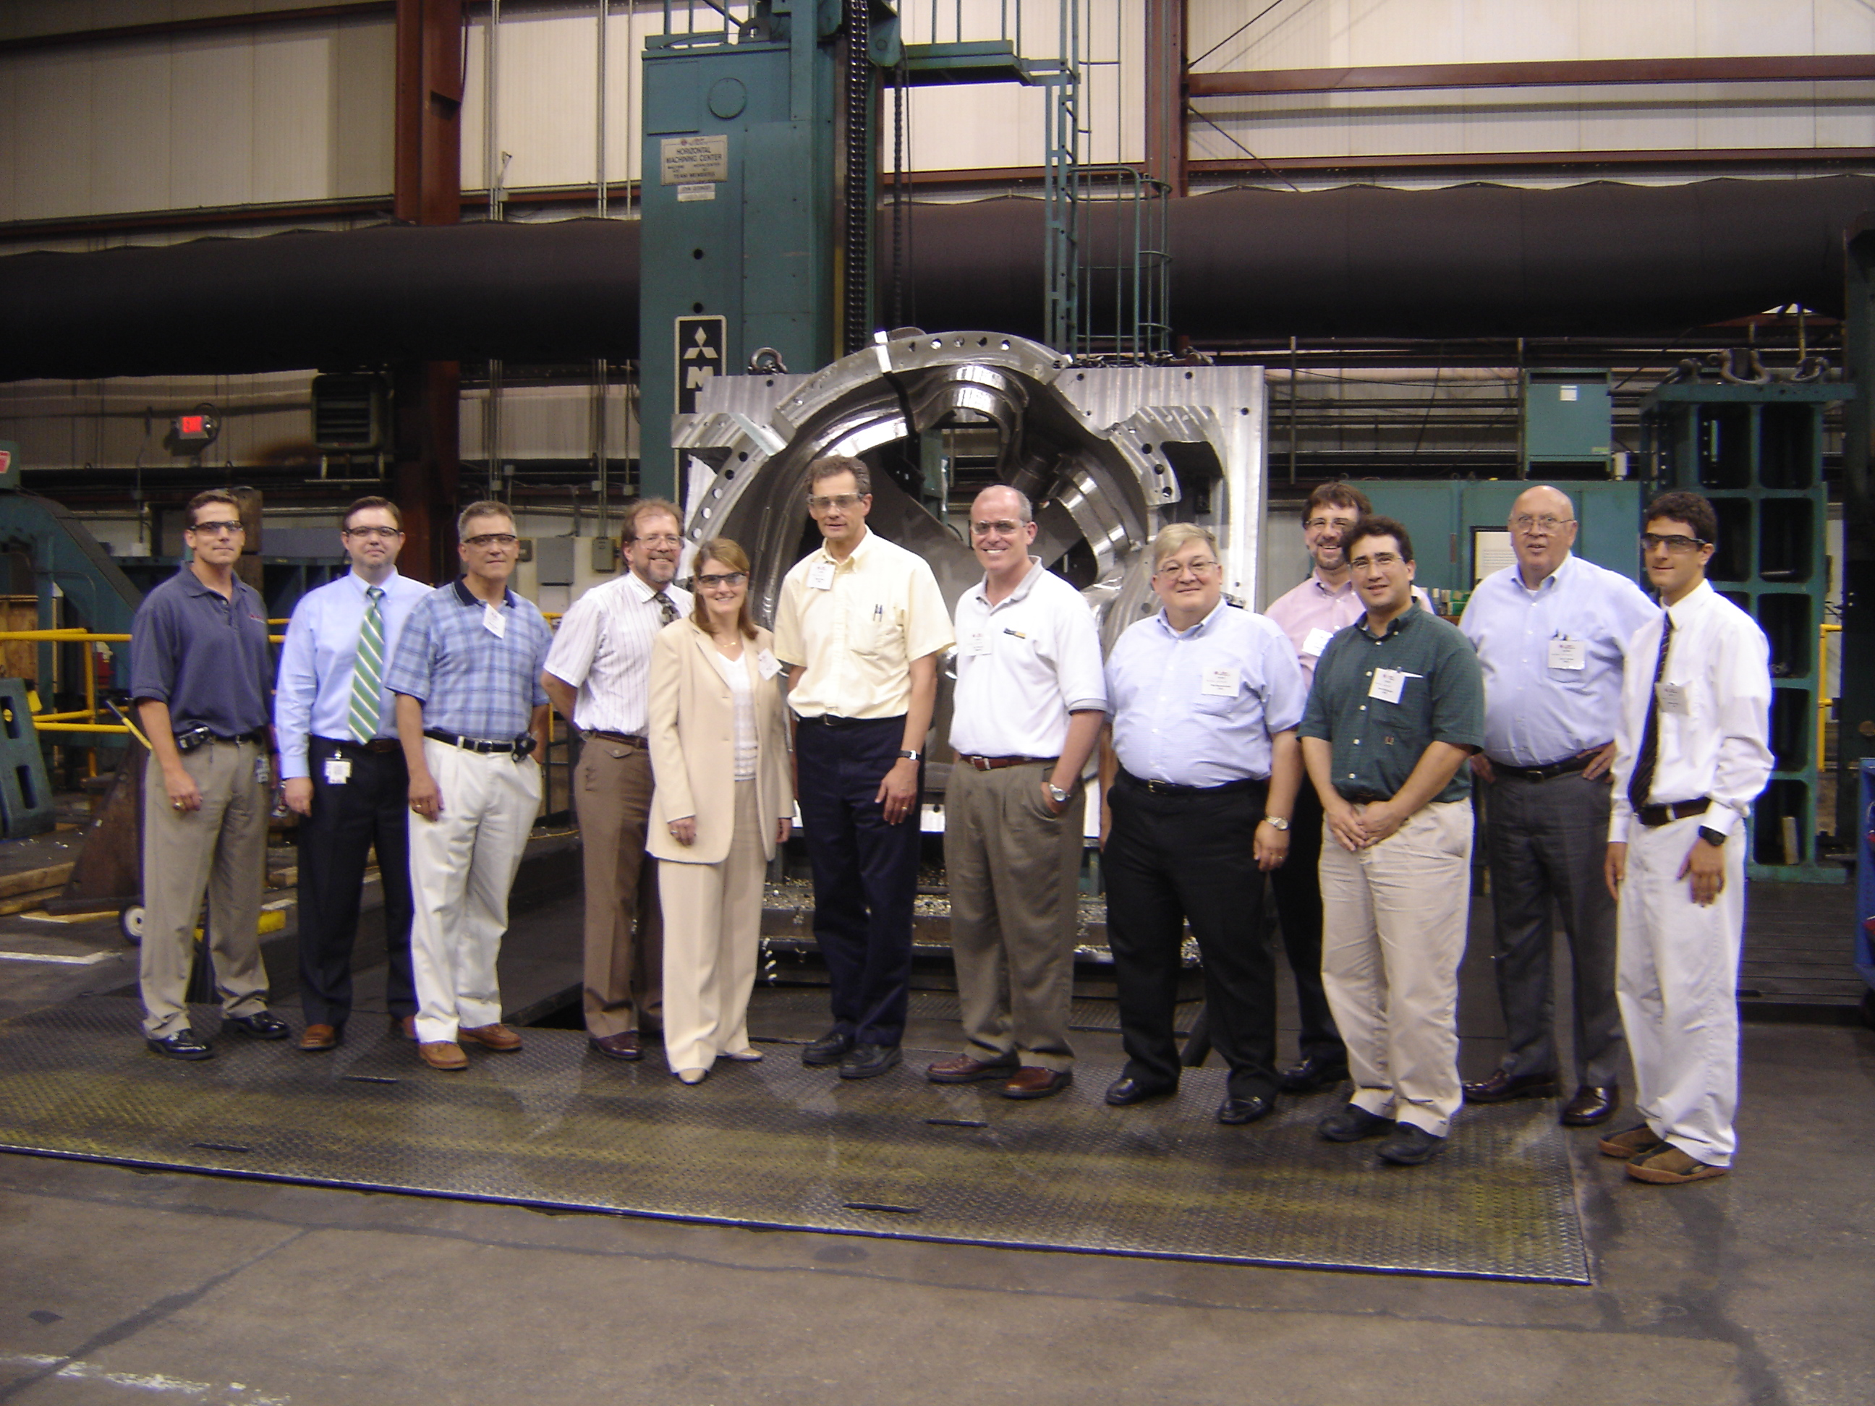

The Team at Major Tool Pictured In Front of C-1
(Pictured from left to right: Joel Manship, MTM; Kevin Bowling, MTM; Peter Djordjevich, EIO; Roy Sheppard, EIO; Nancy Horton, EIO; Hutch Neilson, PPPL; Joe Edwards, MTK; Phil Heitzenroeder, PPPL; Frank Malinowski, PPPL; Steve Raftopolous; PPPL, Larry Sutton, PPPL; Martin Mudry, EIO)

- Administrative Highlights

Our thanks this week go out to Kevin Bowling and the staff at Major Tool, who hosted a meeting this week on the 27th & 28th in Indianapolis. An aggressive agenda was laid out covering the forthcoming Rev 8 to the specification, review of outstanding quality action items and scheduling and delivery concerns on C-1 and subsequent castings. Many of the specific items covered are highlighted in their respective sections (Admin, Tech & Quality) below.

To quickly highlight accomplishments, an agreement was reached on changing surface finish requirements on machined surfaces. Major Tool will issue a deviation request. PPPL is also inclined to have the balance of the castings stress relieved by Metal Tek, and presented a draft revision to the product spec. On 6/29, Larry Sutton followed up with a request for price proposal along with the new language for the spec. Both of these topics have been added as action items and are also discussed in Tech Highlights, below.

In order to expedite delivery, Major Tool has requested the close cooperation of DCMA, EIO and PPPL, particularly in the latter portions of the C-1 schedule. Many of the inspections which need to be performed, also require a witness or hold point. The DCMA representative, Bob Skelly, has agreed to be available on the day each test is performed. Both Frank Malinowski of PPPL and Peter Djordjevich of EIO will be coming out later in the process to begin the document review. Others will be coming out as necessary.

We were also given the opportunity to view both the C-1 & C-2 castings at Major Tool, as well as several segments of the vacuum vessel (the complementary program on the NCSX also underway at MTM). Kevin was able to supply us with several photographs of C-1. These have been posted to the FTP site.

The meeting provided us with an opportunity to introduce two new team members. Joining our engineering team at Major Tool is Mike Griffith. Mike has held several positions within the company, gaining experience in key aspects of machining, and looks forward to taking on the challenges associated with the NCSX program. Mike can be reached at 317-917-2633. Martin Mudry (far right in the above photo) is interning with us for the second summer in a row. Martin was instrumental in helping us to prepare our proposal last summer and is eager to become even more involved the project this year. We welcome him back for another season. His work/cell number is 216-702-5928.

An internal EIO team telecon has been tentatively scheduled for the afternoon of 7/6 to discuss general schedule areas plus specific concerns on A-1 & C-2 castings. Details for team members will be sent out 7/5.

Administrative Action Items:

- (EIO, Metal Tek, Major Tool, Lawton) PPPL to revise specification to eliminate the requirement for prior approval on major weld repairs (Spec Rev 7).
Status: (Closed) Upon receipt of signed amendments from all three subtier contractors earlier in the week, EIO signed and returned Amendment 4 of our contract to PPPL.

- (PPPL) Princeton is reviewing proposed changes to the spec from last week’s meeting at Metal Tek. This would be Version 8.
Status: (Open) Metal Tek has obtained and forwarded the required Lincoln weld data (one lingering open action). PPPL had reviewed EIO team member input and presented modified language during our meeting in Indianapolis. Further modifications to the specification were also presented by PPPL and generally agreed upon by EIO team members. The final iteration of Rev 8 is expected to be incorporated into our contracts in the upcoming week.

- (PPPL, EIO, Metal Tek) All technical and administrative activities related to Prototype Development Contract S-04341F, including Change Order 5 have been completed. Final invoice was submitted to PPPL for payment.
Status: (Open) Paperwork is in process at EIO is expected to be submitted in the next week.

- (EIO, Metal Tek, Major Tool) Disposition instructions for C pattern. PPPL has advised that they don’t anticipate taking possession of the patterns & will seek to have them disposed of at Metal Tek. They have inquired about whether Metal Tek would be keeping possession of a particular pattern until the last machined casting of that type is accepted and received by Princeton.
Status: (Open) Discussed briefly at the meeting in Indianapolis. This will be a subject of discussion during the team telecon on 7/6.

- (EIO, Metal Tek, Lawton) On 6/15 Larry Sutton issued SOW rev 3 under the auspices of the Changes Clause.
Status: (Open) The document was distributed to EIO Subtier Contractors, who have been asked by Ed Galaska of EIO to acknowledge receipt of this document. So far, MTM has responded. A reminder notice was sent to Metal Tek and Lawton this week.

- (PPPL) Payment of EIO Team invoice for Purchase Order PE005678-W for extraction of sample materials.
Status: (Open) EIO was told the check was in process, but according to Edward Galaska, the check has not been received. Larry Sutton verified that the check had been issued and mailed, but since it was not received at EIO, we were advised that the check will be canceled and a new check will be issued.

- (PPPL) Payment of EIO Contract invoice for May. On 7/1, Edward Galaska advised PPPL accounts payable and Larry Sutton that payment for the invoice for May had not yet been received by EIO.
Status: (Open) We learned that due to a major reduction in personnel resulting from retirements and buyouts, the PPPL accounting department is undergoing a realignment of assignments and duties. Larry has promised to assist us in assuring that payments are not overly delayed.

- (EIO, Metal Tek) On 6/29/05, PPPL issued a request for price quote for stress relief of 16 castings. Due date 7/6/05.
Status: (Open) Request is under review at EIO and was forwarded to Metal Tek on 6/29 for input.

- (EIO, Metal Tek, Major Tool, Lawton) EIO Monthly Report for July covering activities in June.
Status: (Open - New) Data is being collected and the report is being prepared for submission to PPPL just after the holiday.

Technical Highlights

Work in progress throughout the Subtier team members is presented below.

C-1

Kevin Bowling reports that MTM is 90% complete on the roughing & semifinal machining, which corresponds to the first 3 milestones reported on MTM’s supplemental chart (dated 6/17/04). More is being done on the initial setup than had been anticipated, but we are now taking our final cuts before we have to flip the part.

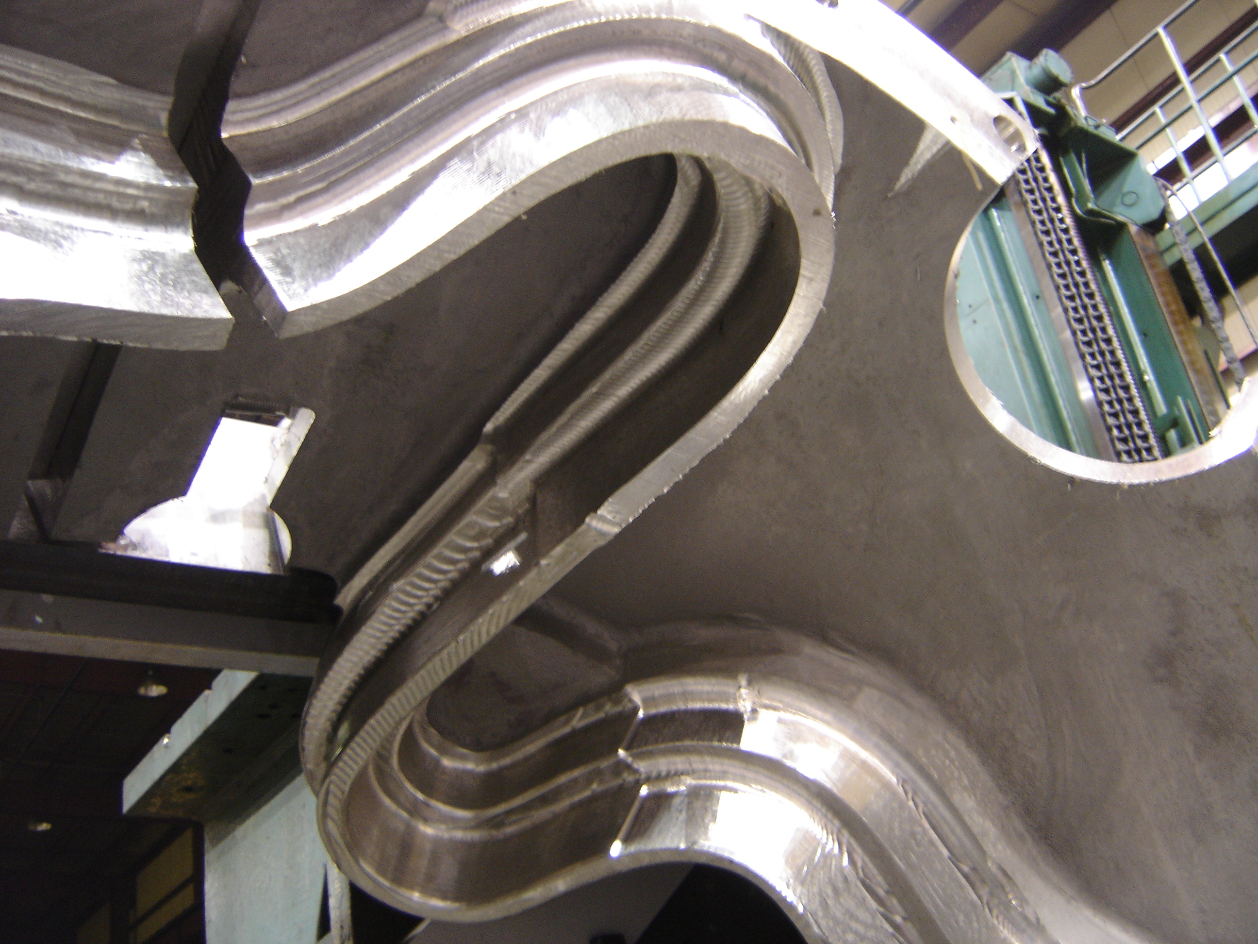

Racetrack on C-1 near poloidal break

The 5-axis experimentation on the prototype has paid off with big dividends. Along with proving out a production method for machining the groove, MTM has devised (through trial & error) the “best” setup for fixturing the casting in the mounting plate during 5-axis machining. This new orientation allows more clearance for the 5-axis head. If we had not been able to prove this design out on the prototype, we would have probably added 2 more days to our schedule once 5-axis machining commenced on C-1. Overall, however, Kevin Bowling does report that he is running 2-3 days behind the 6/17 milestone schedule and that this will push out the remaining milestone dates accordingly.
C-2

The C-2 Casting arrived at MTM on the morning of 6/28. A shim for the C-2 was included with the shipment as well as a surplus shim which MTM will be using for weld qualification. The casting was shipped ahead of our baseline schedule, which proved to be a fortunate break because, although Major Tool started setting C-2 up after our meeting on 6/28, they encountered some challenges that extended the set-up time (likely related to minor over grind conditions, which are being addressed internally by the team),. We are pleased to report that C-2 is now set up in the machining fixture and as of Friday morning, we started cutting chips! Kevin emphasized during our meeting in Indianapolis that he anticipates that the machining lead-time will be more closely aligned to his original 12 week schedule due to the learning on the C-1 casting. We will watch this closely in the upcoming weeks to affirm that in fact, this is the case.

A-1
3-D ScanCo is scheduled to come back to Metal Tek on Tuesday, 7/5. They will be re-shooting the areas of the casting that did not scan properly. We should have new data by 7/7. In the meantime, Barry Craig has informed us that the A-1 X-rays revealed absolutely no shrink! There are several very small hot tears and some surface indications. A-1 has been marked up & is now on hold pending resolution of the ScanCo data.

We also learned this week that Metal Tek is no longer excavating the castings prior to sending them up to MQS for the initial x-ray. Due to the complexity of the geometry, MQS was having problems getting their shots set up correctly with the excavations. Barry Craig reports that A-1 and all subsequently poured castings will be excavated after initial RT.

C-3
Due to possible delays in processing A-1, Metal Tek is trying to pull in the delivery of C-3 to Major Tool from 8/5 to mid July. We had planned on shipping the C-3 casting out to the subcontractor, MQS this week, but unfortunately, MQS was unable to start working on C-3 until after the 4th of July holiday. C-3 is now scheduled to ship out on the morning of July 5th. If minimal repair is required, this casting could still potentially ship out by mid month.

C-4
According to Barry Craig, as of 5:00 p.m. Friday, 7/1, the C-4 pattern is 40% molded and is still on track to pour by the end of next week.

B Pattern
All segments of the upper core box are now complete through routing & are ready for assembly. The lower portion of the drag box has been glued up & is ready for the router. Don Dickert reports that the cope core box as well as the corresponding loose core print pieces have all been modeled & are ready for glue-up

Technical Action Items

- (Lawton) Manufacture of B Pattern
Status: (Open) Programming is running 1-2 weeks ahead of production.
- (Metal Tek) Processing C-3
Status: (Open) Shipping to MQS on 7/5
- (Major Tool) Completion of 3 axis machining of C-1
Status: (Open) MTM estimates that they are 90% complete with this milestone.

- (Major Tool) Shipping crate for C-1
Status: (Open) Discussed during the meeting on 6/28. MTM will increase the size of the bottom skid by 2”in each direction and build a 2x4 & plywood cover box. Revised sketch to follow.
- (Major Tool) Machining C-2
Status: (Open- New) Started setup on 6/28 and commenced machining on 7/1.

- (Metal Tek) Processing C-4
Status: (Open- New) C-4 is scheduled to pour on or before July 8, 2005.

C. Quality Activities

One of the key purposes for the meeting in Indianapolis was to provide PPPL a first hand review of the RMS machined surface of C-1 at <250 µ-inches. As part of the initiative to reduce machining time, the C-1 casting is being machine finished to this specification, with the expectation that the part will later be hand-finished to achieve the final RMS surface finish requirement of <125 µ-inches. Since section 3.1.1.4 of the specification offers that uniform “scallops” which exceed 125 µ-inches…may be acceptable subject to PPPL approval…the question was posed to PPPL as to whether or not they could accept this alternative surface finish on any areas of the part.

After reviewing the C-1 casting in process and discussing this matter with the experts at ORNL, PPPL has agreed in principle that they can increase the maximum surface roughness on all machined surfaces to < 250 µ-inches, except for the 2 “L” areas of the “T” section which will remain <125 µ-inches. It was agreed that Major Tool will submit a deviation request for relaxing the specification requirement at 3.1.1.4, which will be processed by PPPL in an upcoming Spec Revision.

This change will significantly reduce the amount of machining required on each casting, including the balance of the C-1 and enables MTM to recover some of the time lost to other complex machining issues. As the larger step over, discussed last week, will produce surface finishes of 200 µ-inches - 220 µ-inches, the amount of hand polishing MTM will need to do will be limited to the twin L sections.

A second topic on the agenda was the issue of Stress Relief. Stress relieving is generally done either at a foundry’s discretion, when deemed necessary (due to amount & location of weld) or at the insistence of the customer, in their product specification. To date, both C-1 & C-2 were stress relieved by Metal Tek at the foundry’s expense, but there is not a requirement that stress relief be performed on all of the castings. After giving the matter much consideration, PPPL announced that they have decided to have stress relief added to all subsequent castings, to ensure the most consistent castings. This requirement will be added to revision 8 of the product spec.

Another topic of conversation revolved around the review and acceptance of the CMM data. Kevin expressed concern that we not ship until we are certain that all Parties have concurred with the dimensional data obtained on the part. PPPL confirmed that watching the CMM test would not help them with acceptance; rather, it would be the review of the data which would enable acceptance. Therefore, in order to enable this process to occur in real time, significant up-front preparation will be required. Kevin described the process that they use at Major Tool and this was compared and contrasted to the plans at PPPL and ORNL. To facilitate their preparation, Kevin has offered to prepare a “test” CAD file with bogus CMM data to serve as an example of what they will see. This can then be compared to the PPPL data to determine if any adjustments to the plans will be required. The action is added to the list below.

The draft documentation package for C-2 was posted to the EIO ftp site (NOTE – This file is still preliminary and under review) and at the meeting in Indianapolis, Frank Malinowski pointed out to Pete Djordjevich & Roy Sheppard of EIO, that it appeared that the wrong document was posted for chemical analysis on the shims used for the C-2 package. Subsequent review by Pete showed that this was indeed the case. The draft document package for C-2 has now been updated & reposted in a single zip file on the FTP site. We appreciate the assistance from Frank in this process. We are now processing Frank’s preliminary comments on the C-1 doc pack, which were received on 7/1 and will apply relevant comments to the C-2 package prior to formal submission to PPPL.
Upcoming QA Activities
- 4 Side bend tests and 1 tension test by Major Tool
- New scan of A-1 by 3D-ScanCo (scheduled for 7/5)
- Review & submittal of C-2 document package
- C-3 to X-Ray 7/5

QA Action Items:

Please Note: Action item numbers are not necessarily consistent from week to week. As old actions are closed and new actions are added, the numbering scheme will vary, thus meaning that a particular action item’s number could change from week to week. If over time, it appears that this approach is causing confusion, we will reconsider an alternative method.
- (PPPL) Resolution of the remaining material test report concerns transmitted in 5/3, 5/4, and 5/9 e-mails from PPPL). Particularly, follow-up on significant differences between Lab results on cryogenic yield tests is required.
Status: (Open) Metal Tek and EIO Submitted & posted required documentation to FTP site on 6/24/05. Further clarification was given in subsequent Emails on 6/29 & 6/30. Metal Tek will use Westmoreland for Tensile testing at the 77K temperature. ST Louis will perform Tensile testing at room temperature, and all Charpy testing both at room temp and at 77K . Under review at PPPL.

- (PPPL) Action or communication regarding discussions of material testing in both directions and alternative approaches (also see action item #’s 4, 5, 6) Draft Spec issued to EIO team for comments. Comments were returned to PPPL on 6/15/05
Status: (Open) Language has been changed on Rev 8 & Lincoln Weld data showing actual data & ranges has been submitted (closing Metal Tek/EIO portion of this action item). The action is now under review at PPPL.

- (PPPL) PPPL took the action at the meeting to clarify alloy chemistry requirement to determine if an average is acceptable - Ref ASTM A751, paragraph 5.1.1.1) which they did. EIO and Metal Tek took exception to PPPL’s comment that an NCR would be required if a single ladle’s chemistry is outside the requirements. Language in ASTM A703 was cited as the basis for this exception.
Status: (Open) The matter was taken under advisement and while it was discussed at the meeting in Indianapolis, it is not clear if it was resolved. Topic will be added to next week’s QA telecon for clarification.

- (EIO, Metal Tek, PPPL) Nonconformance Report for C-1, C-2, & A-1 for lack of Additional Test Material required by 4.2.2.4. Per e-mail from PPPL: “At the meeting, we discussed the possibility of salvaging the “holes” cut out at MTM and using that material as a source for test pieces for the C-1 and C-2 castings. We also discussed the possibility of cutting coupons from Riser areas of the A-1 and possibly the C-2 scraps. If these remedies are feasible, they should be part of the proposed corrective action.
Status: (Open) Major Tool will not be cutting out test material from port locations for the C-2 & A-1 castings. Currently PPPL is checking on the feasibility of C-1 shim being used for additional test material. The C-1 shim was poured from 1 ladle. Metal Tek raised the possibility that the physical test results obtained from the aggregate pour may not be indicative of the results which could be obtained through testing on the actual shim. PPPL has taken the action to decide whether to accept C-1 shim as test material, or settle for 15 out of 18 test samples. The non-conformance report will be issued after PPPL makes the determination.

- (EIO, Major Tool) PPPL is seeking a Processing Outline from MTM to address welding, and a procedure describing MTM’s welding controls. In addition to general controls, the submittal should answer the same issues already addressed with Metal Tek, such as the documentation to be provided, the pre & post welding inspection, and magnetic permeability checks. A clear date for submission of this information is also required.
Status: (Open) EIO has communicated these requirements to MTM to ensure compliance and they were further addressed during the meeting in Indianapolis. Kevin has promised to make these changes a priority and submit the paperwork as soon as possible. His plan is to incorporate all of the required MIT changes, including the new procedure for machine and hand finish into one submission. With the potential requirement for weld repair on C-2, this action will be monitored closely to ensure it does not cause a schedule delay.

- (EIO, Major Tool) Metal Tek has promised to provide samples to Major Tool for conducting required tests. Corrective Action - additional 4 side bend tests and 1 tension test - for MTM nonconformance report NC17399, due prior to weld repair on any castings other than C-1.
Status: (Open) An extra shim was supplied by Metal Tek with the C-2 casting. MTM will be expediting these tests. Kevin estimates the task will take about 4 weeks and will endeavor to complete prior to shipment of C-1. PPPL has clarified that approval of the C-1 doc pack will be held pending receipt and review of this data.

- (EIO, Metal Tek) Submission and review of C-2 Spec sheet and Documentation Package and shipping release of the casting
Status: (Open) Preliminary document package has been posted to the FTP site for review. Signed shipping release is included.

- (EIO, Major Tool) PPPL has advised that in order to modify the specification to adopt the revised machining surface finish, they will need a formal deviation request submitted by EIO/Major Tool.
Status: (Open - New) Kevin Bowling and Peter Djordjevich are preparing the response, which will be submitted to PPPL.

- (EIO, Metal Tek) PPPL has requested submission of a document or drawing that will link the weld repairs to the radiographic locations. PPPL has also asked for clarification about whether all radiographic shots were taken with the same equipment.
Status: (Open) According to Joe Edwards, there was the possibility that one of the shots might have been performed at Metal Tek. Joe will investigate. The remainder of this action was assigned to Rick Suria at Metal Tek and is under development.

- (PPPL, Major Tool) To facilitate acceptance of the CMM data, Kevin offered to create a CAD file with point cloud data, mimicking that which might occur. The file will be used by PPPL to compare with their data in order to ascertain compatibility.
Status: (Open - New) Kevin Bowling is working with Steve Raftopolous and Tom Brown to prepare the file. Goal for completion was set for 7/6.

If there are any questions or comments related to this week’s report, please don’t hesitate to contact me. I can be reached at 216-496-2314.

Nancy Horton
EIO Program Manager for NCSX

