Energy Industries of Ohio (EIO) Team Weekly Status Report

Report covers the NCSX Modular Coil Winding Form Activities Including:
- Production Contract S005242-F
- Change Order 5 under the Prototype Development Contract S-04341F
- *Added back: PO PEO5678-W for extracting test samples

Week ending July 8, 2005

- Administrative Highlights

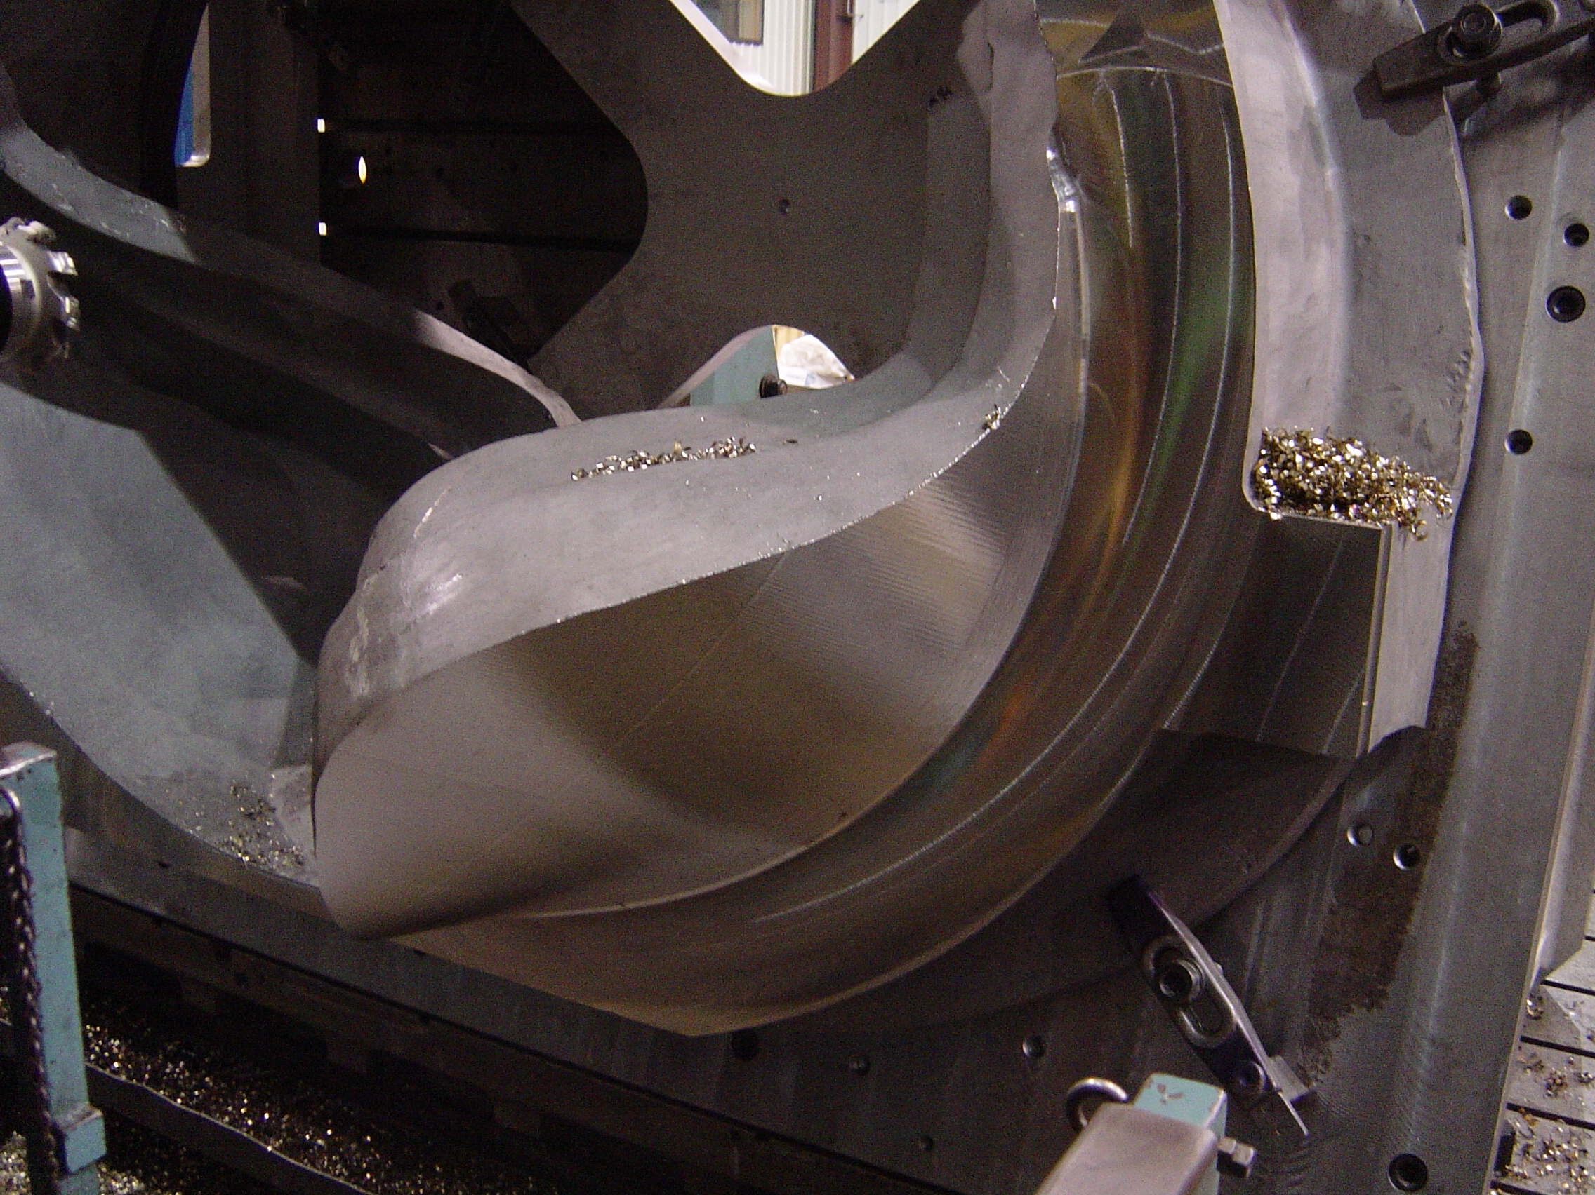

C-2 being machined at Major Tool

Due to the holiday, this was only a four day week, but the team still managed to make a lot of progress in all aspects of the program. Most significantly, we are now machining two production castings. Pictured above is C-2, which is already benefiting from the learning which occurred on C-1 (see details below in Technical Highlights).

On Tuesday, July 5, 2005, EIO and PPPL kicked off the week with our weekly QA telecon. The new format, segregating action items into closed, pending from EIO and pending from Princeton, (all linked to EIO action items) has been an invaluable tool. We are able to quickly evaluate the open items and concentrate on the answers each side needs to provide. This week, Chuck Ruud from Metal Tek was invited to join the meeting as we reviewed PPPL preliminary comments on the C-1 Documentation package, distributed to the team over the weekend.

EIO also held several internal team telecons on 7/7 & 7/8 to discuss our schedule and investigate and resolve several technical questions which had surfaced in recent days (discussed below). The critical path for delivery was reviewed and team members reaffirmed commitments to keep the big picture in view as we deal with day to day production decisions. Information gleaned from these meetings was synthesized into the monthly report which was submitted to PPPL on the morning of 7/8/05.

During the week we also completed our task to provide PPPL with an approach for stress relieving the remaining castings, including associated cost. This submission resulted in a phone call on Friday from Hutch Neilson regarding casting weights. The questions about casting weights are under review at EIO, Metal Tek and Major Tool. Joe Edwards confirmed that he had taken the data from models, but will further investigate to clarify and support the numbers. Meanwhile, we consulted Kevin Bowling, who advised that after running additional calculations, the amount of metal being removed is definitely greater than the 3,000 pounds mentioned during the tour at Major Tool (which in part contributed to PPPL questions). More information from Metal Tek, Major Tool and EIO on the casting weights will be shared with PPPL on Monday 7/11.

Administrative Action Items:

- (PPPL) Princeton is reviewing proposed changes to the spec from last week’s meeting at Metal Tek. This would be Version 8.
Status: (Open) The final iteration of Rev 8 is in process. Language submitted in response to Stress Relief issue may delay completion by another week.

- (PPPL, EIO, Metal Tek) All technical and administrative activities related to Prototype Development Contract S-04341F, including Change Order 5 have been completed. Final invoice was submitted to PPPL for payment.
Status: (Open - No update) Paperwork is in process at EIO is expected to be submitted in the next week.

- (EIO, Metal Tek, Major Tool) Disposition instructions for C pattern. PPPL has advised that they don’t anticipate taking possession of the patterns & will seek to have them disposed of at Metal Tek. They have inquired about whether Metal Tek would be keeping possession of a particular pattern until the last machined casting of that type is accepted and received by Princeton.
Status: (On Hold) Topic to be postponed to a later date. Until then, the patterns will remain at Metal Tek.

- (EIO, Metal Tek, Lawton) On 6/15 Larry Sutton issued SOW rev 3 under the auspices of the Changes Clause.
Status: (Open - No update) The document was distributed to EIO Subtier Contractors, who have been asked by Ed Galaska of EIO to acknowledge receipt of this document. So far, MTM has responded. A reminder notice was sent to Metal Tek and Lawton this week.

- (PPPL) Payment of EIO Team invoice for Purchase Order PE005678-W for extraction of sample materials.
Status: (Open - No update) EIO was told the check was in process, but according to Edward Galaska, the check has not been received. Larry Sutton verified that the check had been issued and mailed, but since it was not received at EIO, we were advised that the check will be canceled and a new check will be issued.

- (PPPL) Payment of EIO Contract invoice for May. On 7/1, Edward Galaska advised PPPL accounts payable and Larry Sutton that payment for the invoice for May had not yet been received by EIO.
Status: (Open - No update) We learned that due to a major reduction in personnel resulting from retirements and buyouts, the PPPL accounting department is undergoing a realignment of assignments and duties. Larry has promised to assist us in assuring that payments are not overly delayed.

- (PPPL) On 6/29/05, PPPL issued a request for price quote for stress relief of 16 castings. Due date 7/6/05.
Status: (Open) EIO/Metal Tek response was submitted on 7/8/05. In process at PPPL.

- (EIO, Metal Tek, Major Tool, Lawton) EIO Monthly Report for July covering activities in June.
Status: (Closed) Report was submitted on July 8, 2005.

Technical Highlights

Work in progress throughout the Subtier team members is presented below.

C-1
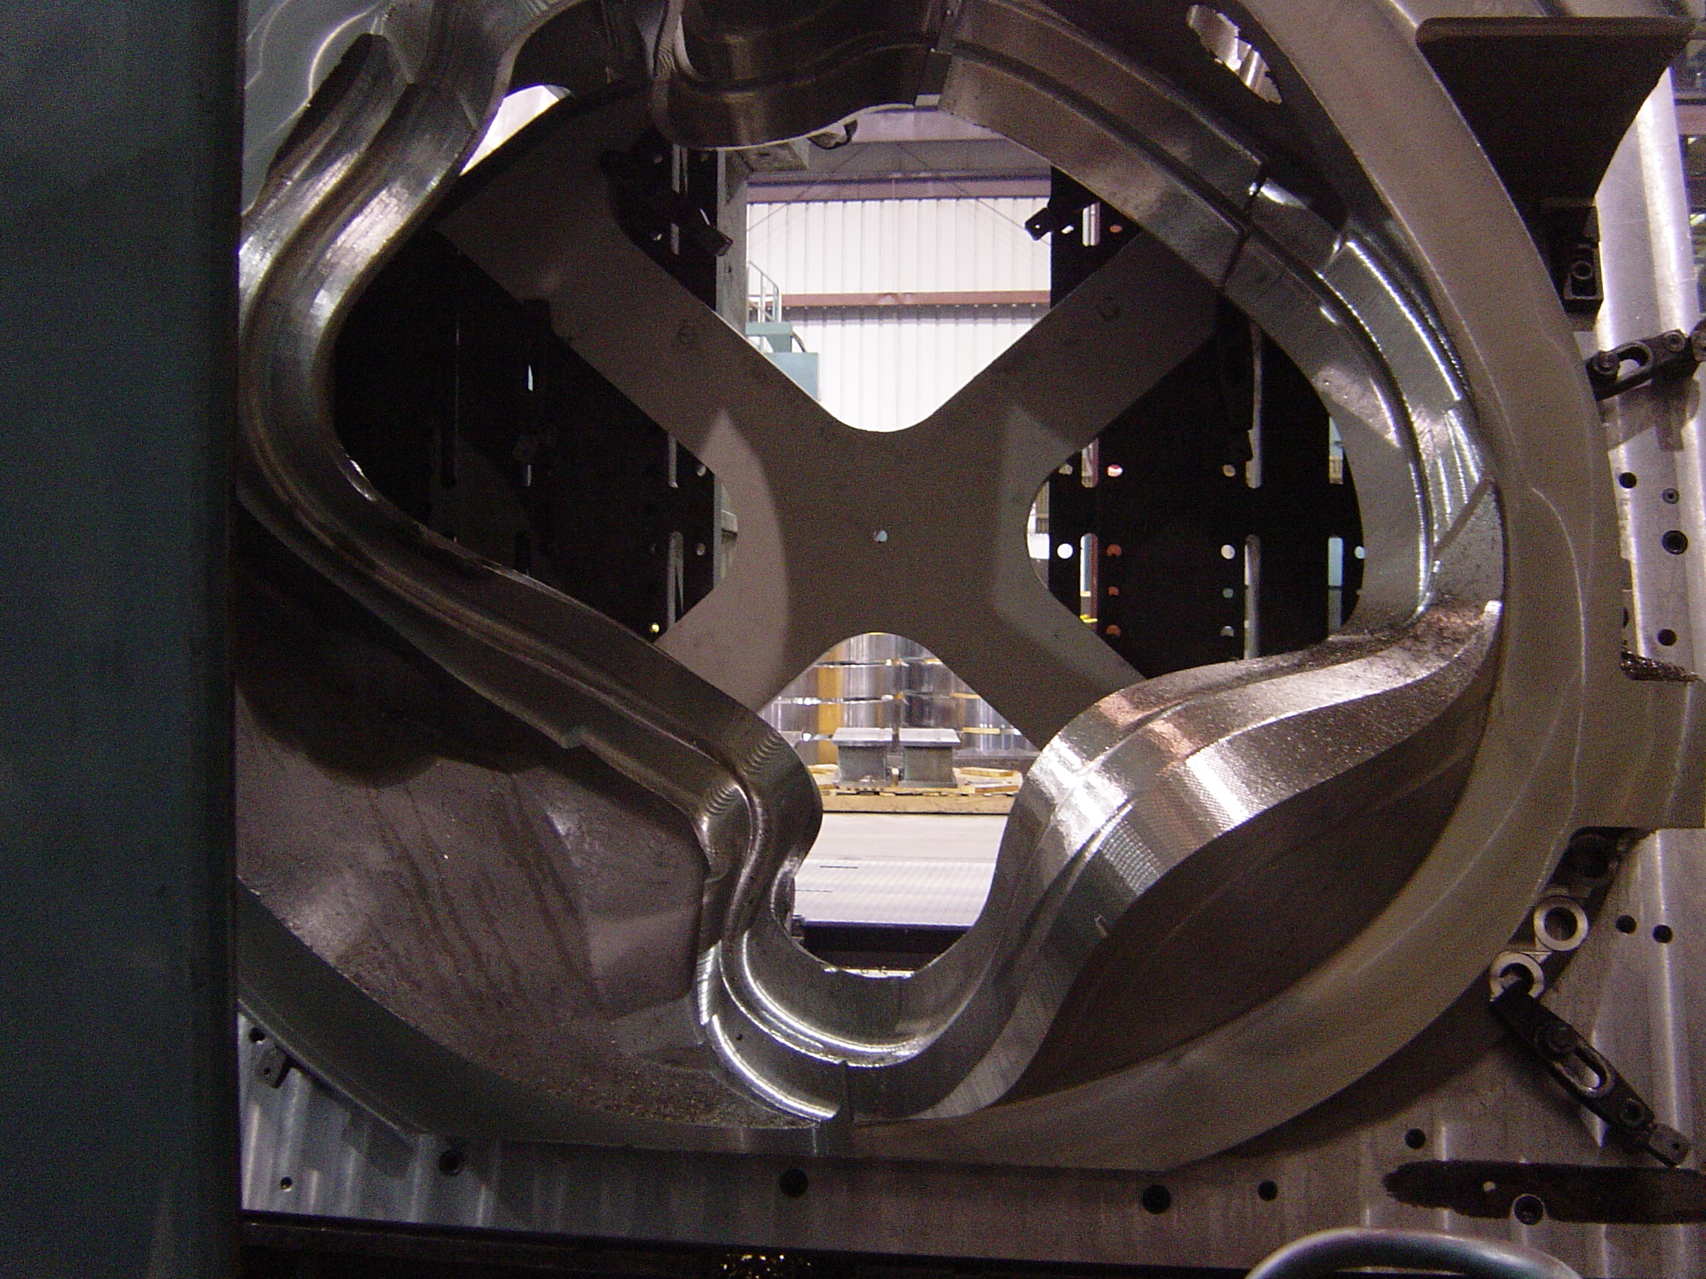

C1 at Major Tool

The above photo shows the part flipped over and on the machine with the wing surfaces and the "T" area machined down to the finished flange face level. Major Tool completed the 1st milestone of the 6/17 Milestone Chart; machining the 1st side of the flange. The casting has now been flipped over & MTM is continuing on the 2nd side in 3-axis machining. Due to the unique shape of the casting, some of the 2nd side was already machined prior to flipping the casting in the fixture. Major Tool is working on a revised milestone chart for C-1 which has been promised for 7/13.

MTM continued to run machining tests on the prototype C casting. These experiments on the 5-axis machine are enabling MTM to develop production machining methods prior to starting in on C-1. Kevin reported on Friday that the 5-axis prototype learning is mostly complete. MTM is now moving the prototype over to another machine to test their tooling and reach-capability to put in the poloidal break holes.

C-2
Machining on C-2 is progressing well this week, thanks to the experience gained on the C-1 casting. Kevin confirmed that they are well ahead of the machining pace on C-1. MTM has roughed the first side flange face and outside flange periphery to .250" stock. The wing surfaces shown in the photo at the top of this report, are also roughed to within .250".
There were some initial difficulties finding the “best fit” during set-up at Major Tool which resulted in additional labor hours to complete the task. After review of dimensional data, it was concluded that the most likely cause of the problem was weld shrinkage and/or over-aggressive grinding. Details of the situation are depicted by MTM in the chart below.

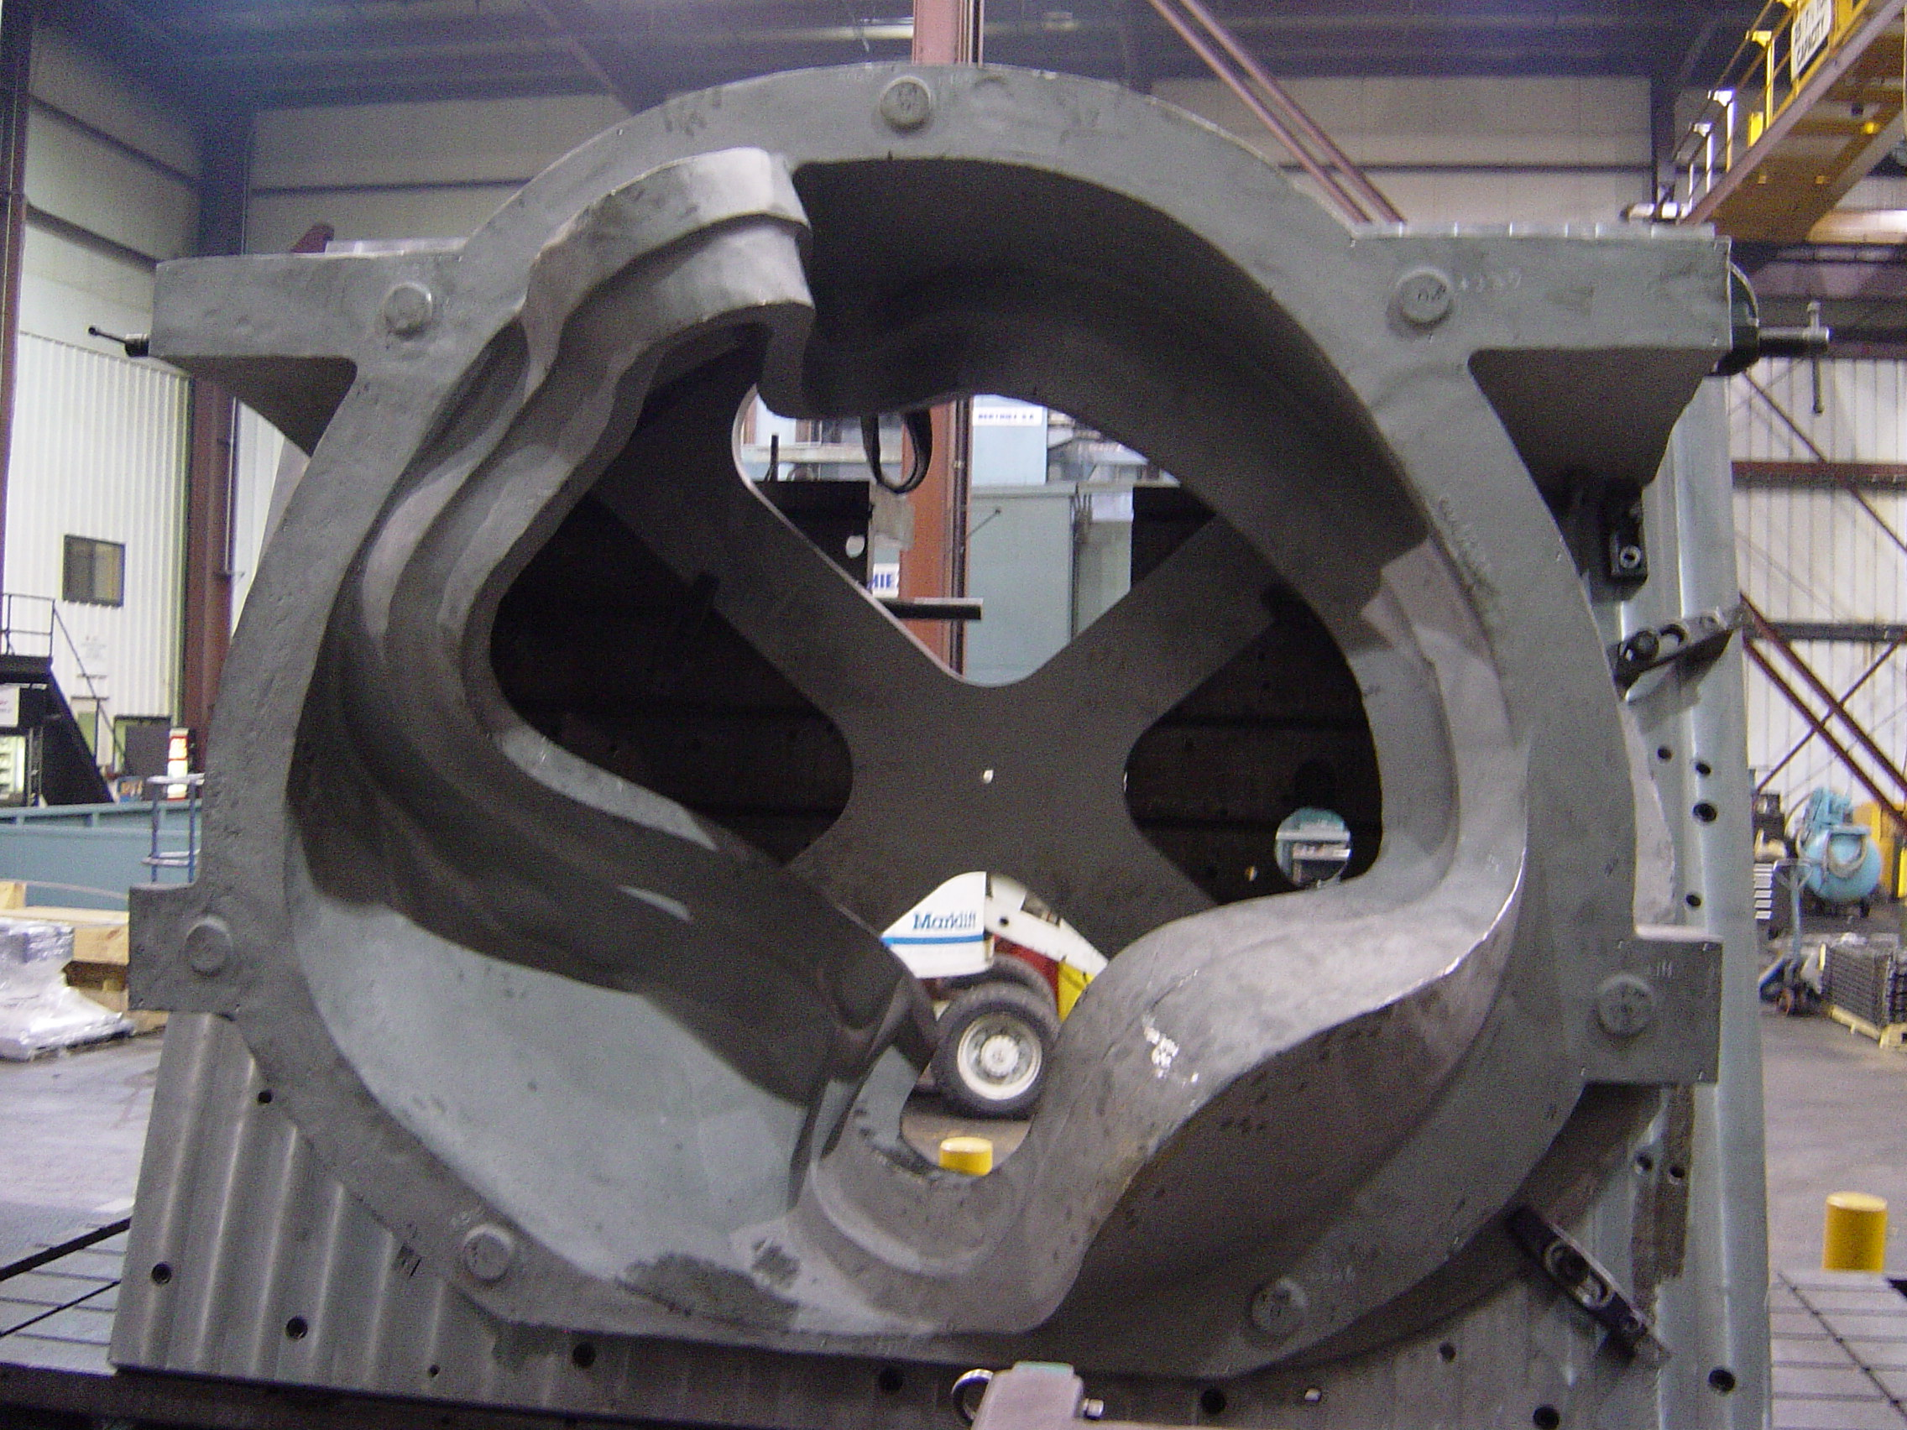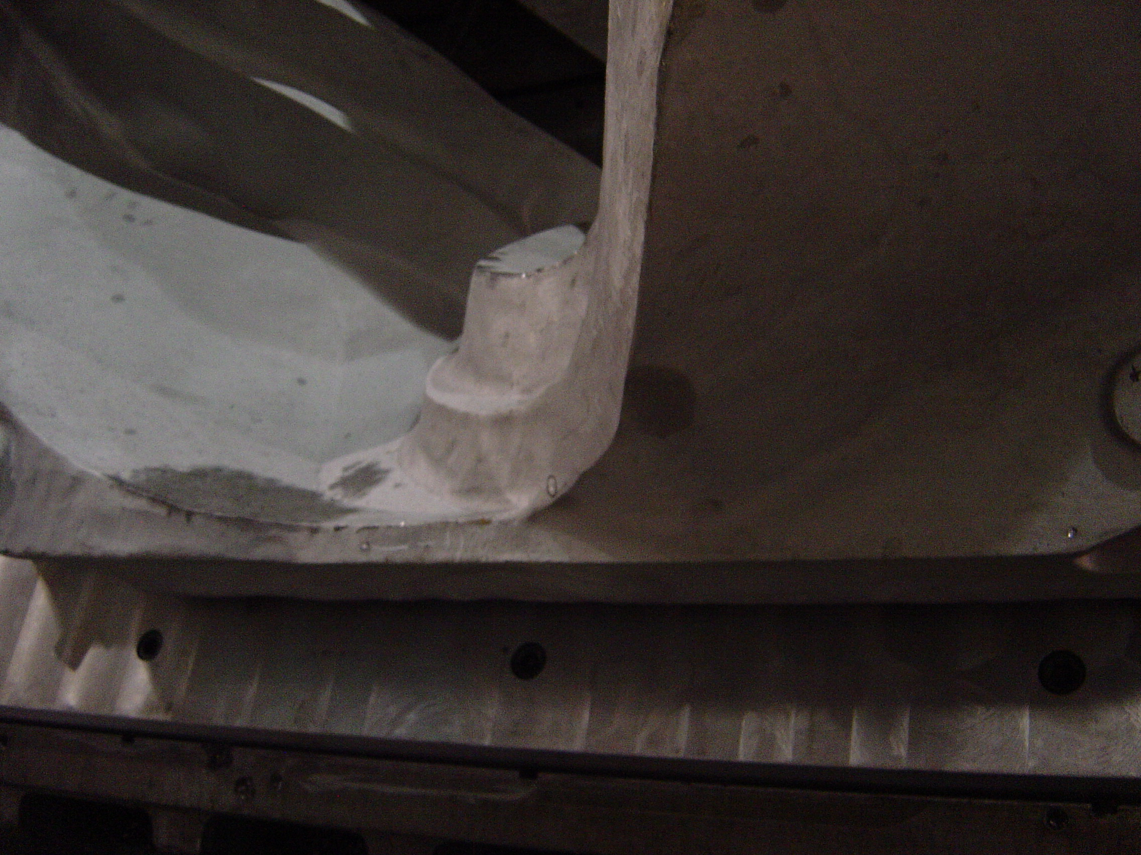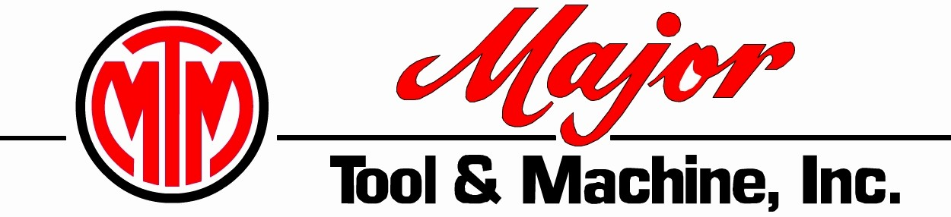
MCWF C-2
K. Bowling 1-July-2005
The inside face of the “T” in this area is short on stock from -.100” to + .100” from finish dimensions. This area will require welding.
This area will be thin but should be within tolerance and not require welding.
The casting is setup in best condition. The items called out on this sketch show where the worst areas exist.
We recommend not performing any welding until after we rough machine down to .250” envelope. After roughing the welding will need to take place.
Our additional weld testing will need to be expedited so we can weld before finish machining this area.

This area will be thin but should be within tolerance and not require welding.

Area of concern on C-2

The EIO team convened in a telecon on 7/8 to review the above data and determine any necessary actions for the future. In summary, there is an area on the part that will not clean up completely on the “T” section (top circle). This area (approximately 5” long by .100” deep) will be welded by MTM later on in processing. During set-up, this minor issue became problematic due to a corresponding thin stock condition opposing this area (bottom section), which inhibited MTM’s ability to shift the casting further.

Our first priority was to understand the severity of the issue and ensure that schedule was not in jeopardy. After a full review, the team members are satisfied that with some minor welding, this situation will be rectified during the machining process. The next question we addressed was how could we avoid this problem in the future. Currently, the dimensional inspection is performed earlier in the casting process to ensure that the foundry has poured an acceptable casting and dimensionally C-2 passed all inspections. As the weld repair on C-2 was performed after Metal Tek’s dimensional check, the problem was not identified until it reached Major Tool.

While the obvious answer is to conduct the dimensional inspection later in the process, this has some drawbacks for the foundry; however, in light of the fact that the C pattern has been proven dimensionally capable, Metal Tek has agreed to move the full dimensional inspection of subsequent castings to a later point in the process (after most post casting processing has been completed). Still under consideration will be the first off castings, where the pattern has not been proven. Since these parts still require dimensional scan upfront, Metal Tek is evaluating conducting a secondary inspection of areas that have been welded or ground. Chuck Ruud and Joe Edwards have taken the matter under advisement and will propose any necessary changes to their MIT/MTS to EIO and PPPL for approval.

A-1
Another important topic of the team telecon on 7/8 involved the new scan information from 3D ScanCo which was posted to their site on 7/7. As previously alluded to in our weekly reports, earlier scan data had several “black” areas where no data was available, so it was difficult to assess what appeared to be some areas under tolerance. While the new data eliminated many of the black areas missing data from the previous scan, there were still several areas that the team needed to address. We brought Karol Hatzilias from ScanCo into the telecon and after discussion, came to the following conclusions:
- Remaining 2 areas of black on the latest scan appear to be in areas where risers were present in the initial scan. Karol had to compensate for the “missing” material on the secondary scan.
- Kevin Bowling is confident that there is sufficient stock in all machined areas of the casting to yield a machined coil.
- An as-cast section of the wall appears to be thin. To further evaluate this, EIO, Metal Tek & ScanCo are attempting to:
  - Take various cross sectional views of the area
  - Take thickness measurements on the solid model produced from the scanned data
  - Get a closer tolerance band on the model provided

All parties will be working this through the weekend and a second telecon has been scheduled for Monday evening. In the meantime, Metal Tek has begun processing A-1. Grinding & excavations were initiated this week and a weld map is being prepared. Barry Craig tells us that welding on A-1 should begin by 7/11. He intends to ship A-1 out for x-ray to MQS on 7/13 and predicts a quick turn around due to fewer weld repairs than performed on previous castings. Depending on the final outcome of the ScanCo data review, A-1 could still ship to Major Tool as early as 7/22.
C-3
During the meeting in Indianapolis, we had explored the possibility that (based on initial visual inspection) C-3 could be expedited to accommodate issues that might impact A-1 delivery. Unfortunately, the C-3 casting is not scheduled to return from MQS (x-ray) until 7/14, which is several days beyond earlier hopes (MQS was likely already previously booked during the period so they were unable to expedite).

We were advised this week that Metal Tek is unable commit to delivery prior to the scheduled date of 8/5, especially with the new date for completion of X-ray; however, they still intend to stick to an accelerated schedule within the foundry. Barry Craig reports that they will have 2 additional qualified welders available for our program in the upcoming weeks which will enable more flexibility in scheduling accomplishment of these tasks.

C-4
The mold for C-4 is completely built and at this point, Metal Tek only needs to ingot the material and schedule the pour. We found out late Friday that pouring of C-4 had to be postponed until the night of 7/12, due to staffing problems. Nonetheless, as this is the fourth C casting, and fifth overall, they have the advantage of the learning curve, and Barry assures us that they are still well within their casting lead-time to meet their delivery promise of 8/25.

B Pattern
Tim Wenninger reports that they have been able to get in a full week on the pattern. The center drag box has been completely routed & is currently being assembled. The loose core box ring of the cope box is now on the router and Tim estimates that this should be complete on 7/13. Meanwhile, Don Dickert will begin modeling the balance of the cope box on 7/11 and will likely have it completed by 7/15. They are still working toward a 9/15 completion date.

Technical Action Items

- (Lawton) Manufacture of B Pattern
Status: (Open) Back on router through 7/13
- (Metal Tek) Processing C-3
Status: (Open) Back from MQS on 7/14
- (Major Tool) Completion of 3 axis machining of C-1
Status: (Open) Have flipped casting onto 2nd side
- (Major Tool) Shipping crate for C-1
Status: (Open) PPPL’s suggestions agreed to. Revised sketch submitted.

- (Major Tool) Machining C-2
Status: (Open) 1st full week completed. Running very well.

- (Metal Tek) Processing C-4
Status: (Open) C-4 is rescheduled to pour July 12, 2005.

C. Quality Activities
As highlighted in the Administrative section, the focus of our quality discussions this week revolved around the document packages. At the start of the week, PPPL provided a detailed list of comments on the C-1 document package, which Metal Tek and EIO have been addressing and resolving. So far, issues have been minor and readily corrected, which indicates that the Metal Tek portion of the C-1 document package will be acceptable in time for shipment.

We have also been assembling documentation for the C-2 document package and have initiated the process of compiling and recording the necessary data associated with the A-1 and C-3 document packages. It is our intent that relevant comments and input from the C-1 doc pack be incorporated into the documentation for subsequent castings.
Upcoming QA Activities
- 4 Side bend tests and 1 tension test by Major Tool (started w/o 7/5)
- Review & submittal of C-2 document package
- A-1 to X-ray 7/13
- C-3 back from x–ray 7/14

QA Action Items:

- (PPPL) Resolution of the remaining material test report concerns transmitted in 5/3, 5/4, and 5/9 e-mails from PPPL). Particularly, follow-up on significant differences between Lab results on cryogenic yield tests is required.
Status: (Open) Metal Tek and EIO Submitted & posted required documentation to FTP site on 6/24/05. Further clarification was given in subsequent Emails on 6/29 & 6/30. Metal Tek will use Westmoreland for Tensile testing at the 77K temperature. ST Louis will perform Tensile testing at room temperature, and all Charpy testing both at room temp and at 77K . Under review at PPPL.

- (PPPL) Action or communication regarding discussions of material testing in both directions and alternative approaches (also see action item #’s 4, 5, 6) Draft Spec issued to EIO team for comments. Comments were returned to PPPL on 6/15/05
Status: (Closed) Requirement removed. The change will be incorporated as part of Spec Rev 8 which is currently being processed.

- (PPPL, EIO, Metal Tek) PPPL took the action at the meeting to clarify alloy chemistry requirement to determine if an average is acceptable - Ref ASTM A751, paragraph 5.1.1.1) which they did. EIO and Metal Tek took exception to PPPL’s comment that an NCR would be required if a single ladle’s chemistry is outside the requirements. Language in ASTM A703 was cited as the basis for this exception.
Status: (Open) Joe Edwards took an action on (Rev 8) to do a study(product analysis off the bars) on one casting and provide the chemistry of the weighted average. During the QA telecon Frank clarified that Joe was going to run an analysis on the zoned bar and demonstrate the mixing, using 3 zoned chemistries and 3 zoned physicals. (RT, cryo) The only thing he would be doing differently would be to take a material sample from one sample from each zone.

The agreement was that Metal Tek would run samples from 3 different zones to show that there wasn't any chemistry difference, which would eliminate the PPPL concern of different ladle points and hopefully show that there wasn't any difference between the ladles being off by 2 points (i.e. difference in chemistries, not in mechanical properties). If Metal Tek could determine the amount of mixing and show the properties with that amount of mixing, then PPPL would feel comfortable.

This information was passed along to Joe Edwards mid week. Joe is following up.

- (EIO, Metal Tek) Nonconformance Report for C-1, C-2, & A-1 for lack of Additional Test Material required by 4.2.2.4. Per e-mail from PPPL: “At the meeting, we discussed the possibility of salvaging the “holes” cut out at MTM and using that material as a source for test pieces for the C-1 and C-2 castings. We also discussed the possibility of cutting coupons from Riser areas of the A-1 and possibly the C-2 scraps. If these remedies are feasible, they should be part of the proposed corrective action.
Status: (Open) PPPL advised us this week that they will settle for 15 out of 18 test samples. They concurred with Metal Tek’s assessment that since the C-1 shim was poured from 1 ladle, the physical test results obtained from the aggregate pour may not be indicative of the results which could be obtained through testing on the actual shim

This information was passed along to Metal Tek and they will begin processing the non-conformance report for C-1, C-2 and A-1 for lack of additional test material.
- (EIO, PPPL) PPPL is seeking a Processing Outline from MTM to address welding, and a procedure describing MTM’s welding controls. In addition to general controls, the submittal should answer the same issues already addressed with Metal Tek, such as the documentation to be provided, the pre & post welding inspection, and magnetic permeability checks. A clear date for submission of this information is also required.
Status: (Open) Kevin Bowling has submitted the revised MIT plan to EIO for review and processing. The revised MIT plan will be forwarded to PPPL on Monday, 7/11 for approval.

- (EIO, Major Tool) Metal Tek to provide sample material to Major Tool for conducting required tests. Corrective Action - additional 4 side bend tests and 1 tension test - for MTM nonconformance report NC17399, due prior to weld repair on any castings other than C-1.
Status: (Open) An extra shim was supplied by Metal Tek with the C-2 casting. MTM will be expediting these tests. Kevin estimates the task will take about 4 weeks and will endeavor to complete prior to shipment of C-1. No status reported this week. EIO has initiated follow-up.

Additional clarification provided in PPPL weekly quality notes reads: Note that PPPL has approved welding on the casting with post-welding qualification of the WPS. PPPL will not reject the casting based on WPS qualification results (PPPL took this risk). However the documentation package portion of the C-1 deliverable will not be accepted until complete, which includes closing of all NCRs (CA’s) as well as completion of the WPS qualification.

- (EIO, Metal Tek, PPPL) Submission and review of C-2 Spec sheet and Documentation Package and shipping release of the casting
Status: (Open) Preliminary document package was posted to the FTP site for review.

- (PPPL) PPPL has advised that in order to modify the specification to adopt the revised machining surface finish, they will need a formal deviation request submitted by EIO/Major Tool.
Status: (Open) Major Tool/EIO submitted the deviation request to PPPL on 7/6/05. Action is now pending PPPL approval and subsequent incorporation into the specification.

- (EIO, Metal Tek) PPPL has requested submission of a document or drawing that will link the weld repairs to the radiographic locations. PPPL has also asked for clarification about whether all radiographic shots were taken with the same equipment.
Status: (Open) Metal Tek has submitted an updated weld map to EIO for review, which will incorporated into the C-1 documentation package on the EIO ftp site. We will also submit the documents directly to PPPL via e-mail.

- (PPPL, Major Tool) To facilitate acceptance of the CMM data, Kevin offered to create a CAD file with point cloud data, mimicking that which might occur. The file will be used by PPPL to compare with their data in order to ascertain compatibility.
Status: (Open) Kevin Bowling is working with Steve Raftopolous and Tom Brown to prepare the file. Meanwhile, Frank Malinowski informed us that as a result of his inquiry as to whether or not PPPL would need a data dump to a spread sheet for the final inspection, (in addition to the STEP file with CMM data points added), that the spreadsheet is not needed.

Please be advised that I will be traveling outside of the country between July 14 and 27, during which time Roy Sheppard will be responsible for submission of the EIO team weekly report. If there are any questions during this time, please contact Roy in the office at 800-337-3083 or on his cell phone at 845-664-4600. Alternatively, you may also contact Edward Galaska for administrative matters and Peter Djordjevich regarding Quality Assurance, both at 216-662-7044.

Nancy Horton
EIO Program Manager for NCSX

