Energy Industries of Ohio (EIO) Team Weekly Status Report

Report covers the NCSX Modular Coil Winding Form Activities Including:
- Production Contract S005242-F
- Change Order 5 under the Prototype Development Contract S-04341F

Week ending August 12, 2005

Administrative Highlights
The EIO team experienced a productive week on many levels. On Monday evening, August 8, 2005, our foundry, Metal Tek poured C-5 (our sixth casting) and by the week’s end, the part had cooled enough to begin breaking it out of the mold.

At Major Tool, machining of C-1 and C-2 were both in full swing. The 3-axis “Mitsu” which had been down for repairs the previous week, was calibrated over the weekend and back on-line first thing Monday morning. On Tuesday, 8/9, Jeff Makiel from DOE, Hutch Nielson, Mike Viola & Larry Dudek from PPPL and Nancy Horton & Roy Sheppard from EIO traveled to MTM in Indianapolis to observe progress and address schedule. The following slide which depicts similar accomplishments on C-1 and C-2 reveals progress on C-2 is moving at nearly twice the rate as C-1, thus validating our learning.
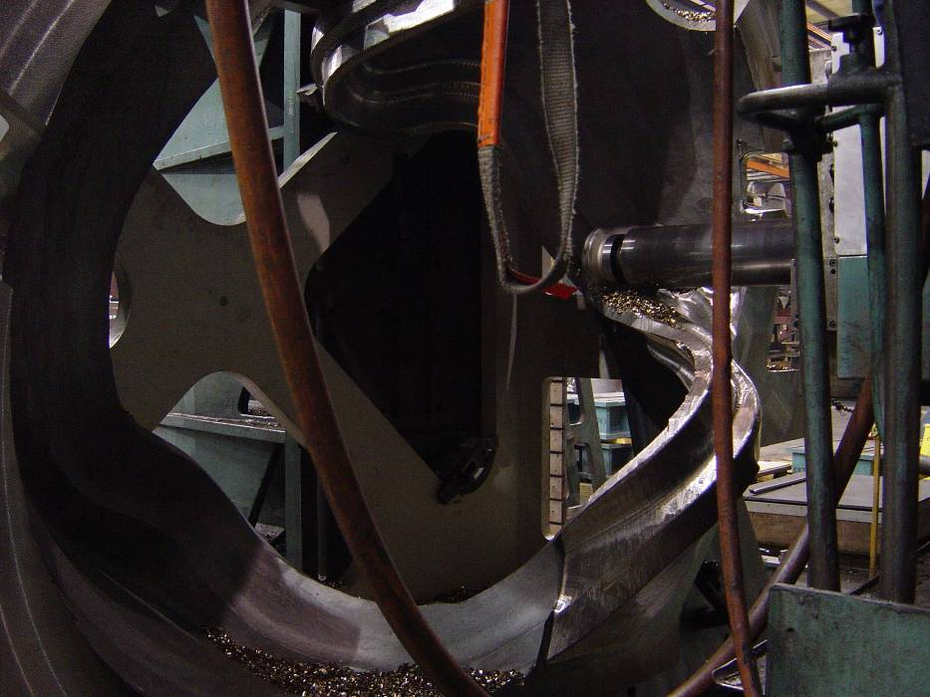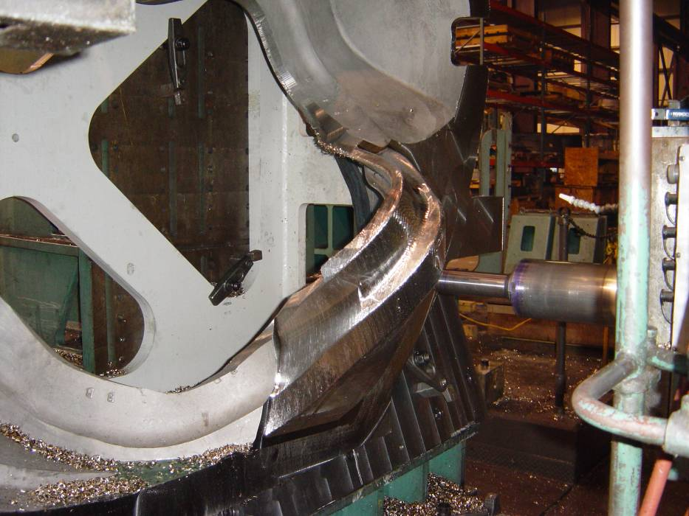
C1 week 6
First side is rough-machined completely. Roughing has begun on the second side.
C2 week 3
First side is rough-machined completely. Roughing has begun on the second side. More roughing on flange face for the second side is performed.
C1 and C2 Progress Comparison

While the significant improvement in the lead-time of C-2 over C-1 is considered excellent news and affirms our team’s potential to recover schedule over the life of the contract, it does not eliminate the many concerns over the continued schedule slippage of C-1. This issue was addressed head-on during our meeting at Major Tool and their staff responded with a detailed explanation of the process used to estimate schedule and the evolution of the methodology applied.

The reason for the on-going “slippage” in schedule seems to be two-fold. First, there’s the issue discussed for weeks now of a “learning curve”. The 12 week machining schedule was always considered a “best case” scenario for the first part and would have required every machining approach applied to be successful on the first run. Experience proved otherwise. MTM needed to discover, often through trial and error, the best path for machining the complex shapes involved, weighing the success of the operation on both machining outcome as well as time to complete. Many different programs which were adequate to perform the tasks, were discarded because they took too long to execute and the process of finding the right path became an added drain on lead-time. The successful outcome of this process is best exemplified by the photos at the top of the report. On week 3 of machining, C-2 was at virtually the same spot that took 6 weeks of machining for C-1; so double the progress in the same time.

The 2nd contributor to the changing schedule was the method used for calculating projections. Earlier estimates were based on the application of a generic machining factor applied to the standard calculations for cutter path “cut times.” While this approach is successful in almost every machining job undertaken at the plant, it became obvious that it was not adequate for the winding forms and a new method for calculating projections needed to be developed.

MTM responded by bringing on board Mark Sweeney, the new Manager of Tech Services and an expert in this area, to support the analysis and develop the new method. MTM replaced their previous software with Vericut which enables them to calculate machine simulation against previous experience to assess the accuracy of their predictions. Using machine simulation modeling, (where the machine head is modeled as well as the cutting tool) for both writing new machining programs and calculating task or program time, MTM breaks down all the tasks in the entire process and calculates the associated lead-time by applying the actual analysis of each coil form. The September16 delivery date for C-1 was formulated using these techniques, as were the projections shown on the learning curve schedule shown in last week’s report for the balance of the C coils.

We also learned that Major Tool has committed significantly more resources to NCSX to ensure C-1 remains on schedule through completion and to enable schedule recovery throughout production. Three (3) full-time programmers were assigned to C-1, each with a specific area of responsibility, so that their experience and expertise on the part can be carried over to every task of that type throughout the process. Over time, these programmers are cross training each other so that ultimately they will all be equally knowledgeable about all of the programs involved in machining the casting.

To further reduce schedule risk on future castings, MTM has purchased a new 5-axis head for the 30’ Mitsubishi. This will give them a backup for the U-5, in case of machine breakdown. The head will be installed mid September and should be operational by the end of that month.

Administrative Action Items:
- (PPPL) All technical and administrative activities related to Prototype Development Contract S-04341F, including Change Order 5 have been completed. Final invoice was submitted to PPPL for payment.
Status: (Open - No update) The corrected invoice along with associated supporting documentation was submitted to PPPL on July 5, 2005.

- (Metal Tek, Lawton) On 6/15 Larry Sutton issued SOW rev 3 under the auspices of the Changes Clause.
Status: (Open - No update) EIO submitted acknowledgement to Larry Sutton, as required, but we still await the acknowledgement from Metal Tek. A friendly reminder will be issued so that we can close out this action.

- (EIO, MTK, MTM) On 7/13 Larry Sutton of PPPL issued Amendment Number 5 to EIO contract, which necessitated EIO to issue Amendment Number 3 to the subtier contractors. The amendment, which incorporates SOW rev 4 and Spec rev 8 into our contracts, was issued to Lawton, MTK and MTM on 7/15/05.
Status: (Open - No update) Signed acceptance of amendments required from MTK and MTM in order for EIO to sign Amendment 5. Larry Sutton reiterated that while the technical changes fall under the changes clause and are therefore already in effect, the associated funding under our contract will not be added until our amendment is signed by both parties. Reminders to our team members were sent.

- (EIO, Lawton, MTK, MTM) On 8/10 Larry Sutton of PPPL issued Amendment Number 6 to EIO contract, incorporating Spec Rev 9 into our contract.
Status: (New) An advance copy Spec Rev 9 was distributed to our subtier team members, while contract amendments are in process. When issued, signed acceptance of the amendments will be required.

Technical Highlights

Thin Wall update
On 8/9 PPPL provided an analysis of the A-1 thin wall condition.

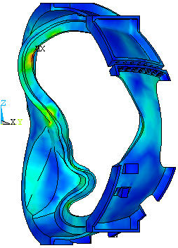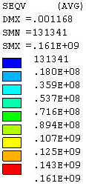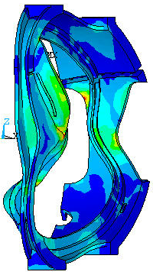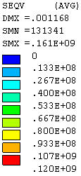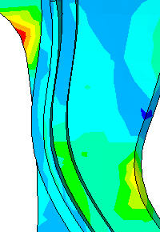
Stress Plot up to 120MPa
This model uses a corrected E and models All Type A Castings as Having A Thin Region Like A1 but t=1.05”
Stresses in Shell Type A for Run No. 4
- E=145 GPa except E(thin wall region)=111 GPa

Slide from PPPL FEA analysis of A casting

The figure above shows the possible stresses in the thin walled area, even postulating a wall as thin as 1.050”. In summary, PPPL’s analysis showed that the most significant effect is the updating of the modulus E to that of the “Stellalloy” and that thin shell areas like that of A1 have an extremely minor affect on the stresses and displacements in ANY of the coils or shells. Reasons provided include:

a) The shape of the tee is not changed by this, and the tee provides most of the bending stiffness

b) Some EM forces are transferred to the shell B from the wing.

c) The thin wall region is not the location for the peak stress and much of the area will be machined away.

The report concludes that since the thin section of A1 has virtually no effect on stresses or deflections of either the coil or shell, PPPL has advised us that the NCR for A1 with the thin region having a minimum thickness of 1.18” will be dispositioned to “Accept As Is.”

Regarding our root cause analysis, after having ruled out the pattern and potential misalignment of the scanned data, our focus is now on the pattern. EIO received an extensive report from ScanCo earlier this week, which is currently under review by EIO and the sub-tiers. Pattern rescan is still under consideration and will be the topic of discussion at a team meeting early next week; however the report indicates that the initial scanned results of the pattern are sound. A copy of the report will be provided to PPPL for our weekly QA meeting on 8/16.
EIO appreciates all of the input provided by the NCSX team as well as Metal Tek, Lawton Patterns and 3D ScanCo to resolve the thin wall dilemma in a timely manner. Work performed on the various castings and the B pattern is reported below.

C-1
As mentioned above, work on C-1 continued on track with MTM’s revised schedule. According to Jim Flannigan, Executive VP at MTM, the 2nd set-up was finished this week and the part was being readied to flip onto datum D, which is actually the 4th set-up. Major Tool decided that it would be more efficient to do the 4th set-up prior to the 3rd in light of the experience so far.

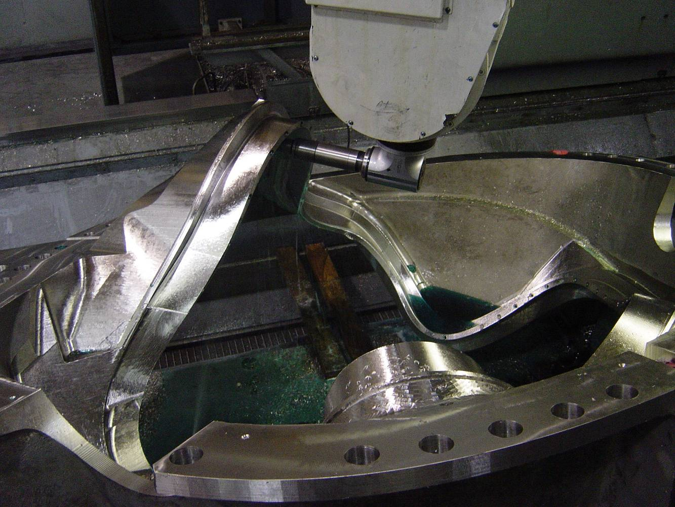

C-1 in 5-axis machining

The new programming for the groove was completed this week as well. This programming now utilizes the modeling of the complete head rather than just the cutting tool.

C-2
As projected in last week’s report MTM was able to get the 40’ Mitsubishi calibrated on 8/7. Machining on C-2 resumed in the early hours of 8/8. The pace at which MTM is currently machining C-2 proves out the learning curve postulated earlier. Major Tool is well on track to deliver C-2 by 10/7. As had been predicted in the initial setup, there is a small area on the casting that did not clean up. Kevin Bowling showed us this area on our tour earlier this week. This area will need to be welded & machined after this current setup. Kevin has assured us that weld repair time has been included in his calculations for projected ship date.

A-1
A-1 returned from MQS this week. There are several additional weld upgrades needed. Metal Tek is preparing the weld map & NCR and plans on repairing A-1 next week. After welding, A-1 may need to go back to MQS (depending on the area needing upgrading) for a final x-ray.

C-3
C-3 is through weld repair. It is shipping to MQS on 8/15. EIO will be conferencing with MTK on 8/15 to discuss the schedule for RT. It appears that there may be an unpredicted queue time at MQS that is impacting schedule (see C-4 below).
C-4
Roger Broman reports that C-4 is expected back at Metal Tek on 8/19.
Metal Tek had previously predicted that C-4 would pass through x-ray this week and return to MTK with the A-1. This did not happen. According to Roger, MQS was unable to process 2 parts at the same time. It is unclear as to whether this is a temporary bottleneck or an equipment limitation. Barry Craig had mentioned that he had investigated alternate sources to expedite the inspection; however the lead-time for qualifying another source exceeded any advantage.

C-5
As Projected, C-5 was poured on the night of 8/8. The team has now poured 6 castings successfully! Roger Broman reports that the casting was being broken out of the mold on 8/12.

B Pattern
Tim Wenninger reports a good week of progress on the pattern, though Lawton is slightly behind their projections for the week. The drag pattern was finished this week as were 3 core boxes. Tim expects to finish an additional 2 core boxes over the weekend. There are 5 remaining large core boxes to rout as well as 6-8 riser cores. Tim still feels that Lawton is on schedule to deliver the B pattern on 9/15

Technical Action Items

- (Lawton) Manufacture of B Pattern
Status: (Open) proceeding well towards 9/15 ship date.
- (Metal Tek) Processing C-3
Status: (Open) welding complete. Shipping to MQS on 8/15.
- (Major Tool) Completion of machining of C-1
Status: (Open) Projected completion is 9/2
- (Major Tool) Machining C-2
Status: (Open) machining resumed 8/8.
- (Metal Tek) Processing C-4
Status: (Open) Expected back from MQS 8/19.
- (PPPL) Eliminating sealing groove in the area of the lead block
Status: (Closed) Prints released 8/8/05

- (PPPL) PPPL has requested that MTM scribe the location of the weld-nuts for lead block locators on each casting.
Status: (Closed) Prints released 8/8

C. Quality Activities
Chuck Ruud of MetalTek, joined our weekly QA meeting again this week on 8/8. Using our customary format of PPPL’s quality notes, we quickly went through all open items. The disposition of these is discussed below:
Upcoming QA Activities
- 4 Side bend tests and 1 tension test by Major Tool (results now expected back by 8/17).
- Cryogenic CVN test at St. Louis (test was scheduled for 8/9)
- QA meeting at Metal Tek on 8/23

QA Action Items:

- (PPPL, EIO , MTK) Resolution of the remaining material test report concerns (transmitted in 5/3, 5/4, and 5/9 e-mails from PPPL). Particularly, follow-up on significant differences between Lab results on cryogenic yield tests is required. (PPPL QA note #3.1)
Status: (Open) Metal Tek and EIO Submitted & posted required documentation to FTP site on 6/24/05. Further clarification was given in subsequent Emails on 6/29 & 6/30. Metal Tek will use Westmoreland for Tensile testing at the 77K temperature. ST Louis will perform Tensile testing at room temperature, and all Charpy testing both at room temp and at 77K. PPPL has advised that response/closure will be based on DCMA witness of a cryogenic CVN test at St. Louis Testing. Tests were scheduled for 8/9. No results reported yet to EIO.

- (PPPL, MTM) PPPL is seeking a Processing Outline from MTM to address welding, and a procedure describing MTM’s welding controls. In addition to general controls, the submittal should answer the same issues already addressed with Metal Tek, such as the documentation to be provided, the pre & post welding inspection, and magnetic permeability checks. A clear date for submission of this information is also required. (PPPL QA note # 2.2)
Status: (Open) MTM’s revised MIT plan was submitted to EIO on 8/11. It was reviewed by both Pete Djordjevich and Roy Sheppard on 8/12 & submitted to Princeton for review. Approval of MIT also requires data from the 4 side bend tests and 1 tension test (see action item #4) which were not complete at the time of submission. Approved MIT required prior to any weld repair at MTM on C-2.

- (EIO, Major Tool) Corrective Action - Additional 4 sides bend tests and 1 tension test - for MTM nonconformance report NC17399, due prior to weld repair on any castings other than C-1. (PPPL QA Note # 2.1)
Status: (Open) The side bend tests expected back from Major Tool on 8/10, did not happen. Jim Flannigan checked with the outside lab and was assured that the test would be run on 8/15 and that results would be back to MTM by the 17th. MTM will submit to EIO after review.

- (PPPL, EIO) Submission and review of C-2 Spec sheet and Documentation Package and shipping release of the casting (PPPL QA notes #2.3)
Status: (Open) New documents have been posted to EIO ftp. PPPL has responded with comments which are currently being addressed
- (PPPL) PPPL has requested the X-Ray technique sheets from MQS (PPPL QA Note 3.4)
Status: (Open) Forwarded to PPPL on 8/5 - under review by Frank Malinowski
- (EIO, Metal Tek, Lawton, PPPL) Determine root cause of the thin wall condition on the A-1 casting. (PPPL QA note # 2.5 & 3.2, 3.3).
Status: (Open) We have been advised that NCR (CA1347), submitted on 8/3 to use the casting as is, will be approved by PPPL. CA 1324 for major weld repairs on A-1 has also been approved. Root cause analysis is in process, as reported under Technical Highlights and upon completion of investigation, EIO will submit the appropriate Corrective Action to PPPL summarizing the root cause analysis and the associated mitigation plan.

- (EIO, Metal Tek) CA 1323 issued by Metal Tek on 7/27 for NCR on erroneous sulfur & phosphorus readings (PPPL QA notes #2.4.1,2.4.2 & 2.4.3).
Status: (Open) PPPL has requested additional data and clarification from MTK in order to process the CA. During our QA meeting, Chuck Ruud of MTK reported that Product Analysis on C3 was done for most constituents using MTK spectrometer. Future castings will all have independent chemical analysis. EIO is starting this process with C-5. Frank clarified that PPPL is looking for at least a sampling of C-2 - C-4 to be independently verified for all constituents to verify that the issues were only with Sulpher and Phosphorous. Chuck will look into the availability of samples large enough to accomplish this and will report on it next week (note, this has been assigned a new action item number 8 below). EIO also agreed to forward St. Louis test data for 11 shims and provide results of the manufacturer’s check of the spectrometer to PPPL by 8/19. A QA meeting to further discuss this matter will be held at Metal Tek on 8/23. At this time, Frank Malinowski, Peter Djordjevich & Roy Sheppard plan to attend in person.
- (Metal Tek) PPPL has requested complete independent chemical analysis on C-2 through C-4 to verify that the only problems with earlier spectrometer readings were limited to sulfur & phosphorus.
Status: (New) Chuck has to check on the availability of additional test material for these tests. PPPL requests that this be done for at least 2 castings. Chuck agreed.

- (MTK, EIO) All comments on the C-1 doc package have been received from PPPL and are now being incorporated into the final package, prior to the expedited review of C-1 after machining. (PPPL QA note 2.3)
Status (Re-opened) EIO has agreed to update & resubmit a revised C-1 Doc package by 8/19. Frank Malinowski stressed that he needs ample time to review this portion of the package

- (MTK, EIO) Weld Map for C-3
Status (New) EIO has been working with MTK to produce an easy to use template for the weld maps. This template is currently being applied by EIO to the C-3 weld map.

- (MTM, EIO) NCR for tool gouges on C-1. Major Tool submitted a report on 8/8 describing 4 gouges on C-1 that need to be dispositioned. (PPPL QA action item 2.6).
Status: (New) During our telecon with PPPL, The only gouge on the C-1 casting that could affect winding is on the tapped hole (see sketch below). MTM has assured PPPL that this gouge will not affect the integrity of either the bore or the tap.
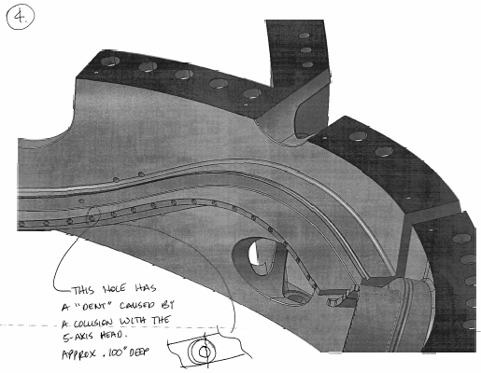
Tool gouge on C-1

As always, we welcome your comments and questions. I can be reached at 216-496-2314 and will look forward to hearing from you.

Nancy Horton
EIO Program Manager for NCSX

