Energy Industries of Ohio (EIO) Team Weekly Status Report

Report covers the NCSX Modular Coil Winding Form Activities Including:
- Production Contract S005242-F
- Change Order 5 under the Prototype Development Contract S-04341F

Week ending August 26, 2005

Administrative Highlights
Friday marked the end of another productive week as the team continued to make significant progress on all aspects of the program. With continued luck and diligence, in the upcoming week or so, we anticipate achievement of several major milestones including: the pouring of C-6 which is the last of the C style coils; shipping A-1 and C-3 from Metal Tek to Major Tool; completion of machining of the C-1 coil; and completion of the routing of the B pattern. Our efforts this week leading up to these projections are explained in greater detail under technical highlights.

On Tuesday, 8/25, Frank Malinowski of PPPL, Rosa Medina of DCMA, and Roy Sheppard & Pete Djordjevich of EIO traveled to Metal Tek for a QA meeting and review (covered in QA Highlights), and while touring the facility, had the opportunity to see the A-1, C-4, C-5 & the soon to be C-6 castings in various stages of manufacture. While onsite, Roy managed to capture a few pictures, some of which are presented below. And, since a picture is worth a thousand words, many of our highlights this week speak for themselves.

Administrative Action Items:
- (PPPL) All technical and administrative activities related to Prototype Development Contract S-04341F, including Change Order 5 have been completed. Final invoice was submitted to PPPL for payment.
Status: (Open) The corrected invoice along with associated supporting documentation was submitted to PPPL on July 5, 2005. A call to PPPL accounting this week did not yield any information, although a promise to investigate was extended. (Also note: June and July invoices on the Production contract are also overdue. Any assistance in expediting will be appreciated).

- (Metal Tek) On 6/15 Larry Sutton issued SOW rev 3 under the auspices of the Changes Clause.
Status: (Closed) Acknowledgement from Metal Tek was received on 8/22.
- (EIO, MTK, MTM) On 7/13 Larry Sutton of PPPL issued Amendment Number 5 to EIO contract, which necessitated EIO to issue Amendment Number 3 to the subtier contractors. The amendment, which incorporates SOW rev 4 and Spec rev 8 into our contracts, was issued to Lawton, MTK and MTM on 7/15/05.
Status: (Open) Signed acceptance of amendments required from MTK and MTM in order for EIO to sign Amendment 5. Reminder notices were sent again this week.

- (EIO, Lawton, MTK, MTM) On 8/10 Larry Sutton of PPPL issued Amendment Number 6 to EIO contract, incorporating Spec Rev 9 into our contract.
Status: (Open) Amendments were issued on 8/14 to all subtier contractors for signature. Upon receipt, EIO will sign & return to PPPL for processing. Reminders were sent again this week.

Technical Highlights
C-1

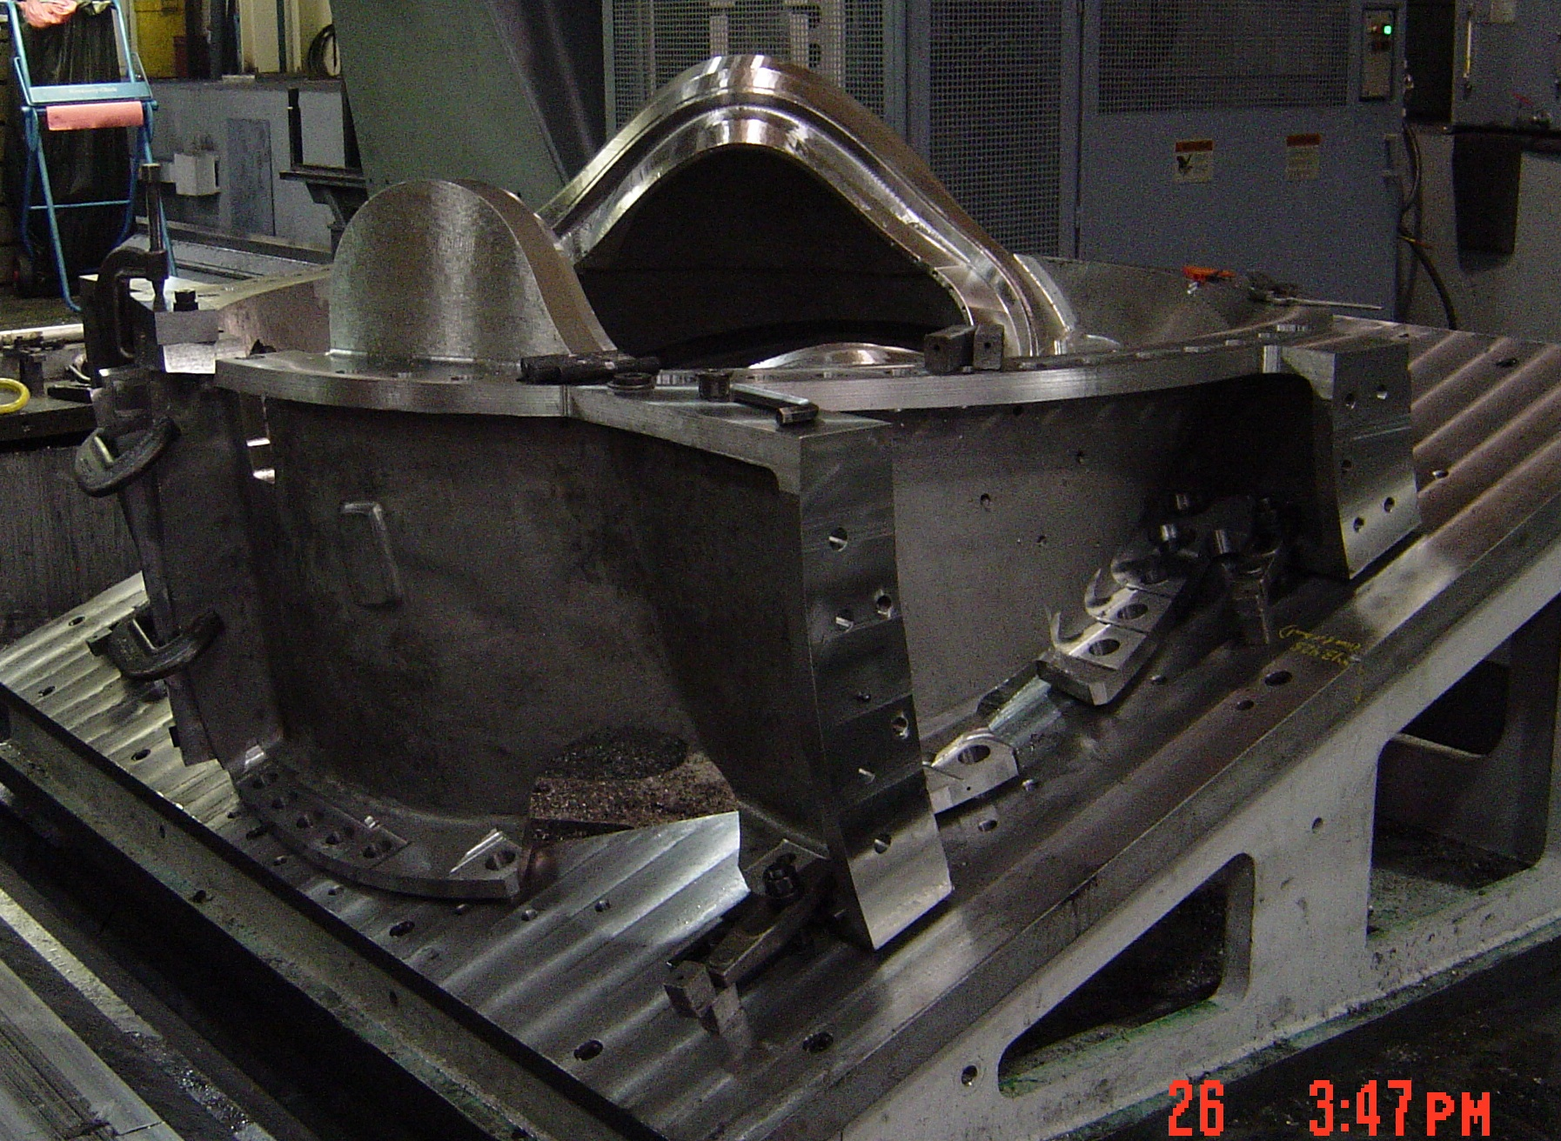

C-1 on 4th set-up of the U-5
The above photo shows C-1 in the last setup. Kevin reports that MTM just finished the “4^{th”} setup and is on track to finish machining the “3rd” or last setup on the U5 by 8/31. All machining, including any required hand finishing is still expected to be complete by 9/2.

C-2

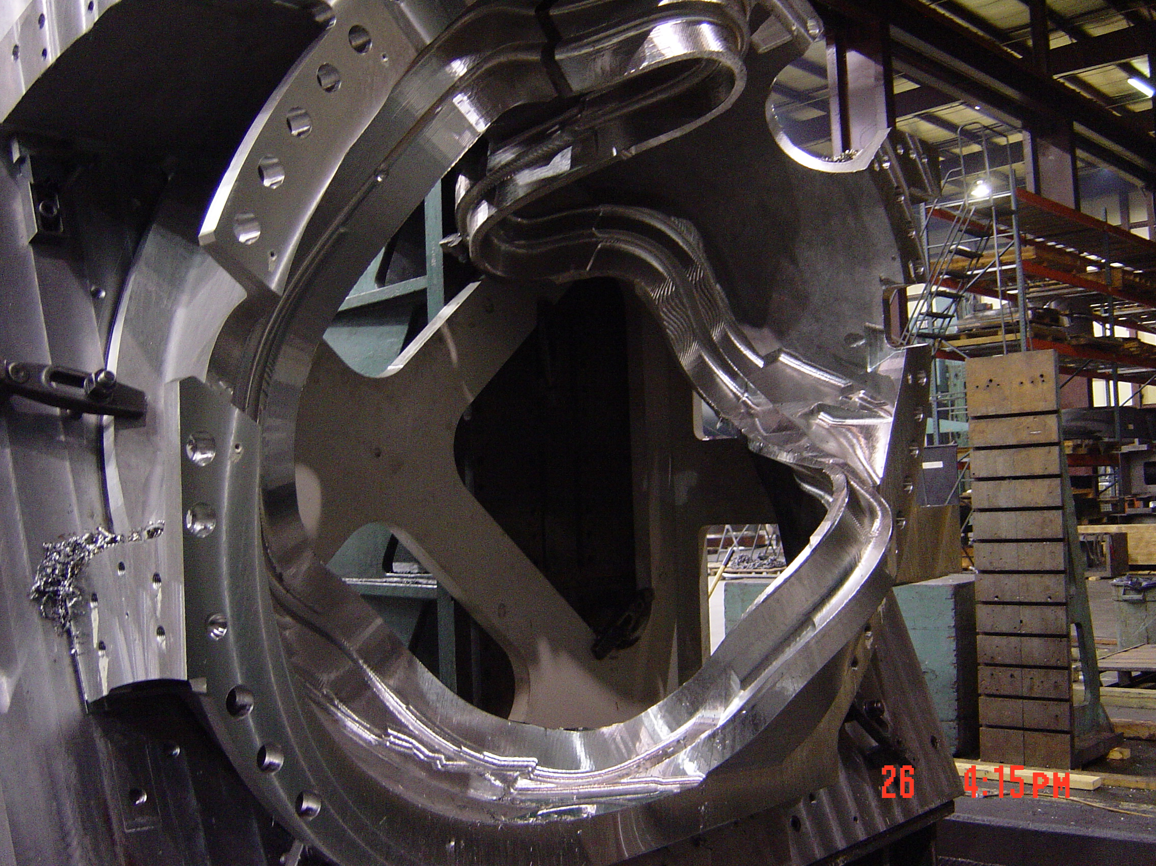

C-2 in rough machining

MTM is finish machining the flanges and holes, and semi-finishing the "T" section on C2. They are currently on schedule for the 10/7/05 delivery date.

A-1
The final 7 weld repairs on A-1 were completed this week with A-1 scheduled for x-ray at Metal Tek during 2nd or 3rd shift on 8/26. The casting will be stress relieved over the weekend & should be ready for final evaluation on 8/29.

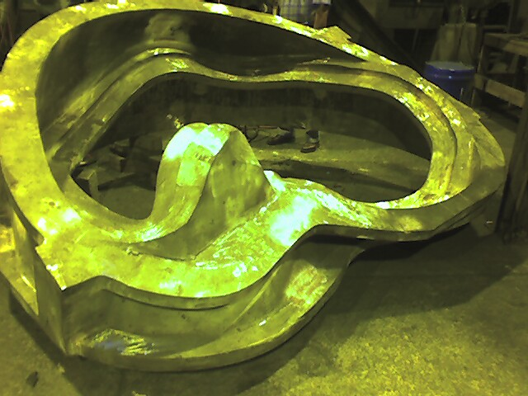

A-1 Casting
The dimensional rescan was also completed this week and confirmed the ScanCo data, (see details below) so upon completion of the documentation package review, A-1 should be ready to ship to Major Tool on 8/29 or 8/30. An initial review of the A-1 document package by Pete Djordjevich at EIO has already been accomplished and was satisfactory. Final review of the x-ray results of the last 7 weld repairs made this week and the stress relief charts needs to be accomplished prior to releasing the casting.

Thin Wall update
Metal Tek completed their scan of A-1 on 8/22. The following screen shot shows the alignment of various sectional scans in Geomagic’s Raindrops software. Unlike 3D ScanCo, where discrete (fixed) overlapping points are used for alignment, Metal Tek uses overlapping features to align the various views. A single point cloud IGS file was created from the multiple sections, and was analyzed by Metal Tek starting on 8/23 through 8/25. An overlay was also created in ProE using the CAD model.

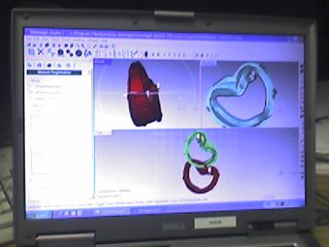

Scanned views of A-1 in Raindrops

According to Roger Broman and Barry Craig the results of the scan were very positive. Roger & Barry report that that they did not find any wall thickness areas thinner than 1.22" Roger added that the scan seems to be consistent with ScanCo's findings. By Friday, Joe Edwards and Roger Broman had both reported that their analysis was nearly complete and they expected to be done with their written findings by early next week. This report, along with EIO’s conclusions will be forwarded to PPPL after review. Plans are now in-place for Tim Wenninger of Lawton to participate with the set-up/molding of A-2 at Metal Tek, currently scheduled for mid September.

C-3
Metal Tek has found several additional major welds which are currently being mapped and Barry Craig informed us that he had committed the resources to work on C-3 through the weekend to complete the required welding. Since the remaining welds can be x-rayed at Metal Tek, Barry is still pushing to ship C-3 by Wednesday, 8/31. He is confident that he will be able to ship by 9/2 at the latest, pending EIO release.

C-4
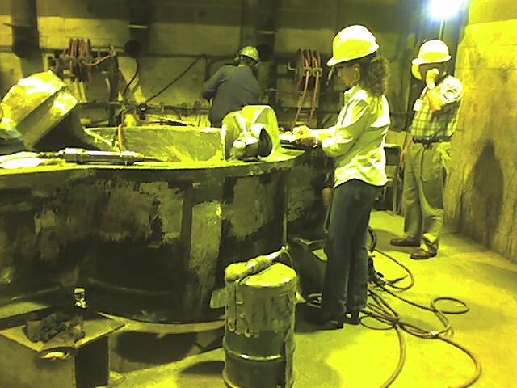

C-4 Casting in excavation

C-4 spent the week being excavated & passing through LP inspection. Metal Tek should start welding next week.

C-5

Metal Tek shipped C-5 to MQS earlier this week for initial x-ray. Casting is expected back at Metal Tek on 9/1. The following picture was captured just prior to sending it off to the test lab.

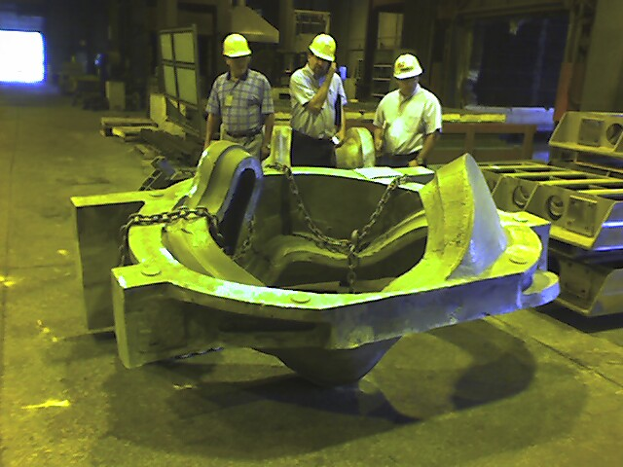

C-5 Cleaned & ready for X-Ray

C-6
Molding for the last C coil casting should be complete by next Tuesday, 8/30. Barry is planning to pour C-6 later that night. This will complete another major milestone for the EIO team!

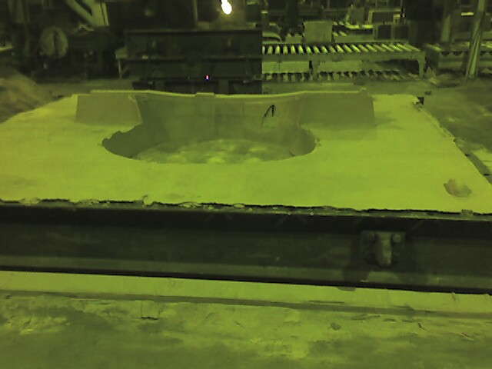

Drag Pattern rammed for C-6

B Pattern

Tim Wenninger reports that we are ahead of schedule. Although the VMC router went down this week, there are only 2 core boxes left to do. As the large router will be open by 8/30, Tim feels we will have plenty of time to finish these 2 boxes and assemble them by the end of next week. All major assembly work (except for these 2 cores) will be completed by 8/26, leaving only minor work on the drag pattern to be finalized.

On 8/22 Don Dickert forwarded the screen dumps of the core setups for the B pattern, to Roger Broman at Metal Tek. These 20 JPG shots will be utilized by Metal Tek as part of their assembly procedure and incorporated into an assembly manual. Copies of these pictures have been posted to the FTP site in the \shared_info\photos\B_pattern directory.

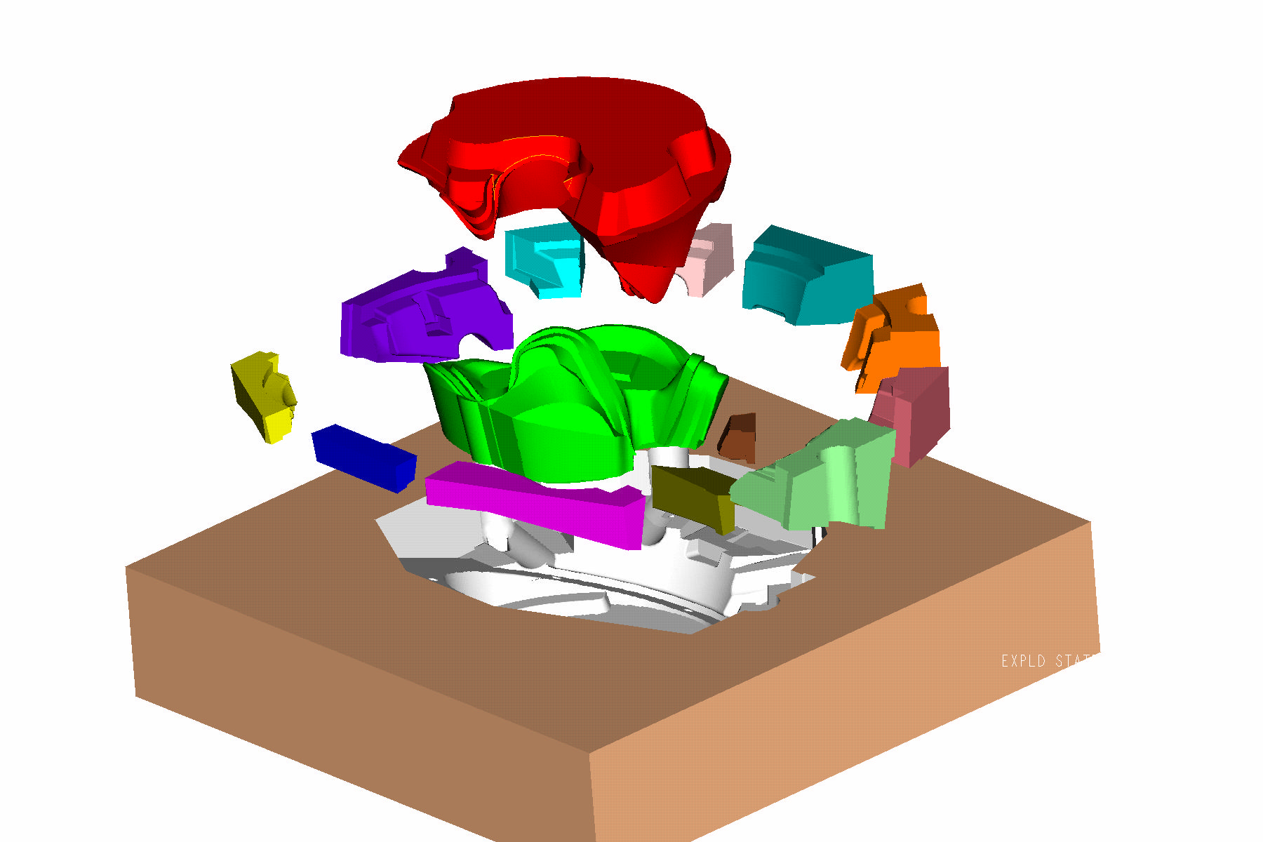

Exploded view of cores for B Pattern

Technical Action Items

- (Lawton) Manufacture of B Pattern
Status: (Open) Routing should finish next week. Est. ship is 9/12
- (Metal Tek) Processing C-3
Status: (Open) Should ship by 9/2
- (Major Tool) Completion of machining of C-1
Status: (Open) On-schedule for 9/2.
- (Major Tool) Machining C-2
Status: (Open) On schedule for completion around the end of September.
- (Metal Tek) Processing C-4
Status: (Open) welding w/o 8/29
- (Metal Tek) Processing C-5
Status: (Open) At MQS
- (Metal Tek) Processing A-1
Status: (Open) plan to ship by 8/30
- (Metal Tek) Pouring C-6
Status: (Open) Plan to pour 8/30
C. Quality Activities
Frank Malinowski of PPPL and Roy Sheppard & Pete Djordjevich of EIO traveled to Metal Tek on 8/23 for a general quality meeting. They were joined by Rosa Medina of DCMA and met with Chuck Ruud & Rick Suria of Metal Tek. The primary purpose of the meeting was to resolve open quality issues and review internal Metal Tek procedures. The open issues are covered below in the Quality Highlights.

During an overview of documentation at the meeting, Frank Malinowski noted a change in the MTS sequence regarding when excavation on coils began. On earlier castings, surface indications were excavated and LP inspected prior to shipping the coil to MQS for X-ray. Based on experience with the first castings and input from the test lab, Metal Tek determined that the better sequence would be to ship the casting for initial x-ray prior to completion of trimming (cleaning of all surfaces). The matter was discussed at length and it was agreed that the sequence change does not have any effect on the quality or delivery of the final part. However, as Frank noted, it is a deviation from the approved MTS and as such, should have been highlighted as a change at the time of the decision. The topic will be added to next week’s QA meeting for final resolution.

An addendum report from Metal Tek regarding CA1323 (high phosphorus & sulfur readings) was submitted to PPPL and posted to the ftp site on 8/22. In part, the report dealt with the failure of the Spectrometer to properly register these trace elements. This failure has been traced back to a bad optical card on the spectrometer that will be replaced on 8/29.

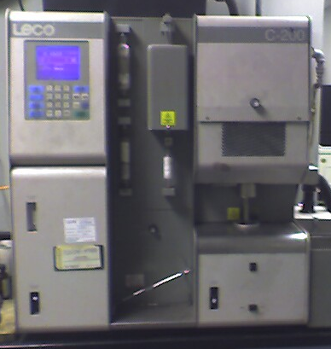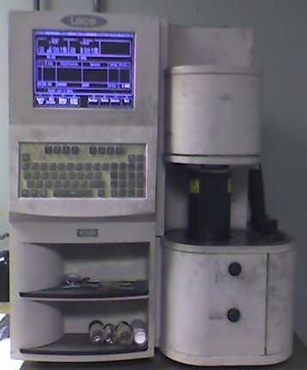

Carbon & Nitrogen Inspection at Metal Tek

Results of the side bend and tensile tests were submitted to PPPL on 8/22 and during PPPL review, some questions regarding data related elongation results, (not part of the required testing, but performed as part of the routine testing) were raised and addressed in several telecons on Friday 8/26. EIO and Major Tool have been asked to provide additional input for next week’s QA meeting.
Upcoming QA Activities
- Preparation, review & release for shipping A-1
- Preparation, review & release for shipping C-3

QA Action Items:

- (PPPL) Corrective Action - Additional 4 sides bend tests and 1 tension test - for MTM nonconformance report NC17399, due prior to weld repair on any castings other than C-1. (PPPL QA Note # 3.3)
Status: (Open) Waiting for disposition from PPPL. Conf. call held on 8/26 - According to Phil Heitzenroeder & Bob Keilbach, the CA from MTM should get approved.

- (PPPL, EIO) Submission and review of C-2 Spec sheet and Documentation Package and shipping release of the casting.
Status: (Open) New documents have been posted to EIO ftp. PPPL has responded with comments which are currently being addressed
- (EIO, Metal Tek, Lawton, PPPL) Determine root cause of the thin wall condition on the A-1 casting. (PPPL QA note # 2.1).
Status: (Open) Metal Tek completed their scan of A-1 earlier this week as reported in the Thin Wall section of Technical Highlights. Initial results are good and seem to validate ScanCo data. A report should be forthcoming.

- (EIO, Metal Tek) CA 1323 issued by Metal Tek on 7/27 for NCR on erroneous sulfur & phosphorus readings (PPPL QA notes #2.2).
Status: (Open) PPPL has received addendum from Metal Tek which explained how parameters were set. Frank needs to see:
1) independent chemical analysis being done at Wisconsin Centrifugal
2) report from spectrometer manufacturer (visit planned 8/29)
- (Metal Tek) PPPL has requested complete independent chemical analysis on C-2 through C-4 to verify that the only problems with earlier spectrometer readings were limited to sulfur & phosphorus (PPPL QA note #2.2.3)
Status: (Open) Samples are at Wisconsin Centrifugal now – waiting for results.

- (MTK, EIO) All comments on the C-1 doc package have been received from PPPL and are now being incorporated into the final package, in order to expedite review of C-1 after machining. (PPPL QA note 2.3)
Status (Open) Reviewed at St Louis meeting. EIO updated & resubmit a revised C-1 Doc package on 8/25. Spreadsheet still needs to be updated and is being worked on by Pete Djordjevich.

- (PPPL) NCR for tool gouges on C-1. Major Tool submitted a report on 8/8 describing 4 gouges on C-1 that need to be dispositioned. (PPPL QA action item 3.2).
Status: (Open) Waiting disposition from PPPL

As always, we welcome your comments and questions. I can be reached at 216-496-2314 and will look forward to hearing from you.

Nancy Horton
EIO Program Manager for NCSX

