Energy Industries of Ohio (EIO) Team Weekly Status Report

Report covers the NCSX Modular Coil Winding Form Activities Including:
- Production Contract S005242-F
- Change Order 5 under the Prototype Development Contract S-04341F

Week ending September 2, 2005

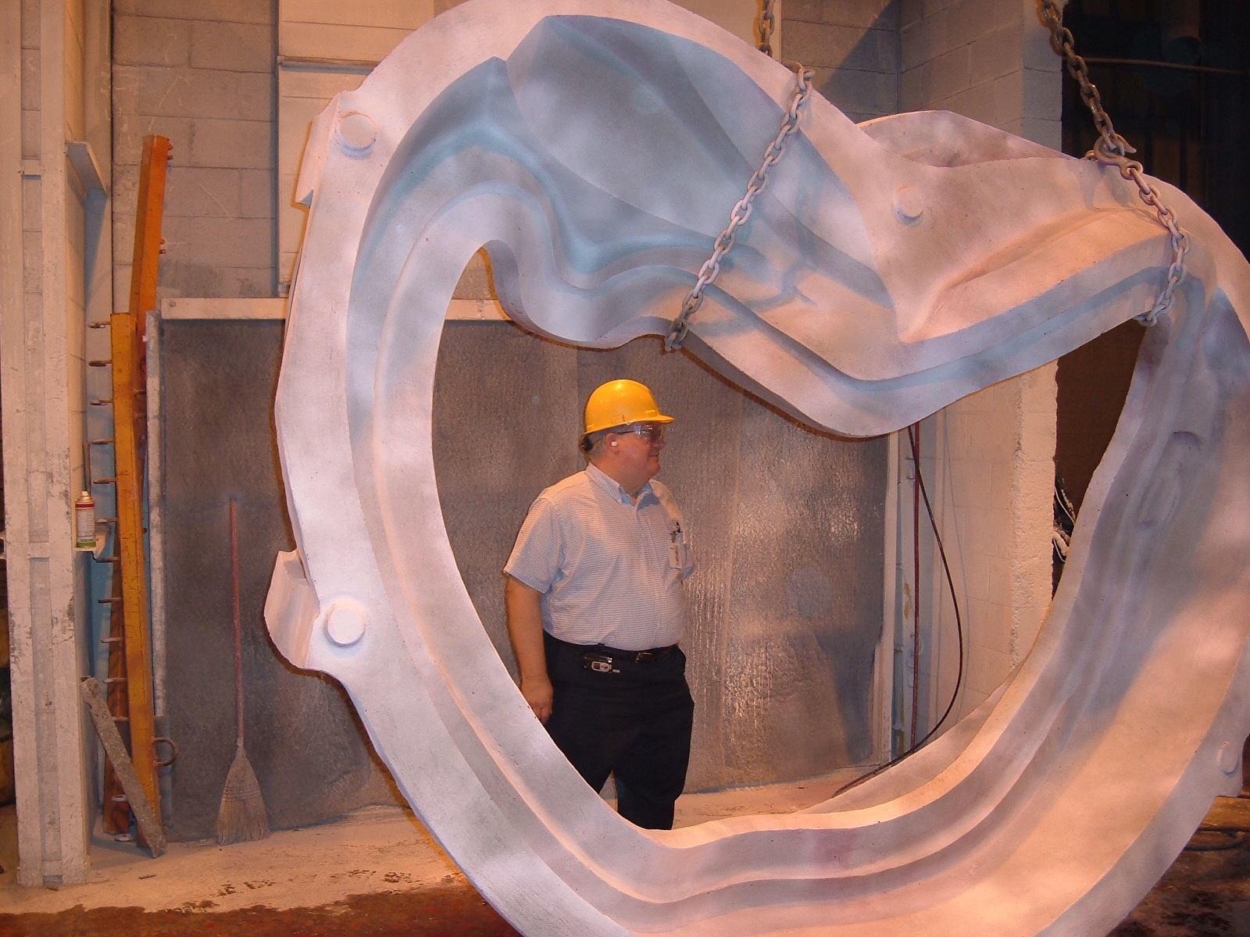

A-1 prepared for shipment

Administrative Highlights
EIO team members at Metal Tek and Major Tool welcomed Phil Heitzenroeder from PPPL to their plants this week as he made his way across the Midwest. The above photo shows Phil inspecting the A-1 casting at Metal Tek as they began preparations for shipment to Major Tool. During the same time frame (8/31), Metal Tek also successfully poured C-6, the last casting in the C series.

Phil was then on-hand at Major Tool when C-1 came off the U-5 (9/1). While there are still a few more technical challenges on the horizon, the part is officially entering the last machining stage prior to inspections. In an effort to expedite the inspection process, DCMA, EIO and PPPL all plan on having personnel on hand to witness the various processes & resolve any last minute questions. As of 9/2, Kevin Bowling has given us the following schedule for planning purposes.

Projected inspection schedule – C-1
- Magnetic Permeability……………..9/8
- Liquid Penetrant………….…………9/8 – 9/9
- Radiography………………………...9/9 – 9/13
- CMM Layout…………………………9/13 – 9/15
- Cleaning and preparation…………..9/15 – 9/16
- Assembly……………………………..9/16 – 9/19
- Electrical resistance test…………….9/19

Assembly, submission, review and approval of the documentation packages for each of the castings has been yet another area for team learning as we strive to present a complete archive of the relevant data associated with each winding form. In recent weeks EIO team members, working in close collaboration with PPPL, have been providing increasing attention to overcoming the administrative challenges associated with preparing accurate and complete records of our technical activities. While the review of the C-1 documentation package for the casting phase is still on-going, we seem to be nearing agreement on data to be included and format for submission. These lessons are currently being applied to the subsequent doc packages for C-2, A-1, C-3, C-4 etc.

Ultimately, the goal is to assemble, submit, review, approve and collate all documents into a complete package prior to release of the castings for shipment. On A-1, we have made considerable progress toward this goal; however, as noted above, there are still issues to be resolved. This learning will likely be repeated as we assemble the final documentation package for C-1 after machining, and as already acknowledged and discussed with PPPL, final approval of the doc package is expected to remain open after release of the casting. Participation by key players during the final inspection stage is one way the team is endeavoring to facilitate the process.

Finally, as this week also marked the end of the month, EIO has been reviewing our team‘s progress for the month of August, concurrently compiling the monthly report for submission to PPPL.

Administrative Action Items:
- (PPPL) All technical and administrative activities related to Prototype Development Contract S-04341F, including Change Order 5 have been completed. Final invoice was submitted to PPPL for payment.
Status: (Open) The corrected invoice along with associated supporting documentation was submitted to PPPL on July 5, 2005. A call to PPPL accounting this week did not yield any information, although a promise to investigate was extended. (Also note: June and July invoices on the Production contract are also overdue. Any assistance in expediting will be appreciated).

- (PPPL) On 7/13 Larry Sutton of PPPL issued Amendment Number 5 to EIO contract, which necessitated EIO to issue Amendment Number 3 to the subtier contractors. The amendment, which incorporates SOW rev 4 and Spec rev 8 into our contracts, was issued to Lawton, MTK and MTM on 7/15/05.
Status: (Open) Signed acceptance of amendments received by lower tier subs and signed Amendment 5 has been submitted to PPPL by EIO for processing.

- (PPPL) On 8/10 Larry Sutton of PPPL issued Amendment Number 6 to EIO contract, incorporating Spec Rev 9 into our contract.
Status: (Open) Signed acceptance of amendments received by lower tier subs and signed Amendment 6 has been submitted to PPPL by EIO for processing.

Technical Highlights

C-1
On 9/1 C-1 came off the U-5 as planned, finishing the final setup. According to Phil Heitzenroeder (who was visiting MTM) and Kevin Bowling, a problem was identified with the current plan to drill the holes on the poloidal break. The plan called for using a 34” long drill that was unsupported along its length. MTM was afraid that this could allow the drill point to walk. To address this challenge, MTM has devised a new plan, which includes building a custom fixture. This jig will be ready for use on 9/6. It now looks like C-1 will not be ready to ship until 9/19. The revised inspection schedule was set-forth above under administrative highlights.

C-2
C-2 continues to go according to projections. Kevin Bowling reports that the 3-axis machining should be complete by 9/9. The coil will move onto the U-5 center on 9/10. According to MTM’s time studies from C-1 machining, C-3 should complete machining on 9/27.

A-1

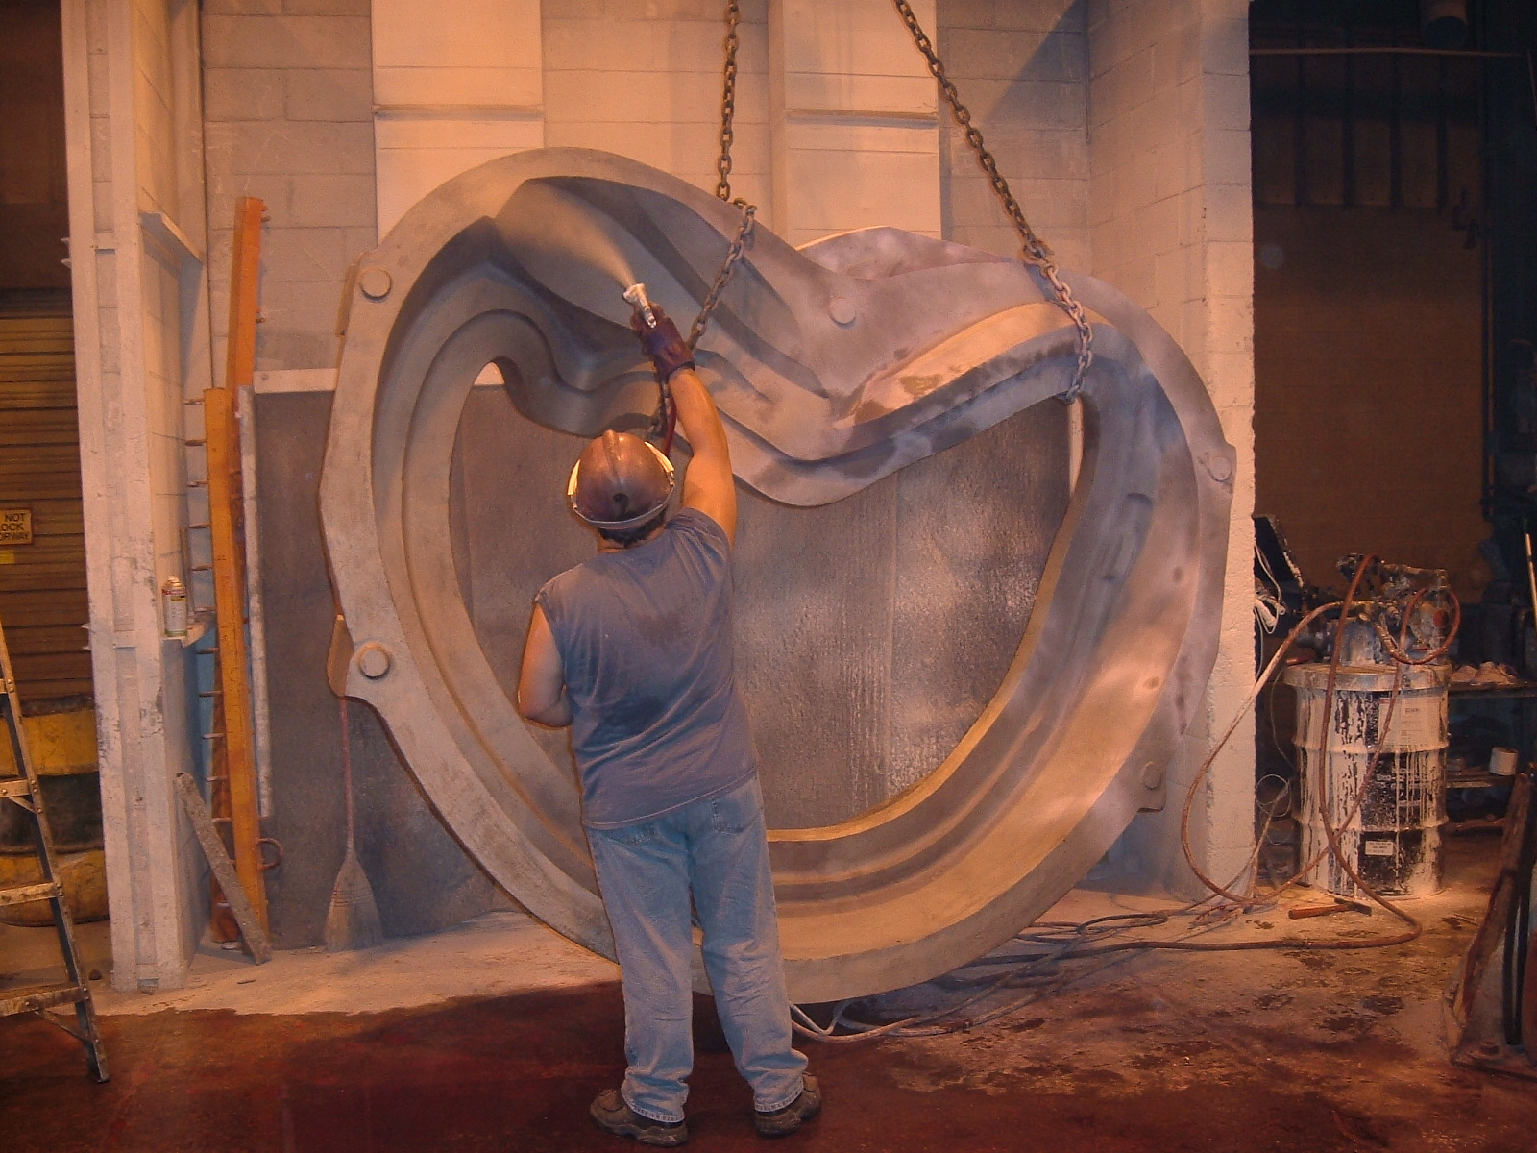

A-1 Casting

A-1 appeared to be well on the way to shipping on Wednesday. No problems were found in RT, and the casting flew through penetrant inspection and stress relief. Metal Tek discovered that the test report from Westmoreland for weld material had a miss-test on elongation. The test specimen broke outside of the gauge area. EIO was immediately notified and shipment of the casting was put on hold, pending resolution and possible retest. This is discussed more under quality highlights below.

Thin Wall update
As previously reported, the scan performed at Metal Tek of the A-1 Coil compared well with the corrected report from 3D ScanCo. Consequently Metal Tek has notified us that they will not scan any of the tooling at this time. Instead, Metal Tek intends to carefully monitor the core and mold assembly and note any issues. Tim Wenninger of Lawton will also be on-hand at the foundry to assist with the pattern set-up. The Metal Tek scan of the A-2 Coil casting will then be compared to the A-1 scan to determine if there are any changes from A-1. The outcome of these activities will be analyzed and included in the final root cause analysis report.

C-3
Metal Tek had finished welding C-3 on 8/31 but ran into problems in X-Ray. Barry Craig reported that due to the thickness of the area in question there were insufficient pennies in the shots. Barry had the casting re shot on Friday (9/2) and found some additional RT rejects. These defects have been excavated and were scheduled to be welded and then re-X-rayed on Friday evening. Assuming that the shots are clean, the part still needs to be stress relieved and scanned prior to shipping, so the new estimated ship date will be later next week (9/8 or 9/9).
C-4
Due to personnel constraints, Metal Tek was unable to start welding C-4 this week. Barry Craig feels this situation will be alleviated next week as crews come off other jobs which are just being completed. Barry plans to start welding C-4 early next week.
C-5
Although Metal Tek expected to have C-5 back in-house on 8/31, the coil was delayed at MQS this week due to an equipment breakdown. C-5 is on a truck now and was expected back at Metal Tek later Friday night (9/2). Due to the Labor Day holiday, films will not be reviewed until Tuesday, 9/6

C-6
The last C style casting was poured on 8/31. Barry Craig reports that all went well with the pour. Barry is bringing a crew in on Saturday, 9/3 to break C-6 out of the sand. On 9/6, the coil will be moved off the floor to make way for starting A-2
A-2
The next casting poured will be A-2. Barry Craig plans on starting molding early next week. A-2 is tentatively scheduled to pour w/o 9/26.

B Pattern
The last core box for B-1 came off the router Friday, completing all routing on the pattern. Final assembly of this box will start on Labor Day (Monday, 9/5), coinciding with the beginning of the pattern scan. Tim Wenninger feels that he will be able to complete assembly while ScanCo works on the other parts of the pattern. The scan should be complete by 9/8, with the data available by the end of next week. Lawton plans on shipping the pattern on 9/12 pending release by EIO. During the last two weeks, there has been considerable coordination with DCMA to ensure that all questions were answered prior to commencing the scan.

Technical Action Items

- (Lawton) Manufacture of B Pattern
Status: (Open) Routing finished off 9/2. Est. ship is 9/12
- (Metal Tek) Processing C-3
Status: (Open) Additional weld needed
- (Major Tool) Completion of machining of C-1
Status: (Closed) 5-axis machining complete
- (Major Tool) Processing & hand work on C-1
Status: (Open) started 9/2
- (Major Tool) Machining C-2
Status: (Open) On schedule for completion 9/27
- (Metal Tek) Processing C-4
Status: (Open) welding w/o 9/6
- (Metal Tek) Processing C-5
Status: (Open) returned from MQS 9/2
- (Metal Tek) Processing A-1
Status: (Open) Shipment on hold pending EIO release
- (Metal Tek) Pouring C-6
Status: (Open) Poured 8/31 – Mold break out 9/3
- (Metal Tek) Molding A-2
Status: (New) will start 9/7
C. Quality Activities

Quality Activities were again spotlighted this week as the team got closer to shipping the A-1 & C-3 castings to Major Tool. Close coordination between EIO, PPPL and Metal Tek was required to ensure all the correct documents were supplied and reviewed. The problem described under A-1 technical highlights with the weld material was uncovered late on 8/31. Chuck Ruud immediately notified Pete Djordjevich, who put the shipment on hold and notified PPPL. On 9/1 CA 1379 was generated by Metal Tek and a new test bar was manufactured. This bar is currently at Westmoreland Test Lab and Metal Tek will be pushing to have this test performed quickly. Based on past experience though, results may take 7 -10 days.

Subsequent telecons with Frank Malinowski and Phil Heitzenroeder explained the test procedure and the possible causes of the failure. The material in question is the same certified Lincoln weld wire used previously. The chemical certifications were fine and all previous mechanical tests passed. Both EIO and Metal Tek suspect that there was a problem encountered either at the test lab or in the manufacture of the bar; not a problem with the Lincoln material. This topic has been added to the QA meeting on 9/6. The Parties will investigate whether A1 can be released for shipping and machining based on the chemistry certification of the weld wire while the re- test is performed in parallel.

Several calls were also made this week regarding the welder qualification tests at Major Tool and the low elongation readings. Kevin Bowling was able to supply PPPL with requested information on the shape and manufacturing technique of the bars utilized. Additional information and a missing specification were also supplied on 9/1 (QA action item 1).
Upcoming QA Activities
- Preparation, review & release for shipping A-1
- Preparation, review & release for shipping C-3
- Magnetic Permeability on C-1……………..9/8
- Liquid Penetrant on C-1 ………….…………9/8 – 9/9

QA Action Items:

- (PPPL) Corrective Action - Additional 4 side bend tests and 1 tension test for MTM nonconformance report NC17399, due prior to weld repair on any castings other than C-1. (PPPL QA Note # 3.2)
Status: (Open) Waiting for disposition from PPPL. Additional information requested from PPPL – Missing PQR 437 and corrected info supplied on 9/1.

- (PPPL, EIO) Submission and review of C-2 Spec sheet and Documentation Package and shipping release of the casting.
Status: (Open) New documents have been posted to EIO ftp. PPPL has responded with comments which are currently being addressed
- (EIO, Metal Tek, Lawton, PPPL) Determine root cause of the thin wall condition on the A-1 casting. (PPPL QA note # 2.1).
Status: (Open) Chuck Ruud submitted an email confirming validity of rescan by ScanCo. As part of the corrective action (see PPPL QA note # 2.1.3), the pattern build will be supported by Lawton and closely monitored for A-2 set-up. Final determination will not come until second casting is analyzed.

- (PPPL, EIO, Metal Tek) CA 1323 issued by Metal Tek on 7/27 for NCR on erroneous sulfur & phosphorus readings (PPPL QA note #2.2).
Status: (Open) PPPL has received addendum from Metal Tek which explained how parameters were set. The report from the spectrometer manufacturer (PPPL QA note #2.2.1) was also completed this week and submitted to PPPL over the weekend.

- (Metal Tek) PPPL has requested complete independent chemical analysis on C-2 through C-4 to verify that the only problems with earlier spectrometer readings were limited to sulfur & phosphorus (PPPL QA note #2.2.2)
Status: (Open) Samples are at Wisconsin Centrifugal now – waiting for results. Chuck Ruud informed us on 9/3 that they are still analyzing the data
- (MTK, EIO) All comments on the C-1 doc package have been received from PPPL and are now being incorporated into the final package, in order to expedite review of C-1 after machining. (PPPL QA note #2.3)
Status (Open) Due to comments on the 8/25 C-1 Doc package, EIO updated & resubmit a revised C-1 Doc package on 9/2. Spreadsheet still needs to be updated and is being worked on by Pete Djordjevich.

- (PPPL) NCR 17746 for tool gouges on C-1. Major Tool submitted a report on 8/8 describing 4 gouges on C-1 that need to be dispositioned. (PPPL QA note # 3.1).
Status: (Open) Discussed at 9/30 meeting. Frank suggested that this be disposed of by having DCMA verify the results of the suggested remedies after processing.

- (MTK, EIO) PPPL has requested a copy of the Metal Tek Radiographic Technique used on the A & C type castings (PPPL QA note # 2.4)
Status: (Open - Newly Added) Discussed at 9/30 meeting. EIO has forwarded the request to MTK.

- (MTK, EIO) PPPL has requested a corrected A-1 weld Map showing repair cycles (R-1, R-2) rather than new weld numbers (PPPL QA note # 2.5)
Status: (Open - Newly Added) Discussed at 9/30 meeting. Weld map was corrected; May still need to be updated for R-3 or R-4? In review with A-1 doc package. To be addressed at QA meeting on 9/6

- (MTK, EIO) PPPL has requested Metal Tek’s personnel qualifications for special processes including Penetrant, RT, Weld etc; (PPPL QA note # 2.6)
Status: (Open - Newly Added) Discussed at 9/30 meeting. EIO has forwarded the request to MTK and it has been assigned to Rick Suria

- (MTK, EIO) PPPL has requested a revised MTS showing 100% PT after RT is complete which must include a commitment to radiograph all rejected areas including those that appear to be only surface indications. (PPPL QA note # 2.7)
Status: (Open - Newly Added) Discussed at 9/30 meeting. EIO has forwarded the request to MTK and we have been advised that the update is in-process. . (note: the document was submitted to EIO on 9/4 just before this report went out).

- (MTK, EIO) PPPL has requested either an ITP or MTS update to the Metal Tek MIT/QA Plan addressing current shim processing approach (PPPL QA note # 2.8)
Status: (Open - Newly Added) Discussed at 9/30 meeting. EIO has forwarded the request to MTK and we have been advised that the update is in-process. . (note: the document was submitted to EIO on 9/4 just before this report went out).

- (MTK, EIO) Submission and review of A-1 Spec sheet and Documentation Package and shipping release of the casting.
Status: (Open - Newly Added) New documents have been posted to EIO ftp. EIO has responded with comments which are currently being addressed by MTK. Topic of weld tests will be added to the agenda. As highlighted above, one of the specimens failed at a jaw. A new bar was manufactured and submitted for retest on Friday. Release of casting for shipment to MTM will be addressed at QA meeting on 9/6.
- (MTK, EIO, PPPL) Submission and review of C-3 Spec sheet and Documentation Package and preparation of shipping release of the casting.
Status: (Open - Newly Added) Draft documents have been posted to EIO ftp.
As we endeavor to improve upon the system for documentation review and approval, we would appreciate any feedback or comments on our implementation of the EIO ftp site (ftp://ftp.atc-inc.org) as a vehicle for archiving and sharing documents and conducting reviews. Please feel free to contact me via e-mail or at 216-496-2314 with your thoughts and suggestions. If you have not been able to access the site for any reason, please contact Roy Sheppard at 1-800-337-3083 or via e-mail at RoyJRATC@aol.com.

Nancy Horton
EIO Program Manager for NCSX

