Energy Industries of Ohio (EIO) Team Weekly Status Report

Report covers the NCSX Modular Coil Winding Form Activities Under Production Contract S005242-F

Week ending October 7, 2005

Administrative Highlights

We were advised on Monday 10/3, that C-1 made it safely to PPPL, where it was quickly unloaded and set up for a new round of processing as preparations begin for to the initial coil winding. Throughout the week, we were in contact with PPPL to discuss various points and questions arising from PPPL’s activities. By late Friday afternoon, 10/7, we had received an e-mail from Larry Sutton presenting a preliminary list of MCWF C-1 Non-Conformances developed during Receipt Inspection. The list has been distributed to Major Tool and within EIO for review, coordination and response, as necessary.

Following completion of C-1, all energies were focused on the numerous other activities in progress. With the successful pour of A-2, Metal Tek has been able to take preliminary measurements of the casting which indicate that we have overcome the thin wall condition experienced on A-1. The write-up for the root cause analysis is underway and will likely be submitted in the next week.

We have also been reviewing our production schedule. Very late Tuesday, 10/4 we submitted our annotated monthly report, (which had been updated from the preliminary copy provided to PPPL on 9/21 to assist with fiscal year end cost accrual exercises). As reported in the monthly, the team is still evaluating and assessing the impact of delays as well as the opportunities from learning in order to complete an up-to-date, realistic production schedule. We believe that in the next month we will have more accurate information to assist with this effort. As of Friday, for activities currently in progress, the following projections, set forth in 3 charts, were available from Metal Tek and Major Tool:

1)Upcoming Deliveries to PPPL from MTM
MCWF Part # | Projected Delivery to PPPL
C-2 | 11-14-05
C-3 | 12-29-05

2) Upcoming Deliveries to MTM from MTK
MCWF Part # | Projected Delivery to MTM
C-4 | 10-31-05
C-5 | 11-7-05
C-6 | 12-12-05
A-2 | 12-27-05

3) Next Castings to be Poured by MTK
MCWF Part # | Projected Pour Date
A-3 | 10-14-05
B-1 | 10-31-05

A-1 is not reflected in these charts. A-1, which is currently at MTM, will be machined in a sequence most efficient to the overall production schedule. Currently, as C castings are being delivered to MTM, there is more opportunity to benefit by learning if MTM machines the C castings in sequence. Nonetheless, in the event that there is a delay for any reason in the delivery schedule of the C castings, then A-1 will be set-up and machined in the interim.

It is likely that a similar situation could occur with the B-1 casting. From a foundry perspective, it is prudent to pour the first article well in advance of pouring the second article in the series. As a risk mitigation strategy, this enables time to overcome any surprises or problems that may arise, without unduly delaying the subsequent castings. The EIO team agreed early on that this would be the approach to pouring castings and the machine shop was prepared to accept and machine the castings in this order.

Nonetheless, from a machining perspective, the benefits of learning are most significant when all of the castings in a series are machined sequentially. As a result of the initial complications with A-1, which resulted in a delivery delay to the machine shop, coupled with the steady stream of C castings being received, currently the most viable machining schedule puts processing of A-1 after C-6. Notwithstanding this plan, in the event that there is a sizeable gap in delivery between C castings, due to unforeseen challenges arising at the foundry, the machine shop is prepared to machine A-1 out of sequence.

The schedule projections reported herein are a work in progress and will be submitted more formally with the next monthly report.

Technical Highlights
C-2
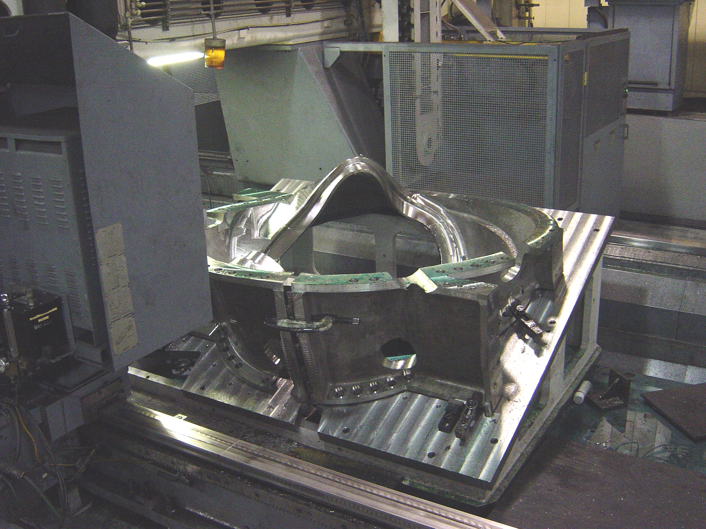

C-2 in 5-axis machining

As projected, C-2 went on to the U-5 last Saturday, 10/1 & processing is again underway. Kevin Bowling and Joel Manship report that the machining is progressing well. Delays on C-1 did have an adverse impact on the machining schedule for C2, as the part was not able to move onto the U5 as quickly as it was ready. Accounting for this delay and the additional leadtime for routine maintenance of the U5 which was conducted last week, delivery of C-2 to Princeton will probably not occur before mid-November. As highlighted above, MTM’s system prediction at this point is 14-Nov-05. This added schedule time for C-2 should not carryover to the subsequent casting leadtimes.

C-3
MTM began machining C-3 on Monday 10/3. Kevin Bowling reports that we are still benefiting from the learning curve experienced on C-1 & C-2, which means we continue to see gains in schedule. After the 1st full week of machining, C-3 is further along than C-2 had been after its 1st week of 3-axis machining. Kevin fully expects MTM to continue to reduce machining time on both this & subsequent operations. Current projections indicate that MTM will be able to ship C-3 by the end of the year even with the holidays.

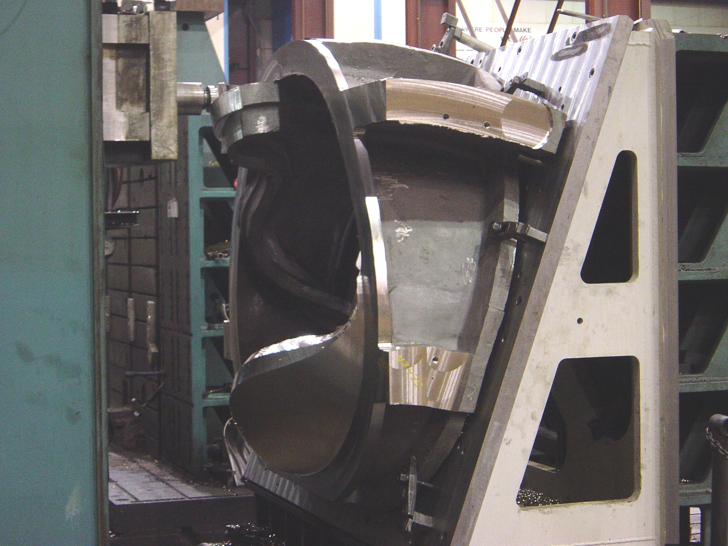

Cutting chips on C-3

C-4
After a successful LPI of C-4, MTK was finally able to ship the casting to MQS on Friday, 10/7 for NDT of the weld repairs. We have been advised that C-4 should be back from MQS by the end of next week for continued processing. Barry Craig expects to ship C-4 to Major Tool by the end of October.

Over the past 2 months, the weld repair cycle has resulted in a bit of a bottleneck at Metal Tek as they have encountered problems of repeat minor weld failures. Despite the fact that the majority of the indications on the castings have been non-reportable “minor” welds, which should have been easily corrected, the experience has been otherwise and in the last month, the situation has had the potential of effecting overall schedule, not to mention the added expense to the foundry. Metal Tek has been actively conducting an internal investigation and has explored several possible factors. Some of these “possible causes” were shared in August with DCMA’s Rosa Medina (worker fatigue, portable fans) and were presented to PPPL in her report. These “potentials” were later ruled out, when the problems persisted after corrective measures had been taken. In the last couple of weeks, the mystery was finally solved. The root cause, an intermittent leak in the argon gas leads, was discovered to be disrupting the argon gas field which was leading to porosity and lack of fusion of the welds. Once the main “culprit” was identified, Metal Tek was able to trace the leaky lines to the bulk tank and correct the problem. The situation was formally documented and submitted to EIO on 10/6 and will be shared with PPPL for discussion at the upcoming QA meeting on 10/11.

C-5

A weld map for C-5 was submitted to EIO on 10/5. After review, this was posted to our FTP site for PPPL review on 10/7. According to Chuck Ruud, welding has commenced on the casting. With the solution to the argon gas disruption highlighted above, Chuck feels confident that welding should progress more smoothly on C-5 & subsequent castings. According to Barry Craig, C-5 is on track to ship by 11/7/05.

C-6
C-6 was also shipped up to MQS on Friday, 10/7 for initial NDT. Although tentative, Barry Craig has projected a ship date of mid December for the last of the C coils.

A-2

As part of our follow-up investigation to identifying the root cause of the Thin Wall Condition on A-1, on 10/4, Chuck Ruud took a wire brush to sections of the A-2 casting. After rough cleaning the surface on both sides of the casting, he was able to use large transfer calipers to take ROM measurements of the same areas that were thin on A-1. Chuck found that no area he checked was less than 1 3/8th”. Although this is a crude measurement at best, Chuck felt that the section wall thickness was acceptable for further processing and A was released to the floor. This finding has brought the EIO Team closer to resolving the outstanding issue of the root cause of the thin wall condition, and will be documented in our upcoming report.

After these rough measurements were taken, initial cleaning and washing off of gates & risers commenced. Chuck Ruud reports that A-2 made it through heat treat this week and will continue processing next week at MTK. Barry Craig plans on shipping A-2 to MTM by the end of this year.

A-3

MTK has started molding A-3. Barry Craig plans on pouring A-3 on 10/14.

B-1

Immediately after pouring A-3, MTK plans on molding the initial B casting. Barry Craig reports plans to pour the B-1 casting on 10/31.

Technical Action Items

- (Major Tool) Machining C-2
Status: (Open) 5-axis machining started 10/1
- (Major Tool) Machining of C-3
Status: (Open) Machining commenced 10/3

- (Metal Tek) Processing C-4
Status: (Open) Shipped to MQS
- (Metal Tek) Processing C-5
Status: (Open) Map submitted – In weld
- (Metal Tek) Processing C-6
Status: (Open) Sipped to MQS
- (Major Tool) Machining of A-1
Status: (Open) Currently on-hold for processing of C castings

- (Metal Tek) Processing A-2
Status: (Open) Through heat treat

8) (Metal Tek) Molding A-3
Status: (New) Pour planned for 10/14

Quality Activities

Our joint QA weekly telecon on 10/4 covered outstanding issues at both Metal Tek & Major Tool. A new action item was added requiring Major Tool to provide a listing of personnel involved with all special processes, including LPI. To assist with this process, further clarification to determine whether PPPL requires a generalized list of the employee “pool” (those individuals with the requisite capabilities at both MTK & MTM available to our program) or coil specific lists which identify the employees assigned to each casting, is sought from PPPL.

On Thursday, 10/6, EIO was informed of a potential “non-conformance” with the fasteners used by Major Tool on the poloidal break. During incoming inspection, the mag permeability check revealed that the bolts, washers & nuts were all made from 4340 steel, which apparently was not PPPL’s intended choice. EIO immediately contacted Kevin Bowling at MTM, who confirmed that 4340 steel was used and referred to the PPPL drawing which cited ASTM A286 as the requisite material. Kevin noted that the 4340 was selected because it meets the most stringent requirements for strength and durability of all of the metals outlined in the ASTM spec.

In further telecons with PPPL it quickly became evident that 3 of the NCSX drawings (DS141-036, DS141-060 & DS141-079) all call out the ASTM A286. Email from PPPL shows that ironically, they meant to specify A286 UNS S66286 which is Allegheny’s Altemp® superalloy. A careful review of both the ASTM A286 spec and the replacement spec – ASTM A434 show a table of permissible materials allowed under this spec. As noted above, following industry standards, MTM chose the strongest available material under this spec. The material chosen was 4340, a common bolting hardware material covered under both specs. Neither A286 UNS S66286 nor the generic AISI type 660 SS are allowed under either spec.

Late Friday, 10/7 PPPL sent over an initial review of the casting generated from incoming inspection. The above information was incorporated into the preliminary list ( #9). Also included were various workmanship questions and non conformances, all of which are being reworked at PPPL. As highlighted in the administrative section of this report, EIO has forwarded this list on to MTM for discussion on 10/10.

Upcoming QA Activities
- Radiography for C-4 and C-6…………shipped to MQS on 10/7
- Review & update of C-1 doc package
- Review of C-1 inspection report from PPPL
- Thin wall condition report

QA Action Items:
- (PPPL, EIO) Submission and review of C-2 Spec sheet and Documentation Package and shipping release of the casting.(PPPL QA note #3.6.1)
Status: (Open ) New documents were posted on 10/4. PPPL has these under review now. PPPL QA notes indicate that their review is on-hold pending completion of C-1 issues. EIO will continue to update the preliminary package as more data becomes available.
- (EIO, Metal Tek, Lawton, PPPL) Determine root cause of the thin wall condition on the A-1 casting. (PPPL QA note # 2.1).
Status: (Open) Rough measurements revealed nominal wall thickness of 1 3/8”. All data is now in. Report to follow.
- (PPPL) CA 1323 issued by Metal Tek on 7/27 for NCR on erroneous sulfur & phosphorus readings (PPPL QA note #2.2).
Status: (Open) waiting for independent lab analysis of new type standard
- (MTK) PPPL has requested complete independent chemical analysis on C-2 through C-4 to verify that the only problems with earlier spectrometer readings were limited to sulfur & phosphorus (PPPL QA note #2.2.2, 2.2.3, 2.2.4)
Status: (Open) On10-5-05 Chuck Ruud checked the C-4 coil casting for magnetic permeability. Approximately 200-300 points, including numerous weld repairs and the race track were tested. All met the 1.02 requirement except one location. Grinding revealed a small sand inclusion. The area was repaired by grinding and re tested. The result showed compliance. Remaining action is to analyze chemistry at Wisconsin Centrifugal.

- (EIO, MTM, PPPL) All comments on the C-1 doc package have been received from PPPL and are now being incorporated into the final package, in order to expedite review of C-1 after machining. (PPPL QA note #2.3)
Status (Open) All updated documentation from MTK has been integrated into the doc pack. MTM has forwarded a preliminary document package for C-1 to EIO. This has been passed along to PPPL for review

- (PPPL) PPPL has requested a copy of the Metal Tek Radiographic Technique used on the A & C type castings (PPPL QA note # 2.5)
Status: (Closed)

- (PPPL) PPPL has requested Metal Tek’s personnel qualifications for special processes including Penetrant, RT, Weld etc; (PPPL QA note # 3.2)
Status: (Open) Qualifications were submitted and are under review at PPPL.

- (PPPL) PPPL has requested a revised MTS showing 100% PT after RT is complete which must include a commitment to radiograph all rejected areas including those that appear to be only surface indications. (PPPL QA note # 2.5)
Status: (Open) Submitted to PPPL on 10/3. Now under review.

- (PPPL) PPPL has requested either an ITP or MTS update to the Metal Tek MIT/QA Plan addressing current shim processing approach (PPPL QA note # 2.6)
Status: (Open) Submitted to PPPL on 10/3. Now under review.

- (PPPL) Submission and review of A-1 Spec sheet and Documentation Package (PPPL QA note 3.6.2).
Status: (Open) A-1 doc package posted on EIO ftp site for PPPL review and comment. Review on-hold pending completion of C-1 issues.

- (EIO, MTK, PPPL) Submission and review of C-3 Spec sheet and Documentation Package and preparation of shipping release of the casting. (PPPL QA note # 3.6.3)
Status: (Open) Posted to ftp. Review on hold pending completion of C-1 issues.
- (EIO, MTK) Metrode material lots WO21735 & WO19711 do not meet chemistry requirements of NCSX-CSPEC-141-03-09 particularly in MN
Status: (New) Late on 10/7 PPPL informed EIO that the weld engineer review had found a discrepancy. EIO had already been alerted to the discrepancy by Chuck Ruud of Metal and an internal spec review was underway.
- (EIO, MTM, PPPL) PPPL has requested a list of certified LPI inspectors from MTM that worked on C-1.
Status: (New) Request forwarded to MTM. Clarification to determine whether PPPL requires a generalized list of the employee “pool” (those individuals with the requisite capabilities at both MTK & MTM available to our program) or coil specific lists which identify the employees assigned to each casting, is sought from PPPL.

- (EIO, MTM) On 10/7 PPPL provided a “preliminary” list of MCWF C-1 non-conformances to EIO as a potential tool for helping avoid the repeat of these non-conformances on C-2.
Status: (New) The list has been distributed to MTM. Review will commence next week.

Questions and comments on this week’s report can be directed to the undersigned or to Roy Sheppard at 800-337-3083. Your feedback is always welcome and appreciated.

Nancy Horton
EIO Program Manager for NCSX
216-496-2314

