Energy Industries of Ohio (EIO) Team Weekly Status Report

Report covers the NCSX Modular Coil Winding Form Activities Under Production Contract S005242-F

Week ending October 14, 2005

Administrative Highlights

I am very pleased to report that late Friday, 10/14 (as planned), Metal Tek poured the third “A” casting, A-3. This is the 9th casting in “metal” for the EIO team. Additionally, Barry Craig, Metal Tek Plant Manager reports that preparations for the first B casting have commenced.

Also this week, on Thursday, 10/13 and Friday, 10/14 a small contingent from EIO and Major Tool including Nancy Horton, Roy Sheppard, Kevin Bowling and Jim Flanagan had the privilege of viewing C-1 in its new home at PPPL.

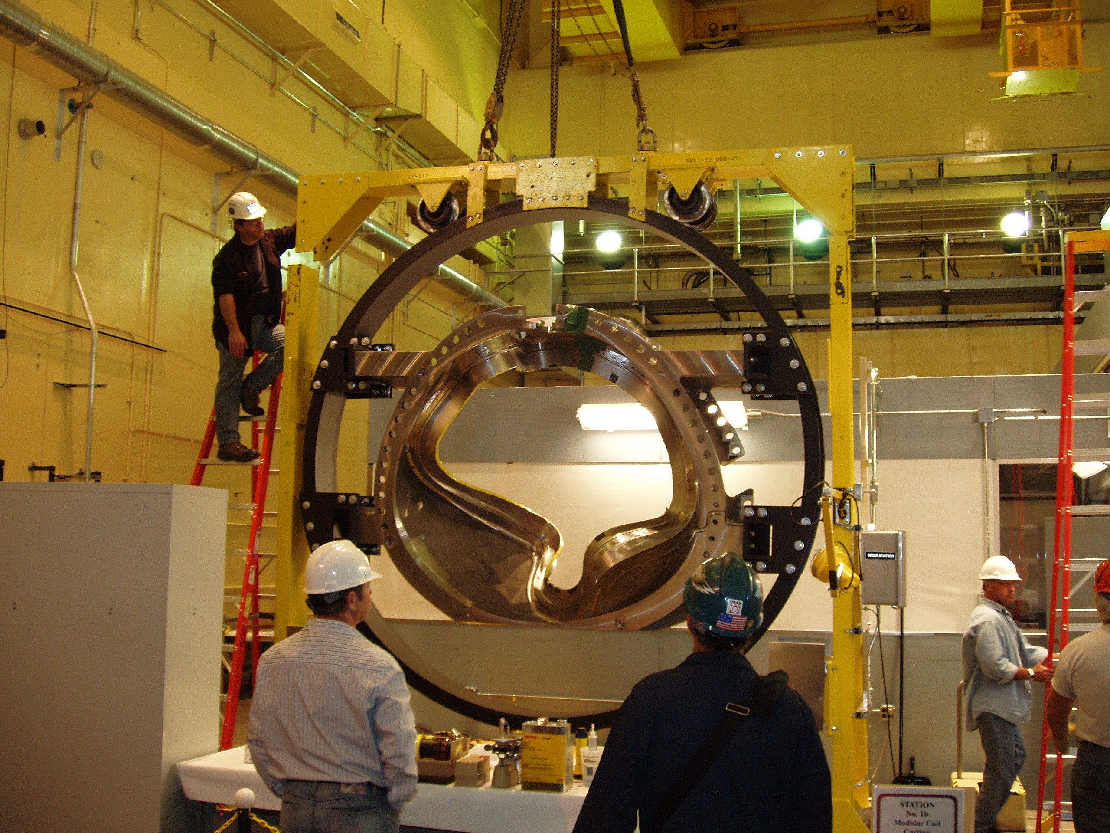

C-1 being installed in the winding bay

The visit included tours of both the NSTX facility and the NCSX coil winding plant. During the walk through, we were able to see previous EIO team accomplishments, including the prototype “C” casting and the twisted racetrack. Stopping by to greet EIO and inspect the casting was Greg Pitonak from DOE. Deputy Director, Richard Hawryluk, provided opening remarks, acknowledging PPPL’s awareness of the technical hurdles which had been overcome by the EIO team in order to deliver the first casting. He also emphasized the importance of schedule recovery, including steady delivery of castings from this point forward, to enable PPPL to efficiently and effectively plan resources and meet programmatic commitments. EIO team members have all pledged continued dedication to this project as we enter our second year under contract.

The remainder of the meeting centered around a thorough review of the C-1 casting, where key members of the PPPL winding team including Jim Chrznowski and Steve Raftopolous highlighted areas on the casting which differed from their expectations and thus presented challenges to the PPPL staff. With participation from additional PPPL team members including Hutch Neilson, Phil Heitzenroeder, Frank Malinowski, Larry Sutton, Rod Templon, Mike Viola and (through teleconferencing and Net-Meeting), Brad Nelson and Dave Williamson from ORNL, the items were addressed and resolved one at a time.

Discussions covered administrative matters, technical process changes, and quality details. Some of the discussions resulted in actions which have been added into Action Item lists in this week’s report. One example is depicted in the photo below. PPPL is proposing to add 3 bearing plates to each side of the poloidal break to replace the washers & the doubled G-11 material. This action will require a request for proposal/change order to EIO to address manufacture of the bearing plates, new assembly drawings and new quality requirements for electrical testing, as bolts will now be grounded to each other in series of 2 or 3.

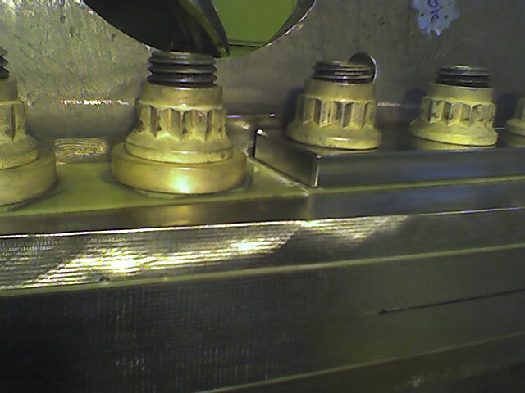

Proposed bearing plate eliminating washers

Administrative Action Items

- (PPPL, EIO, MTM) Request for quote to EIO/MTM for purchasing 9 ½" studs & washers. New studs to be A286 UNS S66286 to ASTM A453 Grade 660 B
Status: (New) Based on agreements at the meeting, quotes will be sought immediately. ORNL has already secured one quote which will be evaluated against the quotes secured by MTM. These will be provided to PPPL as part of a proposal package in response to formal direction expected from PPPL early next week.
- (PPPL, EIO, MTM) List of additional changes desired by PPPL for machining on C-2 and beyond, as covered on 10/13/ & 10/14
Status: (New) PPPL to formally issue a request for impact to EIO & MTM. Response, including impact to schedule & cost will be provided. Based on a cost/benefit analysis, PPPL may issue a contract change order to incorporate the changes if desired.
- (PPPL, EIO, MTM) Revisions to Specification based on agreements at the meeting of 10/13 & 10/14.
Status: (New) Some of the revisions which do not impact cost or schedule (e.g. Hardware & permeability) will be incorporated immediately. The rest need to await results of # 2 above. Formal direction expected from PPPL.

Technical Highlights
C-2
C-2 has been running for 2 full weeks now on the 5-axis machine. According to Mike Griffith, the machining is approximately 50% done. Machining will continue throughout the weekend. On Monday, MTM plans to flip C-2 over to begin machining the 2nd side. According to Mike, the 5-axis programs developed on C-1 have been running very well on the C-2.

C-3
At just under 2 weeks on the 40’ Mitsubishi, Mike Griffith reports that we are close to roughing the 1st side to within .250” of stock. Mike expects to flip C-3 before the end of next week to begin the 2nd side roughing. According to Mike, MTM is approximately 25% complete on 3-axis machining.

C-4
C-4 is still at MQS; however, as of Friday afternoon, Chuck Ruud reported that the data had come back for analysis. It appears that there will be a few additional weld repairs that need to be made on C-4. As MTK will be able to radiograph these upgrades on-site at MTK, Chuck is confident that they will not impact the 10/31 ship date. C-4 is expected back from MQS early next week.

C-5

Welding continued on C-5 this week. Chuck Ruud expects to have this complete & shipped up to MQS by the end of next week. According to Chuck, the changes to the weld procedure highlighted in last week’s report seem to have been effective. Chuck cautions though that MTK cannot be completely sure until they have RT results.

C-6
C-6 remains at MQS undergoing initial RT. Chuck Ruud expects this to be complete on 10/18.

A-2

A-2 was in grinding all week in preparation for initial 100% RT.

A-3

As highlighted above, Barry Craig reported that A-3 was poured late in the evening on 10/14.

B-1

Molding is scheduled to start next week. Tim Wenninger of Lawton has offered to assist with set-up if that will be beneficial to the foundry.

Technical Action Items

- (Major Tool) Machining C-2
Status: (Open) 2nd setup on U-5 on 10/17
- (Major Tool) Machining of C-3
Status: (Open) Finishing up roughing on 1st side

- (Metal Tek) Processing C-4
Status: (Open) A few additional weld repairs needed
- (Metal Tek) Processing C-5
Status: (Open) In weld
- (Metal Tek) Processing C-6
Status: (Open) RT will be finalized on 10/18
- (Major Tool) Machining of A-1
Status: (Open) Currently in the queue for machining at MTM. Nancy Horton, Roy Sheppard, Kevin Bowling and Jim Flannigan spoke about plans for A-1 during the meeting on the 14th. From the perspective of the machine shop, there are numerous efficiencies to be gained from machining a continuous series of C’s prior to commencing machining of the first A casting. These include the lead-time for set-up, the learning and experience of personnel handling the castings, and the increased risks and impracticalities of “switching” from one casting to another, to name a few. Despite the apparent upfront “loss” of time for machining A-1, in the grand scheme, this is actually the most productive and time saving approach. Notwithstanding, Kevin and Jim have promised that they will continue to address machining of A-1 to ensure on-going processing of the casting while they machine the C castings.

- (Metal Tek) Processing A-2
Status: (Open) In grinding

8) (Metal Tek) Pouring A-3
Status: (Open) Poured 10/14
9) (Metal Tek) Molding B-1
Status: (New) Starting next week.
10) (PPPL, EIO, MTM) Eliminate the use of Moycote™ on all hardware.
Status: (New) Formal direction to be provided by PPPL; however, MTM will implement immediately.

Quality Highlights
The weekly telecon on 10/11 addressed the open items at Metal Tek, including the doc packages for C-1 and other castings in process. Specifically, the purpose of the spreadsheet was discussed. Frank Malinowski noted that originally, the spreadsheet was conceived to assist in posting chemistries as soon as they became available, to facilitate “real-time” reviews. For example, chemistry for C-6 and A-2 have not yet been posted, even though they should be available. It was acknowledged that there have been some unexpected results during the past several months, which required analysis and discussion, prior to posting. As these anomalies are better understood and resolved, there is an expectation that the approach to updating the spreadsheet will better match the original intent. Meanwhile, the spreadsheet has provided benefit for program management, by providing a single summary of all contract QA requirements for each casting.

Primarily, C-1 was in the QA spotlight this week. The visit to PPPL centered around the initial inspection reports generated by PPPL, with particular emphasis on those items that PPPL would prefer not to see repeated on subsequent castings. The urgency of this discussion was on everyone’s mind, since C-2 is actively in the final stages of machining. A report highlighting the items/agreements was developed over the course of the meeting & copied to all participants. This report was also posted to the EIO FTP site under \Quality_Review. On any topics impacting C-2, MTM agreed to take immediate action to minimize delays. The conversation will continue at the upcoming QA meeting on 10/18.

Upcoming QA Activities
- On 10/14 MTK notified EIO and Rosa Medina of DCMA that material for Charpy impact testing is at St. Louis Testing ready for witness
- Radiography results for C-4 and C-6 pending
- Review of C-1 inspection report from PPPL
- Thin wall condition report

QA Action Items:
- (PPPL, EIO) Submission and review of C-2 Spec sheet and Documentation Package and shipping release of the casting.(PPPL QA note #3.6.1)
Status: (Open) New documents were posted on 10/4. PPPL has these under review now. PPPL QA notes indicate that their review is on-hold pending completion of C-1 issues. EIO will continue to update the preliminary package as more data becomes available.
- (EIO, Metal Tek, Lawton, PPPL) Determine root cause of the thin wall condition on the A-1 casting. (PPPL QA note # 2.1).
Status: (Open) All data is now in. Report to follow.
- (PPPL) CA 1323 issued by Metal Tek on 7/27 for NCR on erroneous sulfur & phosphorus readings (PPPL QA note #2.2).
Status: (Open) waiting for independent lab analysis of new type standard
- (MTK) PPPL has requested complete independent chemical analysis on C-2 through C-4 to verify that the only problems with earlier spectrometer readings were limited to sulfur & phosphorus (PPPL QA note #2.2.2, 2.2.3, 2.2.4)
Status: (Open) Although independent results from Wisconsin Centrifugal have been reported to PPPL, MTK has now been requested to supply copy of Wisconsin Centrifugals’ report (see # 5)
- (EIO, MTM, PPPL, MTK) All comments on the C-1 doc package have been received from PPPL and are now being incorporated into the final package, in order to expedite review of C-1 after machining. (PPPL QA note #2.3)
Status (Open) PPPL has requested a certification of chemical properties on C-1 from Wisconsin Centrifugal be added to the doc package by MTK. MTM handed off updated paper copy of C-1 doc package to PPPL with an electronic copy to follow.

- (PPPL) PPPL has requested Metal Tek’s personnel qualifications for special processes including Penetrant, RT, Weld etc; (PPPL QA note # 3.5)
Status: (Open) Qualifications were submitted and are under review.

- (PPPL) PPPL has requested a revised MTS showing 100% PT after RT is complete which must include a commitment to radiograph all rejected areas including those that appear to be only surface indications. (PPPL QA note # 3.7)
Status: (Open) Submitted to PPPL on 10/3. Frank reported on 10/11 that the revised MTS had been approved. Formal paperwork to follow.

- (EIO, MTK) PPPL has requested either an ITP or MTS update to the Metal Tek MIT/QA Plan addressing current shim processing approach (PPPL QA note # 3.8)
Status: (Open) PPPL response was received on 10/11 and included additional comments. Comments will be addressed and revised documents submitted to PPPL.

- (PPPL) Submission and review of A-1 Spec sheet and Documentation Package (PPPL QA note 3.6.2).
Status: (Open) A-1 doc package posted on EIO ftp site for PPPL review and comment. Review on-hold pending completion of C-1 issues.

- (EIO, MTK, PPPL) Submission and review of C-3 Spec sheet and Documentation Package and preparation of shipping release of the casting. (PPPL QA note # 3.6.3)
Status: (Open) Posted to ftp. Review on hold pending completion of C-1 issues.
- (EIO, MTK) Metrode material lots WO21735 & WO19711 do not meet chemistry requirements of NCSX-CSPEC-141-03-09 particularly in MN (PPPL QA note # 2.6)
Status: (Open) Waiting for NCR from Metal Tek
- (PPPL) PPPL has requested a list of certified LPI inspectors from MTM that worked on C-1.
Status: (Open) Paper copy showed to EIO at 10/14 meeting. Passed on to Frank Malinowski for review.

- (EIO, MTM, PPPL) On 10/7 PPPL provided a “preliminary” list of MCWF C-1 non-conformances to EIO as a potential tool for helping avoid the repeat of these non-conformances on C-2.
Status: (Closed) Discussed at great length at meeting on 10/13 & 10/14. Some items have already been resolved. The remaining items will be picked up as separate QA, Administrative & Technical action items in the EIO and PPPL QA weekly reports.
- (MTM) Web holes (top of T section) were miss-numbered – Must be changed on subsequent castings.
Status: (New) MTM has agreed to change. NCR needed to close.
- (MTM) Major Tool’s IDC gave single report on all surface finishes (31 – 500 micro). Future reports must break surface finish conditions into zones, particularly where out of tolerance conditions are cited.
Status: (New) MTM has agreed to do this starting with C-2 on.

Many thanks to Phil Heitzenroeder for arranging for the EIO/MTM visit, particularly on such short notice. The timing enabled immediate resolution of critical action items and ensured participation by key players. Further thanks go out to the many members of PPPL/ORNL staff who conducted lab visits and worked very late into the night of the 13th to accommodate our travel schedules. It was an extremely useful and productive meeting. Moreover, it was a thrill to see the casting up on the fixture in the next stage of production and to share in the enthusiasm of the PPPL team.

Nancy Horton
EIO Program Manager for NCSX
216-496-2314

