Energy Industries of Ohio (EIO) Team Weekly Status Report

Report covers the NCSX Modular Coil Winding Form Activities Under Production Contract S005242-F

Week ending November 18, 2005

Administrative Highlights

More good news this week: the B-1 casting was successfully poured by Metal Tek late in the evening on Friday, November 11, 2005. All three types of winding forms (A, B, & C) are now in production. Following the news, Tim Wenninger of Lawton made necessary arrangements with 3D ScanCo and Metal Tek to have B-1 scanned the week of December 5, 2005.

Members of the EIO staff were on the road again this week participating in plant visits and QA discussions at Metal Tek and Major Tool. On Tuesday, November 15, Peter Djordjevich, EIO Quality Manager, Frank Malinowski, PPPL QA Manager, Rosa Medina, DCMA and Chuck Ruud, Metal Tek QA Manager had the opportunity to view 4 castings in progress, discuss open action items and review X-Ray films together at Metal Tek’s facility in St. Louis.

On Thursday, Roy Sheppard of EIO joined Frank Malinowski in Indianapolis where they were hosted by Mike Griffith of Major Tool. The visit provided the opportunity to see the three castings in process, review X-ray films and inspect C-3 non-conformances that were discovered during the week. The on-site inspection also facilitated timely resolution of the NCR’s, enabling MTM to continue machining throughout this weekend and avoid delays to schedule. More details on this topic are covered under the Technical and QA Highlights sections of the report.

As reported last week, the issue of casting sequencing was addressed and resolved this week within the EIO team. The EIO team members have determined that C-6 will follow B-1 at the foundry but will be queued for machining prior to B-1 at Major Tool. With the B-1 pour successfully completed, Metal Tek has already begun set-up for pouring C-6. With this decision in place, Major Tool projects the following machining sequence/casting delivery to PPPL as most advantageous for the program:
C-1, C-2, C-3, C-4, C-5, A-1, C-6, A-2, A-3, A-4, A-5, B-1, A-6 etc. Further analysis will continue based on lessons learned and customer input.

FTP Postings this week
(found at: ftp.atc-inc.org:/PPPL/shared_info)

Location | File Name | Date
/Quality_Meeting-notes | PPPLQualityNotes11-14-05_Notes.doc | 11/15/05
/Quality_Review/ A1_Doc | A1CoilWCChem11-3-05.pdf | 11/14/05
/Quality_Review/ A1_Doc | AandCcoilchimchem9-24-05revised.pdf | 11/14/05
/Quality_Review/ A2_Doc | AandCcoilchimchem9-24-05revised.pdf | 11/14/05
/Quality_Review/ C2_Doc | C2_Doc_package11-15-05 | 11/15/05
/Quality_Review/ C3_Doc | C3_Doc_pack11-16-05 | 11/16/05
/Quality_Review/C4_Doc | C-4CoilWCChem11-3-05.pdf | 11/14/05
/Quality_Review/C4_Doc | C-4Roemerreport.pdf | 11/14/05
/Quality_Review/C4_Doc | Doc3.pdf | 11/15/05
/Quality_Review/C4_Doc | cryoreport3018513-78308.pdf | 11/16/05
/Quality_Review/C5_Doc | Doc3.pdf | 11/15/05
/Quality_Review/C5_Doc | cryoreport3018513-78308.pdf | 11/16/05
/Quality_Review/Excel_Doc_Spreadsheets | CSPEC-C-3ShimS-N4Casting.xls | 11/16/15
/Quality_Review | RTNewSource11-10-05.htm | 11/1/05
/Reports_Weekly-Monthly/Weekly | 05-11-11_eio_wk.doc | 11/14/05
/SOW_Spec_Drawings | New_RFD-10-25-05.pdfr | 11/15/05
More

Note: When searching EIO ftp site, please click the button at the bottom right corner to display all files

Administrative Action Items

- (PPPL, EIO, MTM) Request for quote to EIO/MTM for purchasing 9 ½" studs & nuts. New studs to be A286 UNS S66286 to ASTM A453 Grade 660 B
Status: (Open) Quotes are being solicited by Kevin Bowling of MTM. Plan is to procure 1/3 of the hardware and conduct mag permeability check. Based on results, PPPL will determine most cost effective method to proceed with the procurement.

- (EIO, MTM, PPPL) List of additional changes desired by PPPL for machining on C-2 and beyond, as covered on 10/13 & 10/14
Status: (Open) Larry Sutton issued letter to accept C-2 cooling hole “as-is” (meaning the previous configuration, as spelled out in the contract specification rather than the RFD configuration) in order to avoid a significant delay in the delivery of the casting. Contract definitization of the RFD is pending the outcome of Action item #1,

- (PPPL) Revisions to Specification based on agreements at the meeting of 10/13 & 10/14.
Status: (Open) Spec Rev 10 is in the signature cycle at PPPL

Technical Highlights
C-2
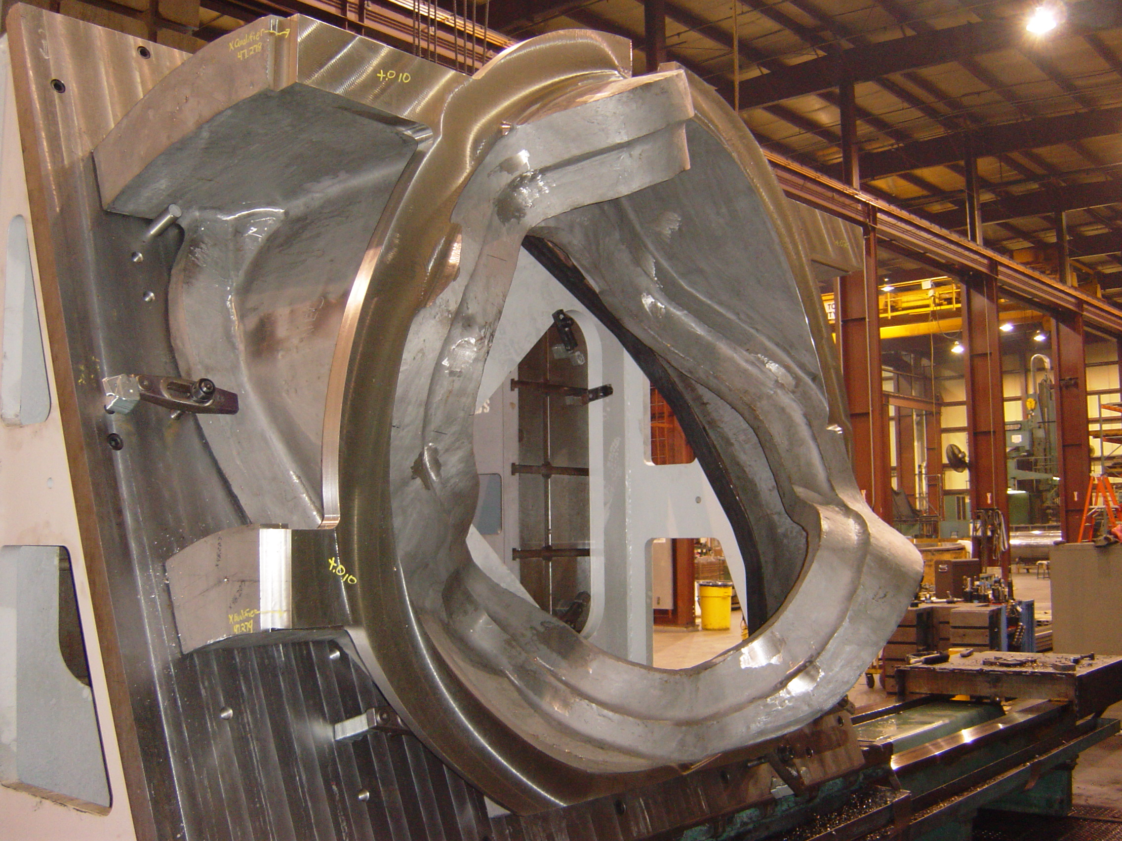
C-2

C2 is on the final operation. Mike Griffith of Major Tool reports that they are presently finishing the poloidal break flange. Operation is expected to be completed next week at which time hand finishing will begin. Current delivery to PPPL is projected for the week of 12/5/05; however all efforts, including running shifts throughout the weekends and holidays, are being taken to expedite.

C-3

A casting defect at the base of the Tee, roughly 1.6” long by .50” wide by .20” deep was discovered by MTM and reported to PPPL on Wednesday, 11/16/05. The weld map of the part was reviewed and no major welds were found in the area, so it is likely an inclusion in the part. After an on-site review by Frank and Roy, a telecon with EIO, MTM, PPPL and ORNL was held on 11/17/05. It was agreed that MTM would weld repair the defect. It was further agreed that PPPL would waive the X-ray requirement for this area as it is not in a high stress area and the weld will mostly be ground away, thus allowing LPI to adequately validate the result.

During the inspection, two tool gouges were also discovered on the tip of the racetrack and they were also addressed during the telecon. It was determined that one of the gouges would be completely machined away while the other could leave a slight indication which will be hand blended at the end of the process. NCR’s for both the defect and the gouges were submitted to PPPL on Thursday 11/17/05 and approved for disposition by Larry Sutton on Friday, 11/18/05, thus enabling continued performance through this weekend, without disruption.

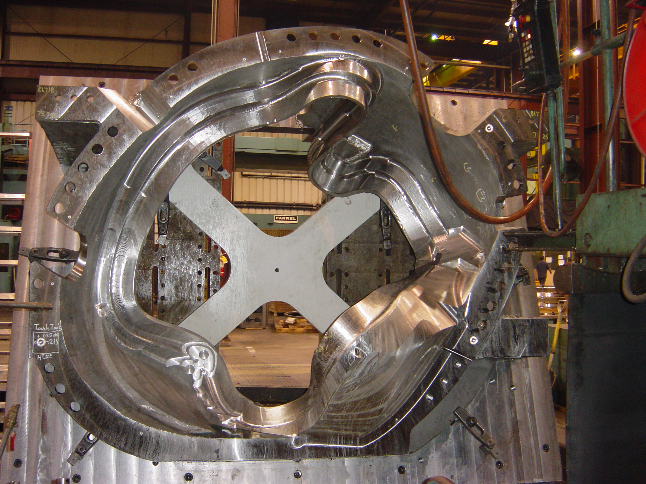

C-3

(shot taken on 11/18/05 at 4:30 pm)

Regarding accomplishments, MTM started roughing the poloidal break on 11/17/05. By late Friday afternoon, 11/18, Mike Griffith reported that the part was already on the final programs of the datum -D side. MTM expects to turn the part around next Tuesday 11/22.

C-4

C-4 is being rough machined on the 40T Lucas, a plan that may prove to help overall leadtime. As of 11/18/05, the machine roughing of E-flange had been completed and the part was ready to be flipped for roughing of the D-flange.

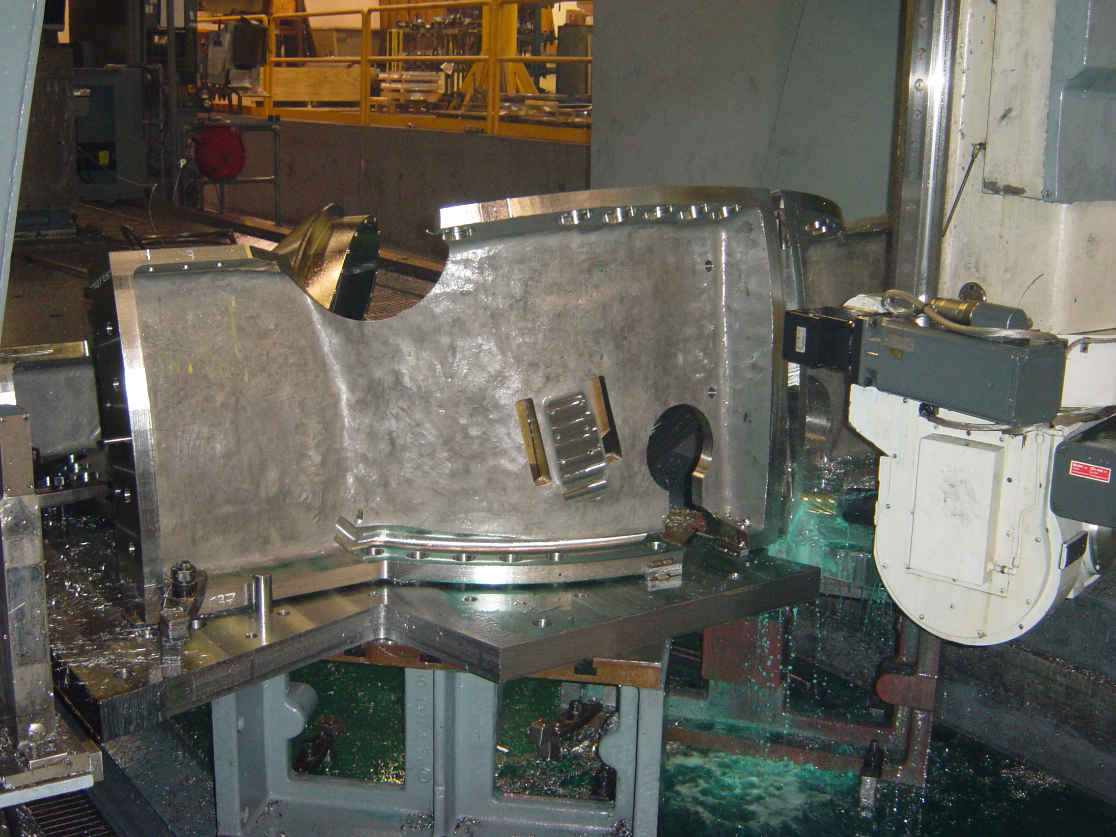

C-4

C-5

On 11/14 and 11/15 final touch-ups from LPI were completed and the part proceeded to final inspection including stress relief. EIO was advised late Friday, 11/18 that during final QA review and inspection of the C-5 documentation package, Metal Tek put shipment of C-5 on hold pending outcome of a metallurgical evaluation and if required, submission of NCR. Chuck Ruud has been investigating and plans to issue his report, including root cause analysis and recommended action, on Monday, 11/21/05. If necessary, a telecon will be scheduled for Monday or the action will be addressed during next Tuesday’s QA telecon.

A-2

A-2 is currently being welded and by Friday MTK had completed one side. Barry Craig reports that overall the X-rays on this part have been extremely positive and the part is “moving along well.”

A-3

As planned, A-3 was shipped to MQS for X-ray on 11/15 and Barry tells us that he is working to get the part shipped back to the plant on Monday 11/21. Upon return, Chuck Ruud intends to take preliminary measurement to confirm dimensional consistency with A-2.

B-1

Notwithstanding projections in last week’s report, the crew repairing the furnace at MTK did a “fantastic job” installing the new lining, thus enabling the foundry to complete required sintering last Friday 11/11 and pour the casting that same night during the late shift. Barry reported that during the early part of this week, the part had been shaken out of the mold and cut-off. As of 11/18 B-1 was in the furnace being heat treated. By Monday, MTK will likely begin grinding.

C-6

On Monday 11/1/4, with the input of Major Tool and EIO, Metal Tek made the decision to pour C-6 after B-1. By Friday, 11/18 the area had been cleared from the B-1 pour and C pattern had been set-up and MTK was already molding the pattern. The pour date is anticipated to be 11/29 or 11/30.

Technical Action Items
- (Major Tool) Machining C-2
Status: (Open) On final operation. Presently finishing the poloidal break flange
- (Major Tool) Machining of C-3
Status: (Open) On the final programs of the datum -D- side and will likely be turned around on Tuesday 11/22.

- (Major Tool) Processing C-4
Status: (Open) roughing of –E- flange is complete. Part is ready to be flipped for roughing of –D- flange.
- (Metal Tek) Processing C-5
Status: (Open) Part is complete and on-hold awaiting shipping release.
- (Metal Tek) Processing C-6
Status: (Open) Pattern set-up underway. New pour date scheduled for 11/29 or 11/30.

- (Major Tool) Machining of A-1
Status: (Open) In the queue at MTM for machining after C-5.
- (Metal Tek) Processing A-2
Status: (Open) In weld repair

8) (Metal Tek) Processing A-3
Status: (Open) At MQS for X-ray
9) (Metal Tek) Molding B-1
Status: (Open) Poured 11/11/05. Currently in heat treat.

Quality Highlights
Visits to Metal Tek and Major Tool this week by Frank Malinowski, Peter Djordjevich and Roy Sheppard enabled hands-on reviews of X-ray films and inspection of parts in process. At Metal Tek, the parties had the opportunity to compare the X-ray films to the reader sheets and weld maps, thus verifying that the reports are representative of the radiographic results.

At Major Tool, evaluation of the X-ray sheets showed that shots taken at the 45˚ angle were not providing any useful information and were therefore probably not necessary at least until more stock is removed. Regarding the implementation of Ultrasonic Testing (UT) for upcoming and future castings, Greg Masood, QA Manager described MTM’s process to the visitors. According to Greg, MTM is working to ASTM-1901. MTM has a generic UT procedure more attuned to plate and forged stock, which they intend to customize for use on the coils. Greg plans to use a combination of both straight and angled waves, shooting the part from different views and angles with a variety of transducers to see what works best. To test the procedure, MTM will machine a test piece from left over shim material to emulate the Tee section. “Flaws” will be introduced into the test piece by drilling various size holes to see how they are depicted by UT. While they do not believe they will have the technique developed in time for C-2, they are hopeful that it will be ready for C-3.

The on-site review of the castings, particularly C-3 also provided the opportunity to make real-time decisions about the disposition for 2 minor tool gouges discovered during inspection as well as the defect which had been spotted the previous day.

Finally, at least one action from the previous week’s visit to Major Tool, review of the RFD drawing for the new cooling hole, resulted in the decision by PPPL to accept the C-2 casting “as-is” and drill the new hole in-house when the part is received. The decision was made when it was learned that C-2 would have to be removed from the U-5, put back on the fixture and then reinstalled on the U-5, likely a day and a half activity, just to drill the single hole. PPPL confirmed that this task could more readily be accomplished in-house. This will not be necessary for future castings as the required hole will be incorporated into the machining program so that it is accomplished when the part is in the appropriate configuration on the fixture.

Upcoming QA Activities
- Shipping Release for C-5
- Electronic submission of complete C-1 Doc package by MTM

QA Action Items (from PPPL Quality Notes for 11/21/05):
The QA Action Items presented below have been extracted from the PPPL Quality Notes for the Week of November 21, 2005. Per agreement with PPPL, EIO will utilize the PPPL generated list to facilitate the weekly discussions and resolution of open actions. Since this is the first week in the new format, the former EIO action item numbers will be included this week in order to assist anyone interested in tracking the item to last week’s report.

- Closed Items:
  - (PPPL, EIO, MTM) NCR’s for C-3 casting defect and tool gouges
Status: (Closed) NCR’s were submitted to PPPL on 11/17 and approved dispositions were returned on 11/18.
- Pending from EIO:
  - (EIO, MTK) Update MetalTek CA1323 - for erroneous reported chemistry (sulfur and phosphorous values for C-1 through C-4, A-1, & 11 shims and Manganese on those castings, plus C-5). As of 10/25 MTK is awaiting return of the new Stellalloy standard from the 2nd lab. (formerly EIO Action #3)
Status: (Open - No update) Due from MTK by 11/21. A successful test will closeout this item.
  - (PPPL) For A-1, update MetalTek chemistry in the documentation package and spreadsheets to report the post-PM MetalTek Product Analysis with the Wisconsin Centrifugal results as validation. As of 11/10, the C-1, C-2 & preliminary C-3 packages are updated and posted. (formerly EIO Action #8)
Status: (Open) ON 11/14, EIO posted the Metal Tek Product Analysis with WC results- see /Quality_Review/ A1_Doc/ A1CoilWCChem11-3-05.pdf and AandCcoilchimchem9-24-05revised.pdf
  - (EIO, MTM) Address comments from PPPL review (10/13) of MTM C-1 data package. The first 3 are items for inclusion in the updated MTM C-1 documentation package. The other 2 concern documentation for C-2 and on. (formerly EIO Action #5)
Status: (Open) MTM is waiting to receive approved outstanding NCR’s prior to reissuing the updated C-1 documentation package. EIO to coordinate submission and posting to ensure final package includes all missing documents.
    - Provide corrected electrical inspection results for C-1. Document posted 10/28. This needs to be incorporated into the C-1 documentation package.
    - For C-1 and future castings, provide completed shop travelers or process sheets. C-1 document posted 10/28. This needs to be incorporated into the C-1 documentation package.
    - Include missing C-1 certifications for weld material, identified as Items #8 & #9 (mc106164.tif & mc106579.tif) in the TOC, and for G11 flat sheet, item #10, (mc107081.tif) in the digital package.
    - For future castings, report surface finish for the “L” sections of the Tee (125 requirement) separately from the rest of machined areas (250 requirement). Report location and extent for all out of tolerance areas separately.
    - For future castings, include surface inspection grid. For magnetic permeability, agreed to have DCMA witness and have photos taken in progress. This will not be complete mapping. Dimensional inspection grid should be apparent from results.
  - (EIO, MTK) Update of CA 1347 with the outcome of EIO investigation into the A-1 casting thin wall and actions to ensure wall thickness consistency on subsequent castings. Note: still open, awaiting A2 and A3 measurements to confirm dimensional consistency. (formerly EIO Action #2)
Status: (Open) Preliminary measurements of A-3 to be taken when the casting returns from MQS.
  - (EIO, MTK) Provide a copy of the issued 9/28/05 revision of MetalTek casting Quality Plan (conditionally approved - 10/11 email), with the noted changes. (formerly EIO Action #7)
Status: (Open -No update). Will follow issuance of Rev.10 of NCSX-CSPEC-141-03.
  - (EIO, MTM) Provide a copy of the updated MTM process outline incorporating recent changes.
Status: (Open -No update). Will follow issuance of Rev.10 of NCSX-CSPEC-141-03.
  - (EIO, MTM) EIO/MTM input on PPPL C-1 NCR’s 3618, 3619, 3620, & 3621.
Status: (Open). Due 11/9 Input for 3617 provided on 11/10 in form of MTM internal NCR. Discussed with Mike Griffith during meeting on 11/17– he’ll send an email addressing the remaining four. EIO sent follow-up reminder
  - (EIO, MTM) MTM NCR addressing elongation below specification requirements for Metrode ER316Mnnf, Batch # W020132, used to repair C-1.
Status: (Open). EIO sent follow-up reminder
  - (EIO, MTM) Room temperature tensile test results for Metrode ER316Mnnf, Batch # W020132, MTM used to repair C-1.
Status: (Open). EIO sent follow-up reminder. It was noted during this week’s QA telecon that if tests are successfully completed, an NCR is not required; however, if there is not enough material to run the tests, then an NCR will be required. As a corrective action, PPPL has addressed weld wire properties in Spec Rev 10.
  - (MTK) Results of MTK review of what caused the porosity in C-6.
Status: (Open). Chuck Ruud reported possible root causes are insufficient burn-out of mold; core wash not being adequately dried; atmospheric moisture; metal gas. Actual root cause not apparent – therefore MTK plans to attack all potential causes.
- Pending from PPPL
  - Review and disposition MTM C1 NCR NC 18297 for dimensional nonconformances. Revised copy received 11/10.
  - Review and disposition MTM C1 NCR NC 18315 for missing dimensional inspection data. Revised copy received 11/10.
  - Disposition outstanding PPPL C-1 NCRs: (requires EIO input – see 2.7 above)
    - PPPL 3617 - MTM hole numbering,
    - PPPL 3618 - MTM PB Fasteners,
    - PPPL 3619 – Cooling Tube hole drilling,
    - PPPL 3620 – PB Shim contour,
    - PPPL 3621 – MTM back spot face/thru-hole interference.
  - Review MetalTek special process personnel qualifications. DCMA has reviewed these. PPPL will also review, but with lower priority than other items on this list.
  - Advance review of preliminary MetalTek documentation packages for:
    - C-2, Review updated version posted 11/8 addressing PPPL comments.
    - A-1 and C-3. Note still under development. Partial C-3 posted. A-1 to come.
- Specification and drawing changes. Revision 10 of NCSX-CSPEC-141-03 is in the signature cycle and is likely to be issued by the time of the Tuesday teleconference.
  - PPPL to follow up on tolerance update on Sheet 10 of 141-116, zone D2. Need to get drawing posted and notify EIO through Larry and added to drawing change list in the spec. Note: drawing updated and will be formally transmitted with spec revision.
  - NCSX-CSPEC-141-03-10 includes this wording in 3.1.1.8:
3.1.1.8 Inspection for Internal Defects in the High Stress Areas
Each casting shall be free of internal defects exceeding 0.080” (major dimension) in the web region of the Tee in the High Stress Areas (as defined in Appendix A - 7.1 ) . Radiographic inspection or radiographic inspection in combination with ultrasonic (UT) inspections shall be used. Radiographic inspections shall be performed as defined in MSS SP 54. UT inspections shall be performed in accordance with procedures and personnel qualifications submitted to PPPL for approval prior to use. Defects exceeding these limits shall be repaired per Section 3.2.3.2 (Repairs) if performed prior to any significant amount of machining has been accomplished. Defects exceeding those limits which are identified after the winding form is significantly machined (i.e., within 0.25” of final dimensions) shall be reported on an NCR for evaluation. Repairs at that stage shall only be made if formally approved in the disposition of the NCR, and as defined in the NCR disposition.

Please feel free to contact me with questions or comments.

Nancy Horton
EIO Program Manager for NCSX

