Energy Industries of Ohio (EIO) Team Weekly Status Report

Report covers the NCSX Modular Coil Winding Form Activities Under Production Contract S005242-F

Week ending November 25, 2005

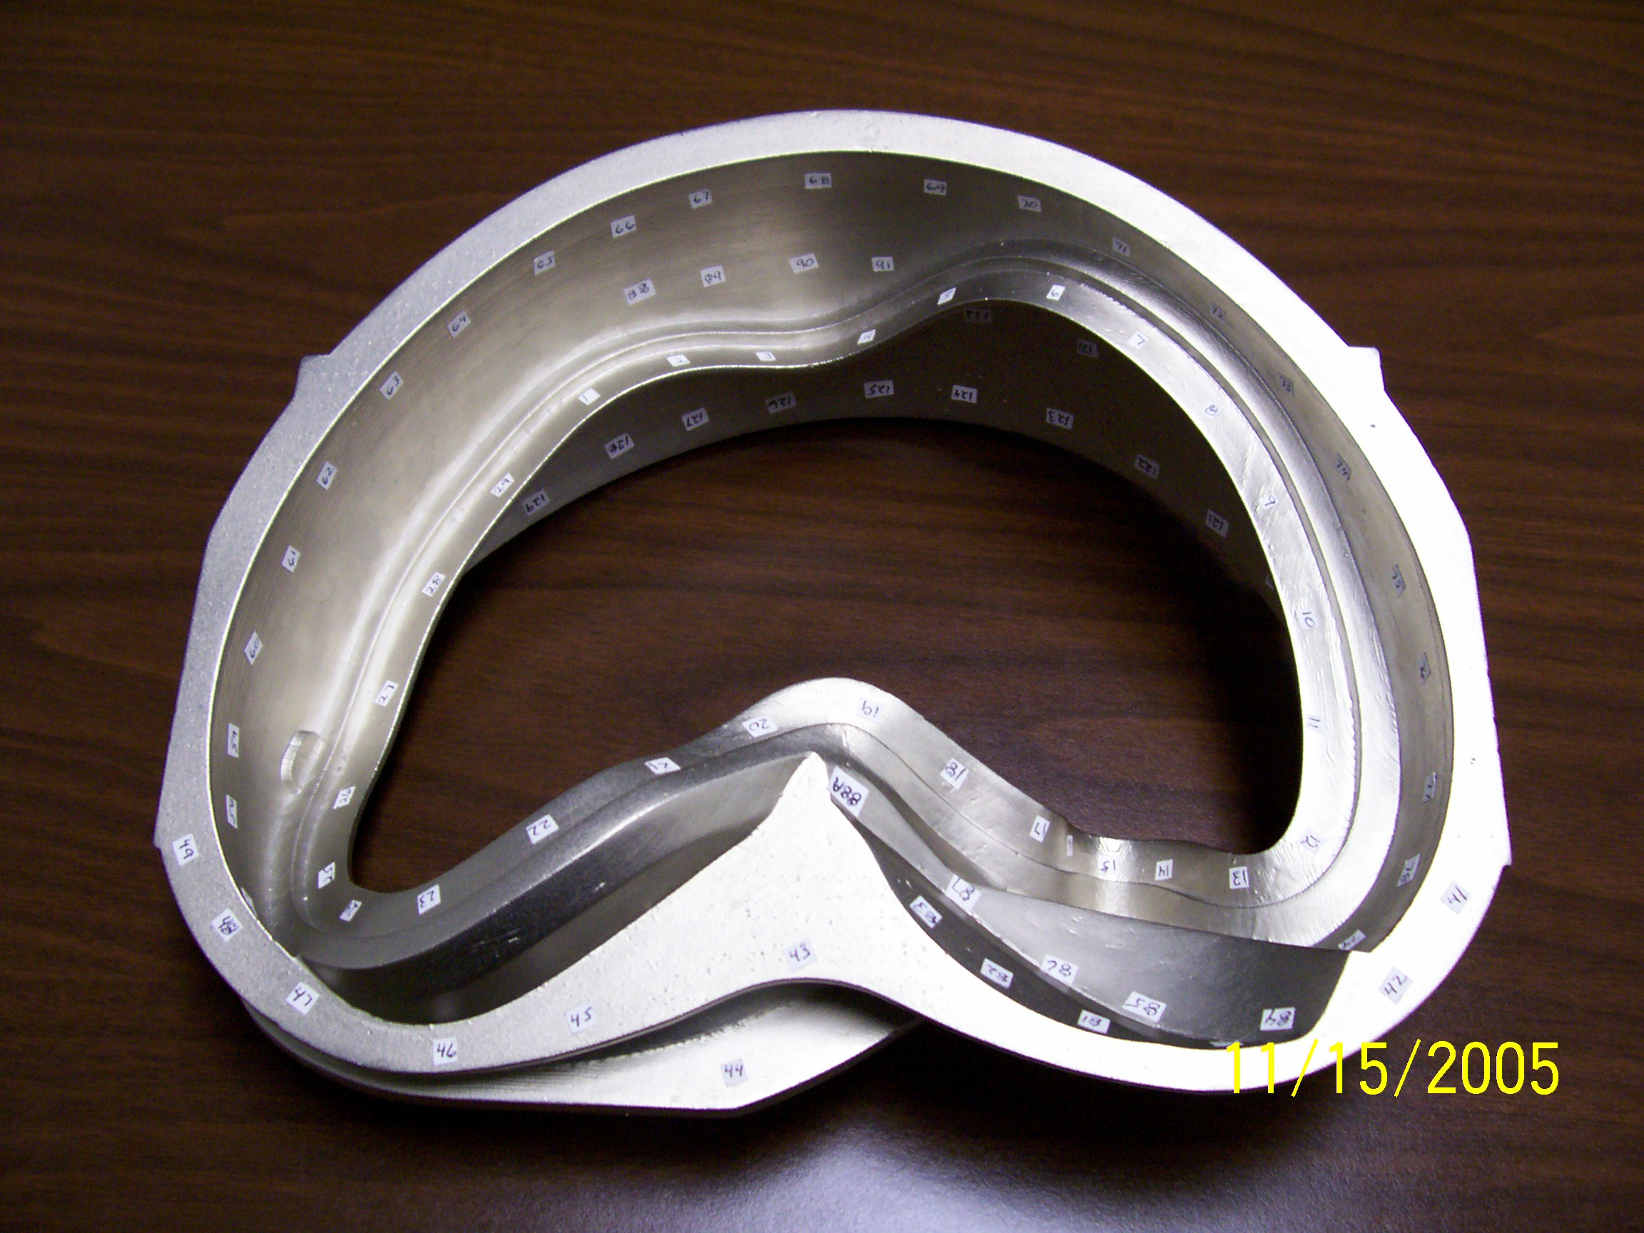

RP model of A in use at MTK

Administrative Highlights

The Rapid Prototype model of the type A casting, shown above, represents one of the many tools used by EIO team members to evaluate and determine casting and machining methods for the NCSX program. Depictions such as this are particularly useful during engineering meetings, providing illustrations that facilitate discussions and enable participants to review the part from the same perspective. Of course, even with the best methods, the details about these parts are still a challenge to communicate, as was discovered during discussions about the location of the new the cooling holes (details below). The above photo was taken by Frank Malinowski during his meeting at MTK on 11/15/05 presumably during discussions on radiographic technique.
On Monday, 11/21, Larry Sutton issued Amendment No. 8 incorporating the new NCSX-CSPEC-141-03 Rev 10 to EIO’s contract. The revised specification includes PPPL’s request for deviations (RFD) along with changes requested by MTK & MTM particularly regarding permissible weld materials and inspection criteria/techniques. Upon receipt of the amendment and in accordance with the changes clause, EIO notified Larry Sutton that the outstanding ROM proposal formerly submitted by EIO on 10/27/05 in response to PPPL’s RFD was applicable to this amendment. The proposal remains open while Major Tool seeks to find the appropriate vendor and secure a firm fixed price quote for the Poloidal Break fasteners.
Copies of the Rev 10 spec were distributed to the subtier contractors for review and implementation while formal amendments to their contracts are processed at EIO. During review of the directed change, EIO noted that the new drawings associated with the changes were not posted to PPPL FTP site. On 11/23, PPPL posted the documents.
On 11/21, Major Tool notified EIO and PPPL that bearing plates did not meet the magnetic permeability requirement of 1.02. In order to avoid any processing delay, the parties held an impromptu telecon with key players and resolved that the minor variance (1.03) was not of concern. Confirming the telecon, Larry Sutton issued written e-mail approval to accept a permeability of 1.03 (vs. the spec. limit of 1.02) for the 316SS bearing plates for the poloidal break. In addition, MTM submitted a formal RFD through EIO to PPPL on 11/23 documenting the verbal request.
Regarding the Poloidal break fasteners; a conference call was held with Major Tool, EIO & PPPL on 11/22 to determine the most effective and economical way to attain permeability of 1.02 on the nuts and studs without over-specifying requirements and running up the cost. Over the past couple of weeks, MTM had raised the possibility that cold working of A-286 alloy could raise permeability. NCSX checked with Dick Reed concerning the risk of the permeability of poloidal break fasteners exceeding 1.02 if procured to ASTM A453, Grade 660 B. Dick was not concerned, as both alloy charts and past history with this material have shown that A-286 hardware easily passed the permeability spec. Brad Nelson added that bolts ORNL has purchased to this spec in the past were well below 1.02.
Consequently the parties agreed that MTM should supply the hardware to the agreed upon ASTM A453, Grade 660B designation; however, (if it can be achieved cost effectively) MTM will seek to purchase 30% of the fasteners up front and screen for permeability. Associated prices will be forwarded to PPPL when available, so that PPPL can confirm this approach. If agreeable, PPPL will issue formal direction for the procurement of the 30% and acceptance of the risks associated with parts exceeding desired permeability.
Using the feedback from MTM’s permeability tests, the NCSX team will determine how to proceed with the procurement of the remaining required parts. It was recognized that the hardware will not be available in time for installation on C-2 and it was agreed that the old hardware will be used and replaced by PPPL when the new hardware is received. Earlier instructions on the RFD, as confirmed by Rev 10 of the spec had eliminated the use of Molycote on the hardware. Brad Nelson expressed a desire for a different lubricant (Nucoat?) to be used before tightening to ensure that all bolts can be easily removed. Formal direction will be required.

The telecon also touched on RFD 14-009 Rev 1, item # 7. There was a print interpretation question concerning the location of a new cooling hole. The drawing provided with the RFD did not appear to match the IGS file supplied later. Although NCSX initially contended that the drawing did match the IGS file, during the telecon it rapidly became clear to all, that the drawing supplied with the RFD was confusing at best, and open to various interpretations. As discussed in last week’s QA notes, PPPL has agreed to hand place this hole on C-2. For C-3 on, this hole will be programmed in and drilled at MTM. Kevin Bowling will capture this in an RFD.

FTP Postings this week
(found at: ftp.atc-inc.org:/PPPL/shared_info)
Location | File Name | Date
\Reports-Weekly-Monthly\weekly | 05-11-18_eio_wk.doc | 11/21/05
\Quality_Review\C3_Doc | S5242NC18607_2_C3weldrepair.pdf | 11/21/05
\Quality_Review\C3_Doc | S5242NC18654_C3Gouges.pdf | 11/21/05
\Quality_Review\A2_Doc | WeldMap11-17-05.pdf | 11/21/05
\Quality_Review\A2_Doc | WeldMap11-18-05.pdf | 11/21/05
\SOW_Spec_Drawing | NCSX-CSPEC-141-03-10-Signed.pdf | 11/21/05
\SOW_Spec_Drawing | drawing_changes-10-10-10-25.zip | 11/21/05
\Quality_Review\C5_Doc | c5_elong-CA1454.zip | 11/21/05
\Quality_Review\C5_Doc | CSPEC-C-5withattachments.zip | 11/21/05
\Quality_Review\C5_Doc | CSPEC-C-5ShimS-N5Casting.zip | 11/21/05
\Quality_Review | MTM-RT-UT-qual.zip | 11/21/05
\Quality-Meeting_notes | PPPLQualityNotes11-21-05_notes.doc | 11/21/05
\Quality_Review | MTM_PQR-files_8-31-05.zip | 11/21/05
\Quality_Review\C3_Doc | C-3_Doc_pack-11-22-05.pdf | 11/21/05
\Quality_Review\C5_Doc | CA1454_signed.pdf | 11/22/05
\Quality_Review | RFD-003.pdf | 11/23/05
\Photos\C2_Photos | c-2-11-23.zip | 11/23/05

Administrative Action Items
- (PPPL, EIO, MTM) Request for quote to EIO/MTM for purchasing 9 ½" studs & nuts. New studs to be A286 UNS S66286 to ASTM A453 Grade 660 B
Status: (Open) Quotes are being solicited by Kevin Bowling of MTM. Plan is to procure 1/3 of the hardware and conduct mag permeability check. Based on results, PPPL will determine most cost effective method to proceed with the procurement.
- (EIO, MTM, PPPL) List of additional changes desired by PPPL for machining on C-2 and beyond, as covered on 10/13 & 10/14
Status: (Open) Larry Sutton issued letter to accept C-2 cooling hole “as-is” (meaning the previous configuration, as spelled out in the contract specification rather than the RFD configuration) in order to avoid a significant delay in the delivery of the casting. Contract definitization of the RFD is pending the outcome of Action item #1.

- (PPPL/ORNL) Decision and direction about the use of a lubricant to secure the bolts on C-2 and beyond

Status: (New) Discussion underway at PPPL.

- (EIO, MTK, MTM) Revisions to Specification based on agreements at the meeting of 10/13 & 10/14.
Status: (Open) Spec Rev 10 issued to EIO via Amendment No. 8 and distributed to team. EIO to issue formal contract amendments to subtier contractors and upon completion will sign and return Amendment No. 8 to PPPL, with the understanding that the change proposal submitted in response to RFD 14-009 Rev 1 will be incorporated into the contract in a follow-up amendment.

- (PPPL, MTM) Return Shipping Container to Major Tool for shipment of C-2

Status: (Open) If still desired by MTM, Parties need to coordinate to ensure timely return of the container prior to upcoming shipment.

Technical Highlights
C-2
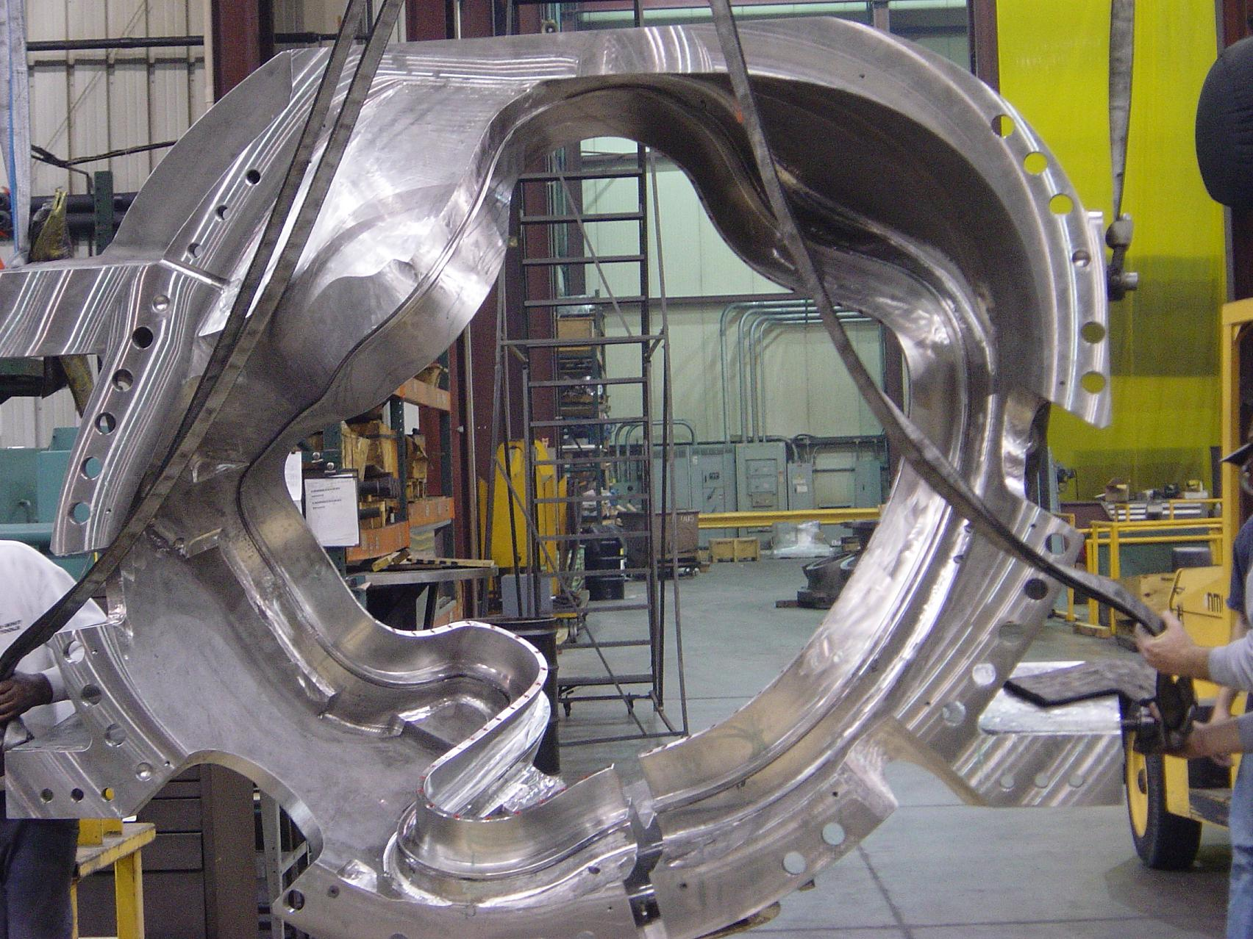

C-2 Off the machine & in cleanup

C-2 came off the U-5 this week and is now in the final stages. As reported earlier, MTM has scheduled crews to work through the weekend on C-2. Kevin Bowling reports that C2 is progressing through the washing and inspection steps through the weekend. Kevin expects that the NDT should be complete on Saturday. At that point, the poloidal break will be assembled. MTM plans to finish the CMM work on Tuesday next week. Additional pictures posted to the EIO FTP site.

C-3

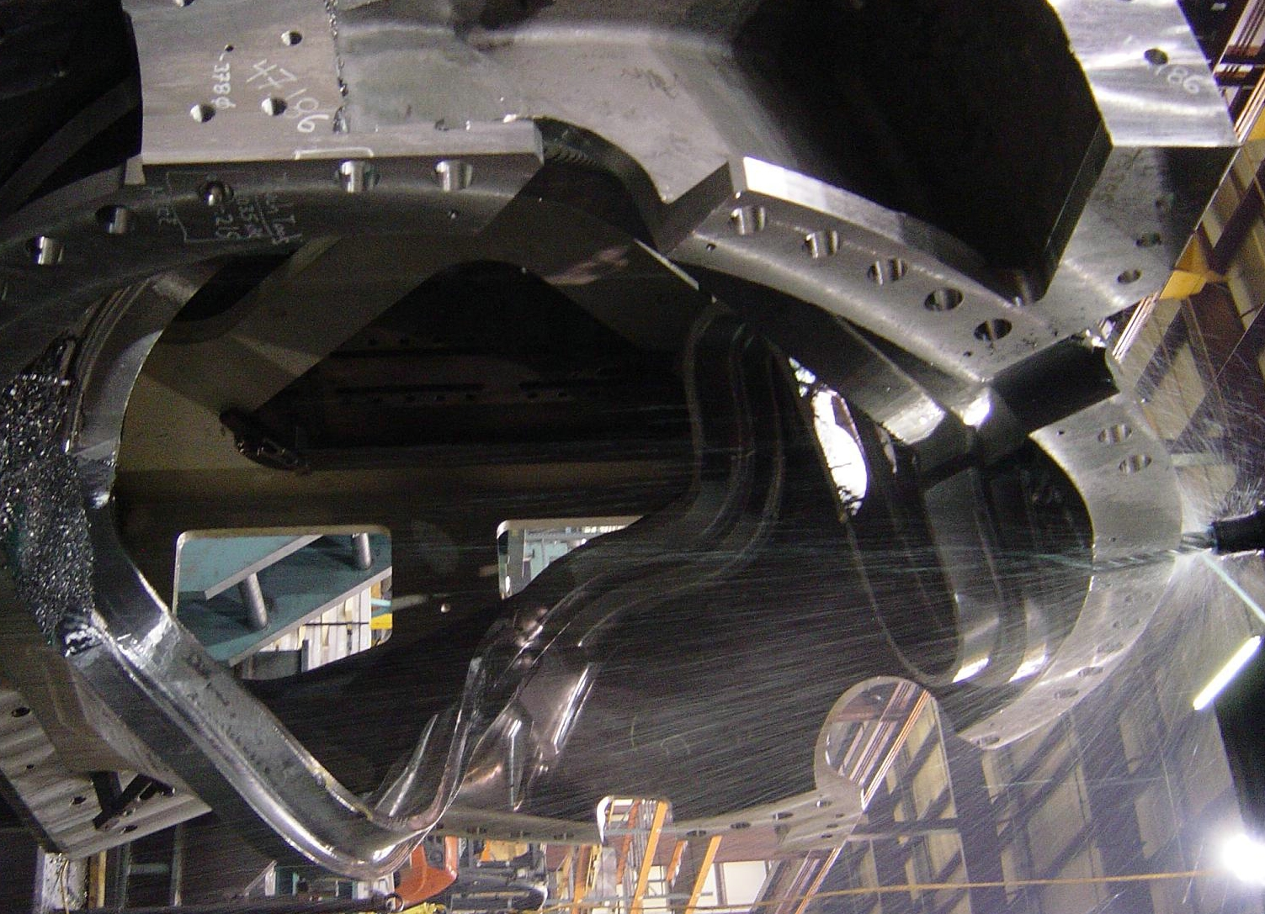

C-3 is on the 3-axis Mitsubishi. The photo above shows the poloidal brake being machined in.

C-4

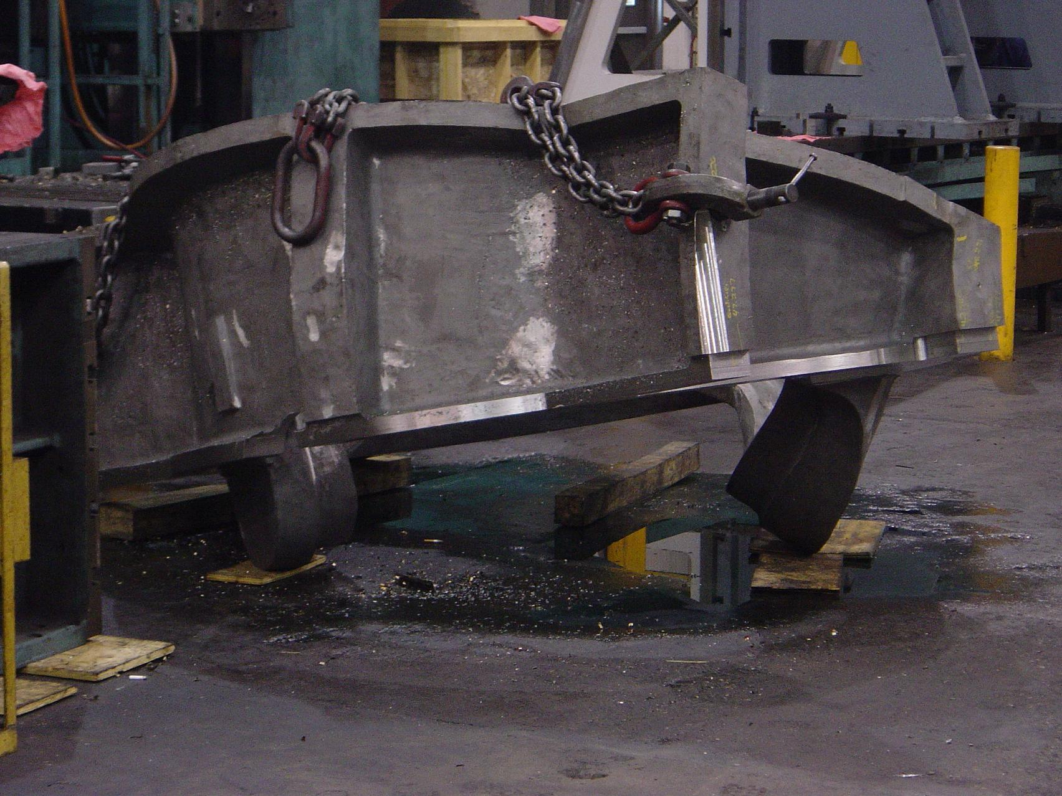

C-4 – ready to flip

C4 first side 3-axis mill operation is complete and the second will
begin on Monday.

C-5

As reported last week, C-5 was placed on hold by MTK on 11/18 pending the outcome of a metallurgical evaluation. On 11/21 MTK forwarded an NCR (CA-1454) for a low elongation at cryogenic temperatures that occurred on 1 of 3 test bars. The specifics of the NCR are covered below under Quality Highlights. PPPL approved CA-1454 on 11/22 and the casting was released to ship on the morning of 11/23. Due to the Thanksgiving holiday, though, MTM has requested that the casting arrive no earlier than 11/28. Joe Edwards of Metal Tek reports that MTK has set-up a truck to pick up C-5 on Saturday, 11/26 for arrival at MTM on 11/28.

A-2

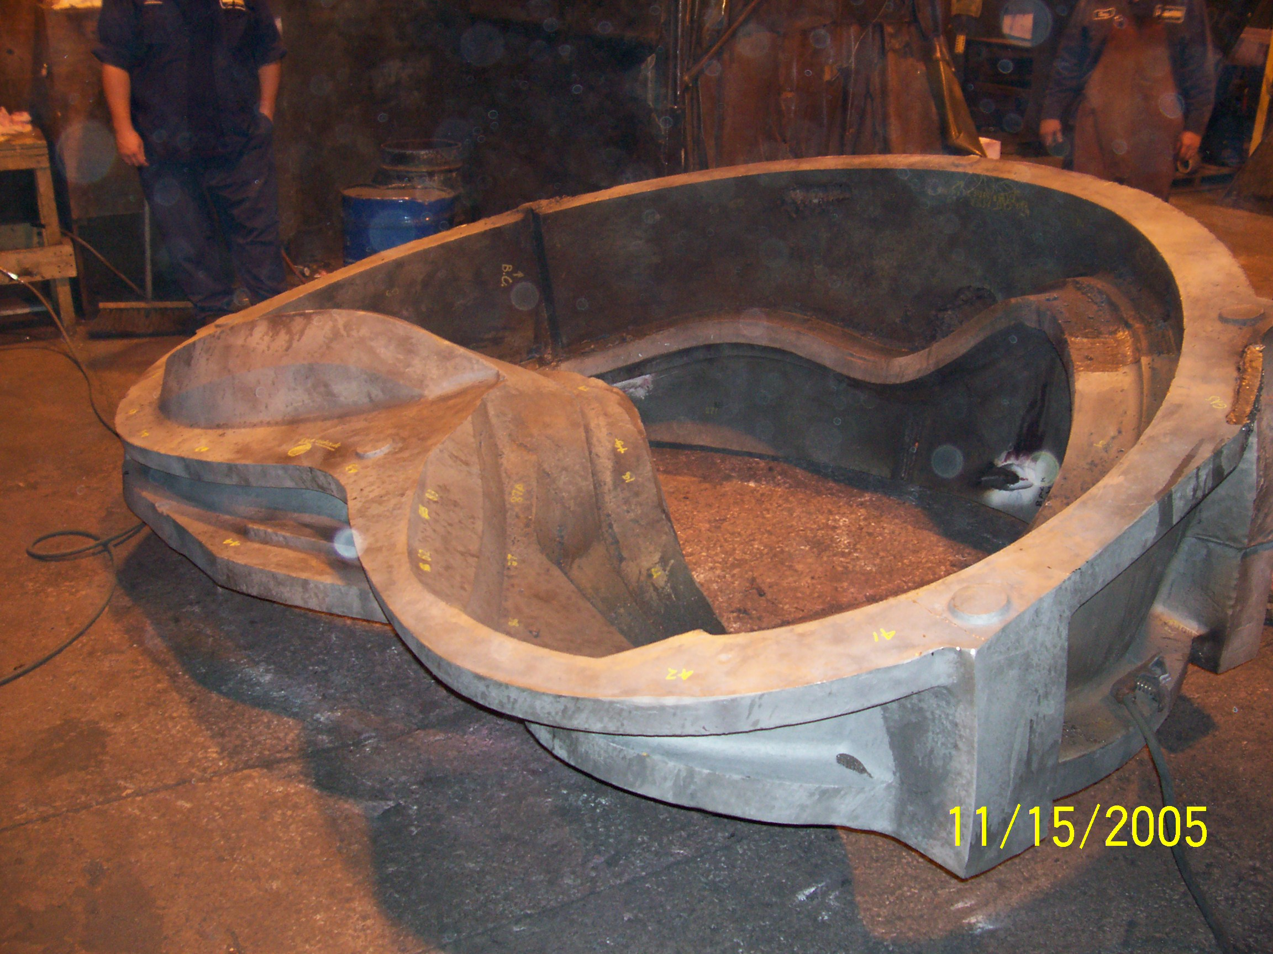

A-2 remains in welding this week. Barry Craig estimates that they will finish up welding by 12/9.

A-3

A-3 is now complete with initial x-ray at MQS. It will be back at the foundry on Monday, 11/28 for evaluation and processing. Meanwhile, Barry Craig has requested advance input from MQS, on the results.

B-1

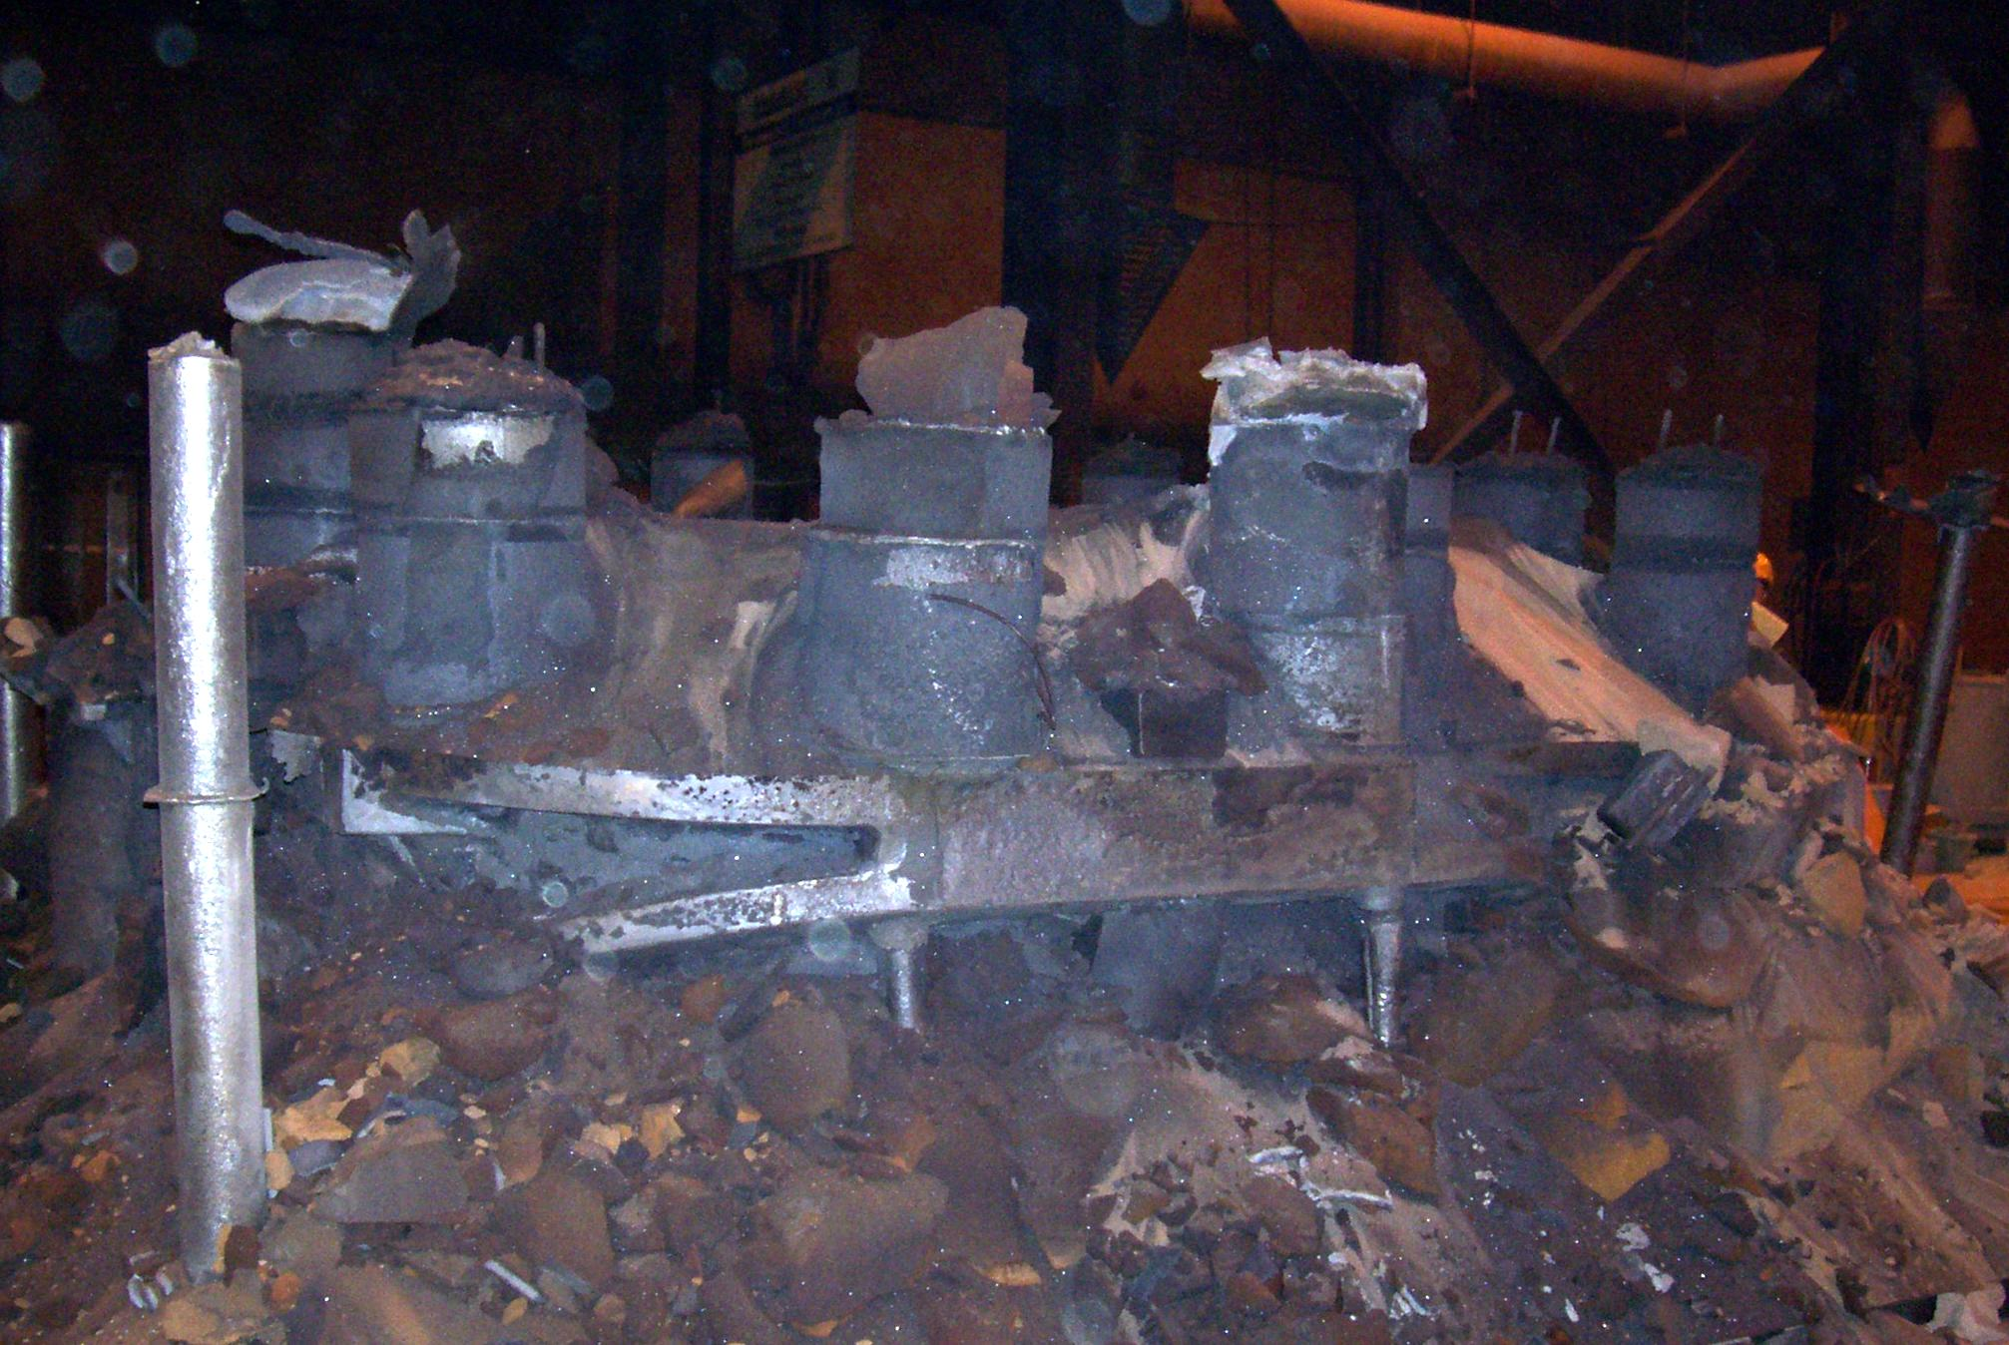

B-1- Fresh, out of the box!

B-1 has been heat treated and is waiting to be ground. ScanCo is scheduled to come in to MTK on the 12/5 for the digital scan. MTK will get as much of the part ground as possible prior to that.

C-6

Barry reports that the new C-6 is still on track to pour on 11/30. MTK made the mold this week and will start assembling it tonight (11/23).

Technical Action Items
- (Major Tool) Machining C-2
Status: (Open) Now in final stage
- (Major Tool) Machining of C-3
Status: (Open) On the 3-axis mill, roughing poloidal break

- (Major Tool) Processing C-4
Status: (Open) First side 3-axis mill complete
- (Metal Tek) Processing C-5
Status: (Open) released to ship 11/23
- (Metal Tek) Processing C-6
Status: (Open) new pour date of 11/30

- (Major Tool) Machining of A-1
Status: (Open) In the queue at MTM for machining after C-5.
- (Metal Tek) Processing A-2
Status: (Open) In weld repair

8) (Metal Tek) Processing A-3
Status: (Open) returning from MQS
9) (Metal Tek) Molding B-1
Status: (Open) in grinding

Quality Highlights

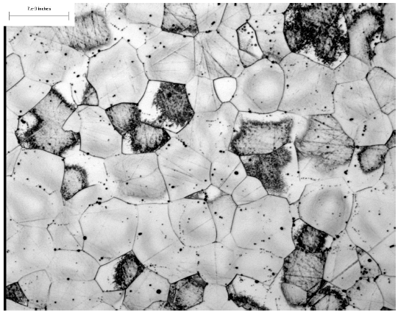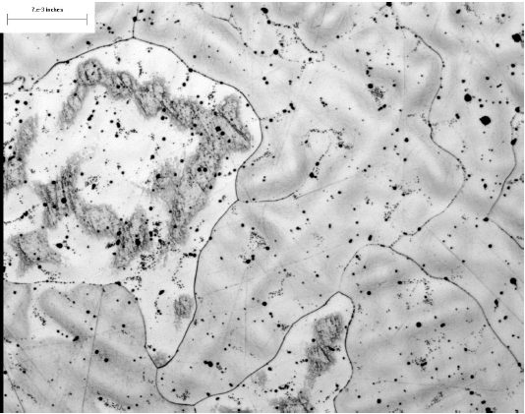

Grain structure comparison of test bars – Zone 1 Vs Zone 2

When the cryogenic test results came back on the C-5 test bars, MTK noted that 1 of the bars (from zone 1) had a lower elongation (31%) than was called for in the spec (32%). A subsequent retest of a bar from the same zone also yielded lower results (29%). All other properties measured on both bars exceeded specifications. Test bars from the other zones all passed all requirements.

Metal Tek next tried to determine the possible cause. Additional test bars from each zone were sent to the St Louis Testing Lab. A cross section was removed from the each sample, encapsulated, ground, and polished for micro-examination in accordance with ASTM E 3-01. The cross sections were examined in the un-etched and etched condition (the above pictures show un-etched samples from zone 1 & zone 2). Examination of the cross sections disclosed significant differences in the grain structure of the samples.

Examination of the cross section of sample from Zone 1disclosed a fine equiaxed grain structure. The typical appearance of this condition is shown in Figure 1. Examination of the cross section of the samples from Zones 2 & 3 disclosed a coarse equiaxed grain structure with dendrites within the grains. Photomicrographs were also taken at Westmoreland Labs, to verify that neither test bar from Zone 1 had any internal defects. Copies of these photos were attached to CA 1454 and forwarded to PPPL.

According to Chuck Ruud, Metal Tek has concluded that the root cause of the lowered elongation was that the test bars in Zone 1 “…solidified with much less superheat than the other zones as a result of their relative orientation in the mold and mold filling”. The “cold” metal entering the test bar mold would have caused the finer grain structure. Further heat treating experiments were conducted on a zone 1 test bar, to emulate the actual heat treat the coil is exposed to. Although there was some coarsening of the grain, the results were not significant.

A possible preventative action would be to relocate the cast on Zone 1 bars. Although PPPL has signed off on CA 1454 (to use as is) they would like to discuss the possible relocation of the bars in the next QA meeting.

Our weekly QA meeting was held on 11/22, attended by representatives of NSCX, EIO, MTK & MTM. Along with covering the QA open items, a discussion was also held on the new Rev 10 spec just submitted by PPPL. Chuck Ruud expressed a concern on 3.1.1.8 – Inspection for Internal Defects in the High Stress Areas. In particular, MTK wanted to ascertain that the requirements listed did not pertain to their scope of work. It was agreed that both the RT & UT requirements listed would all be performed by MTM. The team still needs to discuss what would transpire in the event that a defect is uncovered which could not be seen in RT by MTK and that also does not exceed internal radiographic defects defined in MSS SP 54.

Upcoming QA Activities
- Electronic submission of complete C-1 Doc package by MTM

QA Action Items
In our on-going efforts to improve and simplify reporting, the format change for this section which was implemented in last week’s report, was discussed at the QA meeting on 11/22 where it was agreed that everyone would evaluate the usefulness to determine whether or not further changes are merited. It was expressed by PPPL that they appreciate the timely status updates in advance of the Tuesday QA meeting; however, this they acknowledge that this approach still results in maintenance of two lists. It was noted however that further consolidation to one list would result in a second weekly report strictly for Quality Action status. All agreed that the ideal solution is probably still to be determined. Keep watching for additional changes in the upcoming week.

- Closed Items:
Based on telecons and activities this week, EIO believes that items 2.7 and 2.10 below are now closed. We will look for confirmation in next week’s QA notes from PPPL.
- Pending from EIO:
  - (EIO, MTK) Update MetalTek CA1323 - for erroneous reported chemistry (sulfur and phosphorous values for C-1 through C-4, A-1, & 11 shims and Manganese on those castings, plus C-5). As of 10/25 MTK is awaiting return of the new Stellalloy standard from the 2nd lab.
Status: (Open) Discussed during meeting. MTM did not like initial results from Stellalloy button. Wants to obtain more test results prior to utilizing button for calibration of spectrograph
  - (EIO) For A-1, update MetalTek chemistry in the documentation package and spreadsheets to report the post-PM MetalTek Product Analysis with the Wisconsin Centrifugal results as validation. As of 11/10, the C-1, C-2 & preliminary C-3 packages are updated and posted.
Status: (Open) PPPL wants documents for A-1 incorporated in a single Doc package
  - (EIO, MTM) Address comments from PPPL review (10/13) of MTM C-1 data package. The first 3 are items for inclusion in the updated MTM C-1 documentation package. The other 2 concern documentation for C-2 and on.
Status: (Open) MTM is waiting to receive approved outstanding NCR’s prior to reissuing the updated C-1 documentation package (see 3.1, 3.2 & 3.3). EIO to coordinate submission and posting to ensure final package includes all missing documents.
    - Provide corrected electrical inspection results for C-1. Document posted 10/28. This needs to be incorporated into the C-1 documentation package.
    - For C-1 and future castings, provide completed shop travelers or process sheets. C-1 document posted 10/28. This needs to be incorporated into the C-1 documentation package.
    - Include missing C-1 certifications for weld material, identified as Items #8 & #9 (mc106164.tif & mc106579.tif) in the TOC, and for G11 flat sheet, item #10, (mc107081.tif) in the digital package.
    - For future castings, report surface finish for the “L” sections of the Tee (125 requirement) separately from the rest of machined areas (250 requirement). Report location and extent for all out of tolerance areas separately.
    - For future castings, include surface inspection grid. For magnetic permeability, agreed to have DCMA witness and have photos taken in progress. This will not be complete mapping. Dimensional inspection grid should be apparent from results.
  - (EIO, MTK) Update of CA 1347 with the outcome of EIO investigation into the A-1 casting thin wall and actions to ensure wall thickness consistency on subsequent castings. Note: still open, awaiting A2 and A3 measurements to confirm dimensional consistency.
Status: (Open) Preliminary measurements of A-3 to be taken when the casting returns from MQS on 11/28/05.
  - (EIO, MTK) Provide a copy of the issued 9/28/05 revision of MetalTek casting Quality Plan (conditionally approved - 10/11 email), with the noted changes.
Status: (Open) Rev 10 Spec issued - MTK thinks they will have this done by 12/2.
  - (EIO, MTM) Provide a copy of the updated MTM process outline incorporating recent changes.
Status: (Open -No update) Rev 10 Spec issued - Kevin Bowling to have this done by 11/28
  - (EIO, MTM) EIO/MTM input on PPPL C-1 NCR’s 3618, 3619, 3620, & 3621.
Status: (Closed) Discussed each of the above during QA meeting and subsequent telecon on 11/22 and according to PPPL, that was enough to close these items.
  - (EIO, MTM) MTM NCR addressing elongation below specification requirements for Metrode ER316Mnnf, Batch # W020132, used to repair C-1.
Status: (Open) MTM to supply by 12/5
  - (EIO, MTM) Room temperature tensile test results for Metrode ER316Mnnf, Batch # W020132, MTM used to repair C-1.
Status: (Open) MTM looking for actual certs from Metrode that can be used from that heat of weld wire. Baring that MTM may manufacture test bars out of weld material if there is enough material left. If tests are successfully completed, an NCR is not required; however, if there is not enough material to run the tests, then an NCR will be required. As a corrective action, PPPL has addressed weld wire properties in Spec Rev 10.
  - (MTK) Results of MTK review of what caused the porosity in C-6.
Status: (Closed) Chuck Ruud reported possible root causes are insufficient burn-out of mold; core wash not being adequately dried; atmospheric moisture; metal gas. Actual root cause not apparent – therefore MTK plans to attack all potential causes. MTK plans to go forward with a combination of actions meant to address all potential causes.
- Pending from PPPL
  - Review and disposition MTM C1 NCR NC 18297 for dimensional nonconformances. Revised copy received 11/10. PPPL to process by 11/28
  - Review and disposition MTM C1 NCR NC 18315 for missing dimensional inspection data. Revised copy received 11/10. PPPL to process by 11/28
  - Disposition outstanding PPPL C-1 NCRs
    - PPPL 3617 - MTM hole numbering - Done
    - PPPL 3618 - MTM PB Fasteners Conf call held on 11/22 Decided on plan to purchase 30% of the fasteners upfront – to be checked by MTM for permeability
    - PPPL 3619 – Cooling Tube hole drilling Conf call held on 11/22- problem with print interpretation explained. PPPL to drill C-2 by hand – MTM to program correct hole into C-3 & on
    - PPPL 3620 – PB Shim contour C-2 shim already machined to same file as C-1 – C-3 & on will be machined to new supplied STP file
    - PPPL 3621 – MTM back spot face/thru-hole interference. MTM will hand grind off extra stock as required to eliminate interference
  - Review MetalTek special process personnel qualifications. DCMA has reviewed these. PPPL will also review, but with lower priority than other items on this list. No change
  - Advance review of preliminary MetalTek documentation packages for:
    - C-2, Review updated version posted 11/8 addressing PPPL comments.
    - A-1 and C-3. Note still under development. Partial C-3 posted. A-1 to come.
- Specification and drawing changes. Revision 10 of NCSX-CSPEC-141-03 is issued. Discussed during 11/22 teleconference.
  - PPPL to follow up on tolerance update on Sheet 10 of 141-116, zone D2. Need to get drawing posted and notify EIO through Larry and added to drawing change list in the spec. Note: drawing updated and will be formally transmitted with spec revision. Problems in formatting are holding up posting of the new print revisions
  - NCSX-CSPEC-141-03-10 wording in 3.1.1.8 was also reviewed.

Crews at Metal Tek and Major Tool will be working through the holiday weekend to keep the program moving forward. During this time of Thanksgiving, let me express our gratitude for our team members’ dedication. We will look forward to sharing any additional accomplishments this week in next week’s report. As always, the EIO staff will also be available by phone for any questions, concerns or issues that may arise during this time. Just leave a message! Numbers during the holiday:
- Nancy: 216-496-2314
- Roy: 845-386-3890
- Peter: 440-610-0276

We also appreciate our partners at DOE, PPPL, ORNL and DCMA who have worked collaboratively with us over the past year as we moved through our various stages of production. You make it a pleasure to serve!

Have a wonderful Thanksgiving.

Nancy Horton
EIO Program Manager for NCSX

