Energy Industries of Ohio (EIO) Team Weekly Status Report

Report covers the NCSX Modular Coil Winding Form Activities Under Production Contract S005242-F

Week ending December 9, 2005

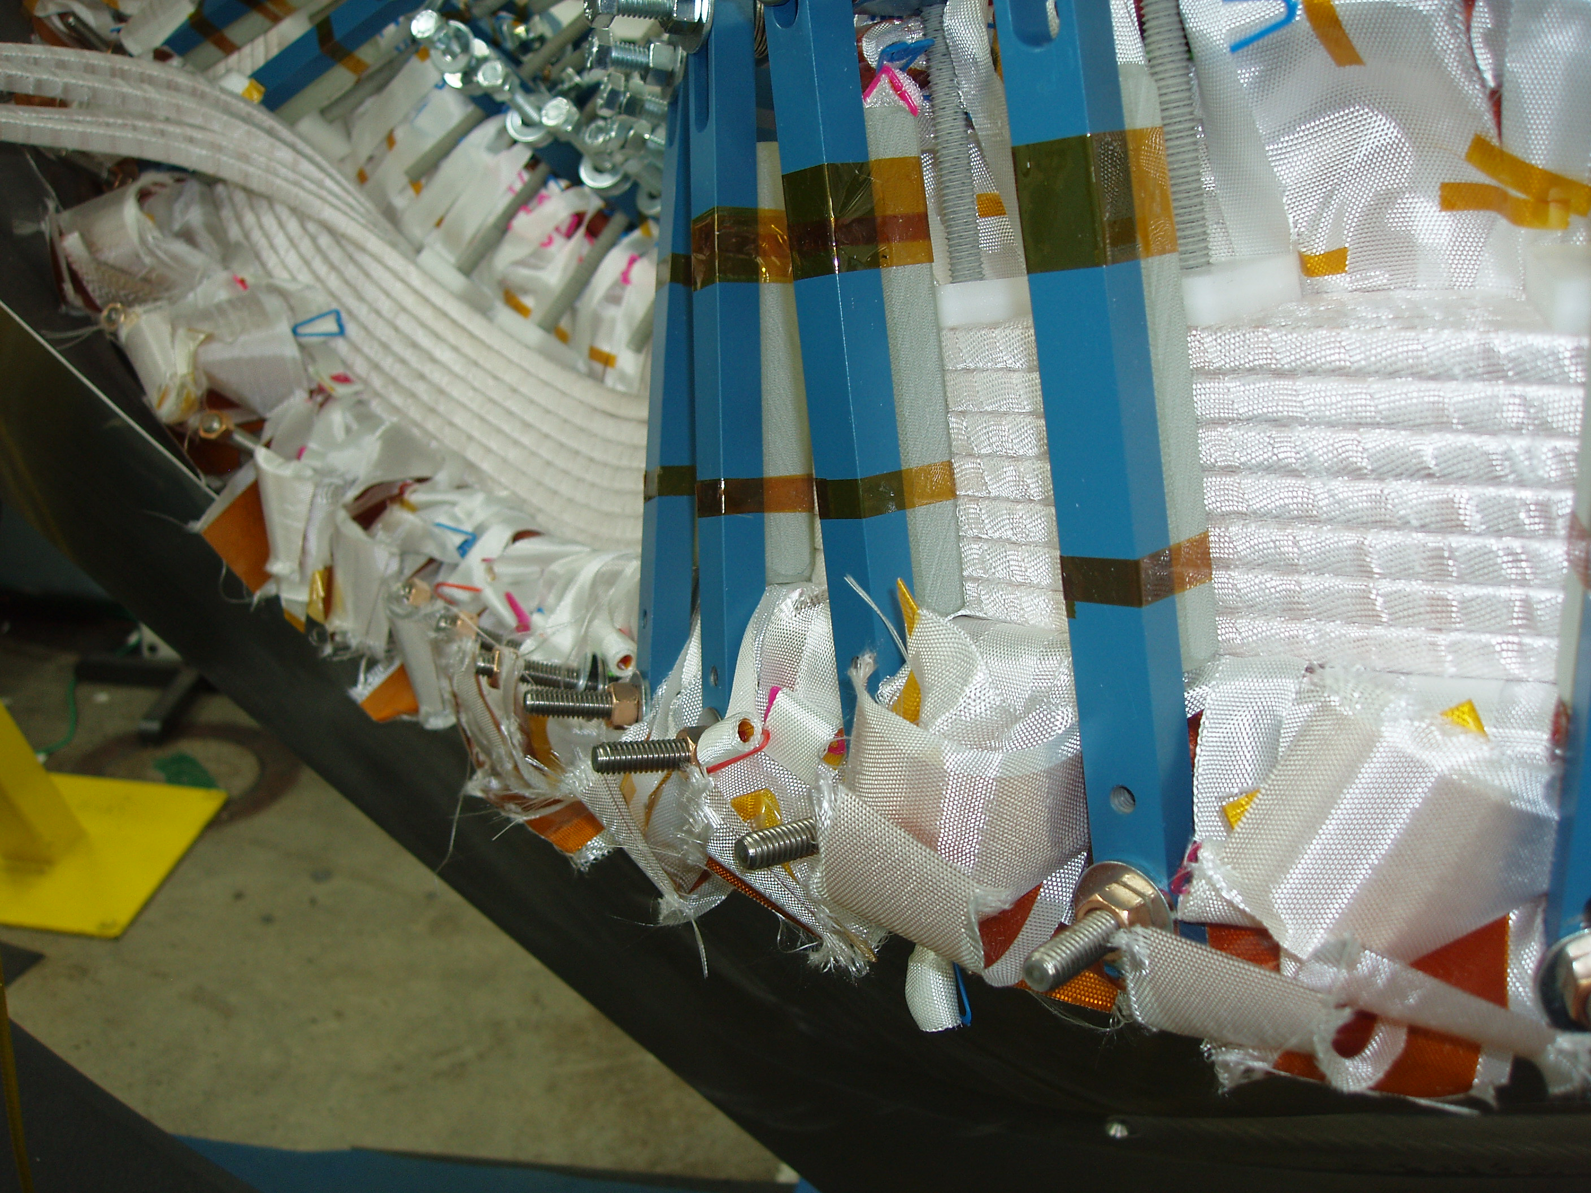

Administrative Highlights

Some of the photos in this report were provided by Jim Chyrzanowski and Mike Viola of PPPL. Additional photos were posted on the EIO FTP site by Phil Heitzenroeder (see chart below for location). The above photo shows the cable conductor being wound on the left side of the T. The studs holding the blue bars are welded onto the base of the T, which is covered by the fiberglass insulation. EIO would like to thank the many team members of NSCX for sharing the continued progress of the C-1 casting as it winds it way through the Coil Shop. It serves as continued motivation for all of us.

This week offered several opportunities for reflection on contract status. At the start of this week, EIO submitted the monthly report covering accomplishments in November as well as projections for the remainder of the contract period. Schedule, coupled with technical compliance is the number one priority for the entire EIO team and is regularly addressed each week during numerous telecons. While the team has many technical achievements and successful accomplishments to date, there are on-going technical challenges to overcome and lingering complexities to solve. Among all of the team members, the contract has proven far closer to an R&D effort than a straight forward production contract. In the most current example, while learning from C-1 has lead to gains on C-2, they have not been significant enough for MTM to achieve anything close to their desired 12 week leadtime. In response, we have been told that they are aggressively working multiple scenarios to positively impact throughput. For instance, their initiative to put the Lucas T into the production mix will reduce time on the 40’ Mitsubishi, currently a bottleneck in production. Another plan, which is discussed below under Technical Highlights – C-5, will recapture downtime as castings are repositioned on the Mitsubishi. These, along with initiatives at the foundry, provide continued optimism for successful achievement of the technical requirements. Nonetheless, achievement of the contract schedule is a demanding challenge that we are advised, has yet to be overcome.

Also this week, EIO was invited to participate in an interview for PPPL Audit 0601 of the NCSX Procurements. The interview, which took place on 12/8 and lasted roughly an hour, provided a forum for discussion about contract communication, particularly related to contract SOW and specification changes. Participating from PPPL were Judy Malsbury, Bob Simmons, Charles Gentile and Joe Labis. Peter Djordjevich, Roy Sheppard and I were all in attendance from EIO. It is worth repeating that throughout our contract, PPPL and ORNL have been responsive to EIO team member suggestions and concerns about the communication and transmission of spec changes. As a result, PPPL now provides draft versions of the specification revisions in advance of issuance to enable adequate review. This is usually followed by a telecon for discussion, comment and further revision as necessary to ensure mutual agreement. For recent spec changes, this has averted some of the confusion and misunderstandings that arose earlier in the project. Of course, the fact that we are on Rev 10 of the specification serves as another reminder of the developmental nature of this project.

As part of this on-going contract review, both EIO & PPPL will be out visiting team members next week. Nancy Horton & Roy Sheppard will be traveling to Metal Tek on 12/15 to review project status and discuss specific areas of interest including schedule and technical matters. This visit may coincide with pouring of A-4, which could enable the team to capture video of the event, something PPPL has expressed interest in obtaining.

On 12/14, Pete Djordjevich of EIO will be joining Phil Heitzenroeder, Hutch Neilson and Larry Sutton on a visit to Major Tool. We understand that the primary purpose of PPPL’s visit is the vacuum vessel project; however, as time permits, the team will also be interested in addressing technical challenges in the schedule for machined coils as well. Phil Heitzenroeder has specifically asked if there can be a discussion of utilizing the 30’ Mitsubishi on this program. Phil has also invited EIO and MTM to identify aspects of the coil winding that may be “over-designed” and could be impacting schedule.

Below is a listing of our team members’ holiday closings, which includes recent input from ORNL and PPPL. For the benefit of those at PPPL/ORNL who will be accessing their e-mails remotely, EIO plans to submit the weekly status report through the holidays.

EIO | None scheduled
Major Tool | 12/24 - 12/26 + 1/1 - 1/2
Metal Tek | 12/24 - 12/27 + 12/31 - 1/3
ORNL | 12/23, 12/26 & 1/2
PPPL | 12/23 (noon) thru 1/3

FTP Postings this week
(found at: ftp.atc-inc.org:/PPPL/shared_info)
Location | File Name | Date
\Quality_Review\C1_Doc | C1-Doc_pack-MTM-12-05-05.pdf | 12/05/05
\Reports_Weekly-Monthly\Weekly | 05-12-02_eio_wk.doc | 12/05/05
\Solidification_Models | 65707-2pointcloud2.igs | 12/07/05
\Solidification_Models | 65707-2pointcloud1.igs | 12/07/05
\Photos\C1_Winding-PPPL | 9 new JPG photos of C-1 winding | 12/08/05
\Photos\MiscMachiningPhotos | 6 jpg photos of machining at MTM | 12/08/05
\Quality_Review | CoilCastingQPlan12-5-05.doc | 12/08/05
\Quality_Review | NC18715-C2_indications-12-7-05.zip | 12/08/05
\Quality_Review | NC18776-C3_indications-12-7-05.zip | 12/08/05
\Reports_Weekly-Monthly\Monthly | Milestone_Schedule_Monthly_Report_12-05-05.xls | 12/08/05
Quality-Meeting_notes | PPPLQualityNotes12-5-05_notes.doc | 12/08/05
\Quality_Review | 1st_response-MTK-C-3_defects-12-8-05.zip | 12/08/05
\Quality_Review\B1_Doc | certificateofcomplicianceCoilB.doc | 12/08/05

Administrative Action Items
- (PPPL, EIO, MTM) Request for quote to EIO/MTM for purchasing 9 ½" studs & nuts. New studs to be A286 UNS S66286 to ASTM A453 Grade 660 B (RFD 14-009 Rev 1)
Status: (Open) As of 12/9, we were advised that quotes are still being solicited by MTM.

- (EIO, MTM, PPPL) List of additional changes desired by PPPL for machining on C-2 and beyond, as covered on 10/13 & 10/14
Status: (Open - No update) Contract definitization of RFD 14-009 Rev 1 is pending submission of a firm price, based on the outcome of Action item #1.

- (EIO, MTK, MTM) Revisions to Specification based on agreements at the meeting of 10/13 & 10/14.
Status: (Open) Spec Rev 10 issued to EIO via Amendment No. 8 was formally issued to subtier team members for signature on 11/25 via Amendment #5 to their contracts. EIO to return signed amendment to PPPL when process is complete. Reminder notices sent this week to subtier team members.

- (EIO) Submission of November Monthly Report

Status: (Closed) Submitted to PPPL on 12/5 & posted to EIO FTP

Technical Highlights
C-2
C-2 is in the final stages at MTM. On 12/7, Kevin Bowling posted the point cloud IGES files to the FTP site. The files are currently under review at PPPL by Tom Brown. Kevin and Mike Griffith are working on getting the profile report generated from the data. The process is taking a bit longer than expected due to a learning curve with implementing the Verisurf software package with the CMM data. Mike and Kevin will be working the data through the weekend and expect to have a report to EIO on 12/12.

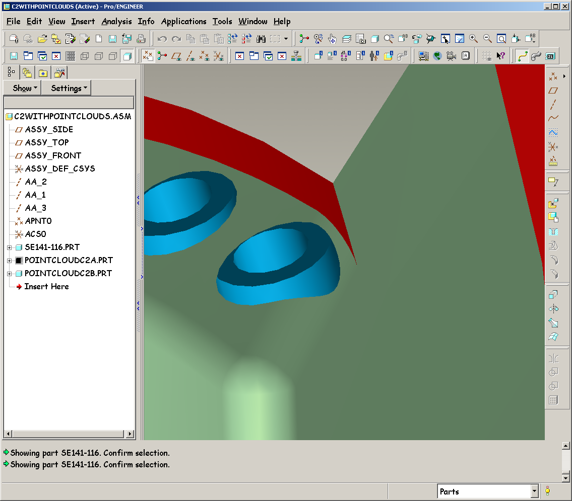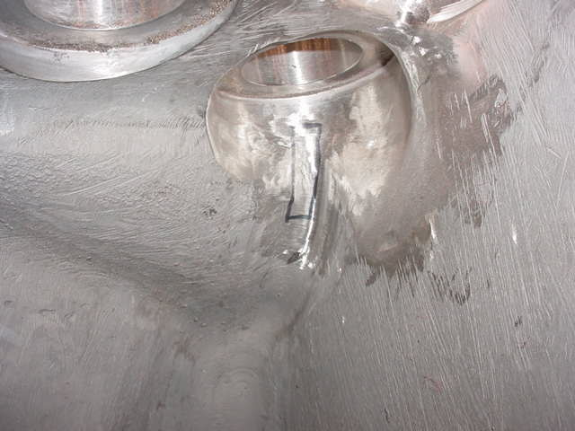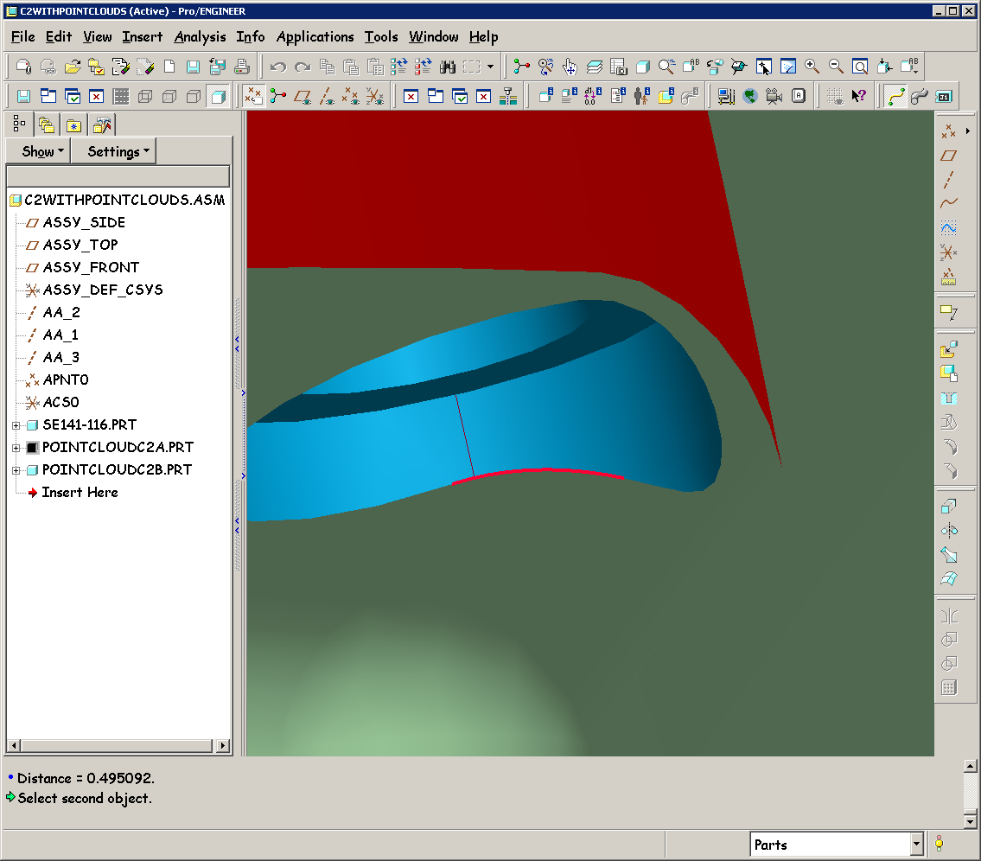
ProE model
Photo of crack
Approximate boundary of Pro-E part
1.88 (ref)
1.8 (Crack)
0.5 in min
Remaining indication on C-2

MTM also spent the week completing cleanup of the part, including the indications reported last week. The one indication on the T section, as well as one of the two indications in the as cast surface have been blended out successfully. The remaining indication actually grew as MTM attempted to blend it out. The location of this indication is shown in the photo above. Originally, .625” long, the indication grew to approximately 1.70” at .75” depth. At that point MTM stopped work on the crack and reported their findings to EIO during our weekly intra-team telecon on 12/9. EIO convened a conference call with NCSX team members and MTM later that afternoon to discuss the location and possible remediation.

This indication is located in a large as-cast fillet, at the juncture of the leg, flange and shell. There is no practical way to determine the depth & extent of the crack through NDT (x-ray or UT) due to the thinness of the indication, the location, and the thickness of the wall in this area. MTM’s approach to this point had been to “surgically” remove small bits of metal over the crack while die penetrant testing, so as to make the shallowest divot possible. Kevin Bowling shared that this approach had taken 2 full shifts without successfully finding the end of the crack.

The fillet where the indication is located does not appear on the ProE machined model. This feature was added into the stocked casting model for flow solidification. Consequently, late Friday, 12/9 NCSX provided direction for MTM to aggressively grind out the indication to at least an additional ¼” and then die penetrant inspect. If the crack is still present, MTM should continue to grind until they reach the ProE model envelope. At that point, if the indication is still evident, PPPL has agreed to have C-2 shipped to PPPL, accepting the failed LPI inspection report as an NCR, since the indication is in a non-critical location. Once at the lab PPPL will do additional FEA analysis of the indication.

C-3

C-3 is still pushing through on the last operation in 3-axis machining. Mike Griffith now projects that C-3 will be off the machine on 12/14. Both Kevin and Mike are concerned that the 40’ Mitsubishi has now become a bottleneck for production. Some steps were taken on C-4 to alleviate this (pre-machining on the Lucas T).

C-4

C-4 remains on hold, waiting for C-3 to move to the U-5

C-5

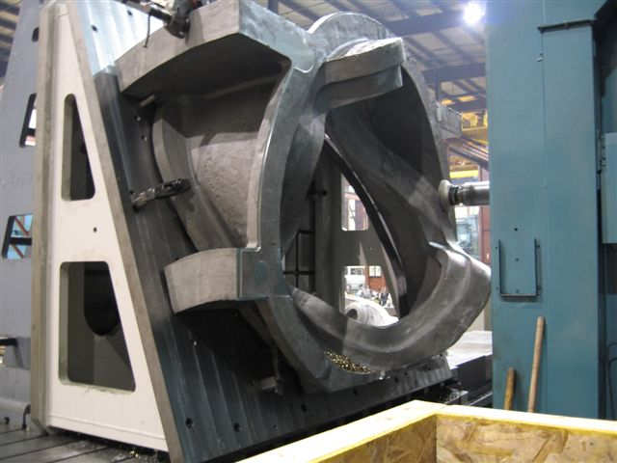
C-5 on Lucas
C-5 has been moving well on the Lucas T. On 12/9 the coil was flipped onto the 2nd side. Roughing of the flanges will continue next week to the .250” stock envelope before moving onto the 40’ Mitsubishi. Kevin and Mike also shared a plan with us yesterday that should help to eliminate additional time on the Mitsu. The poloidal Break needs to be cut on the Mitsu. Currently this is done as an additional setup. What MTM plans to do now is to “double up” on the table. Both C-4 & C-5 will be on the Mitsu at the same time. While C-4 is being changed over to a new setup, MTM will use what would have been down time to cut the poloidal break.

A-2
Barry Craig reports that the final X-ray repair excavations have been done & have passed LPI. A-2 remains in welding. Barry’s projected ship date of 12/16 to MQS is still on track.

A-3

Excavations are under way now. Chuck Ruud forwarded the initial weld map to EIO on 12/9 for review. Chuck promises to provide caliper measurements of the wall to EIO on 12/12.

B-1

B-1 was scanned by 3-D ScanCo on 12/5 & 12/6. Metal Tek is waiting to see the dimensional report prior to sending B-1 off to MQS. According to Tim Wenninger of Lawton, the report is expected very shortly. As of 11:00 a.m. on 12/10, the report had not been posted to ScanCo’s FTP site.

C-6

C-6 passed though heat treat this week. On Monday, 12/12, Barry plans on washing off the balance of the gates & risers. EIO discussed the possibility of reallocating resources on the C-6 to expedite this particular coil through the shop. This will be a topic of discussion at our meeting in St Louis next Thursday.

A-4

As of 12/9 the mold had been filled and Barry was preparing to strip the pattern. After that the mold will be prepared for the pour and closed. Although, the pour is tentatively scheduled for 12/20, Barry is hoping to get this poured earlier. Roy Sheppard of EIO will be arriving in St Louis on the evening of 12/14. He has offered his services as a spectator & videographer if the pour can be moved to the night of 12/14.

Technical Action Items
- (Major Tool) Machining C-2
Status: (Open) finishing data report from CMM scan
- (Major Tool) Machining of C-3
Status: (Open) move off 3-axis on 12/14

- (Major Tool) Processing C-4
Status: (Open) in queue for 3-axis
- (Major Tool) Processing C-5
Status: (Open) Flipping onto 2nd side on 12/9
- (Metal Tek) Processing C-6
Status: (Open) passed through Heat Treat

- (Major Tool) Machining of A-1
Status: (Open) In the queue at MTM for machining after C-5
- (Metal Tek) Processing A-2
Status: (Open) Final week of weld repair

8) (Metal Tek) Processing A-3
Status: (Open) 1st weld maps completed

9) (Metal Tek) Processing B-1
Status: (Open) Scanned – waiting for report
10) (Metal Tek) Molding A-4
Status: (New) Stripping pattern 12/9

Quality Highlights
The weekly QA telecon was held on 12/6 with additional participation of Chuck Ruud of MTK and Mike Griffith and Kevin Bowling of MTM. Indications, particularly those uncovered in the C-3 casting were discussed at length. As part of the investigation, Chuck provided copies of the RT shots and location ID to EIO and PPPL for review. More discussion is required. In the meantime, it was agreed that MTM will try to perform UT inspection on this area.

During the telecon, Mike also reported that the CMM activity on C-2 was taking longer than expected. Initial data review showed that the required grid was not obtained, thus requiring additional inspections. Mike expected to have the data review complete and the documentation package to EIO by Wednesday, 12/7.

As reported in Technical Highlights for C-2, MTM worked feverishly to complete the final tasks. By week’s end, several open actions remained, which were given urgent priority. Close coordination between EIO, MTM and the NCSX team helped to resolve a last moment problem with an indication that had stopped some of the processing on the casting. Kevin Bowling worked with Tom Brown and others to resolve technical glitches PPPL was having while attempting to import the IGES files into ProE (these files are being used for immediate review pending the release of the data from MTM). Since final compilation of the data was still in process and further grinding of the indication was considered desirable, with the concurrence of PPPL, delivery of C-2 was postponed until Tuesday, 12/13 to allow ample time for submission, review and discussion of the results.

Upcoming QA Activities

- CMM data report on C-2
- ScanCo data report on B-1
- Review, release & shipping of C-2 to PPPL
QA Action Items

- Closed Items: (EIO Recommended)

  - PPPL reviewed the 11/15/05 C-2 Documentation package from Metal Tek and returned 4 minor comments on 12/2. These have been incorporated into the Doc package which will be reposted on 12/12 (see 2.9)
  - MTM added corrected electrical inspection data to C-1 Doc package (see 2.3.1)
  - EIO submitted & posted MTK QA plan for review (2.5)

- Pending from EIO:

  - (EIO, MTK) Update MetalTek CA1323 - for erroneous reported chemistry (sulfur and phosphorous values for C-1 through C-4, A-1 & 11 shims, and Manganese on those castings, plus C-5). As of 11/22, MTK did not like the initial results from Stellalloy button and wants to obtain more test results prior to utilizing button for calibration of spectrograph.
Status: (Open) Chuck Ruud reported on 12/6 that the new button is expected back from the 3rd lab on 12/12

  - (EIO) For A-1, update MetalTek chemistry in the documentation package and spreadsheets to report the post-PM MetalTek Product Analysis with the Wisconsin Centrifugal results as validation. As of 11/10, the C-1, C-2 & preliminary C-3 packages are updated and posted.
Status: (Open) Will be accomplished over week of 12/26. In the meantime, chemistries are being updated. Waiting for one final revised document from MTK for A-1.

  - (EIO, MTM) Address comments from PPPL review (10/13) of MTM C-1 data package. The first 3 are items for inclusion in the updated MTM C-1 documentation package. The other 2 concern documentation for C-2 and on.
Status: (Open) Package posted to FTP site for review on 12/5. Initial feedback from Frank Malinowski provided on 12/8 & discussed with Mike Griffith on 12/9.
    - Add corrected electrical inspection data to Doc package.
Status: (Recommended: Closed) reviewed and accepted
    - For C-1 and future castings, provide completed shop travelers or process sheets
Status: (Open) Not added. Mike will discuss with Kevin & add in.
    - Include missing C-1 certifications for weld material, identified as Items #8 & #9 (mc106164.tif) in the TOC, and for G11 flat sheet, item #10, (mc107081.tif) in the digital package
Status: (Open) Metrode cert added but cryogenic test results missing. G11 flat sheet, item #10 (mc107081.tif) have been added, reviewed & approved.
    - For future castings, report surface finish for the “L” sections of the Tee (125 requirement) separately from the rest of machined areas (250 requirement). Report location and extent for all out of tolerance areas separately.
Status: (Recommend: Closed) This has been incorporated into C-2. CMM inspection reports will be available by 12/12. This should close out this note.
    - For future castings, include surface inspection grid. For magnetic permeability, agreed to have DCMA witness and have photos taken in progress. This will not be complete mapping. Dimensional inspection grid should be apparent from results.
Status: (Recommend: Closed) This has been incorporated into C-2. Successful review of inspection reports for C-2 should close out this note.
    - The Table of Contents (TOC) lists certifications to be added later for the casting and for the shim. These certifications are actually the first part of the package.
Status: (New - Open) Roy Sheppard notes: “Hopefully there is no intention to duplicate them. A reference to the earlier part of the package would be preferred, but maybe for internal Visual Manufacturing purposes, this existing reference is needed.
    - TOC Item #7 lists C of C for G-11 Round bar. The certification is for 3.125” thk.Sheet. The TOC should be corrected
Status: (New - Open)
    - TOC Item #11, G-11 Round Bar C of C is not in the package
Status: (New - Open)
    - NC17452 for a tool gouge is not in the package
Status: (New - Open)

  - (EIO, MTK) Update of CA 1347 with the outcome of EIO investigation into the A-1 casting thin wall and actions to ensure wall thickness consistency on subsequent castings. Note: still open, awaiting A2 and A3 measurements to confirm dimensional consistency.
Status: (Open) Preliminary measurement of A-3 to be taken. Chuck Ruud has promised this for the meeting on 12/12.
  - (EIO) Provide a copy of the issued 9/28/05 revision of MetalTek casting Quality Plan (conditionally approved - 10/11 e-mail), with the noted changes.
Status: (Recommended: Closed) Submitted to PPPL & posted to FTP.

  - (EIO, MTM) Provide a copy of the updated MTM process outline incorporating recent changes
Status: (Open - No update) Promised by 12/9. MTM to provide new completion date

  - (EIO, MTM) MTM NCR addressing elongation below specification requirements for Metrode ER316Mnnf, Batch #W020132, MTM used to repair C-1.
Status: (Open - No update) Promised by 12/9. MTM to provide new completion date

  - (EIO, MTM, PPPL) Room temperature tensile test results for Metrode ER316Mnnf, Batch #W020132, MTM used to repair C-1.
Status: (Open - No update) Actual results from this batch of weld wire are not available from Metrode. Metrode did supply MTM with actual results obtained from a previous lot. As this is a standard weld wire for Metrode, EIO has submitted these results to PPPL for review on 12/1 in lieu of creating new test bars or an NCR. (see 3.5 below). PPPL advised that results may be acceptable but must be incorporated into an NCR. NCR promised by 12/9. MTM to provide new completion date

  - (EIO) Corrections need to be made to C-2 doc package to reflect comments from PPPL on 12/2
Status: (Recommend: Closed) Corrections made week of 12/5 with the exception of replacing CA1323 with a finalized copy. Will repost by 12/12.

- Pending from PPPL

  - Review MetalTek special process personnel qualifications.
Status: (Open - No update) DCMA has reviewed these. PPPL will also review, but with lower priority than other items on this list.

  - Actual results from a previous Metrode weld wire lot were submitted to PPPL on 12/1 for possible acceptance in lieu of actual results from lot used which are not available.
Status: (New) NCR due from MTM

- New Specification & Drawing Changes: NONE

The above QA action item list has been completely reformatted in an effort to eradicate a strange glitch in the numbering scheme that caused considerable problems for all using the document. I caution against cutting, copying and/or pasting any text from previous versions of the list into this version, as the previous formatting feature seems to have been buried into each letter of the text…this totally new list seems to be the only hope of avoiding similar problems in the future.

I look forward to being able to report successful delivery of C-2 to PPPL in next week’s report. Meanwhile, you may direct any questions or comments about this report to Roy Sheppard (a coauthor on this weekly report) or me. As always, we look forward to hearing from you.

Nancy Horton

EIO Program Manager for NCSX

