Energy Industries of Ohio (EIO) Team Weekly Status Report

Report covers the NCSX Modular Coil Winding Form Activities Under Production Contract S005242-F

Week ending February 10, 2006

Administrative Highlights

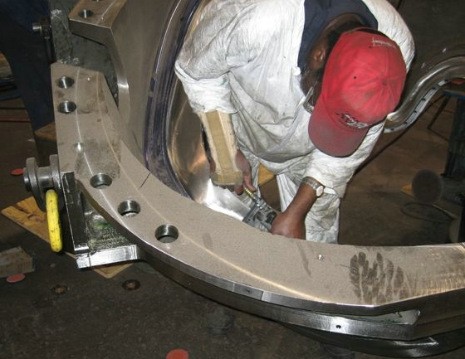

C-3 in final prep

Administrative Highlights

EIO continued discussions with MTM and PPPL to reach a mutual agreement on delivery for the remaining MCWF’s. MTM generated a plan to significantly reduce machining times in order to complete the MCWF’s within PPPL’s programmatic requirements which was submitted to PPPL very late on 2/3. In preparation for taking this revised delivery schedule to DOE, PPPL has been working with EIO and MTM to ensure resolution of their concerns and satisfaction of their needs as we continue to fulfill our obligations.

C-3 has now entered the last phase of production. Since Wednesday when the part was removed from the U5, MTM has been performing handwork and blending to complete the poloidal break and fasteners. Final inspections and tests are commencing over the weekend. Completion of C-3 enabled a seamless transition for C-4 as it moved from the 3 axis to the 5 axis machine. C-5, which was already in position for machining on the 3 axis, is also now ready for the next stage of machining. With A1 set-up on the 40T Lucas, all work stations are in production mode. Jim Flanagan relayed on Friday, that MTM has now started the 24 hours per day– 6-day per week schedule discussed during his visit to Princeton on 1/31/06. This schedule has been implemented on both the 40’ Mitsubishi and the U-5 North center. The 40T Lucas currently remains on a 16 hours per day – 6 days per week schedule.

At the foundry, MTK began making final adjustments to the B pattern this week as they prepare for pouring the last 5 castings. The next casting, B-2, is scheduled to pour on 2/21 for a late April delivery to MTM. Meanwhile, MTK reports that B-1 is on-track for delivery to MTM at the end of February.

On Tuesday, Larry Sutton issued Amendment 9 to EIO contract which includes the signed version of Rev 11 of the spec: NCSX-CSPEC-141-03-11 & the new statement of work; NCSX-SOW-141-02-05. Tom Brown also posted the revised drawings and a new “readme” file. These documents have all been posted to the EIO FTP site, along with numerous QA submissions as outlined below.

FTP Postings this week
(found at: ftp.atc-inc.org:/PPPL/shared_info)
Location | File Name | Date
\Quality-Meeting_notes | PPPLQualityNotes2-6-06_notes.doc | 2/7/06
\Quality_Review\B1_Doc | B-1weldmap2-7-06.pdf | 2/7/06
\Quality_Review\C6_Doc | EIOQAReleasedocC62-03-06.doc | 2/7/06
\Quality_Review\C6_Doc | C6CoilDocpart2.zip | 2/7/06
\Quality_Review\C6_Doc | CSPEC-C-6ShimS-N6.zip | 2/7/06
\Reports_Weekly-Monthly\weekly | 06-02-03_eio_wk.doc | 2/7/06
\Quality_Review\Misc_NCR_CA | Signed_off-CA1538_B1Dimensions_0206.pdf | 2/8/06
\Quality_Review\Misc_NCR_CA | Signed_off-NCR18812.pdf | 2/8/06
\Quality_Review\Misc_NCR_CA | S5242l2-07-06TypeAflanges.pdf | 2/8/06
\Quality_Review\Casting_Scans | A2Scan.pdf | 2/8/06
\SOW_Spec_Drawings | Readme.doc | 2/8/06
\SOW_Spec_Drawings | ECN-5059-r2.pdf | 2/8/06
\SOW_Spec_Drawings | ECN_5045.pdf | 2/8/06
\SOW_Spec_Drawings | ECN_5064-r1.pdf | 2/8/06
\SOW_Spec_Drawings | ECN_5066.pdf | 2/8/06
\SOW_Spec_Drawings | NCSX-CSPEC-141-03-11-Signed.pdf | 2/8/06
\SOW_Spec_Drawings | NCSX-SOW-141-02-05.pdf | 2/8/06
\SOW_Spec_Drawings | production_mcwf_pdf_r7.zip | 2/8/06
\SOW_Spec_Drawings | production_mcwf_step_r7.zip | 2/8/06
**note – file names may be changed from the original for clarity

Administrative Action Items
- (PPPL) List of additional changes desired by PPPL for machining on C-2 and beyond, as covered on 10/13 & 10/14
Status: (Open) EIO submitted our FFP proposal in response to PPPL’s direction, (including a copy of the quote for hardware from South Texas Bolt), on 1/25/07. We were advised this week that PPPL has accepted our proposal. A formal contract amendment is anticipated.

- (EIO, MTK) Revisions to Specification based on agreements at the meeting of 10/13 & 10/14.

Status: (Open) Spec Rev 10 issued to EIO via Amendment No. 8 was formally issued to subtier team members for signature on 11/25 via Amendment #5 to their contracts. Still awaiting signed copy from MTK. Numerous reminders have been sent.

- (PPPL) PPPL has requested an updated delivery schedule which incorporates recent changes to machining processes, including specification changes resulting from the meeting in Indianapolis on 1/4. Due date to PPPL is 1/24/06.

Status: (Open) Plan was shared with PPPL on 1/31/06. Hardcopy of the presentation and supporting back-up data were submitted to PPPL on 2/2 and 2/3. Further updates were provided to PPPL on 2/9 and 2/10 and the matter is currently under review at PPPL.

- (EIO) Submission of the Monthly Report.

Status: (Closed) A version of the report was provided to Ron Strykowsky prior to the meeting on 1/31. Updated report incorporating the latest casting sequence and planned delivery schedule was submitted.

- (EIO) Distribution of Spec Rev 11 & SOW 141-02-05 via amendment to lower tier subcontractors and Execution of Amendment (via signature) back to PPPL.

Status: (New) On 2/7, Princeton released the signed version of Rev 11 of the spec: NCSX-CSPEC-141-03-11 & the new statement of work; NCSX-SOW-141-02-05, via Amendment 9 to EIO subcontract. These will be forwarded for signature to Metal Tek and Major Tool, as Amendment 6 to their subcontracts.

Technical Highlights

At the start of the week, models and drawings for the A type castings had become the hot topic as machining of A-1 commences. On Tuesday, 2/7, Roy Sheppard of EIO and Mike Griffith of MTM, held a telecon with Phil Heitzenroeder & Tom Brown of PPPL. Tom had noticed problems in the tolerancing of the wing area of the A style casting that needed to be addressed. Through concurrent engineering, the team was able to come up with a solution that both addressed Princeton’s concerns and allowed MTM sufficient profile tolerance.

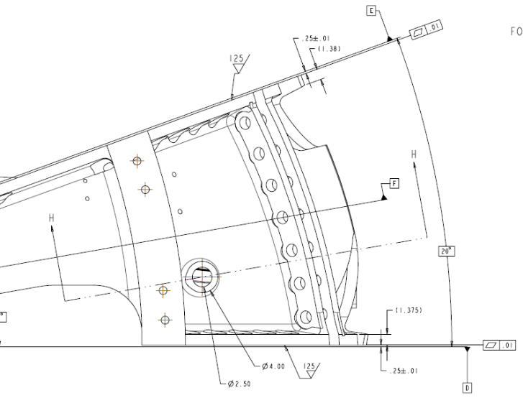
Flange reference dimension (1.38 – 1.375) change

Another telecon was held later that day about a condition found at MTM while getting best fit on the A-1 casting. An area of the outboard flange (A to A mating) was slightly bowed. After machining, MTM felt that certain areas of the flange would be reduced below the reference dimension of 1.38”. Although this was just a reference dimension, Mike Griffith wanted to ascertain the minimum flange thickness Princeton could accept. Mike called Roy Sheppard of EIO, who linked Phil Heitzenroeder, Tom Brown and Dave Williamson into the call. Again, through concurrent engineering, it was determined that PPPL could live with a minimum flange thickness of 1.25”. Mike felt that the tolerance should just be stated as a minimum, not a range and the NCSX team concurred. Rather than making another drawing change now, PPPL will handle this as an RFD. Dave will hold off on changing the drawing until the next round of changes are implemented. Larry Sutton issued a letter confirming this agreement later that evening. A copy of the letter was posted to the FTP site & forwarded to Major Tool.

During this telecon the team also discussed the XYZ inspection point file created by Dave Williamson for the C style MCWF. According to Mike, this file integrated seamlessly with his CMM software. Dave noted that he was virtually done with the A & B point files. MTM will need the file for A-type MCWF by the middle of next week, as they intend to start programming the CMM with the A point data as soon as C-3 comes off the CMM.

To help ensure on time deliveries, the team has been evaluating changes to the processing at all levels of the MCWF. In January, with the help of NCSX, we were able to implement a host of tolerance and specification changes to help reduce machining and inspection time. In a similar vein, MTK is proposing that we eliminate NDT and upgrading in a few specific areas of the MCWF. These areas all exist in the as-cast version of the coil, but are completely machined away at Major Tool. EIO solicited feedback from PPPL and Frank Malinowski’s initial reaction was that this is more a matter for intra-team discussion, as the changes would not affect any of the areas of the final machined MCWF delivered to Princeton. Frank has forwarded this request on to Brad Nelson and Phil Heitzenroeder for their input. Meanwhile, Barry Craig of MTK is proposing to devise a hard template that would exceed the boundaries of the post machining metal by 2”. Anything within the template would receive full inspection and upgrading.
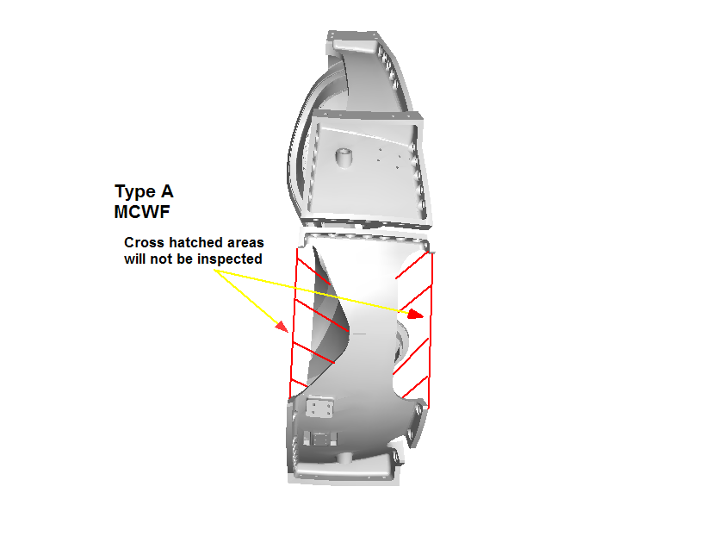
Proposed change to MTK processing

Late Friday Kevin Bowling of Major Tool shared his thoughts on this idea. Kevin notes that he is “... in total agreement with not performing welds that are inside areas to be cut away! …any defects within 2" of the anticipated finished surfaces though should be repaired to make sure that no indications are left in the casting.” Further discussions will be held next week to ensure full team consensus. If agreed, the plan will be formalized.

C-3

C-3 came off the U-5 this week and is now in the final stages of the process. The coil form is being hand worked over the weekend (see photo at the beginning of the report) in preparation for starting the CMM on Monday. After significant effort over the last several weeks, Mike Griffith is now confident that the CMM data will sync seamlessly with Verisurf. The reports generated from the system, should be ready before the end of next week.

C-4

As predicted, C-4 came off the Mitsubishi this week. A small tool gouge was welded (see details under QA highlights) and C-4 is now set up on the U-5. According to Kevin Bowling, the 5-axis machining is now underway.

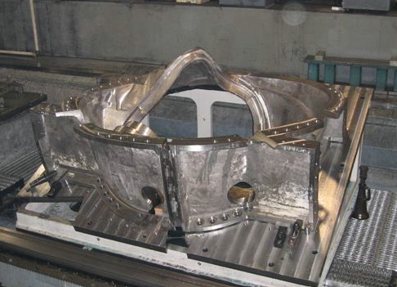

C-4 on the U-5

C-5

Major Tool is finishing the plunge routing of the poloidal break area. Once that is accomplished, a temporary shim will be welded in place and C-5 will be moved onto the fixture. MTM will commence 3-axis machining at that point.

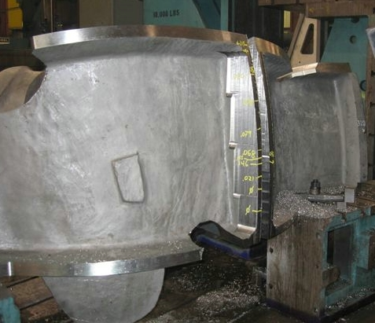
Cutting the break on C-5

A-1
Kevin Bowling reports that the chips are flying on A-1. To date, the new roughing programs for the A-style MCWF are progressing well. Although there is significantly more surface area on A than the other MCWF, MTM feels that these coils should be the easiest to process due to the geometry. Tom Brown posted the new ProE & PDF files for the changes on the MCWF and related parts. MTM is using these files now to create the upper level programs needed for the A coils. These files have also been posted to the EIO FTP site.
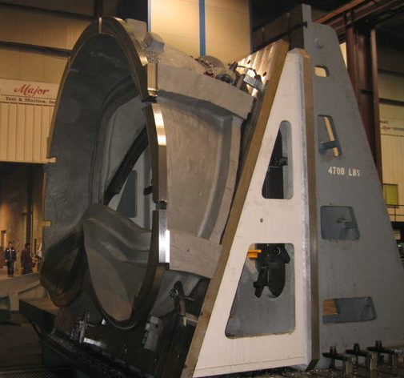
A-1 on the Lucas
C-6

Kevin Bowling reports that C-6 is now safely tucked away at Major Tool.

B-1

Metal Tek has completed the weld repairs on B-1. As the repairs needed for this MCWF were not nearly as extensive as past coils, MTK will be able to do the X-ray validation in house. Barry Craig intends to do this during the weekend. In light of the excellent progress to date, B-1 is on-schedule to ship by the end of this month.

A-4

The initial weld maps for A-4 have been completed and are expected to be passed along to EIO by Monday for review. Metal Tek intends to start welding the coil this weekend. This puts A-4 roughly 1 week ahead of schedule.

A-5
A-5 is at MQS for initial X-ray. The casting is expected back at MTK on 2/15.

A-6
MTK will heat treat A-6 over this weekend. Barry Craig reports that the heat treat furnace has been modified to include an argon gas line into the top of the furnace. Barry expects that this process will help to further minimize the 0² “attacks” to the skin of the casting, reducing the amount of upgrades required. As discussed by Chuck Ruud at the QA meeting on Tuesday, this is 1 of a myriad of small steps taken that have helped to reduce welding on the MCWF castings and improve overall leadtimes.

B-2
Metal Tek has completed the required changes to the B pattern and has started molding the core boxes. The mold will be assembled and ready to go by the end of next week. Barry noted that the issue of the flange being out of place is still being studied. The mold will be carefully measured in this area during assembly. Depending upon the results of the casting produced, Metal Tek may look to do further modifications to the tool prior to pouring B-3. As 1 of the furnaces used in these pours is currently undergoing preventive maintenance (re-grouting & re-lining), B-2 is scheduled to pour on 2/21.

Technical Action Items

- (Major Tool) Machining of C-3
Status: (Open) Completed machining – In hand work
- (Major Tool) Machining of C-4
Status: (Open) Moved to 5-axis
- (Major Tool) Machining of C-5
Status: (Open) Cutting poloidal break
- (Major Tool) Processing C-6
Status: (Open) Casting awaits machining

- (Major Tool) Machining of A-1
Status: (Open) On 40T Lucas
- (Major Tool) Machining A-2
Status: (Open) Next casting in queue for 40T Lucas
- (Major Tool) Processing A-3
Status: (Open) Casting awaits machining

- (Metal Tek) Processing B-1
Status: (Open) In house X-ray this weekend
- (Metal Tek) Processing A-4
Status: (Open) Starting weld upgrade
- (Metal Tek) Processing A-5
Status: (Open) At MQS for X-ray
- (Metal Tek) Processing A-6
Status: (Open) Heat treat this weekend
- (Metal Tek) Molding B-2
Status: (Open) mold complete next week

Quality Highlights
As reported in last week’s QA Highlights, MTM had requested that a file be exported from Metal Tek’s point cloud data to use as an overlay for checking the stock condition on the casting & to help during “best fit” operations. Mike Griffith had requested that MTK try sending the scan for C-5 first, as this is the next casting to start 3-axis machining. Steve Pilgram of MTK exported a file and uploaded this to the FTP site. The file is very large – 451 MB and is currently available intra-team. Roy Sheppard of EIO was able to download the file and open it within Solid View. The file opened slowly but flawlessly.

This week’s QA meeting was attended by Chuck Ruud, Pete Djordjevich, Roy Sheppard and Frank Malinowski. As MTM was not on the call, EIO fielded the questions regarding open issues from the machine shop. Mike Griffith had been unable to complete the C-2 Doc package as there was still 1 NC outstanding and 1 signed NC that was “locked” and could not be incorporated. Both issues have been subsequently resolved

The rest of the meeting concentrated on items pending from PPPL. Most of these are specifically covered in the QA notes below. In general though, it looks like the majority of these were close to fruition and were either resolved this week or will be shortly.

The meeting closed with the topic of weld upgrade reduction. As has been noted in previous reports the amount of major welds needed has greatly decreased from the initial coil forms. Even if C-1 is excluded (as this was an anomaly) there is a definite trend that can be seen. Over the last couple of weeks, EIO has discussed this briefly with PPPL. At the QA meeting, Chuck Ruud highlighted some of the factors that have contributed to the reduction:
- Timing of the melt has improved.
- Argon gas leak problem resolved
- Drying/heating of mold
- Casting now coated prior to HT to reduce 0₂ attacking surface

Chuck stressed that these were only a few of the continuous process improvement changes that MTK has made. As noted in Technical Highlights for A-6, this is an ongoing process that will continue throughout the final coil forms.

Mike Griffith forwarded 2 NC reports to EIO this week. The 1st, NC19209 is for a weld repair for a tool gouge on C-4. Although MTM can (and did) repair this without a NC, they have asked that RT inspection be waived, necessitating disposition by PPPL. Frank Malinowski started this NC through the system on Friday, 2/10. Late Friday evening, Frank forwarded an Email to EIO requesting further information on the final machining of this weld repair and the reason for requesting the RT waiver. This will probably be discussed in the QA meeting on 2/14.

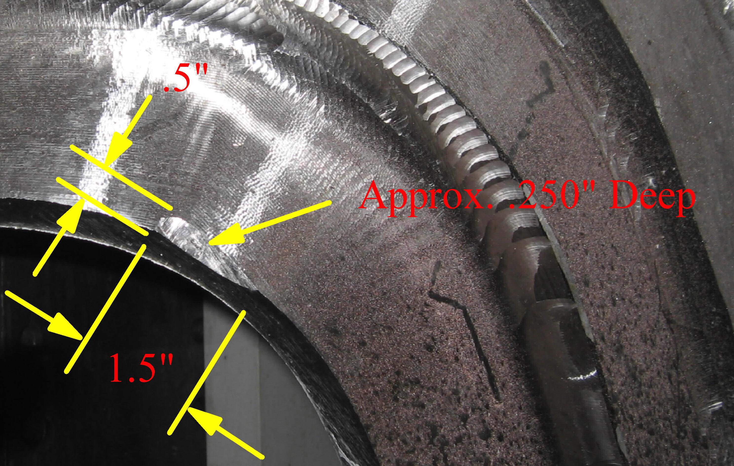
Tool gouge on C-4

The 2nd, NC19215 covered counterbores on the top of the T on C-3, some of which are too deep. This NC is currently under discussion at PPPL. Frank expects both of these to be resolved next week.

Upcoming QA Activities
- Finalizing C-2 doc packages at MTM
- CMM measurement of C-3
- Final QA testing on C-3

QA Action Items
- Closed Items:
  - Revised drawings to incorporate changes shown below resulting from 1/4, 5, & 6 meeting and to incorporate RFD 14-012 changes were posted on 2/8 (see 3.1 below)
  - CA 1538 for thin wall condition on B-1 accepted & signed on 2/8. Posted to FTP (see 3.6 below)
- Pending from EIO:

  - (EIO, MTM) Provide a copy of the updated MTM process outline incorporating recent changes
Status: (Open) Per Kevin Bowling, both the process plan & C-2 Doc package will be submitted Monday, 2/13.

  - (EIO, MTM) Complete corrective action (RT) for dispositioned MTM NC 18776 (C3) addressing rejectable LPI indications found during machining.
Status: (Open) C-3 NC 18776 will remain open until radiograph of ~18” of the adjacent flange region has been accomplished and it is verified that those regions are free of unacceptable indications. NDT expected to be done w/o 2/17.

  - (EIO, MTM) Develop a UT Technique and submit the procedure and procedure qualification for examining the high stress areas of the casting.
Status: (Open) On 2/10 Kevin Bowling confirmed that UT procedure would be complete & submitted by the end of the month.

  - (EIO, MTM) Change requests and Process Outline changes regarding items discussed at 1/4, 5, & 6 meeting.
    - Revised IDC that shows CMM inspection of every other hole on Tee. All holes will still be inspected for cleanliness and thread integrity.
Status: (Open) Due 2/13 per Kevin Bowling
    - Revised IDC that shows hand tool inspection of poloidal break dimensions.
Status: (Open) Due 2/13 per Kevin Bowling
    - Propose port cut-out deviation requests for the Type A & B MCWF’s.
Status: (Open) Per Mike G. – RFD for C port openings has not been completed. Mike does not expect to have any issues at this point with A or B.

- Pending from PPPL

  - Revise drawings to incorporate changes shown below resulting from 1/4, 5, & 6 meeting and to incorporate RFD 14-012 changes.
Status: (Closed) Posted 2/8
  - Disposition final MetalTek CA1323 (provided 1/24) - for erroneous reported chemistry (sulfur and phosphorous values for C-1 through C-4, A-1 & 11 shims, and Manganese on those castings, plus C-5). Note that C-1 & C-2 packages will not be complete until this NCR is closed
Status: (Open) Ready to close-just needs signatures.

  - Disposition MetalTek CA 1537 (provided 1/24) for B-1 Chemistry. Note that CA includes a request to increase allowable Phosphorous levels
Status: (Open) Ready to close-just needs signatures. Phosphorus levels will not be increased

  - Disposition CA 1347 (provided 1/24) which documents the outcome of EIO investigation into the A-1 casting thin wall and actions to ensure wall thickness consistency on subsequent castings. Min wall verification on A-2, A-3
Status: (Open) – Comments passed back from Frank Malinowski to Pete Djordjevich seeking clarification.

  - Disposition CA 1536, addressing Manganese nonconformances (provided 1/24) for A-3, A-4, A-5 & C-6
Status: (Open) Although spec was not changed, these castings are expected to be accepted.

  - Disposition CA 1538 for Thin wall condition on B-1
Status: (Closed) Accepted & signed on 2/8. Posted to FTP
  - Disposition for request to modify RFD 14-013 for drill point at the bottom of counterbore replacement for spherical seats.
Status: (Open) Although this has been verbally agreed to, signed copy of RFD showing modification is requested.
  - Disposition CA 1549 for low Mn on C-6 shim.
Status: (Open) This shim was poured early in the project. It was not processed because all castings needed mechanical properties and cost was inappropriate for single shim. Now with no mechanical test required for shims, shim was recovered and used.
- New Specification & Drawing Changes:
4.1 NCSX-CSPEC-141-03-11 was released and posted
4.2 NCSX-SOW-141-02-05 was released and posted
4.3 New ProE & PDF drawing files were released and posted.

The highlights shared in our weekly report provide a brief glimpse of the many activities and conversations taking place throughout the week. We endeavor to highlight significant accomplishments, summarize important topics of discussion, record agreements reached by team members, and capture items that result in changes and improvements to our processes. We also use the report to notify and remind others of upcoming events and to track open action items through resolution. During our conversations over the past several weeks, the reports have proven to be a useful account of the MCWF production process over the last year. If you have additional ideas about ways to make the report more useful, please let us know.

Nancy Horton

EIO Program Manager for NCSX

