Energy Industries of Ohio (EIO) Team Weekly Status Report

Report covers the NCSX Modular Coil Winding Form Activities Under Production Contract S005242-F

Week ending March 24, 2006

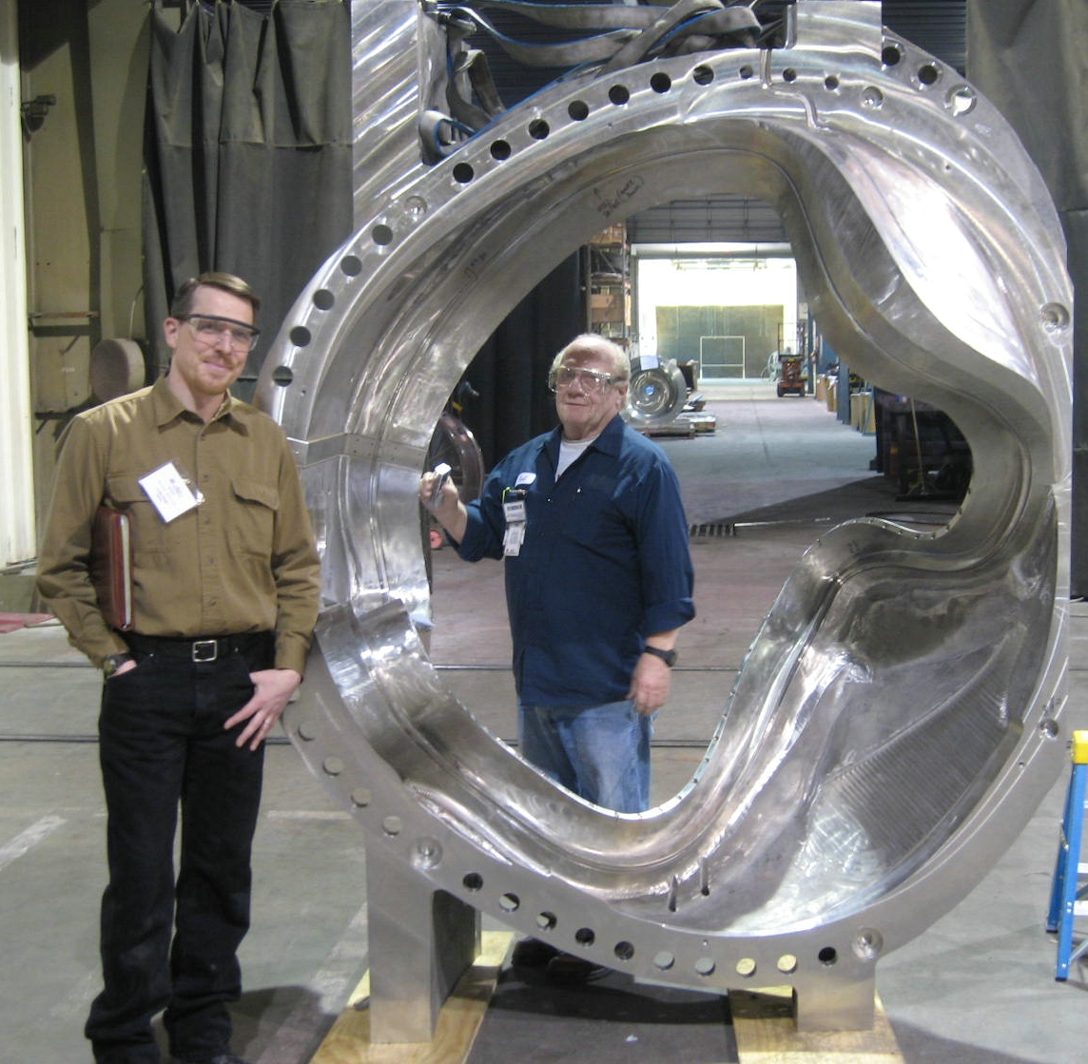
Colin Phelps at MTM

Administrative Highlights

C-4 was formally released for shipment to PPPL, late Friday, 3/24/06, with the mutual agreement that MTM would postpone actual delivery to PPPL until the 29th. This will enable Major Tool to perform some additional, requested grinding over the weekend (see Technical Highlights) followed by a thorough final check prior to loading on the truck, all of which will reduce processing time at PPPL.

Release of the casting came about as a result of administrative efforts of MTM, EIO, PPPL & ORNL throughout this week to finalize the team’s work on this coil form. Trips to MTM by Peter Djordjevich (EIO) on the 20th & 21^{st,} followed by Roy Sheppard (EIO) & Colin Phelp’s (PPPL) on the 22nd & 23rd offered additional perspectives throughout the inspection process, while facilitating resolution of last minute issues. Numerous telecons up through late Friday ensured that all stakeholders were involved in the analysis and decision process.

One issue that is being addressed is the bearing plates. On 3/20, Larry Sutton issued a change order to EIO’s contract directing the team to cast bearing plates from Stellaloy. This will eliminate the permeability problem that persists. MTK and MTM have been tasked by EIO to address the change and provide associated impact to EIO. By Friday, we learned that Barry Craig of Metal Tek had issued in-house direction to place material orders and commence patterns. Meanwhile, per direction MTM assembled C-4 with the existing plates.

FTP Postings this week
(found at: ftp.atc-inc.org:/PPPL/shared_info)
Location | File Name | Date
\Quality_Review\A5_Doc | A-5WeldMap3-18-06.pdf | 3/22/06
\Quality_Review | 3-20-06TypeAchange-thermocple.pdf | 3/22/06
\Quality_Review\A6_Doc | A-6Coilweldmap3-23-06.pdf | 3/24/06
\Quality_Review\A6_Doc | A-6Coilweldmap3-24-06.pdf | 3/24/06
\Quality_Review\C4_Doc\MTM-notes | ProfileofInsideWingDside.xls | 3/24/06
\Quality_Review\C4_Doc\MTM-notes | 65707-4Edatumup.zip | 3/24/06
\Quality_Review\C4_Doc\MTM-notes | HolePositionsinFeet.zip | 3/24/06
\Quality_Review\C4_Doc\MTM-notes | ProfileofMItoNI.zip | 3/24/06
\Quality_Review\C4_Doc\MTM-notes | NC19455-PT_rej.zip | 3/24/06
\Quality_Review\C4_Doc\MTM-notes | NC19475Photos.zip | 3/24/06
\Reports_Weekly-Monthly\Weekly | PPPLQualityNotes3-20-06.doc | 3/26/06
\Quality_Review\C4_Doc | C-4_shipping_release.pdf | 3/26/06
\Quality_Review\C4_Doc\MTM-notes | NC19321_C4_signed.zip | 3/26/06
\Quality_Review\C4_Doc\MTM-notes | NC19483_IDC_C4.zip | 3/26/06
\Quality_Review | RFD-14-015_Type_C_Ports.pdf | 3/26/06
\Quality_Review | C-coil_pattern.doc | 3/26/06
\Quality_Review | CA032206-1PC5_Flange_Thickness_leg.doc | 3/26/06
**note – file names may be changed from the original for clarity

Administrative Action Items
- (EIO, MTM, MTK) List of additional changes desired by PPPL for machining on C-2 and beyond, as covered on 10/13 & 10/14
Status: (Open) EIO returned our signed amendment 11 to PPPL on 3/14/06. Since that time, the use of bearing plates, included as part of this amendment has resurfaced, as none of the acquired plates meet PPPL permeability requirements. EIO sought input from MTK to determine if the plates could be cast cost effectively from Stellaloy and after receiving confirmation from MTK and MTM that this approach was feasible, and conducting a cost comparison with the alternatives, PPPL concurred with this approach. Larry Sutton issued Change Order 1 directing commencement of activities to cast the plates. Assessment of the formal price impact is currently in process and will be submitted to PPPL when complete.
- (EIO) PPPL has requested an updated delivery schedule which incorporates recent changes to machining processes, including specification changes resulting from the meeting in Indianapolis on 1/4. Due date to PPPL is 1/24/06.

Status: (Open) On 3/21, Larry Sutton issued amendment 12 to EIO contract. EIO is currently processing the subtier agreement with MTM.

- (PPPL) Distribution of Spec Rev 11 & SOW 141-02-05 via amendment to lower tier subcontractors and Execution of Amendment (via signature) back to PPPL.

Status: (Open) On 2/7, Princeton released the signed version of Rev 11 of the spec: NCSX-CSPEC-141-03-11 & the new statement of work; NCSX-SOW-141-02-05, via Amendment 9 to EIO subcontract. EIO received MTK signed amendment this week and has signed and returned our amendment to PPPL.

- (EIO, MTK, Lawton, MTM, PPPL) Pattern Storage after six castings have been delivered to MTM.

Status: (Open) Resequencing of machining the C coils means that the C pattern will need to be stored for an extended period. Lawton does not recommend outdoor storage. PPPL has identified a suitable location in their motor generator building. We were advised late 3/17 that Larry Sutton will be forwarding the necessary paperwork instructing the team to ship the pattern to PPPL for storage. Early this week, PPPL, requested additional info from the team regarding the size needed for pattern storage. Barry Craig had a word document created that graphically depicts each of the core boxes & patterns along with the size. This has been posted to the FTP site for PPPL review.

Technical Highlights

C-4

CMM inspection commenced on Monday, as planned; however, an equipment malfunction required MTM to devote almost 3 shifts to troubleshooting. Despite the disruption, MTM managed to keep the part moving through the process, with all CMM data submitted to PPPL for review by early Friday morning. A telecon at 9:00am with MTM, EIO, PPPL & ORNL on 3/24 provided Mike Griffith of MTM an opportunity to review the data, along with the PT and RT results, enabling PPPL to better focus their analysis. One area immediately identified by PPPL as problematic was the lack of the chamfer on the wing of C-4. Somehow the revision, which was incorporated under an earlier version of the specification had been overlooked on this part. PPPL directed EIO/MTM to correct prior to shipment and that action was immediately taken.

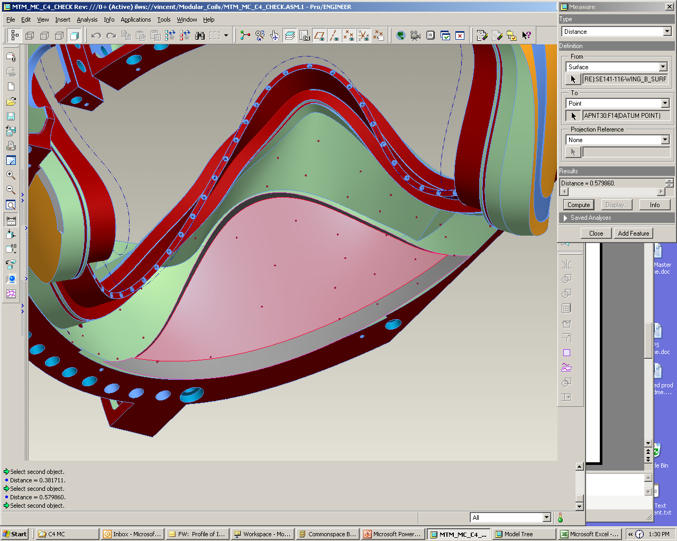
Distance to interfacing surface
+.073”
+.146”
+.110”
+.604”
+.571”
+.337”
+.110”
+.171
+.283
+.323
+.240
+.382
+.580
+.357
The area enclosed will need to be ground as it is too close to the nominal mating wing surface and even closer to the final machined surface shown in previous view graph.
We need to grind this area so there is ~ .25” to .30” of clearance to nominal mating surface.

Meanwhile, most other areas of non-conformance were considered minor and acceptable “as-is” with one exception. Tom Brown’s study of the IGES data showed the area of concern highlighted above. Tom was concerned with the clearance needed during assembly of the coils. MTM had ground the bottom half of this surface (as had been done on C-2 & C-3) to help with interference issues. The circled area however remained as cast. A late telecon ensued Friday, to determine if this would be done at PPPL or whether MTM would be tasked to complete this effort. For expediency, Mike Griffith of MTM agreed to undertake this effort at MTM at their expense and with that concession, PPPL agreed to release the part while grinding of C-4 continued over the weekend, with intent to go through a final visual inspection on Monday, 3/27 prior to actual shipment.

C-5
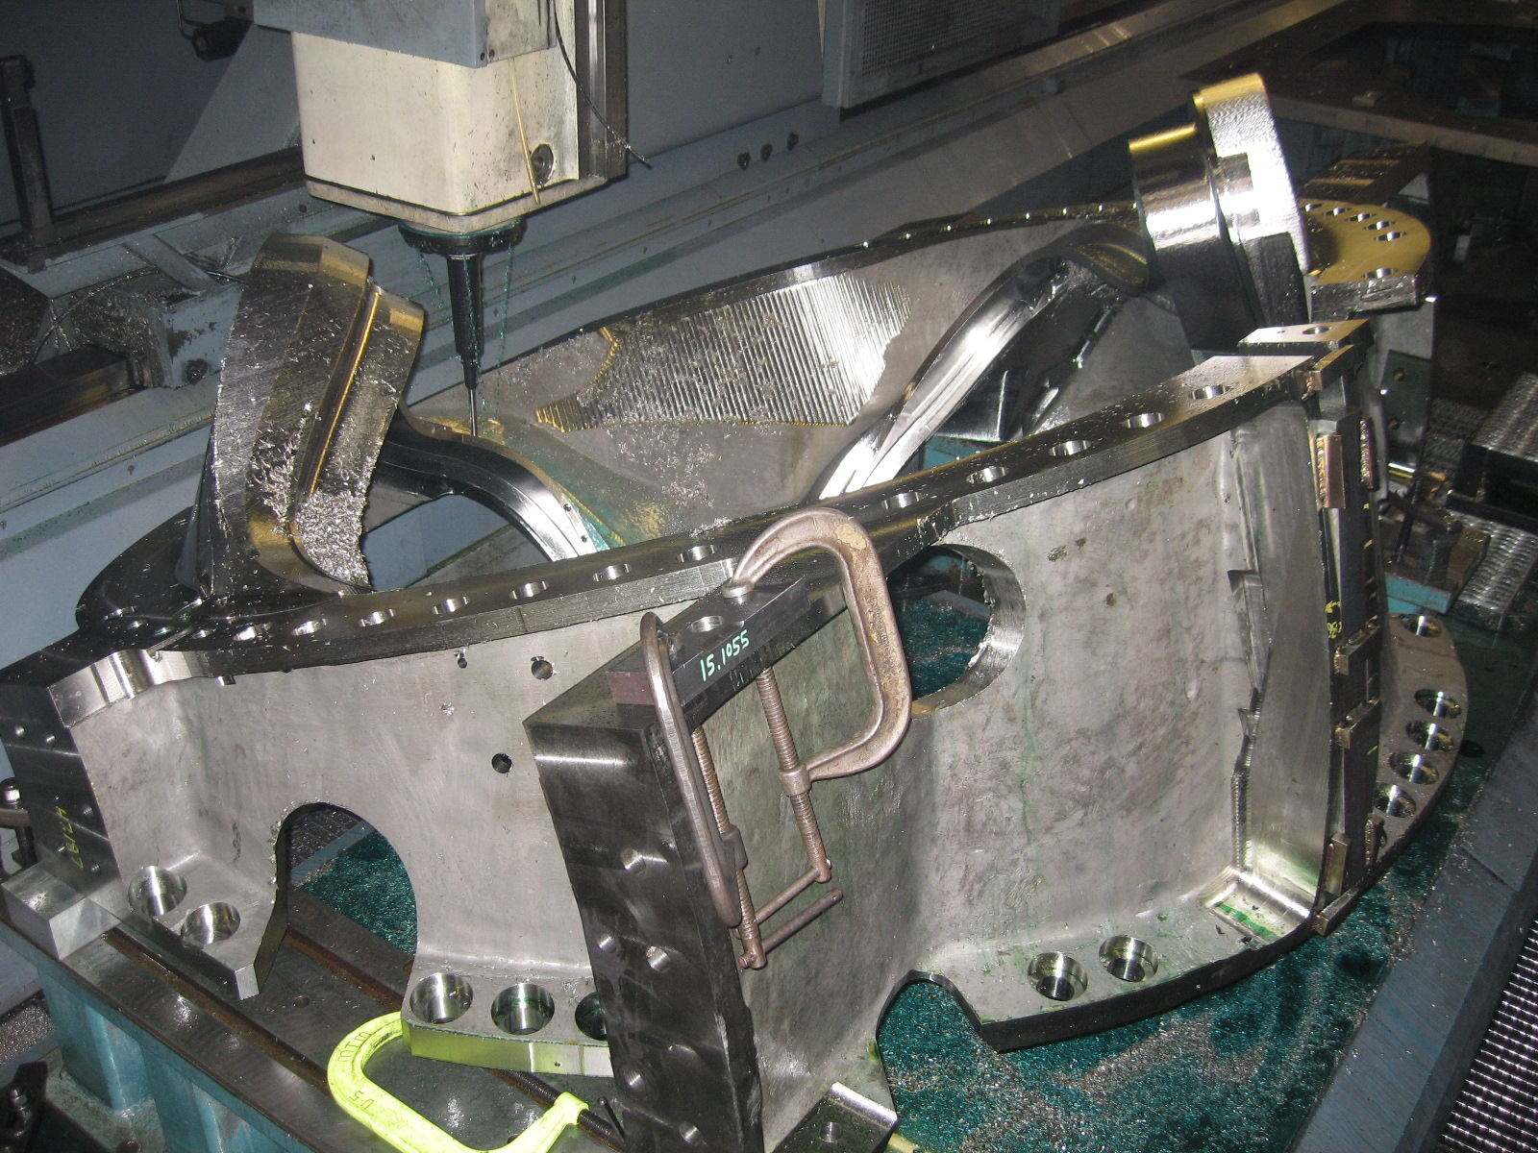
C5 on U-5
C-5 went onto the 3rd operation (of 5) on Wednesday, this week. Mike Griffith expects to start the 4th operation by the middle of next week.

A-1
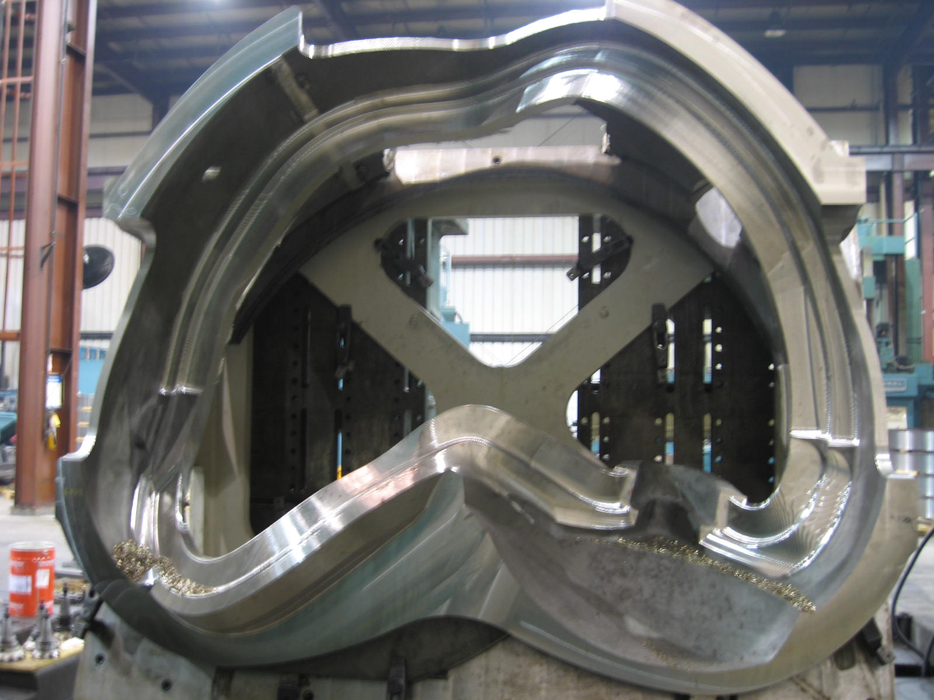
A-1 on the Mitsu
A-1 is progressing very well in 3-axis operation. For the most part, the lessons learned on the C castings have transferred over onto the A style coils. Some cutter paths have needed to be refined for A type MCWF’s. Mike Griffith feels though that this optimization will translate into even better cut rates on A-2.

A-3 & A-4

A-3 & A-4 are continuing along the successful route started with the first set of A castings. A-3 finished the 1st op on the Lucas & was taken off the frame. A-4 (freshly arrived last week from MTK) was then set up on the fixture & the 1st op is now being ‘rerun’ on this coil. MTM plans on repeating this sequence next week to start the 2nd roughing op on the Lucas.

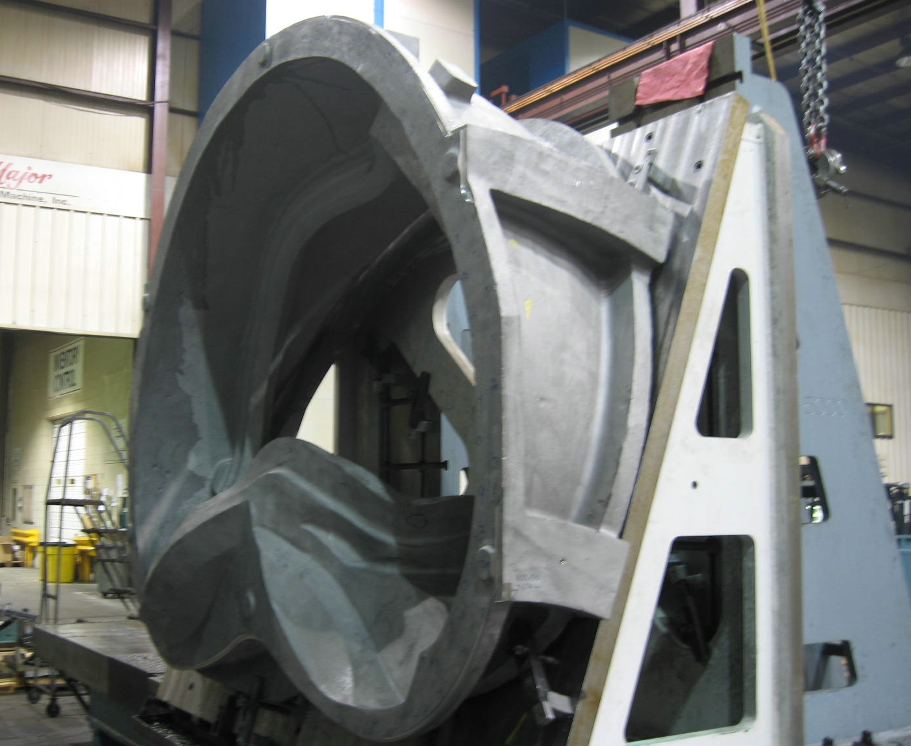

A-4 on the Lucas

A-5

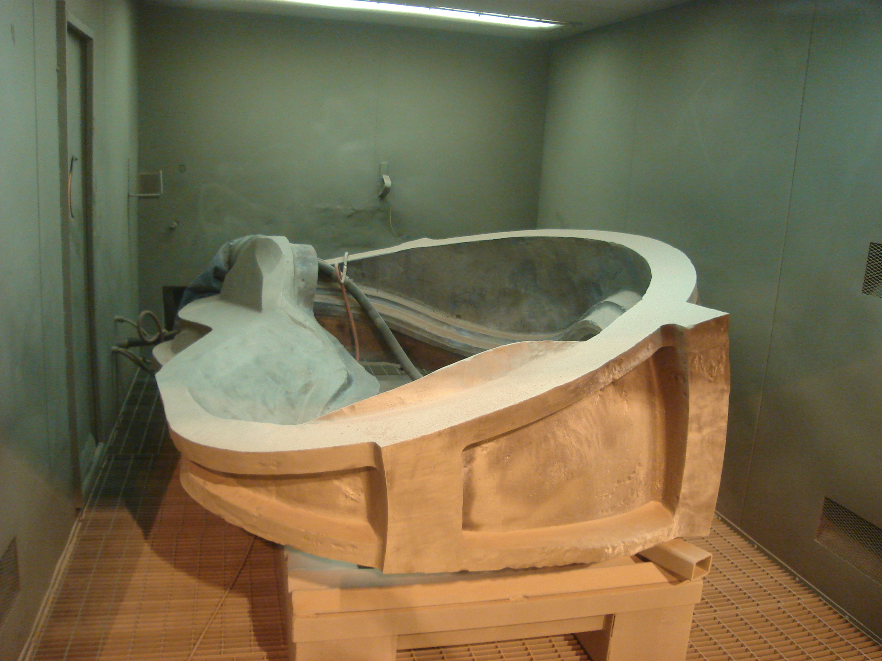
A-5 – ready for final inspection

Metal Tek was unable to schedule DCMA for final LPI review prior to 2/27 (a.m.). Pending a successful test (and EIO release), A-5 is otherwise ready to ship to MTM. PPPL was advised of this change in plans on 3/24.

A-6

As planned, Barry Craig started excavation on A-6 last weekend. The 1st side of A-6 has been successfully mapped and the coil is now in weld upgrading.
B-2

B-2 remains at MQS for preliminary RT. As of 3/24, the casting is scheduled to be finished by noon on 3/28. Barry Craig has arranged for B-2 to be shipped back immediately, straight through to MTK.
B-3

Metal Tek finished arc removal of the gates, pads and risers on B-3 on 3/24. The casting is now in grinding in preparation for initial RT

B-4

Although MTK had considered pouring B-4 ahead of schedule (Friday evening pours offer several in-house benefits), they decided this week to move the pour back to the originally scheduled date of 3/28, to accommodate the staff. The mold will be closed on Monday 3/27 and have the heater inserted in preparation of pouring late Tuesday night. A “heads-up” regarding this change was given to PPPL on Friday 3/24.

Technical Action Items

- (Major Tool) Machining of C-4
Status: (Open) Prepping to ship
- (Major Tool) Machining of C-5
Status: (Open) On U-5
- (Major Tool) Processing C-6
Status: (Open) On-hold

- (Major Tool) Machining of A-1
Status: (Open) On 40’ Mitsubishi
- (Major Tool) Machining A-2
Status: (Open) On deck for Mitsubishi
- (Major Tool) Machining A-3
Status: (Open) Finished 1st op Lucas

- (Major Tool) Processing B-1
Status: (Open) On deck for Lucas
- (Major Tool) Machining A-4
Status: (Open) Machining on Lucas
- (Metal Tek) Processing A-5
Status: (Open) Final LPI today
- (Metal Tek) Processing A-6
Status: (Open) In welding
- (Metal Tek) Processing B-2
Status: (Open) At MQS for initial RT
- (Metal Tek) Processing B-3
Status: (Open) Finishing arc removal
- (Metal Tek) Molding B-4
Status: (Open) Closing mold 3/27

Quality Highlights

QA activities this week centered mostly around Major Tool & specifically around the C-4 coil. The week started with EIO’s Pete Djordjevich’s trip into MTM. As mentioned last week, Pete was able to concentrate on general inspection procedures at the shop as well as inspect all of the work in process & in the queue. Part of this inspection, along with a joint telecon between MTM & MTK, helped yield the disposition put forth this week on the thin flange evidenced on C-5 (see 2.9 below). Pete’s investigation found that this same circumstance was evident in C-4 and would probably repeat in C-6 (not yet machined). Pete found that although the raw casting stock seems to be sufficient, typical variances in casting dimensions require best fit setup which detracts from flange thickness. EIO has posted internal CA-032206-1P.

The weekly QA meeting was held as usual on Tuesday, 3/21, with Peter Djordjevich participating from Major Tool. The team has made significant progress reducing open action items and overall turnaround time for most actions has improved dramatically since this process was initiated almost a year ago. Frank Malinowski does an outstanding job of conducting an extremely efficient meeting, providing a predictable forum for resolution of questions, while ensuring adequate spotlight on unfinished business.

As previously highlighted, Colin Phelps (PPPL) & Roy Sheppard (EIO) were at MTM on 3/22 & 3/23 with the specific intent to go review the final inspection of C-4. The coil form was just finishing up CMM inspection. Although that data was not available for review late Thursday afternoon (3/23), Colin availed himself of the opportunity to closely inspect all aspects of the casting which would affect winding operations at the lab. Areas that could be blended out were identified as well as any NC’s needing to be dispositioned. Mike Griffith, working with Colin and Roy, generated a list of these cosmetic items (NC-19475) which was forwarded to EIO/PPPL on 3/23 for disposition.

During their inspections, Colin & Roy checked the permeability of "rust spots" on C-4 located on as cast surfaces (see 2.7.4). PPPL had noted a problem on C-3 with high permeability in such areas. Our inspection on C-4 found a similar problem. Some of these areas read > 1.1 - The areas of concern were marked up & MTM plans on doing a quick surface grind to remove prior shipment.

While on locations, the parties took the opportunity to evaluate other castings in process for this problem. A subsequent examination of B-1, recently received by MTM, found similar results. Although there was no rust, there were several large scrapes. These scrapes all tested above 1.1 - Upon closer examination, Colin & Roy found slivers of metal embedded into the surface of the casting. These were easily dislodged with just a fingernail. The slivers were all highly magnetic. MTM has marked up these areas & will remove the contamination. Both MTM and MTK were made aware of this problem, which seems to occur sometime during handling after permeability is checked at the foundry. Further root cause analysis will continue with the goal of reducing or eliminating the problem. Until then, MTM will address these spots prior to shipment.

Mike Griffith started sending in the CMM scans for review on 3/23. These scans show that C-4 is geometrically, the “best” casting shipped to date. The low deviation shown on the cast scan for this coil form from Metal Tek, continued through the machined casting.

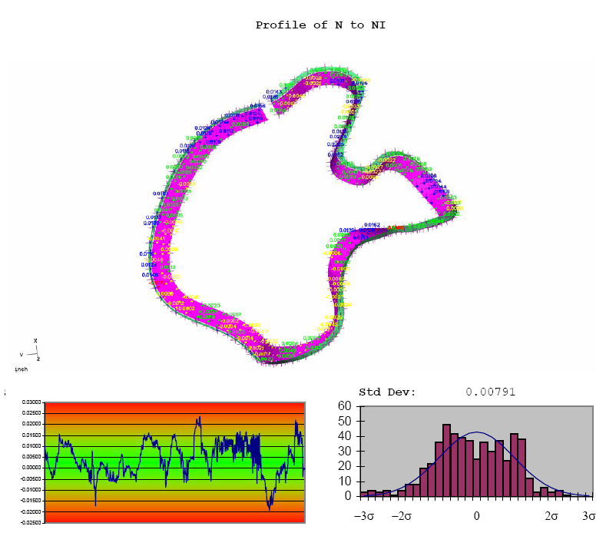
Slide from C-4 Verisurf report

As set forth under Administrative and Technical Highlights, the team held a telecon on Friday morning to discuss the scan data, the results of the PT & RT and the resulting NC’s. Of particular concern were areas on the casting which might still require upgrading prior to winding and assembly. Tom Brown (PPPL) was tasked with analyzing the data provided. He shared the initial results of his review later that afternoon, which highlighted several areas of potential interference in the wing areas during assembly. While these are not necessarily areas of non-conformance, they are still areas that must be addressed by PPPL. MTM agreed to complete the tasks at their facility prior to shipment, which will save considerable time and expense at PPPL when the casting is received.

Upcoming QA Activities
- Scan results from A-5
- Final LPI A-5
- Scanning B-2
- C-3 Doc package (MTM)

QA Action Items

- Closed Items:

  - NC19209 was updated with documentation of post-weld inspections and is now closed.
  - Closed and dispositioned NC19269 for LPI indications found on C-3 was transmitted to EIO.
  - CA-032206-1P for flange thickness of C-5 (see 2.9 below).
  - RFD for C style ports (see 3.1)
  - NC-19321 for tool gouge on C-4 (see 3.2)
  - NC 19233 & 19234 for bearing plate permeability (see 3.4)
  - CA 1538 for B-1 Thin wall condition (see 3.5)
  - Type A MCWF thermocouple hole placement (see 3.9) sent by PPPL – now action item for MTM to provide marked up drawing (see 2.10)

- Pending from EIO:

  - (EIO, MTM) Develop a UT Technique and submit the procedure and procedure qualification for examining the high stress areas of the casting.
Status: (Open) Attempts at UT on Stellalloy have to proven out to date. MTM tried straight & angled beam using various transducers on a test block with non-repeatable results. On 3/23, MTM tried straight beam UT on a known RT flaw on C-4. These results were also non conclusive. This approach may be abandoned.

  - (EIO) Provide final documentation packages for completed MCWF’s.
    - C-3 (includes RT film)
Status: (Open) –Films already provided. MTM needs dispositioned NC 19314 for dimensional discrepancies.

  - (EIO, MTK) Initiate RFD for casting areas where it is proposed to not inspect and not repair.
Status: (Open) Initial approach discussed 2/16. Update expected by 2/22. This has been delayed as making the template is more complicated than expected.

  - (EIO, MTM) Update NC 18607 to show that corrective action has been accomplished
Status (Open) To be included in MTM portion of C-3 doc package. The documentation of corrective action will clearly be tied to the NC – either on that form or separate document with references.

  - (EIO, MTM) Update NC 18654 to show that corrective action has been accomplished
Status (Open) To be included in MTM portion of C-3 doc package. The documentation of corrective action will clearly be tied to the NC – either on that form or separate document with references.

  - (EIO, MTK) Update CA 1625 (A-1 linear indication) after machining.
Status (Open) MTM to document condition after machining for MTK evaluation. MTM reports that another 0.050 inches needs to be removed. Will take about another 1.5 weeks

  - (EIO, MTM) Address actions to prevent recurrence of issues (listed below—not all may need specific actions) discussed in 3/7/06 C-3 Results from Visual Inspection teleconference.

    - Modify CMM inspection to include poloidal break (to detect shifts such as seen on C-3). MTM added points, but did not change the wording of the process sheets.
    - Better identify surface divots – especially those on tee edges.
    - Remove steel bushings.
    - Watch for rust indications –possible permeability issues. MTM notes that they checked the permeability for rust stains on the type A and B the castings which are in storage at MTM and could not duplicate high permeability results. Subsequent checks by EIO & PPPL showed areas on C-4 & B-1 with high permeability – seems to be related to handling.
    - Assure cooling line holes are clear
    - Verify 2” clearance on flange holes. 2”H x 3” dia. gage will not fit in most holes. MTM checked again with a tapered gage based on the washer. 2 7/8” dia. at bottom for ½” then expands to 3” dia. for another 1 ½”- The gage centered on hole. Most holes now pass. The balance will be remediated MTM notes that this took a fair amount of grinding on C-4. – NOTE all holes on C-4 were checked by PPPL on 3/22 at MTM

Status (Open) new

  - (EIO, MTK) Notify PPPL about when additional test coupons will be shipped. EIO to investigate.
Status (Open) Due to ship by 3/24.

  - (EIO, MTM) Provide NCR for C-5 flange thickness concern raised by MTM in the 3/7 teleconference. Flange may be shifted so “best fit” makes flange too thin when there‘s actually enough cast thickness.
Status (Closed) CA submitted by EIO – posted for review.

  - (EIO, MTM) Type A MCWF thermocouple hole placement – general placement agreed to by PPPL – MTM to mark up drawing
Status (New) added 3/23

- Pending from PPPL

  - Process EIO’s proposed RFD for C-Type MCWF port cut-out deviation received 2/17.
Status: (Closed) Submitted to EIO

  - Disposition NC19321 with weld repair approach, including waiving RT, for gouge on C-4. Note: MTM confirmed that the CMM will get at least 4 points, so profile will be assured.
Status: (Closed) Submitted to EIO

  - Provide CSPEC update addressing revised poloidal break inspection/tolerances. Poloidal break flange fit-up, 0.005” through and 0.015” at edges – edge defined as no more that 1/8” penetration.
Status: (Open) Rapid response guidance sent 3/16. Wording for next CSPEC revision is in process.

  - Process EIO’s NC 19233 & 19234 for bearing plate permeability
Status: (Closed) Submitted to EIO – New bearing plates to be made from Stellalloy

  - Evaluate revised document of corrective actions for MetalTek CA 1538 for B-1 Thin wall condition. Actions include adding stock to Core Box #9, weld repair of the thin flange area, and further evaluation/possible action regarding wing interference areas.
Status: (Closed) Submitted to EIO

  - Process NC 19314 for C-3 dimensional deviations.
Status: (Open) ORNL says all are acceptable – PPPL to disposition and process by 3/24

  - PPPL approval of final C-1 documentation package is needed.
Status: (Open) due from PPPL by 3/23

  - Review submitted final C-2 documentation package. Films were sent with C-3 films.
Status: (Open) – target date: 3/29.

  - PPPL to provide guidance on Type A MCWF thermocouple hole placement.
Status: (Closed) – Rapid response guidance drafted and sent on 3/20. Updated on 3/22- MTM to implement & send drawing.

- New Specification & Drawing Changes:
- MCWF Inspection Point change- MTM requested a different reference system and pointed out that PPPL did not specify all points. PPPL will post by Wednesday 3/22. As of 3/26, the paperwork was not received at EIO. This item is now considered “HOT.”

Nancy Horton

EIO Program Manager for NCSX

