Energy Industries of Ohio (EIO) Team Weekly Status Report

Report covers the NCSX Modular Coil Winding Form Activities Under Production Contract S005242-F

Week ending April 21, 2006

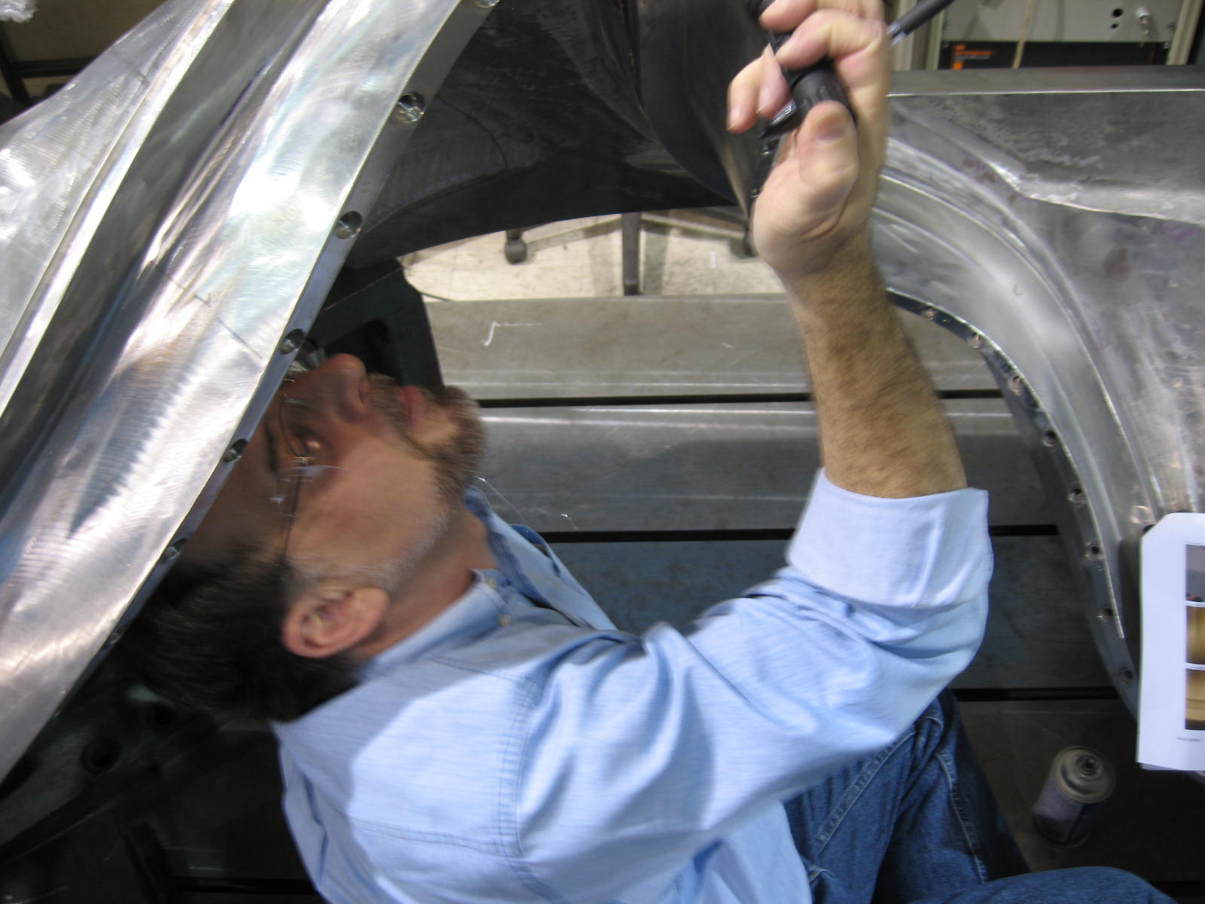

Frank Malinowski at MTM this week

Administrative Highlights

On Friday, 4/21, A-6 was released for shipment from MTK to MTM. This is the 13th casting completed by the foundry. The EIO team is also nearing shipping milestones for B-2 (final processing steps underway at MTK) and C-5, which is in final review for delivery to PPPL. During the final stages of processing and inspection, the need for timely interaction, discussion and documentation is generally most intense. With A-1 also entering its final stage of machining, the team has been extremely busy.

Roy Sheppard of EIO joined Frank Malinowski and Wayne Reiersen of PPPL at Major Tool this week to participate in the final review of C-5. While at the facility, they had the opportunity to investigate the magnetic permeability mystery, as well address and resolve several new dilemmas in real time (see Technical and QA Highlights). More discussion on both topics are already planned for next week.

FTP Postings this week
(found at: ftp.atc-inc.org:/PPPL/shared_info)
Location | File Name | Date
\Reports_Weekly-Monthly\Weekly | 06-04-14_eio_wk.doc | 4/16/06
\Quality_Review\Open_NCR-CA-RFD | CA1671_A6-testbar-4-17-06.zip | 4/17/06
\Quality_Review\A6_Doc | pelim_doc-A-6-MTK.zip | 4/21/06
\Quality_Review\A6_Doc | A-6coilshimSN6docs4-20-06.zip | 4/21/06
\Quality_Review\Casting_Scan | A6_casting_scan.pdf | 4/21/06
\Quality_Review\Open_NCR-CA-RFD | CA_1671_A-6-tensile-4-20-06.pdf | 4/21/06
\Quality_Review\Open_NCR-CA-RFD | ProposedchangestoA1.885holes.doc | 4/21/06
\Quality_Review\Closed_NCR-CA-RFD\RFD | S5242l4-20-06RpdRespHoleonA1.pdf | 4/21/06
\Quality_Review\C5_Doc | dispositonsforC5_LPI_indications.xls | 4/21/06
\Quality_Review\B2_Doc | B-2WeldMap4-19-06.pdf | 4/21/06
\Quality-Meeting_notes | PPPLQualityNotes4-17-06.doc | 4/21/06
\Quality_Review\C3_Doc | RT-MAP_HIGH_STRESS_REGION-C3.zip | 4/21/06
\Quality_Review | MCWFTypeA-NewlocationforTC1thermocouple.pdf | 4/21/06
\Quality_Review\Closed_NCR-CA-RFD\CA | Signed_off_CA032206-1P-C5.zip | 4/21/06
**note – file names may be changed from the original for clarity

Administrative Action Items
- (EIO, MTM, MTK) List of additional changes desired by PPPL for machining on C-2 and beyond, as covered on 10/13 & 10/14
Status: (Open) EIO returned our signed amendment 11 to PPPL on 3/14/06. Since that time, the use of bearing plates, included as part of this amendment has resurfaced, as none of the acquired plates meet PPPL permeability requirements. Under the direction of Change Order 1, MTK is casting the bearing plates for MTM. Previously procured/rejected plates will be shipped to PPPL when new plates are available. Amendment 13, definitizing this change, was issued to EIO on 4/19/06. EIO issued subtier contract amendments to MTK and MTM on 4/20. When signed subtier agreements are returned, EIO will sign and return amendment 13 to PPPL.

- (PPPL) PPPL has requested an updated delivery schedule which incorporates recent changes to machining processes, including specification changes resulting from the meeting in Indianapolis on 1/4. Due date to PPPL is 1/24/06.

Status: (Open) On 3/21, Larry Sutton issued amendment 12 to EIO contract. On Wednesday, 4/19, EIO was advised of an administrative glitch at PPPL which required EIO to re-sign and Fed Ex the amendment to PPPL for proper processing. EIO complied with the request.
- (PPPL) Pattern Storage after six castings have been delivered to MTM.

Status: (Open - No update) Resequencing of machining the C coils means that the C pattern will need to be stored for an extended period and outdoor storage is not an option. PPPL has identified a suitable indoor location in their motor generator building and is processing the necessary paperwork to direct the EIO team. Meanwhile, the “A” and around the end of April, the “B” patterns will also be ready for storage.

Technical Highlights

C-5
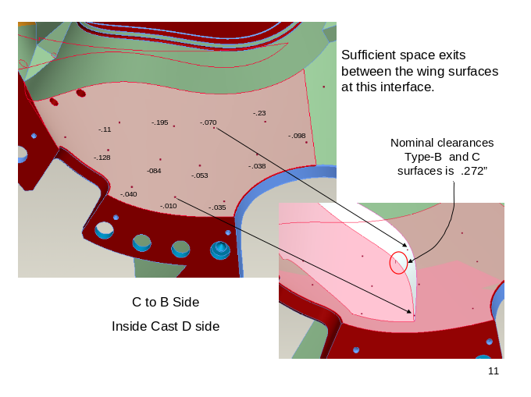
Slide from PPT of C-5 – T. Brown
Although C-5 completed all inspections by 4/21, the initial review of the CMM data at MTM raised questions. Wayne Reiersen & Frank Malinowski had a chance to preview the data on Thursday afternoon. While the flange and wing data looked excellent, the true position of the race track appeared to vary more than previously delivered MCWF’s. IGES data was sent to Tom Brown for evaluation. Although the thickness of the T was consistent throughout, deviations from nominal position had been found ranging +/- .040”. This topic dominated the Friday a.m. EIO/MTM telecon. In a subsequent call between EIO & PPPL, an inter-team meeting was set for 1:00 p.m. During the course of this meeting, NCSX discussed the problems with winding that would be experienced with this tolerance shift. Possible remediation was discussed, which included the potential of MTM machining or grinding off the areas that were +.040”. During the meeting, Steve Raftopoulos postulated that the raw data being evaluated could be improved by running “best fit” analysis using the track points. The team decided that the best course was to rerun the data to best fit (1) using all track points & (2) using just the points on the long side of the track. Afterwards, MTM will pick the set that looks best and re-output the data. This exercise will be run over the weekend and should be complete late on 4/24. The discussion will reconvene on 4/25 as part of the morning QA meeting.
A-1
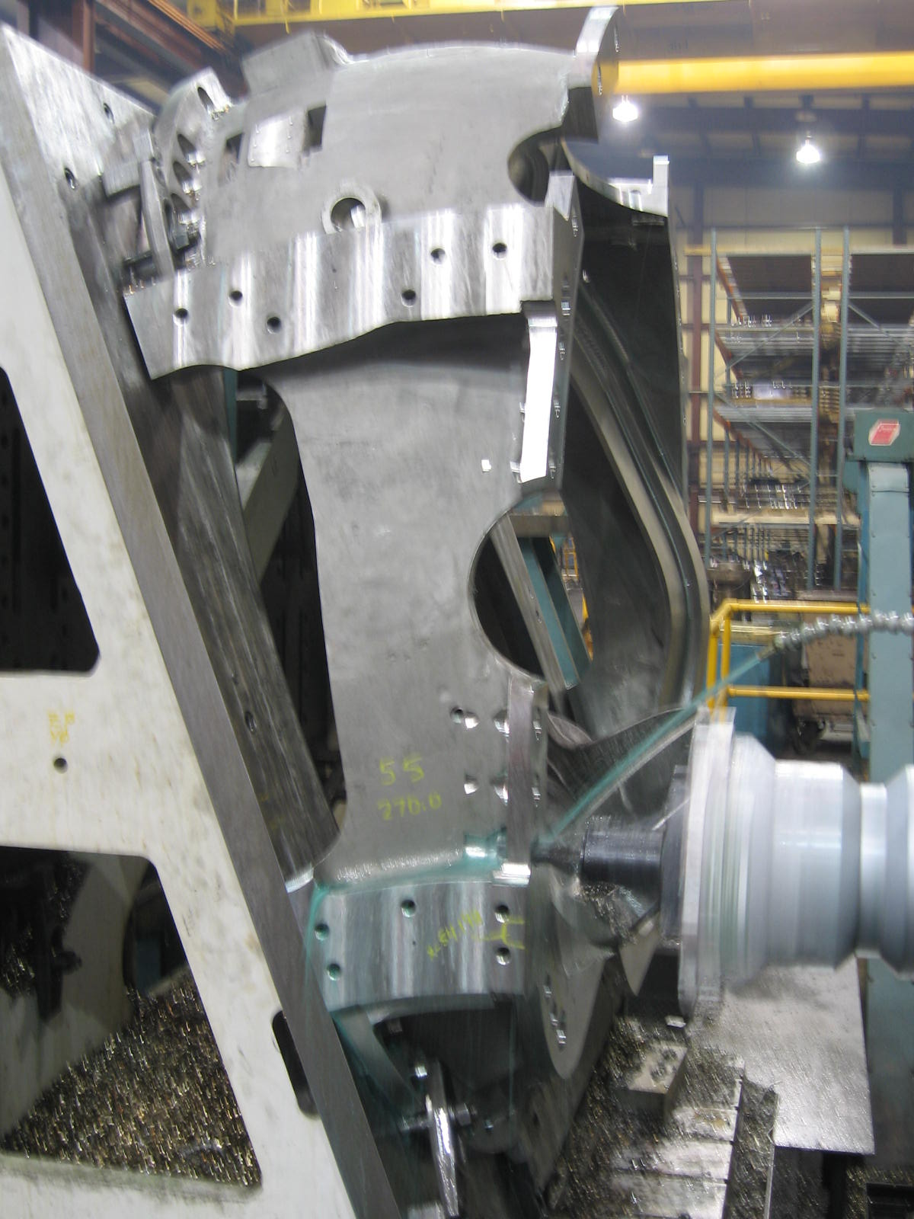
A-1 on final ops

The final operations were winding up on 3-axis machining of the A-1 coil form. The casting is expected to finish up machining over the weekend and be moved onto the U-5 by Monday. During the week, several rapid response meetings were held on 2 counterbores with significant cast interference (discussed in last week’s QA highlights). Initially, MTM sought permission to weld these holes shut sufficiently to drill & tap with a 1 ⅜” tapped hole. Although PPPL agreed to the change on 4/20, an MTM “brainstorming” meeting determined that this “fix” would take significantly longer than originally estimated. Instead, MTM plans on tapping the hole at its current size. Two special Stellalloy plugs will be fabricated that can be screwed into the holes. These plugs will each be tapped with 1 ⅜” holes. A separate RFD was prepared this week dealing with a change to tapped holes on a majority of the flange holes for the remaining A castings. This RFD is discussed under QA highlights below.

A-2

A-2 will be moved onto the 40’ Mitsubishi as soon as A-1 comes off the machine.

C-6

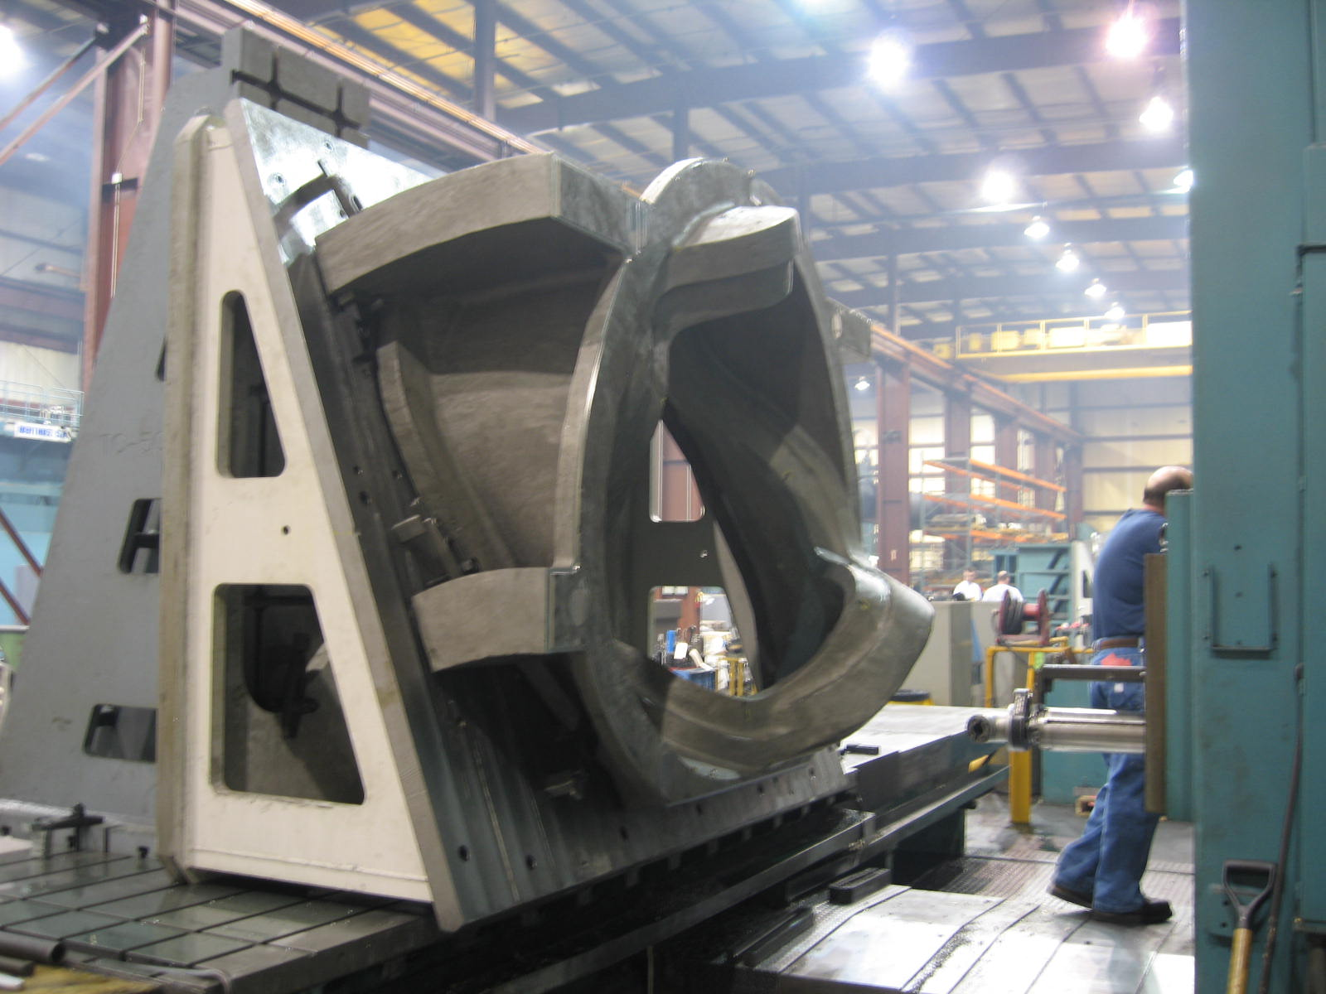

C-6 on the Lucas

Due to fixture constraints, MTM will not be able to start working on the B-1 casting until after either the 1st operation on A-1 on the U-5 or the 1st operation of A-2 on the Mitsubishi (which ever finishes first). The fixture plates used for these operations are also needed for the initial operation on the B coil forms. Due to this, MTM has decided to jump ahead and start Lucas operations on C-6. The casting was loaded onto the machine on 4/20 and initial machining began. MTM will continue to machine C-6 until an A/B fixture plate is available.

A-6

As mentioned in the Administrative Highlights, A-6 was shipped from Metal Tek to Major Tool on 4/22. According to Terri Vietor, Traffic Manager at MTK, the casting is scheduled to arrive early Monday. MTM has been advised of the shipment.
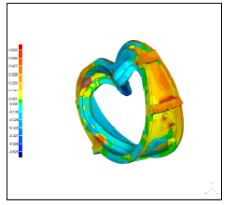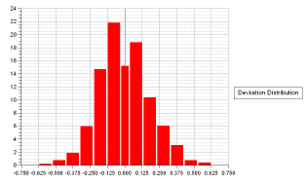
A-6 scan showing overall deviation distribution

As the shots above show, the castings continue to show very tight geometric tolerance to the cast model. The scan is comprised of 1,196,593 data points with a max deviation of 0.625” & min of -0.624”. The scan has been posted to the FTP site for review.

B-2

MTK made a final upgrade to B-2 this week. The casting was dressed & passed through final RT. B-2 went through stress relief on 4/21 and is scheduled for final LPI and mag permeability test on Monday. B-2 should be ready to ship by mid week pending EIO release. We have confirmed that this revised ship date will not delay processing at MTM, since required fixtures are currently in use on other castings (see C6 for explanation).

B-3

MTK started excavating B-3 on Monday, 4/17. As of Friday, 4/21, all excavations had been completed and the casting had passed LPI. The excavations will be mapped & welding will commence next week.

B-4

B-4 completed initial RT at MQS on Friday, 4/21. MQS reports that the casting has only 14 initial RT repairs required! B-4 will ship back to MTK on Monday for upgrading.

B-5

MTK finished the arc removal of the gates & risers this week on B-5. The casting will move into grinding early next week. B-5 should be ready to ship to MQS by week’s end for initial RT.

B-6
Barry Craig reports that the mold is now filled and Metal Tek is well on track for the scheduled pour date of 4/28. This will be the final MCWF pour for the project and a significant achievement for the team.

Bearing Plates

The bearing plates remain on hold pending resolution of the pre-cast holes. Although the plates can be used for the A-style MCWF’s, we are still evaluating whether or not they can be modified for the B style as well. On paper, there would appear to be enough stock between the cast vs. machined hole size, and hole to hole location. Whether this follows through in reality has yet to be determined. In any case, a minimum of 3 sets for the C’s must be recast. On 4/21, a separate problem was reported by MTM. They have detected some areas of high surface permeability on the cast bearing plates. This is discussed further in QA notes 2.8 & 2.9.

Technical Action Items

- (Major Tool) Final processing of C-5
Status: (Open) Shipment is on hold pending data resolution
- (Major Tool) Machining C-6
Status: (Open) On 40 T Lucas

- (Major Tool) Machining of A-1
Status: (Open) Going on to U-5
- (Major Tool) Machining A-2
Status: (Open) Going on Mitsubishi
- (Major Tool) Machining A-3
Status: (Open) On deck for Mitsubishi

- (Major Tool) Processing B-1
Status: (Open) On deck for Lucas
- (Major Tool) Machining A-4
Status: (Open) Staged for Mitsubishi
- (Major Tool) Processing A-5
Status: (Open) On-hold
- (Metal Tek) Processing A-6
Status: (Closed) Shipped to MTM
- (Metal Tek) Processing B-2
Status: (Open) Stress relief on 4/21
- (Metal Tek) Processing B-3
Status: (Open) Starting weld upgrade
- (Metal Tek) Processing B-4
Status: (Open) Shipping back from MQS
- (Metal Tek) Processing B-5
Status: (Open) In grinding pending initial RT
- (Metal Tek) Pouring B-6
Status: (Open) On track for 4/28
- (Metal Tek) Processing Bearing plates
Status: (Open) On hold pending resolution of as-cast holes.

Quality Highlights

The discussion on high permeability on as-cast surfaces continued this week. Mike Griffith, Frank Malinowski and Roy Sheppard performed the “visual permeability check” discussed in last week’s notes on C-5. In total 19 areas were found with a surface permeability > 1.02. Although 1 was able to be wiped off with a cloth (viscous substance) the remaining 18 required grinding. Of these, 2 areas were quite large and should have been picked up by the 6” grid. The 1st area was "L" shaped - about 4" wide on each "leg" Each Leg was approx 6" long. It was located on the inside wall of the casting. The other area was 1" wide by 4" long on the outside wall. Both areas were able to be ground off easily.
The remaining 16 areas were all small and would not have readily been picked up by a surface grid. Of these, 11 were surface conditions easily removed. There were 5 sub-surface indications though which needed to be excavated. Most were shallow, but 1 was about .200” deep.
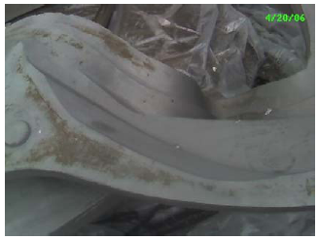 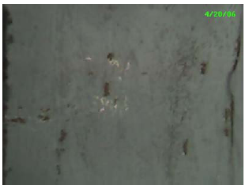
On 4/20, Frank Malinowski & Wayne Reiersen had a chance to perform a similar inspection on A-5. The casting has been sitting outside of MTM’s plant since it arrived 3 weeks ago. Although this was just a cursory look, there was evidence of a similar surface condition over the casting. The photos above are 2 examples taken from a report forwarded to EIO by Frank on 4/21. This report is under EIO review and will be forwarded to Metal Tek & MTM for comment.

Interference of Counterbore feature on A castings was another topic of investigation this week. As mentioned in the Technical Highlights, MTM has contrived a new, quicker and (technically) superior way of resolving the interference on the 2 holes identified for the A-1 casting. Going forward though, the team is proposing that many of the flange holes on A-1 be converted to tapped holes. In short, all holes on the datum E flange (with 1 exception) would be drilled & tapped to 1.375-6 UNC-2B. These holes are all A-B mounting holes & the preliminary EIO review by Roy Sheppard found ample clearance to install bolts from the B side. There are also 9 holes on the A-A mounting flange (D datum) that MTM would also like to convert to tapped holes. This proposal was forwarded to Bob Simmons & Phil Heitzenroeder for review on Thursday, 4/20.

Final inspection reports for C-5, including LPI, RT and CMM were other critical topics addressed this week. Numerous indications were uncovered during PT which were described and photographed for evaluation by PPPL. Several of these required further grinding, which was performed at MTM this week and subsequently dispositioned by PPPL. CMM results proved to be trickier, as described under Technical Highlights, and require continued analysis. The team hopes to resolve and wrap-up activities related to C-5 during next week’s QA meeting.

Upcoming QA Activities
- Final LPI & Mag permeability check on B-2
- New CMM data C-5
- Shipping release C-5
- NC(s) for C-5 deviations

QA Action Items

- Closed Items: (EIO Recommended)

  - New drawing submitted to PPPL showing revised thermocouple location (2.6).

- Pending from EIO:

  - (EIO) Provide final documentation packages for completed MCWF’s.
    - C-2 (reopened)
Status: (Open - No update since QA meeting on 4/18) PPPL on reviewing package noted missing documents (NCs are for weld wire and elongations…spec will be updated to include this). PPPL also noted that weld map does not correspond to pictures. Updates being processed at EIO. Mike notes those NCs were included in C1 and wondered why PPPL wants them with C2. Frank wants them with C2 if the spec was not updated prior to them being welded. Will review during trip.
    - C-3 (reopened)
Status: (Open - No update since QA meeting on 4/18) Comments from PPPL in process at EIO:
1) It should be made clear, through initials or signature or similar, that Steps on the MetalTek MTS that are marked “N/A” or “Do Later” have been deleted, skipped, or re-sequenced by authorized personnel.
2) MetalTek CA 1581 should be part of their documentation package.
3) Some MTM reports, especially some RT reports, are fairly faint. Please generate or scan to be more legible. (Mike Griffith noted that use of electronic signature will improve document legibility) Forwarded to PPPL on Tuesday 4/18.
    - C-4
Status: (Open - No update since QA meeting on 4/18) –Films already provided. Need open NCR 19475 Rev.1 (3.2 below) to complete

  - (EIO, MTK) Update CA 1625 (A-1 linear indication) after machining.
Status (Open - No update since QA meeting on 4/18) Updated by MTM on 3/31- will leave .030” of stock on flange face for cleanup on U-5 – final disposition after that operation. Looks like it’s cleaning up, but won’t know until machining is finished. MTM looked with LPI and considers the indication minor.

  - (EIO, MTK) Provide inspection history requested 3/31 for the area of the 4” linear discontinuity documented on PPPL NCR 3644. PPPL provided a guess at the RT history using the MetalTek C-4 documentation package and the RT Technique sheets to EIO for confirmation or correction on 4/5.
Status (Open). MTK’s lead radiographer reviewed it, but no firm conclusions yet about which shots included this discontinuity. Will discuss next week and will try to develop a better way of cross referencing the locations of the shots. Chuck requested history from MQS. PPPL ground out this indication. Phil will get the results of the post grinding inspection. Subject remains under investigation at MTK for discussion on 4/25.

  - (EIO, MTK) Provide additional information for CA 1671, A6 test results below spec for elongation. MTK to check with Westmoreland regarding the rate of pull. MTK’s specialists will report on their appraisal next week.
Status: (Open) CA 1671 for a failed test bar on A-6 was resubmitted to PPPL twice this week; the 2nd time with excellent results. The new set of test bars sent to Westmoreland Labs passed. It was noted though that the zone #s could not be read on the test bars. To be discussed at QA meeting 4/25
  - (EIO, MTM) Disposition rejected SS316 bearing plate material documented on EIO’s NC 19233 & 19234.
Status: (Open) Will close after 316 bearing plate material is shipped back to PPPL, which will be after Stellalloy bearing plates are in use. (Plates were poured week of 4/7 - first set shipped to MTM on 4/13; however, cast starter holes did not meet C coil requirements and will be repoured). Old plates may ship with C-5 end of next week. Topic was to be addressed during Frank’s visit to MTM. No update provided

  - (EIO, MTM) Get marked up drawing back to PPPL re location of initial thermocouple hole on A MCWF.
Status: (Closed) PPPL has received this and will get drawings updated.

  - (EIO, MTM) Process CA for C-4 features compliant to SE141-116, Rev. 7, but not to Rev. 8.
Status: (In-Progress) On 4/12, Peter Djordjevich issued Corrective Action Report 041006-1P to MTM with a request to complete prior to 4/18 Quality Meeting. Due to other workload constraints at MTM, this action is still open.

  - (EIO) Investigate and take steps to mitigate source of ferromagnetic contamination seen on C-4 & B-1. Report back so that PPPL can disposition NCR 3633.
Status: (In-Progress) –As described in detail in QA Highlights above, similar conditions found on C-5 (some sub surface), A-5 & on bearing plates. Discussion and investigation of the topic will continue within the EIO team with the goal of solving this mystery.

  - (EIO, MTK) – Bearing plate processing
Status: (Open) As mentioned in Technical Highlights, the bearing plates are currently on hold while it is determined whether or not they can be used, as-cast for B type coils. It is known that for C coils, they must be recast. A second issue, (see 2.8 above referencing permeability issue) was reported on 4/21. Bearing plates were still in the packing box & showed same high spot-permeability condition.

- Pending from PPPL

  - Provide updated requirements documents incorporating the following changes:
    - CSPEC update addressing revised poloidal break inspection/tolerances. Poloidal break flange fit-up, 0.005” through and 0.015” at edges – edge defined as no more that 1/8” penetration.
Status: (Open) Rapid response guidance sent 3/16. Wording for next CSPEC revision is in process.

    - PPPL to incorporate guidance on Type A MCWF thermocouple hole placement provided 3/20 into requirements documents.
Status: (Open) – Marked up drawings submitted by MTM –. (see 2.6 above)

  - Return signed NC19475 (C-4 misc. discrepancies) revision 1, posted 3/29, to EIO.
Status (Open) – This also has the info on the thin flange region noted in 3.4. NCSX will get it to EIO by next week. Phil will check on this.

  - Review 4/7 update of bearing plate processing plan posted 4/14.
Status (Open) –Satisfactory.

- Discussion Topics for Teleconference:

  - New Specification & Drawing Changes
  - CMM Data for C-5

Nancy Horton

EIO Program Manager for NCSX

216-496-2314

